

Lab: IPv4, Subnetting, VLSM and IPv6 Addressing

- Understanding IPv4 and IPv6 addressing (word count 1000)
This part of lab worksheet require you research and write a report on “Features of IPv6”. You may discuss but not limited to structure, address types, advanced functionalities and security.
- Subnetting and VLSM

NOTE: To complete this part you would need full understanding of Lab 10 to 14.



Using the Network address 172.16.2.0/24, VLSM the network to support the following requirements:
Subnet A: 16 hosts
Subnet B: 2000 hosts
Subnet C: 6 hosts
Subnet D: 500 hosts
Subnet E: 60 hosts
Subnet F: 180 hosts and Serial links between routers

Table 1
Subnet | Network Address | Subnet mask | First Address | Last Address | Broadcast Address
B/21 | 172.16.2.0 | 255.255.248.0 | 172.16.2.1 | 172.16.9.254 | 172.16.9.255
D/23 | 172.16.10.0 | 255.255.254.0 | 172.16.10.1 | 172.16.11.254 | 172.16.11.255
F/24 | 172.16.12.0 | 255.255.255.0 | 172.16.12.1 | 172.16.12.254 | 172.16.12.255
E/26 | 172.16.13.0 | 255.255.255.192 | 172.16.13.1 | 172.16.13.62 | 172.16.13.63
A/27 | 172.16.13.64 | 255.255.255.224 | 172.16.13.65 | 172.16.13.94 | 172.16.13.95
C/29 | 172.16.13.96 | 255.255.255.248 | 172.16.13.97 | 172.16.13.102 | 172.16.13.103
R1-R2/30 | 172.16.13.104 | 255.255.255.252 | 172.16.13.105 | 172.16.13.108 | 172.16.13.107
R2-R3/30 | 172.16.13.108 | 255.255.255.252 | 172.16.13.109 | 172.16.13.1010 | 172.16.13.111

Report

IPv6 is everywhere. It is the default on all major operating systems and is widely deployed across the Internet. Further, its growth is exponential and at the current rate all Internet users will be using IPv6 by 2020

The IPv6 is a powerful and flexible compared to its predecessor the IPv4. The IPv6 addresses are assigned to interfaces, rather than to nodes, in recognition that a node can have more than one interface. Additionally, multiple IPv6 addresses can be assigned to an interface.

The IPv6 address consists of 128 bits in length and 16-bit fields. Each field contains a hexadecimal number. Although most IPv7 addresses do not occupy all of the 128 bits. This results in fields of zeros. As a result it is possible to replace the fields of zeros with colons.

As shown in table 1, the IPv6 has a packet header size of 40 bytes, a more secure transfer of 1280 bytes and an unlimited extension of header levels, this makes it a far superior model.

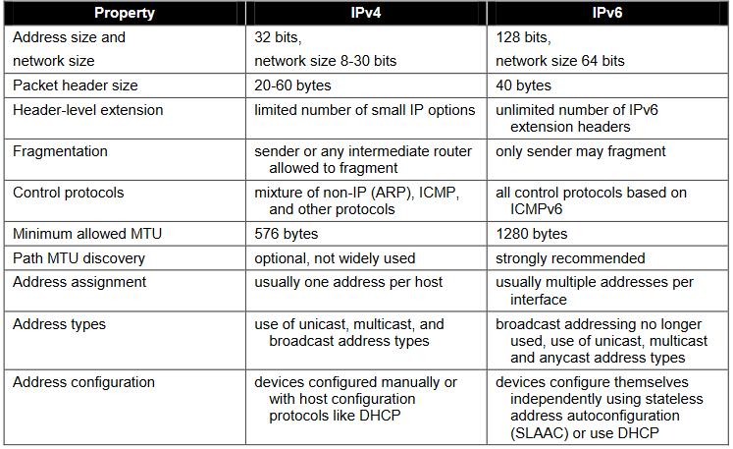
Table 1: Comparison

Many of the IPv6 addresses ranges are reserved or defined for specific purposes as specified by the IETFs IPv6 standards and the IANA [1, 2, 3, 4].

There are misconceptions that IPv6 is more or less secure than IPv4, however, it isn’t. The reason is simple, in the network there are no IPv4 stacks, all stacks are IPv6 stacks. Therefore, whether using IPv6 or not the vulnerability surface of your IPv4 network is practically identical to that of an IPv6 network. There is a combined vulnerability surface consisting of IPv4 and IPv6 vulnerabilities. Comparing the two is therefore meaningless.

The following points highlight the improvements of the IPv6 over the IPv4:

• Attributes: length, scope and lifetimes
• It is normal for IPv6 interfaces to have multiple addresses
• IPv6 addresses can change over time
• DIFFERENT Multicast is very important in IPv6
• There are large numbers of methods for assigning interface identifiers
• DIFFERENT How addresses are used and managed are different
• DIFFERENT Global public addresses are the norm
• A huge number of addresses

Ultimately, the IPv6 is used primarily in modern networks, purely for its additional features, it provides a wealth of security measures, enabling the user to have more freedom within their network. However, there are still potential security risks which can be mitigated, using a range of techniques. [1, 2, 3, 4]

References

[1] | National Institute of Standards and Technology, Guidelines for the Secure Deployment of IPv6, Gaithersburg, <D: U.S. Department of Commerce, 2010.
[2] | B. A. Oliviero, Cabling Part 1: LAN Networks and Cabling Systems, Indianapolis, Indiana: John Wiley & Sons. Inc, 2014.
[3] | B. Sandberg, Networking The Complete Reference, Third Edition, McGraw-Hill Education., 2015.
[4] | B. Woodward, Cabling: The Complete Guide to Copper and Fiber-Optic Networking, Indianapolis, Indiana: John Wiley & Sons, Inc, 2014.

