Network Infrastructure Project
Demonstration of work

Student Name: Aziz Ahmad Tahir
Student ID: 2424161: Course: Network
Course Module: 5023
Lecturer: Dr Sadeeq Imam
Date: 01/05/2026

Table of Contents
1. Windows Server Dashboard
2. Features Installation
3. Server Roles
4. RRAS Installation
5. RRAS Configuration
6. NAT Configuration
7. ICMP Rule
8. APIPA Issue
9. Ping Test
10. Active Directory
11. DNS
12. DHCP
13. Client Domain Join
14. File Sharing
15. Group Policy
16. IIS

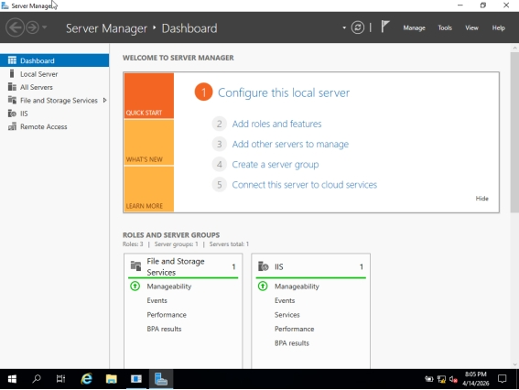
Figure 1: Windows Server Dashboard

Explanation: Server Manager dashboard used to manage roles.

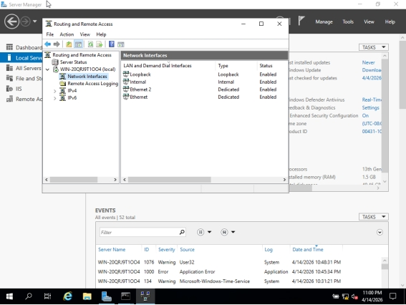
Figure 2: Features Installation
Explanation: Install features like .NET Framework.

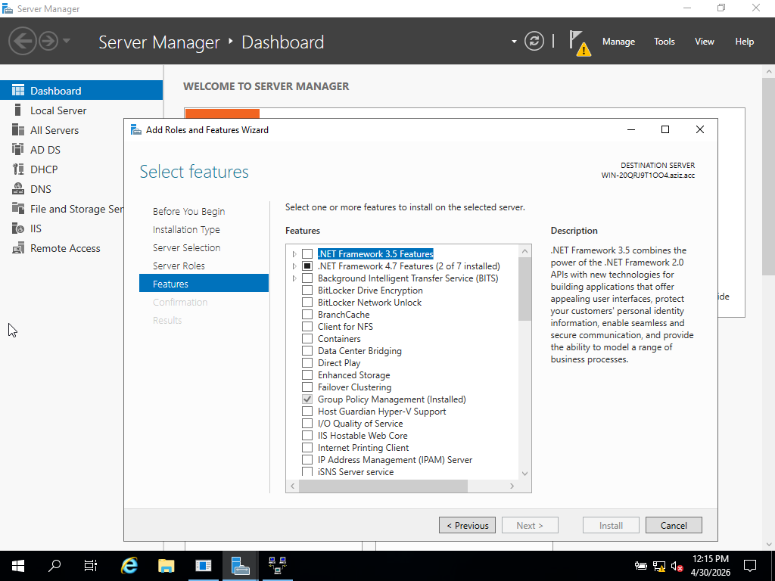

Figure 3: Server Roles

Explanation: Installed roles like AD, DNS, DHCP, RRAS.

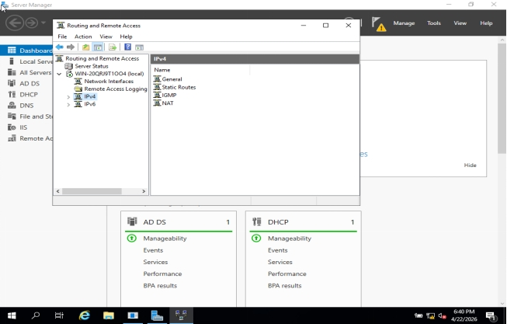
Figure 4: RRAS Installation

Explanation: RRAS installed for routing.

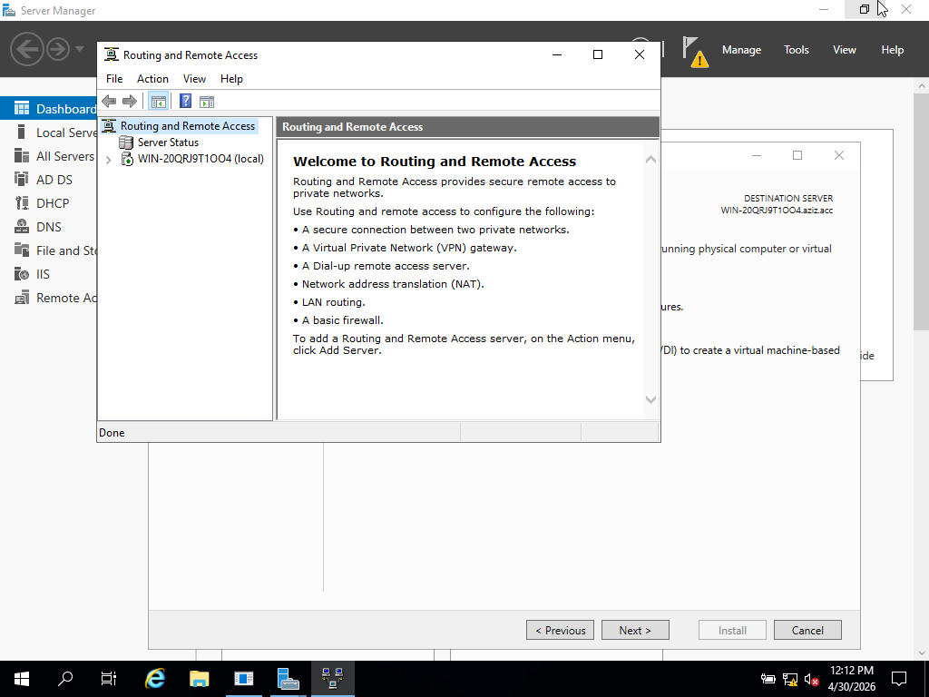

Figure 5: RRAS Configuration

Explanation: Configured routing services.

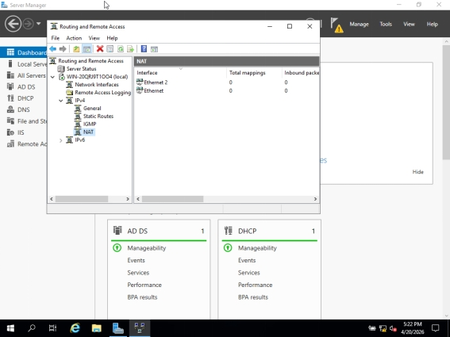
Figure 6: NAT Configuration

Explanation: Allows internal network access.

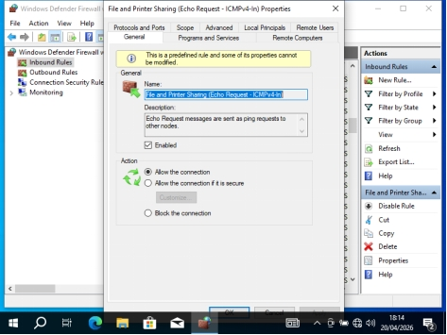
Figure 7: ICMP Rule

Explanation: Enables ping.

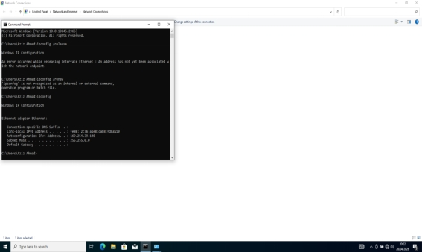Figure 8: APIPA Issue
Explanation: Occurs when DHCP fails.

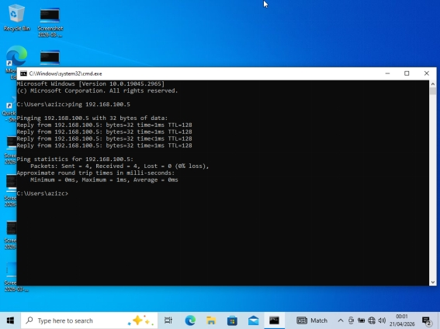
Figure 9: Ping Test

Explanation: Confirms connectivity.

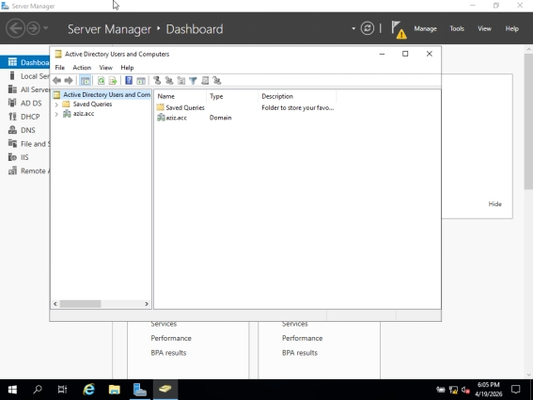

Figure 10: Active Directory

Explanation: Manages users and domain.

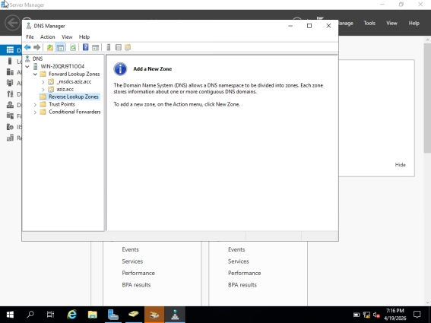
Figure 11: DNS

Explanation: Resolves domain names.

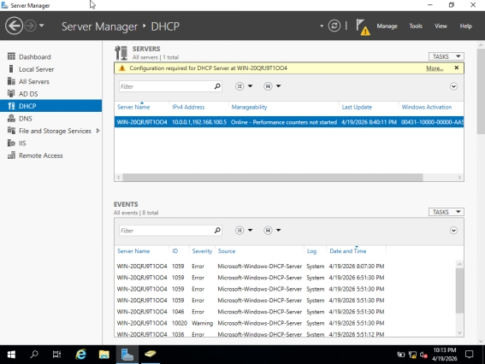

Figure 12: DHCP

Explanation: Assigns IP addresses.

Figure 13: Client Computer Joined to Domain

Explanation: Client joins domain.

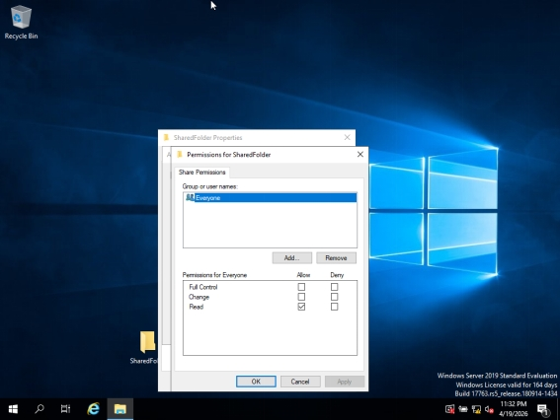
Figure 14: File Sharing

Explanation: Share files over network.

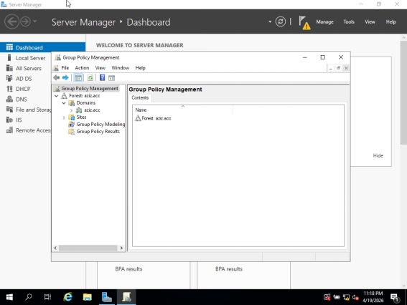

Figure 15: Group Policy

Explanation: Control settings.

Figure 16: IIS Website

Explanation: Host web pages.

