Business Plan

RBD Shoes
Footwear company

- Your business and objectives
Student: Bernard Amoako
Student number: 1909476

Briefly describe your business, outlining the different product(s) and/or service(s) you offer:
RBD Shoes is an online shoe business for male, female and unisex shoes. It originally started one year ago when Raynel started work with the company Alive Shoes which gave him an opportunity to design and sell his shoes online. This company, based in Italy works with many other big brands like Gucci, Fendi, etc.

Our company still works with Alive Shoes and is selling shoes online through their platform, but it has plans to find other producers and possibly make its own website in the future.

There are plans to expand our shoe business and after establishing our brand we wish to also expand into clothing.

Objectives:

Short term (current year):
A short-term plan outlines your goals within a year’s span as well as concrete positive action necessarily to reach them. It also takes into consideration the company’s present state and develop strategies to get it ahead. And this may include courses for employee, more efficient marketing or new equipment to improve production. In a nutshell the short-term business plan focuses on things that seek to improve the company’s performance right away. Some of our short-term objectives are:

- Get 5000 customers: One of our short-term plan is to get a number of customers up to 5000 online. And this can be done through online advertisement and by using electronic billboards. It can also be achieved by introducing promotional discount based on recommendation through a customer. Doing so we hope to win more people from them in a short time
- Design new models: We also plan to know the interest of the customers that will help us design to their taste. And that will also help us get more customers in the short time and also more to catch the eye of more people to subscribe on line. We also intend to give out new shoes based on the company’s new developed designs and also customers reviews and feed backs.
- Get more customer engagement with our products: Customers engaging with the producers and products on social media makes them better remembered and gives us free marketing, so encouraging that will be in our advantage.

Medium term (next 1 – 2 years):
A medium-term business plan covers a period of about three years. A medium-term objective demands more permanent solutions to the type of problem it needs to address. This may include plans to open a new store or enter a new market.

- Design shoes for women and children.: As we know earlier Alive shoes deals with Men shoes only foe now. We also have the plan to add shoes for women and children to also help get more customers for the business to grow. We know the impact women and children make when it comes to buying but this is set to be achieved at the medium term plan. Also product quality needs to be addressed, so we will set regulations to check quality control. In an attempt to do that there will be the need to assign a supervisor to take charge of that

- Give 70% of our time to the company: With the individual experiences that we have we hope to dedicate more of our times to this business to help it grow. Right now we also work on our time besides the company, and it is not very efficient to exhaust ourselves on 2 jobs and it also makes our concentration on the company weaker. So more time dedicated to the company means a better future for the company

- Establish a 24-7 dedicated customer service line: A customer service line is very important when talking about a delivery service and online only business like ours, so we need to make sure our customers are always happy and their complaints are always heard so that we make a good reputation of always listening to customers and always helping them which will make our brand stronger and more customer friendly.

- Establish after sales service centre.

Long term (3 years and beyond):
A long term objective demands the development of comprehensive strategies that will drive the company ahead towards the greater achievement. It also defines the companies’ vision and also have intensions that extend beyond profit making. This goals also addresses the company’s activity in all fields such as the economic, social and political environment. It is also the range where the business cease to solve larger problems that require solution of a higher order. This business objective may include coming up with a more efficient corporate culture developing ties with strongly position strategic partners.

- Find new partners.: Looking for partners to help us get knowledge and experience we lack. Also, to put in more money into the business to help it grow and to attract more investors. They will also help us to save cost by also involving in paying part of the cost that comes in. The partners can also help the company to catch those that we missed, that is where we have blind spot.

- Physical shop: With the help of the investors we hope to make more profit so we can have physical shops where people can walk in and buy. It will also help us get more customers who can’t buy from online. Also, for customers to touch know how quality our shoes are. Also, to have branches in so many parts of the world to create jobs for other people.

- Expand into clothing: We are also planning to expand our production also into clothing for men and women, boys and girls etc.

2. Your skills and experience

Outline any previous experience, employment or other work that you have done that is relevant to your business:
Skills and experiences of our members:

- Bernard (): Company Role -Director; He has managing experience for a period of 5years, having previously worked as a site director, which he uses in the company directing the members to their tasks.

- Edit (): Company Role-Marketing; She was a volunteer in 2008 at a Hungarian Animal and Environmental Civil Organisation where she made an informative and educational web page for children. This was her first work where she could practice what she learned about online marketing and advertisements. The Civil Organisation liked her work and the web page was well visited.

From 2009 she worked with as online assistant for 2 online businessmen and helped them advertise different link pages in their blog articles. After this she worked with an online small family business helping with the administration and she wrote articles on their blog that followed SEO¹ compatible rules.

- Kacper():Company Role-Product and market analysis ; When he was very young he used to help his stepfather in his coffee shop. He was trying to understand all of what he was doing for company and how one should run a company to make a constant profit.

- Lucian(1907758): Company Role -Accountant; He worked as a volunteer in a non-governmental organization in his native country of Moldova helping in the developing of various project as well as in the finances.

- Raynel(): Company Role-Designer ; Around 4 years ago he started to invest his money buying shoes from Id sports in London and selling them in Amsterdam. He was checking if the shoes that were available in London were also being sold in Amsterdam and as some models were, he saw an opportunity and supplied them in Amsterdam making a 30 percent profit. This defined his first experience in shoe selling.

- Cosmina():Company Role-Management and organization ;

Outline any education or training you have had that is relevant to your business:
BERNARD: Studied Business management at the Accra polytechnic with Higher National diploma and Degree in Business Administration from the University of Ghana, Legon in Accra.

Raynel: Graphic Lyceum in Amsterdam, where he learned to be an artist, how to design and create, for example for commercial advertising, logo design. Mainly he learned to be a shoe and fashion designer.

Edit: Her online training is her main education in online business and marketing.

She participated in a variety of online marketing courses and when she moved to London from Hungary, she

started thinking of her own business. Her main interesting is digital marketing and e – business and how the mix

of offline and online marketing support each other. She continuously learns more by herself in subjects such as:

SEO¹, social media marketing, online advertise, digital marketing.

Kacper: University of Wales Trinity Saint David education.
Lucian: University of Wales Trinity Saint David education and volunteer training in a non-governmental organisation

Outline any transferable skills, talents or traits you have that are relevant to your business:
- Bernard: With my written communication skills I will be able to check orders, placed by customers and see to it that all had been packaged and delivered. And also will use that skills tom respond to emails. I can also be able to update customer reviews.

- Edit: Academic skills; Self-learning skills;

- Kacper: Communication skills; Academic skills; Internet research skills;

- Lucian: Internet research skills; Academic skills;

- Raynel: Communication skills; Academic skills;

Briefly outline any gaps in your skills, experience or qualifications and explain how you will address these:
- Bernard:
- Edit: Communication skills;
- Kacper:
- Lucian: Communication skills(confidence);
- Raynel:
- Robert:

- Search Engine Optimisation

Product and Services
Student: Kacper Zaleski
Student number: 1818719

The designed brand of our company is RBD Footwear. Shoes are not just something to put over your feet and be done with it, there are many thing that is important in shoes, and many things that they say about a person, and we want our shoes to say that a person is fashionable and values comfort and good quality.
This product is designed to meet up to the new fashion trends and the needs of long-time comfortable and fashionable walking. This product is more suitable for the European cold weather situation, but it doesn’t mean that it won’t be interesting to others from other climates. Customers can have different categories of the product, like sports product, fashionable product, party shoes and type of shoes that match and are a good wear to the jeans to the suit etc. Most of the work on the shoes is done by hand which makes us unique. RBD shoes are made from high quality materials like leather, which, for example is a very important material in shoes and can have a lot of variation in quality based on what type of it is used, from full grain, top grain and many more types of leather it is hard for most people to truly know what type is best for high quality, but our shoes only use high quality leather in order to deliver good durability and beauty that leather provides and not the cheap one that easily tears and is loses colour and shine. There is also, gum, and other high-quality materials -in order to make very comfortable shoe sole and laces are made from plastic materials. RBD is not yet the most famous mark in Italy, or anywhere yet in Europe or the USA but we all the time are developing our skills and very soon whole world will wear our products, or at least will hear of someone else who wear them. They are produced by the best shoemakers in the industry in the Shoe valley in Italy which is a traditional shoe making place and many of the craftsmen who hand make shoes are incredibly skilled, and what might seem like a simple shoe at first can be revealed to be a work of art done by a professional which will last for a long time and will fit perfectly. The manufacturer of course plays a in part in the quality of our product and we are proud of it. Compared to a factory they are made much more meaningfully and passionately which give shoes a certain beauty and soul to the shoe that cold machines and overworked workers could not give. We give our product our utmost care from designing them to producing and delivering, and even if the latter two are done by “Alive Shoes” we plan to keep the same care and importance to those as this company did when we start making shoes with our own, and perhaps we will be able to give them a quality and soul even in a factory if we care for them enough otherwise.
We also want to make clothes in the future based on the same principle of quality materials and very good craftsmanship at first but also make them more available in the future for everyone.
In the future we want to make special shoes for people with foot problems or other such products to make people feel more comfortable and help them wear fashionable shoes. We also want to add a smaller but professional design for a specific person as a service.
Demographic Details of Target Customers:
Age | Gender | Income | Regions
15 to 70 | Unisex shoes | £20000 to £50000 | National

The target customers of RBD Footwear are limited but only by age but not at all. The products are be offered by RBD Footwear are smart shoes. Primarily the focused customers are adults. Children are not likely to use smart shoes. Again, some of users may buy smart shoes for the children but the segment is very low and attract by brand. Firstly, we have no current brand power to impress the royal customers. So, income range from £20000 to £5000 Is mainly target customers of us. The product of RBD Footwear would be unisex primarily. In initial level we will produce adult size shoes and targeting the middle-class customers. The primary market boundary of RBD Footwear would be within the national boundary of Wales. The products would be delivered through reputed courier companies currently by Alive Shoes, but later by our trusted carrier companies. After 2 years having expected customers RBD Footwear would have delivery agents nationwide to deliver the products. The potential customers are fixing according to the product price and beginner. Many reputed footwear companies are already offering smart shoes to the potential customers. Though smart shoes are not available to the common mass, targeting the middle-class customers we would be the first market pioneer to promote the shoes in Wales (Wallwork, 2012). Based on Wales of course, we can make a strategy for the rest of the UK and based on the UK we can make one on the whole of western Europe which is still similar enough.
In the future when we get more finances, with more sales or maybe with an investment, we will make shoes for everyone, from women to children and all kinds of designs, we want to make high quality shoes for all classes of people, and maybe also make cheaper shoes as well for those who want to buy them. We could make shoes specially for people that is mean if you have unusual foot size or any other foot defect don’t worry, we will make it! Our company is focused only on customers not only Money is important, which is why we always make our shoe designs with the customers in mind and we will always make shoes with our customers in mind even when we become a big company.
Also, we plan to make our own brand of not only shoes, but also clothes, because once we enter the fashion business with shoes, we will have experience and more drive to also start designing and producing clothes. We will make them match perfectly with our other products in order to make a person fashionable and beautiful without needing to look for a specific way to dress themselves, so it would be good for both fashion oriented people who look at fashion news everyday and for people who mostly only look for ways to look good without keeping in mind that it is a specific season for a type of fashion products. When we will start making clothes, we will make the designers think through outfits and combinations of clothes and shoes to make sure that no matter what combination of products from RBD a person wears they will look beautiful and stand out from the crowd.
We want our brand to be strong, because a brand needs to have personality and be able to give customers a feeling of connection with it, it must be associated with something, (Stobart 1994). For example, we want our brand to make our customers think about the quality of our products and how durable, comfortable and useful they are for them. We want them to also associate it with style and fashion because we started as high quality and fashionable shoe sellers, and we want to continue our brand to be about fashion and beauty and having people see it as a symbol, as a way to show yourself that you are fashionable and as a way to stand out from more mainstream and already long-existing brands. Of course, the customers will also see and feel our passion to make our products better and will be attracted to them by it.
Of course, when we start being by ourselves with no Alive Shoes, we will have even more freedom to make products after our vision and make them better.
How shoes shape people
I think that by designing and being a part of a team that sends people shoes we can be part of a persons life, because a shoe is always a part of a persons life, and a good shoe can be a big part of a person’s life because they value it, even if most of the time people don’t think about them they are very important to how people feel, for example if a shoe is uncomfortable, the person will constantly think about it and will not be able to concentrate and feel happy about what they are doing otherwise. It also helps people with self esteem because if they see from time to time the shoes, they wear are beautiful and eye-catching they will know that they are not invisible and that they attract the attention of those around them. So, it is psychologically important for a person that we make high quality and well-designed shoes. It will be even more important for clothes when we start making them because clothes are more visible and have an even bigger effect on what someone feels.
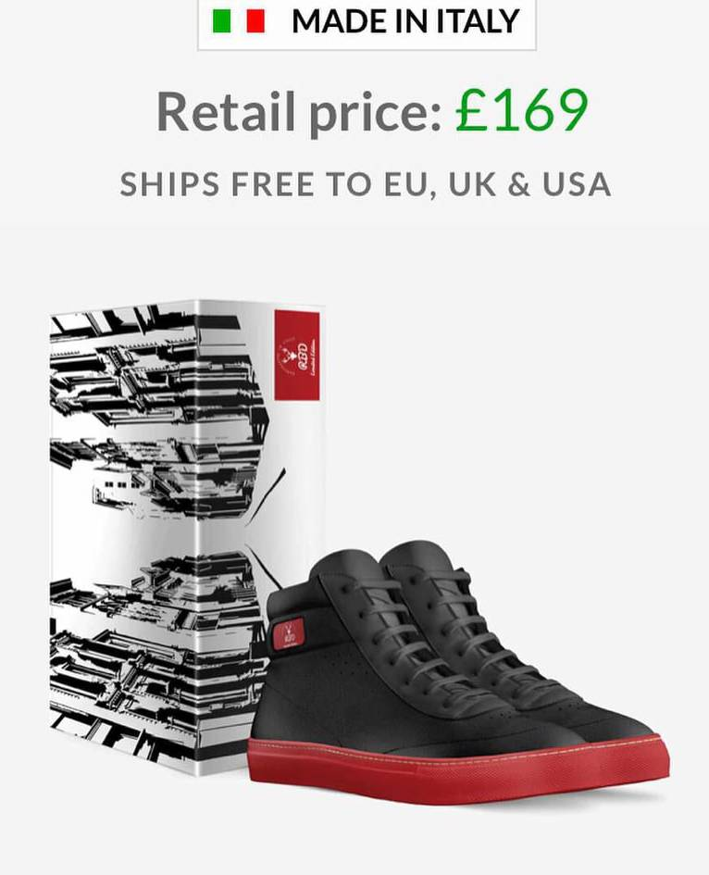
For an example of our shoes is this, it is a sleek and ergonomic design, it has beautiful colours used, handmade by experts in Italy. This pair uses nice contrast, a comfortable design and eye-catching bottom rubbers, all made with high quality materials and with a price that is smaller for the same quality than many other brands. This is an example of what is truly high quality and we sell it very well, it is from our more early designs but it is still popular. It gives an aura of quiet uniqueness and it makes one stand out subtly but beautifully.

Market Analysis
Before entering the market, huge market experience and research should be conducted by the marketing and product development team so that we know better what the situation is. The premium shoe market is always growing and anytime is a good opportunity to enter it with full force, but it is also very varied and has many types and trends and different people looking for many specific things other than just simple shoes. Top shoemakers are available in UK and they are very much serving quality products, besides that the Smart shoe concept is not new, and customers are welcoming the product to the UK market. The pricing of the product represents the simplicity and the higher quality together. Our price is lower than the similar top brand shoes like Gucci or Chanel who are making it the same place that is call The Shoe Walley in Italy handmade by master Italian craftsmen. This fact gives a good background of these shoes and guarantee this new upcoming independent brand is a good choice for men who want their shoe life comfortable and clever. Introducing reasonable priced smart shoes would not be an easy task for the marketing department. The potential buyers are highly attracted by brand value as this special product is not commonly used. The users of our shoes are not huge, but we will change it. So, the user’s information would be helped to impress those offering low price good shoes. Once the product can be introduced to the potential customers hopefully the sales would be boost. The online marketing would be helped a lot to create market opportunity and reach the customers from other parts of world.

Marketing

Student: Edit Bona
Student Number: 1909474

- Market research and competition
The RBD'S Shoes is selling his online web shop what is working under the http://www.aliveshoes.com/rbd-7 online business system. The potential customers buy online that's why the marketing research use online tools: Google Keywords Plan, Google Trends, Social Media, Google Survey, Google Analytics.

Online research
The Google Trends is very useful tool to know our product how popular on the market and which locations. Searched for worldwide, past 12 months (05.05.2019 – 05.04.2020) and shopping category on web search.
The first research was „Italian sneakers” and got very good rated 5 country: 1. Australia 100% 2. United States 85% 3. Italy 41% 4. United Kingdom 39% 5. Canada 26%.

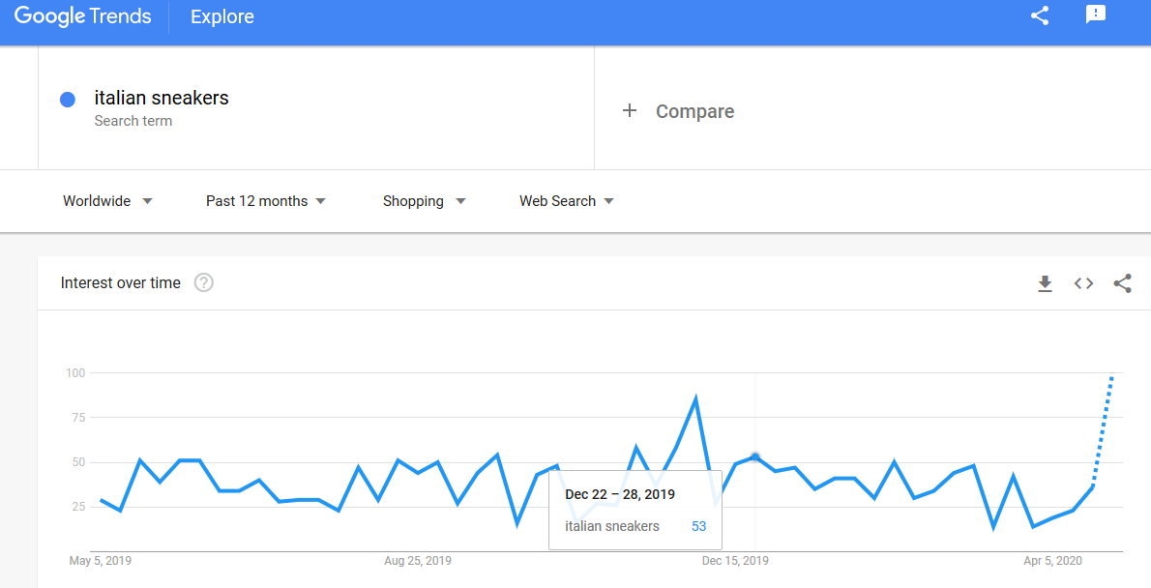

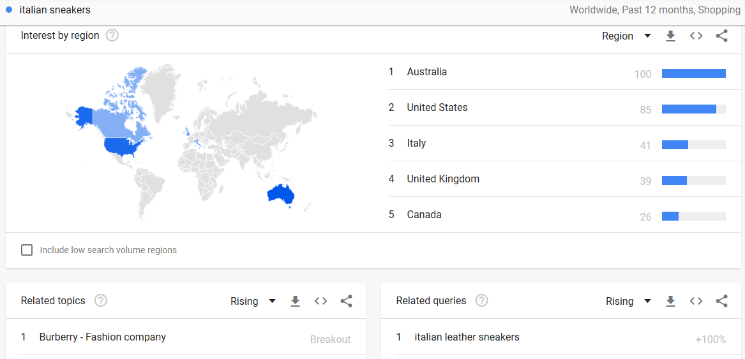
GoogleTrends.com (2020)

The second research was „italian shoes men” and showed very popularity 2 country: 1. United Kingdom 100% 2. United States 79%.

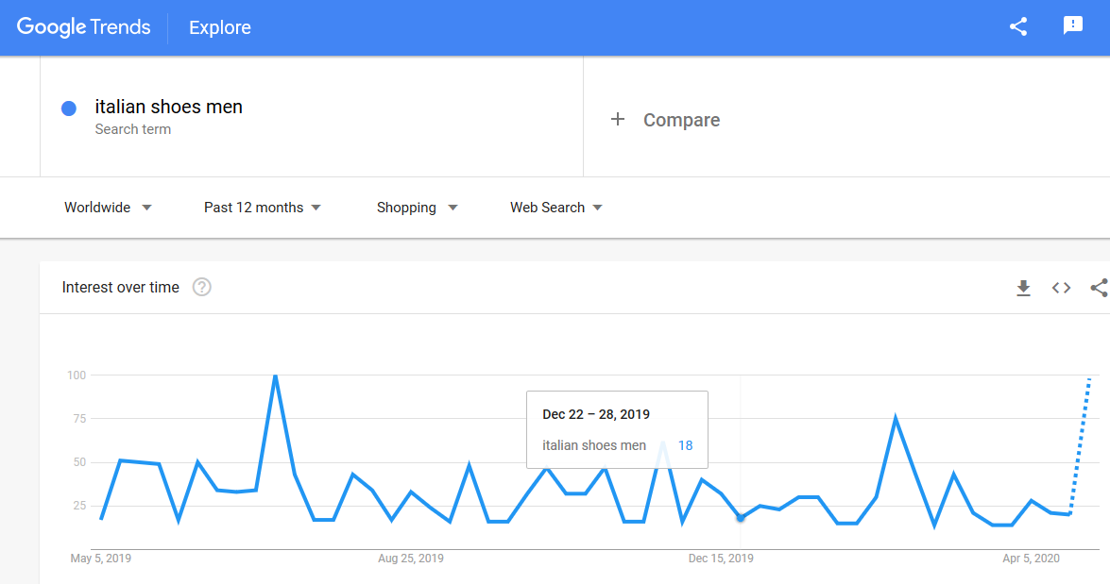

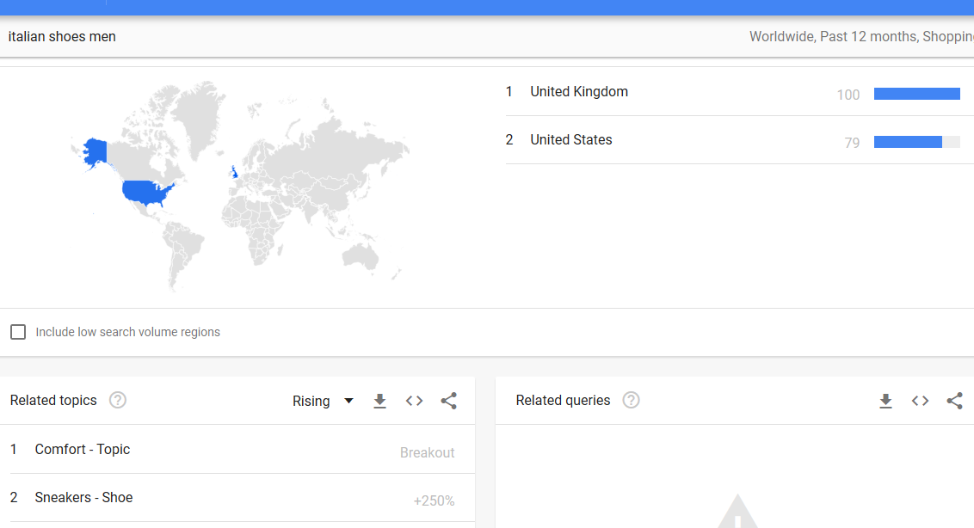
GoogleTrends.com (2020)

The third research was „minimalist shoe” what is very popular 3 country: 1. United States 100% 2. Canada 82% 3. United Kingdom 38%.

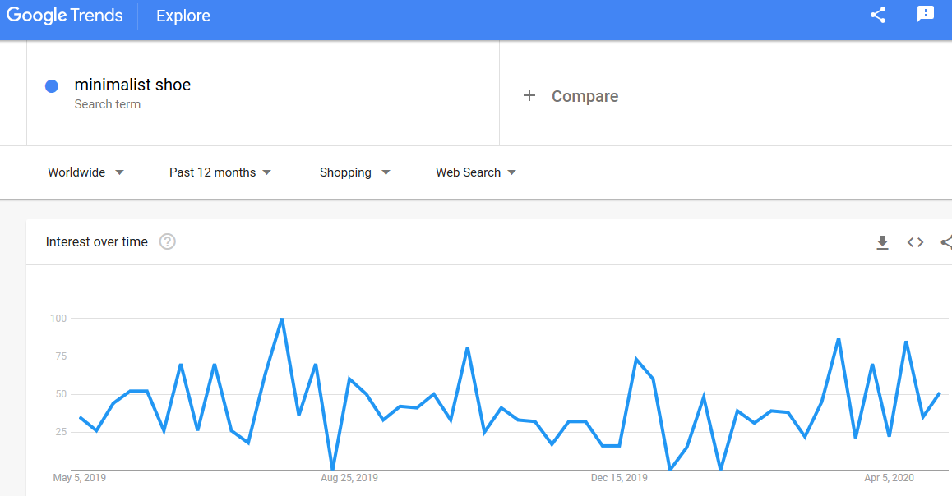
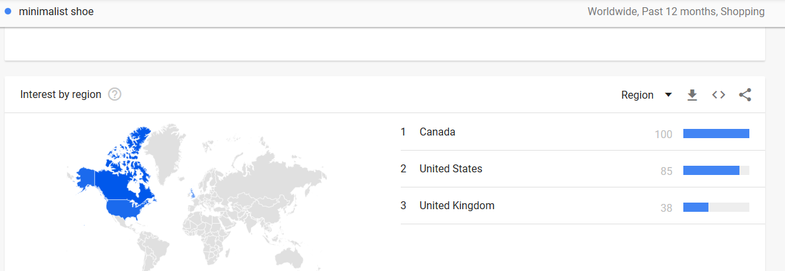
GoogleTrends.com (2020)

These results give us very good chance on the shoe market because the people like very much this type of style, and got very good rate especially in the big city like London and New York. The classic and simple style is also higher rated in the big brands like Chanel and the black version. The preferred colour for shoes by men are the black, brown, white, blue and grey. As seen above, for the future selling the italian sneakers and shoes very popular in the most marketable countries. The minimal style got higher rate especially in the United States what is mean a good segment on the shoe market.
Social media research
On Facebook there are small shops who sell similar or under the same system handmade crafts shoes worldwide and there are the segment everywhere.
On Instagram I found some competitions with the same derby sneakers with different design under this same system from the USA the most. What I saw was that they just put some pictures on their private profile what is not so professional and don't motivate the potential customers to buy.
On YouTube I cannot find anyone who sell under this system but other sellers are very creative this online video platform. The people find very informative these sellers channels and the comment section is very busy.
The conclusion about this research is this type of shoes are very popular among men. On the social media is a very good platform to connect the potential customers but need to use clever. Today one of the most effective tools are the video and the pictures what we can use the most social media. The video is the best way to inform and motivate the customers.

- SWOT Analysis
The next section represent a SWOT analysis about a competitor (http://cobblondon.com) and our company to help to see where we are at the moment in the online market and where are the similar competitors. Gives a guideline about what we are good at, what need to improve, what are the future opportunities are and what we have no influence over but give pay attention to. It gives a good guidance on what competitors are doing and what we could do better to stand out from the crowd.

Cobblondon.com
Strength  - 6 different styles shoes in 2 colours  - Strong Facebook, Twitter and Instagram activity  - Webpage with worldwide selling  - Free shipping policy worldwide  - Good quality  - Cheaper the price  - Return policy is free in the UK | Weakness  - No video marketing and YouTube channel  - The webpage social media icons not visible on mobile phone  - Few product  - No offline shop  - No big brand  - Return policy outside of the UK not free
Opportunity  - More social medis activities  - Video marketing  - More product palette  - Webpage optimize on mobile  - More online advertise | Threats  - Too much noise online  - Too much competitors  - Not enough money  - Webpage server stop

RBD'S SHOES
Strength  - Unique design  - High quality shoes  - Online sell worldwide  - Free delivery and return policy worldwide  - Free webpage platform  - Free online marketing tools | Weakness  - Weak marketing  - One product  - Unknown brand  - Lack of capital  - No personal activities online
Opportunity  - Strong social media marketing  - Low cost advertisment  - Video marketing  - More product | Threats  - Too much noise online  - Too much competitiors  - Replika’s ont he design  - Webpage server stop
Conclusion from the two analyzes is as follows. The competitor is strong some social media platform so our business need to target more social media. The video marketing and YouTube present is a very highly recommend strategy what make it stronger our marketing and the potential customers availability. Our price is higher with £45 but this price give one of our preference what is a free delivery and return policy worldwide plus express delivery in Europe, UK and USA. The social media and other icons on the competitor webpage not visible what is a very huge mistake because not just lost followers but the navigate ont he website is not user friendly. Our business sell at the moment just one product with one style but in the future we will open more segment and product type. The threats are common with both side because the online market noise is the same for us.

- Marketing Strategy
In this section will show some strategies for promote the business and the shoes. How reach and arouse the people’s interest and make them a buyer. There are several technique reach this goal and maintain the attention in the long run.

4.1 Social media
The online presence on the most social media platform is necessary to meet our potential customers. Very important not just make an account but the daily activity is keep up the people interesting.
Today one of the most effective tool is the video marketing. With a YouTube account lots of platform can share the videos with one work. Making video campaigne about the 30 days pre orders and every single day promote, introduce the product and tell why worth it wait for the product. Tell the story behind the brand, make a personal connection with the customers. Build the personal brand for Raynel who is the buisness owner and designer of the shoes is a great opportunity to meet with people who interest the product. Let them ask questions and ask their oppinion. Every single video within the 30 days campaign available, shareable, and anyone can to connect till the last days. After the campaigne ask the people who bought their shoes tell about the product their opinion and feelings. Share their experiencies. This will be the introductory campaign for the product but we will plan similar campaign in the future (christmas, father day, valentine’s day etc). Other option make videos about the stylish look give advice how and what to wear different occasion these type of sneakers. The videos can share on the other social media platforms too so 1 video can share more places. This is one of the best and free marketing.
On the Facebook page ask people show the shoes when they got them and share their happy moments in a live video or pictures. Ask give 5 stars and comment. Facebook, Instagram, Twitter and Google is a very good advertised platforms for the 30 days campaign and for sign up for Newsletter. These social media platforms need to share content every day at least 2-3 times a day and use the live videos too. This will help to keep up the interest for the followers and good places for the different campaign. People can share their thoughts and experiencies about the products and they can recommend to others. Handle the different social media daily is useful to outsourced to an independent agency.

4.2 SEO
„SEO stands for Search Engine Optimization, which is the practice of increasing the quantity and quality of traffic to your website through organic search engine results.” /https://moz.com/learn/seo/what-is-seo /
The point with this online marketing tool the people who looking for product with the Google search need to find the first page our website. For this result lots of trick help: the blog articles on the website written by keywords what is the most use keywords on Google Search and relevant with the business.
We plan to start a blog with Wordpress and use this SEO method in the articles. The blog support useful and relevant informations about the business and products. Share the articles and build the links inside and outside between webpages and social media.

4.3 Advertisement
Other way to reach the people to advertise the product the most relevant and popular platforms where we can. Online the most wellknown and used tool the Google search what give us quality buyer who find us because our product interes them. Worth it use Google ads because of this result. Social media as Facebook and Instagram ads can be productively thanks the cookies what help to show our commercials users who more relevant interesting with our products. Important continously advertise if we want to present in front of the people and be part of the qualitative online noise.

4.4 Google and social media analytics
Google analytics is a useful tool to watch how behave the people ont he website. A great adviser what need to improve or change for the best result what is in this case the shopping. The analytics follow the user path ont he website and we see where they are from, how long was the page and which page(s). The other social media platforms have their own analytics tool so possible analyse separately all of them.

- Marketing Budget
The last section outlines a marketing budget what gives a guideline that we can spend on marketing for the first year. The most editions are for advertising and after this the social media platform handle by social media agency. Need a webhost because we write articles using wordpress blog and will make landing pages for the campaign. The legal part give secure for the users their data is safe. The campaign cost include the social media agency and content marketing cost.The banner ads for advertise, wordpress blog and landing pages create by me without extra cost. This can vary depending on it whether there is a shiftin the business in a negative or positive direction. If necessary the budget change there is an emergency reserve for this case.
WHAT TO DO | QTY | PROJECTED COST PER UNIT | PROJECTED SUBTOTAL |  | COMMENTS
Content Marketing |  |  | SUBTOTAL | £ 1.000,00
Landing Page, SEO, E-mail | 4 | £ 250,00 | £ 1.000,00
Social Media |  |  | SUBTOTAL | £ 6.000,00
Social Media Agency | 12 | £ 500,00 | £ 6.000,00
Online |  |  | SUBTOTAL | £ 1.250,00
Blog | 1 | £ 750,00 | £ 750,00
Legal | 1 | £ 500,00 | £ 500,00 |  | GDPR, privacy policy, cookies, data protect
Advertising |  |  | SUBTOTAL | £ 12.000,00
Online | 12 | £ 1.000,00 | £ 12.000,00
Web |  |  | SUBTOTAL | £ 152,88
Website Host | 12 | £ 5,93 | £ 71,16 |  | the 1th year after this £13.52/month
Online retail's Insurance | 12 | £ 6,81 | £ 81,72
Sales Campaigns |  |  | SUBTOTAL | £ -
Campaign A | 1 | £ - | £ - |  | The cost is include above
Campaign B | 1 | £ - | £ - |  | The cost is include above
Campaign C | 1 | £ - | £ - |  | The cost is include above
Campaign D | 1 | £ - | £ - |  | The cost is include above
Emergency substitute |  |  | SUBTOTAL | £ 10.000,00
Emergency substitute | 1 | £ 10.000,00 | £ 10.000,00
Total |  |  |  | £ 30.402,88

Conclusion

A new business always get a lots of challenges especially the first year. The RBD’S design shoes sell worldwide online so the marketing research, analyse and marketing strategy is happening online. Italian casual men sneakers very popular and the online tools like Google Trends, Google analytics, SEO, YouTube and social media help to them to find our business. The online marketing campaign advertise on social media and Google is give several way to reach this goal. The marketing budget is important tool to use out these possibilities.

Student: Raynel Dors
Student number: 1908587

Explain the approach and pricing your products and services?

As the designer of the company, I’m designing my shoes online working with alive shoes together. My Vision is to invest money and design shoes that are attractive for every class of people. Because I’m working together with alive shoes, they offer me £30, - on rental 1 pair shoe that sales. For me to sell more shoes I make sure that I m creating shoes what customers like and what their eyes want to see. Advertising will made through the Facebook and Instagram. I have friend around me that have small for own and some organizing events so I visit the events sometimes to advertise my shoes and from there I’m getting connection people will know my shoes business. I give them information where and way they must do if they want by shoes. What I also going to is design shoes for myself to wear because every time when I wear nice clothes and shoes people love to ask where I bought it. I going to win some customers by wearing my own designed shoes. If my shoes business going well, I will still try work with Alive shoes butt only to buy shoe pair and designing cost. Further the make the business I want design clothing because my logo is very unique logo what people want to see.

What customers need or problem does your product or service address?

The customers need footwear that they like and is suitable for their eyes and have strong leader to wear and also if they can wear the shoes for a long term. The price must reasonably, and the must be satisfied by our service. If there is a problem, we always going sure that customers will leave with a smile on their face. We always going to sure we are head with this business to overcome problems with our customers.

How many customers we estimated are in target region for this financial year?

In the first business year we estimated about 5000 worldwide for this financial year. Maybe more because we try to get customers not only online also true events and advertising by our people.

Briefly describe your target customers and any other distinguishing features, expanding on any of the areas you have already highlighted above:

Customers they will be targeted by trying get them have interest in the shoes what I’m going to design for them. I will make sure that it the lights like Christine Dior and Fendi etc. How I’m going to get highlights is by designing shoes with rich colors and models what they have seen yet. I will sell my shoes with my good and say to every that I meet that there is a new design out it they name it RBD. They will show their interest and I lead them to my website. If can sell dreams that going to come true, they will expose the RBD in the matter of time.

Briefly outline any gaps in your skills, experience or qualifications and explain how you will address these:

Raynel Dors: Hospitality, health and safety nvq level 1 and 2.

Back up plan

The Back plan is that this always going to have money that going to saved for any obstacles that may come we are cover. We not only good sell shoes we also going to sell clothes and more. Opening of stores.

Designing process.

On the website you can design shoes down to the last detail. You can Choose and customize from more than 70 bases, including women’s fashion, men’s classic, and unisex sneakers and sports styles.
Pick from an extensive palette of colors and materials. Add your own logos to the designs.
Create your own unique packaging. I will choose every single model of footwear to design and I putt very powerful colors on it so that I look very Attractable for costumers. You can choose different opinions of logos on the site, but I created my own logo on the website. For the front and side of the shoes. The logo you cannot putt easily as it you get it as a normal format. They let you choose a size of format and it must have exactly the same size as it shows on the website. After design the shoes you have to press craft done and it comes as one of the models you design. Without invest you only put 2 models out to sell online. If you invest £ 100, - then you can like then pairs to online. How the online shop works is like what I want to sell the make a website for me with there name and my logo name, to let the customers customers can find details about what they want to buy and shipping proceeds.

Management, operations and logistics

Student: Cosmina Andreea Babuta
Student number: 1907090

Management and business structure
RBD shoes objective is not to start a small footwear company like common small scale shoe shops around the corner; our aim is to build a shoe and footwear manufacturing company with one store in London and an online based store that will be available for customers around Europe and America with international delivery option.
Even though our shoe and footwear manufacturing company is not comparing with big labels like Nike, Clarks, Adidas, New Balance, Puma et al we plan to put the right structure in place in order to maintain a continuous growth on the market.
Our vision is to employ people that are experienced, honest, energetic, customer focused and ready to work with us as a team to build a prosperous business that will benefit all the stake holders (the owners, employees and customers).
Our team will be based on cultural diversity, different age and multiple business vision for a successful development.

- Chief Executive Officer – Bernard Amoako

Roles and responsibilities
As a Chief Executive officer (CEO) Bernard Amoako is the highest-ranking individual in the RBD Shoes Company. The main role of Bernard Amoako is to take responsibilities for overall success of the business and to take top-level managerial decision. He may ask the rest of the members for input in his decision but he will be the ultimate authority in making final decision.
Apart from the overall success of the business the Chief Executive Officer is taking the responsibility of developing and executing long-term strategies aiming to increase the shareholder value.
Bernard Amoako will also be responsible for:
- Communicating in behalf of the company with shareholders and government entities.
- Leading and developing long-term and short-term business strategy
- Managing the work of other executive leaders in the company, including the director.
- Maintaining awareness of the competitive market, growing opportunities and development.
- Ensuring the company is maintaining social responsibility
- Assessing risks to the company and monitored them and minimized them.
- Set up strategic goals and ensuring they are measurable, describable and achievable.

As a Chief Executive Officer Bernard Amoako will lead the company with experience and key skills like:
- Strong communication and listening skills
- Building relationships
- Realistic optimism
- Understanding
- Willingness to take measured risks
- Coaching employees effectively
- Thinking outside the box
- Analytical thinking approach

- Market development manager- Edit Bona
Edit Bona was a volunteer in two thousand and eight at a Hungarian Animal and Environmental Civil Organization where she made an informative and educational web page for children. This was her first work where she could practice what she have learned about online marketing and advertisements. The Civil Organisation was pleased with her work and the numbers of web page visitors was very high.
From two thousand and nine she worked as an online assistant for two online business men and helped them to advertise different link pages in their blog articles.
After this she worked with an online small family business helping with the administration and she wrote articles on their blog that followed SEO compatible rules.
Roles and responsibilities of the Market Development manager vary from putting together estimates and budgets for marketing campaign, working with advertising agencies, being involved in negotiations, preparing sales and advertising contracts, managing online and in store advertisements.
For RBD Shoes Company as a marketing development manager Edit Bona is responsible for the online based shop and the physical store in London advertising and commercial campaign.
She will have the administrative role of the online store and will be fully responsible for Customer Services available by e-mail.
Marketing is defined by Dr. Philip Kotler as ‘’the science and art of exploring, creating and delivering value to satisfy the needs of a target market as a profit’’.
As a Marketing manager Edit Bona aims to reach a number of five thousand potential customers in order o return sales by way of advertising, promotional and direct marketing.

- Operations manager- Cosmina Babuta
As an Operations manager Cosmina Babuta’s role will be working with the senior team of the company to clarify the strategy and objectives within the budget. The retail Operations manager is responsible to deliver the RBD Shoes and Footwear Company’s sales plan.
Cosmina Babuta has been demonstrated team leadership experience from her previous job role in a similar business where she was associate in a small fashion industry business.
The skill that characterised Cosmina as an Operations Manager is leadership and management.

Cosmina will be responsible for the store based in London and she will accomplish the following responsibilities:
- Manage store opening, closing elements which relate to registers, daily reconciliation
- Manage store supply requirements expenses
- Managing inventory stock
- Managing health and safety requirements
- Handle customer queries and train store employees to be able to do the same
- Develop the employees skills to complete the roles and improve performance
- Optimize resources to improve productivity, minimize shrink
- Maintain a safe working environment for employees
- Recruitment
Cosmina is the perfect Operations Manager and her skills will help her succeed and the RBD shoes and Footwear business to grow.
- Product performance manager- Kacper Zaleski
Kacper Zaleski has been demonstrating an enhanced knowledge of analytical processes and a high level of theoretical, operational and procedural experience.
As a Product Performance Manger, Kacper Zaleski will create analytical reports and dashboards, will provide policy and operational support through data analysis.
The skills that qualify Kacper Zaleski as an Product Performance Manager are strong interpersonal skills, initiative to drive process, interest in developing solutions, team player and excellent communicator.

- Accountant- Lucian Scobiola
Lucian Scobiola as the accountant of RBD Shoes and Footwear Company will provide financial information to management by researching and analysing accounting data and prepare reports.
Lucian Scobiola is suited for this role because of his developed skills:
- Accounting
- Reporting skills
- Attention to detail
- Dead-line orientated
- Confidentiality
- General Maths skills
- Time management
- Corporate Finance
Lucian Scobiola will be the Accountant for RBD Shoes and Footwear Company with the following responsibilities:
- Prepare asset, capital account entries
- Recommends financial actions by analysing accounting options
- Summarizes current financial status by preparing balance sheet, profit and loss statement and other reports
- Reconciles financial discrepancies
- Secure financial information by creating back-ups
- Prepare payments by verifying documents
- Complies with legal requirements
- Designer- Raynel Dors
Raynel Dors is the soul of RBD Shoes and Footwear business as he is the one creating the product.
RBD Shoes and Footwear is focused on creating shoes for middle age men with a price range that could vary from one hundred pound up to three hundreds pound. The quality of our product is similar with top ranked shoes brands like Nike, Adidas and also Gucci, Prada and Valentino.
Raynel Dors has finished his studies in Amsterdam as a graphic designer mainly focused on shoes and fashion design and his skills are:
- Creative eye and flair for colour, texture and patterns
- Knowledge of foot anatomy
- Excellent communication skill
- Good drawing ability and computer aided design skills
- Interest in fashion, design and textiles
- Ability to work well alone, as well as in a team environment
Raynel Dors designer responsibilities are:
- Making sample shoes to present his ideas
- Working with other designers o styles and trends
- Making rough design drawing by hand or using a computer
- Researching ideas at fashion shows and events
- Conducting quality checks and overseeing production
- Sourcing, selecting and buying fabrics and trims
- Budget control

Operations and logistics
- Production
At the moment our shoes are produced by Alive Company which provides us the shoes production, product delivery in our London store and also the online marketplace.
The relationship between our company and Alive Company is partnership with a contract relationship status.
- Delivery to customers
Our shoes will be delivered to our store in London by Alive Shoes Company and also the customers accessing online store will choose to have their product delivered by national and international mail service for a delivery fee in rapport with their delivery address.
- Payment methods
Checkout is a global online company that allows our business to accept all major credit cards and local payment solution in Europe by collaborating with iDeal and Alipay.
Checkout also came with real time analytics and fraud protection tools with developer friendly apis.
Chase Paymentech owned and operated by Chase, allow us to accept payment in store and online through mobile devices. Payment methods include all major credit and debit cards, PayPal, electronic checks, and international payments in more than one hundred currencies.
Chase also offers Quick Pay which enables us to send and receive money from virtually anyone in the world and make our payments easy towards our suppliers.

- Suppliers

Name and location of supplier | Items required | Payment arrangements and terms | Reason for choosing supplier
Winiw International Co. Ltd  www.microfiberleather.com  Location: Fujian, China | - Suede microfiber leather material  - Faux suede leather material  - Microfiber material for shoes lining  - Synthetic suede leather for shoes lining  - Sweat absorption microfiber material  - Insole board  - Eva foam and sponge  - Adhesive | European Union Regulation of Payment Terms  - Maximum payment terms is 60days  - Interest of 8% per day on late and overdue payments | - Large range of materials  - Reliable  - Free delivery to United Kingdom  - Experience on the market and current references  - Response to change –in orders and products  - Flexibility  - Value for money  - Cost- covering price, Total Cost of Opportunity

- Premises
RBD Shoes store in London will be place in a trendy neighbourhood in a metropolitan area with commercial properties.
RBD Shoes store will operate in a mall with a high footfall in Unit twenty, Canada Square, Canary Wharf, London.
The unit will be rented for the next five years with a tenancies contract.
- Equipment
Item required | Already owned | Purchased from | Price
- Insole cardboards  - Chemical non woven fabric  - Reinforcement tapes  - Shoemaker knife  - Shoemaker hammer  - Shoemaker pincers  - Shoemaker rasp  - Shoes last  - Shank board  - Texon board  - Silver pen for Shoes making |  | Winiw International Co. Ltd  www.microfiberleather.com | Different price and discount applicable

- Transport
Railway system is the cheapest and safest way to transport goods.
Railroads are the most efficient form of land transportation.
For fast and cost- effective deliveries over long distances we will choose railway transportation system.
Our goal is to minimize the distribution costs by consolidating loads in shipments and minimize packaging products usage.

- Insurance requirement
Public liability insurance for our shoe shop in London and employers’ liability insurance required by law.
It will cover claims from employees who have been injured or became ill as a result working with us.
All business equipment will be covered to take care of the day to day risks.

- Legal requirements
- Product safety – General Product Safety Directive in the European Union
- Chemicals- restricted substances- Registration, Evaluation, Authorisation and Restriction of Chemicals regulation (REACH)
- Labelling of footwear
- Made-In labelling
- Products from wild plants and animals- Convention on International Trade in Endangered Species regulation (CITES)
- Safety shoes and CE Marking
- Intellectual property rights
- Business Social Compliance Initiative (BSCI)
- Ethical Trading Initiative (ETI)
- Fair wages and improved working conditions
- Child labour- International Labour Organization (ILO)
- Building safety

Finance
Student: Lucian Scobioala
Student number: 1907758

Current projected income:
Our business is in a partnership currently with the company “Alive Shoes” which is the one through which we produce, sell and ship the shoes, while design and marketing is mostly managed by our company. From these sales we get a profit of 30 pounds per pair, which is the way our business currently generates income.
The growth of the footwear market is expected to be 3.1 percent per year based on 2019 data (Credence Research 2019), in a steady way, and though some other markets may be hard hit from the outbreak of coronavirus, footwear is a necessity and a commodity based on the type of shoes you wish to buy, and it is predicted to be a small hit on the market In general, though it might be a bigger problem for the more expensive shoes market of which we are currently a part of, nevertheless we do not predict a big influence on our company in particular. A bigger hit is currently because of our reliance on our partner, the company “Alive Shoes” which produces our pairs of luxury shoes in Italy, a country hit very hard by the outbreak inside its’ borders.
Our goal this year is to have 5000 sales of our 160-pound pairs of shoes through “Alive Shoes” bringing us an average profit of 12500 pounds per month and a total profit of 15000 pounds.

We are also looking for an investment of 100000 in order to start planning our expansion into women’s footwear and also shoes in many other price ranges in order to expand our market base and further increase our income and profits.

 | Year 1 |  | MONTHS
Cash in-flows | Description (as required) | Starting point | 1 | 2 | 3 | 4 | 5 | 6 | 7 | 8 | 9 | 10 | 11 | 12 | TOTAL
Total anticipated sales | This is our income from sales of our RBD-brand shoes through "Alive Shoes" network | £0 | £12.500 | £12.500 | £12.500 | £12.500 | £12.500 | £12.500 | £12.500 | £12.500 | £12.500 | £12.500 | £12.500 | £12.500 | £150.000
Investments |  | £100.000 | £0 | £0 | £0 | £0 | £0 | £0 | £0 | £0 | £0 | £0 | £0 | £0 | £100.000
Existing assets for business purposes |  | £0 | £0 | £0 | £0 | £0 | £0 | £0 | £0 | £0 | £0 | £0 | £0 | £0 | £0
Total cash in-flows |  | £100.000 | £12.500 | £12.500 | £12.500 | £12.500 | £12.500 | £12.500 | £12.500 | £12.500 | £12.500 | £12.500 | £12.500 | £12.500 | £250.000

This is the projected cash in-flow for this year, where our goal is for 5000 sales for a total income of 15000 pounds and an investment for our expansion of 100000 pounds.

 | Year 2 |  | MONTHS
Cash in-flows | Description (as required) | Starting point | 1 | 2 | 3 | 4 | 5 | 6 | 7 | 8 | 9 | 10 | 11 | 12 | TOTAL
Total anticipated sales | This is our income from sales of our RBD-brand shoes through "Alive Shoes" network | £0 | £25.000 | £25.000 | £25.000 | £25.000 | £25.000 | £25.000 | £25.000 | £25.000 | £25.000 | £25.000 | £25.000 | £25.000 | £300.000
Investments |  | £0 | £0 | £0 | £0 | £0 | £0 | £0 | £0 | £0 | £0 | £0 | £0 | £0 | £0
Existing assets for business purposes |  | £0 | £0 | £0 | £0 | £0 | £0 | £0 | £0 | £0 | £0 | £0 | £0 | £0 | £0
Total cash in-flows |  | £0 | £25.000 | £25.000 | £25.000 | £25.000 | £25.000 | £25.000 | £25.000 | £25.000 | £25.000 | £25.000 | £25.000 | £25.000 | £300.000

This is the projected cash in-flow for the next year where through marketing our goal is to double our sales and reach 10000 sales per year bringing us an income of 25000 pounds per month.

Current Costs:
We do not currently need to spend money on producing and selling, which are the parts done by “Alive Shoes”, and, while the selling price of our shoes is 160 pounds our profits are only 30 pounds. This is a safe way to generate income at first, because we do not have any risk in the operation with producing, storing and sending but it also means that we don’t receive all the profit.
Our current costs include the pay of all of our 6 business members in order to supply us with an additional source of income and pay for our services, though we currently do not work full time for the business, we do plan on increasingly relying on the income from it in order to dedicate our time fully to working for the company. We pay £4.534,4 pounds per month for 6 members, calculated from minimum wage in the uk for work for 20 hours a week.
Aditionally we pay for design equipment and software that is used to design the shoes, the software in particular is named inkXE and is a one time payment of 6000 pounds which includes the full enterprise package and all aditional packages with support.
The equipment which includes various devices like tablets and stiluses, hard drives and other equipment used for the other members’ information gathering and storing accounts for an average of 680 pounds per year, payed at the beggining of each year.

Year 1 |  |  | MONTHS
Cash out-flows | Description (as required) | Starting point | 1 | 2 | 3 | 4 | 5 | 6 | 7 | 8 | 9 | 10 | 11 | 12 | TOTAL
Member pay | Money used to pay the members of the company. | £0 | £4.534,4 | £4.534,4 | £4.534,4 | £4.534,4 | £4.534,4 | £4.534,4 | £4.534,4 | £4.534,4 | £4.534,4 | £4.534,4 | £4.534,4 | £4.534,4 | £54.412,8
Design Software | Design software inkXE that is a one time payment to buy. | £6.000 | £0 | £0 | £0 | £0 | £0 | £0 | £0 | £0 | £0 | £0 | £0 | £0 | £6.000
Marketing | Based on the marketing budget calculated separately in the marketing section. | £0 | £2.533,5 | £2.533,5 | £2.533,5 | £2.533,5 | £2.533,5 | £2.533,5 | £2.533,5 | £2.533,5 | £2.533,5 | £2.533,5 | £2.533,5 | £2.533,5 | £30.402,88
Devices | Various devices needed for design, backups, information storage, etc. | £680 | £0 | £0 | £0 | £0 | £0 | £0 | £0 | £0 | £0 | £0 | £0 | £0 | £680
Total cash out-flows |  | £6.680 | £7067,9 | £7067,9 | £7067,9 | £7067,9 | £7067,9 | £7067,9 | £7067,9 | £7067,9 | £7067,9 | £7067,9 | £7067,9 | £7067,9 | £91495,68

This is a projected year 1 cash out-flow showing all expenses. The chart for year 2 is not yet projected due to lack of marketing and other budget data for the needs in the future.

Your net cash flow (A-B) | £993320 | £5.432,1 | £5.432,1 | £5.432,1 | £5.432,1 | £5.432,1 | £5.432,1 | £5.432,1 | £5.432,1 | £5.432,1 | £5.432,1 | £5.432,1 | £5.432,1 | £158504,32

This is the net cash flow for the first year showing our net profit.
Potential cost analysis:
We are looking for an expansion into Asian manufacturing, for example in Vietnam due to the low prices in manufacturing footwear in said region as well as the increased manufacturing efficiency and speed as compared to others thanks to different factors like work culture(Chow, Shields and Chan 1991).
Research reveals that 12 pounds are the average cost in order to produce a pair of shoes that would then be priced in the end country for sale for 55 pounds, and while our company is currently more engaged in high quality rather than mass produced shoes, the profits can be dramatically risen by doing the future models without the middleman that is “Alive Shoes”.
Other than production cost we also need to factor other costs like shipping and design in the total cost.
A 40-foot shipping container, the size of a semi-truck trailer, holds about 5000 pairs of shoes, which means that it would be the minimum order so that we would not lose money during the shipping. Such a trip would cost about 2000 pounds and keeping in mind that the production side also costs 12 pounds per pair we find that the production of 5000 of the pairs will cost 59930 pounds by itself. Adding the 2 prices gets us 61930 pounds, to which we need to add 20% for the import vat into the UK which brings us to 73916 pounds of cost, but should we sell these for 55 pounds a pair our income would be 275000 netting us a 201084 pound profit.
Of course we might need to increase the costs of production because of our low leverage due to being still a small company which might increase our production expenses by 20% as compared to big companies like Nike or Adidas which also produce in Asia, bringing the cost to 74000 pound for production, final cost with VAT to 88400 pounds, nevertheless bringing a profit of 186600 pounds, and the more we can produce and sell, the more our leverage and thus our power to lower production prices will fall.
Of course, we will also have expenses beside the production and initial shipping by ship to the UK, namely keeping the shoes in a warehouse and then shipping them from there to their final destinations, with shipping and storing adding 7 pounds per pair of cost for shipping all over Europe from the UK, with the cost rising once again to 123400(+35000) and profit falling to 151600, which is 30 pounds per pair profit.
A 30 pound profit would bring us to the same one as Alive Shoes but without the need to rely on a middleman and with a potential for far more profit, as, for example this calculation is done on a 55 pound selling price as compared to the 160 pound selling price of the shoes by “Alive Shoes”, which if sold directly by us and produced by a factory contracted by our company would bring a bigger profit margin of 463000 or 92.6 pounds if profit per pair, which could very well be used in order to pay all the members and employees of the company and reinvest the rest into further increasing the production and marketing.
The conclusion to this analysis is that, with a proper investment it is possible to greatly increase our profits, and while this presents some risks in the form of various problems with each part of the operation, they are more than offset with the possible benefits, therefore it is an important future goal to expand into this direction and found our own manufacturing and distribution.
Also, the growth of online shopping due to the coronavirus pandemic and subsequent isolation of the population in their own homes also makes our sales even more likely to increase while affecting brands that mostly rely on physical shopping spaces.
Besides all of these costs there are also preliminary plans for buying physical stores and increasing our reach and brand name even more, of course these are rather long term plans that would require a big financial input, therefore they are as of yet just long-term objectives rather than concrete goals.

The members of our company currently do not work full time for the company, and it only pays minimum wage, though as the company expands the initial salaries will increase and the members will switch to work full-time for the company. The company will take the responsibility to pay the survival budgets of the members then.

Personal income | Description (as required) |  | Monthly net income (£)
Outside employment | Employment outside our company, as our member currently don’t work full-time for the company, and they work elsewhere. |  | £1.500
Member pay | Member pay based on 20 hours on minimum wage. |  | £755.7
Total income across all sources: |  |  | £2255.7
Personal expenses | Description (as required) |  | Monthly net expenses (£)
Rent or mortgage payments | Renting an appartment with the price of 1180 pounds a month, with a roommate |  | £590
Council tax | Council tax of 1000 pounds split with a roommate |  | £500
Utilities |  |  | £248
Phone and internet |  |  | £50
TV Licence | Colour TV licence cost |  | £158
Personal and property insurance |  |  | £0
Grocery shopping |  |  | £172
Transport costs | Public transportation |  | £100
Subscriptions |  |  | £0
Clothing |  |  | £50
Leisure and entertainment |  |  | £50
Money put into savings | The remaining money is put into savings. |  | £337.7
Total expenses across all areas: |  |  | £2255.7

Supporting evidence

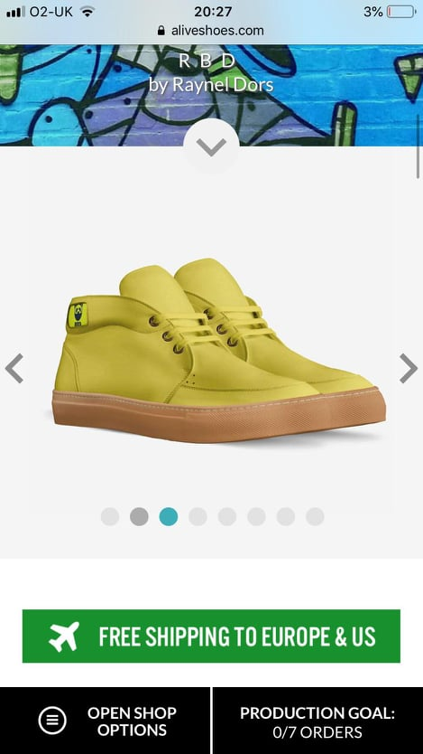

References
Abrams, R. M. (2010). The successful business plan: Secrets & strategies (5th ed.). Palo Alto, CA: The Planning Shop
CBI Ministry of Foreign Affairs, 2016, What requirements should footwear comply with to be allowed on the European market, available at https://www.cbi.eu/market-information/footwear/buyer-requirements/ accessed 10th of May 2020
Chow, C. W., Shields, M. D., & Chan, Y. K. (1991) „The effects of management controls and national culture on manufacturing performance: An experimental investigation”. Accounting, Organizations and Society, 16(3), pp. 209–226.
Credence Research (2019) “Footwear market by material, by distribution channel, by End-user – Growth, Future prospects & Competitive analysis” Credence Research, viewed 1.05.2020< https://www.credenceresearch.com/report/footwear-market>
Government UK (Unknown) Write a business plan. Available at: https://www.gov.uk/write-business-plan (Accessed: unknown)
https://www.gov.uk/write-business-plan accessed 10th of May 2020
https://www.startuploans.co.uk accessed 10th of May 2020
Invest Northern Ireland (Unknown) NI Business Info. Available at: https://www.nibusinessinfo.co.uk/digitalmarketingplan (Accessed: unknown)
Ligos, Mindy (2017) ’Digital Marketing’, Mid Jersey Business, Vol.93(6), pp. 20-24.
Maund, A. Schriek, M. and Tinkler, P. (2017). Certificate in Higher Education: Skills for the Workplace Student Yearbook. Sage Publications
Morgan, P. (2016). The Business Student’s Guide to Study and Employability. Sage Publications
Sebring, Stephanie (2017) ’Digital Marketing Evolves’, Credit Union Managment, Vol.40(10), pp. 36-38.
Start Up Loans (Unknown) How to write a business plan Available at: https://www.startuploans.co.uk/business-advice/how-to-write-a-business-plan/ (Accessed: unknown)
Stobart P. (1994) Brand Power Macmillan Press , London, pp. 33-53;
Wallwork, A. (2012). Business vision (2nd ed.). Oxford University Press.

Appendix
- Google Trends (2020) Italian sneakers. Available at: shorturl.at/cqsE9 (30.04.2020)
- Google Trends (2020) Italian shoes men. Available at: shorturl.at/irvHV (30.04.2020)
- University of Wales Saint David Trinity (2020) Marketing Budget Plan. Available at: shorturl.at/dpXY2 (04.05.2020)



