Sustainable Development

Analysis of Development impacts of Sand Rabbits Beach School Port Talbot

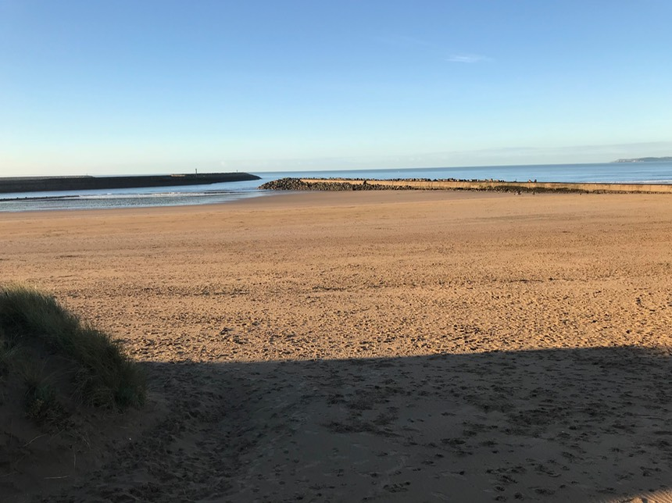
Credit (Aberavon Beach .co.uk ,2018)

Rhian Peto
July 2018

Table of Contents

1. Introduction to Assignment
2. Background Information Sand Rabbits
3. United Nations Sustainable Development Goals
4. Analysis and impacts of Sand Rabbits
5. Conclusion
6. References
7. Appendixes

Abbreviations
Sustainable Development Goals – SDGS
Sustainable Development – SD

- Introduction to the Assignment
The report firstly introduces the Sand Rabbits Beach School in Port Talbot. Secondly it explains how this venture encompasses the United Nations Sustainable Development Goals, then it discusses any impacts to the four pillars of Society, Environment, Economy and Culture, and finally conclusions are achieved .

2 . Aims and Introduction Sand Rabbits Beach School
Sand Rabbits is an outdoor Beach School for children aged 2 to 9 and supports Early Childhood Development for ages 2 to 9. The beach school is located at Aberavon Beach. The aim of the Beach School is to enhance natural environments for learning and play through outdoor ,the overall goal for children to form connections at an early age to wildlife and conservation. In addition the Beach School supports and incorporates some of the United Nations Sustainable Development Gaols. Table A included gives an overview of the SDGs and those the setting supports .The Well-being of Future generation act 2015 has been introduced in Wales and this setting also supports this initiative, for the purpose of this report the setting has concentrated on the SDGs.
Beach school settings incorporate Forest school concepts. The concepts of Forest schools originated in Scandinavia, practitioner’s adapted woodland to support children’s learning taking on board the traditions of being close to nature. Forests schools were introduced in the United Kingdom in 2002 they are defined as an outdoor learning experience( Knight ,2009 ).There are slight differences to each setting, although the principles are the same for both settings and activities are similar ( see Table A). (Knight ,2009) .
Staff undertaking forest or beach school training covers various modules including land management, in this case the coast. Practitioners learn about sustainable management of marine beach eco systems. (Archimedes Earth, 2018.) A report by (Natural resources Wales, 2015) illustrates that forest schools contribute to learner’s knowledge of the environment .Outdoor practitioners are trained to a high standard in order to pass this knowledge to children. Outdoor Practitioners have a tendency to be passionate about the environment and education. Practitioners stem from backgrounds in education, and conservation and environmental disciplines, from personal observation this would seem to be the case. ( Knight ,2009 ) ( See Appendix A )
Both settings schools encompass The Foundation phase curriculum to support learning. Activities designed aim to support The Foundation Phase learning outcomes. The Framework for children’s learning for 3 to 7 years old in Wales illustrates that outdoor environments are conducive for children’s learning (Welsh Assembly Government ,2018) Both settings encompass holistic learning and place emphasis on child led learning hence supporting wellbeing and children’s development. ( See Appendix B)

Differences between both Forest and Beach settings: Table A
Forest School Settings | Beach School Settings
Location  Woodland, Forestry, parks , garden , country areas , mountain’s .(permission is required form land owners to create a forest school setting ) | Location  Coastal area, beach fronts, on beach arcade.  The term Beach school is common in England, in Wales these are referred to as Coastal School.( permission is required from land owners to create a beach school setting )
Natural resources - Trees , leaves, mud , flora and fauna, bugs, rocks , stones, wildlife ie bees, butterflies or dragon fly’s | Natural resources -shells, sea, sand, flora and fauna, aquatic wildlife (ie) crabs, fish.  caves , rocks , pebbles
Shelter -Wind shelter protection from trees or hedges and shelter if the setting has one | Shelter - Limited wind and sun protection unless you have sun shade ie shelter
Access to streams, rivers, ponds or puddles. This is dependent on risk assessments ie whether children play near these areas ,however it is encouraged | Access to sea or rock pools some settings will not access the water , this is dependent on insurance and risk assessments
.Activities Making Dens, Bug hunting , arts and crafts, storytelling , singing , leaf rubbings , clay faces , ID of flora and fauna , mud play , puddle jumping , tree climbing , stickmen creation , tree rubbings .. | Activities ( Appendix D) Making dens, storytelling, singing , arts and crafts , painting shells, rock pooling , ID of flora and fauna , making sand castles , wildlife identification ,painting with natural resources ie sand , stickmen creation

Picture of a Forest School site: Aberdare Lady Bird’s parents and toddler group
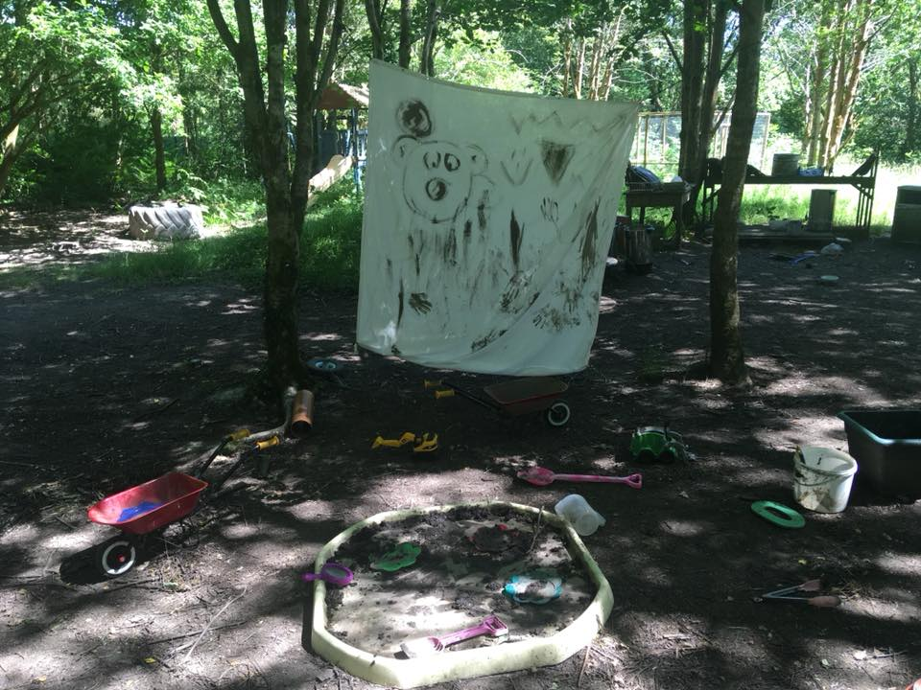
Credit (Igniteup.co.uk ,2018)

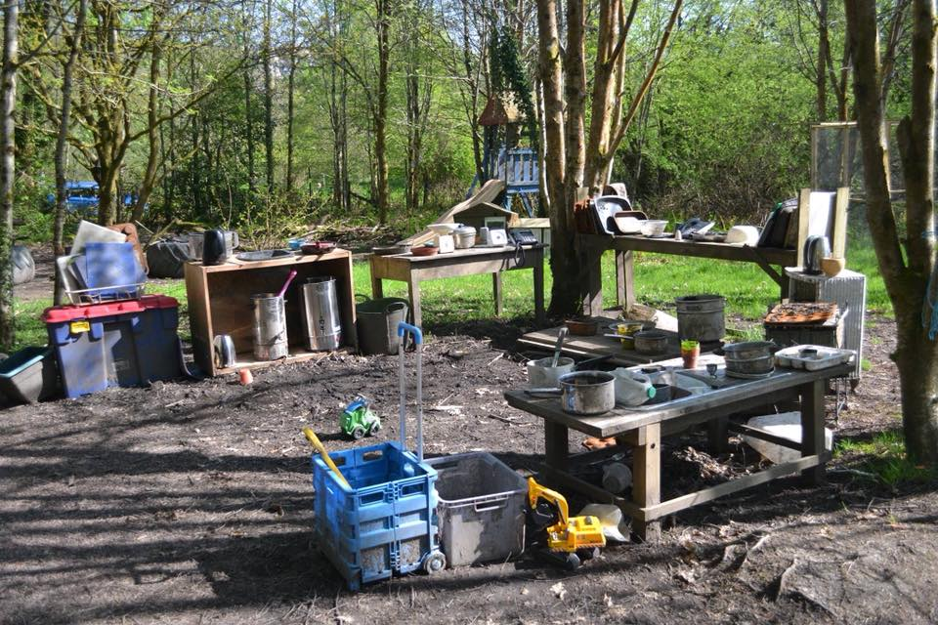
Cooking Area Ladybirds group credit (igniteup.co.uk .2018)

Background information Aberavon
Port Talbot is an industrial town, Tata Steel and AB Ports are near the seafront. Aberavon Beach is a long sandy beach split in two sections by a small pier walkway. Sand Rabbits operates to the left of the pier, housing estates surround this area .The beach is used daily by both residents and tourists. It is important to note Port Talbot is a densely populated area with both affluent and disadvantaged areas. In addition Port Talbot is a flying start area and many families are in receipt of flying start provision .Flying Start supports families with young children, providing families with health visitors, child care settings and other services (nptfamily.com, 2018). During 2014-15. 37,260 children accessed Flying Start services It appears there is a necessity for flying start services in areas of deprivation . (Gov. Wales, 2018). The area could have an effect on the ventures growth in respect of families Woking at TATA Steel works with the loss of wages and motivation. (See Appendix C )

- The Sustainable Development Goals

It is important firstly to define the term Sustainable Development .The (Institute for International Sustainable Development ( 2018) defined it as “Sustainable Development that meets the needs of the present without compromising the ability of future generations to meet their own needs “. Any initiative will encompass this definition and aim to work towards Sustainable Development. Sustainable Development goals are a United Nations initiative devised form the 2030 agenda for Sustainable Development. The SDGSs are not legally binding, however the initiative quotes governments would be “expected to take ownership and establish national frameworks for the achievement of the 17 goals “. (UN.org, 2018). The goals were devised to end poverty, protect the planet and ensure prosperity for all. The time frame given to achieve this is fifteen years, in reality achieving these goals could take far longer and require the cooperation of all involved, in this changing world these goals may not be at the forefront of some countries agendas and counteract the SD definition.

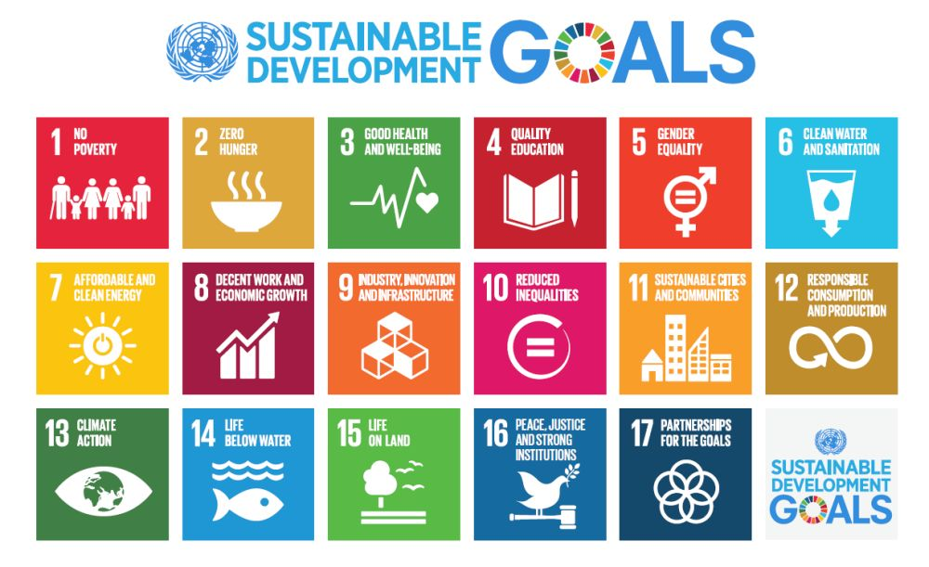

Credit -(GTP Headlines ,2018)

How the venture supports Sustainable Development Goals-(Table B)

 | Sand Rabbits Beach School Aimed SDGs Goals | How Sand Rabbits implement SDGs
 | Goal 2 Zero Hunger | Food served on session reduces dependency on resource exploitation
 | Goal 3 Good Health and Well being | Activities encourage healthy lifestyles choices, which reduce stress and encourage interaction ie socialisation .
 | Goal 4 Quality Education | Elements of the Foundation Phase curriculum is incorporated into the Beach Schools learning outcomes
 | Goal 10 Reduced Inequalities | Activities are designed to support all groups inc those on reduced wages or disabilities encouraging interaction with others.
 | Goal 11 Sustainable cities | By enhancing natural resources.  Enriching natural spaces promoting value of environment .  Local residents could walk to access this setting or cycle hence decrease the effect on Carbon footprint.
 | Goal 14 Life below water | Educating children on care of the coast and wildlife
 | Goal 13 Climate Action | Educating children relevant topics ie Earth Hour 2018
 | Goal 17 Partnership for the Goals | The beach school liaises with local authorities and litter collection groups.

- Analysis of Impacts -
This section of the report will further expand on information listed in Table B . Table B illustrates any impacts in ref to the four pillars of Sustainable Development ie society, Environment, Culture and Economy. It is important to remember that this venture has only been trading for a short time there may be limited data in some sections.

(Table B)
SD Goal | Positives | Negatives
Goal 2 Zero hunger | Fresh Fruit and water for families on sessions. The food provided is included in the price of the sessions.  Food items do not exploit natural resources. | This impact would be small due to the frequency of sessions. The food provided is only a snack and not a meal.
Goal 3 Good Health and Well Being  (Appendix E) | Activities are outdoor and involve some physical movement ( ie )balance and skills (Knight, 2009) .  Children who did not venture outdoors at all this goal would support this interaction and support Good Health and Well Being .  Adapts and supports Maslow’s Hierarchy of needs ,the aim children’s growth will progress when a need is met (Gross,2005 ) | The impact would be small due to the frequency of sessions.  Although (Knight, 2009)points out Forest school settings can have a ripple effect (ie ) families venturing out on weekends and exploring .  Again not all children will access this setting hence this would not apply.
Goal Four Quality Education | The Foundation Phase learning outcome would be incorporated into sessions. (WAG, 2018)  For Children younger than three, these settings would support sensory experiences (Knight, 2009)  Support flying start provision of children in the area contributing to wellbeing of society ..  Children play in all weathers in forest or beach settings ,hence children’s understanding of weather and seasons  settings.( Knight ,2009)  There is limited bilingual interaction ie Welsh , Welsh is included to support culture of the area  Events would be themed such as St David's Day | The impact would be small due to frequency of sessions.  Mothers may not bring small babies and younger children onto the beach  This setting charges for services and as such is not free for families in receipt of flying start, however the setting attempts to keep prices are manageable  . From observation changing parent’s perceptions can be difficult.  This would be of limited dialogue greetings, numbers and colours. Again not all children will attend.
Goal 10 reduced inequalities | Activities are universal for both sexes designed for all children to access the setting, Inc children with additional learning needs  Contributing to the greater good of society. | Not all children will attend sessions conducted.  Families may not enjoy outdoor interaction.  Families may be ‘put off ‘with weather conditions.
Goal 11 Sustainable Cities | Education and reinforcing conservation efforts about the coast and aquatic wildlife inc - plastic pollution.  Reinforcing use of recyclable products and litter disposal to support the environment and society.  This ventures is inclusive for all families including tourist families.ie enhancing environments (economy)  (Career Wales ,2018 ) illustrates that outdoor business attract visitors to Wales and contributes to 481 million of the total economy . | Carbon footprint (ie) access the beach for families relying on transport, this impact would be small due to the frequency of sessions.  Does take time to undertake a litter collection ie prior to and before a session.  Families from other countries have not attended sessions to this date.  The likely hood of this happening is low, due to the fact the setting does not operate a walk in system or open access system.
Goal 14 Life below water | Educating families on conservation of wildlife (ie)the coast  Raising awareness of issues affecting the coast (ie) plastic pollution /litter to the beach environment  Mitigating measures are put In place to minimise disturbance to wildlife and natural resources. ie small group numbers. Risk assessments undertaken. | Even with education plastic pollution is still growing –you cannot rely on humans to dispose of their littler correctly.  There should be no impact ,if any it is estimated very slight impact on disturbance to species. ie children handling species.
Goal 13 Climate Action | Educating families on issues arising in the environment ie carbon footprint .  Education families of relevant issues ie Earth Hour and Dark Skies , this is done through events.. | Not all families will attend sessions- hence sessions may be missed  The impact would likely be on a small scale at local level ,and no impact at global level.
Goal 17 Partnerships for the Goals | Working with other organisations local councils and groups( ie)  Keep Wales tidy  Outdoor ventures contribute to data collection and conservation (ie) bio diversity | Communication may be limited between parties due to small scale ventures.  Small business are not always recognised as official contributors to data.  Compared to national and global business ventures. This business is small scale.

Evaluation of Table B
Table B has illustrated that SDGs are encompassed into the setting, although the setting more than likely works towards other remaining goals not listed here, the impacts of the goals at local level is small, however the goals are being incorporated and this setting is working towards achieving these with an overview whist the setting is still ongoing it supports the SD definition.
At local level the setting undertakes data collection, with the aim to share information to local authorities and academics in Conservation and Education. Data is limited on Beach schools due to their newness, however Forest School have been established since 2002 and there is a vast amount of literature available to view.
Children’s education is actively supported through sessions ,as pointed out forest and beach settings encompass holistic learning and wellbeing, this settings adapts Maslow’s Hierarchy of Needs. Table B has pointed out that as children growth increase a need is met, in this case children would need to attend this in reality to receive long term gain .(Gross, 2005)
There will be unlikely any financial impact to the community of Port Talbot , however data collected from this setting illustrates families have visited from outside the location as well as from Port Talbot . This could bring small financial gain ie buying refreshments at local venues .Although awareness of the area would be highlighted and attract visitors to the sea front. At present this venture may be of benefit to families who have visited the setting.
Forest and Beach settings aim to educate children on care of the environment as illustrated in the introduction and table B, in this case the setting operates monthly and not regular, although (Willer .,2018) refers to community projects such as allotments schemes, which provides opportunity for young people to engage in society and change attitudes, however with the possibility of budget cuts could such schemes be still in existence?

- Conclusion
The ventures does work towards achieving the SDGs although on a small scale and there are both negative and positive impacts to this, families visiting this setting will have likely benefited from this interaction. The setting has sustainable development at the forefront and will continue to incorporate these in sessions... The settings does meet the aim of this business ie supporting children’s early interaction to nature, conservation and forming connections at an early age.

- References:

Archimedes Earth (2018) Beach Schools .Available at http://www.archimedes earth.com (Accessed: 10 March 2018)
Careers Wales.com (2018) Available at https://s3-eu-west1.amazonaws.com (Accessed :18th March 2018)
Flying Start (2018) Available at www. NPT Family .com (Accessed: 2nd march)
Gross, R, (2005) Psychology The Science Of Mind and Behaviour London:Hodder Arnold
Gov Wales (2018) Flying Start available at http:'//gov.wales/topics/( Accessed: 10 March 2018)
GTP Headlines (2018) Available at http://news .gtp (Accessed: 10 July 2018)
Ignite (2018) Available at http://ingiteup.co.uk (Accessed: 12 July 2018)
International Institute for Sustainable Development (2018) Available at http://iisd.org/topic (Accessed 13 :July 2018)
Natural resources Wales( 2015) A guide to Forest Schools in Wales Available at http://www.outdoorlearnignwales.org (Accessed 13 July 2018)
Knight, S(2009) Forest Schools and Outdoor learning in the Early Years sage London : Sage Publications
United Nations (2018) Sustainable Development Goals Available at htpp://www.un.org/sustainabledevelopment/cities (Accessed 8th March 2018)
Sand Rabbits (2018) Available at https://sandrabbits.co.uk (Accessed: 10th march 2018)
Welsh Assembly Government (2018) Wellbeing of Future Generations Act. Available at http://gov.wales/topics(Accessed 13:July 2018)
Welsh Assembly Government (2008) Framework for children’s learning for 3 to 7 years olds in Wales Available at: http://www.unesco.org/curricula (Accessed: 10th July 20180
Willer. M,(2018) ‘ Grow You Own Help ‘Earth Care, People care, future care Permaculture,95,pp.18-19

Bibliography:
Welsh Assembly Government (2018) Wellbeing of Future Generations Act. Available at http://gov.wales/topics(Accessed 13:July 2018)
Welsh Assembly Government (2008) Framework for children’s learning for 3 to 7 years olds in Wales Available at: http://www.unesco.org/curricula (Accessed: 10th July 20180
Simmons, I.G (1997) Humanity & Environment A cultural Ecology Essex: Addison Wesley Longman ltd

- Appendix

Quote Beach School (A)
Once the course is completed, the learner will be able to understand the sustainable management of marine beach ecosystems as a learning resource through the development of understanding of the ecological structure, management methods of local marine ecosystems and be able to demonstrate how to use and teach a range of practical skills appropriate to Beach Schools
Ref( Archimedes Earth 2018)

Welsh Assembly ( B)
Indoor and Outdoor environments that are fun , exciting , stimulating and safe promote children’s development and natural curiosity to explore and learn through first-hand experience “ Ref( WAG . 2018).

(C) Flying start Areas –Port Talbot Ref (NPT family.com, 2018)

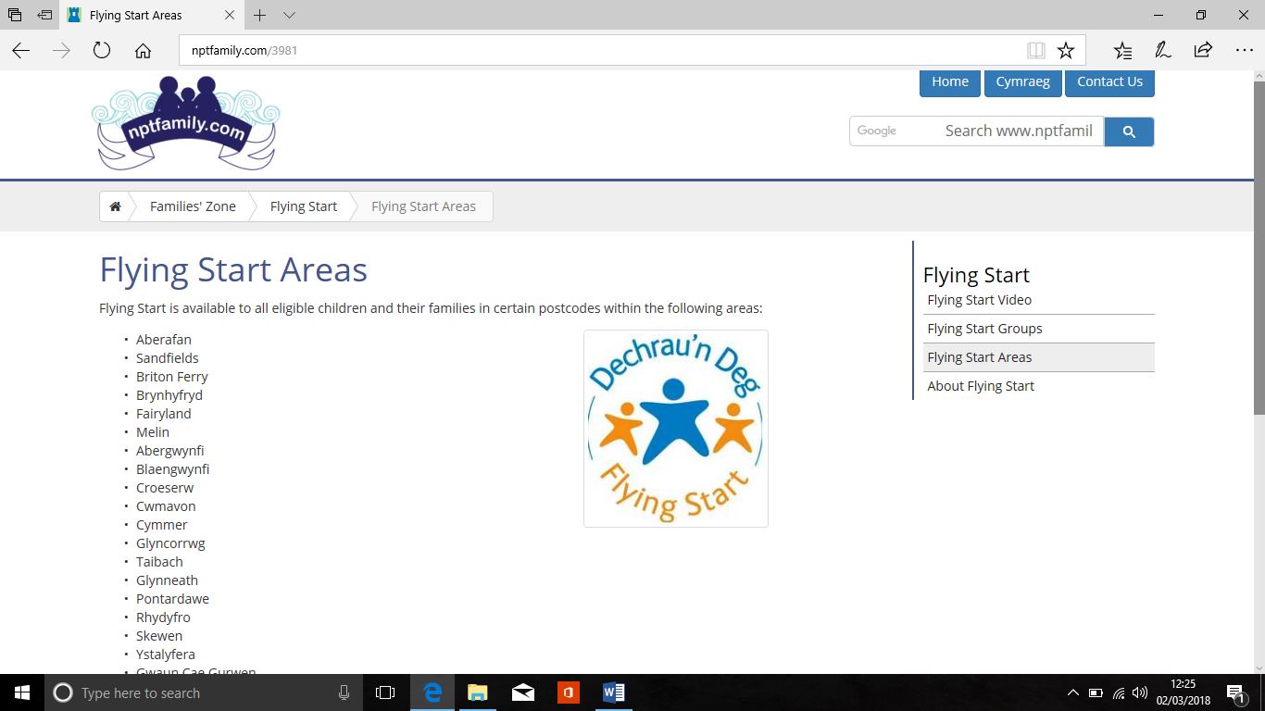

(D) Activities created by Sand Rabbits– Wellington Walks Ref (Sand Rabbits.com, 2018)

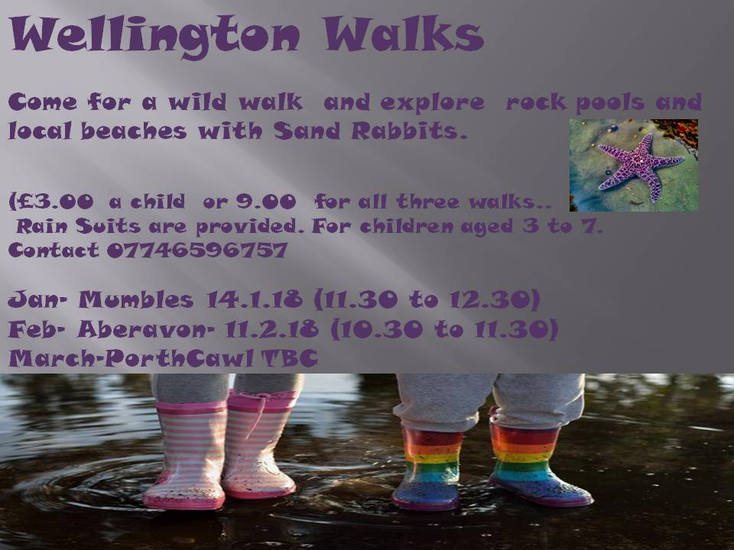

(E ) Maslow’s Hierarchy of Needs Ref ( simplypyschology ,2018)


