‘Utilising the Entrecomp Framework, critically evaluate your own creativity and enterprise skills and consider how you might be able to develop the creative and enterprising skills of primary learners, through your own pedagogy’.
Within this assignment, I will aim to define and discuss the importance of creative and enterprising skills within primary education, both for staff and learners and how to further develop and encourage these skills for children throughout their learning. Through using the Entrecomp Framework (Bacigalupo, et al. 2016), I will assess and evaluate my own creative and enterprising skills within my teaching abilities, proposing recommendations on how to further develop these skills. I will also discuss the importance of developing these skills with primary learners, using my own pedagogy and make recommendations on how a teacher needs to develop creativity for children in the future.
According to Sternberg, (1999, p. 3), to be creative is to possess the, ’ability to produce work that is both novel and appropriate’. Csikszentmihalyi, (2013 p. 23) supports this, stating creativity is an idea or action which is new or valuable to learning within society. Both theorists argue for a person to be deemed as being ‘creative’, they should possess the ability to develop ideas that are original and useful, which can be used and adapted to resources in our changing society (Sternberg, 1999 and Hartshorn and Hanson, 2005). Robinson, (2000 cited in Grainger and Barnes, 2006) however, defines creativity to be a critical component within learning and a skill possessed by all humans. He suggests that creativity, along with imagination are of great importance within education and development within today’s changing society. This is also supported by Craft (2000, cited in Grainger and Barnes, 2006) who suggests creativity can be found within all areas of the curriculum, not only within the ‘arts’. Csikszentmihalyi, (2013) contradicts the idea that all humans possess this skill, suggesting the production of creative thinking and ideas occurs within the minds of ‘special people’. Craft, (2000, cited in Grainer and Barnes, 2006) however, supports Robinson’s definition of creativity suggesting that it is a ‘state of mind in which all our intelligences are working together… involving seeing, thinking and innovating’ and is not only confined to these ‘special people’.
To be creative, can often be linked with enterprising skills, through producing and inventing new ideas, especially when developing entrepreneurial skills. Although this essay is focusing on developing enterprising skills within learners, it can be useful to remember that these two skills can often come together, especially within the Entrecomp Framework (Bacigalupo, et al. 2016). Enterprising skills can be defined as, ‘a notion of the adaptability and creativity of young minds’ (Hartshorn and Hannon, 2005). Furthermore, skills in both creativity and enterprise, are closely linked and have educational benefits that will enable children to become ‘ambitious, capable learners’ (Donaldson, 2015), whilst also preparing them with skills to accomplish and overcome obstacles and challenges that they may face in the future, with confidence (The National Parent forum of Scotland, 2017). In my opinion, enterprise skills are being able problem solve through producing an idea and developing this to find a suitable solution to the problem.
As we are becoming aware of the importance of creative and enterprise skills within the current and new curriculum, it can be useful to acknowledge the benefits and challenges, that both teachers and students face, when implementing these skills within their schools. Many educational professionals have found the current curriculum to be extremely rigid within its teaching of skills and expectations of learners, therefore not allowing opportunities to maximise the use and development of creative and enterprising skills (Grainger and Barnes, 2006). Additionally, the pressure put on pupils to perform well in assessments can limit opportunities for the development of these skills, as teachers place a greater focus on teaching the core skills, such as those within literacy, numeracy and science (Grainger and Barnes, 2006) and therefore creative thinking skills are sometimes confined to expressive subjects such as music and art (Robinson, 2009 cited in Azzam, 2009). Robinson (2009, cited in Azzam, 2009) suggests, creativity takes place within the whole curriculum of education and not just in ‘special activities’.
On the other hand, there are many benefits to teaching for and promoting creativity within education, including opportunities to enhance curiosity and engagement within learning, ‘improving self-esteem, motivation and achievement’, as well as self-determination and active thinking to solve problems and new challenges that children may face in the future (Grainger and Barnes, 2006 and The Parent forum of Scotland, 2017). Creativity can be of great importance, especially within early child development. It is understood that children learn best within environments that allow them to use their curiosity and exploration skills to become creative and enterprising learners (Donaldson, 2015). Although it is vital for children to be encouraged to explore and think independently, if too many opportunities or obstacles for curiosity, risk or exploration are present, ‘creativity can be easily extinguished’ (Csikszentmihalyi, 2013).
When assessing creative ability within teachers, the Entrecomp Framework (Bacigalupo, et al. 2016) can be a very useful tool to use. The framework aims to ‘build a bridge between the worlds of education and work’, through supporting and developing staff and children’s understanding of the importance and link between creative thinking and future careers opportunities. The framework consists of 3 competence areas; Into Action, Resources and Ideas and Opportunities and 15 competences, ‘with 8 levels of proficiency which unfold to 442 learning outcomes’. The 8 levels of proficiency fall under 4 headings; foundation, intermediate, advanced and expert, of which understanding and ability are assessed against, from ‘relying on support from others’ in the foundation level, to ‘driving transformation, innovation and growth’ within the expert level (Appendix 6). When using the framework to assess ability in creativity and enterprise skills, it is important to understand the competences, especially as the framework focuses more on the development of skills in entrepreneurship. Competences such as, ‘Creativity, valuing ideas and taking the initiative’ can have a greater link with both creativity and enterprising skills, compared to competences such as ‘ethical and sustainable thinking and financial and economic literacy’ (Bacigalupo, et al. 2016).
Similarly, to all frameworks within education, the Entrecomp Framework comes with benefits and challenges to its use. The framework was introduced to provide children and young people with the knowledge and skills required for later life, whether that be in continuing their education or entering the workplace. The framework,
‘enables citizens to nurture their personal development, to actively contribute to social development, to enter the job market and to start up ventures which may have cultural social or commercial motive’.
(Bacigalupo, et al. 2016:p.10)
Through this, learners are also equipped with a greater understanding of creative, enterprising and entrepreneurial skills for progression in life long learning, in careers that may change in the future (European Union, 2017). This is supported by Donaldson, (2015) who suggests that teachers should put a greater focus on teaching how to be creative and developing skills in this, rather than what creativity is in general, therefore putting a greater emphasis on higher order thinking skills, such as those in creativity and enterprising. This links to Bloom’s Revised Taxonomy, as creativity has become an important skill needed for later life (Wegenf, 2010).
The Framework has certain limitations, one of which is that currently there is no evidence of successful use within school settings, neither has it been adapted to supporting either the current or new curriculum when assessing teacher creativity (Bacigalupo, et al. 2016). Alongside this, teachers have not been equipped with suitable training of its use, including suitable pedagogical strategies for teaching pupils in the classroom. However, it does have the capacity, within education, to support teachers in assessing their own creative ability, in order to provide learners with the opportunity to develop their creative and enterprising skills and understand their next steps in encouraging them to become creative thinkers. Therefore, children will be able to assess their own creative ability, through understanding what they are able to do, have not yet achieved and how they can further progress within each competence (Bacigalupo, et al. 2016).
Wallach (1971, cited in Moon, 2004 p.13) suggests, ‘to teach creativity to children, teachers need to possess the ability to be creative themselves’. Firstly, it is important for a teacher to know and understand their creative ability, assess their progress and find ways in which they can advance in their understanding of how they can use their own skills to foster creativity and enterprise in their learners (Moon, 2004). To evaluate my own creative and enterprise skills within my teaching, I will assess myself against the ‘Creativity’ competence within the Entrecomp Framework (Bacigalupo, et al. 2016).
When assessing my proficiency in the ‘Creative’ competence, I have found my knowledge and understanding of creative components within teaching to be at an intermediate level, where I am beginning to build independence (Appendix 1). Throughout my past experiences when teaching in school, both on professional teaching practice and volunteering in my local school, I have built upon my personal abilities in creativity. During teaching practice, I have often found a difficulty in a way to track pupils progress throughout my lessons. Therefore, I have created different approaches to overcome this difficulty (Appendix 2), ‘searching for new solutions that meet my needs’ (Bacigalupo, et al. 2016). Changing and testing different strategies can be an integral part of teaching, especially when developing creativity. Through creating another approach to tracking pupils learning, I was able to progress in this competence and think creatively.
Desailly, (2015 p. 84) suggests for a teacher to be creative, they need to ‘be comfortable with flexibility and able to change routines where appropriate’. Flexibility within teaching can hold great importance in developing teachers own creative skills, as well as fostering creativity in their students. When supporting and teaching for creativity, teachers need to be knowledgeable of how to foster creativity within their learners, whilst being aware of the importance of viewing each child’s representation as ‘unique’ and providing equal opportunities for them to flourish in this skill (Duffy, 1998). Teachers can often find that the lessons which have been planned for the day need to be changed due to other commitments arising within the school routine. Therefore, they need to be flexible and improvise. These characteristics are supported by Costa (date unknown, cited in Cox, 2018a) within his 16 Habits of Mind, in which he suggests all creative people possess. During teaching practice, some of my lessons have not quite followed my plan, resulting in the need to improvise and adapt the lesson to meet the needs of the learners (Appendix 3 and 4). This shows that I am able to reflect on my own creative skills and test situations to adapt them to ‘better meet my needs’ and those of my learners (Bacigalupo, et al. 2016). However, possessing the ability to be flexible is a weakness that I struggle with on teaching practice as I have often found that my lessons need to follow the ideas of the teacher and be suitable to what they would like in their childrens’ books. During my time in a year 5 class, I proposed an idea to the class teacher, of allowing the children to create a suitcase out of recycled materials, which they could then pack with different items that they would need if they were an evacuee for the day. Unfortunately, I was unable to use this idea, as it was not found within the schools learning framework which they had chosen to use for that year. I have found that using learning frameworks, such as ‘Cornerstones’ to generate ideas for lessons around a certain topic, can often hinder teacher creativity, especially if the idea is not found within the guidelines, or does not match exactly to a specific skill within the curriculum. At times that I have taught in a class that uses a framework such as ‘Cornerstones’ I have been able to adapt ideas given and modify them to meet the needs of the learners and the learning objectives for the lesson. In my opinion, using given frameworks for teaching themes can be beneficial, however they can have greater effect if they are used loosely and provide room for adjustments. By taking a lesson provided and making it my own, I am beginning to progress into the next proficiency within the framework.
Although I am progressing within the ‘Creativity’ competence of the framework, there are still ways in which I can foster my creativity to advance further, into the advanced proficiency. One way of ensuring progress within this area is through reflecting upon my understanding of different creative teaching strategies, to support myself in beginning to foster creativity in my learners. For example, through wider reading of creativity and enterprise skills within education, including becoming fully aware of the new curriculum and the areas of learning and experience (Donaldson, 2015). I have also started taking part in different conferences to further my knowledge within important and changing areas of education (Appendix 5).
To ensure that children are provided with the best opportunities to develop their creative and enterprise skills, schools should work closely with outside agencies and local businesses, such as musicians, artists and dancers, both within and outside of the classroom learning environment. Providing children with these opportunities will allow them to ‘make the crucial link between the skills built in class and the working world’ (Enabling Enterprise, 2018). Additionally, the learning environment in which creativity is being developed, can have a significant effect on the ideas produced. Teachers should provide children with a range of learning environments for them to explore and experiment in, using their curiosity and caters for their needs, where they feel that their ideas are accepted and valued by all (Duffy, 1998). Desailly, (2015) suggests adjusting the classroom layout to allow for group work, where children can work together and develop their curiosity and inquisitiveness through using others’ ideas. This is supported by Mercer, (1995, cited in Wegenf, 2010) who calls this ‘Cumulative Talk’ in which children share their ideas with each other and build upon them, without being criticised for their original idea. Through discussion, ideas will be developed and extended using additional vocabulary. Once a new and original idea, of value has been produced, ‘creative talk’ is evident within the children and their creative abilities can be developed upon (Mercer, 1995 cited in Wegenf, 2010). Horwitz (1979, cited in Esquivel, 1996) also supports this, suggesting that opening the classroom learning environment can show encouraging attitudes towards creative development and enterprise skills. On the other hand, whilst acknowledging the opportunities of new ideas that can arise from group activities, Sternberg (1999 p.419) suggests children need to be given activities that are structured also, which still allow for ‘spontaneity, innovativeness and risk-taking’. Taking children outside of the classroom for a walk can allow them to begin to think divergently, producing many creative ideas. This can then develop into convergent thinking, through engaging in activities and group work that allow for them to discuss ideas and find the best solution to the problem (Guildford, date unknown, cited in Cox, 2018a). Torrance, (1974, cited in Cox, 2018b) adapted Guildford’s Models of Thinking, through creating Torrance tests that aims to assess children abilities to be creative. He also suggests 8 different characteristics, similar to Costa’s Habits of Mind, which children are assessed against. He then narrowed this to 4 characteristics that foster creativity in learners. Therefore, it is important to ensure that teachers possess the ability to be creative, in order to know ways in which they can promote creative thinking for their learners.
Lastly, it is important to incorporate creative learning into all educational activities, in order to develop talk and ideas that are creative and imaginative, which have room for reflection and to be built upon by new and extended ideas, to find the best solution for the task set (Wegenf, 2010). With the current curriculum in place, teachers may find difficulty in producing tasks which allow for creative and enterprising skills to flourish due to the rigidity of curriculum skills and the focus upon the core subjects, such as that of Maths and English. However, with Donaldson’s (2015) new curriculum beginning to take place within schools, an emphasis is being placed upon the importance of providing children with opportunities to be creative within lessons, across the continuum. The new areas of learning and experience will provide greater opportunities for the skills to be developed within all subjects across the continuum, in a cross-curricular way. He suggests creativity and enterprise skills to be essential skills for modern life, which at every opportunity within a child’s education should be developed and extended to give them a greater start in their future careers (Donaldson, 2015).
To conclude, creative and enterprise skills need to be an integral part of development and progressing within education. In order to prepare children for further or higher education or employment, they need to be encouraged and supported to fully develop entrepreneurial behaviours and skills. The Entrecomp Framework (Bacigalupo, et al. 2016) aims to provide the link between education and employment, however it appears to be more closely linked to the world of work and especially self-employment. At the foundation levels it is often relevant to primary education and a useful tool. In contrast, the higher levels seem less applicable to education, focusing greatly on the ability to gain independent business skills, rather than those for employment. In order to develop within my teaching, I need to focus on the importance of being adaptable and flexible, able to embrace change and take more risks within creative aspects of lessons. I need to overcome my lack of confidence and anxiety in doing something wrong, in order to facilitate this. Through fostering creativity within learners, teachers are preparing them to become ‘enterprising, creative contributors’ within later life and work, through applying their creative knowledge and skills to real life situations which hold meaning to them. It can give them the grit to persevere through life and achieve their full potential (Donaldson, 2015).

Reference list

Azzam, A. (2009) Why Creativity Now? A Conversation with Ken Robinson. Educational Leadership, 67(1), 22-26.
Bacigalupo, M, Kampylis, P, Punie, Y and Van den Brande, G. (2016) Entrecomp: The Entrepreneurship Competence Framework. Luxembourg: European Union. Available at: http://publications.jrc.ec.europa.eu/repository/bitstream/JRC101581/lfna27939enn.pdf [Accessed on: 14th January 2019].
Cox, T. (2018a) Think like a 5 year old: Creative thinking. Available at: https://moodle.uwtsd.ac.uk/pluginfile.php/184490/mod_resource/content/3/Think%20like%20a%205%20yr%20old%20presentation.pdf [Accessed on: 24th January 2019].
Cox, T. (2018b) You don’t think of an idea, you find it. Available at: https://moodle.uwtsd.ac.uk/pluginfile.php/184492/mod_resource/content/3/Finding%20ideas.pdf [Accessed on: 24th January 2018].
Csikszentmihalyi, M. (2013). Creativity : The psychology of discovery and invention (First Harper Perennial Modern Classics ed.). New York: Harper Perennial Modern Classics.
Desailly, J. (2015) Creativity in the Primary Classroom. London: SAGE.
Donaldson, G. (2015) Successful Futures: An Independent Review of Curriculum and Assessment Arrangements in Wales. Cardiff: Crown Copyright.
Duffy, B. (1998) Supporting Creativity and Imagination in the Early Years. Buckingham: Open University Press.
Enabling Enterprise, (2018). Primary School: A complete approach to building essential skills. Available at: http://enablingenterprise.org/wp-content/uploads/2018/02/Brochure-Primary-2018.pdf [Accessed on: 24th January 2019].
Esquivel, G. (1995). Teacher behaviors that foster creativity. Educational Psychology Review, 7(2), 185-202.
European Union, (2017) Entrecomp: The Entrepreneurship Competence Framework. Europe: European Union. Available at: file:///C:/Users/Carys/AppData/Local/Packages/Microsoft.MicrosoftEdge_8wekyb3d8bbwe/TempState/Downloads/KE-04-17-328-EN-N%20(1).pdf [Accessed on: 17th January 2019].
Grainger, T and Barnes, J (2006) Creativity in the Primary Curriculum. London: Routledge. Available at: http://oro.open.ac.uk/12953/2/4C7A8273.pdf [Accessed on: 17th January 2019].
Hartshorn, C and Hannon, P. D. (2005) ‘Paradoxes in entrepreneurship education: chalk and talk or chalk and cheese? A case approach’, 47(8/9). Pp. 616-627. Available at: file:///C:/Users/Carys/AppData/Local/Packages/Microsoft.MicrosoftEdge_8wekyb3d8bbwe/TempState/Downloads/Paradoxes_in_entrepreneurship_.pdf [Accessed on: 15th January 2019].
Moon, J. (2004) A handbook of reflective and experiential learning theory and practice. London: Routledge Flamer.
Sternberg, & Sternberg, Robert J. (1999). Handbook of creativity. Cambridge: Cambridge University Press.
The National Parent forum of Scotland, (2017). Creativity, Enterprise and Employability: Skills for Learning, Life and Work. Scotland: Skills Development Scotland. Available at: https://www.npfs.org.uk/wp-content/uploads/2017/05/creativity_E.pdf [Accessed on: 17th January 2019].
Wegenf, R. (2010) Mind Expanding: Teaching for Thinking and Creativity in Primary Education. London: Open University Press.

Appendix 1
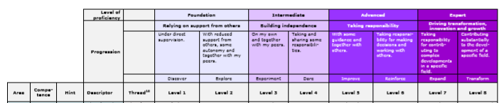
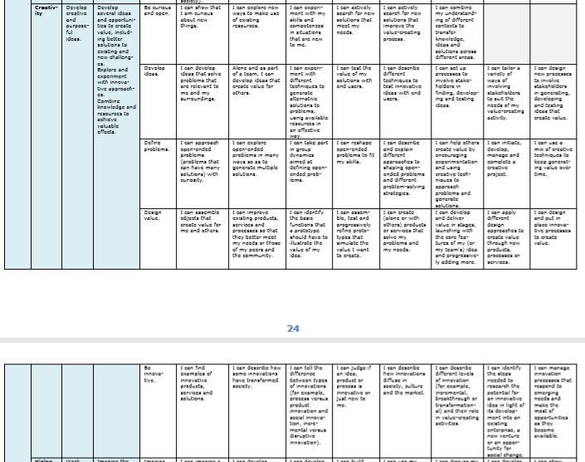

Appendix 2
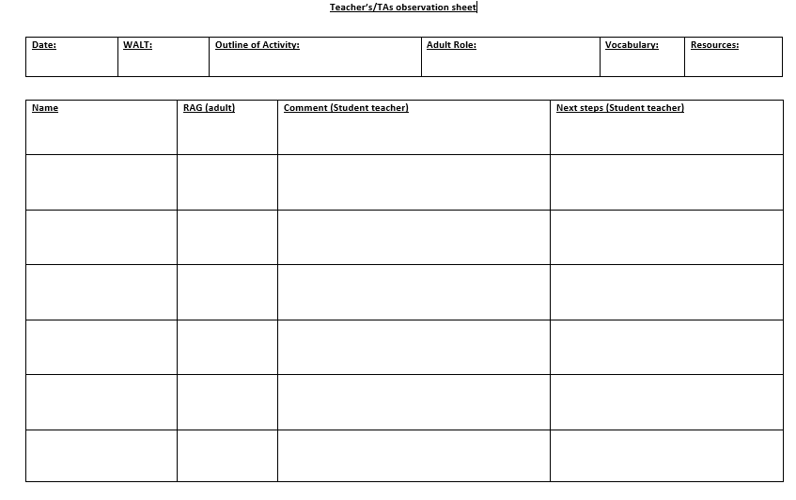

Appendix 3

Model Beirniad Wedi Adfyfyrio (BWA)

Assisted Reflective Conclusions (ARC) Model
Dyddiad/Date: 1st February 2018
Digwyddiad critigol (Ffocws)/Critical incident (focus): to understand how Muslims see the natural world and how that is similar to our beliefs.

Profiad/ Experience

Teimladau/  Feelings  Beth yw eich teimladau ynghylch y profiad?  “What are your feelings regarding the experience?” | I felt prepared for this lesson as I had all of my resources ready and work had been stuck into the children’s book. I was also very nervous as this lesson was being observed by my class mentor. Overall, I was not very happy with how this lesson went as there were a lot of things that did not go well at all. However, I realise what went wrong and now know how I can improve of these aspects. I received feedback from my class mentor on what went well and what did not go so well in order to improve.
Cofio a Deall/  Remember and Understand  Allwch chi restru’r agweddau ar y profiad dysgu a aeth yn dda?  “Can you list the aspects of the learning experience that went well?”  Pa elfennau o’r profiad dysgi oedd yn siomedig?  “What were the elements of the learning experience that were disappointing?” | It was good that I read the story to the children, rather than playing it on the CD Rom. My class mentor said that this was good as it allowed for me to show my interaction with the children, which us important to do in an observation.  My questioning was good and related to the story and allowed for the children to think wider about their answers.  The activity for the CC was good and related to the learning objective. It allowed for the children to meet the success criteria for that lesson. They children in this group understood the task set and could answer the question well.  My voice was much louder today in order to address the children (when needed).  My class management was terrible during this lesson. At some times I was not aware of what some of the children were doing;  - When sitting in the circle I sat on the chair. This prevented me from seeing the children sitting next to me who were fiddling with things underneath the chair. Although I had told them to stop, as soon as I turned my back they started to do it again.  - I had the problem of certain children sitting together who shouldn’t have been as they do not work well together.  - Some children shouted out answers. I reminded them that if they shout out I would not answer them. However, my teacher noticed that after telling on child not to shout out, I took the answer from a child who did shout out straight after.  - During the work with my group, some children on the carpet were arguing over the blocks. I did not handle this and my class teacher had to step in. also I warned children that I would ‘not tell them again’ if they were doing something they shouldn’t have been. However, I then went and told them again anyway.  My introduction session on the carpet was way too long for the children and many of them began to lose concentration.  The activities for the EE and SS did not relate to the learning objective.
Gwerthuso a dadansoddi/  Evaluate and analyse  Beth fyddwch chi’n cadw’r un fath i sicrhau dysgu ac addysgu effeithiol yn y dyfodol?  “What will you keep the same to ensure effective teaching and learning in the future?”  Beth oedd achos yr elfen siomedig bwysicaf?  “What was the cause of the most important disappointing element?” | I would read the story to the children again as this showed my interaction with them well.  I would use the same questions again in order to create discussion about the book.  I would use the same task or the CC.  My classroom management was the cause of most of the disappointing elements in this lesson.
Casgliadau a chamau gweithredu/  Conclusions and actions  Beth yw eich atebion posibl i’r materiaon siomedig a nodwyd?  “What are your possible solutions to the disappointing issues identified?”  Beth ydych yn mynd i’w wneud nesaf?  “What will you do next?” | When reading the story, I will either;  - Organise the circle one by one, preventing any problem. I would also sit in the circle with them, in a place which would allow me to see all of the children.  - Keep the children sitting in their carpets spots.  I will make sure to remind the children at the start of the discussion that I would not be taking any answers from any children who shout out and remind them that they need to put their hand up if they have something to say.  I will ensure that there is always an independent activity for the children to be completing, to prevent any problems or arguments from arising.  Regarding my classroom management, I will ensure that I use the appropriate behavior management strategy for each incident and make sure that I follow through with any consequences given.  I will make sure that my carpet sessions do not exceed at least 15 minutes as any time after this would be away too long for the children to sit on the carpet for. This will allow for me to get the most understanding from the children in their tasks.  I will ensure that all activities set are related and meet the learning objective and success criteria set.
Y profiad newydd / Transformed experience

Appendix 4

Model Beirniad Wedi Adfyfyrio (BWA)

Assisted Reflective Conclusions (ARC) Model
Dyddiad/Date: 5th February 2018
Digwyddiad critigol (Ffocws)/Critical incident (focus): to understand how Muslims view the natural World.

Profiad/ Experience

Teimladau/  Feelings  Beth yw eich teimladau ynghylch y profiad?  “What are your feelings regarding the experience?” | I felt prepared for this lesson as I had all of my resources printed an ready to stick into the books.
Cofio a Deall/  Remember and Understand  Allwch chi restru’r agweddau ar y profiad dysgu a aeth yn dda?  “Can you list the aspects of the learning experience that went well?”  Pa elfennau o’r profiad dysgi oedd yn siomedig?  “What were the elements of the learning experience that were disappointing?” | The children responded well to the questions asked during the introduction.  I did not keep the children on the carpet for too long.  My class management was better today and I used my new class management tool to get the children’s attention. I also introduced the class sticker chart for rewards.  The children understood and enjoyed the task and got on well with the independent task set.  The IWB would not work for me and I had to improvise (which was not that big of a problem and the task still worked well).  Timings were not great again today, some children did not complete the task. However, there was only two of us in class today.
Gwerthuso a dadansoddi/  Evaluate and analyse  Beth fyddwch chi’n cadw’r un fath i sicrhau dysgu ac addysgu effeithiol yn y dyfodol?  “What will you keep the same to ensure effective teaching and learning in the future?”  Beth oedd achos yr elfen siomedig bwysicaf?  “What was the cause of the most important disappointing element?” | I will keep the introduction the same as it was short and easy for the children to understand and they grasped the main point of it quickly.  I will keep the task the same as it was accessible for all of the children and the children seemed to enjoy completing it.  I will keep the independent task the same.  The IWB did not work but that was not a big issue and I improvised.  My time management could be better.
Casgliadau a chamau gweithredu/  Conclusions and actions  Beth yw eich atebion posibl i’r materiaon siomedig a nodwyd?  “What are your possible solutions to the disappointing issues identified?”  Beth ydych yn mynd i’w wneud nesaf?  “What will you do next?” | I will continue to work on my class management by using the sticker chart as a reward system and ensuring that I give consequences that I can follow through with.  I will continue to work on my timings to ensure that the children get the best understanding within the lesson.
Y profiad newydd / Transformed experience

Appendix 5

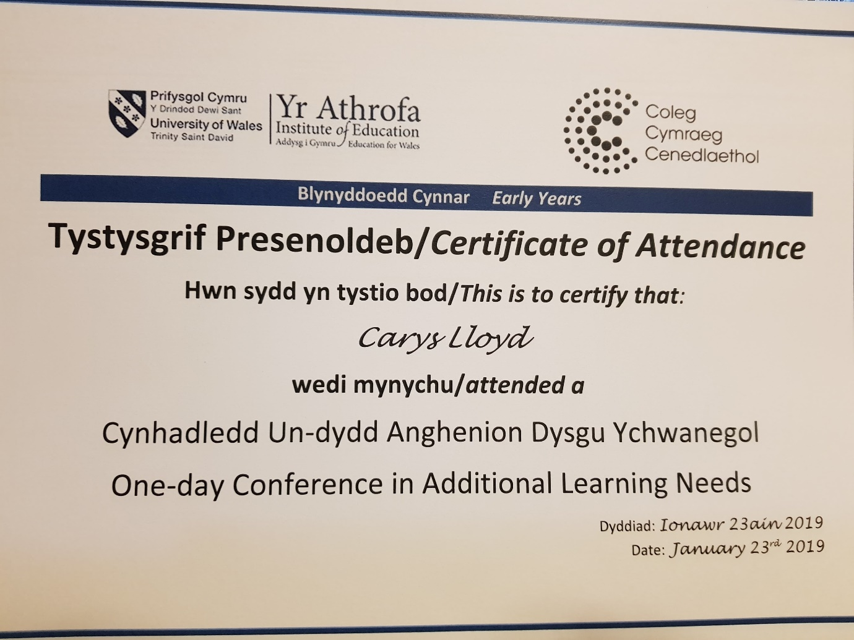

Appendix 6


