
Skills for the Workplace
Module Assignment Submission
Student Name: | Alexandra Jade Allan
Student Number: | 1811559
Module No: | BMSK6004
Module Title: | Strategic management.

Statement of Confirmation of Authenticity
By the act of making this submission, the student declares that this is the work of the student named above. The work has not, in whole or in part, been knowingly presented elsewhere for assessment, or where assessment has been built on a previous assessment, this has been identified. Where materials have been used from other sources it has been properly acknowledged. If this statement is untrue, the student acknowledges that an assessment offence has been committed.
Attention is drawn to the plagiarism and unfair practice policies of both the University and of ILM.
Permission for ILM to use this script
ILM uses learners’ submissions – on an anonymous basis – for assessment standardisation. By submitting, both the centre and the learner agree that ILM may use this script on condition that identifying information is removed. However, if you are unwilling to allow ILM use this script, please refuse by ticking the box: □

Table of Contents
Management Synopsis 3
Introduction 3
Section 1 3
Section 2 3
Reference list 4
Bibliography 5
Appendix 6

Management synopsis

The author of this report is a female healthcare professional who provides specialist care to a diverse range of patients within a variety of clinical settings. The author aims to use the knowledge gained from her university course, to aid her transformation from a healthcare worker to a manager within the retail sector.

introduction

Within the following report the author aims to answer the questions: what the organisation is currently doing, is it working and can it be improved. The author offers an internal and external environment analysis on her chosen organisation, she continues to highlight her stakeholders and their expectations. The author uses a range of models and theories to assist her in her analysis on her organisations current strategy and aid her appraisal on the organisation strategic direction. The author finishes her report with a proposal for improvement, a new strategic direction that she believes will aid the organisation in tackling some the main issues and gaps that she has highlighted within her report.

Section 1

Depth of critical analysis of your chosen organisations internal and external environment.
The author has selected The National Health Service as her organisation, which she will use for discussion throughout the following report. The author selected this organisation as she is familiar with it, having worked within the organisation for nine years, she deems herself to have relevant knowledge on the organisation. It is common knowledge that our National Health Service is one of a few publicly funded services in the world, this means that all information is easily accessible for all, this will aid the author in her report, making her research and gathering of data easy and with minimal barriers.
To aid the authors environment analysis, she has conducted a SWOT analysis (see appendix one) for her internal analysis and a PESTLE analysis for her external analysis (please see appendix two). The author enters this section with the assertion that the current market force is coming from an external source due to the coronavirus pandemic and the biggest competitors to The National Health Service is the private sector.
Within the authors PESTLE analysis, she highlighted the covid-19 pandemic as an environmental driving force for change. The current market is under immense pressure due to this force, not only due to the level of demand for the service but also financially and due to staffing levels, all as a result of the covid-19 pandemic (Western mail, 2021). (The Guardian, 2021) describes the NHS as a tank that has been run dry as a result of covid-19, they continue to describe how the pressures won’t ease until years after the number of cases drop, the question is, can it survive that long? The answer is, it has too, the biggest competitor to the NHS is private hospitals, within the UK they are the only alternative (Guy, 2019) and these competitors are not treating covid (The Times, 2021). (Toynbee, 2021) offers a recent, evidence based and lengthy discussion on how the NHS has struggled and continues to struggle whilst the private sector, its competitors are thriving, the private sector is not treating covid-19 however they have been supporting the NHS by covering a lot of surgeries which the NHS has been unable to do as a result of the pandemic, how honourable? (Marsh, 2020) discusses the deal that the private sector offered the NHS, renting out all their acute clinical equipment, staff and service for non-covid treatments at a whooping 8.2% increase in costs, suddenly their assistance seems more of a strategy to gain as appose to assist. To conclude, the external forces continue to provide immense pressure on the NHS, all factors within are being impacted, from the organisations ability to achieve objectives, staff retention and training, services and funding all being negatively impacted whilst their competitors thrive. The author agrees with her initial assertion that the current market is struggling as a result of this environmental driving force.
The author completed a SWOT analysis (see appendix one), within this internal environment analysis the author highlights the reduction of healthcare professionals as a threat to the organisation. The author believes that the sudden reduction in staffing levels within the NHS is due to the external driving force of covid-19, furthermore she believes this internal environmental driving force has resulted in a complete in the market, making it nearly impossible for the organisation to meet its targets, this is backed up by (snow, 2011) who highlights that even pre-pandemic staffing levels were critical to the organisation meeting targets. (Monteith, 2021) describes the shift in the market as one that has brought the organisation to the brink of collapsing, stating that in Scotland alone they were 500 consultants short before the pandemic, now they are 4800 consultants short, he continues to describe the figures for other healthcare professionals are far worse. To conclude, the author has highlighted staffing levels as an internal environmental driving force for change, sadly this change being a negative one, the author has highlighted how such staffing levels have had a cataphoric impact on the market and the organisation’s ability to achieve targets.

Conduct a stakeholder analysis and an evaluation of stakeholder’s expectations.

To aid this section, the author has completed a stakeholder analysis (please see appendix three). The author has selected two stakeholders whom expectations she shall analysis during this section, she has chosen the managing director and the employees.
The author highlighted the managing director as the highest-ranking stakeholder, thus giving the assertion that their expectations should be meet with the upmost priority, secondly, she selected the employees whose expectations ranked second highest within her stakeholder analysis. (MENA Report, 2014) outlines the role of the manging director of the NHS as A Medical Director is a member of the board of an NHS organisation with a clinical background, they continue to describe how the role has developed and aided the organisation, claiming this is evidenced in research by the King’s Fund and Birmingham University, that demonstrates that 10-20% of consultants are now involved in formal leadership roles in most trusts. (Monitor, 2012) cited in (MENA Report, 2014) argues that the role will gain yet more importance in the years ahead due to the need for a sustainable leadership within the NHS. (Darzi, 2008) summarises the expectations of the NHS and its stakeholders as “high quality care for all that is free at the point of contact and without immense waiting times”, these expectations give the author the assertion that the strategy of the organisation is to the healthcare needs of all, this is what the stakeholder wants to achieve when they accept the managing director role of the National Health Service. In order to maintain the support, the funding and the compliance of the managing director I would ensure that they receive regular updates, I maintain communications as they see fit and that they remain involved in the judgements on the organisation’s strategy, (Matthias, 2016) offers a supported and in depth analysis on how the NHS is detreating and failing to meeting targets set out by its strategy, highlighting studies on peoples perception of the service and summarising that we’ve seen a significant increase in people saying that public services have got worse. In 2016, 40 per cent said services had got worse over the previous five years, up from around 30 per cent saying the same in 1998 – despite the late 1990s being a period of pressure on public services, before Labour loosened controls on spending. But there is also seemingly contradictory good news. In 1998, 40 per cent of people said public services were falling short of their expectations – but only 28 per cent said this by 2016. It’s an almost perfect mirror: we are more likely to think services are worse, but also more likely to say that’s acceptable to us, does this show improvement or acceptance of poor standards? To conclude, the author believes that the managing director be the highest-ranking stakeholder within our National Health Service, she believes that meeting their needs and interest be of most importance due to their level of power, she has highlighted their expectations but proven that they are not being met, this giving the assertion that their strategy needs changing, she questions why this has not happened yet? The free for all strategy, has it failed to change out of fear of reactions? If so, when one assesses the state of our National Health Service it is clear that doing nothing will be far worse that changing their strategy.
The second stakeholder selected for assessment by the author is the employees, who ranked second on the level of importance showing that their interests must be met due to them having a decent level of power. It is the authors assertion that employees expect good working conditions, a financial return for their time and support from their employer when required. (Hyde et al, 2013) offers an outdated yet still relevant discussion on the topic, their assertions are backed up and their credentials are listed thus giving them authority, Hyde et al conducted a survey which concluded that nurses within the National Health Service expected respect from Managers and Colleagues, safer nursing shifts and gratitude. The expectations outlined above indicate that nurses feel undervalued and over worked whilst risking patient safety. The current strategy for staffing levels within the NHS is discussed by (Bretherton et al, 1959) who backs up the assertion that a lack of safe nurse to patient ratio can result in a lack of moral, furthermore they believe that a balanced nurse-to-patient ratio can result in better treatments, improved patient satisfaction, enhanced job satisfaction and reduced fatigue in nurses. With an appropriate nurse-to-patient ratio, nurses are able to provide quality healthcare to the patients without straining themselves, the author believes that the current no nurse to patient ratio strategy is having a negative impact on the stakeholders due to their expectations not being met. If the author was within a position of authority, she would approach higher ranking stakeholders with her findings and request change, offer evidence on the need for change and provide them with evidence on the impact their current strategy is having on the culture within the organisation. To conclude, the author deems this stakeholder to be one of importance, she has evidenced her assertion that their current expectations are not being met under the current strategy and recommends re-instating a safe and set for all nurse-to-patient ratio strategy.
Application of a range of relevant academic theories/ models.
For this section the author has selected two models to aid her assessment on her organisation. The first model selected for assessment is the porters five forces model cited in (Dobbs, 2014). The author has selected this model as she deems this tool to be an effective template for understanding the forces that shape and threaten an organisation, she believes it can also be used to help adjust a company’s strategy to suit their competitive environments and improve on meeting expectations. This model shows five areas for assessment, the first being supplier power. Supplier power focuses on any group who supplies to the organisation, for example employees supply the service and due to them being the sole enablers of this service, according to porter cited in (Yunna and Yisheng, 2014) making the number of suppler options for this service so limited, thus making the organisation depend on this supplier the supplier can demand fees, this is backed up (Patrick, 2020) who wrote an article on the recent demands being made by NHS employees, marches and strikes being planned in an attempt to gain more pay. The second force within Porters model is buyer power. Buyer power is defined by (Cox et al, 2002), they conclude that buyer power refers to a customer’s ability to reduce prices, improve quality, or generally play industry participants off one another, this force could offer insight into existing operational tactics and strategies that directly drive industry revenue such as pricing or consumer targeting, when relating this to the national health service, the customer is the public and living in a day and age where information and reviews can spread far and fast it would be reasonable to assume that the public do hold the ability to drive a change in standards at any time, recent research by the author provided her with evidence that a private healthcare plan would cost £10 per annum less than her level of national insurance contributions (Fourquet et al, 2019) describe this as a barrier to healthcare and one that could eliminate healthcare inequalities, however the government make those contributions mandatory thus removing a lot of the power from this buyer. The third force identified by porter is competitive rivalry. It is common knowledge that there is a private healthcare sector but due to its level of cost and inaccessibility it is clear that is less of a competitor of the NHS and more of sister service, furthermore our NHS is like no other service thus removing any competitors from the equation. The fourth driving force identified by Porter is threat of substitution, this force is discussed by (Lin-Greenberg, 2019) as those products or services that meet a particular consumer need but are available in another market. A substitute product is a product from another industry that offers benefits to the consumer similar to those of the product produced by the firms within the industry, remembering the discussion on competitors, the author has concluded on the notion that yes there is similar services available, but they are not accessible for all thus removing any private sector from a list of competitors to the authors organisation. The final driving force, that can impact on the organisation’s strategy is the threat of new entry. The author acknowledges that worth wild markets will attract new entrants, (Santandrea et al, 2016) offers statistics on the growth of the private healthcare market, stating that it is expected to grow by 40% from 11.8 billion to 13.8billion between 2018 and 2023, thus proving that the healthcare market is a profitable market which new entrants will seek however, remembering the assertion by the author that although the two sectors provide the same service, they are not competitors, if private healthcare was available to all then the author believes that costs would fall, standards would raise and healthcare inequality would vanish. To conclude, using the porters five forces model has allowed to the author to highlight areas in which her organisation could be at risk. The author has concluded that there are no competitors to out National Health Service due to the mandatory national insurance contributions, the authors believes that if this was an option for all, then the choice of a private insurance policy or national health service would then enable competitors to compete for the profits. The author has also highlighted that suppliers are currently trying to drive up costs, the author believes that the no ratio policy is having a negative impact on job satisfaction, staff retention and overall quality of care provided, the author offers a second recommendation that the old nurse to patient ratio be reintroduced and enforced.
The second model selected by the author to aid this section of her report is the Mckinsey 7s model cited in (Ali abdul, 2013), the author has selected this model as she believes it is a great tool for assessing the internal environments of an organisation, using the seven key factors one could determine the level of organisational success. The first factor within this model is strategy, the author relates this factor to her organisation as ‘how do they achieve’, (McLeod, 2020) offers a holistic answer this, a removal of the government funding and statistical analysis on targets, he believes the NHS achieves by saving lives, the author agrees with this notion, relating this to the recent pandemic, thousands of patients have been hospitalised with this virus yet have been treated and returned home (The express, 2021). The second factor is skills, this factor can be assessed by common knowledge, all healthcare professionals required training and skills to be deemed competent, it is illegal to allow staff to work within your clinical setting if their skills are outdated or non-existent. The third factor is staff, (The Guardian, 2021) discusses the staff shortages within the authors organisation and describes the shortages of staff as widespread within the NHS, continuing to discuss how such shortages exist across all disciplines. It is common knowledge that the NHS is on the brink with too few nurses, midwives, GPs, hospital doctors and mental health workers. Staff are leaving the service due to low job satisfaction whilst recruitment and retention continues to be a growing problem, thus creating a gap in the organisation’s strategy. The next factor is style of leadership, the author believes that the leadership within her organisation is authoritarian, the organisation is so large that it would be impossible to seek input from all and when dealing with peoples lives one must make informed decisions for all. The fifth factor systems, the author sees vast similarities to the gap acknowledged here and the one acknowledged within the third factor, yes, the organisation is constantly trying to recruit and train and monitor but sadly the is a huge lack of interest for their roles, the author believe this is due to the widespread of information relating to reduced job satisfaction within the organisation. The sixth factor is structures, at the top of the hierarchy is the department for health who control funding, then sustainability partnerships who bridge the NHS providers, then NHS Wales, then health boards and primary care settings (Alllan et al, 2008), this shows that is a hierarchy in place and control stems down from the top. The final factor within this model is shared values, (Fielden and Mountford, 2011) propose that the reforms offer an opportunity to once again solve staff shortages, staff being underpaid and overworked and reintroduce the shared values which shape all that NHS does, (Newbigging, 2015) acknowledges four main shared values held within our NHS, working together for patients, respect and dignity for all, commitment to quality of care and compassion, it is common knowledge that these shared values are enforced, if an individual does not fit in with the care culture they risk being dismissed. To conclude, this model has highlighted some hard impacting factors and other factors that are influenced by culture, for example strategy is a hard factor which provided the conclusion that the organisation achieves by saving lives whereas staffing is a factor that is influenced by culture. This model has shown a that there is definitely room for improvement within the authors organisation, the author would recommend that the organisation address the gaps highlighted above and by doing so would improve on their services and internal workplace culture.

Provide a critical appraisal of your chosen organisation’s current strategic direction.
The NHS patient safety strategy is about maximising the things that go right and minimising the things that go wrong. It is integral to the NHS’ definition of quality in healthcare, alongside effectiveness and patient experience (Fedele and Porter, 2020). This strategy aims to reduce the number of accidents experienced by patients by implementing patient safety specialists to analysis past events and eliminate risks for the future (Litchfield, 2018), this strategy was introduced in 2014 and aimed to set a direction for reducing harm, they want to use this strategy to measure patient safety. (NHS England, 2021) publish their accident reports on an annual basis, their 2021 report showing an increase by 21.5% to a total of 602975 accidents reported in the year leading up to June 2021. This shows that the current strategic direction to reduce patient accidents is not followed and does not achieve the intended goals, the author acknowledges potential impacting factors such as tired staff, reduced moral, staff shortages all as factor which can impact on patient safety, the nurse’s campaign to gain more nurses and higher level of pay is based on their ideology that by not doing these things, patient safety is risk, so when healthcare employees are crying out for additional support why is it that one of the world’s greatest healthcare systems is failing thousands of patients after a funding squeeze and a drive to privatise (Hawkes, 2012). Patient safety is the avoidance of unintended or unexpected harm to people during the provision of health care. We support providers to minimise patient safety incidents and drive improvements in safety and quality. Patients should be treated in a safe environment and protected from avoidable harm (Ocloo and Fulop, 2021), achieving this is the expectation of both internal and external stakeholders, it is the vision of the organisation but sadly it is not being achieved, the author wonders why there is an enhanced public fury due to the lack of satisfying stakeholders. To conclude, the current strategic direction is not working, patient accident levels are on the increase despite such a large and widespread strategy being implemented a decade ago, it is failing achieve targets and meet stakeholder expectations, the author believes this is due to internal forces not being addressed, the staffing crisis for one, staff moral and dangerous nurse to patient levels, all of these factors could make it seem impossible for a human being to catch eliminate every risk factor and protect their patients.

Depth and clarity of the proposed new strategy.
Remembering the authors findings from the above tasks, she has identified internal and external forces, stakeholders and their expectations, used two models to back up her claims and she believes she has proven that her organisations current strategic direction is not working, thus all proving the need for a new strategic direction.
The author proposes a new strategic direction, one which focuses on the happiness of the authors second to highest ranking stakeholder, the employees. (Silvera, 2014) highlights the salary of nurses to be the main factor affecting staff retention and recruitment, this is backed up by (Zangaro and Soeken, 2007) who highlighted job stress vs salary was then making the profession undesirable. A consultation by the RCN found that almost 92% of nurses in England believe the recent 3% pay increase offer is unacceptable, this shockingly high figure shows the level of unhappiness within the organisation. The union wants nurses pay to go up by 12.5%, this figure was desired due to inflation, which has continued to rise since 2011 and the value of NHS pay has fallen by around 12% (Smith, 2016).
The author proposes a strategic direction that aims to tackle staff retention and recruitment issues previously highlighted within this report. The author believes that by doing so staff moral would improve, workplace culture would be benefited, and the organisation would have the resources to tackle their obvious patient safety issues.
(Hansen et al, 2016) discusses the barriers likely to be experienced when changing strategic direction. They believe that change can be hard on employees and behaviours and attitudes are likely to be impacted when bringing about any organisational change, however the author would argue that as this change is widely sought after, the likelihood of a rebellion or negative impact would be small. (Richards, 2011) discusses the different type of changes that can be applied to different organisations, he concludes that the type of change should fit the situation and the problem that the company is facing at the time, in this case this would staff happiness, he continues to describe the time frame in which a change should take place, highlighting the importance on managing the speed of the change, the author believes that being too late on the implementation of the change can impact on the effectiveness of the change, that is why the author would argue that this organisational change needs to happen now and not slowly brought in, she believes that by delaying the implementation of a new strategic direction, the negative impacts of the current state are going to felt harder at a time when the organisation is on the brink of collapse.
To conclude, the author believes her new strategic direction for her organisation be the best hope for sustainable growth. Their current strategic direction has been in place for nearly a decade and yet the findings prove it continues to fail the system, the service and its clients, thus backing up the authors claim that change is needed and needed now. The author believes her new target to tackle staffing levels till they reach a safe level will aid staff retention, reduce staff sickness and aid workplace culture and morale, secondly the author believes that a fair pay rise for the employees will show all that they are seen, their efforts are valued, and this will reinstate the old ideology that the National Health Service is the best healthcare system within this world and it deserves protecting. The author sees staffing levels are the cure to patient safety issues, but to tackle staffing levels one must tackle recruitment issues and the answer to that is to make the NHS a desirable employer once more.

Reference list

News Article. 2021a.

News Article. 2021b.

News Article. 2021c.

News Article. 2021d.

News Article. 2021e.

News Article. 2021f.

Doctors, nurses, porters, volunteers: the UK health workers who have died from Covid-19 - A project to remember those who lost their lives working in hospitals, surgeries and care homes during the coronavirus outbreakCoronavirus ? latest updatesSee all our coronavirus coverage. 2020.

Thousands of NHS staff to march in cities across UK to demand higher wages. 2020.

Junior doctors' strike: What does the mass walkout mean for patients and services? 2016.

NHS Pay Row: Nurses and Paramedics Vote for Strike Action in England. 2014.

United Kingdom : NHS Shared Business Services announces its new Managing Director. 2014. MENA Report, .

ALI ABDUL-FATTAH ALSHAHER, 2013. THE MCKINSEY 7S MODEL FRAMEWORK FOR E-LEARNING SYSTEM READINESS ASSESSMENT. International journal of advances in engineering and technology, 6(5), pp. 1948.

ALLAN, H., TSCHUDIN, V. and HORTON, K., 2008. The Devaluation of Nursing: a Position Statement. Nursing ethics; Nurs Ethics, 15(4), pp. 549-556.

COX, A., IRELAND, P., LONSDALE, C., SANDERSON, J. and WATSON, G., 2002. Supply Chains, Markets and Power : Managing Buyer and Supplier Power Regimes. Hoboken: Taylor and Francis.

DARZI, A., 2008. High quality care for all NHS next stage review final report. London: The Stationery Office.

DOBBS, M.E., 2014. Guidelines for applying Porter's five forces framework: a set of industry analysis templates. Competitiveness review, 24(1), pp. 32-45.

FEDELE, S. and PORTER, S., 2020. COVID‐19 NHS infection control strategy: Errare humanum est, perseverare autem diabolicum. Oral diseases, .

FIELDEN, J. and MOUNTFORD, J., 2011. A chance to optimise “value” in the NHS. BMJ; BMJ, 342, pp. 2477-d3244.

FOURQUET, J., ZAVALA, D.E., MISSMER, S., BRACERO, N., ROMAGUERA, J. and FLORES, I., 2019. Disparities in healthcare services in women with endometriosis with public vs private health insurance. American Journal of Obstetrics and Gynecology; Am J Obstet Gynecol, 221(6), pp. 623.e1-623.e11.

GORDON, S., BRETHERTON, T. and BUCHANAN, J., 2008. Safety in numbers nurse-to-patient ratios and the future of health care. Ithaca: ILR Press/Cornell University Press.

GUY, M., 2019. Between ‘going private’ and ‘NHS privatisation’: patient choice, competition reforms and the relationship between the NHS and private healthcare in England. Legal studies (Society of Legal Scholars), 39(3), pp. 479-498.

HANSEN, J.R. and JACOBSEN, C.B., 2016. Changing Strategy Processes and Strategy Content in Public Sector Organizations? A Longitudinal Case Study of NPM Reforms' Influence on Strategic Management. British Journal of Management; Brit J Manage, 27(2), pp. 373-389.

HAWKES, N., 2012. English NHS could be £54bn in red by 2021 if budget or output doesn’t increase. BMJ : British Medical Journal; BMJ, 345, pp. e8208.

HYDE, P., SPARROW, P., BOADEN, R. and HARRIS, C., 2013. High performance HRM: NHS employee perspectives. Journal of health organization and management; J Health Organ Manag, 27(3), pp. 296-311.

LIN-GREENBERG, E., 2019. Backing up, not backing down: Mitigating audience costs through policy substitution. Journal of Peace Research, 56(4), pp. 559-574.

LITCHFIELD, I., GILL, P., AVERY, T., CAMPBELL, S., PERRYMAN, K., MARSDEN, K. and GREENFIELD, S., 2018. Influences on the adoption of patient safety innovation in primary care: a qualitative exploration of staff perspectives. BMC family practice; BMC Fam Pract, 19(1), pp. 72.

MATTHIAS, O. and BROWN, S., 2016. Implementing operations strategy through Lean processes within health care: The example of NHS in the UK. International journal of operations & production management, 36(11), pp. 1435-1457.

MCLEOD, H., 2020. Reducing health inequalities in England: does the demise of NHS Stop Smoking Services matter? Analysis of mandatory monitoring data. Journal of public health (Oxford, England); J Public Health (Oxf), 42(1), pp. 12-20.

OCLOO, J.E. and FULOP, N.J., 2012. Developing a 'critical' approach to patient and public involvement in patient safety in the NHS: learning lessons from other parts of the public sector? Health expectations : an international journal of public participation in health care and health policy; Health Expect, 15(4), pp. 424-432.

RICHARDS, K., 2011. Research resource review: Understanding the Changing Planet: Strategic Directions for the Geographical Sciences. Progress in Physical Geography, 35(6), pp. 843-846.

SANTANDREA, M., BAILEY, S. and GIORGINO, M., 2016. Value for money in UK healthcare public–private partnerships: A fragility perspective. Public policy and administration, 31(3), pp. 260-279.

SNOW, T., 2011. Action on staff sickness needed as NHS fails to meet reduction target. Nursing standard; Nurs Stand, 26(13), pp. 6.

ZANGARO, G.A. and SOEKEN, K.L., 2007. A meta-analysis of studies of nurses' job satisfaction. Research in nursing & health; Res.Nurs.Health, 30(4), pp. 445-458.

Appendix

Appendix one
Swot Analysis
(Sarsby, 2016)
(Allan, 2021)

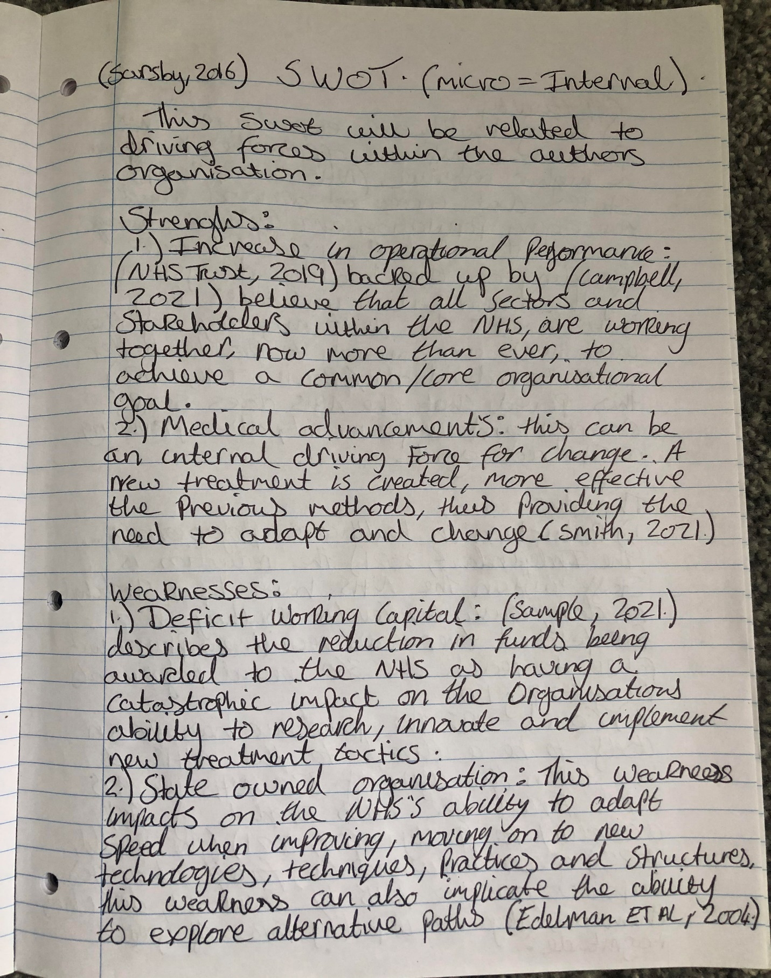

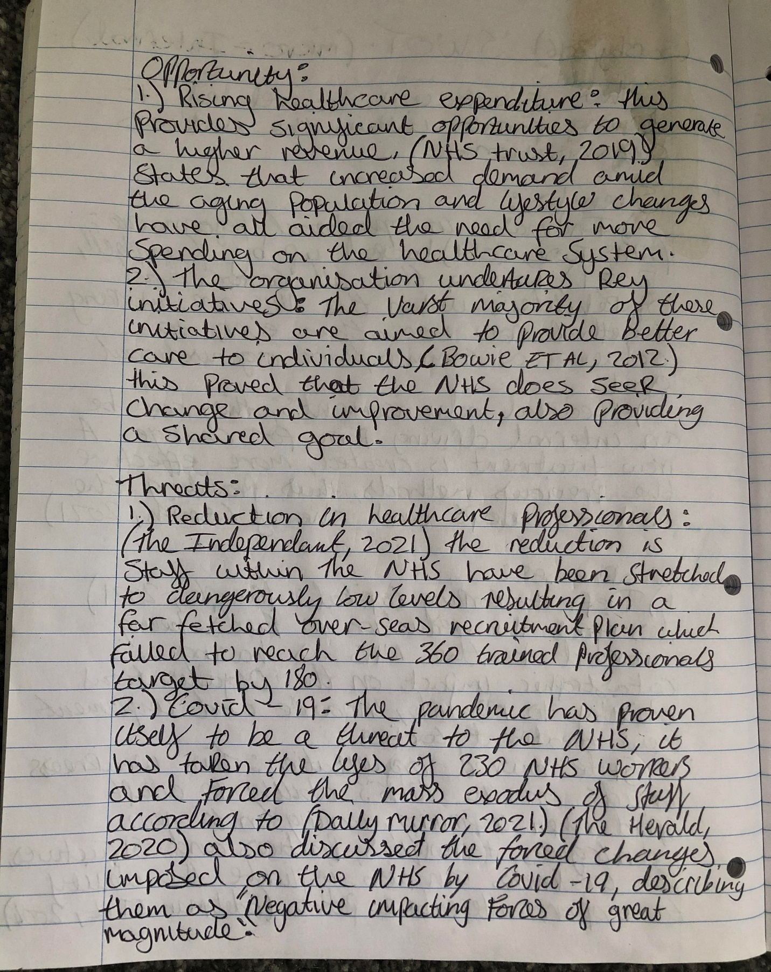

Appendix two
PESTLE Analysis
(Wall, 2011)
(Allan, 2021)

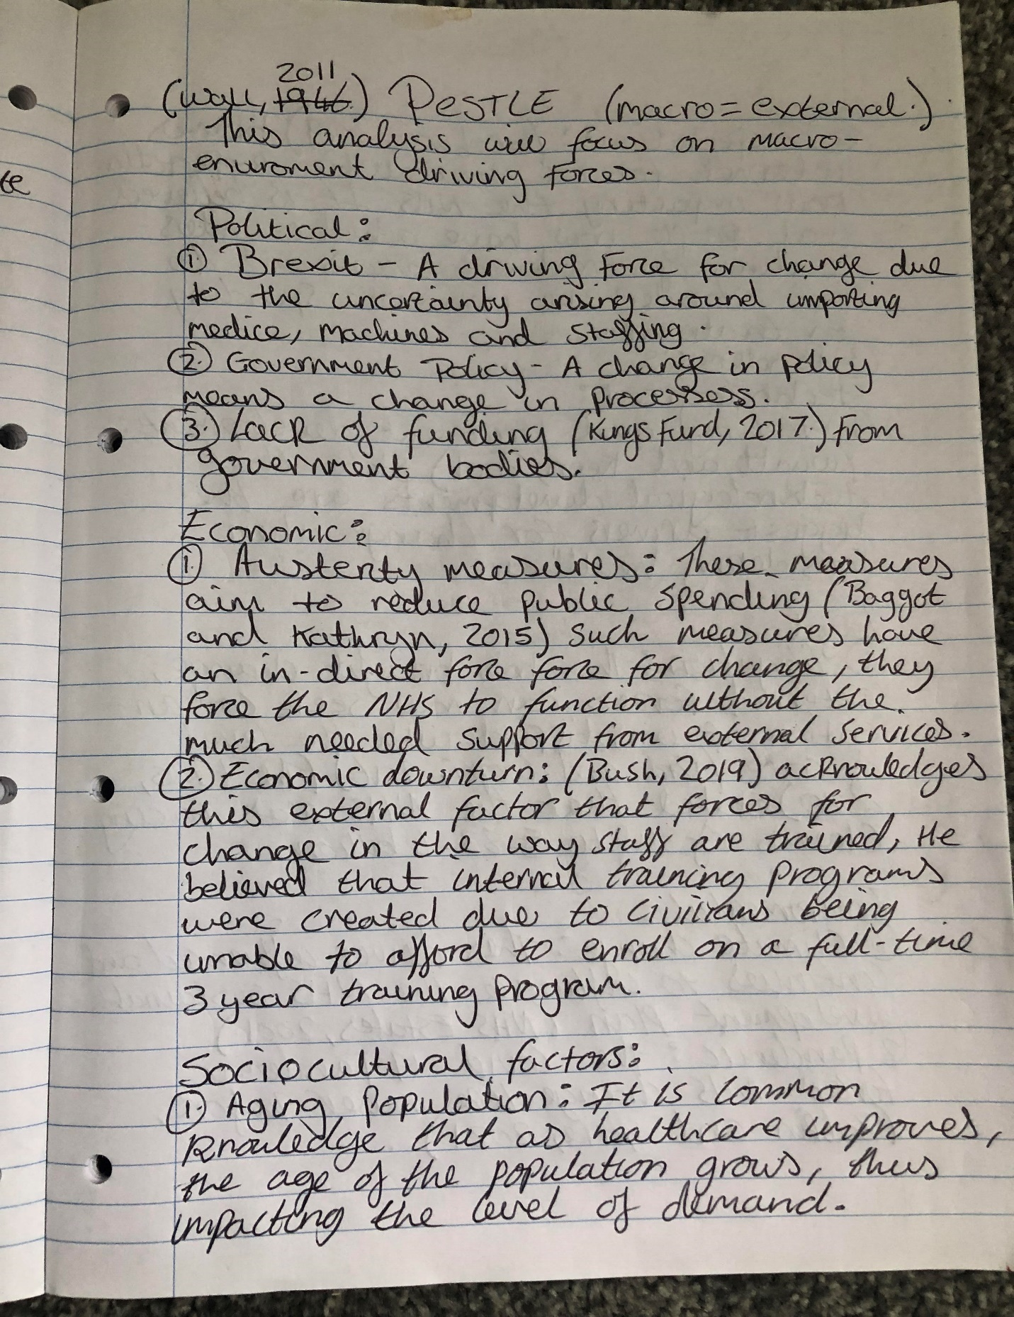
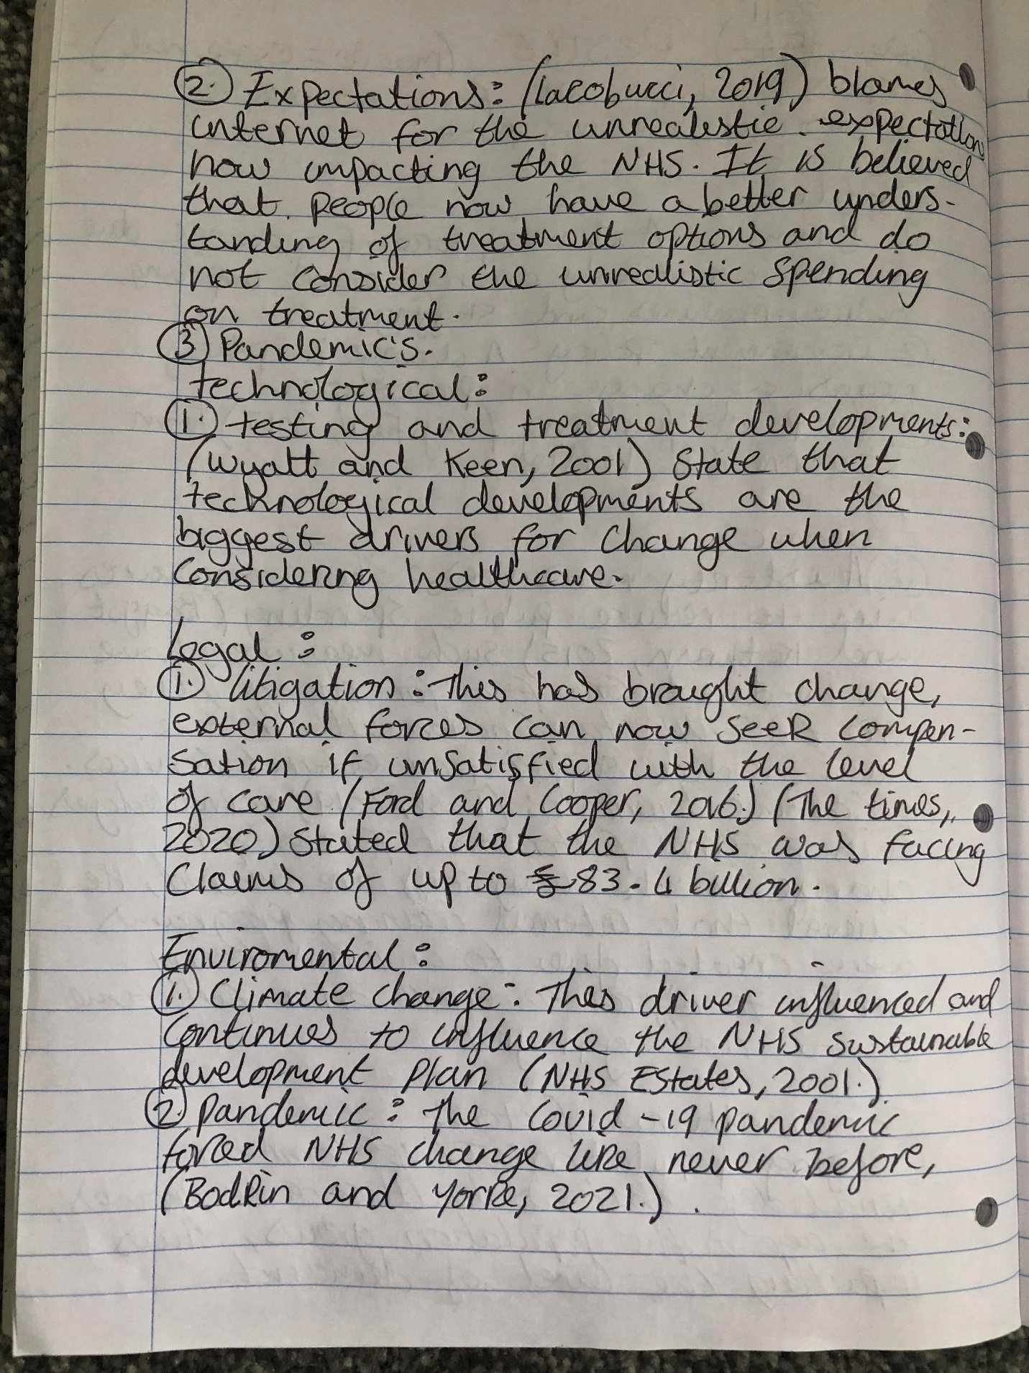

Appendix three
Stakeholder analysis
(Ferrero et al, 2018)



