

A Comparative Analysis of Sentiment Classification Algorithms Using the Sentiment140 Dataset

by
Matthew Dene Lewington

Supervisor: Dr Nik Whitehead

Project submitted as part of the requirements for the award of MSc Data Science and Analytics

November 12, 2021

DECLARATION

I, Matthew Dene Lewington declare that I am the sole author of this Project; that all references cited have been consulted; that I have conducted all work of which this is a record, and that the finished work lies within the prescribed word limits.

This work has not previously been accepted as part of any other degree submission.

FORM OF CONSENT

I, Matthew Dene Lewington hereby consent that my Project, submitted in candidature for the M.Sc. Data Science and Analytics degree, if successful, may be made available for inter-library loan or photocopying (subject to the law of copyright), and that the title and abstract may be made available to outside organisations.

ABSTRACT
Machine learning, part of the natural language processing family, can be applied to dozens of tasks and specialised areas, with sentiment analysis being one sector. Several pre-existing classification algorithms are tuned, trained, and tested on the Sentiment140 dataset to distinguish between positive and negative sentiment. Various evaluation techniques are applied to the performance metrics which are generated and extracted from the classification algorithms, and a comparison of the performance metrics determines that the logistic regression classifier is the best for performing sentiment analysis on the Sentiment140 dataset, closely followed by the naïve Bayes classifier.
Table of Contents
Table of Figures ix
Table of Tables xii
1 Introduction 1
1.1 Background 1
1.2 Purpose 1
1.3 Aims and Objectives 2
2 Background and Related Works 3
2.1 Social Media 3
2.1.1 Social Media Usage 3
2.1.2 Twitter 4
2.2 Big Data 5
2.3 Machine Learning 6
2.3.1 Supervised Learning 6
2.3.2 Unsupervised Learning 7
2.3.3 Semi-supervised Learning 7
2.3.4 Reinforcement Learning 7
2.4 Natural Language Processing 7
2.4.1 NLP Tasks 8
2.4.2 NLP Techniques 9
2.5 Sentiment Analysis 10
2.5.1 Knowledge-Based Approach 11
2.5.2 Learning-Based Approach 11
2.6 Classifiers 11
2.6.1 Naïve Bayes 11
2.6.2 K-Nearest Neighbours 12
2.6.3 SVM 15
2.6.4 Decision Tree 17
2.6.5 Random Forest 18
2.6.6 Logistic Regression 18
2.7 Evaluation Measures 19
2.7.1 Classification Accuracy 19
2.7.2 Confusion Matrix 20
2.7.3 Receiver Operating Characteristic 22
2.7.4 Model Fitting 23
2.8 Datasets 25
2.8.1 Sentiment140 25
2.8.2 SemEval 26
2.9 Sentiment Analysis of Twitter Data 26
2.9.1 Sentiment140 Studies 26
2.9.2 SemEval Studies 27
2.9.3 Other Studies 28
2.10 Conclusion 28
3 Methodology 30
3.1 Research Methodology 30
3.1.1 Philosophy 30
3.1.2 Strategy 30
3.1.3 Approaches 30
3.1.4 Data Evaluation Methods 31
3.1.5 Ethics 32
3.1.6 Risks 32
3.1.7 Validity, Reliability & Generalisability 32
3.2 Development Methodology 33
3.2.1 Data Mining Methodology 33
3.2.2 Software Development Methodology 33
3.3 Resources 33
3.3.1 Hardware Resources 34
3.3.2 Software Resources 34
3.4 Conclusion 35
4 Implementation 36
4.1 Dataset 36
4.2 Business Understanding 36
4.3 Data Exploration 37
4.3.1 Value counts 37
4.3.2 Missing Values 38
4.3.3 Duplicate Values 39
4.3.4 Tweet Word Count 39
4.3.5 Word Cloud 41
4.4 Pre-Processing 42
4.4.1 Dataset Structure 42
4.4.2 Data Cleaning 44
4.4.3 Label Encoding 50
4.5 Classifier Training 50
4.5.1 GridSearchCV 50
4.5.2 Naïve Bayes 51
4.5.3 KNN 53
4.5.4 Logistic Regression 55
4.5.5 Decision Tree 57
4.5.6 Random Forest 59
4.5.7 Training Results 61
4.6 Conclusion 62
5 Results 63
5.1 Naïve Bayes 63
5.2 KNN 65
5.3 Logistic Regression 66
5.4 Decision Tree 68
5.5 Random Forest 70
5.6 Conclusion 71
6 Evaluation 72
6.1 Accuracy 72
6.2 Precision 73
6.3 Recall 73
6.4 F-Score 74
6.5 ROC 75
6.6 Runtime 77
6.7 Cross Validation 78
6.8 Fitting 80
6.9 Conclusion 81
7 Conclusions and Recommendations 82
8 Reflection 84
9 References 86
Appendix A – SVM Results 97

Table of Figures
Figure 2-1 Global active social media users per month (as of April 2021) 3
Figure 2-2 Change in global active social media users 4
Figure 2-3 KNN classification 13
Figure 2-4 Euclidean distance 14
Figure 2-5 Manhattan distance 15
Figure 2-6 Hyperplane position 16
Figure 2-7 SVM optimal hyperplane 16
Figure 2-8 Decision tree 17
Figure 2-9 Random forest 18
Figure 2-10 Sigmoid function 19
Figure 2-11 Confusion matrix 20
Figure 2-12 ROC curve 22
Figure 2-13 ROC AUC 23
Figure 2-14 ROC AUC (2) 23
Figure 2-15 Overfitting 24
Figure 2-16 Underfitting 25
Figure 4-1 Positive and negative value counts 38
Figure 4-2 Sum of NA values 38
Figure 4-3 Sum of NULL values 38
Figure 4-4 Duplicate tweets 39
Figure 4-5 Positive tweet word count 40
Figure 4-6 Negative tweet word count 40
Figure 4-7 Positive tweet word cloud 41
Figure 4-8 Negative tweet word cloud 42
Figure 4-9 Duplicate tweet removal 43
Figure 4-10 Unnecessary column removal 43
Figure 4-11 Lowercase function 44
Figure 4-12 Lowercase conversion 44
Figure 4-13 Abbreviation .json file samples 45
Figure 4-14 Abbreviation expansion function 45
Figure 4-15 Abbreviation expansion example 45
Figure 4-16 Abbreviation expansion example (2) 46
Figure 4-17 Emoji conversion 46
Figure 4-18 Emoji conversion (2) 46
Figure 4-19 Pre-processor cleaning example 47
Figure 4-20 Remove punctuation function 47
Figure 4-21 Remove punctuation example 47
Figure 4-22 Stopword samples 48
Figure 4-23 Stopword removal function 48
Figure 4-24 Stopword removal example 48
Figure 4-25 Lemmatisation function 49
Figure 4-26 Lemmatisation example 49
Figure 4-27 Combined data cleaning function 49
Figure 4-28 Combined data cleaning example 49
Figure 4-29 GridSearchCV parameters 50
Figure 4-30 Naïve Bayes algorithm 52
Figure 4-31 Naïve Bayes results 52
Figure 4-32 Naïve Bayes results 53
Figure 4-33 KNN algorithm 54
Figure 4-34 KNN best score and parameters 54
Figure 4-35 KNN results 55
Figure 4-36 Logistic regression algorithm 56
Figure 4-37 Logistic regression best score and parameters 56
Figure 4-38 Logistic regression results 57
Figure 4-39 Decision tree algorithm 58
Figure 4-40 Decision tree best score and parameters 58
Figure 4-41 Decision tree results 59
Figure 4-42 Random forest algorithm 60
Figure 4-43 Random forest best score and parameters 60
Figure 4-44 Random forest results 61
Figure 5-1 Naïve Bayes confusion matrix 63
Figure 5-2 Naïve Bayes classification report 64
Figure 5-3 Naïve Bayes ROC 64
Figure 5-4 KNN confusion matrix 65
Figure 5-5 KNN classification report 65
Figure 5-6 KNN ROC 66
Figure 5-7 Logistic regression confusion matrix 67
Figure 5-8 Logistic regression classification report 67
Figure 5-9 Logistic regression ROC 68
Figure 5-10 Decision tree confusion matrix 68
Figure 5-11 Decision tree classification report 69
Figure 5-12 Decision tree ROC 69
Figure 5-13 Random forest confusion matrix 70
Figure 5-14 Random forest classification report 70
Figure 5-15 Random forest ROC 71
Figure 6-1 Accuracy comparison 72
Figure 6-2 Precision comparison 73
Figure 6-3 Recall comparison 74
Figure 6-4 F-score comparison 75
Figure 6-5 ROC curve 76
Figure 6-6 ROC AUC comparison 77
Figure 6-7 Cross validation results 79
Figure 6-8 Cross validation naive Bayes vs logistic regression 80
Figure A-1 SVM algorithm 97
Figure A-2 SVM best score and parameters 97
Figure A-3 SVM confusion matrix 98
Figure A-4 SVM ROC 99

Table of Tables
Table 1 Example of polarity classification 10
Table 2 Sentiment140 field description 26
Table 3 Training accuracy 61
Table 4 Runtime comparison 77
Table 5 Cross validation scores 78
Table 6 Training vs test accuracy 81
Table 7 SVM classification report 98

Introduction

Background
Sentiment analysis is not only a challenging research area within natural language processing, but also an extremely powerful tool that almost every business and social domain is able to harness in order to aid them by gathering critical feedback about products or services they provide [1, p. 7], [2], and by answering the questions asked by those who need to know, such as:
- Why have our sales spiked or dropped this week?
- What is the general feeling toward our newly released product?
- The survey data said that this would be a guaranteed success, but why was it not successful?
- How are people reacting to the new service of competitor ‘X’?

A social data insights report produced by Twitter [3] states that although there is a plethora of data, the analysis of said data is just not able to keep up, with even 63% of marketers failing to see how social data can provide any form of benefit to their business.

Purpose
The purpose of this project is to develop software which can successfully classify the sentiment polarity of a tweet into either positive or negative. This will then be followed by a comparative analysis, taking into consideration several metrics, which will then determine which of the given classification models are the best suited for the task and why.
Classification models are then able to be applied to the real world by various end users, and they can be utilised to assist with the points and questions posed in the above background section. This can arm companies and businesses with a powerful instrument which can provide information and possibly support in making a business decision, or at least automate some of the menial and monotonous tasks (such as sentiment classification) that the business may be paying a person/team to perform instead, cutting costs, and increasing productivity as a machine should be able to perform tasks faster than a human.

Aims and Objectives
The aim of this project is to synthesise the various tools and techniques discovered (whilst completing both an undergraduate degree in software engineering, and a postgraduate degree in data science and analytics) to develop software which can process a dataset containing Twitter data, and successfully perform sentiment analysis. This software will provide a polarity classification on the available tweets from the dataset, and in turn the model trained will be able to successfully predict the sentiment of another tweet. The objectives of this project are as follows:
- Perform data exploration and analysis of a dataset,
- Perform data cleaning on a dataset,
- Develop a software which can perform sentiment analysis on a dataset,
- Train the developed software with the dataset,
- Test the developed software to ensure it is fit for purpose,
- Analyse the produced data from the software and produce an evaluation on the results, determining which classification algorithm is best suited for sentiment analysis of the given dataset,
- Answer any business questions that are to be determined through the CRISP-DM process.

Background and Related Works
This section will outline the background theory and information for the project, and will build on the initial literature review detailed in the research proposal which has previously been submitted.

Social Media
Social media platforms such as Facebook, Twitter, Instagram, and YouTube are some of the most popular platforms for internet users to share their voices, opinions, and sentiments across a multitude of topics, products, and services. Due to the volume of transactions that these platforms process on a daily basis in terms of tweets, comments and reactions, these platforms are viewed as an extremely valuable resource in the world of computing as a free source of human text input [4], [5].

Social Media Usage
Reports produced by DataReportal [6], in partnership with HootSuite [7] and We Are Social [8], show just how much of the global population (7.85 billion people) utilise various social media platforms, with Facebook being the most popular at almost 2.8 billion users (Figure 2-1).

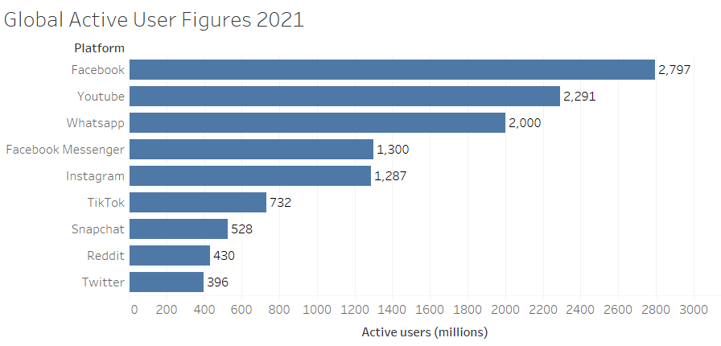
Figure 2-1 Global active social media users per month (as of April 2021)

Figure 2-2 displays the quarterly change from Q2 of 2019 through to Q2 of 2021. This shows an overall increase of 23.36% in the amount of active social media users in this timespan [6], and a steady increase overall in global usage of various social media platforms.

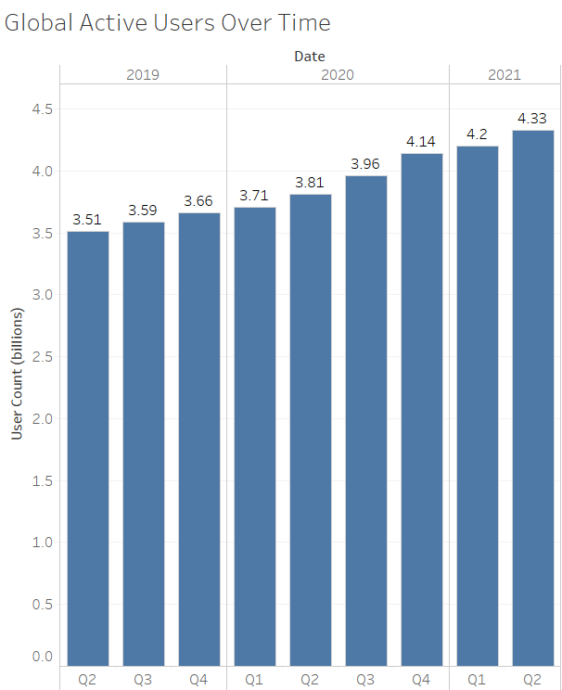
Figure 2-2 Change in global active social media users

As the userbase and usage of social media increases, so too does the plethora of various pieces of information readily available for processing for companies.

Twitter
For this project, the core focus will be on Twitter and the data, or tweets, of Twitter users. Twitter is one of the many popular microblogging applications, however the niche difference between Twitter and other social media platforms (where a user can produce text data) is that Twitter only allows users to exchange and post messages (tweets) of up to 280 characters per tweet [9]. The tweet can contain multimedia such as images or videos, and users are also able to post web links.
A user is then able to interact with the given tweet as they can “like” the tweet, and they are also able to “retweet” the tweet. This function essentially re-post the tweet on their own profile for their own followers to see and interact with [10].
A user can “follow” an account, which essentially subscribes them to the target account and each time a tweet is broadcast from the target account, it will be displayed in the homepage of the user [11]. This also allows users to send direct messages between each other – the Twitter version of private messaging. Unless a user explicitly restricts their tweets through the account settings, tweets are publicly available by default, meaning that anyone can view the tweets (even if they are not a twitter user) and interact with said tweets [12].

Big Data
Due to the various forms of Twitter data (text, images, videos, web links) and the sheer volume of continuous transactions (in a 2018 report by Mention [13], there were roughly 500 million tweets per day), Twitter is seen as a key source of big data [14], [15].
Big data is a term which is describes a large volume of data and is represented by structured and unstructured data, with the latter comprising of the majority [16, p. 35]. Big data is classified with the following five characteristics [17], [18]:
- Volume – The amount of data created in a unit of time – second, minute, hour, day, week,
- Velocity – How fast new data is generated and transmitted,
- Variety – The different formats and file types of the data, such as a text file (.txt, .docx, .pdf), image (.jpg, .png, .bmp), video (.mp4, .mkv, .avi),
- Veracity – Accuracy and trustworthiness of the generated data in terms of uniformity and consistency,
- Value – The leverage value that the data has for the individual or organisation to achieve a goal.

Machine Learning
Machine learning is the field within computer science that gives machines the ability to learn through being trained, not by just being programmed. Due to the impracticality of using humans to process big data (in terms of cost, speed, and accuracy), techniques from machine learning are used instead. A machine learns by processing and mapping input data into meaningful outputs, or targets [19, pp. 5–6], [20, p. 2].
Machine learning models can be classified depending on the type of supervision they receive [20, p. 7]:
- Supervised learning,
- Unsupervised learning,
- Semi-supervised learning,
- Reinforcement learning.

Supervised Learning
Supervised learning is the mapping of input data to known targets, or labels. The dataset for supervised learning contains features, and the algorithm used can map the data (input) to the corresponding label (output) by using the given features.
This is used primarily in classification or regression tasks, and the tasks cover areas such as optical character recognition (OCR), image classification and language translation for example [19, p. 94].
An example application of supervised learning and classification is the commonly used iris dataset [21]. The dataset is labelled with the species of each iris plant, then a supervised learning classification algorithm can learn which attributes correspond to which species. Once the training is completed on the training dataset, it can then be applied to a test dataset to test the classification accuracy.
Some of the various supervised learning algorithms which are used are random forest, neural networks, naïve Bayes and support vector machine (SVM) [22]–[24].

Unsupervised Learning
Unlike supervised learning, unsupervised learning does not have the aid of any explicit feedback [25, p. 653]. It is applied to attempt to extract information from data. It can often be found in data visualisation and data analytics, with common tasks being clustering and dimensionality reduction [19, p. 94].
Some of the most important unsupervised learning algorithms used are K-Means and DBSCAN in clustering, and principal component analysis (PCA) for dimensionality reduction [20, p. 10].

Semi-supervised Learning
In semi-supervised learning, the training and test datasets contain both labelled and unlabelled information. There is usually a data imbalance, with a greater amount of unlabelled data. The addition of the unlabelled data can assist the semi-supervised learning algorithm in training a better model, as the algorithm should be able to leverage an increased probability distribution in the labelled data [26, p. 4], [27].

Reinforcement Learning
The reinforcement learning field has primarily been applied to video games since its birth in the 1950’s. This learning style has the system (agent) observe the environment, and then perform actions. These actions then either provide rewards or penalties to the agent. This allows the agent to learn the optimum output by trial and error [20, pp. 609–610], [28].

Natural Language Processing
Machines have had the ability to process languages since they were invented – Fortran, LISP, Pascal, and C. However, these languages are programming languages and are interpreted and used as algorithms for the machine to process.
Natural language processing (NLP) is a research topic within computer science that involves the processing of either text or spoken words of natural languages such as English, Spanish, or Welsh, into data, which a machine is then able to harness in order to read and understand the natural human languages in a way that it can be of value to a computer [29, p. 4].
There are several areas of research which the umbrella of NLP has been successfully applied to, such as:
- Chat applications and chat bots [30],
- Detecting signs of an astronauts speech or language disorder during space missions, potentially highlighting psychological impairments [31],
- Email spam detection [32],
- Sentiment analysis (will be discussed in length in a later section).

NLP Tasks
NLP, as mentioned, includes the processing of data for a machine to understand and work with. These tasks use a variety of methods, some of which are speech recognition, part-of-speech tagging, word sense disambiguation, and named entity recognition, to name a few.

Speech Recognition
Speech recognition, or speech-to-text (not to be confused with voice recognition – the identification of the person speaking), is the method which can identify spoken words (voice data) and then processes the voice data into text data [33].

Part-of-Speech Tagging
Part-of-speech tagging (PoS tagging), or grammatical tagging, is the process which can classify words within a part of speech with tags such as noun, verb, adjective, adverb, etc. [34], [35, pp. 179–181] and related to this project, adjectives can be important indicators of opinion and sentiment [36, p. 49].

Word Sense Disambiguation
Word sense disambiguation is a task that is applied when a homonym, or polysemous word (a word which has multiple meanings) is encountered and the correct sense is to be identified in a given context [35, p. 28], [37], [38, p. 330].

Named Entity Recognition
Named entities are definite nouns which refer to certain real-world objects. This could be a person, location, date, time, money, etc. The named entity recognition (NER) system is used to identify and classify the elements in text [35, p. 281], [38, p. 332], [39].

NLP Techniques
There are various techniques (also known as subtasks) which NLP utilises to complete the tasks mentioned above, such as tokenization, stemming, and lemmatization. Each one of these plays an important role in NLP but is not explicitly used for each task mentioned above.

Tokenization
Tokenization is the process of splitting data (a sentence, phrase, or paragraph) into tokens (individual sentences if tokenizing a paragraph, or words if tokenizing a sentence). This can be carried out on a variety of rulesets, such as a separation character being a space (“ ”), also known as white space tokenization. Or a rule to split on nonalphanumeric characters (‘, !, ?, etc.) [40, pp. 21–24].

Stemming
Stemming is the process of removing affixes of a word and extracting the root word. A simple example of this process is using the words “stemming” and “stems”. After removing the affixes “ing” from stemming and “s” from stems, the remaining root word is “stem” [35, p. 107], [38, p. 128], [41].

Lemmatization
Lemmatization shares similarities with stemming in that it is has the same goal – to reduce inflectional forms of a word. However, lemmatization includes the morphological analysis of words [38, p. 131], [40, pp. 30–31]. An example of this would be “good”, “better” and “best”. These words can be lemmatized, and the root word (also known as the lemma) is “good”.

Stop Word Removal
Stop words are another part of text processing that must be taken into consideration. The stop words are classed as “filler” words, which add no significance to a piece of text for a machine. They can easily inflate the memory and time processing complexity with their existence. Through the removal of these stop words, the text count can reduce by up to 40% through a document [42].

Sentiment Analysis
A sentiment is a view or attitude towards a person, place, or thing. Importantly, the opinion is personal or subjective, rather than objective. Sentiment analysis is one of the many study areas that come under the umbrella of NLP and is comprised of the computational research into processing opinion related information (emotion, mood, attitude) gathered from a body of text data. This text data can emanate from sources such as a review on a company product review page, or thanks to the proliferation of social media, a plethora of data such as a tweet from Twitter, a wall post or comment on Facebook, a comment on a YouTube video, and so on, is readily available [1, p. 7], [4], [36, p. 1], [38, p. 320], [43].
The data is processed by having various techniques (supervised and unsupervised machine learning) applied to it to extract the opinion related information, and then the polarity of the sentiment is classified into either positive, neutral, or negative [44].
A basic example of sentiment analysis is shown in Table 1. The classification of some sample text is carried out, and the polarity is categorised with scores of 1 (positive), 0 (neutral) and -1 (negative) values.

Comment | Score | Polarity
Wow! Brilliant effort all around. Loved everything! | 1 | Positive
Not bad, but it could have been better. | 0 | Neutral
The service I have received has been absolutely appalling! | -1 | Negative
Table 1 Example of polarity classification

Sentiment analysis can follow one of two approaches – a knowledge-based approach, or a learning-based approach.

Knowledge-Based Approach
A knowledge-based approach to sentiment analysis utilises predefined dictionaries or databases. Two well-known databases are:
- WordNet [45], containing nouns, verbs, adjectives and adverbs which are interlinked via conceptual-semantic and lexical relations.
- SentiWordNet [46], builds upon the prior WordNet dictionary by annotating the terms within the corpus and providing labels that state a sentiment polarity.

Learning-Based Approach
A learning-based approach to sentiment analysis makes use of a large labelled training dataset and does not rely on existing lexicons to store any information such as sentiment polarity labels for a given word – the larger a training dataset is, usually the greater the classification precision [4].
These approaches generally apply the machine learning methods to utilise various classifier algorithms.

Classifiers
Classifiers are used to predict which of two or more classes an observation belongs to. In the case of sentiment analysis, the classifiers need to be trained to be able to distinguish between positive and negative sentiment [1, p. 61].

Naïve Bayes
Naïve Bayes is one of the most well-known linear statistical classifiers for probabilistic modelling, and it is also a fast and accurate supervised machine learning technique [47], [48]. naïve Bayes is based on applying Bayes’ theorem while assuming that none of the features in the input data depend on the values of any other features (hence being known as naïve) [19, p. 14]. In a basic manner, a naïve Bayes classifier attempts to assign inputs into one of the n classes (C₁, C₂, …, C_{n}) based on the input features.

$$P\left(A | B\right)= \frac{P(B|A) ∙P(A)}{P(B)}$$ (1)

Equation (1) shows the naïve Bayes theorem:
- $P\left(A | B\right)$ is the posterior probability of A being true, given the that B is true,
- $P(B|A)$ represents the probability of B being true, given that A is true,
- $P(A)$ referred to as the prior belief. This is the prior belief of A being true,
- $P(B)$ corresponds to the prior probability of B being true.

An example of naïve Bayes being applied to a problem can be found in e-mail spam classification with an e-mail being classified into one of two filters; spam or not spam [49, p. 327], [50].

K-Nearest Neighbours
K-Nearest Neighbours (K-NN or KNN) similar to SVM, can be applied to both regression and classification tasks [51, p. 143].
When applied to a classification task, the objective of the KNN algorithm is to find the $k$ nearest data points (in a data set) to a subject data point, based on their similarity [49, p. 305].
For example, take four classes (C₁, C₂, C₃, C₄), $k$ = 3, and a new data point of X. Of the three closest neighbours for data point X, two belong to C₃, one to C₁, and zero belong to neither C₂ nor C₄. Through the nearest neighbour algorithm, the new data point (X) must belong to the C₃ class, as it contains the most “nearest neighbours” (Figure 2-3).

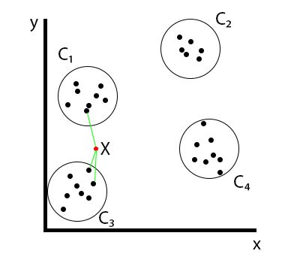
Figure 2-3 KNN classification

There are several variants of the standard K-NN classification algorithm, which use different distance metrics such as Euclidean, Manhattan, and Minkowski distance [52].

Euclidean Distance
A popular distance metric for a K-NN classification algorithm is the Euclidean distance, or as it is known, the straight line or “as the crow flies” [53], [54], [55, p. 72].
The Euclidean distance is determined as the square root of the difference between each data point (2).

$$d\left(A,B\right)= \sqrt{\sum_{i=1}^{n}{{(x_{i}- y_{i})}^{2}}}$$ (2)

This is applied to an example as shown in Figure 2-4, visualising the equation and how it works.

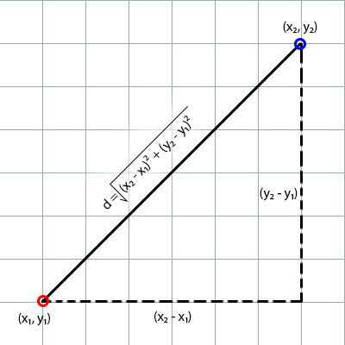
Figure 2-4 Euclidean distance

Manhattan Distance
The Manhattan distance, or city block distance, is named due to the distance being calculated in “blocks”, similar to two points in a city (‘x’ blocks down, ‘y’ blocks over) [55, p. 72], is determined as the sum of the absolute differences between two data points, and it also the distance between objects measured along axes at right angles [56] (3).

$$d\left(A,B\right)= \sum_{i=1}^{n}{|x_{i}- y_{i}|}$$ (3)

The Manhattan distance is shown in Figure 2-5, highlighting the method. Either of the red or green lines can be used for example, they will provide the same result.

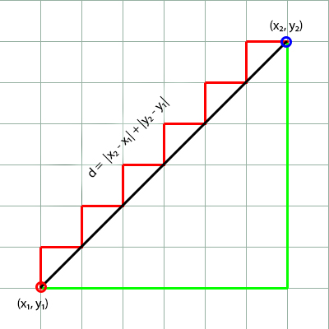
Figure 2-5 Manhattan distance

The Manhattan distance is able to achieve similar scores to the Euclidean distance whilst also being less susceptible to outliers [57], [58]; a comparison between the two may well provide interesting results for analysis.

Minkowski Distance
The Minkowski distance is considered a generalisation of both the Euclidean and Manhattan distances [55, p. 73] (4).

$$d\left(A,B\right)= {\left(\sum_{i=1}^{n}{{\left(|x_{i}- y_{i}|\right)}^{p}}\right)}^{\frac{1}{p}}$$ (4)

In some instances the Minkowski distance is able to outperform other metrics such as Euclidean and Manhattan distances [59], so again this could fare well in this project.

SVM
One classifier that can outperform naïve Bayes in certain scenarios of sentiment analysis is a support vector machine (SVM). SVM is more than capable of performing several tasks such as linear or nonlinear classifications, regression and even outlier detection [20, p. 153]. Due to the versatility of an SVM, it is a powerful algorithm that can execute text classification with ease and is a very popular model in machine learning [24], [48].
The primary goal of a SVM is to find a dividing line, or hyperplane, between classes in a dataset. Sometimes it can be difficult to find where to place the optimal hyperplane at first glance (Figure 2-6).

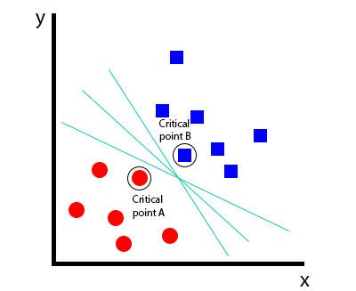
Figure 2-6 Hyperplane position

An SVM utilises data points that are nearest to the hyperplane as support vectors (Figure 2-7), which are the critical points in the dataset - if these were removed then the hyperplane position would be adjusted.

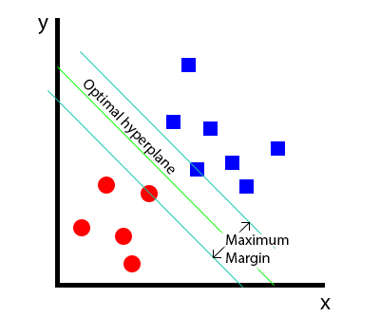
Figure 2-7 SVM optimal hyperplane

SVMs are also able to excel at representing data in higher dimensions if it is difficult to distinguish data on a 2d plane [48], however this project is only dealing with binary classification as the Sentiment140 dataset training data has only positive and negative polarity values included – no neutral, else it would be trinary classification.

Decision Tree
Decision tree is an algorithm that can again be applied to both regression and classification tasks.
A decision tree follows a flowchart-like style; a top-down approach which has a binary outcome by breaking the input dataset, known as the root, into increasingly smaller subsets of data, known as child codes.
At each child node a question is asked, and decision made, based on a specific feature. Upon examination of the feature and the decision that is made, further child nodes can be produced if required. Otherwise, a decision has been made on the categorisation [19, p. 16], [26, p. 9], [51, p. 144], [60] as shown in Figure 2-8 with the blue nodes being child nodes, and the red nodes the category decision.

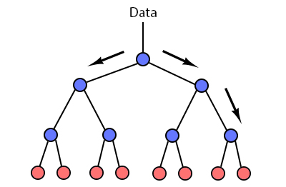
Figure 2-8 Decision tree

Decision trees are also the fundamental components that make up the random forest algorithm [20, p. 175].

Random Forest
The random forest algorithm is part of the “ensemble learning” family (a group of predictors [20, p. 189]) and involves the formation of a large number of decision trees which utilise feature randomness for each tree in attempt for them all to remain uncorrelated. The individual outputs are then convened into a final result which is decided by a majority vote system [19, p. 16], [25, pp. 697–698], [61]. This is highlighted in Figure 2-9 with several instances of decision trees, all with their own decision. The majority vote just takes a count of the class votes, and the final class decision is decided.

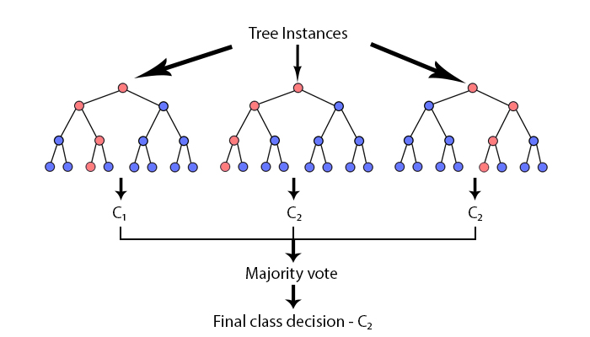
Figure 2-9 Random forest

Random forest classifiers have a major advantage with computational efficiency over other classifiers, and they also do not suffer from overfitting [62]. This allows many trees to be set as a parameter and created for use within this algorithm.

Logistic Regression
Logistic regression, despite its name, is an algorithm which can be applied to classification tasks, as it can model the probability of an input variable belonging to a specific class [20, p. 8], [26, pp. 6–9]. It is a variation of the linear regression model which uses the sigmoid function, and as shown in Figure 2-10 the sigmoid function plots a data point between 0 and 1 [63, p. 183], [64].
Figure 2-10 shows that an x value of -2 to below 0 (0 – 0.5) would return a class value of 0, and an x value of 0 to 2 (0.51 – 1.0) would return a class value of 1.
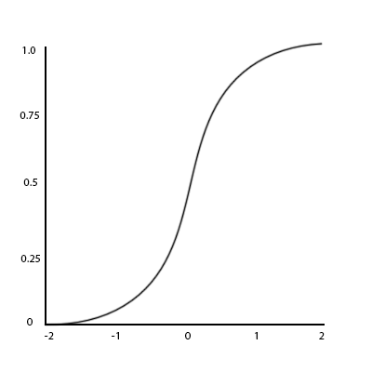
Figure 2-10 Sigmoid function

Evaluation Measures
The evaluation of a classification model can potentially be significantly more difficult than evaluating a regression model [20, p. 88]. Thankfully, there are many evaluation measures available to produce metrics and reports to assess the effectiveness of the classification algorithms.
Upon completion of the sentiment analysis program, these performance measures will be employed for each algorithm used.

Classification Accuracy
Classification accuracy is one of the measures used to evaluate the efficiency of a model. There are four possible outcomes that could occur with a prediction [20, pp. 90–97], [65, p. 264]:
- True positive (TP) – The ratio of positive observations correctly classified as positive,
- True negative (TN) – The ratio of negative observations correctly classified as negative,
- False positive (FP) – The ratio of negative observations that are incorrectly identified as positive,
- False negative (FN) – The ratio of positive observations that are incorrectly identified as negative.

Classification accuracy is defined as the ratio of the number of correct predictions in comparison to the total number of predictions made [20, p. 89], [51, p. 103] (5).

$Accuracy= \frac{TP+TN}{TP+FP+FN+TN}$
(5)

Confusion Matrix
A confusion matrix (or error matrix) can be a better way to perform evaluation of a classification algorithm [20, p. 90], [65, p. 264]. It is a two dimensional table of the previously mentioned outcomes (TP, TN, FP, FN), calculating and allowing the visualisation of the result of the classification, or misclassification, of each class [25, p. 710], [66], as shown in an example 2x2 confusion matrix (Figure 2-11).
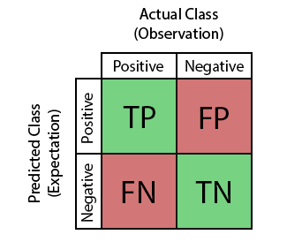
Figure 2-11 Confusion matrix

The confusion matrix is also used to calculate two other important performance metrics which are precision and recall [26, p. 15].

Precision
Precision is defined as the ratio of correct positive predictions to the number of positive predictions. This includes false positives along with true positives (6) [65, p. 265], [67].

$$Precision= \frac{TP}{TP+FP}$$
(6)

The fewer false positives that a model produces, the higher the precision, so the more relevant the results will be.

Recall
Recall is effectively the opposite of precision as it is defined as the ratio of correct positive predictions to the number of positive cases (7) [65, pp. 265–266], [67].

$$Recall=\frac{TP}{TP+FN}$$
(7)

Higher recall values refer to the percentage of the total relevant results which have been correctly identified by the classification algorithm.

F-Score
The F-score (also known as F₁ score, or F measure) is a calculation of the harmonic mean of both the precision and the recall values (8), only allowing a high F score if both the recall and precision values are high [20, p. 92], [35, p. 240], [68].

$$F_{1}=2×\frac{Precision×Recall}{Precision+Recall}$$
(8)

Receiver Operating Characteristic
The Receiver Operating Characteristic (ROC) curve plots the false positives versus true positives and produces a chart to visualise the trade-off between the two [20, p. 97], [25, p. 710] as shown in Figure 2-12.

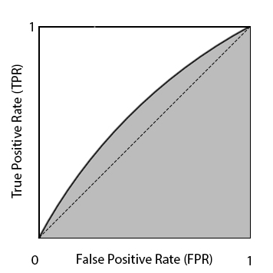
Figure 2-12 ROC curve

A ROC curve can only be used as a means of assessment in classifiers which return a probability of prediction [26, p. 18].

Area Under the ROC Curve
To acquire a score which determines the effectiveness of the given ROC curve, a calculation called Area Under the ROC Curve (ROC AUC) can be used [25, p. 710]. Taking the previous example (Figure 2-12), rather than just the visual representation, the ROC AUC can be used to simply apply a value to improve ease in determining performance between algorithms (Figure 2-13).
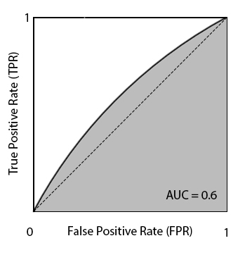
Figure 2-13 ROC AUC

The higher the curve, the higher the value of the AUC (Figure 2-14).
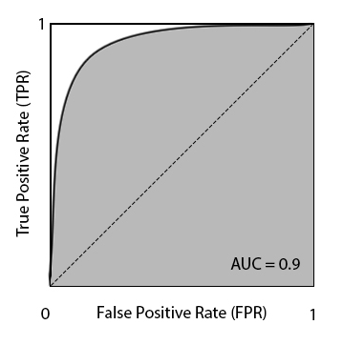
Figure 2-14 ROC AUC (2)

Model Fitting
Though not a metric, the fitting, or generalisability of a model is always a potential problem in machine learning. It is imperative that the model must neither overfit nor underfit, regardless of the previously mentioned performance indicators.

Overfitting
Overfitting is where the model can perform well on the training data, but it is not generalisable and is unable to be applied to another unseen data source for testing in a reliable manner [20, p. 27].
Overfitting could stem from model complexity. If the model is too convoluted, or if is too vast a number of features, this could increase the variance and cause an overfitting problem [26, p. 11].
A visualisation as shown in Figure 2-15 is an example of overfitting, and questions could be raised over how reliable it would be at classifying data based on the erratic image.

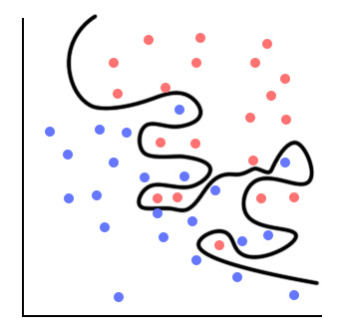
Figure 2-15 Overfitting

Two methods to help increase the generalisability and reduce overfitting are to use a lower amount of attributes (if possible), and to increase the size of the training data [25, p. 663].

Underfitting
Underfitting is where a model is unable to find a pattern in the data [20, p. 29], [25, p. 655]. It could be that the model is very simple, or that the features contained within the data do not provide enough information for the model to learn.
A representation of a model failing to learn as shown in Figure 2-16 is an example of underfitting. Little effort has been put into learning the classification of the two different classes, and the model would likely be unable to reliably predict the class of a new data point.

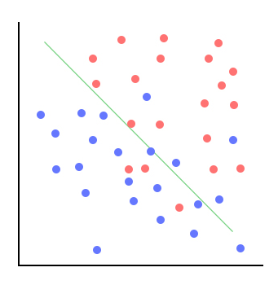
Figure 2-16 Underfitting

To counter underfitting it may be a case of either developing a more complex model, or to utilise features which provide more information to enable the model to perform correctly s[26, p. 9].

Datasets
There exist several datasets which can potentially be suitable for this project. The most suitable two have been chosen for comparison and investigation.

Sentiment140
The Sentiment140 dataset was created during a research project by a team at Stanford university [2]. The dataset contains 1.6 million tweets which were gathered by using a keyword search with the Twitter API. With the researchers approach, it was assumed that any tweets with emoticons that may express happiness (“:)”) are positive, and those that may express disappointment or sadness (“:(“) are negative. The dataset contains six fields as shown in Table 2.

Field | Description
0 | Tweet polarity (0 – negative, 2 – neutral, 4 – positive)
1 | Tweet ID
2 | Tweet date time
3 | Query
4 | User
5 | Tweet content
Table 2 Sentiment140 field description

As one of the fields (0) is polarity, this dataset has already been annotated by the research team to provide the sentiment polarity of the given tweet, which can make this a very good dataset for performing sentiment analysis due to there already being polarity values to test against.

SemEval
SemEval [69] is an annual series of NLP research seminars which focus purely on making advancements within the field of semantic (Sem) analysis and evaluation (Eval). Each year, different areas of study are completed which have previously covered topics such as sentiment analysis, temporal annotation, word sense disambiguation, lexical simplification, and various other fields of interest.
The most recent SemEval workshops which have specifically covered sentiment analysis have been SemEval 2016 [70] and SemEval 2017 [71].
The datasets for each year are attained (as per official SemEval instructions) by running a script [72], passing a text file containing the list of tweet ID’s as a parameter, this then retrieves the tweets for processing.

Sentiment Analysis of Twitter Data
The integration of all prior sections leads neatly to sentiment analysis of Twitter data. A maximum character limit of 280 (previously 140) means that each tweet holds as much information as possible in as little space as required, which should help with sentiment analysis. There are dozens of studies completed on each dataset, the most recent and relevant of which will be briefly highlighted.

Sentiment140 Studies
The Sentiment140 dataset and research project [2] successfully introduced sentiment analysis to microblogging services, such as Twitter, and the application of certain machine learning algorithms (naïve Bayes, maximum entropy and support vector machines) coupled with various features (unigrams, bigrams, PoS tagging) was able to achieve a polarity classification accuracy of over 80%, when trained with the given Sentiment140 training dataset. The size of the training dataset along with the accuracies achieved in the research paper across various classification algorithms will be a good baseline for this project. A research project carried out by AbdulSattar et al. [73] utilised the Sentiment140 dataset with the end goal of performing sentiment analysis via various machine learning classifiers. Rather than developing their own neural network, the team were able to use WEKA to apply various machine learning algorithms to the dataset. The results achieved through the numerous algorithms were up to 78.1% accuracy (and the lowest of 64.65%) of tweets having their polarity classified correctly. The highest scoring classifier was the random forest classifier, followed by SVM, decision table, instance based-k, and adaptive boosting.
Dhahi and Waleed [74] successfully implements a combination of user behaviour, semantic, and lexical features for their sentiment analysis research and improve on polarity classification accuracy. Through the pre-processing stage of this project, features which are previously considered “noise” in other research (user mentions, URL’s, emoticons, hashtags, etc..) and removed are instead used as features to increase the classification accuracy. This research is carried out again using SVM, and naïve Bayes classifiers, and surprisingly this approach produced an up to 94% accuracy with the naïve Bayes classifier and 93% accuracy with the SVM classifier.

SemEval Studies
SemEval 2016 (task 4, subtask A) [75] covered sentiment analysis with Twitter data which the SemEval team had acquired via a Twitter-tuned named entity recognition system. The SemEval tasks include a two-point, three-point and five-point classification and quantification goal. The two-point classifies between positive and negative [76], the three-point follows on and includes neutral [77], then the five-point classification goal [78] includes strongly and weakly negative and positive levels. Each of the participating teams were able to outperform the given baseline scores, and out of the top ten performing teams, five used neural networks to a high degree. The end scores had a top accuracy of 64.6%, and when applied to earlier datasets (<2016), they also outperformed the highest ranked team algorithm for that year.
SemEval 2017 [79] follows on from the previous years attempt at sentiment analysis with all subtasks being repeated. This time, the Twitter data also included Arabic tweets. Similarly, to the previous year, the highest scoring teams made use of neural networks and several teams utilising SVM classifiers. The evaluation method which was focussed on was average recall, with the highest two teams achieving 68.1% average recall and an accuracy of 65.1% and 65.8% respectively [80], [81].

Other Studies
There are several other sentiment analysis studies which utilise Twitter as a data source. One paper produced by Wongkar and Angdresey [82] investigated the application of three algorithms (naïve Bayes, KNN and SVM) to a dataset they were able to create using a Twitter web crawler which surrounded the public satisfaction toward the performance of the presidential candidates of the Republic of Indonesia in 2019. The NB, KNN and SVM classifiers scored 80.9%, 75.78% and 63.99% respectively with their dataset.
One final study by Huq, Ali and Rahman [83] applied and compared a KNN and SVM model with varying features and parameters. Each model had a varying number of “Word”, “N-Gram”, “Pattern”, “Punctuation”, and “Key-based” features. From the results given it seems as though with an increase in features used, there is an increase in most performance metrics; accuracy, precision, recall and F score. The KNN algorithm outperforms the SVM algorithm at every stage with an equal number of features used.

Conclusion
Most of the research papers mentioned within the previous sentiment analysis of twitter data section have successfully applied several algorithms and it is easy to see which are the most effective at classifying sentiment polarity through their studies, namely naïve Bayes and SVM classifiers or neural networks.
Much of the research has been surrounding machine learning techniques and utilising a learning-based approach to the task of sentiment analysis, rather than a knowledge-based approach using lexical resources.
There is a large amount of information provided on how best to apply these techniques to both given datasets, along with references to documents that have already carried out their own investigations. These papers can provide a guideline as to the required evaluation performance, and it will be interesting to see how they compare.
Upon completion of the background research, it has been decided to use the Sentiment140 dataset, and develop a program that utilises a machine learning approach to classify the sentiment of tweets into either positive or negative. This will then be followed by finally performing a comparative analysis of each algorithm applied, to determine which is the most effective for performing sentiment analysis on the Sentiment140 datasett.

Methodology
This section will highlight and discuss both of the research and development methodologies required for this project to be a success.

Research Methodology
The research methodology will outline the techniques that are used which include the philosophy, the strategy, and the three types of approaches decided upon for this project.

Philosophy
The philosophy chosen for this project is a positivist philosophy. As one of the tasks is to create and test a piece of software whilst using already existing principles and theories of software engineering, it is believed that this is the most suitable for this project. It is also well suited for the type of strategy to implement.

Strategy
The strategy is a deductive strategy. The reason for this is that there are experiments carried out, which ensures the end product is of acceptable quality. Upon the completion of the software development, data is cultivated from the individual algorithms for evaluation and review.

Approaches
There have been three approaches chosen to follow for this project. The approaches are a literature review, software development, and experiment. This will be explained in the subsequent section.

Literature Review
The first approach surrounds confirming that there exists a relevant level of knowledge to achieve process success. This is completed by reviewing relevant literature such as books, journal articles and conference proceedings, all on the given subject matter. Potential issues were highlighted during the proposal phase of this project, so evidently this is an important step.
Throughout a project, it is important to keep up to date with upcoming and important information surrounding the project area, so after the initial literature review, it was an ongoing process to keep well-informed about (and broaden) the knowledge gained in the project area.

Software Development
The second approach is software development which is necessary to develop the software to be used to perform the sentiment analysis assignment.

Experiment
Once the software development is at completion, the algorithm effectiveness is benchmarked and assessed against the Sentiment140 test dataset.
Each algorithm has accompanying evaluation metrics which are used to provide a comparison between each one.

Data Evaluation Methods
This section will outline the methods used to collect any data required throughout this project, the type of data, and how the data is evaluated.

Data Collection
The initial data collection is the Sentiment140 dataset as this is publicly available – just a simple download on one of the various repositories. The one used for this project is from Kaggle [84].
Upon completion of the software, each algorithm that is developed produces the various evaluation metrics (accuracy, confusion matrix, precision, re-call, F-score, and ROC curve). These are gathered to carry out the formal comparison of the different algorithms.

Data Evaluation
The data gathered is evaluated by using the evaluation metrics (highlighted prior) to determine the most effective algorithm at sentiment classification for the Sentiment140 dataset. It should be the case that the higher the accuracy, the better the algorithm. However as mentioned within the literature review there are other metrics at hand that can negate that theory such as model fitting issues.

Ethics
During the initial investigation and proposal of the project, an ethical issue was identified due to the original plan involving developing a web crawler to collect tweets. This would have been a grey area and against the Twitter acceptable usage policy and terms and conditions. Instead, a pre-existing dataset will be used.
Most personally identifying information in the dataset has already been removed by the Stanford university team. The username is still present within the dataset along with a tweet ID, so these will be deleted. There is nothing else to link a tweet to a person.

Risks
The main risk for this project is the capability of the hardware used. The machine used has, historically, struggled with machine learning tasks as it is not of high specification. However, a workaround has been used previously with great success in a classification project; the Google Colab platform [85]. As this project is larger than the previous work, there are alternatives to Google Colab which will be outlined in the resources section.
The second risk is possibly the failure to develop the proposed software. This should not come to be an issue as there is already a history with software development due to acquiring an undergraduate degree in software engineering. Though there is not a plethora of experience with the language to be used, previously through this course other languages (R) have been taken to with relative ease.

Validity, Reliability & Generalisability
The validity of this project can be asserted due to the use of a dataset containing real-world data. This data has not been generated by the dataset producers, nor is it artificial.
The reliability of this project can be ascertained by utilising a consistent approach outlined within this report, and to ensure that the theory behind the practical element is understood and appropriately applied. If the project is to be repeated, it must be confirmed that the same algorithms are applied to the same dataset. If this is mirrored, the project will be reliable.
As the project progresses and the model is developed from the software, the model will be able to be applied to further tweet data and extended to other datasets. This makes the project generalisable.

Development Methodology
The development methodology will now outline the two methodologies to be used. This is a mixed methodology project as there is an equal amount of data mining as there is software development; both will be explained here.

Data Mining Methodology
As this project must first involve data mining, an appropriate data mining methodology must be executed to ensure the data is in a practical state for processing with the software. The Cross-Industry Standard Process for Data Mining (CRISP-DM) methodology is used to work towards understanding the data via data exploration, preparing the data for, and performing, data pre-processing, and the evaluation of the data from the dataset.

Software Development Methodology
Upon completion of the data mining processes, the software development began. Though there is no specific development methodology for machine learning projects, it was decided that a Feature Driven Development (FDD) methodology will be employed.
FDD fits well with single person projects and allows continuous and frequent software releases with the completion of different features.

Resources
Outlined here will be the main hardware and software resources required to complete this project.

Hardware Resources
It should be a case of only one piece of hardware being used; a computer. As explained in the risks section, there may be some issues with the device limitations, however the computer is still needed to complete the code and perform the evaluation.
A machine with at least 16GB RAM and a powerful CPU with multiple cores and a fast clock rate, such as one of the newer generations from the Intel Core i9 family [86].

Software Resources
Due to its suitability for machine learning tasks, the software is to be developed using the Python programming language [87]. For this, Jupyter Notebook [88] from within the Anaconda program [89] is to be used.
Several Python libraries are to be used in the production of the software:
- spaCy [90],
- NumPy [91],
- pandas [92],
- Matplotlib [93],
- Natural language toolkit (NLTK) [94],
- seaborn [95],
- wordcloud [96],
- tweet-preprocessor [97],
- scikit-learn (sklearn) [98].

Tableau [99] will be used for graphing and visualisation of results.
If there are problems with the current hardware, then Microsoft Azure Machine Learning Studio [100] will be used to complete the project. There are some limitations with this service in that it is credit based, and there are limits to the hardware available on a compute instance for a student subscription, with a maximum of four cores and 14GB RAM [101].

Conclusion
With the research and development methodologies outlined, the practical part of the project will now begin with the implementation and development of the various machine learning classifiers in the next section.

Implementation
As described in the prior methodology section, a CRISP-DM methodology must first be applied to the dataset to understand, prepare, model, and evaluate the data.
The discussion and justification of the dataset chosen, the initial exploration and visualisation of the dataset, the required and relevant pre-processing performed on the data will be outlined in order.
Upon completion of the steps required in the CRISP-DM methodology, a feature driven development methodology will then be employed for the development of the required software for this project. Each algorithm will be developed, trained, and tested, to ensure the model is accurate and generalisable.
Once all the algorithms are developed, trained, and models available, the evaluation will commence.

Dataset
The dataset selected for the project is the Sentiment140 dataset from the Stanford university. The SemEval data could well be a useful dataset, however, due to it not being readily available in a repository like the Sentiment140 dataset, there is the chance that some of the data could be edited or missing as the script to retrieve the tweets would need to be executed now to compile the list of tweets selected by the SemEval team.
Upon the initial data investigation period, it is found that there are no tweets which are scored with a neutral polarity – only positive or negative. As per the Stanford paper, the research performed does not consider any neutral tweets in neither the training data file nor test data file. The reason for this was given as many tweets do not have a form of sentiment and are seen as objective, rather than subjective [2]. Due to the need to classify sentiment, the data to be investigated is required to be subjective in that it must be influenced by personal feelings or opinion.

Business Understanding
As outlined in both the literature review and the introduction, the problem definition for this project is that there is a requirement for businesses and organisations to acquire tools which can perform sentiment analysis to evaluate end user opinion and provide insight into the opinion and reception of newly released products and services, or the companies themselves. The results of sentiment analysis can highlight to a company where any improvement can be made, and they would then be able to allocate resource to developing this area, or the result can provide emphasis to what a company is doing right and to continue as they are. From this, business questions can be raised such as:
- Can machine learning be used to perform sentiment analysis on Twitter data?
- How successful could this model be in terms of prediction accuracy?

To repeat from the beginning of this report, the project objectives are as follows:
- Perform data exploration and analysis of a dataset,
- Perform data cleaning on a dataset,
- Develop a software which can perform sentiment analysis on a dataset,
- Train the developed software with the dataset,
- Test the developed software to ensure it is fit for purpose,
- Analyse the produced data from the software and produce an evaluation on the results, determining which classification algorithm is best suited for sentiment analysis of the given dataset,
- Answer any business questions that are to be determined through the CRISP-DM process.

Data Exploration
On completion of the business understanding, the next step in the CRISP-DM process is to understand the data. Data exploration has been carried out to first understand the dataset and provide visualisation of the data which can also lead to potentially interesting areas of investigation.

Value counts
The dataset is already known to contain 1.6 million records from the dataset description and the shape of the data frame, but the balance of the two classifications is not yet known. By using the value counts, it is possible to see the value count for the specified attribute - polarity.
As seen in Figure 4-1, there is a count of 800,000 records for both positive (4) and negative (0) classes, therefore it is reasonable to say this dataset is currently perfectly balanced.

Figure 4-1 Positive and negative value counts

Missing Values
Missing values can originate from various sources and can cause problems with most machine learning algorithms [20, p. 63]. Missing values are typically dealt with by data imputation techniques [26, p. 6].
The main concern would be the polarity or content missing values, however with this dataset there are no N/A or NULL values as highlighted in Figure 4-2 and Figure 4-3.

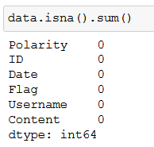
Figure 4-2 Sum of NA values

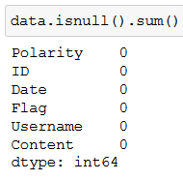
Figure 4-3 Sum of NULL values

As missing values are not a problem with this dataset, there is no need to perform any pre-processing specifically for N/A or NULL values and the next data exploration step can be performed.

Duplicate Values
As duplicate values can potentially skew the outcome of a model, it is important to investigate if there are any within the given dataset.
From Figure 4-4, it is shown that there are several thousand duplicate tweets in the dataset.

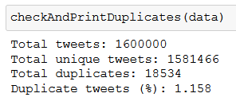
Figure 4-4 Duplicate tweets

Out of the total 1.6 million tweets, 1,581,466 are unique and 18,534 are duplicates (approximately 1.158%). These are to be dealt with in the pre-processing stage.

Tweet Word Count
Before and pre-processing is carried out, some visualisation was performed on the tweets. The tweets were split into negative and positive, to help with visualisation, and upon checking the word count of the tweets almost all the tweets a word count of less than 30, with most tweets being ten or less words (Figures 4-5 and 4-6).

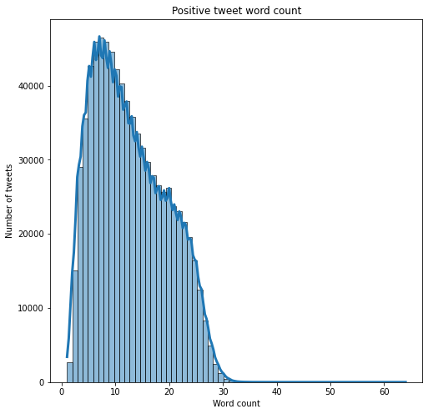
Figure 4-5 Positive tweet word count

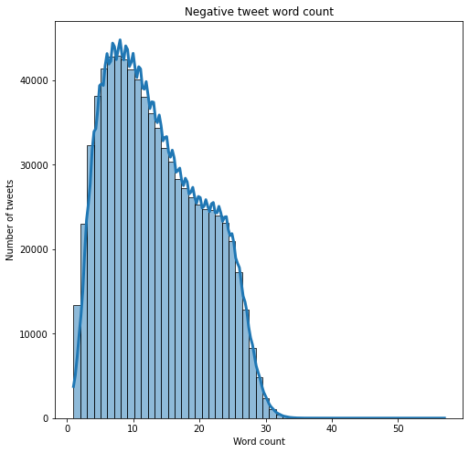
Figure 4-6 Negative tweet word count

The figures show a possibility of another subset of data, due to the double hump in the graph. This can be further investigated after completion of the main project requirements.

Word Cloud
A word cloud can visualise common words within a series of text. The larger the word, the more frequent it occurs. As can be seen in Figure 4-7, some of the largest words are ‘love’, ‘lol, and ‘thank’.

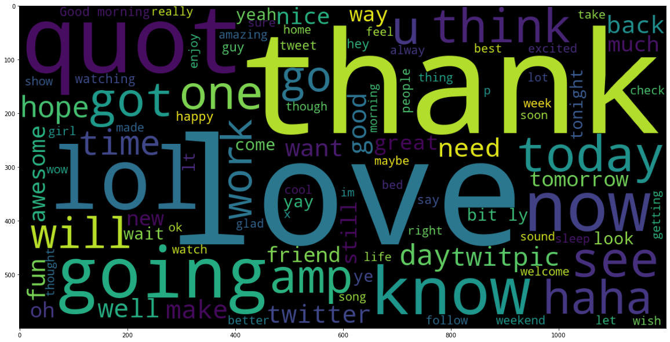
Figure 4-7 Positive tweet word cloud

Figure 4-8 highlights the common words associated with the negative sentiment tweets.

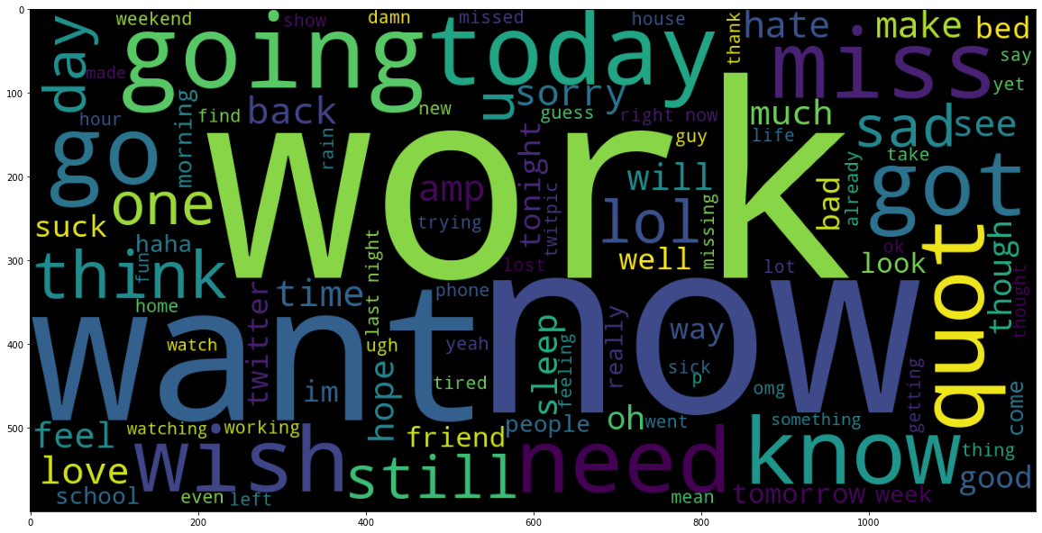
Figure 4-8 Negative tweet word cloud

The visualisation of the word clouds has also highlighted the need to deal with special characters (quot, amp) during the pre-processing stage.

Pre-Processing
As part of the data preparation stage of the CRISP-DM methodology, and typically one of the largest parts of a data science project, the pre-processing stage concerns itself with ensuring the data is in a state in which the machine learning can be completed by processing the data correctly.

Dataset Structure
One of the first parts of the data cleaning for this project is the structure of the data – processing dataset attributes that are not required.

Duplicate Handling
As highlighted in the duplicate values section, just under 1.6% of tweets are duplicates – a total of 18,534.
Due to the nature of the data to be used (tweet content – opinions), it would be extremely difficult to impute any records to prevent data loss. As this is a relatively small amount, the choice has been made to remove these tweets from the dataset.
On execution of the function to drop any duplicates, there remain 1,581,466 tweets (Figure 4-9).

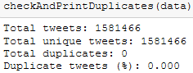
Figure 4-9 Duplicate tweet removal

Column Handling
The only two relevant columns for this project are the tweet content and the sentiment classification. All other columns have been dropped as they are either deemed unnecessary, or they contain potentially identifying information (username). The remaining dataset is shown in Figure 4-10.

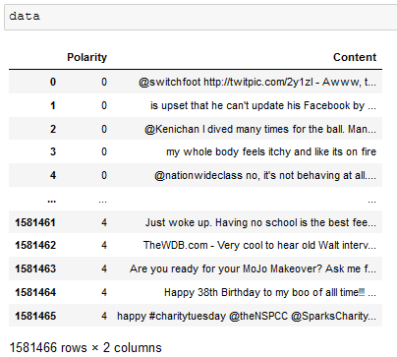
Figure 4-10 Unnecessary column removal

The dataset is now in a state where there are no more duplicate records, and column selection has been completed to proceed and carry on with ensuring the data itself is in a condition to allow the classification algorithms to work with it.

Data Cleaning
The data cleaning will involve various methods to remove unwanted elements in the tweet content, such as a URL, a hashtag, a user mention, and special characters.

Lower Case Conversion
The conversion of upper case to lower case letters can help with improving accuracy scores by ensuring the input is uniform [102]. This has been performed by simply calling a string conversion function within python to fulfil this task (Figure 4-11).
This was completed as the first cleaning task as other tasks such as expanding acronyms will be faster.

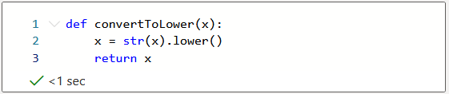
Figure 4-11 Lowercase function

The “.lower(string)” function is simple enough to not require a function, however this was added just to show example conversion (Figure 4-12).

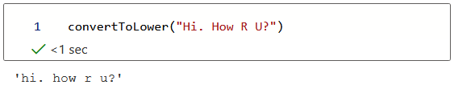
Figure 4-12 Lowercase conversion

Abbreviation and Acronym Expansion
As every tweet is also lower case from the previous data cleaning step, there is no need to check for upper case abbreviations.
To ensure the input is consistent across every tweet, any abbreviations or acronyms in the tweet content have been expanded. The list is a simple .json file containing the abbreviation, and the correlated expansion (Figure 4-13).

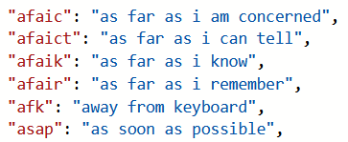
Figure 4-13 Abbreviation .json file samples

The code (Figure 4-14) loads in the json file and saves it as “abbreviationList”. The function to expand the abbreviations searches through the list, and if the value is found it is replaced.

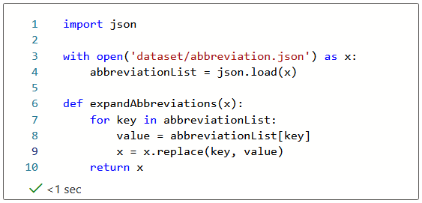
Figure 4-14 Abbreviation expansion function

As previously mentioned, the lowercase conversion was completed first to help reduce the time to run these functions. Figure 4-15 fails to expand an uppercase abbreviation.

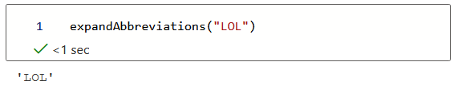
Figure 4-15 Abbreviation expansion example

However, as shown in Figure 4-16 the function successfully expands “lol” into “laughing out loud”.

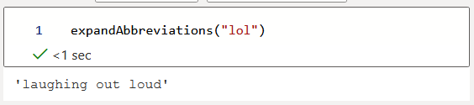
Figure 4-16 Abbreviation expansion example (2)

Emoji Conversion
As an emoji can be used to show emotion, rather than removing these entirely it was decided to replace them with a word which relates to their emotion. For example, the “:)” emoji can be substituted with happy, “:(” can be replaced with sad.
This process is completed in a simple way, the same as the above abbreviation expansion (Figures 4-17 and 4-8).

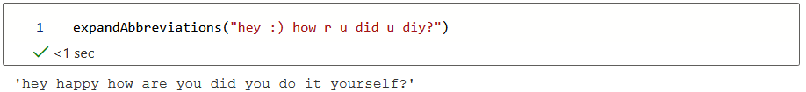
Figure 4-17 Emoji conversion

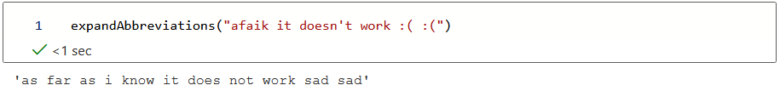
Figure 4-18 Emoji conversion (2)

URLs, Hashtags, and User Mentions
A URL, hashtag, and a user mention, though can be tokenised, provides no meaningful input to a tweet in terms of sentiment analysis as the algorithms only process the text content of the tweet. It is more productive to remove these, so only relevant content is analysed by the classifiers.
By using the tweet-preprocessor library [97] and specifying to remove URL, user mentions, hashtags, and reserved words, it is simple to call the “.clean(string)” function which can successfully process the removal the chosen parameters (Figure 4-19).

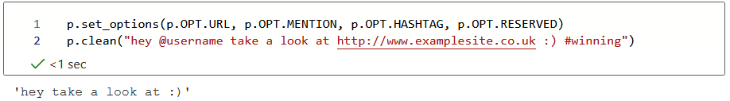
Figure 4-19 Pre-processor cleaning example

Punctuation Removal
The removal of any apostrophes within words will have been taken care of by the abbreviation expansion function, however, there remain other punctuation characters such as question marks and exclamation marks.
A function was written that performs a translation on any punctuation within a string, and just removes it (Figure 4-20).

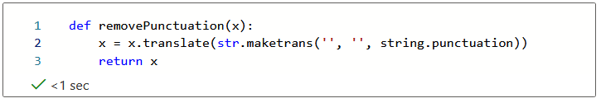
Figure 4-20 Remove punctuation function

As shown in Figure 4-21, the three punctuation characters are successfully removed from the given sentence.

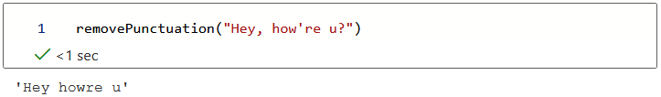
Figure 4-21 Remove punctuation example

The expansion of “how’re” to “how are” would have been taken care of by a previous step – it is just included here to show the punctuation removal.

Stop Word Removal
The stop words are set using the stopwords library from NLTK [94]. The English stopwords (Figure 4-22) are used for this project and comprise of 179 words which add no meaningful value to a tweet in terms of NLP.

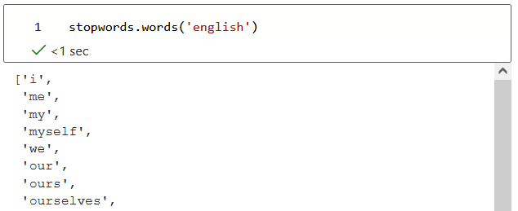
Figure 4-22 Stopword samples

Figure 4-23 shows the code for this function. The stopwordList is set using the specified corpus. If a word is not in the stopwordList, it is appended to the sentence and returned.

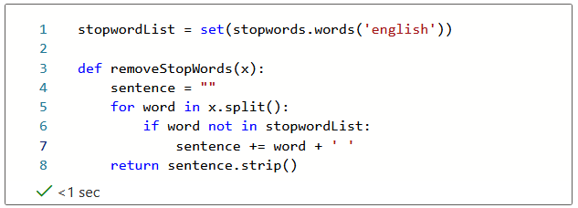
Figure 4-23 Stopword removal function

Figure 4-24 shows the stopword removal function working and successfully removing four stopwords.

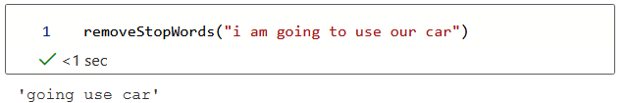
Figure 4-24 Stopword removal example

Lemmatisation
The spaCy library [90] is used to perform lemmatisation tasks. Figure 4-25 shows the definition of the lemmatiser using the ‘en_core_web_sm’ package. spaCy works by tokenising the sentence, then lemmatising any words which appear in its language data.

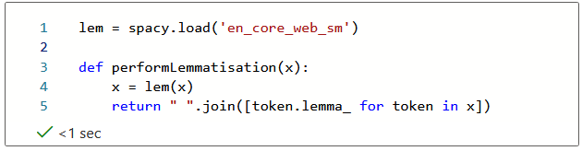
Figure 4-25 Lemmatisation function

Figure 4-26 shows this in an example, with the return value containing the lemmata.

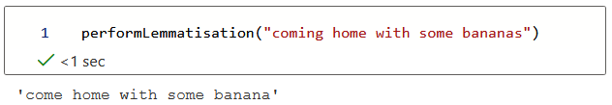
Figure 4-26 Lemmatisation example

Combined Data Cleaning
All previous steps are combined into one function (cleanTweet()) to carry out all required data cleaning at once for each tweet (Figure 4-27).

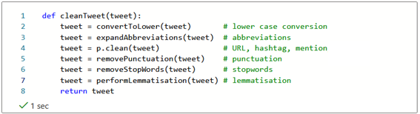
Figure 4-27 Combined data cleaning function

Figure 4-28 shows all data cleaning steps being completed on an example tweet and the resulting tweet returned for processing by the classifiers.

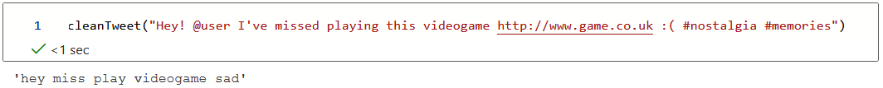
Figure 4-28 Combined data cleaning example

Label Encoding
The target labels are encoded using the SciKit Learn label encoder [103]. This step simply provides a target label with a value between 0 and n_classes-1. This is to distinguish the different classes during the upcoming classification task.

Classifier Training
When the data is in a state to perform machine learning tasks, the data fitting and optimisation of the machine learning algorithms begins. This section will highlight the hyperparameter tuning completed to improve the classifiers.
The hyperparameters used are not the only available ones for tuning; there are several additional parameters available (depending on the classifiers), however as this project is already computationally expensive with the number of records available and the way that GridSearchCV works, they have not all been included as some classifiers (such as SVM and random forest) have up to 17 different hyperparameters available for tuning.

GridSearchCV
To assist with hyperparameter tuning, GridSearchCV [104] has been used on each classifier. GridSearchCV can generate, and fit models from a grid of manually specified parameters.
GridSearchCV parameters take the classifier, the parameter grid, the integer value for the cross validation splitting strategy, and the score measure (accuracy, roc_auc, precision, f1, and so on) as shown in Figure 4-29.

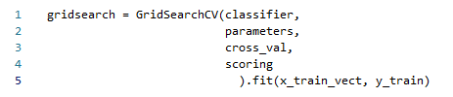
Figure 4-29 GridSearchCV parameters

Upon initialisation, GridSearchCV then can perform automatic evaluation on the spawned models and retain the best combination of parameters found. Due to the way GridSearchCV works, in that it produces and runs a model with every parameter combination specified, it can be extremely time consuming with already complex models such as SVM or KNN. Because of this, and the time complexity of several algorithms, the decision was made to reduce the number of hyperparameters from the original algorithm and the record numbers used was capped at 400,000 rather than the full 1,600,00.
Upon testing algorithms with only 50,000 records, the SVM classifier breached the 14-hour runtime mark to complete, and when attempted on the 400,000 records the classifier approached a full 48 hours of runtime with no hint of completion. It was deemed impractical to continue with this classifier due to increasing Azure costs, and time constraints, for the project. This classifier was not utilised on the 400,000 records, however, the results are still produced for the 50,000 record run and are shown in Appendix A.
To perform validation through this stage, the algorithm will perform StratifiedKFold cross validation (default for binary classification tasks) with a fold value of 3.
To reinforce the hyperparameter decisions made by GridSearchCV, various graphs have been produced for evaluation to ensure that the parameter choices are justified. Each model outputs results to a .csv file and these are plotted and visualised in Tableau.

Naïve Bayes
The multinomial naïve bayes classifier has two main hyperparameters which can be modified [105]:
- Alpha – also known as Laplace smoothing, assists in solving the zero-probability problem. Floating point parameter,
- Fit_prior – whether class prior probabilities are learned, or if a uniform prior is used. Boolean parameter.

The hyperparameter values passed into GridSearchCV are shown in figure 4-30 (nb_params), with various alpha values ranging from 0.00001 to 25, along with the fit_prior set as either ‘True’ or ‘False’.

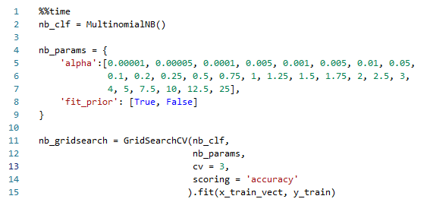
Figure 4-30 Naïve Bayes algorithm

Upon completion of the algorithm, the best score for the accuracy on the training dataset was 76.21%, and the best hyperparameters as highlighted in Figure 4-31 show that the ‘alpha’ parameter being set to 1.5 and the ‘fit prior’ parameter being set to false. The runtime for this classifier is also displayed as 39.6 seconds for it to finish fitting the training data.

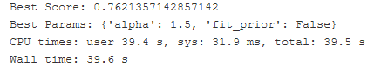
Figure 4-31 Naïve Bayes results

As this classifier only has two main parameters, the results are easily visualised (Figure 4-32), and the best score and parameter output from GridSearchCV are justified with the highest mean accuracy across all folds.

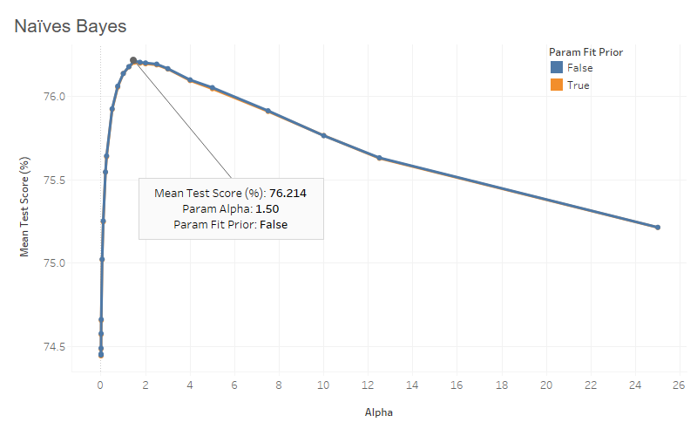
Figure 4-32 Naïve Bayes results

The “fit prior” parameter made little impact between the results as both lines in the graph overlap, however it is clear that there is a steep incline with the lower alpha parameter with a slow decline after the optimum alpha value is passed.

KNN
The KNN classifier has several hyperparameters which can be changed [106]. The two which were compared were the number of neighbours and the distance metric:
- N_neighbors – the number of neighbouring data points to use when classifying a specified data point. Integer parameter,
- Metric – the distance metric, with the choice of Minkowski, Manhattan, or Euclidean as discussed within section 2.6.2.1 through 2.6.2.3. String parameter.

The GridSearchCV arguments for the hyperparameters are shown in Figure 4-33 as “knn_params”.

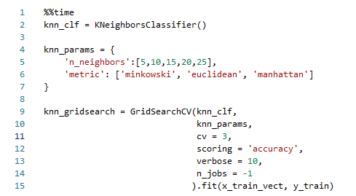
Figure 4-33 KNN algorithm

On algorithm completion, the highest accuracy score for the training dataset was 68.08% with the best parameters being the Manhattan metric, and the number of neighbours set to 20, as highlighted in Figure 4-34. It is also worth noting the run time for this algorithm (shown as the wall time) being 9 hours and 29 minutes to successfully fit the training data.

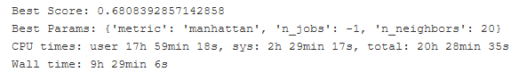
Figure 4-34 KNN best score and parameters

To confirm the results, the mean test score was plotted against the number of neighbours (Figure 4-35). The Minkowski and Euclidean distances provides very similar results and are overlapped. The Manhattan distance metric is the highest performing metric along with 20 neighbours, providing an accuracy score of 68.08%.

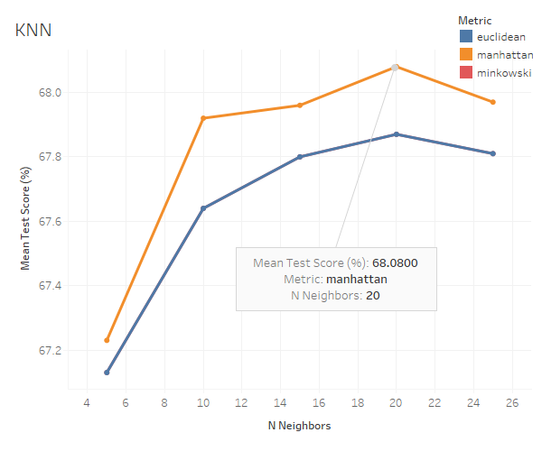
Figure 4-35 KNN results

Logistic Regression
Logistic regression [107] has a large number of hyperparameters which are available for modification. One of the main hyperparameters is the solver to be used in the algorithm. These solvers were compared:
- Solver – as per the documentation, the ‘sag’ and ‘saga’ solvers are faster for larger datasets. There are two further options of ‘newton-cg’ and ‘lbfgs’ which are also included in the pipeline for comparison.

The arguments provided to GridSearchCV are shown in Figure 4-36 and the logistic regression GridSearchCV object is then created.

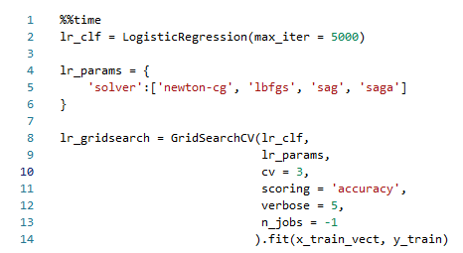
Figure 4-36 Logistic regression algorithm

When the algorithm completes, the best score was 76.85% and the best performing solver being ‘saga’, as shown in Figure 4-37. A runtime of 30 minutes for this classifier to complete the fitting of the training data.

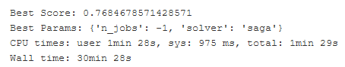
Figure 4-37 Logistic regression best score and parameters

Figure 4-38 highlights the fact that all the solvers perform almost equally, with the ‘saga’ solver outperforming the others by only 0.01%. This could be further investigated by additional hyperparameters being investigated, however the addition of any parameter, for example ‘penalty’ (which adds a specified penalty of either l1, l2 or none) would increase the compute time to such a level that the kernel was interrupted after breaching 24 hours – a considerable difference to only 30 minutes.

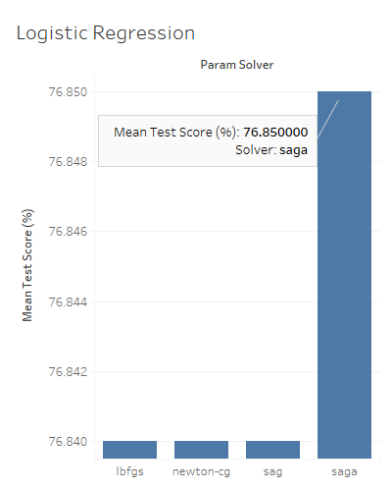
Figure 4-38 Logistic regression results

Decision Tree
Decision tree [108] has several hyperparameters which can be modified, namely the criterion, minimum samples per split, and minimum samples per leaf:
- Criterion – the function which can measure the quality of a split. The choices are either “gini”, for the Gini impurity, or entropy for the information gain,
- Min_samples_split – the minimum number of samples required to split a node,
- Min_samples_leaf – the minimum number of samples requires to be at a leaf node.

The algorithm is shown in Figure 4-39, with the above hyperparameters being tuned with different values.
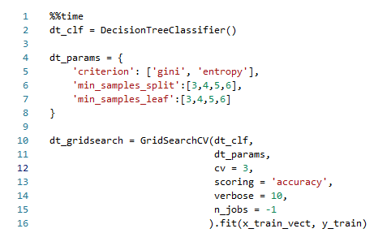
Figure 4-39 Decision tree algorithm

The decision tree results are shown in Figure 4-40, with a best score of 71.98%, and the best parameters being a ‘gini’ criterion, ‘minimum samples per leaf’ of 6, and ‘minimum samples per split’ at 5. The runtime for the fitting of the training data to this classifier was also 1 hour and 40 minutes.

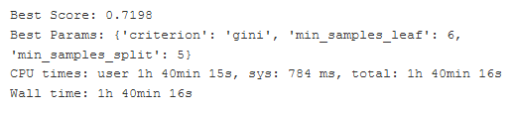
Figure 4-40 Decision tree best score and parameters

Figure 4-41 confirms that the ‘gini’ criterion outperforms the ‘entropy’ criterion, but again only by a relatively small amount when testing with the same leaf and split values.
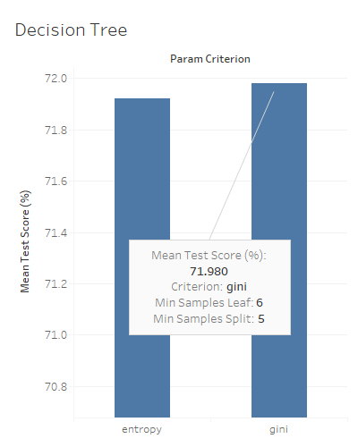
Figure 4-41 Decision tree results

Random Forest
Random forest [109], as an extension to the decision tree classifier, has similar hyperparameter options available for tuning. The main ones selected for comparison are the number of estimators, criterion, minimum samples per split, and again the minimum samples per leaf. Three of the hyperparameters are described above in the decision trees section, the only difference being the number of estimators, which is simply the number of decision trees in the forest.
The same values from the decision tree classifier were used, with the addition of the number of estimators (‘n_estimators’) having various integer values set for comparison (Figure 4-42).

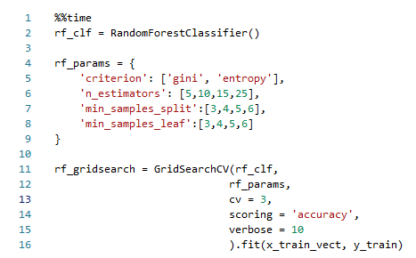
Figure 4-42 Random forest algorithm

The random forest has produced a best score of 74.88%, with the ‘gini’ criterion as the better criterion, ‘minimum samples per leaf’ of 3, ‘minimum samples per split’ of 6, and ‘number of estimators’ of 25 as shown in Figure 4-43. The fitting of the training data for this classifier is also 4 hours and 33 minutes.

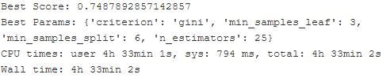
Figure 4-43 Random forest best score and parameters

Figure 4-44 displays the comparison between the ‘entropy’ and ‘gini’ criterion parameters, with the highest score and parameters confirming what the previous Figure 4-43 states.
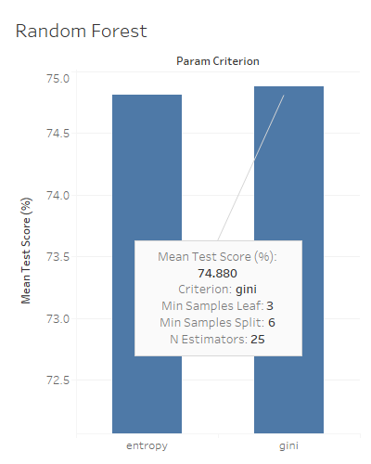
Figure 4-44 Random forest results

Training Results
The data gained from the training section may provide an insight into which classifier may perform best on the test data, or at least provide baseline scores to ensure there is not a potential issue with the overfitting or underfitting of data (Table 3).

Classifier | Accuracy Score (%)
Naïve Bayes | 76.214
KNN | 68.08
Logistic Regression | 76.85
Decision Tree | 71.98
Random Forest | 74.88
Table 3 Training accuracy

From these results, the logistic regression and naïve bayes seem to be the best performing models, but this still requires validation and evaluation.

Conclusion
With the training complete for each classifier, the models will need to be applied to the test dataset which was created during the train/test split. The produced results will then be gathered and discussed in order to gain insight into the effectiveness of the individual models.

Results
This section outlines the individual classifier results (confusion matrices, classification reports, and ROC AUC scores) which are produced from the application of the various trained models to the test dataset. The results are then discussed, and any key points are raised.

Naïve Bayes
On application of the produced naïve Bayes model to the test data, the naïve Bayes model has successfully classified 47,666 negative (0) and 43,551 positive (1) tweets as per the confusion matrix which has been produced (Figure 5-1).

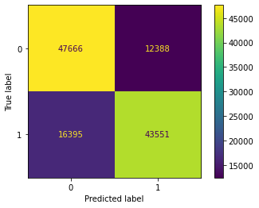
Figure 5-1 Naïve Bayes confusion matrix

A total of 91,217 correctly identified tweets when classifying the test data of 120,000.
The classification report for the naïve Bayes model (Figure 5-2) has produced some very well-rounded figures for each of the metrics discussed in section 2.7.2, with an accuracy of 76%. There is also a high precision and recall score meaning that the results are relevant, and they are also correct, hence the high F score.

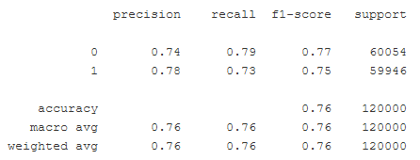
Figure 5-2 Naïve Bayes classification report

The ROC AUC score for the naïve Bayes model is 83.53, as shown in Figure 5-3 with the curve being visualised.

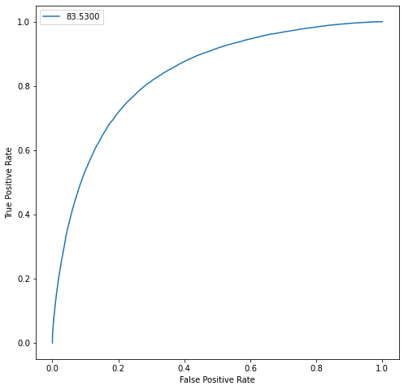
Figure 5-3 Naïve Bayes ROC

KNN
The confusion matrix produced for the KNN model when applied to the test dataset was able to successfully classify 40,506 negative and 42,254 positive tweets (Figure 5-4), a total of 82,760 correctly classified tweets.

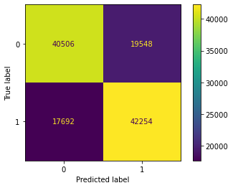
Figure 5-4 KNN confusion matrix

The classification report generated for the KNN model (Figure 5-5) again produces relatively similar results across the board, swapping precision and recall scores, and with an equal F score. There is an accuracy of 69% for this classifier against the test dataset.

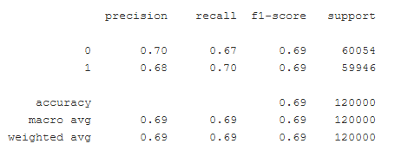
Figure 5-5 KNN classification report

The ROC AUC score for the KNN model is a respectable score at 76.02, as shown in Figure 5-6 where the curve has been visualised. The ROC curve does have a slight bump toward the upper end, however.

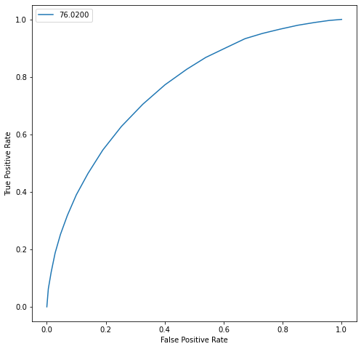
Figure 5-6 KNN ROC

Logistic Regression
44,4835 negative and 47,136 positive tweets are correctly identified by the logistic regression model as per Figure 5-7 - a total of 91,971 tweets correctly classified.

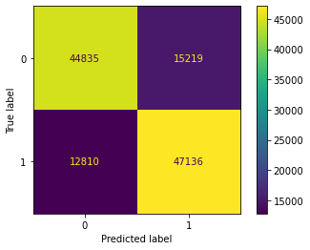
Figure 5-7 Logistic regression confusion matrix

The classification report for the logistic regression model looks impressive, with scores relatively high across the board (Figure 5-8), proving that there are a low number of false positives, and the identified results are relevant from the recall score. The end accuracy is 77%, which is the highest accuracy so far.

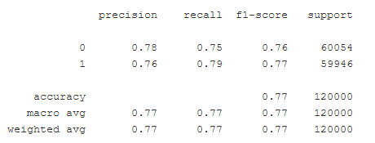
Figure 5-8 Logistic regression classification report

Figure 5-9 shows the ROC AUC score for the logistic regression model at 84.24, with a very smooth curve.
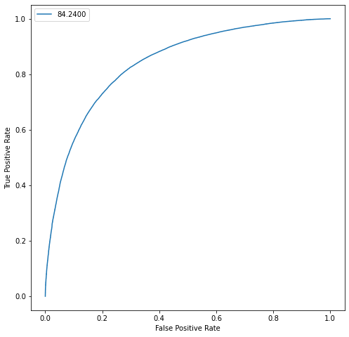
Figure 5-9 Logistic regression ROC

Decision Tree
The confusion matrix for the decision tree model (Figure 5-10) reveals that 43,772 negative tweets, and 43,331 positive tweets are correctly labelled. A total of 87,103 correctly labelled tweets.

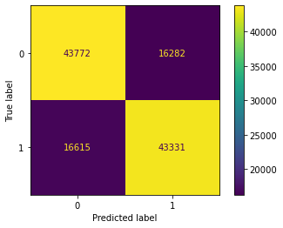
Figure 5-10 Decision tree confusion matrix

All metrics produced from the confusion matrix, as shown in the classification report in Figure 5-11, are all over 70% again, and all very similar. There is an accuracy of 73% for this model.

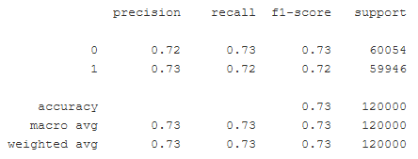
Figure 5-11 Decision tree classification report

The ROC AUC score for the decision tree model is 79.46 and the resulting curve is presented in Figure 5-12.

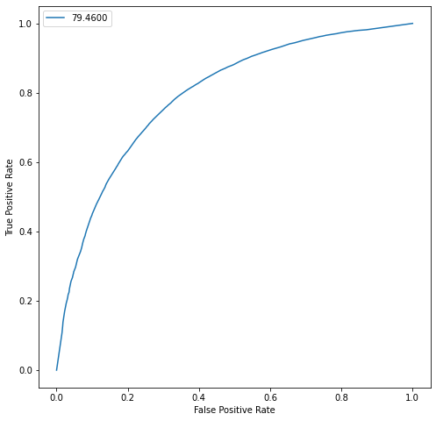
Figure 5-12 Decision tree ROC

Random Forest
The final classification report produced for the random forest model (Figure 5-13) shows that 45,989 negative tweets, and 44,545 positive tweets are correctly classified, a total of 90,534.

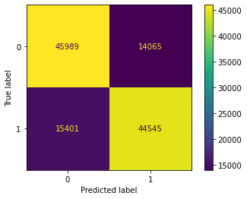
Figure 5-13 Random forest confusion matrix

The last classification report produced for this model (Figure 5-14) again has very close results across all three metrics of precision, recall and F score. There is a final accuracy of 75%.

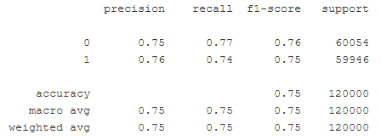
Figure 5-14 Random forest classification report

The ROC AUC score for the random forest model is 83.11, as shown in Figure 5-15, and there is again a relatively smooth curve displayed.

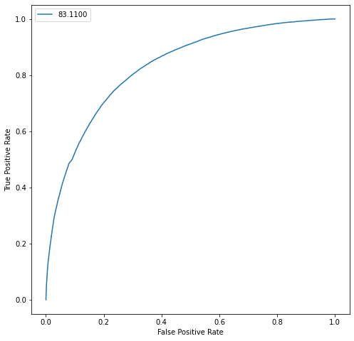
Figure 5-15 Random forest ROC

Conclusion
From the data displayed within this section, it is possible to see which classifier has performed the best with the task outlined for this project. However, it is not glaringly obvious as it is relatively close. The upcoming evaluation section will combine the results for each evaluation metric, and provide a definite answer as to which model is the highest performing classifier for this task.

Evaluation
The evaluation is now carried out in order to determine which is the most suited classifier for the task of sentiment analysis on the Sentiment140 dataset.
Various metrics are taken into consideration when performing the final analysis, and several visualisations are produced to assist with making the decision and provide additional evidence to bolster the decision as to which classifier provides the highest performance.

Accuracy
The main metric for any classification task (with others being “support” metrics to validate this), accuracy is key to determine the effectiveness of these models.
As shown in Figure 6-1, four out of five models achieve an accuracy of over 70%, with the top score being logistic regression at 76.643% closely followed by naïve Bayes with an accuracy score of 76.014% - a score difference of only 0.629%. The lowest accuracy score is the KNN model with an accuracy of 68.967%.

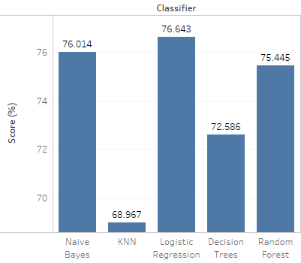
Figure 6-1 Accuracy comparison

Precision
The precision (or the relevance of the results) scores are shown in Figure 6-2. Logistic regression is the highest with a score of 76.69%, followed again by naïve Bayes with a score of 76.13% (a difference of only 0.56%). The higher score of logistic regression means that this model produces the lowest number of false positives out of the group. Again, the KNN classifier has the lowest performance at 68.99% precision.

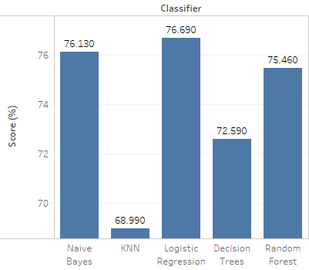
Figure 6-2 Precision comparison

Recall
A higher recall means that the model is able to correctly identify the relevant results. Following the trend of the prior metrics, as shown in Figure 6-3 logistic regression once again outperforms the other models with a score of 76.64%, and naïve Bayes coming just after again, with a score of 76.01%. KNN is again the lowest scoring model in this metric with a score of 68.97%.
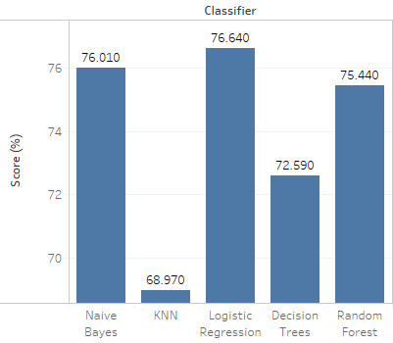
Figure 6-3 Recall comparison

F-Score
The F-score metric can only be high if the prior precision and recall metrics are also high. As both precision and recall metrics are similar across every classifier, the F-scores will reflect this. As shown in Figure 6-4 each classifier has similar scores to both their precision and recall scores, with logistic regression surpassing every model again with an F-score of 76.63%, and naïve Bayes close behind with an F-score of 75.99%.

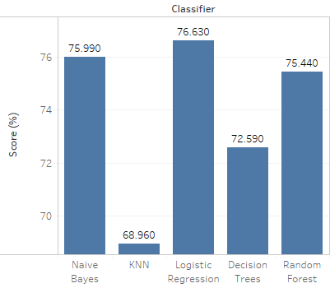
Figure 6-4 F-score comparison

ROC
The ROC allows the visualisation of True Positive Rate (TPR) vs False Positive Rate (FPR). As shown in Figure 6-5, the logistic regression model once again appears to have the better result, followed again by the naïve Bayes model, with the KNN model being the lowest performing model.

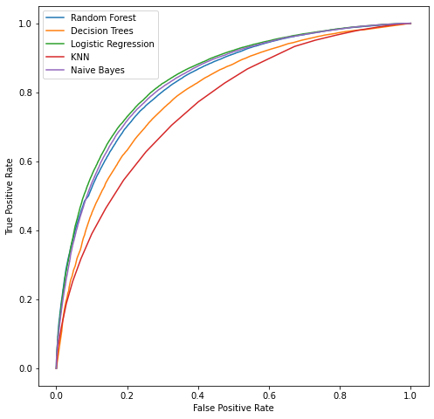
Figure 6-5 ROC curve

The ROC AUC score (Figure 6-6) helps with providing a numerical value to the ROC score, so it can be easier to understand the performance of each model and how it is related to the previous ROC curve in Figure 6-5. It justifies the curve, and confirms the performance of the models with logistic regression performing better and KNN achieving the lowest score.

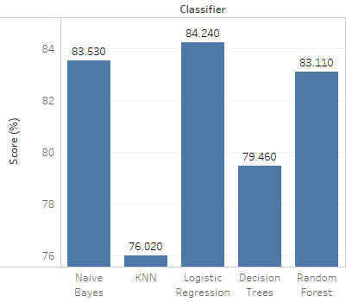
Figure 6-6 ROC AUC comparison

Runtime
The runtime for the test data will be faster than the training data as the model is now only fitting test data, performing predictions and predicting probabilities. As shown in Table 4, the naïve Bayes classifier by far takes the winning spot for fastest runtime at only 0.115 seconds, followed by logistic regression with a runtime of 25.6 seconds. Again, the KNN classifier is the lowest performing in the final comparison metric with a runtime of 59 minutes and 23 seconds.

Classifier | Runtime
Naïve Bayes | 00:00:00.115
KNN | 00:59:23
Logistic Regression | 00:00:25.6
Decision Tree | 00:02:26
Random Forest | 00:00:09.82
Table 4 Runtime comparison

Clearly runtime can have a large impact on any business, so this would need to be taken into consideration.

Cross Validation
To further bolster the statement that the logistic regression model is the better model for this task, cross validation was performed on each model with a fold value of 10. The results are then produced and shown in Table 5, further being visualised in Figure 6-7.

Fold | Naive Bayes  (%) | KNN  (%) | Logistic Regression (%) | Decision Tree (%) | Random Forest (%)
1 | 76.1179 | 68.8429 | 76.7143 | 72.0071 | 75.3393
2 | 76.3750 | 69.0964 | 76.9786 | 72.6250 | 75.4429
3 | 76.2286 | 69.2679 | 77.0107 | 72.8071 | 75.3964
4 | 76.4500 | 69.0214 | 77.0571 | 72.6357 | 74.9321
5 | 76.0750 | 69.0179 | 76.5607 | 72.5429 | 74.9714
6 | 76.2714 | 69.3107 | 77.0286 | 72.6857 | 75.3643
7 | 76.2857 | 68.2893 | 76.7714 | 72.4536 | 75.0536
8 | 75.9179 | 69.3286 | 76.7750 | 72.7429 | 75.4536
9 | 76.1179 | 68.2607 | 76.4929 | 72.2821 | 74.6821
10 | 76.2964 | 69.0214 | 77.0714 | 72.4500 | 75.3214
Max (%) | 76.4500 | 69.3286 | 77.0714 | 72.8071 | 75.4536
Min (%) | 75.9179 | 68.2607 | 76.4929 | 72.0071 | 74.6821
Range | 0.5321 | 1.0679 | 0.5785 | 0.8000 | 0.7715
Median (%) | 76.2500 | 69.0214 | 76.8768 | 72.5839 | 75.3304
Table 5 Cross validation scores

All folds of the cross fold validation are similar between across each classifier, with no worrying outliers. Logistic regression and naïve Bayes showing to be the most consistent with the lowest range between the maximum and minimum values. These values are visualised in Figure 6-7.
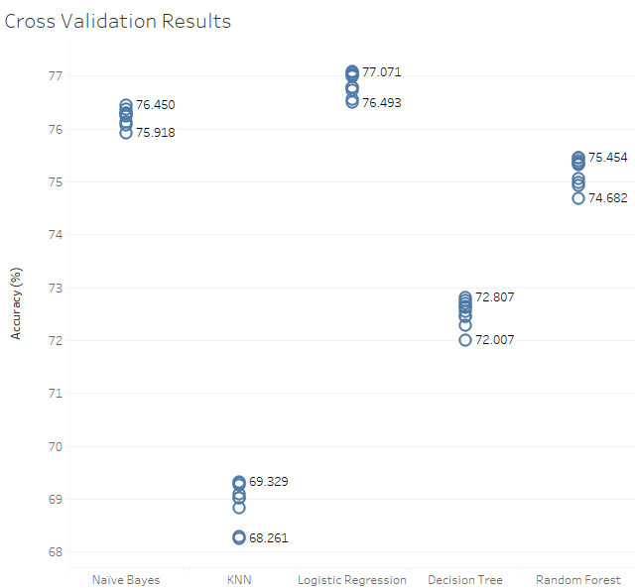
Figure 6-7 Cross validation results

As shown, the logistic regression model outperforms all other models consistently through each fold, and KNN is consistently the lowest performing.
The model which comes closest to achieving a similar accuracy to the logistic regression model is the naïve Bayes model (Figure 6-8).
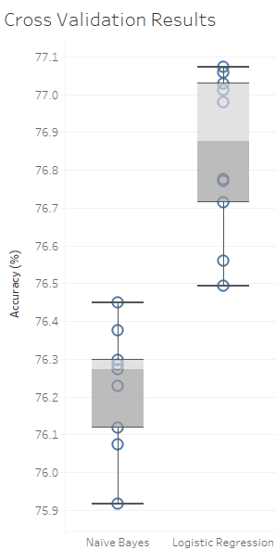
Figure 6-8 Cross validation naive Bayes vs logistic regression

Fitting
One final measure is to ensure there are no problems with overfitting or underfitting, as the model needs to be generalisable, and needs to successfully find patterns in data. Ideally a similar training and testing accuracy score would be better, however a slight difference between the two should not cause much of a problem.
The results from section 4.5.7 for the training accuracy are shown and pitted against the results from this evaluation section (Table 6), indicating a very small difference in values between the two sets. Each of the models seem to cope well with the fitting of the data, so it is fair to say that they are generalisable and should be able to handle future data input.

Classifier | Training Accuracy Score (%) | Test Accuracy Score (%)
Naïve Bayes | 76.214 | 76.01
KNN | 68.08 | 68.97
Logistic Regression | 76.85 | 76.64
Decision Tree | 71.98 | 72.59
Random Forest | 74.88 | 75.45
Table 6 Training vs test accuracy

Conclusion
The developed models are able to correctly classify the sentiment polarity of a tweet in up to 77% of the time, therefore the business question of whether machine learning can be effectively utilised in order to predict sentiment polarity of tweets, has been answered with a “yes”. So too has the question regarding the effectiveness of the prediction accuracy.
The evaluation metrics are close, however, the best performing model through this project has been the logistic regression model, followed by naïve Bayes, random forest, decision tree, and finally KNN – not to say that the KNN classifier is a poor performing classifier, it just may not be well suited for this specific task.
The main question that would need to be answered by a business would be the runtime preference; a faster, but slightly less accurate model, or a slower, but slightly more accurate model?
The top three, or possibly four, models would be able to be approved for business use.

Conclusions and Recommendations
As shown throughout this report, there are potential applications for machine learning in many areas, with NLP being just a section of possible functions. The theory and application of machine learning classification tasks have been successfully implemented in this project, with a respectable outcome in terms of the various evaluation metrics and accuracy.
The models produced in this project have shown that they are able to successfully predict the sentiment polarity of a tweet in up to 77% of the time and answer the business questions as to whether machine learning can be applied to this assignment.
The top four models, all consistently achieving over 70% accuracy, are able to be approved for use in a business, with the logistic regression model being the highest achieving model, and naïve Bayes being a close second, but with a lightning-fast runtime (in comparison to logistic regression).
Some of the given classification algorithms clearly outperform others, but there is also potentially a sacrifice in terms of compute time. Is it better for a more accurate, but slower result? Would an end user just want a faster, but slightly less accurate result? These are decisions that would need to be made by an end user adopting these techniques.
Clearly processor power is a large part of machine learning tasks and unfortunately has been a limiting factor in this project. This project could easily be repeated with a higher performance machine, or virtual machine on a cloud service, which can process classifiers with larger sets of parameters and a larger train and test set to potentially enhance the accuracy of the classifiers, as there are several classification algorithms which were limited due to the device this project was completed on. Some of the original hyperparameters that were going to be tested were removed from the pipelines, so it is not possible to say that all of these classifiers were fully optimised. As mentioned in the classifier training, one of the main hyperparameters for the logistic regression model (penalty) was removed due to the inflation on runtime. There are several hyperparameters available for logistic regression, so there may be an opportunity to improve these scores and evaluation metrics further.
Along with the proposed increase in records and parameters, it would be interesting to see how the removal of any data pre-processing steps may affect the end results – what would happen to the accuracy of the classifiers if, for example, lemmatisation was excluded? Would the ranking of classifiers change at all? Would the exclusion of stop word removal make much of a difference also? How would using a different vectorizer, such as TFIDF, affect the classifiers?
There may also be better alternatives to develop a pipeline per classifier rather than GridSearchCV. As the name suggests it performs cross-fold validation on the models for a given number of repetitions. Rather than this being completed at this stage, only performing this once all models are fit would also significantly reduce the compute time.
A simple multi layered perceptron, through to a full neural network can also be developed, trained, and compared to the classifiers included in this project to provide another method of classification.
It may also be possible to run these algorithms in a cluster, spreading out the “greedier” algorithms to assist with reducing the overall compute time.
Mentioned in the literature review were other datasets from several SemEval events. It may be interesting to test the resulting classification models on their test dataset to see how the models within this project compare.
One idea that came to mind during the proposal was to also develop a simple website where a user could input a string of 140 characters (the size of a tweet), it could perform the sentiment analysis, provide the result, and highlight the negative and positive words in the string. This could be extended to streaming live tweets and automatically classifying them, but this then begins to encroach on the realms of web scraping which, as discussed in the proposal, is a grey area and was avoided for the duration of this project sue to some ethical concerns.
Originally this project was going to also predict neutral sentiment, however the dataset had no annotated records for neutral tweets so it would have required a large amount of manual work to determine the sentiment and that then could lead to bias problems as there would be no second opinion. This project could be repeated with a dataset that has neutral records available, allowing the models to perform ternary classification, or even further with a “very positive” and “very negative” classification option.

Reflection
It is believed that the previous three-year undergraduate degree in software assisted in both this project and the entirety of the postgraduate course for data science and analytics as there existed already a knowledge of software engineering, allowing for further enhancement throughout this course. Primary data science and analytics module contributions toward this project include:
- Application of Machine Learning – Exploring the breadth of the world of machine learning, participating in completing both regression and classification tasks with classic regression algorithms and neural networks, this was a very intense and interesting introduction to machine learning as it had not been a topic encountered previously,
- Data Mining and Visualisation – An introduction to the CRISP-DM model, data mining, data exploration, justification for performing data mining projects and of course visualisation of data and findings,
- Advanced Statistical Programming – The ability to apply a statistical mindset to a problem rather than just a software engineering perspective of “problem solving” has proven valuable during the evaluation.
The data science and analytics course was originally decided on due to the lack of data visualisation skills and a want to develop them. Along with this, one of the weakest areas through the postgraduate course was the machine learning module. Again, to develop these skills this project was chosen to enhance current knowledge of machine learning as it is an area of interest and a growing area of employment, so the combination of data science with a background in software engineering should be able to provide an alternate career path and area of expertise.
The literature review and background reading performed at the beginning of this project was very interesting, and it is believed to have increased the knowledge of various machine learning tasks and classification techniques. This understanding will prove invaluable when undertaking any machine learning classification task going forwards (with a higher-powered machine), or further learning on other machine learning areas such as regression tasks, or the development and application of neural networks.
Frustration emerged while working on the notebook – the usual hiccups that every software engineer faces during development, however it was not taken into consideration the length of time that the final runtime would take. This unfortunately ate into productivity as there were significant periods of downtime while waiting for the notebook to run, or a certain section to complete, to perform the writeup and evaluation. The main annoyance was waiting for the SVM classifier to finish, the Azure portal refreshing, and losing any output – after almost 48 hours of runtime. It was impossible to say when the algorithm would finish running, and having to restart the compute instance (as the kernel interrupt did not work during the SVM execution) would lose any variables that the compute instance already has stored.
Overall, this project and course has proven extremely interesting, and the skills achieved and improved will be added to the existing skillsets. No doubt that there will be a uniting of skills at some point throughout a career and the knowledge will be invaluable.

References
[1] N. Danneman and R. Heimann, Social Media Mining with R, 1st ed. Packt, 2014.
[2] A. Go, R. Bhayani, and L. Huang, “Twitter Sentiment Classification using Distant Supervision,” [Online]. Available: https://cs.stanford.edu/people/alecmgo/papers/TwitterDistantSupervision09.pdf.
[3] “Social Data Insights Report.” Accessed: Mar. 30, 2021. [Online]. Available: https://data.twitter.com/content/dam/data-twitter/harris-inforgraphic/Twitter_Insights-Report_Paginated-Verison_Final.pdf.
[4] Z. Wang, C. S. Chong, L. Lan, Y. Yang, S. Beng Ho, and J. C. Tong, “Fine-grained sentiment analysis of social media with emotion sensing,” in 2016 Future Technologies Conference (FTC), Dec. 2016, pp. 1361–1364, doi: 10.1109/FTC.2016.7821783.
[5] B. J. W. Sayyed and R. Gupta, “Social Media Impact: Generation Z and Millenial on the Cathedra of Social Media,” in 2020 8th International Conference on Reliability, Infocom Technologies and Optimization (Trends and Future Directions) (ICRITO), Jun. 2020, pp. 595–600, doi: 10.1109/ICRITO48877.2020.9197995.
[6] “Digital 2021 April Statshot Report — DataReportal.” https://datareportal.com/reports/digital-2021-april-global-statshot (accessed Jun. 02, 2021).
[7] “Hootsuite.” https://www.hootsuite.com/ (accessed Jun. 02, 2021).
[8] “We Are Social.” https://wearesocial.com/ (accessed Jun. 02, 2021).
[9] “New user FAQ.” https://help.twitter.com/en/new-user-faq (accessed Apr. 06, 2021).
[10] “Twitter Retweet FAQS.” https://help.twitter.com/en/using-twitter/retweet-faqs (accessed Jul. 12, 2021).
[11] “Twitter - Following on Twitter.” https://help.twitter.com/en/using-twitter/following-faqs (accessed Jun. 02, 2021).
[12] “Twitter privacy and protection settings.” https://help.twitter.com/en/safety-and-security/public-and-protected-tweets (accessed Jun. 02, 2021).
[13] Mention, “2018 Twitter Report.” [Online]. Available: https://go.pardot.com/l/891571/2020-12-10/tdx/891571/1607615685ZsZFefkr/Twitter_Engagement_Report_2018___Mention.pdf.
[14] H. Pekdogan and A. Erguzen, “Twitter Big Data Analysis,” Int. J. Trend Sci. Res. Dev., vol. 5, no. 2, pp. 50–53, 2021, [Online]. Available: https://www.ijtsrd.com/papers/ijtsrd38266.pdf.
[15] V. Gupta and R. Hewett, “Real-Time Tweet Analytics Using Hybrid Hashtags on Twitter Big Data Streams,” Information, vol. 11, no. 7, p. 341, Jun. 2020, doi: 10.3390/info11070341.
[16] P. Simon, Too Big to Ignore: The Business Case for Big Data, 1st ed. Wiley, 2013.
[17] T. L. Nguyen, “A Framework for Five Big V’s of Big Data and Organizational Culture in Firms,” in 2018 IEEE International Conference on Big Data (Big Data), Dec. 2018, pp. 5411–5413, doi: 10.1109/BigData.2018.8622377.
[18] J. Patel, “An Effective and Scalable Data Modeling for Enterprise Big Data Platform,” in 2019 IEEE International Conference on Big Data (Big Data), Dec. 2019, pp. 2691–2697, doi: 10.1109/BigData47090.2019.9005614.
[19] F. Chollet, Deep Learning with Python. Manning, 2018.
[20] A. Géron, Hands-on Machine Learning with Scikit-Learn, Keras & TensorFlow, 2nd ed. O’Reilly, 2019.
[21] “UCI Machine Learning Repository: Iris Data Set.” https://archive.ics.uci.edu/ml/datasets/iris (accessed May 27, 2021).
[22] K. R. Dalal, “Analysing the Role of Supervised and Unsupervised Machine Learning in IoT,” in 2020 International Conference on Electronics and Sustainable Communication Systems (ICESC), Jul. 2020, pp. 75–79, doi: 10.1109/ICESC48915.2020.9155761.
[23] M. Bhatt, V. Dahiya, and A. Singh, “Supervised Learning Algorithm: SVM with Advanced Kernel to classify Lower Back Pain,” in 2019 International Conference on Machine Learning, Big Data, Cloud and Parallel Computing (COMITCon), Feb. 2019, pp. 17–19, doi: 10.1109/COMITCon.2019.8862181.
[24] A. M. Rahat, A. Kahir, and A. K. M. Masum, “Comparison of Naive Bayes and SVM Algorithm based on Sentiment Analysis Using Review Dataset,” in 2019 8th International Conference System Modeling and Advancement in Research Trends (SMART), Nov. 2019, pp. 266–270, doi: 10.1109/SMART46866.2019.9117512.
[25] S. Russell and P. Norvig, Artificial Intelligence A Modern Approach, 4th ed. Pearson, 2021.
[26] A. Burkov, The Hundred-Page Machine Learning Book, 1st ed. 2019.
[27] F. Nie, L. Tian, R. Wang, and X. Li, “Multiview Semi-Supervised Learning Model for Image Classification,” IEEE Trans. Knowl. Data Eng., vol. 32, no. 12, pp. 2389–2400, Dec. 2020, doi: 10.1109/TKDE.2019.2920985.
[28] A. Notsu, K. Yasuda, S. Ubukata, and K. Honda, “Optimization of Learning Cycles in Online Reinforcement Learning Systems,” in 2018 IEEE International Conference on Systems, Man, and Cybernetics (SMC), Oct. 2018, pp. 3530–3534, doi: 10.1109/SMC.2018.00597.
[29] H. Lane, C. Howard, and H. Hannes, Natural Language Processing in Action: Understanding, analyzing, and generating text with Python. Manning, 2019.
[30] S. Karthick, R. J. Victor, S. Manikandan, and B. Goswami, “Professional chat application based on natural language processing,” in 2018 IEEE International Conference on Current Trends in Advanced Computing (ICCTAC), Feb. 2018, pp. 1–4, doi: 10.1109/ICCTAC.2018.8370395.
[31] R. S. Trofin, C. Chiru, C. Vizitiu, A. Dinculescu, R. Vizitiu, and A. Nistorescu, “Detection of Astronauts’ Speech and Language Disorder Signs during Space Missions using Natural Language Processing Techniques,” in 2019 E-Health and Bioengineering Conference (EHB), Nov. 2019, pp. 1–4, doi: 10.1109/EHB47216.2019.8969950.
[32] A. Junnarkar, S. Adhikari, J. Fagania, P. Chimurkar, and D. Karia, “E-Mail Spam Classification via Machine Learning and Natural Language Processing,” in 2021 Third International Conference on Intelligent Communication Technologies and Virtual Mobile Networks (ICICV), Feb. 2021, pp. 693–699, doi: 10.1109/ICICV50876.2021.9388530.
[33] M. B. priya and E. Kannamal, “Investigation of Speech recognition system and its performance,” in 2020 International Conference on Computer Communication and Informatics (ICCCI), Jan. 2020, pp. 1–4, doi: 10.1109/ICCCI48352.2020.9104068.
[34] S. G. Kanakaraddi and S. S. Nandyal, “Survey on Parts of Speech Tagger Techniques,” in 2018 International Conference on Current Trends towards Converging Technologies (ICCTCT), Mar. 2018, pp. 1–6, doi: 10.1109/ICCTCT.2018.8550884.
[35] S. Bird, E. Klein, and E. Loper, Natural Language Processing with Python - Analyzing Text with the Natural Language Toolkit, 1st ed. O’Reilly, 2009.
[36] B. Liu, Sentiment Analysis Mining Opinions, Sentiments and Emotions, 2nd ed. 2020.
[37] K. Samhith, S. A. Tilak, and G. Panda, “Word sense disambiguation using WordNet Lexical Categories,” in 2016 International Conference on Signal Processing, Communication, Power and Embedded System (SCOPES), Oct. 2016, pp. 1664–1666, doi: 10.1109/SCOPES.2016.7955725.
[38] D. Sarkar, Text Analytics with Python: A Practical Real-World Approach to Gaining Actionable Insights from your Data. Apress, 2016.
[39] Y. Du and W. Zhao, “Named Entity Recognition Method with Word Position,” in 2020 International Workshop on Electronic Communication and Artificial Intelligence (IWECAI), Jun. 2020, pp. 154–159, doi: 10.1109/IWECAI50956.2020.00038.
[40] C. Manning, P. Raghavan, and H. Schutze, Introduction to Information Retrieval, 1st ed. Cambridge University Press, 2008.
[41] K. Swain and A. K. Nayak, “A Review on Rule-Based and Hybrid Stemming Techniques,” in 2018 2nd International Conference on Data Science and Business Analytics (ICDSBA), Sep. 2018, pp. 25–29, doi: 10.1109/ICDSBA.2018.00012.
[42] S. Behera, “Implementation of a Finite State Automaton to Recognize and Remove Stop Words in English Text on its Retrieval,” in 2018 2nd International Conference on Trends in Electronics and Informatics (ICOEI), May 2018, pp. 476–480, doi: 10.1109/ICOEI.2018.8553828.
[43] H.-C. Soong, N. B. A. Jalil, R. Kumar Ayyasamy, and R. Akbar, “The Essential of Sentiment Analysis and Opinion Mining in Social Media : Introduction and Survey of the Recent Approaches and Techniques,” in 2019 IEEE 9th Symposium on Computer Applications & Industrial Electronics (ISCAIE), Apr. 2019, pp. 272–277, doi: 10.1109/ISCAIE.2019.8743799.
[44] A. Poornima and K. S. Priya, “A Comparative Sentiment Analysis Of Sentence Embedding Using Machine Learning Techniques,” in 2020 6th International Conference on Advanced Computing and Communication Systems (ICACCS), Mar. 2020, pp. 493–496, doi: 10.1109/ICACCS48705.2020.9074312.
[45] “WordNet | A Lexical Database for English.” https://wordnet.princeton.edu/ (accessed Jul. 20, 2021).
[46] “SentiWordNet: The SentiWordNet sentiment lexicon.” https://github.com/aesuli/SentiWordNet (accessed Jul. 20, 2021).
[47] W. B. Zulfikar, Y. A. Gerhana, and A. F. Rahmania, “An Approach to Classify Eligibility Blood Donors Using Decision Tree and Naive Bayes Classifier,” in 2018 6th International Conference on Cyber and IT Service Management (CITSM), Aug. 2018, pp. 1–5, doi: 10.1109/CITSM.2018.8674353.
[48] T. M. Ma, K. YAMAMORI, and A. Thida, “A Comparative Approach to Naïve Bayes Classifier and Support Vector Machine for Email Spam Classification,” in 2020 IEEE 9th Global Conference on Consumer Electronics (GCCE), Oct. 2020, pp. 324–326, doi: 10.1109/GCCE50665.2020.9291921.
[49] M. Parsian, Data Algorithms. 2015.
[50] Q. Wei, “Understanding of the naive Bayes classifier in spam filtering,” 2018, p. 020007, doi: 10.1063/1.5038979.
[51] I. Goodfellow, Y. Bengio, A. Courville, and F. Bach, Deep Learning, 1st ed. MIT Press, 2017.
[52] C. C, “Prediction of Heart Disease using Different KNN Classifier,” in 2021 5th International Conference on Intelligent Computing and Control Systems (ICICCS), May 2021, pp. 1186–1194, doi: 10.1109/ICICCS51141.2021.9432178.
[53] A. Singh and B. Pandey, “An Euclidean Distance based KNN Computational Method for Assessing Degree of Liver Damage,” in 2016 International Conference on Inventive Computation Technologies (ICICT), Aug. 2016, pp. 1–4, doi: 10.1109/INVENTIVE.2016.7823222.
[54] S. Rukhsar, H. Rehman, Y. U. Khan, and A. T. Khan, “Detection of Epileptic Seizure in EEG Signals Using Phase Space Reconstruction and Euclidean Distance of First-Order Derivative,” in 2017 International Conference on Inventive Computing and Informatics (ICICI), Nov. 2017, pp. 821–826, doi: 10.1109/ICICI.2017.8365251.
[55] J. Han, M. Kamber, and J. Pei, Data Mining Concepts and Techniques, 3rd ed. Elsevier, 2012.
[56] V.-T. Luu, G. Forestier, J. Weber, P. Bourgeois, F. Djelil, and P.-A. Muller, “A review of alignment based similarity measures for web usage mining,” Artif. Intell. Rev., vol. 53, no. 3, pp. 1529–1551, Mar. 2020, doi: 10.1007/s10462-019-09712-9.
[57] L. Greche, M. Jazouli, N. Es-Sbai, A. Majda, and A. Zarghili, “Comparison Between Euclidean and Manhattan Distance Measure for Facial Expressions Classification,” in 2017 International Conference on Wireless Technologies, Embedded and Intelligent Systems (WITS), Apr. 2017, pp. 1–4, doi: 10.1109/WITS.2017.7934618.
[58] R. Kumar, “Analysis of Shape Alignment using Euclidean and Manhattan Distance Metrics,” in 2017 International Conference on Recent Innovations in Signal processing and Embedded Systems (RISE), Oct. 2017, pp. 326–331, doi: 10.1109/RISE.2017.8378175.
[59] N. Vutakuri and A. U. Maheswari, “Breast cancer diagnosis using a Minkowski distance method based on mutual information and genetic algorithm,” Int. J. Adv. Intell. Paradig., vol. 16, no. 3/4, p. 414, 2020, doi: 10.1504/IJAIP.2020.107537.
[60] B. Sugiarto and R. Sustika, “Data Classification for Air Quality on Wireless Sensor Network Monitoring System Using Decision Tree Algorithm,” in 2016 2nd International Conference on Science and Technology-Computer (ICST), Oct. 2016, pp. 172–176, doi: 10.1109/ICSTC.2016.7877369.
[61] K. Shah, H. Patel, D. Sanghvi, and M. Shah, “A Comparative Analysis of Logistic Regression, Random Forest and KNN Models for the Text Classification,” Augment. Hum. Res., vol. 5, no. 1, p. 12, Dec. 2020, doi: 10.1007/s41133-020-00032-0.
[62] M. Belgiu and L. Drăguţ, “Random Forest in Remote Sensing: A Review of Applications and Future Directions,” ISPRS J. Photogramm. Remote Sens., vol. 114, pp. 24–31, Apr. 2016, doi: 10.1016/j.isprsjprs.2016.01.011.
[63] V. N. Gudivada, M. T. Irfan, E. Fathi, and D. L. Rao, Handbook of Statistics. 2016.
[64] X. Zou, Y. Hu, Z. Tian, and K. Shen, “Logistic Regression Model Optimization and Case Analysis,” in 2019 IEEE 7th International Conference on Computer Science and Network Technology (ICCSNT), Oct. 2019, pp. 135–139, doi: 10.1109/ICCSNT47585.2019.8962457.
[65] V. Kotu and B. Deshpande, Data Science Concepts and Practice, 2nd ed. Morgan Kaufmann, 2019.
[66] Y. Lei, Y. Dong, F. Xiong, H. Bai, and H. Yuan, “Confusion Weighted Loss for Ambiguous Classification,” in 2018 IEEE Visual Communications and Image Processing (VCIP), Dec. 2018, pp. 1–4, doi: 10.1109/VCIP.2018.8698693.
[67] G.-H. Fu, F. Xu, B.-Y. Zhang, and L.-Z. Yi, “Stable variable selection of class-imbalanced data with precision-recall criterion,” Chemom. Intell. Lab. Syst., vol. 171, pp. 241–250, Dec. 2017, doi: 10.1016/j.chemolab.2017.10.015.
[68] A. Berger and S. Guda, “Threshold optimization for F measure of macro-averaged precision and recall,” Pattern Recognit., vol. 102, p. 107250, Jun. 2020, doi: 10.1016/j.patcog.2020.107250.
[69] “SemEval | International Workshop on Semantic Evaluation.” https://semeval.github.io/ (accessed Apr. 07, 2021).
[70] “SemEval2016 - Sentiment Analysis in Twitter.” https://alt.qcri.org/semeval2016/task4/index.php?id=data-and-tools (accessed Apr. 17, 2021).
[71] “SemEval2017 - Sentiment Analysis in Twitter.” https://alt.qcri.org/semeval2017/task4/index.php?id=data-and-tools (accessed Apr. 17, 2021).
[72] “GitHub - seirasto/twitter_download: Download scripts for distributing twitter data.” https://github.com/seirasto/twitter_download (accessed Jun. 20, 2021).
[73] K. AbdulSattar, Q. Obeidat, and M. Akour, “Towards harnessing based learning algorithms for tweets sentiment analysis,” in 2020 International Conference on Innovation and Intelligence for Informatics, Computing and Technologies (3ICT), Dec. 2020, pp. 1–5, doi: 10.1109/3ICT51146.2020.9311990.
[74] S. H. Dhahi and J. Waleed, “Emotions Polarity of Tweets Based on Semantic Similarity and User Behavior Features,” in 2020 1st. Information Technology To Enhance e-learning and Other Application (IT-ELA, Jul. 2020, pp. 1–6, doi: 10.1109/IT-ELA50150.2020.9253088.
[75] P. Nakov, A. Ritter, S. Rosenthal, F. Sebastiani, and V. Stoyanov, “SemEval-2016 Task 4: Sentiment Analysis in Twitter,” Dec. 2019, [Online]. Available: http://arxiv.org/abs/1912.01973.
[76] E. Palogiannidi et al., “Tweester at SemEval-2016 Task 4: Sentiment Analysis in Twitter Using Semantic-Affective Model Adaptation,” in Proceedings of the 10th International Workshop on Semantic Evaluation (SemEval-2016), 2016, pp. 155–163, doi: 10.18653/v1/S16-1023.
[77] J. Deriu, M. Gonzenbach, F. Uzdilli, A. Lucchi, V. De Luca, and M. Jaggi, “SwissCheese at SemEval-2016 Task 4: Sentiment Classification Using an Ensemble of Convolutional Neural Networks with Distant Supervision,” in Proceedings of the 10th International Workshop on Semantic Evaluation (SemEval-2016), 2016, pp. 1124–1128, doi: 10.18653/v1/S16-1173.
[78] G. Balikas and M.-R. Amini, “TwiSE at SemEval-2016 Task 4: Twitter Sentiment Classification,” Jun. 2016, [Online]. Available: http://arxiv.org/abs/1606.04351.
[79] S. Rosenthal, N. Farra, and P. Nakov, “SemEval-2017 Task 4: Sentiment Analysis in Twitter,” in Proceedings of the 11th International Workshop on Semantic Evaluation (SemEval-2017), 2017, pp. 502–518, doi: 10.18653/v1/S17-2088.
[80] C. Baziotis, N. Pelekis, and C. Doulkeridis, “DataStories at SemEval-2017 Task 4: Deep LSTM with Attention for Message-level and Topic-based Sentiment Analysis,” in Proceedings of the 11th International Workshop on Semantic Evaluation (SemEval-2017), 2017, pp. 747–754, doi: 10.18653/v1/S17-2126.
[81] M. Cliche, “BB_twtr at SemEval-2017 Task 4: Twitter Sentiment Analysis with CNNs and LSTMs,” Apr. 2017, [Online]. Available: http://arxiv.org/abs/1704.06125.
[82] M. Wongkar and A. Angdresey, “Sentiment Analysis Using Naive Bayes Algorithm Of The Data Crawler: Twitter,” in 2019 Fourth International Conference on Informatics and Computing (ICIC), Oct. 2019, pp. 1–5, doi: 10.1109/ICIC47613.2019.8985884.
[83] M. Rezwanul, A. Ali, and A. Rahman, “Sentiment Analysis on Twitter Data using KNN and SVM,” Int. J. Adv. Comput. Sci. Appl., vol. 8, no. 6, 2017, doi: 10.14569/IJACSA.2017.080603.
[84] “Sentiment140 dataset | Kaggle.” https://www.kaggle.com/kazanova/sentiment140 (accessed Apr. 17, 2021).
[85] “Google Colaboratory.” https://colab.research.google.com (accessed Apr. 17, 2021).
[86] “11th Generation Intel® CoreTM i9 Processors Product Specifications.” https://ark.intel.com/content/www/us/en/ark/products/series/202984/11th-generation-intel-core-i9-processors.html#@nofilter (accessed Oct. 27, 2021).
[87] “Welcome to Python.org.” https://www.python.org/ (accessed Oct. 02, 2021).
[88] “Project Jupyter | Home.” https://jupyter.org/ (accessed Oct. 01, 2021).
[89] “Anaconda | The World’s Most Popular Data Science Platform.” https://www.anaconda.com/ (accessed Oct. 02, 2021).
[90] “spaCy · Industrial-strength Natural Language Processing in Python.” https://spacy.io/ (accessed Sep. 29, 2021).
[91] “NumPy.” https://numpy.org/ (accessed Oct. 02, 2021).
[92] “Pandas - Python Data Analysis Library.” https://pandas.pydata.org/ (accessed Apr. 17, 2021).
[93] “Matplotlib: Python plotting — Matplotlib 3.4.3 documentation.” https://matplotlib.org/ (accessed Oct. 02, 2021).
[94] “NLTK - Accessing Text Corpora and Lexical Resources.” https://www.nltk.org/book/ch02.html (accessed Sep. 29, 2021).
[95] “seaborn: statistical data visualization — seaborn 0.11.2 documentation.” https://seaborn.pydata.org/ (accessed Oct. 02, 2021).
[96] “GitHub - amueller/word_cloud: A little word cloud generator in Python.” https://github.com/amueller/word_cloud (accessed Oct. 02, 2021).
[97] “tweet-preprocessor · PyPI.” https://pypi.org/project/tweet-preprocessor/ (accessed Sep. 29, 2021).
[98] “scikit-learn: machine learning in Python — scikit-learn 1.0 documentation.” https://scikit-learn.org/stable/ (accessed Oct. 02, 2021).
[99] “Tableau | Business intelligence and analytics software.” https://www.tableau.com/en-gb (accessed Oct. 05, 2021).
[100] “Azure Machine Learning – ML as a service | Microsoft Azure.” https://azure.microsoft.com/en-gb/services/machine-learning/ (accessed Oct. 01, 2021).
[101] “Manage resources and quotas - Azure Machine Learning | Microsoft Docs.” https://docs.microsoft.com/en-gb/azure/machine-learning/how-to-manage-quotas (accessed Oct. 02, 2021).
[102] Y. HaCohen-Kerner, D. Miller, and Y. Yigal, “The influence of preprocessing on text classification using a bag-of-words representation,” PLoS One, vol. 15, no. 5, p. e0232525, May 2020, doi: 10.1371/journal.pone.0232525.
[103] “sklearn.preprocessing.LabelEncoder — scikit-learn 1.0 documentation.” https://scikit-learn.org/stable/modules/generated/sklearn.preprocessing.LabelEncoder.html (accessed Sep. 29, 2021).
[104] “sklearn.model_selection.GridSearchCV — scikit-learn 1.0 documentation.” https://scikit-learn.org/stable/modules/generated/sklearn.model_selection.GridSearchCV.html (accessed Oct. 01, 2021).
[105] “sklearn.naive_bayes.MultinomialNB — scikit-learn 1.0 documentation.” https://scikit-learn.org/stable/modules/generated/sklearn.naive_bayes.MultinomialNB.html (accessed Oct. 01, 2021).
[106] “sklearn.neighbors.KNeighborsClassifier — scikit-learn 1.0 documentation.” https://scikit-learn.org/stable/modules/generated/sklearn.neighbors.KNeighborsClassifier.html (accessed Oct. 01, 2021).
[107] “sklearn.linear_model.LogisticRegression — scikit-learn 1.0 documentation.” https://scikit-learn.org/stable/modules/generated/sklearn.linear_model.LogisticRegression.html (accessed Oct. 01, 2021).
[108] “sklearn.tree.DecisionTreeClassifier — scikit-learn 1.0 documentation.” https://scikit-learn.org/stable/modules/generated/sklearn.tree.DecisionTreeClassifier.html (accessed Oct. 01, 2021).
[109] “sklearn.ensemble.RandomForestClassifier — scikit-learn 1.0 documentation.” https://scikit-learn.org/stable/modules/generated/sklearn.ensemble.RandomForestClassifier.html (accessed Oct. 01, 2021).
[110] “sklearn.svm.SVC — scikit-learn 1.0 documentation.” https://scikit-learn.org/stable/modules/generated/sklearn.svm.SVC.html#sklearn.svm.SVC (accessed Oct. 01, 2021).

Appendix A – SVM Results
Due to the runtime of this algorithm, it was run on 50,000 just to see how it performed, and it performed well. However, the runtime was high. However, when running on 400,000 records, it seemed impossible for this to finish.
The SVM classifier [110] has a large number of hyperparameters offered for change. One of the main parameters is the kernel function.
- Kernel – a choice of linear, poly, RBF (radial basis function), or sigmoid. This is the kernel type which is to be used in the algorithm.

The GridSearchCV object is created to perform the SVM tests as shown in Figure A-1.

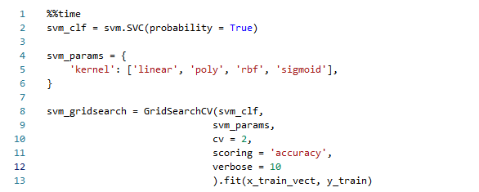
Figure A-1 SVM algorithm

The best parameters for the SVM classifier are shown in Figure A-2.
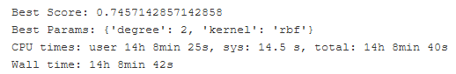
Figure A-2 SVM best score and parameters

The confusion matrix for the SVM classifier is shown in Figure A-3.

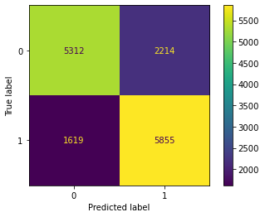
Figure A-3 SVM confusion matrix
The classification report for the SVM classifier is shown in Table 7.

 | Precision | Recall | F1-Score | Support
0 | 0.77 | 0.71 | 0.73 | 7526
1 | 0.73 | 0.78 | 0.75 | 7474
Accuracy |  |  | 0.74 | 15000
Macro avg | 0.75 | 0.74 | 0.74 | 15000
Weighted avg | 0.75 | 0.74 | 0.74 | 15000
Table 7 SVM classification report
The ROC curve and ROC AUC score are shown in Figure A-4.
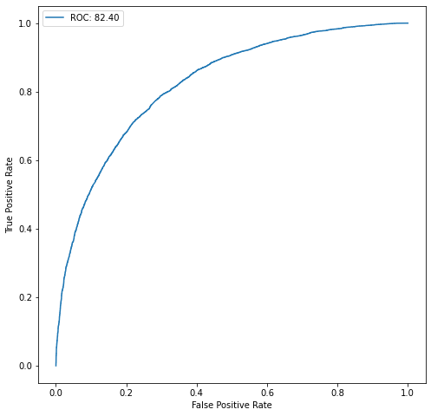

Figure A-4 SVM ROC

