Swansea bay beach
litter picking project
Managing Projects in the Organisation BMSW5009_SWAN
1st August 2025
University of Wales Trinity Saint David Aniko Batki (2313036)
Table of Contents
1. Introduction 2
2. Findings 2
2.1. Initiation Phase 2
2.2. Planning Phase 3
2.3. Implementation 7
2.4. Monitoring and Control 7
2.5. Evaluation 8
3. Conclusion and Recommendations 8
4. Reference list 9

Introduction
At University of Wales Trinity Saint David, United Kingdom, a team called Bay Brighteners was formed in early May 2025 with the purpose of organising a litter picking awareness day on 25th May 2025 in Swansea Bay Beach. The aims of the project were to raise awareness of the negative impact human waste disposal causes on Welsh beaches and public spaces in general. The event also ensured volunteers to join and help in tidying up Swansea City’s most popular beach and its promenade.
The objectives of the project included cleaning the most vibrant beach in three weeks time in Swansea, promoting the initiated event and mobilising a large number of people to take part in, promoting sustainability in the community, increasing the sense of responsibility in people for the environment, protecting it to provide a nice and clean place to live for the next generation.
This report aims to present the lifecycle of the project from initiation to termination demonstrating all the tools and techniques were used during the teamwork.
Academic books, journal articles, websites and university lecture notes on project management were used to support information in this study.

Findings
Project management is a vital life and work-related skill that everybody needs to evolve in themselves (Clegg et al., 2020). It is about applying our knowledge, competencies, tools and different strategies in project duties to meet project aims and objectives (PMI, 2025).

Initiation Phase
The Bay Brighteners team used a SWOT Analysis (Humphrey, 2005) to identify the strengths and weaknesses of the project but also to map opportunities and threats to prepare for thoughtful planning, getting ready for difficulties and unforeseen circumstances, focusing on details and managing risks to deliver the project successfully (Fig. 1).
S | - Effective communication platforms  - Strong commitment to the project
W | - Lack of experience in project management  - Lack of experience in litter picking event  - Limited time and resources
O | - Gaining experience in the project management field  - Gaining experience in the litter picking event  - Raise awareness to public on the impact of littering has on wildlife and environment in general.
T | - Lack of suppliers from City Council  - Lack of control on weather condition  - Unknown ongoing events  - Low attendance from volunteers  - Injury to team members and volunteers through contact with removed rubbish/ sharp items  - Hidden sharps e.g. broken glass, needles, fishing hooks etc  - Animals - bites, stings, attacks  - Bacteria and dirt could lead to illness and infection e.g. Weil’s disease
Figure 1. SWOT Analysis of the Swansea Bay Beach litter picking project based on Humphrey (2005). The analysis was made as a teamwork by the Bay Brighteners.
The Bay Brighteners also applied Belbin’s team role model (Belbin, 2010) in task assignments. According to Belbin’s theory, each team member behaves in a particular manner in teamwork which can be thinking, action or social-oriented attitude. As explained by Belbin (2015), specific team roles in the right balance but at least the three behavioural orientations are needed to be present for a successful team and project deliverables. Our team of six was built up by a Plant, a Monitor Evaluator, a Specialist (thinking roles), an Implementer, a Completer Finisher (action roles) and a Co-ordinator (social role). Fortunately, all three main characters were covered by the team members however, there was a bit much of thinking individuals and too little sociable colleagues which resulted in some conflicts during the project.

Planning Phase
Kerzner (2025) defines project planning as specifying work requirements, the value of work, resources required, listing tasks and activities and assessing potential risks.
Many organisations use branded project management methodologies such as Agile or traditional ones to ensure success. Agile is a flexible and iterative approach for organising projects which is built up by small manageable steps. The biggest advantage of this model is that feedback and any changes are applicable throughout the project cycle which makes benefits obtained earlier (APMG, 2025).
Quad Chart is a visual, single page outline typically divided into four quadrants (Barker and Cole, 2015). This project management tool is used for to shortly summarise project goals, stakeholders, intended outcomes and measures of success. We have prepared a Quad chart to communicate effectively project aims, to support a clear understanding of the project for stakeholders and to help our team in focusing on main deliverables (Fig. 2).
Purpose  To raise awareness of the negative impact that human littering can have on the environment and Welsh Beaches by organising a littering awareness day, where people can volunteer to help clean up the Swansea beach. | Stakeholder/Audience  - General public  - Swansea council  - Volunteers  - Beach Businesses  - Bay Brighteners team members
Desired End Results  - To clean the beach from Civic centre to Black pill.  - To raise awareness of the effect that littering has on Wales beaches wildlife.  - To understand the stages of project management and improve our knowledge of planning. | Measures of success  - Positive feedback from community  - Getting people involved in litter picking event  - Keeping beaches clean at least for one day
Figure 2. Quad Chart of the Swansea Bay Beach litter picking project created by the Bay Brighteners.
Another tool our team have applied is a Gantt chart (Fig. 3) which is a visual bar chart typically used in project managing for project scheduling, task assigning, timeframe and progress control (APM, 2025). The team has decided to separate the project into five major phases: Initiation, Planning and Design, Execution, Monitoring and Control, and Evaluation.
Litter Picking Swansea Bay
Bay Brighteners | Project lead
SIMPLE GANTT CHART by Vertex42 (2025)
TASK | ASSIGNED TO | PROGRESS | START | END
Initiation
Forming the team | Teamwork | 100% | 5/8/25 | 5/22/25
Brainstorming Project Ideas | Teamwork | 100% | 5/8/25 | 5/8/25
Establish comms | Aleksandra | 100% | 5/8/25 | 5/15/25
Team Name and Logo Ideation | Teamwork | 100% | 5/8/25 | 5/15/25
Create Quad Chart | Aleksandra | 100% | 5/15/25 | 5/15/25
Planning and design
Create schedule | Alina | 100% | 5/15/25 | 5/25/25
Identify deliverables | Raluca | 100% | 5/15/25 | 5/24/25
Develop budget | Alina | 100% | 5/15/25 | 5/17/25
Define scope | Raluca | 100% | 5/15/25 | 5/17/25
Identify risks | Aniko | 100% | 5/15/25 | 5/24/25
Execution
Meet and account all participants | Teamwork | 100% | 5/25/25 | 5/25/25
Instruct all participants on health and safety |  | 100% | 5/25/25 | 5/25/25
Execute tasks | Teamwork | 100% | 5/25/25 | 5/25/25
Monitor progress | Roxana | 100% | 5/25/25 | 5/25/25
Manage resources | Alina | 100% | 5/19/25 | 5/27/25
Provide updates | Roxana | 100% | 5/25/25 | 5/25/25
Validation | Roxana | 100% | 5/25/25 | 5/25/25
Evaluation
Monitor progress | Catalina | 100% | 5/25/25 | 5/25/25
Track expenses | Catalina | 100% | 5/25/25 | 5/25/25
Evaluate progress and risks | Aniko | 100% | 5/25/25 | 5/25/25
Address risks | Aniko | 100% | 5/25/25 | 5/25/25
Gather feedback | Catalina | 100% | 5/25/25 | 5/25/25
Figure 3. A simple Gantt Chart created as a teamwork by the Bay Brighteners for Swansea Bay Beach Litter Picking Awareness Day 25th May 2025.
Stakeholder Analysis is a mode to identify the stakeholders and their interests, influences and power on a project, a business or an organisation. The analysis also provides essential information on how to develop a beneficial relationship with them (CMI, 2025). The litter picking awareness day organised on Swansea Bay Beach had several stakeholders with different levels of interest and influence on the project. Team members, Alexandra, Aniko, Catalina, Raluca, Roxana and Violeta, project’s sponsor Rebecca, Swansea Council and the public had high influence but variable interest in the project (Fig. 4). However, all the above-mentioned stakeholders prioritised the success of the project. Team members executed the project, our sponsor gave us guidance, support and knowledge in how to manage a project perfectly, Swansea Council provided tools and equipment well before the event’s day and several groups of the public expressed their appreciation regarding to our litter picking activity on the beach.
Stakeholder | Interest/Needs | Power/Influence | Engagement Strategy
Team Members | Successful projects, teamwork, and skill improvement | High | Provide tasks, support, and frequent opportunities for feedback while, actively participating in the planning and execution process.
Sponsor (Rebecca) | Successful learning outcomes, project completion, alignment with curriculum | High | Engage regularly, provide progress updates; seek guidance, decisions, and approvals
Swansea Council | Public awareness, community involvement, and environmental cleanliness | High | Engage early, request permissions and support
General Public | Beaches that are safe and clean for leisure and health | High | Inform via social media
Volunteers | Personal fulfilment, collaborative service, and concern for the planet | Medium | Provide specified tasks, training, and recognition, keep lines of communication open and show appreciation on a regular basis.
Beach Businesses | Maintain a clean environment to draw clients and safeguard the regional economy. | Medium | Communicate project benefits
Figure 4. Stakeholder Register for Swansea Bay Beach Litter Picking Project generated by the Bay Brighteners Team.

Implementation
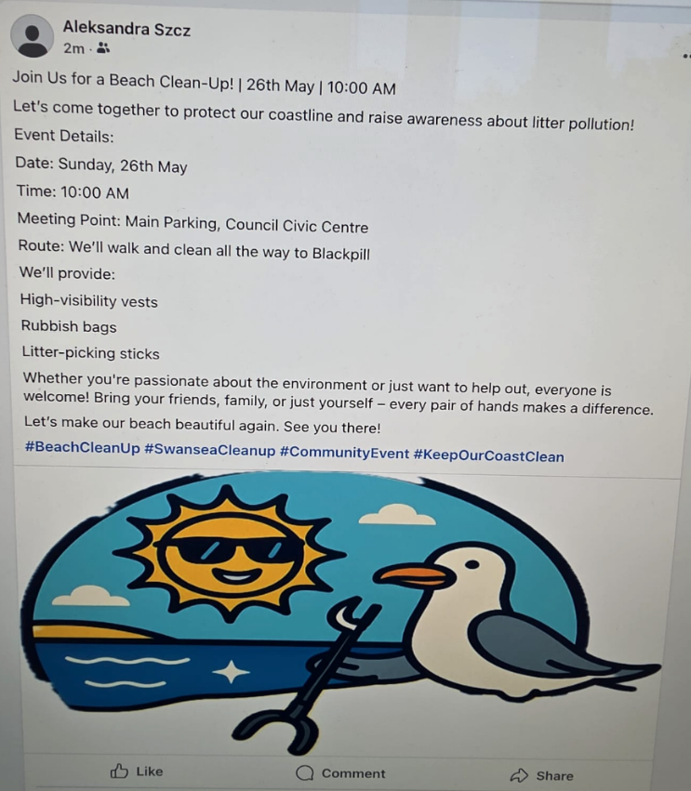
The implementation phase of a project is carrying out tasks, turning plans into actions and accomplishments of deliverables (Carroll, 2024). The Bay Brighteners Team has prepared a Work Breakdown Structure to achieve good performance in fulfilling project purposes. Team members have chosen WhatsApp and OneDrive as online communication channels to share information and documentations. Our colleague, Violeta contacted Swansea Council to figure out details about litter picking rules, tools and equipment provided for any volunteer’s litter picking event. Team member, Alexandra created a Facebook advert highlighting our project’s aims and invited volunteers for the event with exact time, date and place of project start (Fig. 5).

Figure 5. Facebook advert created by our team member, Alexandra to raise awareness of our Swansea Bay Beach Litter Picking event and invite volunteers to join.

Monitoring and Control
Bay Brighteners team carried out a careful and detailed Risk Assessment well before the litter picking event. The risk assessment identified the following potential hazards based on the recommendations of Keep Wales Tidy (2025):
- Delays in getting immediate assistance from emergency services
- Illness and infection caused by bacteria and dirt
- Moving heavy or awkward items resulting in injury
- Injury through contact with removed rubbish/ sharp items
- Hidden sharps e.g. broken glass, needles etc.
- Biohazards and pollution
- Animals - bites, stings or attacks
- Lone Working
- Young Persons and lack of awareness
- Aggressive People.

Evaluation
According to Kerzner (2017) the evaluation phase is the review of the project outcomes and success.
Reflective logs
Gibbs Reflective Cycle

Conclusion and Recommendations
In summary, the Swansea Bay Beach litter picking project was delivered successfully and efficiently.
In future projects, team members should strictly follow their specific responsibilities and respect each other better.

Reference list
APMG International (2025) ‘What is Agile Project Management?’, Available at: https://apmg-international.com/article/what-agile-project-management, [Accessed 1 Aug 2025].
Association for Project Management (2025) ‘What is a Gantt chart?’, Available at: https://www.apm.org.uk/resources/find-a-resource/gantt-chart/, [Accessed 31 July 2025].
Barker, S., Cole, R. (2015) ‘Brilliant project management’, (3rd ed.), Pearson UK.
Belbin, R.M. (2010) ‘Team Roles at Work’, (2nd ed.), Routledge. https://doi.org/10.4324/9780080963242.
Belbin, R.M. (2015) ‘Team Roles in a nutshell’, Available at: https://www.belbin.com/media/1336/belbin-for-students.pdf, [Accessed 17 May 2025].
Carroll, A. M. (2024) ‘Project Management Execution Phase: A comprehensive guide’, Available at: https://project-management.com/project-management-phases-exploring-phase-3-execution/, [Accessed: 1 August 2025].
Clegg, S.R., Skyttermoen, T., Vaagaasar, A.L. (2020) ‘Project Management: A Value Creation Approach’, London: Sage.
Chartered Management Institute (2025) ‘Stakeholder Analysis and Management’, Available at: https://www.managers.org.uk/knowledge-and-insights/resource/stakeholder-analysis-and-management/, [Accessed 1 Aug 2025].
Humphrey, A. S. (2005) ‘SWOT analysis’, Long Range Planning, 30(1), pp.46-52.
Keep Wales Tidy (2025) ‘Generic Litter Picking Risk Assessment.docx – Keep Wales Tidy’, Available at: https://keepwalestidy.cymru/, [Accessed: 23 May 2025].
Kerzner, H. (2017) ‘Project Management: A Systems Approach to Planning, Scheduling, and Controlling’, 12th ed. Hoboken: Wiley.
Kerzner, H. (2025) ‘Project management: a systems approach to planning, scheduling, and controlling’, John Wiley & Sons.
PMI (2025) ‘What is project management’, Available at: https://www.pmi.org/about/what-is-project-management, [Accessed: 24 June 2025].
Vertex42 (2025) ‘Simple Gantt Chart’, Available at: https://www.vertex42.com/ExcelTemplates/simple-gantt-chart.html, [Accessed: 22 May 2025].

