MODULE CODE: LCBB4004
ASSESSMENT 2
MARKETING FUNDAMENTALS ANALYSIS AND EVALUATION
APPLE
BY: IULIA TEODORA BOBOS
TUTOR’S NAME: TUSHARA BALENDRAN

Table of Contents
Introduction 3
Discussion 3
Conclusion 20
Reference List 21

Introduction
The essay establishes various nuances about strategic concepts of marketing, taking one of the biggest companies Apple into consideration. It provides the concept of marketing and its various stages. It also provides an aspect of how the activities of marketing help a company to create customer value regarding the products or services. It also provides information about the internal and external stakeholders of a given company and how can impact the marketing activities.

Discussion
The role of marketing in creating value for customers
Marketing and its various stages
Marketing refers to a set of activities, processes and institutions for communicating, creating and exchanging offerings that are of high value to the customers, partners, clients and society at large. The activities of marketing involve all such actions that are undertaken by the same to draw consumers’ attention and maintain a positive relationship with the same (McDonald, 2018).
The activities may range from promoting, advertisement, selling as well as delivering products or services to the people who have the potential of becoming prospective consumers.
The process of marketing generally consists of four stages. The first one revolves around product orientation of companies on increasing the rate of production, controlling or monitoring the cost and gaining profits through the volume of sales. O'cass and Ngo (2016), have stated in their journal that products that bear a good quality always "sell themselves" on behalf of the company.
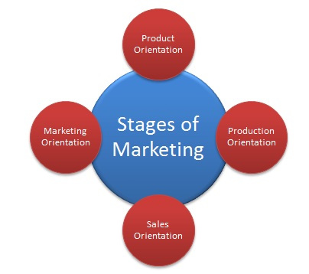
Fig 1: Strategies of Marketing
(Source: Slater et al., 2019)
Social Marketing concept
The concept of Social marketing refers to the aspect of a company mapping out its strategies and scenes of marketing a product or a service on the basis of the current consumer or market demand of a region (Yaşlıoğlu et al., 2017). In this concept, the companies marketing strategies are formulated in accordance with the consumers' requirements and needs as well as keeping in mind a society's long-term needs.

Fig 2: Social Marketing concept
(Source: Yaşlıoğlu et al., 2017)
In recent times, customers are of the expectation that the sellers would not only respond effectively to their needs that are expressed but also in case if understanding their business properly and proactively address their future needs. This concept of marketing is known as the Social Marketing Concept. It has also been revealed from the survey results that included 800 business customers as respondents in Singapore, India, Sweden and United Kingdom; it has been revealed that proactive customer orientation is one of the most consistent drivers of creating customer value (Gallarza et al., 2016). It has also been indicated that companies gain competitive advantage by providing proper solutions to the customers’ articulated requirements as well as their “latent future needs”.
Multinational as well as domestic companies in doing so take the help of marketing and various activities of advertisements in reaching out to its prospective consumers. Slater and Narver (2017), have indicated that in recent times business enterprises try hard to communicate and create value in everything. The customers or the purchasers have an overwhelming "abundance of choices". Customer value can basically be defined as the satisfaction or gratification at customer experiences by accepting a given option in accordance with the cost of the action.
Management of consumer expectations
Marketing also plays a pivotal role in monitoring and managing consumer expectations. Customers are bound to reply to the brands that were consistent in offering quality products and services at an agreeable rate. Thus, companies use marketing to help the consumer group learn about the most reliable offerings or even the best values they are offered in. The internal chain of process, sourcing, sales, marketing, as well as customer service all contribute immensely in creation of value amongst the consumers (Payne and Holt, 2018). People do not purchase things because a company likes them; rather they buy it for themselves.
Customer value can be simplified into the basic formula that it is equivalent to all the benefits that are received by purchasers along with the purchase cost and time. In order for a product or service to have a demand in the market, companies need to incorporate features that are equivalent to the needs and requirements of the purchasers (Gallarza et al., 2016). The companies are also bound to set the products at a price that can easily influence the purchasing intent of consumers at the time of buying it. Marketing is the process that helps in extracting the plans and the medium through which products are oriented to its purchasers.
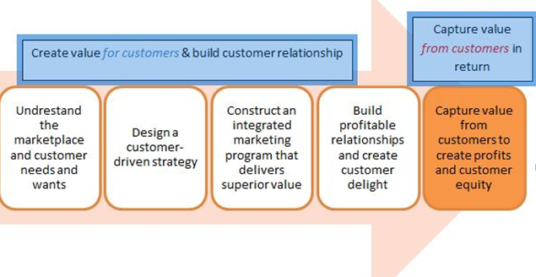
Fig 2: Concept of understanding customer value
(Source: Gallarza et al., 2016)
Educating the consumers
Marketing informs the consumers about a product or service that is offered in the market. Marketing is a tool that is extensively used to create and maintain relevance, demand, and relation as well as gain a comparative advantage over other contemporaries for companies.
The most integral part of marketing is its persuasive intent or the attempt of identifying a consumer needs and informing the same about the company's latest offerings along with its ability to gratify the consumers' requirements (Tournois, 2019). It provides the consumers with proper practical information about products and assists them in making a reliable purchase decision such as product release dates, store hours, its availability, payment methods as well as website links. One of the leading product-based technological companies that have capitalized on the aspect of marketing is Apple.
Apple's mission is to bring the best "user experience" to its customers with the help of its innovative software, hardware and services. Apple also aims at producing the best devices and products on the face of the earth, where customer satisfaction and innovation are the topmost priorities for the company (Woodruff et al., 2019). Apple has been one of the greatest marketers with its consistent and effective marketing strategies that are built on certain specific core disciplines that not only has its theoretical application but also can be used pragmatically.
It has always introduced game-changing products into the market with the aspect of customer preference and necessities in mind. It has already been mentioned in the previous section that the purchasing intent of the customers can only be moulded by providing them products or services that gratuities necessities. Warnaby and Finney (2018), have pointed out that Apple has been voted the overall winner in the “2017 CMO Survey Awards” for the 10th consecutive year.
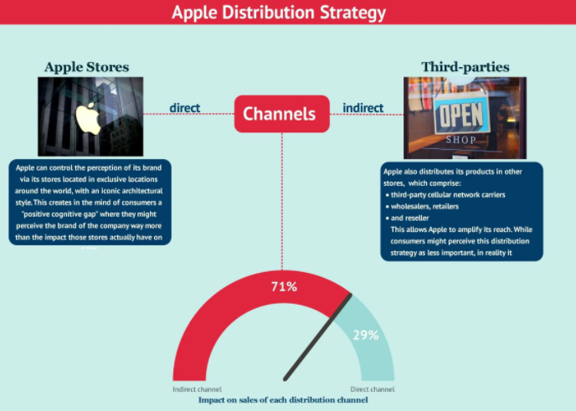
Fig 3: Apple distribution Strategy
(Source: Warnaby and Finney, 2018)
The most effective marketing strategy that Apple has implemented is creating an ecosystem. The company has enjoyed an “unparalleled revenue growth” of $8 billion to $ 18 billion. Christopher (2016), states that Apple was not the only company to have introduced tablet, Smartphone, portable devices to its customers. However, Apple has amassed a proper brand loyalty with the help of its access to data that the company leverages.
Marketing, with the use of consumer behaviour insight, is the main strategy of Apple. Once a consumer downloads iTunes it has access to all the data of that purchaser that it puts into use.
Guenzi and Troilo (2018), have pointed out a purchaser's intent is basically based on effect and cognition, consumer behaviour and consumer environment. In psychology, the “affective system” is defined as an individual's reaction to the external stimuli. Through the beverage brand logo and brand messages across its vase communicative channels, Apple capitalizes the aspect of the external stimuli to a great extent. The company’s marketing, as well as business strategies, leverages the unique ability to develop and design its own operating systems, its hardware application and even the software and services to provide its consumers’ solutions having superior design whilst having utmost ease-of-use.
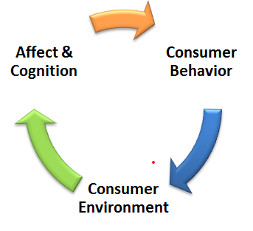
Fig 4: Purchaser Intent
(Source: Guenzi and Troilo, 2018)
Economic Branding and its benefits
There are also various economic benefits to marketing. Marketing is considered to be a key driving force for the consumer economy that helps in the promotion of services as well as goods.
Graf and Maas (2016), have indicated that the more effective strategies a company implements in case of its marketing, it is more likely it is to expand its profit margins. Companies also create an abundance of employment opportunities with a high rate of tax revenue for the government and the overall economic growth of a country. Apple has been successful in creating more than 2,000,000 employment opportunities over 50 states (Hooley et al., 2016). It is responsible for 2.4 million US jobs and has been estimated to contribute $350 billion to the economy of the US by 2023.
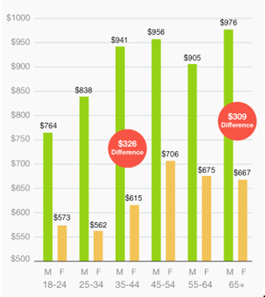
Fig 5: Total sales of Apple products in the US
(Source: Hooley et al., 2016)
It also accounts for fur 0.5% of the total US GDP. With its rapid product innovation like iPod/iTunes, innovation in software like iOS, AirDrop and many more it has also paved the way for many budding entrepreneurs, new avenues expanding the marketing industry further.
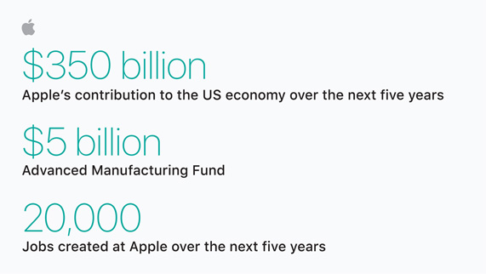
Fig 6: Economic benefit provided by Apple
(Source: Hooley et al., 2016)
Branding
Branding can be defined as the practice of creating a symbol, name and even a design that demarcates and identifies a service or a product from the others. Creating an effective branding strategy provides a humongous edge to business organizations to gain a foothold in the competitive markets.
Advantages of Branding
However, there are innumerable benefits or advantages that branding provides to consumers as well as companies. Mascarenhas et al. (2017), have stated that Branding helps the leading companies to stand out amongst others in a saturated market. There are multiple brands that deliver or cater to products or services similar to others. In such a case, Branding helps the companies to create their own identity and distinguishes itself with the help of a symbol and even a logo that represents the very essence of the company.
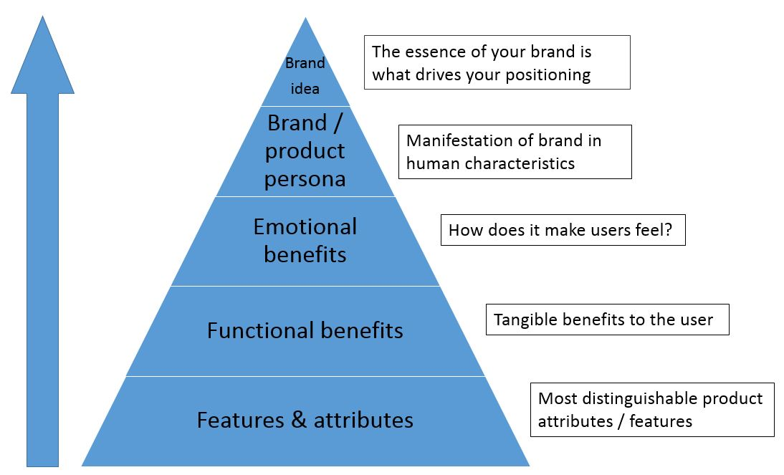
Fig 7: Branding and its benefits
(Source: Nijssen and Frambach, 2017)
Multinational companies like Nike, Adidas, Apple, Target, Google and many more accounts for the most famous logos that offer convenience for the purchaser to remember them. Branding also provides a certain degree of peace-of-mind to consumers. If the bounds to keep up with a certain level of consistency in delivering quality products to its end-users, it achieves in giving the correct peace of mind to the buyers (Nijssen and Frambach, 2017). Branding also results in creating brand loyalty and global recognition which can last for a lifetime. Brands also help its customers to save a hefty amount of time, providing them with the opportunity to make a fast-paced decision. With consistency in providing quality services and products to the customers, it also creates a sense of trust in them.

Fig 8: Total revenue generation of Apple
(Source: Berghman et al., 2018)
As a result of which consumers can easily make their purchase decisions based on the brands compelling them to receive its offerings for the second time without having them to give a second thought about it. In addition to this branding also diminishes the dilemma that purchasers are bound to have at the time of purchasing or availing any service or product as their previous experience has already created a sense of trust and security regarding the brand within their minds.
68% of consumers are reported to select a pre-existing brand or the one they had a good experience with for their next purchase. Brands also help to attract ideal clients. For example, if one has a high-end floral business and aims to attract a “higher-paying client”, the company needs to invest more in high-quality packaging (Berghman et al., 2018). An example, Starbucks, has been given that the premium coffee sellers attract made their branding strategy in line with itself catering to a specific target –consumers or the higher-paying clients who can value quality over price. Brands also help consumers create their identity.
This has a close nexus with the above-mentioned point as selecting a certain brand or service makes a consumer fall under specific categories that are further used in strategic innovations. Buying a specific product or a brand sets people into economic categories (Moorman and Rust, 2020). For example, buyers having a penchant for Nike shoes create a statement or identity for themselves by their purchasing choices. There are various brands that have introduced tablets installed with cutting edge software. However, buying a MacBook creates a commercial identity for a consumer who is then placed in a category according to their purchase.
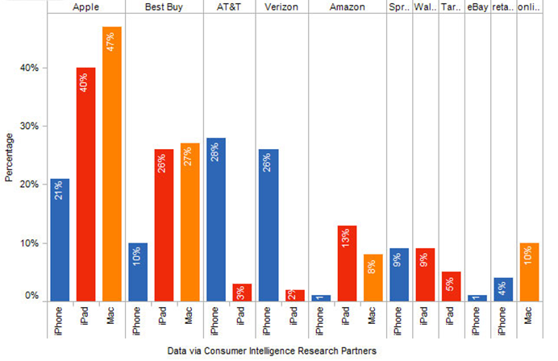
Fig 9: Percentage of Apple products being sold
(Source: Moorman and Rust, 2020)

Ansoff Matrix
Ansoff matrix is one of the most useful marketing tools that also have its pragmatic application. It is also known as product or market expansion Grid which comprises four factors, namely- Market Development, Product Diversification, Market Penetration and Product Development. Market Development refers to the creation of a new product or service that would eventually create new marketing (Graf and Maas, 2019). Product Diversification refers to developing numerous products or services that cater to different target-consumers, whilst market penetration refers to the development of new marketing strategies like marketing schemes or services offers. Lastly, product development suggests diversification of products by the development of variants or repackage. Apple believes in updating their products according to the market and customer’s demands. This builds an advantage for the organisation as they stay ahead of the business from their competitors. This diversification strategy has made Apple the brand it is today.
Ansoff Matrix Model
Ansoff Matrix Model is one of the most popular marketing models and is widely followed by marketers today. However, it has few advantages and disadvantages.
Advantages of Ansoff Matrix Model
- This model helps the marketers in analysing the various risks involved when the organisation is acting towards a particular direction.
- It helps the organisation in growth.
- It shows the organisation the possible options and alternatives that can help in growth.
- It helps the marketing team to understand the risks.
- It is a very convenient and easy way to analyse.
Disadvantages of Ansoff Matrix Model
- This model does not take into account the various competitors of the organisation.
- The environment of the market is ignored.
- It fails to show the various market diversification ways.
- It does not take into account the five forces of Porter.
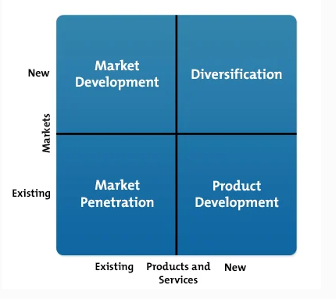
Fig 10: Ansoff Matrix
(Source: Graf and Maas, 2019)
Stakeholder engagement and their significance of marketing activities
Stakeholders and its various types
A stakeholder is a group of people that bears a valid interest in the various undertakings, activity or decisions of a company. The stakeholders are indirectly or indirectly affected by the organizational and operational activities that are undertaken by a company. The group of stakeholders ranging from suppliers, the company's internal staff or employees, manufacturers, shareholders, investors, consumers, as well as local or regional communities (Woodruff and Flint, 2018). The groups of stakeholders are categorized into two divisions- Internal Stakeholders and External Stakeholders.
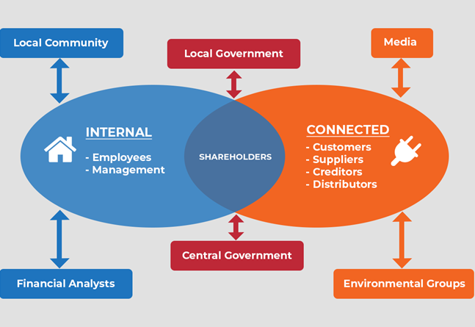
Fig 11: Types of Stakeholders
(Source: Woodruff and Flint, 2018)
The internal stakeholders comprise of internal staff like managers, production units, the board of directors, investors, other employees etc. However, the external stakeholders consist of suppliers, manufacturers, consumers, shareholders and many more. Apple can arguably be deemed as of the greatest technology companies in the US that specializes in development, design and selling of computers, portable devices and software that requires innumerable manpower. It almost has more than 2.4 million employees in the United States belonging from top management to its production units. Albert Gore Jr, Tim Cook, Andrea Jung and many more are the board of directors of Apple and indeed the internal stakeholders.
Some business partners of Apple are Cisco that provides leading networking security to Apple, Enterprise Next provides Apple enterprise expertise like iOS solution workshops, IBM, Salesforce etc. (O'cass and Ngo, 2019). The other investors are Berkshire Hathaway Inc (BRK.A), BlackRock Inc and many more. All these are the ideal examples of Apple’s internal stakeholders.
In the case of its external Stakeholders, the total number of 1.4 million Smartphone purchasers and 3.5 million MacBook consumers are the greatest external stakeholder Apple possesses. The suppliers of Apple are 3M (MMM), Qualcomm, Intel, Micron, Texas Instruments, and much more Apple’s supply chain is on one of the ideal supply-chains in the commercial market. It has over 200 suppliers and over 800 production facilities (Yaşlıoğlu et al., 2016). Hon Hai Foxconn is one of the major external and overseas suppliers of Apple whilst Wistron is a supplier that has helped Apple gain a foothold in India.
Establishment of communication with the stakeholders
Companies are bound to interact with both of its internal as well as external stakeholders at intermittent intervals. Communication as well as culturally are strongly interconnected to each other. Cultural diversity also brings a great impact on the non-verbal and verbal communication amongst stakeholders. However, Apple has been a company that has always emphasized on having a team with employees belonging from culturally diversified backgrounds.
Apple has formulated various training programs like iPadOS, iOS and various training programs on File Vault and system protection for a time-frame ranging from 1 week to 2 days for its employees in order to help them gain additional skill and knowledge along with providing a platform for interactions (Payne and Holt, 2018). The personal belonging from the top management team communicates with the employees face-to-face helping them to overcome any circumstantial inhibition that they might be harbouring. Apple has created a free learning environment for its internal staff and conducts regular meetings where all the board of directors remains present in an attempt to discuss the future strategies of innovation and market expansion.
It also uses various telecommunication services like Skype, email and many more to communicate with its overseas suppliers like Wistron, Foxconn and many more. One of the latest methods of communication that Apple has resorted to is creating a customer support Twitter account (Tournois 2019). The official Apple Support account posts customers tip every day, which has gained it almost 300,000 followers within two months.

Fig 12: Apple’s official customer support Twitter account
(Source: Woodruff and Flint, 2018)
Apple also conducts annual meetings for its shareholders, where he addresses misinformed questions and doubts of its shareholders. It also consists of discussion on the election of directors, Ratification of a public accounting firm and advisory vote to approve the executive compensation.
Impact of stakeholders on marketing activities of the chosen company
Stakeholders have a pivotal role to play in case of affecting the marketing activities of Apple. In the case of one of the most influential stakeholders or the customers, Apple is required to formulate tailored marketing techniques that would appeal to its end-users. Customer visibility is directly proportional to the resounding success of a marketing strategy (Campbell, 2016). In the case of investors and shareholders who form the basis of the backbones of the company are instrumental in deciding the marketing budget of the same.
The more strategic and holistic approach the company would take in its marketing activities, the more profit it is estimated to earn. The financial resources provided to a company are instrumental in carrying out a successful marketing approach. The internal staff or the working units belonging from the sales or marketing department are the creative minds behind a strategic marketing idea. The more creative inputs are provided by the team, the greater would be the possibility for promotional or marketing campaigns to make an impact on the end-user’s mind.

Conclusion
The essay concludes various concepts of marketing, starting from social interaction concept to the economic benefits that marketing provides a company as well as its domestic region. It establishes the reasons how marketing benefits a company to create customer value for its product. The benefits of branding are highlighted, as well. The various communicative strategies that Apple adopted in communicating with its stakeholders are also provided along with the effect of the former on the marketing activities of the company.
Recommendations
In case of establishing a better form of communication with the stakeholders, Apple can create an online forum for its employees wherein they can put forth their opinions, concerns and ideas about the company and its ventures. Employees should also be able to participate in various surveys about the workplace conditions and whether there requires any change to be incorporated.
It will help the board of directors to manage the store’s locations as well as the teams properly. Apple should also conduct monthly meetings with the aim of discussing the pressing issues and post newsletters to shed light on the fact that Apple also cares about the people working behind its products.
In case of increasing interaction with the customers, Apple should take more help from social networking sites like Face book and Instagram and interact with the masses at large.

Reference List
Berghman, L., Matthyssens, P. and Vandenbempt, K., 2018. Building competences for new customer value creation: An exploratory study. Industrial marketing management, 35(8), pp.961-973.
Campbell, A.J., 2016. Creating customer knowledge competence: managing customer relationship management programs strategically. Industrial marketing management, 32(5), pp.375-383.
Christopher, M., 2016. From brand values to customer value. Journal of Marketing Practice: applied marketing science.
Gallarza, M.G., Gil‐Saura, I. and Holbrook, M.B., 2016. The value of value: Further excursions on the meaning and role of customer value. Journal of consumer behaviour, 10(4), pp.179-191.
Graf, A. and Maas, P., 2016. Customer value from a customer perspective: a comprehensive review. Journal für Betriebswirtschaft, 58(1), pp.1-20.
Guenzi, P. and Troilo, G., 2018. The joint contribution of marketing and sales to the creation of superior customer value. Journal of Business Research, 60(2), pp.98-107.
Hooley, G.J., Greenley, G.E., Cadogan, J.W. and Fahy, J., 2016. The performance impact of marketing resources. Journal of business research, 58(1), pp.18-27.
Mascarenhas, O.A., Kesavan, R. and Bernacchi, M., 2017. Customer value‐chain involvement for co‐creating customer delight. Journal of consumer marketing.
McDonald, M., 2018. The role of marketing in creating customer value. Science & Education Journal, 6(4), pp.177-181.
Moorman, C. and Rust, R.T., 2020. The role of marketing. Journal of Marketing, 63(4_suppl1), pp.180-197.
Nijssen, E.J. and Frambach, R.T., 2017. Creating customer value through strategic marketing planning: A management approach. Springer Science & Business Media.
O'cass, A. and Ngo, L.V., 2016. Creating superior customer value for firms through supplier firm capabilities. Industrial Marketing Management, 41(1), pp.125-135.
Payne, A. and Holt, S., 2018. Diagnosing customer value: integrating the value process and relationship marketing. British Journal of management, 12(2), pp.159-182.
Slater, S.F. and Narver, J.C., 2017. Market orientation, customer value, and superior performance. Business horizons, 37(2), pp.22-28.
Tournois, L., 2019. CREATING CUSTOMER VALUE: BRIDGING THEORY AND PRACTICE. Marketing management journal, 14(2).
Warnaby, G. and Finney, J., 2016. Creating customer value in the not‐for‐profit sector: a case study of the British Library. International Journal of Nonprofit and Voluntary Sector Marketing, 10(3), pp.183-195.
Woodruff, R.B. and Flint, D.J., 2019. Marketing’s service-dominant logic and customer value. In The Service-Dominant Logic of Marketing (pp. 201-213). Routledge.
Yaşlıoğlu, M., Çalışkan, B.Ö.Ö. and Şap, Ö., 2017. The role of innovation and perceived service quality in creating customer value: A study on employees of a center establishment. Procedia-Social and Behavioral Sciences, 99, pp.629-635.

