

Module Code: BMHP2023
Module Title: Introduction to Physiology
Assignment Title: Written Assignment (Case Study Report)

Student Name: ANFISA HNATIUC
Student Number: 2333322
Lecturer: Robert Nartowski

Table of Contents
Introduction 3
Regulation of Blood Sugar Levels 4
Cellular Metabolism: How Oxygen and Glucose Produce Energy 5
Labelled Diagram Cellular Respiration Process 6
Recording and Tracking Blood Sugar Levels 7
Evidence-Based Lifestyle Interventions 7
Conclusion 10
References 11

Introduction
Diabetes mellitus is a long-lasting metabolic condition that is characterised by chronic hyperglycaemia, which is caused by anomalies in the secretion of insulin or the action of the combination of the two. Insulin is a hormone secreted by the pancreas, which is very important in blood glucose regulation. In case of the disruption of this mechanism, glucose in the bloodstream increases, which causes a number of acute and long-term complications (Baynes, 2022).
Diabetes has three main types.
Another autoimmune disease that leads to the annihilation of pancreatic 8-cells, giving rise to a complete lack of insulin, is type 1 diabetes.
Diabetes type 1 is an immunological disease causing the pancreatic beta-cells annihilation, leading to complete insulin shortage. Diabetes type 2 arises from insulin confrontation and relative insulin deficiency, often due to obesity, unhealthy eating habits, and a sedentary lifestyle (Morrison et al., 2021).
According to the estimation of Diabetes UK 2024, it is estimated that in the UK, there are more than 4.5 million diabetes cases, Type 2 diabetes consuming about 90 percent of all cases. It is on the rise, with the increase in the cases of obesity, older age, and lifestyle changes. Diabetes has health impacts on the individual, and puts strain on the health care system, increasing the risks of vision loss, kidney failure, and lower limb amputation. Diabetes is a disease that is result of mix of both modifiable and non-modifiable risk issues. Unhealthy eating (primarily the intake of high sugar rates and fats), obesity, smoking, high alcohol and physical activity are just a few factors which can be altered. The non-modifiable ones include genetic predisposition, age (particularly, over 45 years), ethnicity (particularly, South Asian and African-Caribbean residents), and history of gestational diabetes (Tinajero and Malik, 2021).

Regulation of Blood Sugar Levels
The regulation of blood glucose is a crucial process in physiology that holds the balance of energy, and the supply of glucose is constant and sufficient for the cells. The brain and body tissues mostly demand glucose as a primary source of energy, and its level in the blood is highly regulated by a complex network of hormones, the key hormones being insulin and glucagon, both released by the pancreas. Langerhans’s 2-cells of islets produce Insulin, and it reduces the blood glucose level by enhancing the intake of glucose in the liver, fat cells and muscle. On the contrary, the glucagon released by alpha-cells stimulates the elevation of the blood glucose level by facilitating the glycogen breakdown and the glucose production done in the liver (Parker, 2020).
Carbohydrate digestion elevates the blood glucose level during the fed state (post-eating). This is an indication that the pancreas is stimulated to secrete insulin to facilitate the glucose acceptance by tissues and convert excess glucose to glycogen so that it can be stowed in the muscles and liver. Insulin suppresses the breakdown of glycogen and burning of fats also such that main energy source is glucose.
When the level of blood glucose decreases to a post-absorptive or fasting level, insulin secretion is lowered and glucagon is discharged. Glucagon causes glycogenolysis the degradation of glycogen into glucose and gluconeogenesis. the formation of glucose by non-carbohydrate substances like amino acids and glycerol in the liver, thus returning the level of glucose in the blood to normal (Brameld et al., 2023).
Cortisol, adrenaline, and growth hormone are other hormones that have a regulatory role, especially when one is stressed or during fasting. These hormones augment hepatic production of glucose and lower cellular uptake of glucose, which provides adequate glucose to the critical organs.
The resistance of insulin to the cells glucose acceptance is present in patients with diabetes Type 2 and pancreatic 8-cells secretion of insulin is usually not sufficient to counteract the resistance. This causes chronic hyperglycaemia, which interferes with homeostasis and causes long-term effects of neuropathy, retinopathy, and cardiovascular disease (Davidson, 2022).

Cellular Metabolism: How Oxygen and Glucose Produce Energy
The biochemical process that cells use to get energy is called cellular respiration and yields adenosine triphosphate (ATP), the universal currency of energy in the body.
The total response may be summed up as:
C₆H₁₂O₆ + 6O₂ → 6CO₂ + 6H₂O + energy (ATP)
The process takes place in three broad steps and they are glycolysis, the Krebs cycle, and the electron transport chain.
Glycolysis occurs in the cytoplasm, where a molecule of glucose is degraded to generate two molecules of pyruvate, whereby a net increase of 2 ATP is achieved, and NADH, containing high-energy electrons, is obtained. The pyruvate is then transported to the mitochondria, where it is broken down to produce acetyl-CoA and enters the Krebs cycle (or citric acid cycle). Carbon dioxide is emitted as a by-product in this stage, and additional molecules of NADH and FADH2 are produced, which store energy to be used in the next step (Baker and Rutter, 2023).
The process of the electron transport chain (ETC) takes place along the inner membrane of the mitochondria. In this case, the electrons of NADH and FADH2 are passed on in a cascade of protein complexes. The emitted energy is used to generate ATP by oxidative phosphorylation, and oxygen is the ultimate electron acceptor, which combines with hydrogen to produce water. Up to 34 ATP molecules are generated during this step. hence, the step is the most energy-efficient step in cellular respiration.
The cells are unable to effectively use glucose in persons with diabetes because of insulin resistance (Type 2) or insulin deficiency (Type 1). Consequently, cells change to fat metabolism as a source of energy, with the formation of ketone bodies. In Type 1 diabetes, ketones may be fatal because when they build up, they cause diabetic ketoacidosis, which is a potentially lethal condition (Edmonds, 2020).

Labelled Diagram Cellular Respiration Process
Includes: pancreas, liver, skeletal muscle, adipose tissue, blood vessels, small intestine, heart, lungs, mitochondria and brain.

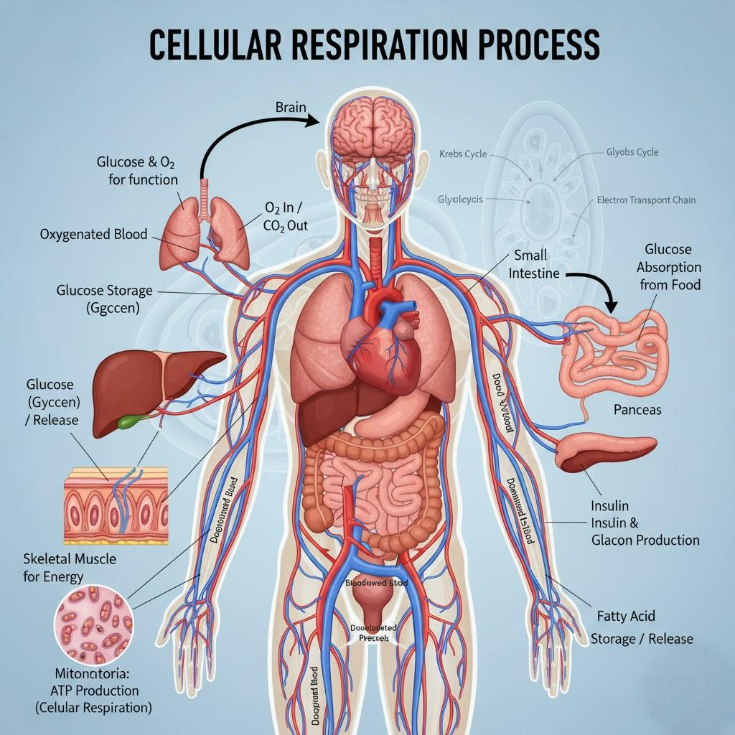
Figure 1

Recording and Tracking Blood Sugar Levels
Regular blood glucose measurement is one of the principles of effective management of diabetes. It enables the individual to monitor the reaction of his or her glucose level to food, physical activity, stress, and medication. By locating tendencies and changes, patients are able to make smart decisions regarding their daily routine and prevent such potentially harmful events as hypoglycaemia (low blood sugar) or hyperglycaemia (high blood sugar). Along with the day-to-day monitoring, the HbA1c test gives a generalised idea of the blood glucose level control in the last two to three months, which gives a long-term evaluation of the quality of diabetes management and treatment outcome (Carlson et al., 2020).
In diabetic patients with Type 2, self-management and empowerment through continuous monitoring help them to take charge of their health. It also assists medical workers in customising treatment programs, such as modified medication, food, and physical activity recommendations. Good monitoring of the level of glucose in the blood minimises the chances of long-term problems like retinopathy, nephropathy, and neuropathy, which are usually linked to uncontrolled diabetes.
The frequency of the recommended monitoring is based on the type of treatment and needs. Patients on insulin are advised to test their glucose level at least once a day, and others can test their glucose lower than once a day depending on the recommendation of their clinician.

Evidence-Based Lifestyle Interventions
The use of Type 2 diabetes does not only rely on medical, but it must encompass sustainable lifestyle change as a sound clinical evidence. Diet, exercise, cessation of smoking, weight management and stress-reduction are lifestyle modifications that play a vital part in the improvement of glycaemic control, insulin sensitivity and prophylaxis of chronic issues (Levy et al., 2021).
Dietary Modification
Diabetes management is based on dietary intervention. According to the findings published in the article of a research group named Look AHEAD (Action for Health in Diabetes) (Cortese, 2020) intensive lifestyle change based on weight reduction by calorie-cutting and increasing physical activity resulted in major weight and glycaemic control improvements in overweight and obese patients with Type 2 diabetes. Likewise, it was demonstrated by Mediterranean Diet Trial that vegetable-based, fruit-based, whole-grain-based, legume-based, olive-oil-based, fish-based diet was linked to reduced HbA1c, improved insulin resistance, and lesser cardiovascular risk.
Some of the suggestions include improving the intake of high-fibre foods such as fruits, vegetables, and whole grains which reduce glucose absorption and maintain the content of blood sugar at a constant level. The patients should limit the amount of refined sugar and saturated fats, which will result in insulin resistance and weight gain.
Physical Activity
Another major aspect of diabetes management is regular physical exercise. It was established that structured exercise programmes that incorporated both aerobic and resistance training had high levels of HbA1c and the overall metabolic health among patients with Type 2 diabetes. According to the American Diabetes Association (Colberg, 2024), the recommended exercises include at least 150 minutes of moderate-intensity exercise, which may be brisk walking, swimming, or cycling, and two resistance training sessions.
Workouts increase insulin sensitivity and glucose can enter the muscle cells with increased efficacy. It also helps in weight control, enhanced cardiovascular performance, and minimisation of secondary complications. Even a brief exercise, e.g., a 10-minute walk after meals, can produce a measurable positive effect on postprandial glucose levels. It should be advised that patients should progressively increase the level of activity, choose activities that they find enjoyable, and check their blood glucose to prevent hypoglycaemia (Zaccardi et al., 2020).
Smoking Cessation
Smoking is a proven risk factor for insulin resistance and diabetes development. A study conducted by Will showed that there were enormous risks that smokers were exposed to Type 2 diabetes and other cardiovascular complications. Cigarette nicotine and other chemicals also harm insulin activity and encourage inflammation, further increasing glycaemic control.
Smoking cessation increases insulin sensitivity, improving the operation of the circulatory system, and lowering the risk of heart disease and stroke. Male quit techniques comprise behaviour counselling, nicotine substitution treatment, and assistance by organising quit programmes. Patient encouragement, follow-up, and provision are crucial roles of medical professionals in helping them quit smoking.
Weight Management
Reduction in weight has a strong correlation with better glycaemic results. The results of the Diabetes Prevention Program showed that a 7 percent weight loss after diet and exercise lowered the chances of developing diabetes by 58 percent among persons with prediabetes. The paper highlighted lifestyle changes as a more effective and long-term solution to preventing and managing diabetes than pharmacological treatment.
The weight management strategies that have been found to be effective are a balanced diet, calorie restricted diet with regular physical activities and integration of behavioural therapy to overcome the weight loss barriers which may either be psychological or emotional in nature. The drive and responsibility is introduced by frequent weight checks and setting self-goals, and realistic planning accomplished by professional advice provided by dieticians or diabetes educators is personalised(Zaccardi et al., 2020).
Stress Minimisation and Sleep Hygiene
When one experiences chronic psychological stress, it causes the secretion of a hormone known as cortisol, which raises blood glucose levels through stimulation of hepatic production of glucose. Continuous high levels of cortisol may enhance insulin resistance and lead to poor glycaemic levels. Mindfulness meditation, yoga, breathing, and relaxation therapy techniques of stress management have been found to reduce glucose spikes associated with stress.
Also, the quality of sleep influences metabolism significantly. Spiegel discovered that lack or low quality, sleep decreases insulin sensitivity and heightens the levels of appetite-regulating hormones, contributing to the rise of glucose levels and possible weight gain. Patients are recommended to get 7-9 hours of restful sleep, keep regular sleep routines and reduce caffeine or screen time before sleep (Hawkes et al., 2023).

Conclusion
Diabetes type 2 is a lifelong and multifactorial disease that needs a comprehensive approach and would include biological knowledge, behavioural modification, and self-management. Proper treatment of diabetes requires the patient to be able to control and keep the blood sugar level at a constant level by making informed decisions and monitoring the level regularly. Frequent blood glucose monitoring allows one to monitor the effect of his/her diet, medication, or exercise on glucose levels and avoid the occurrence of both hypoglycaemia or hyperglycaemia.
This is substantiated by the fact that it was proven through numerous clinical studies that lifestyle interventions such as healthy, balanced and nutrient rich diet, exercise, being in a healthy body weight, and quitting of smoking are instrumental in the improvement of glycaemic control as well as helping to avert the risk of developing long-term complications, e.g. cardiovascular disease, neuropathy, kidney damage. Diabetes management prevails on the education and empowerment grounds. By educating patients about their illness and making them an integral part of it, it is possible to involve them into the treatment process more effectively and make them a contributor to their health. The practice nurses are playing a key role in the process as they will be as the leaders of the process, they will be involved in self-monitoring records evaluation and reinforcement of positive behaviour change with the help of motivational support provision and periodic follow-ups.

References
Baker, S.A. and Rutter, J. (2023) ‘Metabolites as signalling molecules’. Nature reviews molecular cell Biology, 24(5), pp.355-374.
Baynes, K. (2022) ‘Diabetes mellitus, obesity, lipoprotein disorders and other metabolic diseases’. In Medicine for Finals and Beyond (pp. 429-470). CRC Press.
Brameld, J.M., Parr, T. and Bender, D.A. (2023) ‘Carbohydrate metabolism’. Human Nutrition; Oxford University Press: Oxford, UK, p.136.
Carlson, A.L., Criego, A.B., Martens, T.W. and Bergenstal, R.M. (2020) ‘HbA1c: the glucose management indicator, time in range, and standardization of continuous glucose monitoring reports in clinical practice’. Endocrinology and Metabolism Clinics, 49(1), pp.95-107.
Colberg, T. (2024) ‘MEASURING ORGANISATIONAL RESILIENCE: COMBINING STRATEGIC AND OPERATIONAL DIMENSIONS’. JOURNAL OF BUSINESS MANAGEMENT, 22, pp.1-28.
Cortese, S. (2020) ‘Pharmacologic treatment of attention deficit–hyperactivity disorder’. New England Journal of Medicine, 383(11), pp.1050-1056.
Davidson, M.B. (2022) ‘Historical review of the diagnosis of prediabetes/intermediate hyperglycemia:case for the international criteria. Diabetes research and clinical practice, 185, p.109219.
Edmonds, M. (2020) ‘Metabolic Disorders and Management of High-Risk Patients’. Neale's Disorders of the Foot and Ankle E-Book: Neale's Disorders of the Foot and Ankle E-Book, p.261
Hawkes, G., Beaumont, R.N., Tyrrell, J., Power, G.M., Wood, A., Laakso, M., Fernandes Silva, L., Boehnke, M., Yin, X., Richardson, T.G. and Smith, G.D. (2023) ‘Genetic evidence that high BMI in childhood has a protective effect on intermediate diabetes traits, including measures of insulin sensitivity and secretion, after accounting for BMI in adulthood’. Diabetologia, 66(8), pp.1472-1480.
Levy, R.B., Rauber, F., Chang, K., Louzada, M.L.D.C., Monteiro, C.A., Millett, C. and Vamos, E.P. (2021) ‘Ultra-processed food consumption and type 2 diabetes incidence: a prospective cohort study’. Clinical Nutrition, 40(5), pp.3608-3614.
Morrison, A.E., Zaccardi, F., Chatterjee, S., Brady, E., Doherty, Y., Robertson, N., Hadjiconstantinou, M., Daniels, L., Hall, A., Khunti, K. and Davies, M.J (2021) ‘Self-compassion, metabolic control and health status in individuals with type 2 diabetes: A UK observational study’. Experimental and Clinical Endocrinology & Diabetes, 129(06), pp.413-419.
Parker, J. (2020) ‘Glucose metabolism, energy production and regulation of cellular and whole-body metabolism’. Journal of the Australasian College of Nutritional and Environmental Medicine, 39(1), pp.29-33.
Tinajero, M.G. and Malik, V.S. (2021) ‘An update on the epidemiology of type 2 diabetes: a global perspective’. Endocrinology and Metabolism Clinics, 50(3), pp.337-355.
Zaccardi, F., Ling, S., Lawson, C., Davies, M.J. and Khunti, K. (2020) ‘Severe hypoglycaemia and absolute risk of cause-specific mortality in individuals with type 2 diabetes: a UK primary care observational study’. Diabetologia, 63(10), pp.2129-2139.

