Elliott Lewis

Concrete and Steel Frame Buildings.
Compare and Contrast The Jade and NO1 Deansgate

Table of Contents
1. Introduction 3
2. The Jade 3
Design and planning 4
Site Area 4
MRT (Metro) Line 5
Design conclusion 5
Construction 5
Social Impact 6
Environmental Impact 7
3. NO 1 Deansgate 8
Design and planning 9
Construction conclusion 9
Social Impact 10
Environmental impact 10
4. Framing Material Analysis – Compare & Contrast 11
a. Durability and Climatic Resistance 11
Fire and security protection 12
Dimensional tolerances 12
b. Production Process 12
c. Assembly, Adaptation and Life Cycle 13
Adaptation 14
Life Cycle 14
5. Conclusion 14
6. References 15

Introduction

This report studies two habitable buildings and evaluates research on their construction method, framing material, sustainability factors and site-specific considerations relevant to the chosen case studies.

The Jade

Project Data
Site Area | 8705.5 mᶟ
Building Area | 1735 mᶟ
Total Floor Area | 30489.25 mᶟ
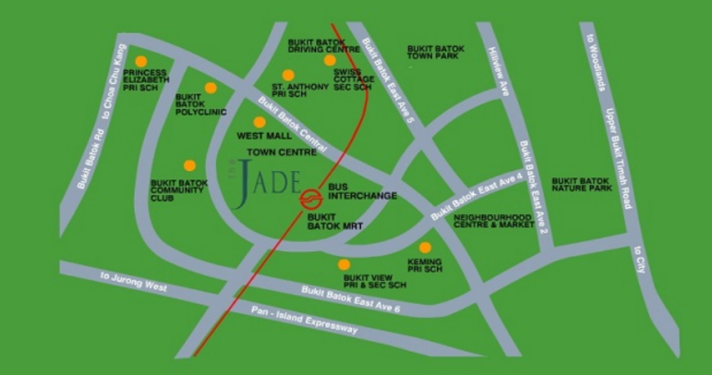
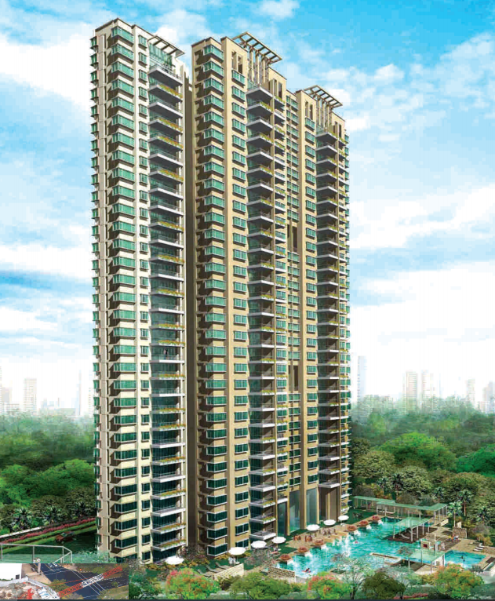
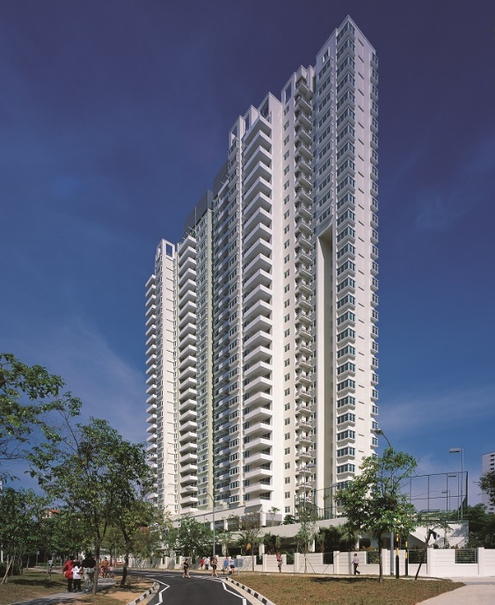
The Jade is in the heart of Bukit Batok Central in Singapore. The residential building consists of 31 stories with one basement and houses 280 units (Sim Lian Group Limited, no date) The project was completed in 2002 and took 29 months to construct by Sim Lian Construction. The structure is concrete framed and 120m in height costing $43.4 million.
(Buildable solutions for high-rise residential development, case study 2, no date)

Design and planning

During the pre-construction phase there were several site-specific constraints for consideration in the final design. Due to the site being small this restricted the amount of available working space. Also, the site being in proximity of the MRT (Metro) line was another significant factor to consider. The ground investigation revealed the earth below was mostly made up of bedrock and as a result the basement design chosen was a flat concrete slab supported on piles in the same way as the residential blocks were all to be founded on piles.

Site Area

Due to site constraints regarding working space, there are several important considerations required before progressing to construction stage. Plant and vehicle size may be compromised and this needs to be balanced alongside site safety. The maximum amount of material that can physically be delivered or removed also needs to be understood so that the programme and design can accurately reflect such constraints (Mace Group, 2016). The design and planning stage needed to consider where to position the two tower cranes and how they would utilise the use of prefabricated components. Offsite preassembly not only saves times, but it also reduces the number of deliveries required. When space is constrained production in a controlled factory environment is safer.
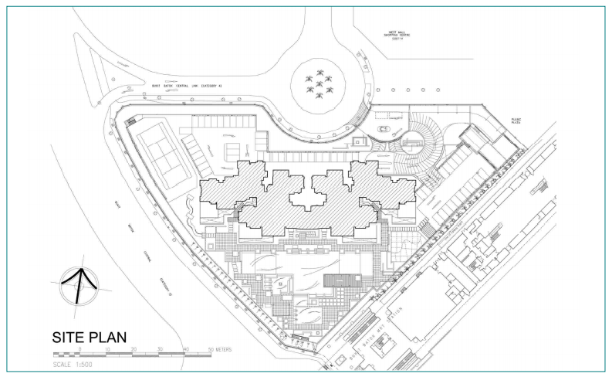
(Buildable solutions for high-rise residential development, case study 2, no date)

MRT (Metro) Line

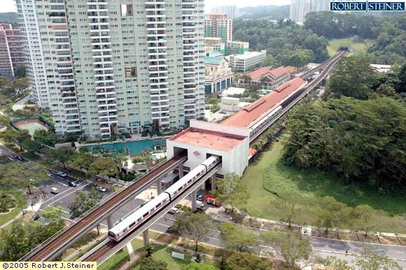
The site is near the MRT station, so the design had to accommodate strict restrictions and criteria set by the Land Transport Authority (LTA). The tower cranes required were not allowed to tower over the MRT station, resulting in several restrictions regarding usage and boom length during the works. As piles were used to support the structure during installation and construction process, monitoring devices were installed to ensure that the MRT structures were not affected by vibrations. The MRT line is regularly used and therefore public safety was paramount.
(Street directory, 2020)

Design conclusion

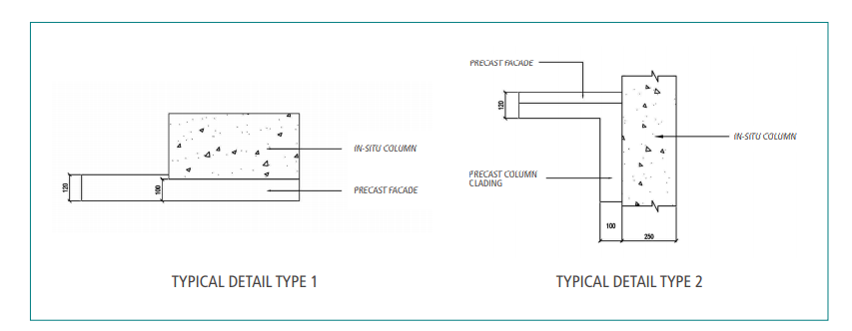
Due to the sites specific needs the decision was made that the combined use of cast in-situ columns with non-load-bearing precast facades as the external envelope of the building would the chosen construction method. This was believed to be the best method as precast facades could help achieve a better-quality wall finish (see figure?). They can incorporate a variety of colours, textures and finishes making them a popular design choice (Architectural precast innovations, INC. 2021) The facades were non load bearing and designed not only to act as the final finish but also as forms for cast in situ columns eliminating the need for framework.
(Buildable solutions for high-rise residential development, case study 2, no date)

Construction

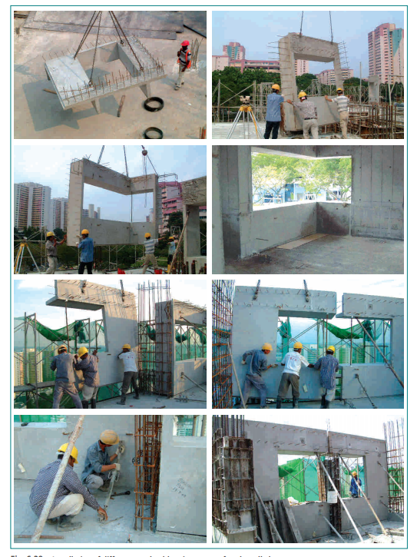
Metal shuttering was used for the in-situ casting of the simpler components such as the flat wall panels and columns. The prefabricated façade panels were cast off-site and delivered as required. They weighed around 4.5 tonnes hence the need for tower cranes to manoeuvre them.
(Buildable solutions for high-rise residential development, case study 2, no date)

Social Impact

Due to its location a quick delivery timescale was critical to reduce the impact in a busy area. The use of precast facades as integrated formwork for cast in-situ columns also reduced the construction time thereby achieving higher productivity and quality. The layout plan was simplistic and floor heights were repeated to facilitate the use of precast elements. Prefabricated components such as precast refuse chutes and precast staircases were used. This also helped limit the noise and improved speed of construction.

Environmental Impact

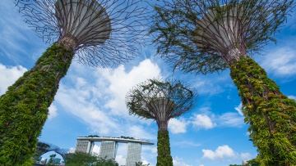
Singapore’s green space plan demonstrates their environmental conscience and how they plan to reduce emissions. Singapore has ambitions to have 80% of its buildings achieve Green Mark Certification by 2030. This certification represents sustainable development and quality living for its residents. One of Singapore’s most recognisable structures, Marina Bay Sands, embodies this vision and is a testament and true monument to environmental sustainability (Visit Singapore, 2021)
(Visit Singapore, 2021)

NO 1 Deansgate

No1 Deansgate is in Central Manchester (see figure?). The steel residential building was completed in 2002 and designed by Simpsonhaugh and Partners. The development was part of the areas redevelopment after the IRA bombing in 1996. The 60 metres high building has 14 floors which consists of 84 apartments also containing 8 penthouses. The apartments sit above a retail level 16 metres high.
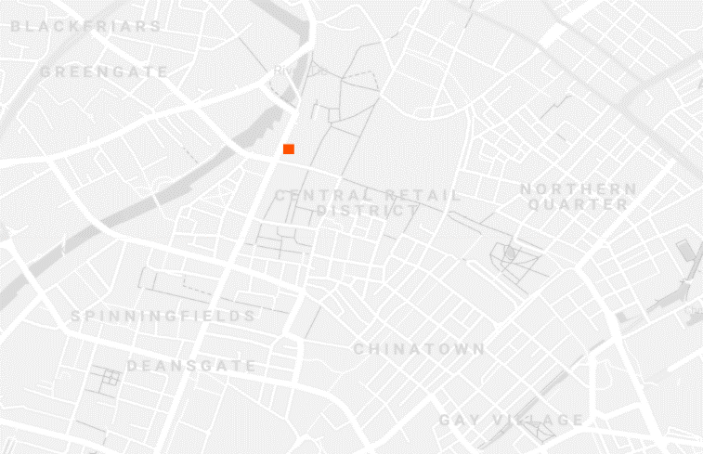
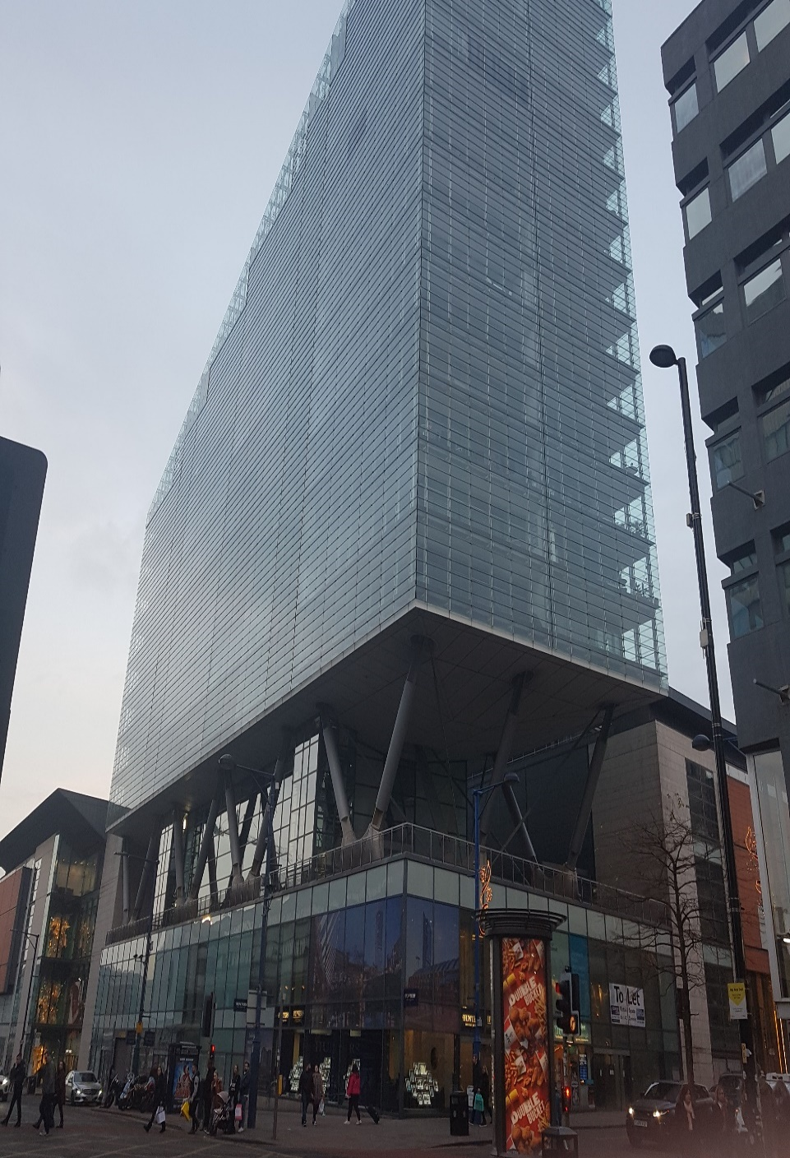
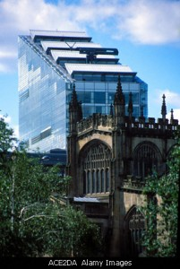
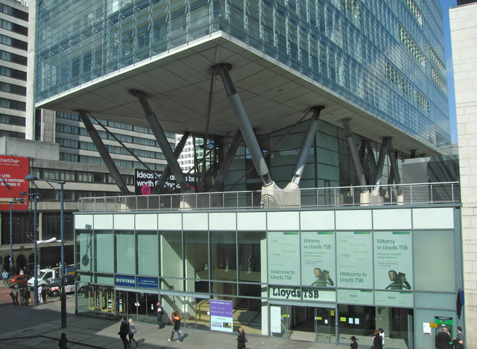
(The steel construction institute, Case study 4 no date)

Project Data
Total Floor Area | 18700 mᶟ

Design and planning

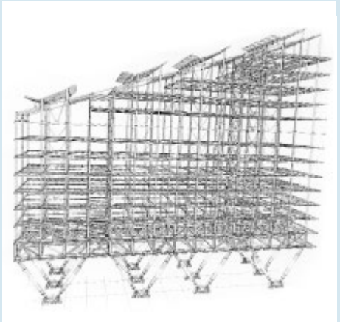
The main constraint with this project was the city centre location and therefore minimal impact and a quick programme was vital to limit the amount of disruption. The project took full advantage of the design opportunities steel construction can provide and subsequent construction of an innovative lightweight mixed commercial and residential building. It used existing foundations where possible again reducing the need for further groundworks. The open podium structure allows for pedestrian circulation below the residential block. It’s an iconic and instantly recognisable building within the city, achieved by its unique crystalline prismatic form of the residential floors supported on a series of dramatic inclined steel columns (Simpsonhaugh 2021) An innovative temporary platform was developed to allow for the floor beams to be erected quickly and safely and was raised each time the build progressed.
(The steel construction institute, Case study 4 no date)

Construction conclusion

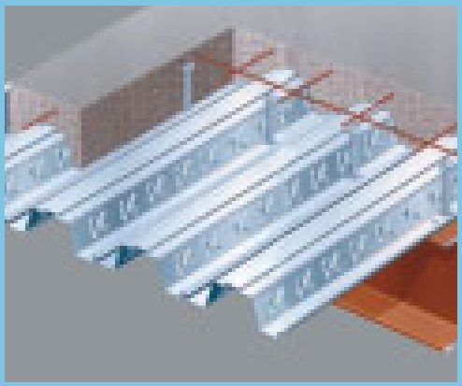
The uppers floors were roughly 60m by 17m and were formed using a regular steel structure in which a 4.1m span composite slab was supported by 6.8m span composite beams using 203mm UC sections that were perforated for services installation. The 165mm thick composite slab used Ribdek 80 decking finished with 40mm of screed (see figure?). At 16m above ground level the upper residential block sits on a one storey steel transfers structure which reduces the wider grid of the retail area below to the sensible residential grid. This was achieved by two directional trusses supported by incline tubular legs. The longitudinal transfer structure was erected as large, braced sections fabricated from UC sections and cruciform from 40mm steel plate. The structure used 800 tonnes of steel to construct.
(The steel construction institute, Case study 4 no date)

Social Impact

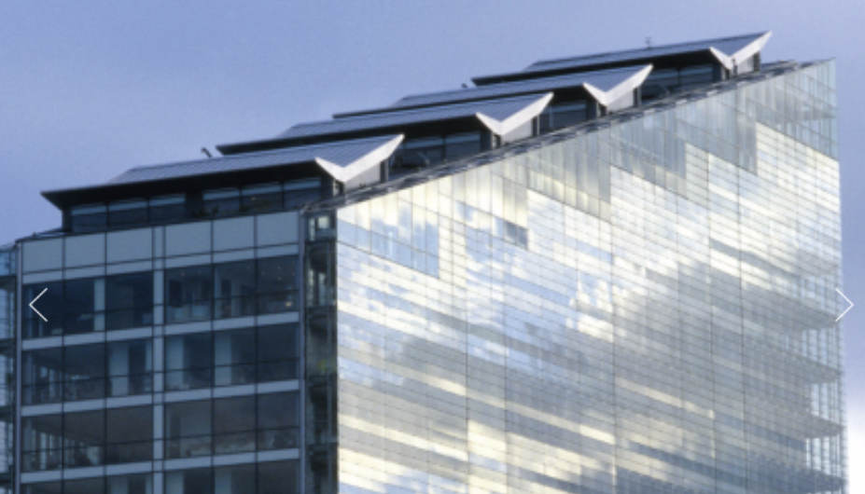
The aesthetic simple form the residential tower exhibits, relates in scale to the surrounding tall buildings, strengthening the dramatic long views down this major route through the city and framing the view of the Cathedral further north along Deansgate. The height of the residential tower steps down from its highest point on St Mary’s Gate acknowledging and respecting the variety of building heights in the surrounding context. Its orientation helps fill it with light and the sloping roof provides penthouses with open terraces.
(The steel construction institute, Case study 4 no date)

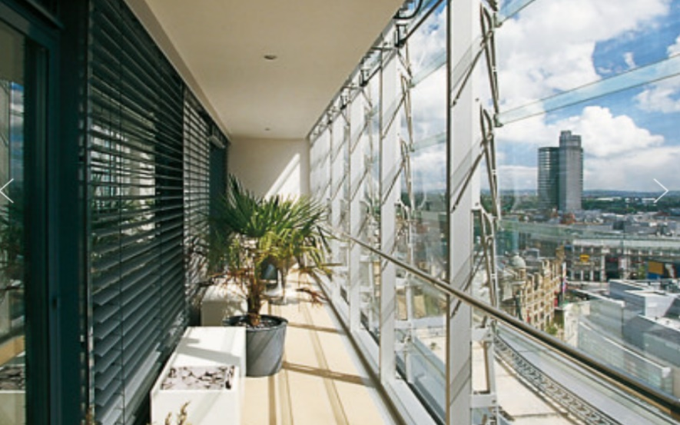
Environmental impact
Simpsonhaugh (2021)

Fully glazed, it incorporates a variable twin skin louvre system to the balcony outer edge, allowing for a highly usable and unique semi-outdoor space to the living accommodation but also assisting with acoustic, solar, and thermal gains.

Framing Material Analysis – Compare & Contrast

Durability and Climatic Resistance

One factor that leads to concrete deterioration as a framing material is freezing and thawing, however as the lowest temperature average in Singapore from data recorded 2005-2015 was 24ᵒc (time and date, 2015) this is not an issue. In Manchester however the climate is a lot colder and the average annual low temperature is 2ᵒc and below 0ᵒ are common over winter periods (time and date, 2015). Freezing and thawing effects faster on surfaces most likely to retain water (Civil Engineering Web, 2021) and therefore in Manchester the concrete facade method that The Jade has would be considerably less suitable unless preventive measures were put in place.
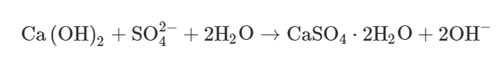
Chemical attack such as acid rain is another factor. Although Singapore is making great efforts to reduce emissions, acid rain is a worldwide issue. When concrete frame structures suffer sulphate attacks, hydration products within cement react with acid rain to produce gypsum, which can expand 1.5–2.2 times in volume (see formula below) (Oxford Academic, 2021). It can lead to cracking due to inside tensile stress which can compromise the structures condition and could lead to additional maintenance costs.
The optimum conditions for corrosion are a relative humidity of 70%-80% and can occur during carbonation (the reaction between the carbon dioxide in the air and the alkalis in the concrete). Carbonation indirectly effects the concretes durability by reducing the alkalinity, which longer term results in de-passivation of the steel reinforcement leading to corrosion (The University of Hong Kong, No date). Similarly, Manchester and Singapore have an average annual relative humidity of 80% (time and date, 2015)

Steel is prone to corrosion and requires frequent treatment to ensure protection from adverse weather and rusting. For corrosion to occur moisture and oxygen is required resulting in the iron in the steel to oxidise producing rust (see equation below). Unlike concrete the durability of steel can be greatly compromised if not correctly maintained (Steel construction, 2021).
Fe + 3O₂ + 2H₂O = 2Fe₂O₃H₂O
(Steel) + (Oxygen) + (Water) = Hydrated ferric oxide (Rust)
Specifically referring to NO1 Deansgate the finished building has exposed structural steel which could be greatly compromised if it were to rust, especially as they have incorporated the elegant treated structural steel into the design combining aesthetics and practicality.
As both buildings are residential their performance and fire durability are vital. Steel doesn’t have the same fire resistance as concrete but there are several solutions to improve its fire resistance. For example, in NO1 Deansgate a suspended ceiling comprising of two layers of 15mm plasterboard is in place to help improve fire resistance and protect the steel.

Fire and security protection
Due to terror risk and fire risk its vital buildings are constructed to offer the best possible protection against any possible threats. Due to current and fatal breaches in cladding of some high rise building eg. Grenfell, its vital open space voids are capped and that all the relevant safety requires are thorough to protect the structure. Effective escape routes should be created to help eliminate both risks.

Dimensional tolerances
When concrete is hot, or the moisture content changes it can expand and if there is no space to allow for this movement it can lead to cracking. Similarly, when steel is hot it can expand. If Deansgate was constructed in The Jades location the full properties of the steel structure would need to be evaluated to ensure the environment would not affect the structure. Change in tolerances, if not accounted for, could potentially compromise building integrity and present major health and safety risks.

Production Process

Steel production can have a negative effect on the environment. The main ingredient is iron ore which is mined from the earth at a rate of 2,000m/tonnes a year and 95% of it goes towards the production steel (The world counts, 2021). The mining itself is extremely energy intensive and can cause air pollution in the form of carbon dioxide, carbon monoxide, nitrous oxide and sulphur dioxide from plant and equipment. Acid drainage is another mining effect which can stay present for thousands of years. Acid drainage is the term given to water polluted by heavy metals and acid that drains away from the mine. A negative effect of using steel is that on average 1.83 tonnes of CO2 is emitted for every tonne produced, making it a key contributor to global warming. On the other hand, some countries are working to develop a new method that is less harmful. For example, Hyundai Steel’s Dangjin plant recycles 100 percent of the biproducts which supply 80% of the operation energy at the plant. This is achieved as the biproduct gas contains carbon monoxide, hydrogen and methane which can be utilised to heat up the plant furnaces (CNN,2011).

Although the production of concrete is not as harmful to the environment, due to concrete’s properties steel reinforcement is required to improve its tensile strength. During concrete production, the embodied energy consumed from the mining and processing of natural resources up to the manufacturing stage is believed to be between 0.86 mj/kg and 1.4 Mj/kg. Moreover, the embodied energy when reinforcement is added increases to 63% as the calculation also accounts for the production of steel rebars (Science direct, 2021)

Assembly, Adaptation and Life Cycle

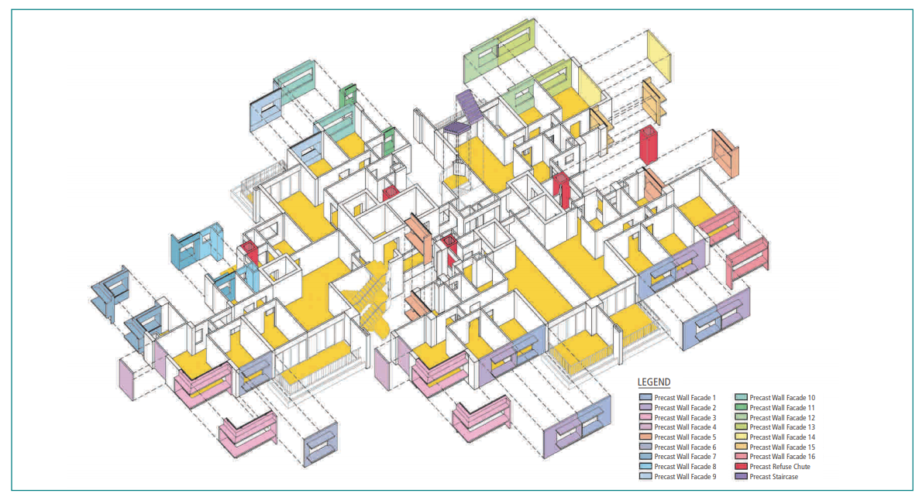
The construction cycle achieved by the concrete frame Jade building was about 10 days per floor. NO1 Deansgate took an average 14 days per floor but still proving that both materials can be erected quickly. Due to both buildings being in very urban areas operating quickly and effectively is vital, materials arrived on site to ‘just in time’ principles.
(Buildable solutions for high-rise residential development, case study 2, no date)
A benefit of prefabrication is that the service ducts can be prepared in advance and in some cases even installed off site. This not only saves time but limits health and safety risk.
Both sites are in highly urban areas making transport on and to site complicated. An advantage of both structures using prefabricated components means that deliveries can be coordinate to arrive just in time. Unlike steel, pouring concrete in situ also causes delivery problems. Traffic and highway planning are critical.

Adaptation
Steel’s ability to be extremely flexible means that future changes or extensions including even vertically can be carried out with minimal disruption and cost. Following the Covid-19 pandemic for example, adaptability is key in the construction sector with more people and the loss of overseas students it may force the repurposing of urban buildings. In general concrete does not offer the same flexibility achieved with steel without greater cost implications.

Life Cycle
Steel can be assembled, dissembled, recycled and reused. Concrete isn’t as easy to recycle and reuse with minimal scrap value. Steel is more expensive and usually requires more skilled labour to install. The Jade cost $43.4 million to construct and although there is not a fixed cost available for the Deansgate its known that the four penthouse suites were sold for £1.5 million each in 2002. These are both well sought-after apartment buildings in popular locations with good transport links and city centre access. Due to the kind of tenant both buildings attract they will be well maintained and consequently the buildings will stay in use for longer, increasing their life cycle.

Conclusion

The case studies demonstrate how different materials are chosen based on design specification and requirements. It is critical for designs to not only consider end user requirements, build material specifications etc. but also external factors including socio, economic and environmental impacts.

Impact | The Jade - Concrete | NO1 Deansgate - Steel
Meeting the Design Specification | - Allow for quick construction time and little disruption to surround environment | - Opportunity to create a unique building
Economic | - The cost of using concrete is usually less.  - Job Creation  - Area enhancement | - Construction cost using steel is generally more.  - Job creation  - Regeneration of area
Social | - Safe, and good housing provision.  - Long building life expectation  - Near to Metro | - Safe and good housing provision.  - Even longer building life expectation
Environmental | - Creation of concrete not conducive to low CO2 emissions longer term.  - Disposal difficult and costly | - Steel can be reused, repurposed  - Aligns to Manchester City’s Climate Change Action Plan -To adapt the city’s buildings, infrastructure, and natural environment to the changing climate.

(Words 2443)

References

Architectural precast innovations, INC (2021) Facades. Available at: Precast Concrete Facades- Architectural Precast Innovations - Default (api-precast.com) (Accessed: 7th February 2021)
Buildable solutions for high-rise residential development (no date) Case study 2. Available at: https://www.bca.gov.sg/publications/BuildabilitySeries/others/bsh_ch6.pdf (Accessed: 7th February 2021)
Civil Engineering Web (2021) Freezing and Thawing effect on durability of concrete-preventive measures. Available at: Freezing And Thawing Effect On Durability Of Concrete-Preventive Measures (civilengineeringweb.com) (Accessed 9th February)
CNN (2011) Hyundai steels itself for a cleaner future. Available at: Hyundai steels itself for a cleaner future - CNN (Accessed 14th February)
Mace group (2016) 6 things you need to know when working on constrained sites. Available at: https://www.macegroup.com/perspectives/161001-6-things-you-need-to-know-when-working-in-constrained-sites (Accessed: 7th February 2021)
Oxford Academic (2021) Effect of acid rain on economic loss of concrete structures in Hangzhou, China. Available at: Effect of acid rain on economic loss of concrete structures in Hangzhou, China | International Journal of Low-Carbon Technologies | Oxford Academic (oup.com) (Accessed 9th February)
Science Direct (2021) Concrete production. Available at: Concrete Production - an overview | ScienceDirect Topics (Accessed 14th February)
Sim Lian Group Limited (No date) Our Portfolio. Available at: https://www.simlian.com.sg/portfolio/residential/our-portfolio/the-jade/ (Accessed: 7th February 2021)
Simpsonhaugh (2021) No1 Deansgate. Available at: No.1 Deansgate | SimpsonHaugh (Accessed: 7th February 2021)
Steel Construction Info (2021) Corrosion of structural steel. Available at: Corrosion of structural steel - SteelConstruction.info (Accessed 9th February)
Street Directory (2021) Bukit Batok MRT Station (NS2) (top view). Available at: Top View of Bukit Batok MRT Station (NS2) Building Image, Singapore (streetdirectory.com)
The steel construction institute (no date) Case study 4. Available at: Resi Case Studies 25-7 (steelconstruction.info) (Accessed: 7th February 2021)
The University of Hong Kong (no date) Durability of reinforced concrete structures, theory vs practice. Available at: Durability of Reinforced Concrete Structures (devb.gov.hk) (Accessed 9th February)
The World Counts (2021) Impact of steel production. Available at: Environmental Impact of Steel - TheWorldCounts (Accessed 14th February)
Time and date (2015) Annual weather averages near Singapore. Available at: Climate & Weather Averages in Singapore, Singapore (timeanddate.com) (Accessed 9th February)
Time and date (2015) Climate & Weather Averages in Manchester, England, United Kingdom. Available at: Climate & Weather Averages in Manchester, England, United Kingdom (timeanddate.com) (Accessed 9th February)
Visit Singapore (2021) Leading the way: Singapore sustainable future. Available at: Leading the Way: Singapore’s Sustainable Future – MICE Singapore (visitsingapore.com) (Accessed: 7th February 2021)

