Student Name Bertha Amoah
Student Number 2324071
Module Code BMHP5015
Module Name Changemakers: Building your personal Brand
Assignment Title Component 1: Online Portfolio of set Exercises
Lecturer’s Name Danni Dunne
Due Date 18th November 2025

Table of Contents
Task 1 - Personal Brand 3
Task 2 - Network Map and Rationale 4
Task 3 - Blog 6
Task 4 - NHS Equality, Diversity and Inclusion Quiz 8
Task 5 - A Letter to Yourself 10
Task 6 - GANTT Chart 11
Task 7 - Making Changes: Report 12
Task 8 - Self-Reflection 14
Reference list 15

Task 1 - Personal Brand
The concept of a “personal brand” represents an individual’s professional identity comprising distinctive skills, experiences, and qualities (Gander, 2024). It defines how one’s value and reputation are perceived by others, particularly within professional contexts. Recognising its importance, I have articulated my personal brand in relation to my current role and career objectives. As a Care Worker at Flexi Coventry, my position demands diligence, adaptability, and the promotion of a positive, supportive workplace culture.
My personal brand aligns strongly with empathy, professional integrity, and inclusive practice, reflecting my commitment to person-centred care. As a reflective practitioner, I continually apply and evaluate health and social care theories to improve practice, incorporating principles such as safeguarding, personalised care planning, and mental well-being. Within my role, I maintain effective communication with colleagues and service users while upholding ethical and professional standards.
In pursuit of my employment goal to deliver high-quality, person-centred care, I have enhanced my understanding of local social care frameworks and developed key competencies for effective service delivery. Evidence highlights that carers who embrace person-centred approaches prioritise individuals’ needs, preferences, and values in decision-making (NHS, 2025). Consequently, my personal brand demonstrates a professional commitment to regulatory compliance and excellence in providing compassionate, individualised care.

Task 2 - Network Map and Rationale
A personal network map identifies and organises individuals within an individual’s personal and professional circle (McCarty et al., 2020). The purpose of such mapping is to analyse the value-based contributions of these connections within a specific professional context. Accordingly, I developed my own network map encompassing four dimensions: career, support, social, and community.
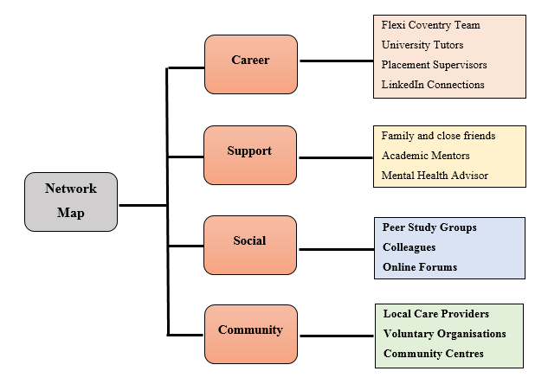
Figure 1: A Personal Network Map
(Source: Author)
The Career Network includes four key contributors—Flexi Coventry, university mentors, placement supervisors, and LinkedIn connections. These professional relationships strengthen my practice by aligning it with sector standards and promoting engagement with multidisciplinary models of person-centred care. The Support Network comprises family and friends, academic mentors, and a mental health advisor. This dimension enhances my emotional resilience and motivation, which are essential for sustaining performance in demanding care environments.
The Social Network includes peers, colleagues, and online forums. Research suggests that social networks facilitate collaboration, shared learning, and informal mentoring (Skills for Care, 2025), all of which broaden my understanding and improve reflective practice. Finally, the Community Network incorporates local care providers, voluntary organisations, and community centres. Active participation in this dimension fosters empathy, enabling me to connect with service users and appreciate their lived realities. Moreover, collaboration with community-based care agencies strengthens my cultural competence and supports the delivery of responsive, person-centred care tailored to diverse user needs.

Task 3 - Blog
Blog: Underfunding and Social Care Crisis in the UK
Target Audience: Care Workers, UK
The UK adult social care sector faces a profound dilemma of funding cuts and resource shortages amid rising demand for services. This situation has become unsustainable, requiring both new and existing professionals to understand the structural challenges that extend beyond individual professional development.
The Funding Gap
Adult social care plays a vital role in ensuring public well-being; however, it has suffered chronic underfunding for over a decade (Johnston and Pratt, 2024). Evidence from Stacey (2025) indicates that around 100,000 adults in the UK have been denied government-funded social care due to insufficient resources. Consequently, the Department of Health and Social Care faces mounting pressure from local authorities to increase financial support. The Institute for Government (IFG) reports a decline in the number of people receiving subsidised care across England, despite rising disability rates. Moreover, the government’s £5.4 billion “Build Back Better” plan (2021) has prioritised NHS integration, leaving unresolved issues such as workforce shortages and deteriorating infrastructure (van OS, 2025). These constraints have contributed to inconsistencies and inequities in care provision.
Care Access Inequality
England’s two-tier care system divides individuals into self-funders and state-funded recipients based on asset thresholds (Bach-Mortensen et al., 2025). This structure perpetuates inequalities: research shows that care homes in affluent areas are more frequently rated “outstanding” by the Care Quality Commission than those in deprived regions. As a result, vulnerable groups—particularly older adults—often receive lower-quality care and face barriers to essential services.
Implications for Practitioners
For both new and existing care workers, recognising the systemic impact of underfunding is essential. It highlights the need for institutional reform, targeted investment, and workforce resilience.
Policy Directions
Advocacy groups such as Care England and Hft are calling for a “multi-year funding settlement” to ensure pay parity with NHS roles and emergency workforce support (Care England, 2025). Such measures are vital to stabilising the sector and safeguarding equitable care for the UK’s ageing population.

Task 4 - NHS Equality, Diversity and Inclusion Quiz
- As part of the NHS EDI Improvement Plan, the institution seeks to foster belonging, trust, and an enhanced staff experience (NHS, 2023). The plan also aims to minimise disparities in care outcomes.
- The EDI/DEI plan proposes greater pay transparency, regular audits, and interventions addressing structural inequalities (NHS, 2023). These measures collectively promote positive EDI outcomes.
- Intersectionality within the EDI Improvement Plan acknowledges the overlapping disadvantages individuals face across race, gender, and disability (NHS, 2023). This recognition ensures tailored strategies to promote equity.
- Creating a psychologically safe work environment allows employees to voice concerns and contribute freely (Learninghub.nhs, 2025). Such an environment enhances well-being, retention, and care quality.
- The EDI plan supports international recruitment through culturally sensitive onboarding and mentorship (NHS, 2023). Fair career progression further strengthens overall staff experience.
- NHS leaders are expected to model inclusive behaviour and remain accountable for EDI outcomes (Nhsproviders, 2023). This leadership embeds equity within organisational culture and decision-making.
- The NHS Improvement Plan prioritises strategies to address workforce inequalities (Learninghub.nhs, 2025). It emphasises equitable access to career development, especially for underrepresented groups.
- Data collection is critical for identifying disparities and tracking EDI progress (NHS, 2023). The plan highlights safeguards in data handling to ensure protection and guide targeted interventions.
- Workforce flexibility supports diverse staff needs and removes barriers for employees with disabilities (Nhsproviders, 2023). This promotes a more inclusive and balanced organisational culture.
- Bullying and harassment are major workplace concerns addressed by mandatory training and reporting mechanisms (Learninghub.nhs, 2025). Leadership accountability further strengthens efforts to prevent and resolve such issues.

Task 5 - A Letter to Yourself
Dear Younger Self
I understand that things have become more complicated with an overwhelming sensation now. Over the years, you have been juggling a ton of responsibilities, studies and expectations, which are key for survival in this demanding world. You have a fair share of opportunities and failures, with doubts creeping in at times, which question your abilities and worth, whether you are contributing enough or there is room for improvement. However, it is appreciable that you have gone beyond expectations.
Fondling past experiences, I literally wish that you had a better hold on your emotions and a strong knowledge of emotional intelligence. The emotional turmoil you felt at times, although it made you strong, a literal concept of EI can help you in gaining self-awareness as well as potential growth. You had the strength, but at times loneliness might not haunt you if you were able to recognise your ability while naming and managing your emotions. You fought alone and never asked for help or even set boundaries, which makes the situation more challenging. Emotional intelligence is the mental wealth that would have allowed you to gain momentum in managing your needs and communicating the same with better clarity & compassion.
Resilience, on the other hand, has taken shape in you. Whenever you make your presence despite exhaustion or reflect without reaction, you demonstrate your resilience. But I highly doubt whether you ever gave it a thought as a skill rather than a mere trait. Overall, you marked your setbacks as stepping stones rather than your doomsday.
With Affection
Your Future Self

Task 6 - GANTT Chart
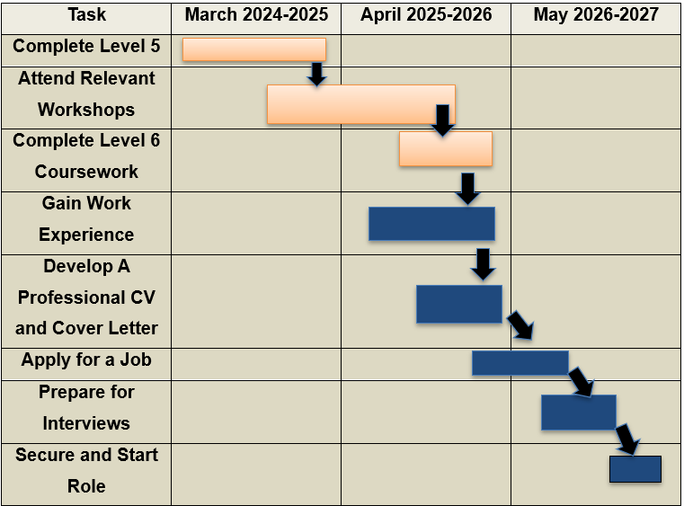
Figure 2: Gantt Chart
(Source: Author)
The Gantt Chart provides a structured framework for achieving my career objectives in the social care sector. As an aspiring professional, a time-bound and organised strategy is essential to enhance employability and support professional growth. The chart breaks down my overall goal into specific, manageable activities, including completing relevant training, gaining practical experience, developing interpersonal skills, and engaging in continuous professional development.
Each task is assigned a defined timeframe, allowing for effective progress monitoring and timely completion. This approach promotes discipline, accountability, and alignment between personal development and sector expectations. Moreover, the Gantt Chart encourages reflection and adaptability, enabling adjustments in response to emerging opportunities or challenges.
By following this timeline, I can systematically build competencies, expand my professional network, and strengthen my position within the social care sector. Overall, the Gantt Chart functions as both a strategic and motivational tool, guiding my progression toward becoming a skilled, confident, and compassionate social care professional.

Task 7 - Making Changes: Report
Introduction
As a Care Manager at Flexi Coventry, I aim to implement digitally enhanced, person-centred care planning. This initiative demonstrates my commitment to accountability and care excellence, highlighting essential skills and identifying potential barriers to success.
Proposed Change
To improve quality and consistency in care, I propose introducing a “digitally enhanced personalised care plan” to replace paper-based records. This transition will ensure accurate, real-time documentation, support effective communication among staff, and enhance collaborative care (England, 2025). Using Lewin’s Change Management Model (Hussain et al., 2020), the implementation will follow three stages:
- Unfreeze: Staff workshops will address limitations of current paper-based systems, share evidence of digital benefits, and engage stakeholders to build trust.
- Change: A user-friendly software tailored to adult care services will be introduced, with hands-on staff training, mentorship, and pilot testing.
- Refreeze: Digital care plans will be embedded into daily routines and audits. Early successes will be shared, and staff feedback used to refine the system.
Required Skills
Effective implementation requires evolving skills: digital literacy for system use, communication and teamwork for peer support, adaptability and resilience to manage transitional stress, and reflective practice to evaluate care improvements.
Potential Barriers
Challenges may include staff resistance to technology, time constraints during training, budget limitations for software and devices, and ensuring robust data privacy compliance.
Conclusion
Overall, this change aligns with CQC standards, promoting a safe and responsive care environment at Flexi Coventry. Applying Lewin’s model allows structured implementation while acknowledging both opportunities and barriers, supporting sustained improvement in person-centred care.
Task 8 - Self-Reflection
Introduction
In this reflective approach, I demonstrated my self-learning experience. In this focus, I applied the “Experience, Reflection and Action” Model (ERA) that offers simplified insights into self-learning and experience gathered through the practice (Viebig, 2023). Upon using this model, I aligned the model perspective with my module-based learning and professional development.
Experience
While exploring the module, I underwent multiple tasks, which have diversified my thoughts on personal brand, network mapping, blog writing that explores the challenge in the adult social care sector, and the change management focus in the workplace setting. In this practice, one of the effective experiences that I gained was writing a blog, which was completely a new area for me. At the same time, this learning has expanded my ideas on the underfunding situation in adult social care. Secondly, writing a letter to the younger version of oneself has enhanced emotional resonance and resilience essential for my professional growth.
Reflection
With the experience that I gathered, I explored both analytical and emotional attributes. This practice has not only strengthened my self-ability of delivering person-centred care but also increased my emotional awareness that support effective communication, teamwork, as well as ethical decision-making. Further, exploring the Gantt Chart, I understand that I need to excel in challenging situations to build professional connections while embracing digital tools.
Action Plan
From the above focus, it has been understood that the insights have embedded a reflective practice, which is critical for self-motivation and growth. However, I need to undergo specific training programs that discuss ideas on trauma-informed care as well as digital literacy. This will enhance both my adaptability and resilience.

Reference list
Bach-Mortensen, A., Goodair, B., Degli Esposti, M. and Needham, C. (2025) ‘England’s two tier care system deepens social care inequalities.’ bmj, 390. Available at: https://doi.org/10.1136/bmj-2025-084808
Careengland, (2025) Social care on the brink: urgent multi-year funding called for to avert collapse. Available at: https://www.careengland.org.uk/social-care-on-the-brink-urgent-multi-year-funding-called-for-to-avert-collapse/ [Accessed 19 September 2025]
England.nhs, (2025) Our strategy to digitise, connect and transform. Available at: https://transform.england.nhs.uk/digitise-connect-transform/our-strategy-to-digitise-connect-and-transform/ [Accessed 20 September 2025]
Gander, M. (2024) ‘Managing your personal brand.’ Perspectives: Policy and Practice in Higher Education, 18(3), pp.99-102. Available at: https://doi.org/10.1080/13603108.2014.913538
Hussain, S.T., Lei, S., Akram, T., Haider, M.J., Hussain, S.H. and Ali, M. (2020) ‘Kurt Lewin's change model: A critical review of the role of leadership and employee involvement in organizational change.’ Journal of innovation & knowledge, 3(3), pp.123-127. Available at: https://doi.org/10.1016/j.jik.2016.07.002
Johnston, C. and Pratt, G. (2024) ‘Automating adult social care in the UK: Extracting value from a crisis.’ Geoforum, 151, p.103997. Available at: https://doi.org/10.1016/j.geoforum.2024.103997
Learninghub.nhs, (2025) NHS equality, diversity, and inclusion improvement plan. Available at: https://learninghub.nhs.uk/resource/43786 [Accessed 19 September 2025]
McCarty, C., Molina, J.L., Aguilar, C. and Rota, L. (2020) ‘A comparison of social network mapping and personal network visualization.’ Field methods, 19(2), pp.145-162. Available at: http://dx.doi.org/10.1177/1525822X06298592
NHS, (2023) NHS equality, diversity, and inclusion improvement plan. Available at: https://www.england.nhs.uk/long-read/nhs-equality-diversity-and-inclusion-improvement-plan/ [Accessed 19 September 2025]
NHS, (2025) Person-Centred Care. Available at: https://www.hee.nhs.uk/our-work/person-centred-care [Accessed 19 September 2025]
Nhsproviders, (2023) NHS England equality, diversity and inclusion improvement plan. Available at: https://nhsproviders.org/resources/nhs-england-equality-diversity-and-inclusion-improvement-plan [Accessed 19 September 2025]
Skillsforcare, (2025) Supporting the adult social care sector. Available at: https://www.skillsforcare.org.uk/Home.aspx [Accessed 19 September 2025]
Stacey, K. (2025) Nearly 100,000 adults in England denied state-funded social care due to cuts. Available at: https://www.theguardian.com/society/2025/jun/25/adults-england-denied-state-social-care-due-to-cuts [Accessed 19 September 2025]
van OS, S. (2025) The Social Care Workforce Crisis in 2025. Available at: https://www.qcaregroup.co.uk/latest-news/the-social-care-workforce-crisis-in-2025-challenges-failures-and-a-path-forward [Accessed 19 September 2025]
Viebig, C. (2023) Learning Entrepreneurship: How Capabilities Shape Learningfrom Experience, Reflection, and Action. Copenhagen Business School [Phd].

