14 Day Weather and Air quality measurement and logging system Report

Name: Morgan jones
Student number: 1706863
Module : (CDA6002)
Lecturer: Gary Jones
Course: Electric and Electronic Engineering

Table of Contents
Name: Morgan jones 1
Introduction 6
Components list 7
Temperature 7
Temperature 7
Humidity 7
Wind speed 7
Wind direction 7
Air borne particle count 8
Sunlight brightness 8
UV levels 8
GPS position 8
VOC level 9
Casing 9
Battery 9
Memory Card Connector 9
Memory Card 10
Connector 10
Microcontroller 10
LED 10
Prototype costs 11

Introduction
This report will contain a literature review of portable weather measurement systems with their features with a personal view of the positives and negatives of each. There will also be a list of components with a choice of three for each component in a comparison table where a column will be highlighted showing the chosen component and the reasoning behind the choice. There is also a full circuit design and a PCB design with prototype costs. The chosen choice will be highlighted in green.

A brief literature review of portable weather measurement systems
The ATMOS 41 is an all-in-one weather station designed to work in harsh environments and has the ability to measure a minimum of 12 weather phenomenon’s such wind speed and direction however there is no GPS, and it is limited on what it can connect to due to the type of connector it uses.
The Bresser 5-in-1 is a weather station with 5 sensor for wind speed, wind direction, humidity, temperature, and precipitation this means that it is limited to the parameters of the sensors which limits what can be measured is also requires wi-fi for some of the functions to works
The Davis Vantage Vue is multi sensored weather station that has sensors that measure seven separate weather conditions these are wind speed, wind direction, Rainfall, Temperature, Humidity, UV & Sunburn ( light intensity ). There is also a wireless screen to view the sensor information
The Youshiko Professional is a weather station that measures seven separate weather phenomenon’s these are outdoor temperature, humidity , Weather index for outdoor dew-point, wind chill, heat index, , UV & Sunburn ( light intensity ).

weather measurement systems | ATMOS 41 | Bresser 5-in-1 Complete Colour WiFi Weather Station with Weather Alerts | Davis Vantage Vue (Highly Accurate & Robust. Optional Mobile Phone App/Web/PC Connectivity) | Youshiko Professional 7-in-1 Weather station
product | 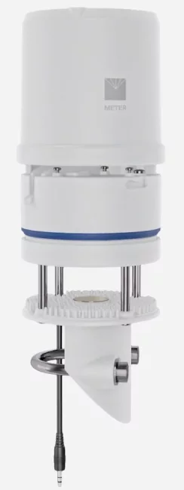 | 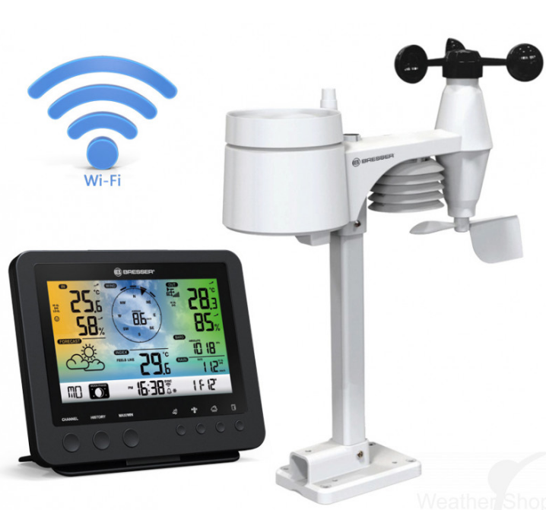 | 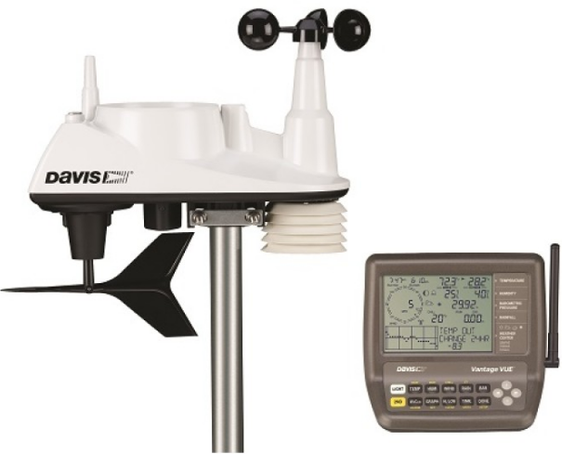 | 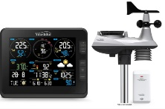
Features | Measures 12 weather variables including: air temperature, relative humidity, vapor pressure, barometric pressure, wind speed, gust and direction, solar radiation, precipitation, lightning strike counter and distance  Easy installation  No moving parts  All weather station data transmitted over a single wire  Digital SDI-12 communication  Connect to ZL6  Designed for continuous deployment in harsh climates  No louvered radiation shield to attract bugs  Accurate at low wind speeds because no moving parts  Detects fine-scale wind speed variations with 0.01 m/s resolution  Integrated weather station accelerometer detects if sensor is off level  Integrated spring acts as a rain gauge filter to keep out large particles but still allow enough water flow  Optional bird deterrent fits perfectly on the weather station funnel | Connects to the Internet via your home WiFi  Measures:  Outdoor temperature and humidity  Wind direction and speed  Rainfall with history  Barometric pressure in relative or absolute readings  ice/frost alert  Indoor base station/display console with integrated stand  5-in-1 multi-sensor suite | Easy installation - rain, wind, temperature & humidity sensors in self-contained sensor suite Transmits data wirelessly to your console anywhere up to 1,000ft (300m) away  Weather data updates every 2.5 seconds!  Wind tunnel tested to 200mph (321kmph)  Solar-powered outdoor sensor suite, with battery backup  View, store and graph your real-time weather data online/on the smartphone app/on your PC, with optional Weather Link software and data logger. | outdoor temperature, humidity , Weather index for outdoor dew-point, wind chill, heat index, , UV & Sunburn ( light intensity ).
Specification | Solar radiation  Range: 0 to 1750 W/m2  Precipitation  Range: 0 to 400 mm/h  RELATIVE HUMIDITY  Range  0 to 100% RH (0.00-1.00)  Air temperature Range: -50 to 60 °C  Humidity sensor temperature  Range: -40 to 50 °C  Barometric pressure  Range: 50 to 110 kPa  Horizontal wind speed  Range: 0 to 30 m/s  Wind direction  Range: 0° to 359°  Tilt  Range: -90° to +90°  Data logger compatibility  METER ZL6 and EM60 data loggers or any data acquisition systems capable of switched 3.6- to 15.0-VDC excitation and SDI-12 communication  Dimensions  Diameter: 10 cm (3.94 in)  Height: 34 cm (13.39 in), includes rain gauge filter  temperature range  –50 °C to60 °C  Connector types  3.5-mm stereo plug connector or stripped and tinned wires  Supply voltage (VCC to GND)  Minimum: 3.6 VDC continuous  Maximum: 15.0 VDC continuous | Indoor temperature (-5°C – 50°C) and humidity with comfort indication  Outdoor temperature (-40°C – 60°C / -40°F – 140°F) and humidity (1 – 99%)  Wind direction and speed (0 – 112 mph, 50 m/s, 180km/h, 97 knots)  Rainfall (0 – 19999mm) with history (hourly, daily, weekly, monthly, total rainfall)  Weather forecast (sunny, partly cloudy, cloudy, rainy, stormy, snowy)  Barometric pressure in relative or absolute readings (hPa, inHg, mmHg) (540 – 1100hPa) (relative range: 930 – 1050hPa)  Weather index (‘feels like’ function, dew point, heat index, wind chill factor)  Moon phase  Selectable ice/frost alert  Programmable alarms for weather extremes: indoor temperature/indoor humidity/outdoor temperature/outdoor humidity/rainfall/wind speed  3-mode display brightness: Hi / Lo / Off  Dimensions 168 x 143 x 24mm (display console)  Batteries  Display console (base station): CR2032 backup battery (not included)  Power Display console (base station): mains power, with optional battery backup  Sensors  The 5-in-1 outdoor sensor suite includes sensors for wind speed, wind direction, humidity, temperature, and precipitation  Wireless transmission range to base station: 150 metres (line of sight)  RF frequency: 868 MHz  Dimensions Outdoor sensor suite: 343 x 393 x 136mm  Batteries | Barometric Pressure, Dew Point, Humidity, Rainfall, Temperature, Wind Direction, Wind Speed  Outdoor Unit  The fully integrated, corrosion-proof sensor suite is built to take all the weather your location can give. The ISS combines a rain collector, temperature/humidity sensors, and anemometer/direction vane into a single unit.  Sensors  Rain Collector Self-emptying tipping spoon measures rain with 0.2mm resolution.  Anemometer Records wind speeds as low as 2 mph and as high as 200 mph.  Temperature and Humidity Provides outside temperature readings from -40°C to 65°C. Also measures relative humidity from 0 to 100%.  Wind Direction Measures wind direction in compass rose points or degrees.  Dimensions 329 x 146 x 340 mm  Power Solar-powered | 8” True Black & Colourful Display for Time & Full Weather Information  Receive Weather Data From 7-in-1 Weather Sensor (YC1136) Via 868 MHz RF  Able To Synchronize UTC Time From Internet And With DST On/Off Function ,  Moon Phase And Sunrise / Sunset  Display For Northern / Southern Hemisphere  Buzzer Alarm Clock With Ice Pre-alert  Outdoor Temperature (°c/°f) & Humidity Readings (YC1136) With Trend  Gust Or Average Wind Speed (mph, m/s, km/h, knots)  Wind Direction In 360°  UV Index (0 – 16) With UV Level Indicator Light Intensity Reading  Measure Rain rate,  Barometric Pressure in Relative Or Absolute Readings (hPa, inHg, mmHg)  Heat Index, Wind Chill, Dew Point Readings  Index, High Wind-speed, High Daily Rainfall & Pressure  Weather Data Calibration (Via the Set-up User Interface) , 3-mode  Support Firmware Update  1 Pc Wireless outdoor 7-in-1 Professional Weather Sensor (YC1136) & 1 x  Up To 7 x Wireless  Wall Mount / Desktop Usage / Power Supply UK Adaptor Included  Product Size: 215 X 172 X 29 Mm (W X H X D) / Back-up batteries 3 x AAA (not included)
Positives | All in one.  Multiple sensors.  Small size  Robust | Multiple sensors  Has GPS  Wireless viewing screen | Multiple sensors  Wireless viewing screen  Protection against the elements and corrosion | Multiple sensors  Wireless viewing screen
Negatives | No GPS  For the ATMOS 41 weather station to meet digital logic levels specified by SDI-12, it must be excited at 3.9 VDC or greater  Limited to what data loggers it can connect to  Requires constant power | Limited to 5 sensors and their parameters  Requires wi-fi to use GPS and for information to be sent to base station | Requires wi-fi for certain functions to work | Requires a socket power supply  Requires wi-fi for certain functions to work
Reference | [1] | [2] | [3] | [4]
Table 1

Components list

Temperature
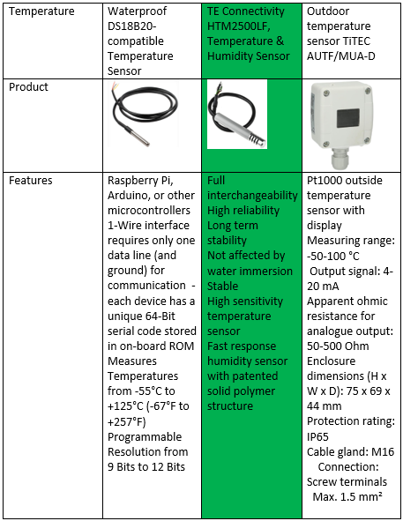
Figure 1
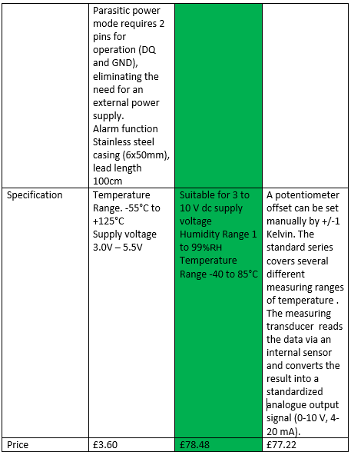
Figure 2
Reference | [5] | [6] | [7]

Humidity
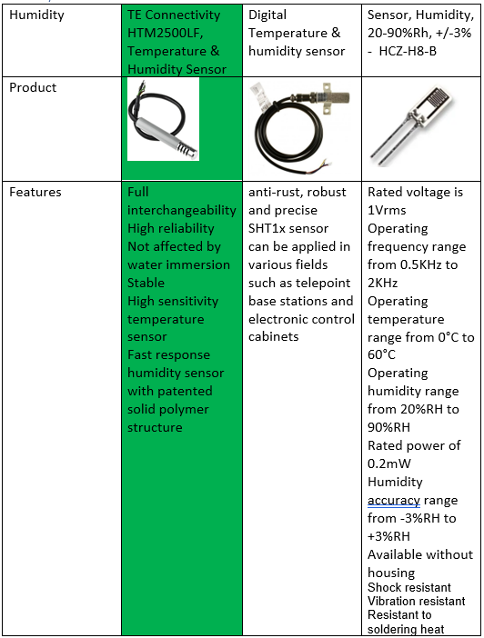
Figure 3
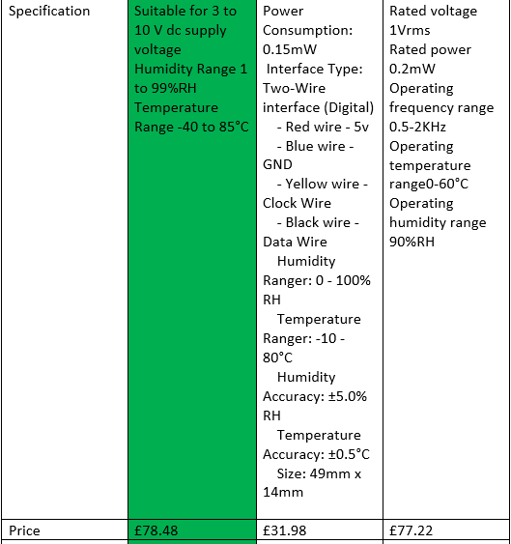
Figure 4
Reference | [6] | [8] | [9]

Wind speed

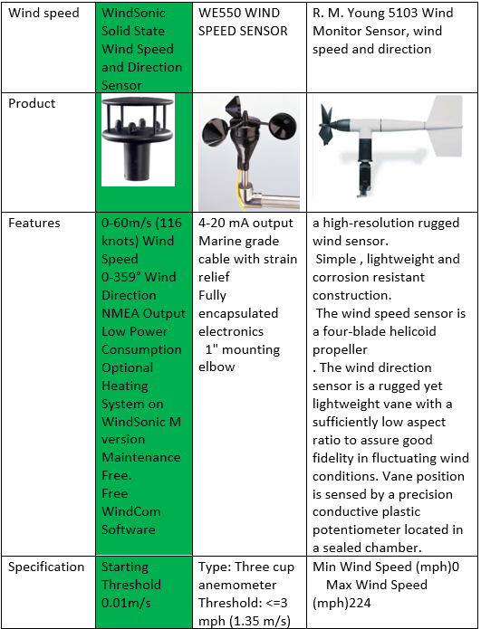
Figure 5
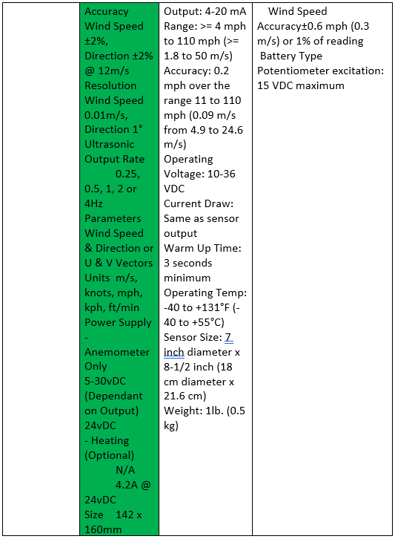
Figure 6
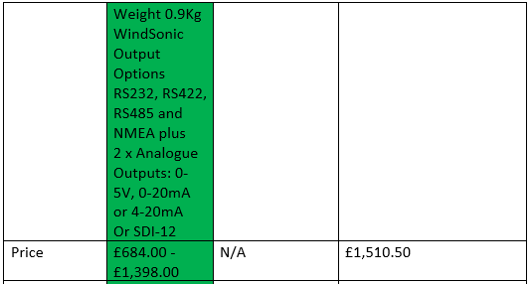
Figure 7
Reference | [10] | [11] | [12]

Wind direction
Wind direction | WindSonic Solid State Wind Speed and Direction Sensor | R. M. Young 5103 Wind Monitor Sensor, wind speed and direction | Wind Sensor Garden Signal Output Aluminium Alloy Wind Direction Sensor Wind Vane Speed Measuring Instrument
Product | 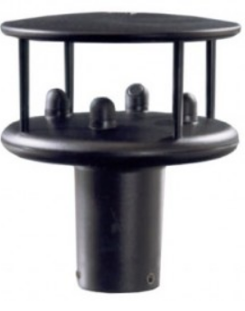 | 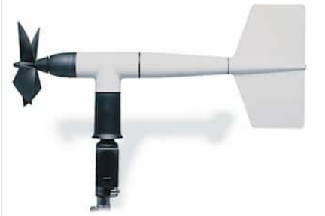 | 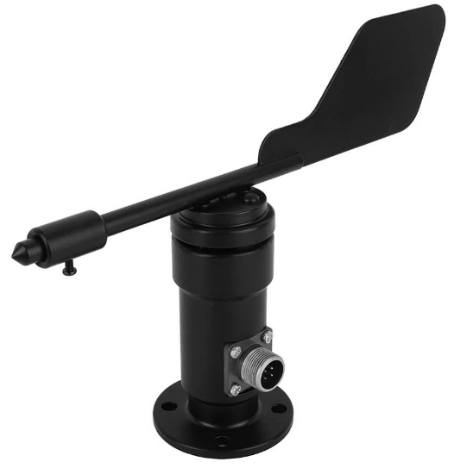
Features | 0-60m/s (116 knots) Wind Speed  0-359° Wind Direction  NMEA Output  Low Power Consumption  Optional Heating System on WindSonic M version  Maintenance Free.  Free WindCom Software | a high-resolution rugged wind sensor.  Simple , lightweight and corrosion resistant construction.  The wind speed sensor is a four-blade helicoid propeller  . The wind direction sensor is a rugged yet lightweight vane with a sufficiently low aspect ratio to assure good fidelity in fluctuating wind conditions. Vane position is sensed by a precision conductive plastic potentiometer located in a sealed chamber. | With RS485 interface.  Aluminium Alloy material
Specification | Starting Threshold 0.01m/s  Accuracy Wind Speed ±2%, Direction ±2% @ 12m/s  Resolution  Wind Speed 0.01m/s, Direction 1°  Ultrasonic Output Rate 0.25, 0.5, 1, 2 or 4Hz  Parameters Wind Speed & Direction or U & V Vectors  Units m/s, knots, mph, kph, ft/min  Power Supply - Anemometer Only  5-30vDC  (Dependant on Output) 24vDC  - Heating (Optional) 4.2A @ 24vDC  Size 142 x 160mm  Weight 0.9Kg  WindSonic Output Options  RS232, RS422, RS485 and NMEA plus  2 x Analogue Outputs: 0-5V, 0-20mA or 4-20mA  Or SDI-12 | Min Wind Speed (mph)0  Max Wind Speed (mph)224  Wind Speed Accuracy±0.6 mph (0.3 m/s) or 1% of reading  Battery Type Potentiometer excitation: 15 VDC maximum | Material: aluminum alloy  For: Wind direction sensor / weather station  Product Type: Six elements of meteorology  Interface type: RS485  Measuring range: 0 ~ 360 °  Accuracy: ±3°  Starting wind speed: ≤0.5m/s  Power supply mode: DC  Output form: current 4~20ma voltage 0~5V 0~10V RS485  Instrument line length: standard: 2.5 meters  Load capacity: current type output impedance ≤250Ω Voltage type output impedance ≥1KΩ  Working environment: temperature -40 ° C ~ 50 ° C humidity ≤ 100% RH  Protection level: IP45  Cable grade: temperature grade: 80 ° C  Rated voltage: 300V  Product power consumption: 5.5mW  Wind direction measurement range; 16 orientation  Wind direction measurement accuracy: 1 position  Response time: less than 5 seconds  Baud rate: 9600  Communication port: RS485  Power supply: 12V-24V DC  Power consumption: <1W  Operating temperature: -30-80 ° C  Operating humidity environment: 0-100% RH (15-95% RH)  Size: Approx. 16 x 23cm/6.3 x 9.06in
Price | £684.00 - £1,398.00 | £1,510.50 | £34.09
Reference | [7] | [12] | [13]
Table 2

Air borne particle count
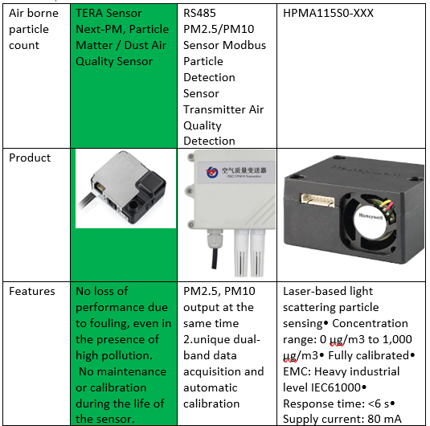
Figure 8
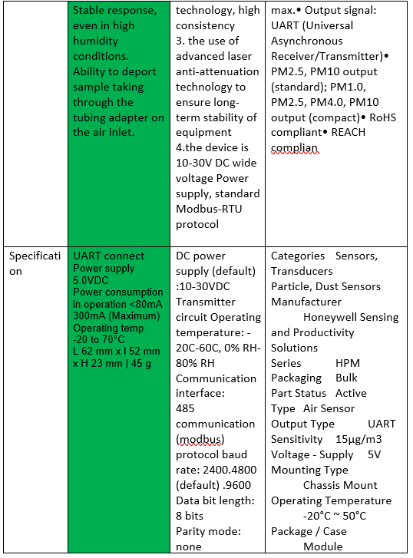
Figure 9

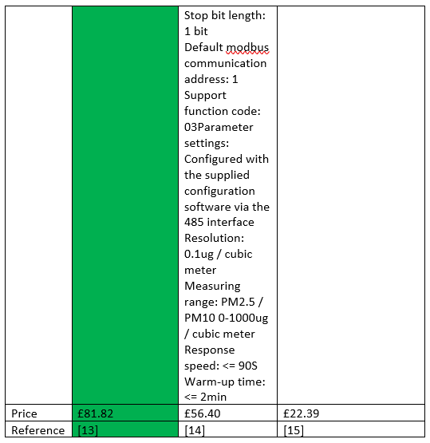
Figure 10
Reference | [14] | [15] | [16]

Sunlight brightness
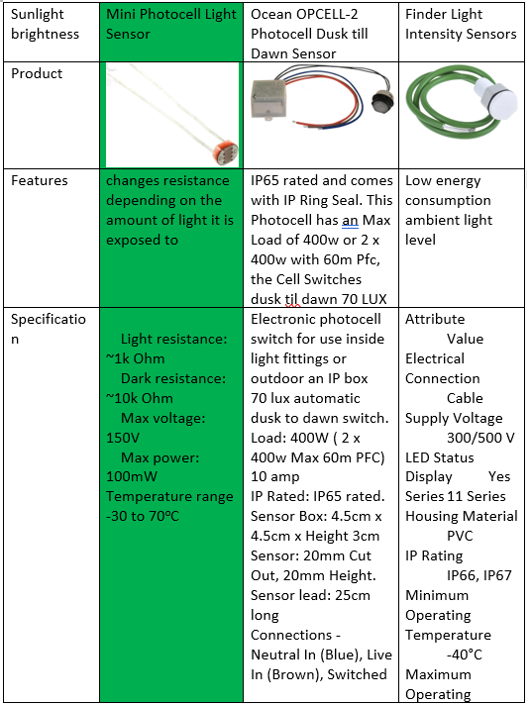
Figure 11
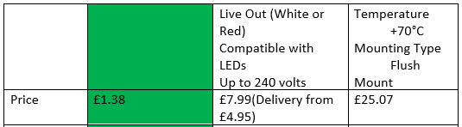
Figure 12
Reference | [17] | [18] | [19]

UV levels
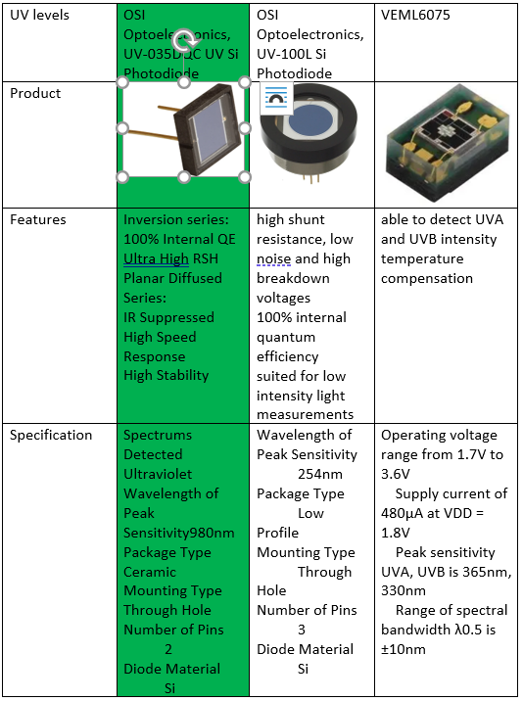
Figure 13
Reference | [20] | [21] | [22]
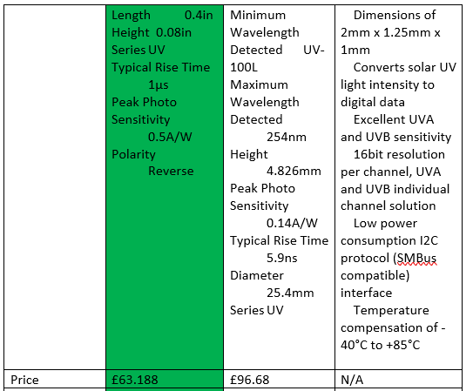Figure 14

GPS position 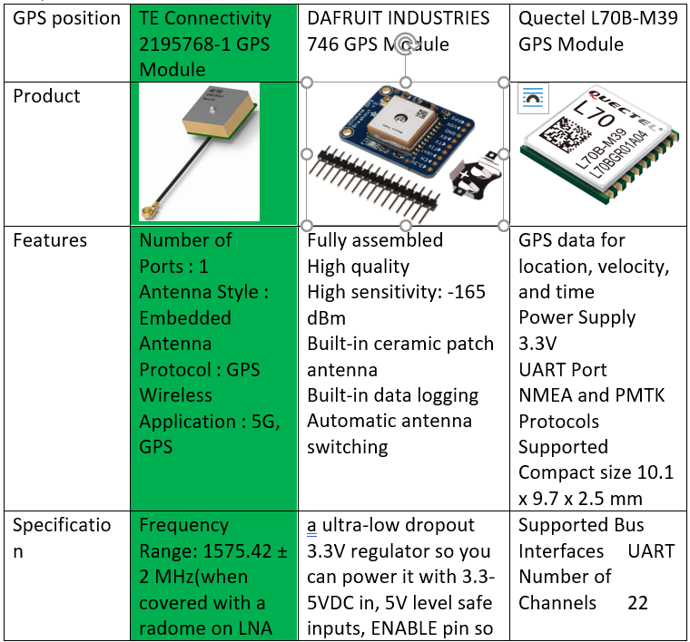
Figure 15
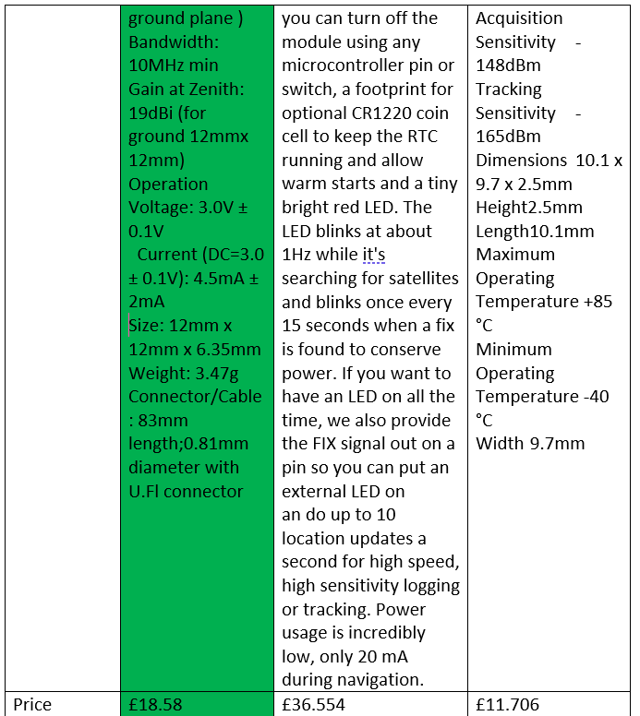
Figure 16
Reference | [23] | [24] | [25]

Volatile Organic Compounds (VOC) level
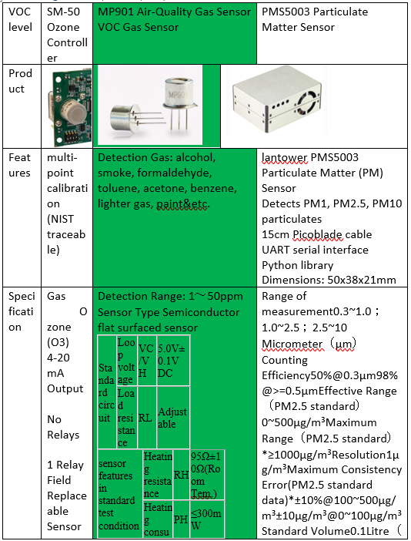
Figure 17
Reference | [26] | [27] | [28]
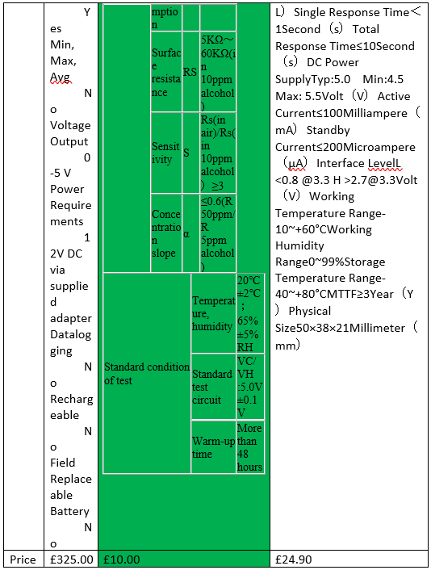Figure 18

Casing
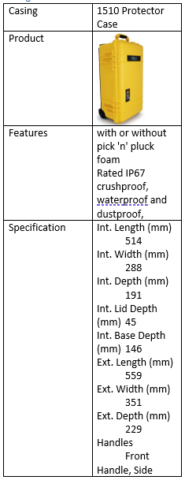
Figure 19
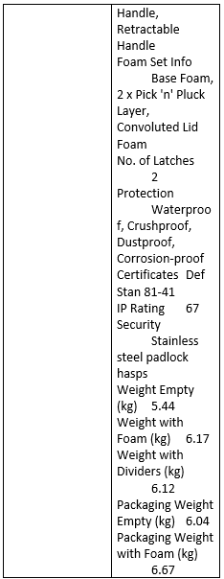
Figure 20
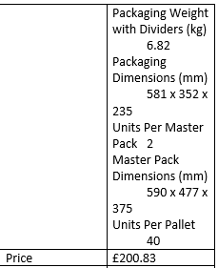
Figure 21
Reference | [29]

Battery
Battery | Portable Power Technology Li Po Powerpack 450+
Product | 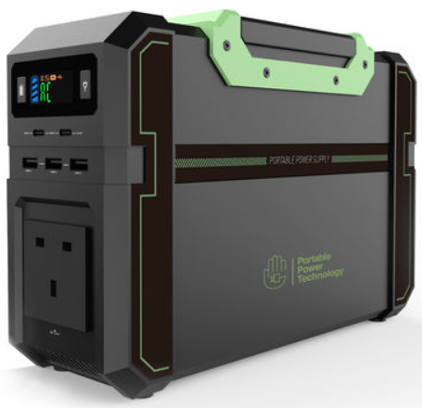
Features | Delivers AC and DC power  Solar charging compatible  Multi safety protection  high temperature resistance  Recharging in the Powerpack 450+ is safe, quick, and easy using the included AC adapter and 12V car adapter. The Powerpack 450+ can also be recharged from solar using the supplied cable and up to a 60 watt solar panel.
Specification | Battery Capacity : 3.7V @ 120Ah (444 Watt Hour)  USB Output : 3 x 5V @ 3.1A total  USB Type C : 1 x 10W, 1 x 40W  Weight: 5kg  integrated LCD control panel display battery and output status  Solar charging compatible that lets you plug in up to 60W of 12V solar without external controller
Price | £499.00
Reference | [30]
Table 3

Memory Card Connector
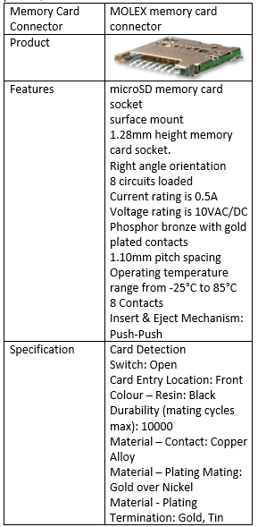
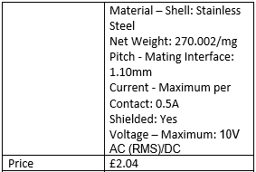
Figure 22
Reference | [31]
Figure 23 Memory card connector

Memory Card
Memory card | SanDisk Ultra 512 GB microSDXC and adapter
Product | 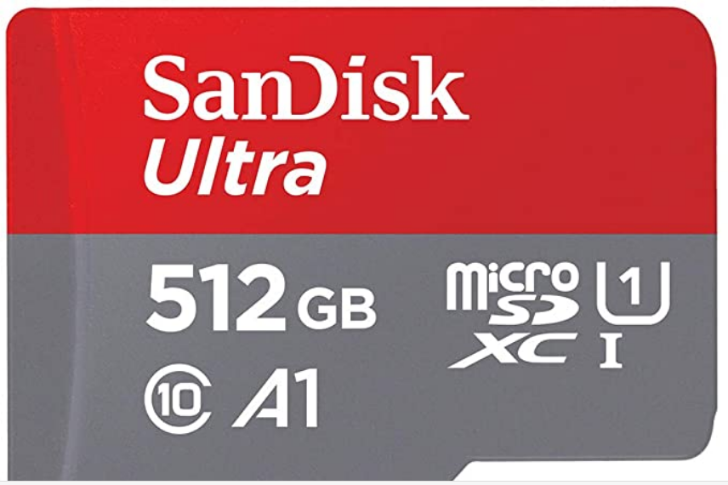
Features | Brand SanDisk  Memory type  Micro SDXC  Colour Red/Grey  Hardware Interface USB 3.0  Speed class Class 10
Specification | Product Dimensions 0.1 x 1.5 x 1.09 cm; 4.54 Grams  Memory Clock Speed 100 Megabytes Per Second  Up to 512 GB capacity
Price | £72.99
Reference | [32]
Table 4

Connector
Connector | RS PRO Crimp Connector, 4 Contacts
Product | 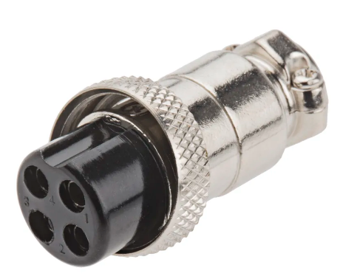
Features | Contacts are tin plated, and other metal parts are brass or mazac, nickel plated.
Number of Contacts: | 4
Mounting Type: | Cable Mount
Plug/Socket: | Plug
price | £4.01
Reference | [33]
Table 5

Microcontroller
Figure 24
reference | [34]

LED
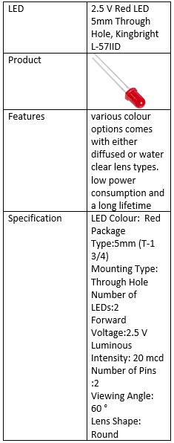
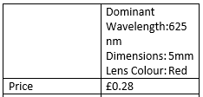
Figure 25
Reference | [35]

Timings
GPS 1 signal when activated no other signals
Temperature 1/15 sec
Humidity 1/15 sec
Wind speed 1/15 sec
Wind direction 1/15 sec
Sunlight brightness 1/10min
UV levels 1/1 hr
Volatile Organic Compounds (VOC) Level 1/1 hr
Air borne particle count 1/1 hr

Prototype costs
Component | Price
Temperature | £78.48
Humidity | £78.48
Wind speed | £684.00
Wind direction | £684.00
Air borne particle count | £81.82
Sunlight brightness | £1.38
UV levels | £63.19
GPS position | £18.58
VOC level | £10.00
Casing | £200.83
Battery | £499.00
Memory card connector | £ 2.04
Memory card | £72.99
Connector | £4.01
Microcontroller | £2.44
LED | £ 0.28
Total cost | £1,719.04

PCB costs
PCB | £15.00 with no Gerber file
Delivery | £8.53 (12-16 Days) the quicker the delivery the more expensive it is

Block Diagram
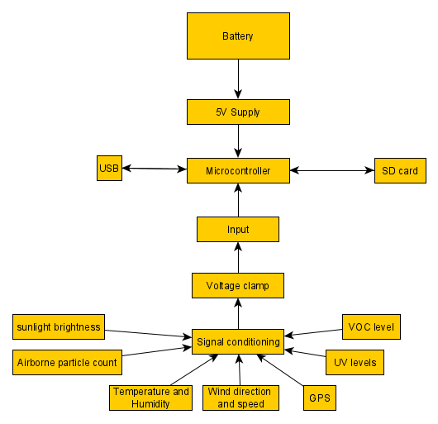
Figure 26

Easy-PC

Schematic View
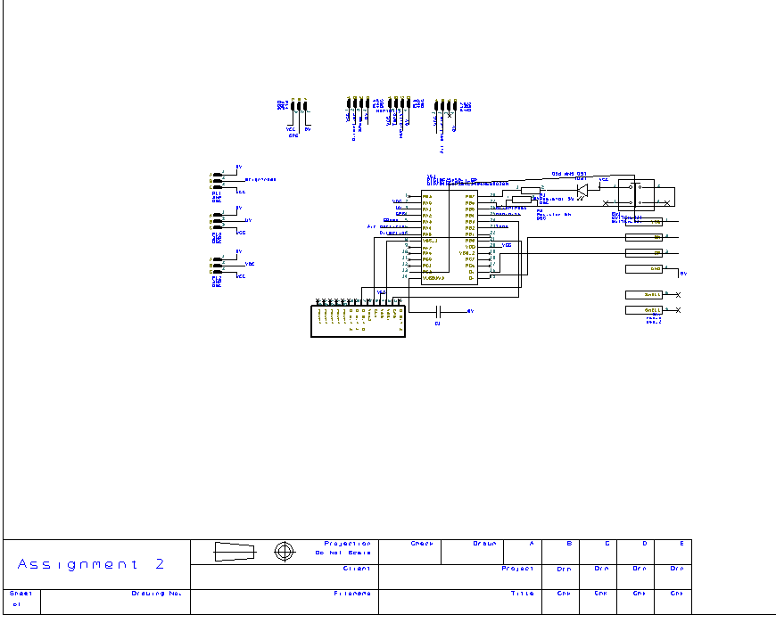
Figure 27

PCB View
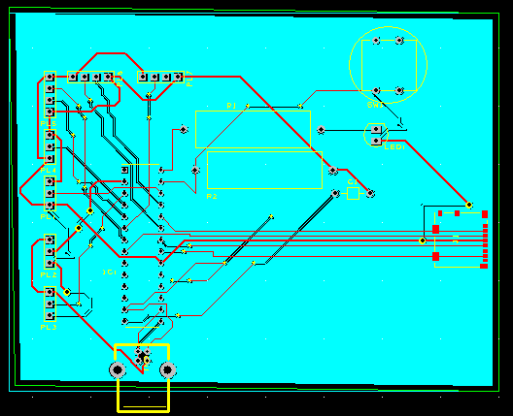
Figure 28

3D view
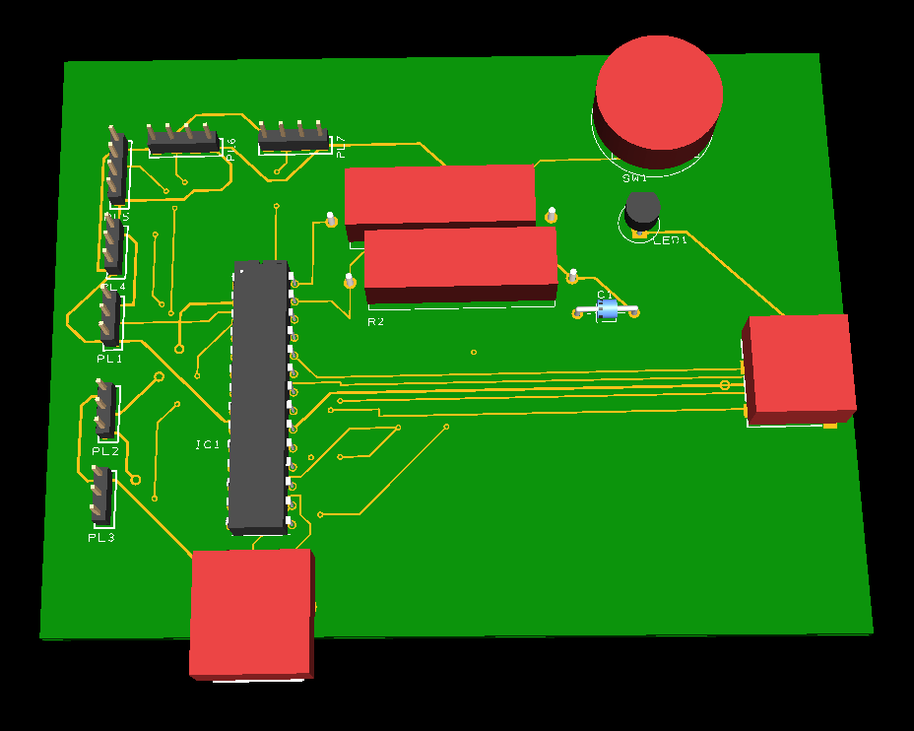
Figure 29

Proteus
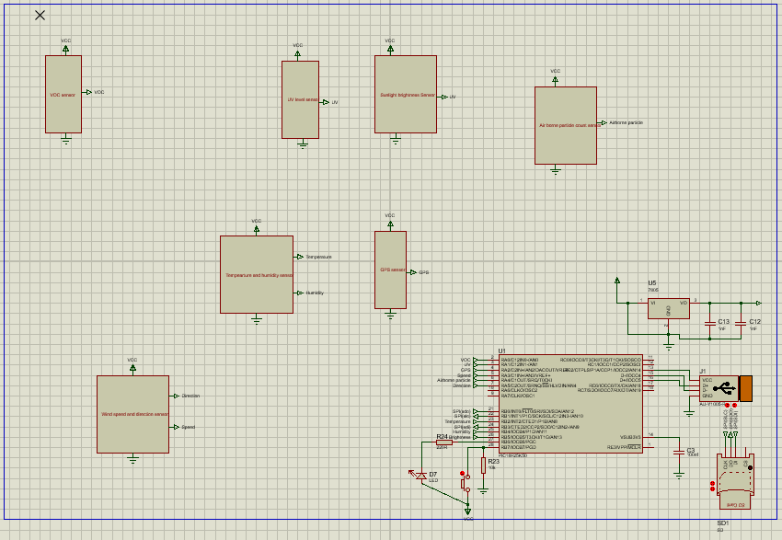
Figure 30

list of suggested improvements
suggested improvement are the component should be combined in to one casing instead of multiple. There should be a wireless screen to view the stored data without using a usb or SD card. The weather station should be able to run of a battery and on solar power. Include a wider variety of sensors for example lighting or rain

References

[1] | “ATMOS 41 WEATHER STATION,” [Online]. Available: https://www.metergroup.com/environment/products/atmos-41-weather-station/?creative=442739627234&keyword=%2Bweather%20%2Bmonitoring%20%2Bequipment&matchtype=b&network=g&device=c&gclid=EAIaIQobChMItuqrmLDG7QIVCr_tCh0qgQDjEAAYASAAEgJN0vD_BwE. [Accessed Decmber 2020].
[2] | “home weather station,” [Online]. Available: https://www.weathershop.co.uk/shop/weather-stations/home-weather-stations/5-in-1-bresser-colour-wifi-weather-station. [Accessed December 2020].
[3] | “davis-vantage-vue-weather-station,” [Online]. Available: https://www.weathershop.co.uk/shop/davis-vantage-vue-weather-station?gclid=EAIaIQobChMI48zsm57I7QIVdIBQBh3RKAMMEAYYBiABEgJ64fD_BwE. [Accessed December 2020].
[4] | “youshiko.co.uk,” [Online]. Available: https://youshiko.co.uk/products/weather-station-premium-quality-official-uk-version-wifi-internet-wunderground-weathercloud-professional-7-in-1-wireless-sensor-wind-speed-direction-rainfall-temperature-humidity-uv-sunburn?variant=31664847585374&currency=G. [Accessed December 2020].
[5] | “Temp data sheet,” [Online]. Available: https://cdn.shopify.com/s/files/1/0174/1800/files/DS18B20.pdf?v=1596806772. [Accessed December 2020].
[6] | “RS datasheet,” [Online]. Available: https://docs.rs-online.com/fcd5/0900766b8142cdce.pdf. [Accessed December 2020].
[7] | [Online]. Available: https://www.automation24.co.uk/outdoor-temperature-sensor-titec-autf-mua-d?previewPriceListId=1. [Accessed December 2020].
[8] | “digital-temperature--humidity-sensor-with-stainless-steel-probe,” [Online]. Available: https://www.robotshop.com/uk/digital-temperature--humidity-sensor-with-stainless-steel-probe.html?gclid=CjwKCAiA25v_BRBNEiwAZb4-ZRvHE7FWRRzOdvs3GL4SHkWsUjB2MM_GWLHs2n6wMJE-uNjWmMpzRBoC6goQAvD_BwE. [Accessed December 2020].
[9] | “outdoor temp,” [Online]. Available: https://www.automation24.co.uk/outdoor-temperature-sensor-titec-autf-mua-d?previewPriceListId=1. [Accessed December 2020].
[10] | “windsonic,” [Online]. Available: https://www.omniinstruments.co.uk/weather-stations-and-instruments/wind-speed-and-direction-sensors/windsonic-solid-state-wind-speed-and-direction-sensor.html. [Accessed December 2020].
[11] | “WE550,” [Online]. Available: http://www.globalw.com/products/we550.html#Options. [Accessed December 2020].
[12] | “R. M. Young 5103 Wind Monitor Sensor,” [Online]. Available: https://www.coleparmer.co.uk/i/r-m-young-5103-wind-monitor-sensor-wind-speed-and-direction/9953618?PubID=UY&persist=true&ip=no. [Accessed December 2020].
[13] | “wind direction,” [Online]. Available: https://uk.banggood.com/Wind-Sensor-Garden-Signal-Output-Aluminum-Alloy-Wind-Direction-Sensor-Wind-Vane-Speed-Measuring-Instrument-p-1624988.html?utm_source=googleshopping&utm_medium=cpc_organic&gmcCountry=GB&utm_content=minha&utm_campaign=minha-gbg-en-pc. [Accessed December 2020].
[14] | “RS datasheet,” [Online]. Available: https://docs.rs-online.com/ab19/A700000006569693.pdf. [Accessed December 2020].
[15] | [Online]. Available: https://uk.banggood.com/RS485-PM2_5PM10-Sensor-Modbus-Particle-Detection-Sensor-Transmitter-Air-Quality-Detection-p-1626018.html?utm_source=googleshopping&utm_medium=cpc_organic&gmcCountry=GB&utm_content=minha&utm_campaign=minha-gbg-en-pc&currency=GBP&cur. [Accessed December 2020].
[16] | “Honeywell,” [Online]. Available: https://www.digikey.co.uk/product-detail/en/honeywell-sensing-and-productivity-solutions/HPMA115S0-XXX/480-7035-ND/7202204?utm_adgroup=General&utm_source=google&utm_medium=cpc&utm_campaign=Smart%20Shopping_Product_Zombie%20SKUs&utm_term=&productid=7202204. [Accessed December 2020].
[17] | [Online]. Available: https://www.robotshop.com/uk/mini-photocell-light-sensor.html?gclid=Cj0KCQiA_qD_BRDiARIsANjZ2LAzFHpQsmSubuTeSYoAdBSUzfk5sUpxh4uRgyiTQ6QtQGfKIRWfaAkaAv28EALw_wcB. [Accessed December 2020].
[18] | “ocean opcell,” [Online]. Available: https://www.oceanlighting.co.uk/lighting-controls-c282/ocean-opcell-2-photocell-dusk-til-dawn-sensor-p22383/s22654?cid=GBP&gclid=Cj0KCQiA_qD_BRDiARIsANjZ2LDS0LcgQ9NEfm9xgdzfNcAjLkB88Pnp2FoXsZ7P4ZUXQQc-RRAGiQkaAssoEALw_wcB. [Accessed December 2020].
[19] | “Finder sensor,” [Online]. Available: https://uk.rs-online.com/web/p/registration-sensors/7114806/. [Accessed December 2020].
[20] | “UV sensor,” [Online]. Available: https://uk.rs-online.com/web/p/photodiodes/1837143/. [Accessed December 2020].
[21] | [Online]. Available: https://uk.rs-online.com/web/p/photodiodes/1769786/. [Accessed December 2020].
[22] | “VEML6075,” [Online]. Available: https://uk.farnell.com/vishay/veml6075/light-sensor-digital-i2c/dp/2523611?ost=uv+senso&searchref=searchlookahead. [Accessed December 2020].
[23] | “RS datasheet,” [Online]. Available: https://docs.rs-online.com/3767/A700000006719961.pdf. [Accessed December 2020].
[24] | “RS data sheet,” [Online]. Available: https://docs.rs-online.com/c562/0900766b814beeb7.pdf. [Accessed December 2020].
[25] | [Online]. Available: https://uk.rs-online.com/web/p/gps-chips-gps-modules/1709178/. [Accessed December 2020].
[26] | “Gas sensing,” [Online]. Available: https://www.gas-sensing.com/sm-50.html#960=. [Accessed December 2020].
[27] | “VOC sensor,” [Online]. Available: https://www.winsen-sensor.com/sensors/voc-sensor/mp901.html. [Accessed December 2020].
[28] | “PMS5003 Particulate Matter Sensor,” [Online]. Available: https://shop.pimoroni.com/products/pms5003-particulate-matter-sensor-with-cable?variant=29075640352851&currency=GBP&utm_source=google&utm_medium=cpc&utm_campaign=google+shopping?utm_source=google&utm_medium=surfaces&utm_campaign=shopping&gclid=Cj0KCQiAoab. [Accessed December 2020].
[29] | “peliproducts.co.uk/1510-protector-case,” [Online]. Available: https://peliproducts.co.uk/1510-protector-case. [Accessed December 2020].
[30] | “Power Pack,” [Online]. Available: https://www.machinemart.co.uk/p/portable-power-technology-powerpack-450/?da=1&TC=GS-010312138&gclid=CjwKCAiA25v_BRBNEiwAZb4-ZQywPSJ8I8i1y8jkjl6Euz8TPeT2Lar0cFt9wo2fkNCEdTB1uwiFjxoCP3wQAvD_BwE. [Accessed December 2020].
[31] | “farnell datasheet,” [Online]. Available: http://www.farnell.com/datasheets/2701368.pdf. [Accessed December 2020].
[32] | “SD card,” [Online]. Available: https://www.amazon.co.uk/SanDisk-microSDXC-Memory-Adapter-Performance/dp/B07SC7BZHR/ref=sr_1_4?dchild=1&keywords=micro+sd+card+512gb&qid=1606226502&sr=8-4. [Accessed December 2020].
[33] | “RS connector,” [Online]. Available: https://uk.rs-online.com/web/p/industrial-circular-connectors/1115756/?cm_mmc=UK-PLA-DS3A-_-google-_-PLA_UK_EN_Connectors_Whoop-_-Industrial+Circular+Connectors_Whoop-_-1115756&matchtype=&aud-813230962291:pla-339061618701&gclid=EAIaIQobChMIn-Oa3cG67QIVDNP. [Accessed December 2020].
[34] | “PIC microcontoller,” [Online]. Available: https://uk.rs-online.com/web/p/microcontrollers/1460209/. [Accessed November 2020].
[35] | “Rs components,” [Online]. Available: https://uk.rs-online.com/web/p/leds/2285821/?cm_mmc=UK-PLA-DS3A-_-google-_-CSS_UK_EN_Displays_%26_Optoelectronics_Whoop-_-LEDs_Whoop-_-2285821&matchtype=&aud-821594433763:pla-307757506505&gclid=EAIaIQobChMI_pGI5qXG7QIVD7LtCh2HLA7mEAQYASABEgLPfPD_BwE&gclsr. [Accessed December 2020].
[36] | “Microchip PIC18F25K42,” [Online]. Available: https://www.microchip.com/wwwproducts/en/PIC18F25K42#datasheet-toggle. [Accessed December 2020].

