  Problem solving and decision making | Lecturer name:  Sylvia Hoffmann  Student name:  Ivan Scarevnea  (2113303)  MODULE CODE:  BMSW4004

Table of Contents
Task 2 – Individual Report 3
Introduction 3
Define a complex in the workplace 3
PESTLE Analysis 4
Analysis Of The Information Of The Identified Problem That Leads To The Decision-Making 6
Cause And Effect Analysis Of The Problem 6
SWOT analysis of Zara 8
Alternative Solutions 9
Use of PMI tool to identify the most appropriate option 10
SMART plan for implementing the solution 10
Communication of the plan with the stakeholders 11
Monitoring and review techniques 12
Conclusion 12
Reference 14
Task 1 – Role-play 16

Problem Solving and Decision Making

Task 2 – Individual Report

Introduction
The vast majority of employees, at one point or another, have voiced discontent with their current jobs to one another. While some people decide to leave their jobs in search of opportunities that are more suited to them, others choose to remain in their existing roles despite being unhappy with the atmosphere at their places of employment. Employees that are unmotivated and underperform might potentially damage a company's reputation because of the bad thoughts they have about the job that they do. Because of this, there was chaos in every department of the organisation, and it even affected the overall financial health of the company. Managers that make an effort to learn about the underlying issues that are causing employees discomfort might take steps to reduce employee unhappiness. A little less than one-third of the workforce is dissatisfied with their current position. This is a worrying indicator for the mental health of the people living in the UK as well as the economics of the enterprises there.

Define a complex in the workplace
A large portion of the working population is discontent with their jobs because of the low wages they are paid. Low-wage workers often have trouble affording even the basics of life. As the cost of living, including rent, utilities, food, and transportation, continues to rise, workers are left with a smaller share of their paychecks to cover these expenses. Many people are unhappy in their jobs because they find it difficult to maintain a comfortable lifestyle on their current salary (Vogue, 2019). Workers may believe they are being underpaid when, in fact, they are receiving a wage that is fair in light of the tasks they have previously handled. If you want your workers to be happy with their current salary, it's a good idea to let them know about potential raises in the next budget, or at least to show them the pertinent comparisons. Using tools like SWOT and PESTLE analyses, as well as methods from PMI and SMART goals, this research has analysed the problem of employee dissatisfaction at Zara and offered a concrete solution.

PESTLE Analysis
Political | Zara is a Spanish, EU-founded worldwide brand. Zara may import raw materials and export completed items via trade agreements. The platform reduces Zara's shipping time and costs. EU is UK's major textile export market. Zara has access to a broader client base in all European states without paying extra border taxes, which boosts sales (Cosmopolitan, 2019). Financial rules impact business operations. India and China are hampered by red tape. Political interruptions damage the market's economics and supply chain. Zara's supply chain was restricted to its native nation and neighbours.
Economical | Despite the UK's dismal economy, Zara remains flourishing. Zara has a loyal following since it meets most shoppers' needs. Zara's lower prices give it a higher market share. A company's finances may suffer from low global economic activity (MEN, 2022). A company might go bankrupt from rising labour or production expenses. Brexit has lowered the value of the pound, caused inflation, and reduced clothing spending. Zara and industrial sales have dropped. The country’s current GDP is 2.71 lakh crores USD (2020) (ONS, 2022). In FY2019, sales at Zara UK increased by a more modest 7%, reaching £826.4m. Earnings before taxes dropped by 67% to £19.1m in FY2020, from £58m in FY2019. The pre-tax profit margin decreased to 3% from 7% the previous year (Statista, 2021).
Social | Social trends impact supply and demand. It impairs work-readiness. Given Zara's size and breadth of products, a societal shift appears unlikely. The company doesn't focus on one market but studies new ones before joining. Culture affects clothes buying. Culture rejects products purchasers can't identify with. Zara isn't adventurous. Items represent local culture. Brand backs social causes. Zara implements energy-saving store management.
Technological | Brand has money and consumers to maximise data utilisation. Massive data sets are studied and analysed to attract customers. Website supports worldwide customers. The company serves customers online and offline. Toyota's JIT and Lean principles helped Zara's manufacturing. Technology helps customers.
Legal | Zara promotes sustainability and ethics. They aim to integrate these ideas throughout their firm and supply chain. Zara follows rules. Living wage rules vary by company. The company engaged in supply chain management to assure brand conformity. When developing new apparel styles, the company experienced copyright problems. Adidas and Balenciaga say the business copied designs. Outdated legal notions enable imitation without repercussions. Zara should enforce copyright rules since their clothes take time and money (CPD, 2022).
Environmental | Fashion is associated with waste since buyers' tastes change quickly. This might hurt Zara's reputation. Zara must embrace sustainable procedures as customers grow more eco-conscious. Zara will green all stores. The brand's plans for cutting down on energy use and water use are laid out here. The corporation has shown unwavering commitment to issues relating to global warming, renewable energy, biodiversity, eco-friendly product design, and animal rights (Reuters, 2020).
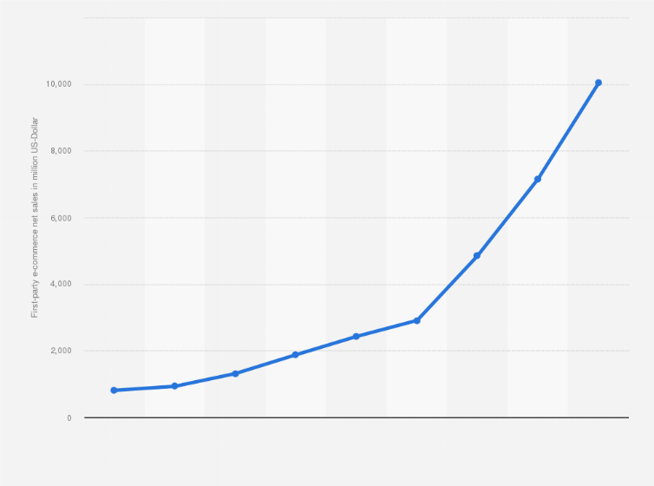
Figure: Zara's brand value worldwide from 2016 to 2021(in million of U.S. dollars)
(Source: Statista, 2021)

Analysis Of The Information Of The Identified Problem That Leads To The Decision-Making

Cause And Effect Analysis Of The Problem
In order to pay a living wage that is fair and equitable, Zara set the objective that all of its major suppliers will have pay structures in place by 2018 (Zara, 2022). However, this target has not been met.
Reason 1: Low pay
Cause: The company neglected to implement its directive to provide customers with the proper wedge. They provide very thinly sliced wedges.
Effect: Working on Sundays is a regular practice, and the firm under investigation often works more overtime than is allowed by law. They must put in extra hours of labour in order to make the legally needed minimum wage (BI, 2021).
Reason 2: A lack of workers
Cause: Because there aren't enough workers, there aren't enough people to do the labour. The staff are thus compelled to work more hours.
Effect: Low wages, excessive overtime, and additional responsibilities linked with household tasks all have negative repercussions, including malnutrition, tiredness, and workplace fainting episodes.
Reason 3: Consumer Need
Cause: The product is in very high demand among customers due to its good reputation and broad appeal.
Effect: As a consequence, workers in factories and warehouses will be forced to work harder in order to earn a salary that is high enough to cover their basic demands. The level of employee dissatisfaction is startlingly high.
Reason 4: Working overtime
Cause 4: Working overtime Because the top management is keeping more of the company's profits, the mass labour force is not receiving the required pay raises. To get more compensation, employees must put in extra time (Tucker, 2018).
Effect: Everyone is affected by inflation, which will become worse if wages don't rise. This imbalance will lead workers to search for jobs at organisations offering higher pay.
Reason 5: Harassment
Cause: The company's top management is poisonous and nasty to its workers, behaving badly toward them and constantly pestering them.
Effect: Employees struggle to persuade their managers since they dislike their jobs and are always wary of their superiors. Women workers must constantly take the initiative to prevent assault. They experience workplace safety as a concern.
Reason 6: Workplace Conditions
Cause: Many Zara shops lack adequate working conditions, including enough lighting, adequate ventilation, and functionally flawed equipment.
Effect: Working in these unfavourable conditions is quite challenging for employees.
As a consequence, there are a lot of mistakes made in the job, workers are becoming ill, and the unfavourable working environment affects employee happiness.

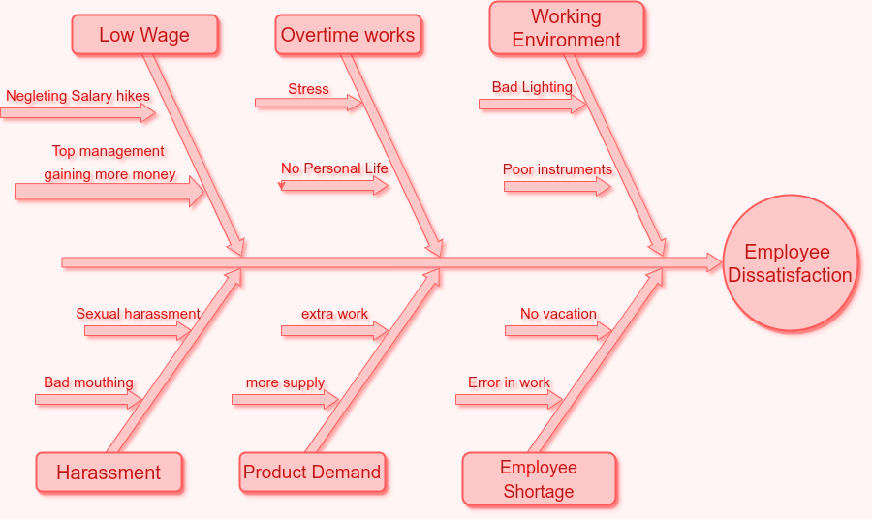
Figure: Fishbone Diagram
(Source: Created by Ivan Scarevnea)

SWOT analysis of Zara
Strengths | - Zara has 2,000 stores across 100 countries.  - Vertical integration implies operations, manufacturing, and supply chain management are managed by the same department.  - Zara's online presence comprises its homepage and other eCommerce sites.  - Mass-produced trendy clothes are inexpensive.  - Zara's latest items are on-trend, trendy, and fast.  - Zara sells handbags, shoes, accessories, and performs.
Weakness | - Comparatively little promotion and advertising  - Zara's strong rivalry implies restricted market share and brand switching.  - Zara is a pricey brand.  - Zara isn't active online, but it's offered via partners.
Opportunities | - Zara may explore additional international markets.  - Zara can utilise online marketing and eCommerce, which is growing in popularity.
Threats | - High-end clothes retailers are a danger.  - A recession might threaten their target market.  - Consumers often swap

Alternative Solutions
The company must first adjust the wedge level for all employees worldwide in order to meet legal requirements. They must also provide bonuses, holiday bonuses, and other holiday and anniversary bonuses to employees. These additions will facilitate communication between staff and management. All of the employees will feel both appreciated and abandoned by their employer (The Guardian, 2020). Workers who are happy in their jobs are more likely to go above and beyond for customers and produce more work, both of which boost the bottom line. Instead of cutting the pay of hardworking industrial workers, the company should look for legal alternatives to cut costs. The company needs to fill open positions with more people to help the current staff out. To get there, Zara will need to promote change for workers at the factory level, encourage social debate at the operational level, and work with governments to establish an enabling legal framework that supports regular wage adjustments, the right to association, and union representation. It is also important to give workers a voice and provide them with the tools they need to negotiate their own salaries, as the company in Spain has done (Giertz-Mrtenson, 2020).

Use of PMI tool to identify the most appropriate option
Decision | Plus | Minus | Interesting
Pay raise at the level preferred by the staff | After receiving their just wedge, the workers will be more committed to their jobs. | At the outset, the brand will experience some setbacks and losses. | The staff's productivity will shortly soar. In the long run, this will increase the company's profits.
Convenient, predetermined work hours should be set up for all employees. | It will be up to each individual worker to determine how quickly they get their task done. The quality of their job will improve. | The organisation will likely struggle to meet its deadlines. | More workers may be added to the payroll without any trouble.
Create a workplace that people want to come to every day. | Staff members will like coming to work and will be able to put in long shifts with little discomfort. | The HR department will have to cope with more than the usual challenges as the firm strives to provide a welcoming place to work for its employees (Sareen, 2018). | Keeping the workplace pleasant for workers is an investment in the company's future success. The corporation may use this as a basis for potential new ventures.

SMART plan for implementing the solution
SMART | Goals | How it helps | How to implement | Time Frame
Specific | To provide a fair salary for the workers | Staff members will be aided in receiving fair compensation as a result. | The HR department has to investigate and study the market to see what other businesses are paying for similar positions. | 4 months
Measurable | to assess the workers' workload | In this way, the employee's burden may be minimised and properly distributed. | Management must set work schedules and allocate tasks fairly to workers. | 1 month
Aggressive | to outright outlaw senior bosses bullying their staff. | Having this policy in place will make the workplace a more pleasant place to be. | Members of the HR department and other interested parties should enforce a strong code of behaviour on a daily basis. | 6 months
Realistic | To offer the crew a feasible project, | The quality won't be compromised, and the staff won't be overworked. | The staff should be split up into several teams, and each team should be given a modest amount of work. | 2 months
Time-bound | to restrict the workers' hours of labour. | The workforce will be youthful and energised. | A suitable schedule for the workplace should be established by management. | 15 days.

Communication of the plan with the stakeholders
Stakeholders at Zara may be contacted by email, social media postings on the Zara website, or even in person if that proves more effective. A more relaxed mode of interaction may be established via lunchtime conversations and continuous team participation. In spite of the best efforts of those who have been educated to keep an eye out for it, discriminating behaviour among team members may occur without detection.
Having a picnic where everyone brings a food from their home country is a great approach to promote inclusion and cultural diversity. One frequent method for increasing employee buy-in to the approach is to have discussions in focus groups, where members may be guided through a dialogue on a predetermined subject (Cunningham et al. 2018).
Further, they allow the company to show its employees how much it values their ideas and efforts toward improvement. High workloads, interpersonal conflict, and low morale are all difficulties that may be avoided in the workplace if these discussions take place often.

Monitoring and review techniques
After a treatment has been implemented successfully, a Post-Implementation Review (PIR) is conducted. Thus, it will determine whether or not its objectives were met, how effectively the strategy was implemented, and what lessons may be used moving forward (Biliska-Reformat and Staczyk, 2018). The plan's efficacy may be gauged by comparing current employee output with that from a period before the implementation of the contract and any company-wide education or training on the topic of inequality. Employees said that since the policy went into effect, they have experienced less bullying and more unprofessional behaviour.
The goal of this infrastructure programme was to make the workplace a safe place for all employees, regardless of their age, race, religion, sexual orientation, or gender. Workers need to be compensated fairly for the work they do. Human resource initiatives designed to boost morale among workers are warranted (Miethlich et al. 2022). The upper echelons of a company should treat its workers with respect and treat them as equals. In order to ensure that all employees are prepared for any future changes to discrimination laws, a comprehensive training programme has been provided.

Conclusion
One of the most significant factors that contributes to a high employee turnover rate at firms is unhappiness in one's current position. The Zara brand has been found to have concerns with employee unhappiness, according to the survey. As a further result of the research, proper measuring tools have been provided for the firm to use in the not-too-distant future in order for it to earn a better reputation for the way it treats its employees, for being fair, and for maintaining its business during difficult times. For the purpose of accurately interpreting the issue and referring to the best feasible solutions, the research has used suitable measuring instruments and evaluation models.

Reference
BI, 2021, “Zara shoppers complain of hour-long lines, messy stores, and poor customer service, as the retail industry struggles with a labor shortage” Available at, https://www.businessinsider.in/retail/news/zara-shoppers-complain-of-hour-long-lines-messy-stores-and-poor-customer-service-as-the-retail-industry-struggles-with-a-labor-shortage/articleshow/83842281.cms [Accessed on 25th August 2022]
Bilińska-Reformat, K. and Stańczyk, I., 2018. Employer branding as a source of competitive advantage of retail chains. Journal of Management and Business Administration. Central Europe, 26(1).
Cosmopolitan, 2019, “9 things Zara employees want you to know” Available at, https://www.cosmopolitan.com/uk/worklife/careers/a20730500/things-zara-employees-want-you-to-know/ [Accessed on 25th August 2022]
CPD, 2022, “Zara Employee Humiliated By Managers For Her Braids” Available at, https://www.populardemocracy.org/news-and-publications/zara-employee-humiliated-managers-her-braids [Accessed on 25th August 2022]
Cunningham, M.R., Jones, J.W. and Dreschler, B.W., 2018. Personnel risk management assessment for newly emerging forms of employee crimes. International Journal of Selection and Assessment, 26(1), pp.5-16.
Giertz-Mårtenson, I., 2020. Zara: How Swedish entrepreneurial culture and social values created fashion for everyone. In European fashion (pp. 201-220). Manchester University Press.
MEN, 2022, “Zara employees explain why shoppers should look for circles and triangles on clothes tags” Available at, https://www.manchestereveningnews.co.uk/news/uk-news/zara-employees-explain-shoppers-should-24159182 [Accessed on 25th August 2022]
Miethlich, B., Beliakova, M., Voropaeva, L., Ustyuzhina, O. and Yurieva, T., 2022. Internal Corporate Policy: CSR and Employee Satisfaction. Employee Responsibilities and Rights Journal, pp.1-15.
ONS, 2022, “Gross Domestic Product (GDP)” Available at, https://www.ons.gov.uk/economy/grossdomesticproductgdp [Accessed on 25th August 2022]
Reuters, 2020, “Fashion giant Inditex working at reduced capacity despite loosened Spanish lockdown” Available at, https://www.reuters.com/article/uk-health-coronavirus-inditex-idUKKCN21V17K [Accessed on 25th August 2022]
Sareen, D., 2018. Relationship between strategic human resource management and job satisfaction. International Journal of Current Research in Life Sciences, 7(03), pp.1229-1233.
Statista, 2021, “Zara's brand value worldwide from 2016 to 2021(in million U.S. dollars)”, Available at https://www.statista.com/statistics/980126/brand-value-of-zara-worldwide/#:~:text=Global%20brand%20value%20of%20Zara%20from%202016%20to%202021&text=This%20statistic%20presents%20the%20brand,billion%20U.S.%20dollars%20in%202019. [Accessed on 25th August 2022]
Statista, 2022, “Net sales of the Inditex Group worldwide from 2013 to 2021, by format(in million euros)”, Available at https://www.statista.com/statistics/456505/sales-inditex-group-worldwide-by-format/ [Accessed on 25th August 2022]
The Guardian, 2020 “Zara and Primark factory workers say they were fired after forming union” Available at, https://www.theguardian.com/fashion/2020/jun/24/zara-primark-factory-workers-myanmar-fired-union [Accessed on 25th August 2022]
Tucker, J., 2018. Employee theft as social control. In Occupational Crime (pp. 65-80). Routledge.
Vogue, 2019, “Sustainability”, Available at https://www.vogue.com/article/zara-sustainable-initiatives [Accessed on 25th August 2022]
Zara, 2022, “Home” Available at, https://www.zara.com/uk/ [Accessed on 25th August 2022]

Problem Solving and Decision Making

Task 1 – Role-play

Role Play conversation.
Dissatisfied employee, Robert and
Management Consultant, Mr Jones.
A conversation on Robert’s dissatisfaction regarding the work environment.
Robert: Good afternoon. May I come in, sir?
Mr Jones: Oh, hello! Good morning. Yes, enter. Seat yourself.
Robert: I'm grateful, sir.
Mr Jones: Why are you here today, please explain.
Robert: Hello, sir. Recently, I've been having some issues at work. I've been itching to chat with you about this for a few days now. But because of your constant busyness, I haven't had a chance to see you in person for the previous several days. You finally found some time for me today. I'm really appreciative.
Mr Jones: It's all OK, now. I've been enmeshed in the organisation's administration. You must already be aware of the political troubles our parent firm is having with the corporation. I must thus handle all of the conferences and discussions with the higher authorities.
Robert: It must be difficult. I understand. I feel bad for troubling you right now.
Mr Jones: No, hold off. This relates to my work. My work also includes listening to you. Please proceed, and let's get right to the subject. Why are you here right now?
Robert: Sincerely, sir, I've been pretty unhappy at work recently. I've been working for your firm for three years, yet this is the first time I've had this feeling. Many of my female coworkers, not just myself, are experiencing the same thing.
Mr Jones: well, is that it? I'm very surprised! I'm glad you chose to speak with me about how you felt about the job. It is my responsibility as your boss to look out for your wellbeing. Could you tell me what may be the main reason of it?
Robert: Sir, the male coworkers of the firm act differently toward us female employees and discriminate against us. We also realised that we are not being paid equally to our male coworkers in the same role. Why, Mr. This is improper. This is morally wrong.
Mr Jones: Please explain what went wrong, Did you visit the department of human resources?
Robert: No, sir; according to my superior, no relevant action is taken by the human resources department. She had already attempted to complain. But, as you may be aware, sir, a couple of my male coworkers have made remarks to the effect that I was hired because I am a lady and I look beautiful. Otherwise, I don't have the qualifications to be employed here as a marketing specialist.
Mr Jones: This is demoralising. This makes me very sad to hear!
Robert: No, sir; many of my female acquaintances have heard remarks to the effect that we are only the company's "eye candy."
Mr Jones: It's not good. Do not worry; I will check into the situation. This can't go on like this.
Robert: Most of my coworkers, sir, are frightened to tell you the truth, but as you are aware, I have never been afraid of you. That is the reason I came here to speak to you.
Mr Jones: You performed well. But I'll tell you one thing: Our economic situation is not favourable. Due to this, our offered wage isn't all that wonderful. This applies to everyone equally.
Robert: so why do we see pay disparities between men and women?
Mr Jones: Basically, you've seen pay disparities for the same work function, correct? This is due to the fact that men tend to have more experience in certain occupations. There is nothing else going on. Look through the factsheets. This is the only explanation. The salary difference is also not that large. You can tell that we do care about our staff. You will get excellent incentives, raises, bonuses, and other benefits as you progress through the organisation with us. I'm hoping you've paid attention to them during the last three years. Right?
Robert: sure, sir.
Mr Jones: The corporation will significantly alter its organisational structure once the political conflict between us and the higher authorities has been resolved. The setting will be entirely digital. There will be progress in technology.
Robert: wow, it sounds fantastic.
Mr Jones: This is not the one. You have been a valuable addition to the business, Robert. I followed your development and saw how much trouble you had gotten us into over the last two years. Therefore, once the company's atmosphere changes, I will suggest your name as the next marketing director.
Robert: This is so kind of you. However, sir, I need serious measures taken against the discriminating remarks we have been subjected to at the workplace.
Mr Jones: Yes, this has also grown to be my top priority. I will shortly work directly with the Human Resources Department and handle the company's application of policies and laws. I'll see to it that the underperforming human resources division becomes a fully operational one.
Robert: That will be really useful, sir.
Mr Jones: Additionally, I will be in charge of enforcing stringent corporate policies and guidelines against staff members who make offensive, racist, or bullying remarks to other employees. I will not put up with careless behaviour at work. please take care of yourself right now. Please let me know if anything bad occurs, and no matter how busy I am, I will take the time to listen to you.
Robert: I'm grateful, sir.
Mr Jones: not to worry. I work here. After the chat, I hope your degree of unhappiness has somewhat decreased!
Robert: Sir, what are you saying? You provided excellent help. I'm shocked at how you, sir, are handling this delicate matter. I'm really appreciative. I'm hoping that I'll be able to live up to your expectations in the following years.
Mr Jones: You are a knowledgeable worker. I'm certain you will. Okay, I must now go. I'm going to meet with the investors once again. Please let me go.
Robert: Yes, sir. I'm grateful. Enjoy your day.

