

BA (Hons) Leadership and Management Skills for the Workplace

Culture in Action: Shaping Structure, Decision-Making, and Global Integration at Walmart

Component 1 - Individual Report

Student Name: Junior Ngimbi

Student ID: 2314976

Module: LCLM 5005 – Organisational Culture

Lecturer’s Name: David Oyebisi

Word count: 3,238
Table of Contents
1 Introduction 1
2 Influence of Culture on Walmart’s Structure and Decision-Making 3
3 Analysing Walmart’s Culture Through Key Frameworks 5
3.1 Schein’s Model: Artefacts, Espoused Values, and Basic Assumptions 5
3.2 Hofstede’s Cultural Dimensions: Multinational Challenges 6
3.3 Handy’s Cultural Types: Walmart as a Role Culture 7
4 Culture as a Tool for Adapting to the External Environment 1
5 Culture as a Barrier to Effective Functioning 4
5.1 Resistance to Local Adaptation: 4
5.2 Authoritarianism and Lack of Employee Voice: 4
5.3 Employee Morale and Public Backlash: 4
5.4 Cultural Pressure and Stress: 5
6 Impact on Performance and Recommendations for Improvement 5
6.1 Positive Impacts on Performance 5
6.2 Negative impacts on performance 6
6.3 Recommendations for Improvement: 7
7 Conclusion 7
8 References and Bibliography 9

List of Figures/Tables:
Figure 1 Corporate Structure at Walmart (Databahn, 2025) 4
Figure 2 Low Price Strategy at Walmart (Corporate, 2020) 1
Figure 3 Asia Pacific Associates are dancing at Walmart (Loveall, no date) 3

Introduction
Organisational culture can be defined as the shared values, beliefs, and norms that influence employees' behaviour and decision-making in a company (Nguwi, 2020). As Deal and Kennedy (1983) stated, the culture is “the way things get done around here.” It can also be seen as a pattern of shared basic assumptions, customary and traditional way of thinking and a distinctive collective programming of the mind that guides behaviours in the organisational settings (Jaques, 1951; Hofstede, 1980; Ravasi and Schultz, 2006; Schein, 2010). Mullins and Christy (2016) highlight how the pervasive nature of culture can significantly impact organisational processes, including decision-making, structure, and the management of a diverse group of people from different nationalities within one culture in today’s globalised world.


Figure 1 People shopping at a Walmart store, USA (Walmart, no date)
Walmart Inc. is one of the largest retailers in the world, with 2.1 million associates operating in many countries and cultures (Walmart, no date). “How things are done around here” guides how Walmart unifies a diverse and multinational workforce into a coherent corporate whole. The culture of belonging in Walmart encourages “respect for the individuals”, where associates and customers feel seen, supported and connected (Walmart, 2025, p. 11).


Figure 2 Walmart Associates Having Diverse Backgrounds (Walmart, no date)
This report highlights Walmart's organisational culture and its influence on structure, decision-making, adaptability, and performance, based on relevant organisational culture frameworks. It also discusses aspects of Walmart's culture that help or hinder the company in managing a diverse multinational workforce, along with recommendations for cultural improvements to enhance organisational effectiveness.
With this, the report will move to the influence of Walmart culture on structure and decision-making in the following section.

Influence of Culture on Walmart’s Structure and Decision-Making
The culture at Walmart is closely linked to its structure and decision-making processes. The widespread hierarchy and function-based organisation at Walmart mean that authority flows from the top down through clear managerial levels, and employees are grouped based on business functions, including operations, HR, finance, merchandising, IT, and more. This hierarchy is not arbitrary; it reflects cultural priorities such as control, consistency, and efficiency, which have been part of Walmart's core since it was founded in 1962. The organisational structure includes top-level leadership, such as the board of directors, President, and CEO, now Doug McMillon, along with the executive council (Corporate Walmart, 2025). Middle management and functional divisions comprise departments such as HR, marketing, finance, and technology, as well as units like Walmart International and Sam’s Club, as illustrated below (Databahn, 2025). Additionally, store-level operations follow a hierarchy consisting of store managers, department managers, and frontline employees and associates. Decisions are made at the headquarters in Bentonville and are efficiently carried out throughout the organisation (Lombardo, 2024; Pereira, 2025).

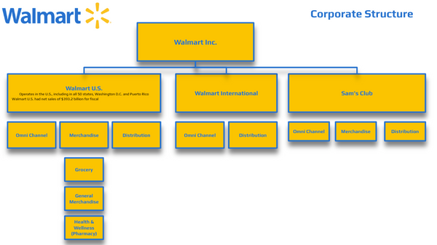
Figure 1 Corporate Structure at Walmart (Databahn, 2025)
As a result, these structures enable Walmart to practice discipline and alignment that promote standard processes and values, achieving success where the culture and structure generate a mutually rainforest system that offers strong managerial control and consistency across thousands of stores (Lombardo, 2024).
“Service To The Customer”, “Respect For The Individual”, “Striving For Excellence”, and “Acting With Integrity” constitute “the values in action” at Walmart (WalmartEthics, no date). These are more than slogans in influencing how decisions are made at every level. Even though the formal hierarchy determines who will make the decisions, such as senior management, store managers, etc. These cultural values are critical to determine how those decisions are made in relation to the criteria and acceptable trade-offs.
However, this approach lacks flexibility at the lower levels because they cannot adjust business practices due to lengthy communication and approvals from middle managers and corporate managers at headquarters. Store managers often lack the autonomy needed to address local preferences and respond promptly to unexpected conditions, as this requires approval from the top level (Lombardo, 2024).
Strategies devised by top leadership and implemented quickly and consistently at stores reflect why Walmart scaled its low-cost business model and dominated many markets over time (Lombardo, 2024). The culture also encourages open communication, as highlighted by founder Sam Walton, who emphasised the importance of employees' insights, quoting, “Listen to your associates; they’re your best idea generators.” (Ugorji, 2022; McGlauflin, 2024).
Now, this report will critically analyse the culture through the lens of different frameworks and models shaping Walmart.

Analysing Walmart’s Culture Through Key Frameworks
To comprehend the organisational culture of Walmart, several theoretical frameworks can work as effective tools, including Edgar Schein’s three-level model of culture, Geert Hofstede’s cultural dimensions in relation to a multinational context, and Charles Handy’s typology of organisational culture. This offers critical insights into visible manifestations underlying values and basic assumptions that reflect Walmart’s culture, as discussed in the following subsections.

Schein’s Model: Artefacts, Espoused Values, and Basic Assumptions
Edgar Schein’s model conceptualises organisational culture in three layers: artefacts, espoused values, and basic underlying assumptions, which are detailed below (Schein, 2010; Ugorji, 2022).
Artifacts:
Artefacts are visible and tangible manifestations of culture. A classic example is the famous “Walmart cheer”, a chant and group cheer (“Give me a W-A-L-M-A-R-T!”), which was introduced by Sam Walton to energise employees each day. The other one is a store greeter. This concept deploys a friendly associate who often welcomes customers with a smile and addresses them (Phúc, 2023). These artefacts are the outward expressions of Walmart’s culture that any employee or customer can readily observe (Schein, 2010).

Espoused Values:
Beneath these surface elements lie Walmart’s stated core values and norms. The core values consist of service to the customer, respect for the individual, striving for excellence, and acting with integrity. The recent emphasis on belonging highlights how Walmart is committed to upholding its values by creating a workplace where all associates feel seen, supported, and connected. This includes workforce representation and belonging updates, such as 51% of the workforce being women (Walmart, 2025, p. 11, no date; WalmartEthics, no date).
Basic Assumptions:
The deepest level of the model reflects unspoken assumptions that guide behaviour, which employees may no longer question. Offering customers low prices is central to the idea, enabled by efficiency, cost control, and scale. Walmart’s “ways of doing things” are replicable regardless of geography, complemented by work ethic, modesty, and frugality that highlight customer preferences (Thomson, 2010; Dauber, Fink and Yolles, 2012; Ugorji, 2022).
Overall, Schein’s framework demonstrates that Walmart remains quite consistent; its artefacts reinforce its espoused values, which, in turn, reflect underlying assumptions.

Hofstede’s Cultural Dimensions: Multinational Challenges
Hofstede’s cultural dimensions theory contextualises Power Distance, Individualism vs Collectivism, Uncertainty Avoidance, Masculinity vs Femininity, and Long-Term Orientation to position the organisational culture (Hofstede, 1980). From the Walmart context, it is constrained when applying its US-rooted culture abroad.
- The US culture enables competition, individualism, and results orientation which are held by Walmart as well, which contrasts with others abroad. For instance, German employees emphasise formal structure, seriousness, and worker involvement, and they view Walmart artefacts such as cheer routines and smile directives as uncomfortable (Thomson, 2010; Hamza and Nizam, 2016).
- Walmart has slowly adapted to local markets, accommodating norms of authority, workplace relationships and customer service, which Belonging manifests, reflecting that one-size-fits-all culture does not work in global markets (Pioch and Gerhard, 2014; Ahmed, 2025a; Walmart, 2025, p. 11).

Handy’s Cultural Types: Walmart as a Role Culture
According to Handy, organisations fall into one of four cultural types: Power culture (Zeus), Role culture (Apollo), Task culture (Athena), and Person culture (Dionysus) (Handy, 2006). Walmart can be best described as mainly a Role Culture.
- In the role culture, power and authority originate from one’s position, not from individual charisma (Thiam, 2024). It contains formal procedures, responsibilities and hierarchical reporting as well as clear rules. The Walmart store manager has defined responsibility where decision-making flows downward largely and ensuring Walmart maintains consistency and control (Ng, Jee and Anuar, 2012).
- Nonetheless, the Walmart organisation also reflects a Power culture in relation to the founder's legacy, where strategic decisions are made by senior leadership, including the Walton family, which remains present (Phúc, 2023).
- Moreover, there are increasing Task culture elements as well, such as cross-functional project teams, comprising e-commerce technology supply chain innovation. This fosters creativity, flexibility, where results matter more than rank. Additionally, these teams are more adaptable and experimental, which often override traditional store operations.
- Finally, a Person culture that prioritises individual autonomy above structure is almost absent in Walmart, having a scalable, standardised and uniform business practice.
With this, the report will analyse how Walmart’s culture works as a tool to adapt to the external environment in the following section.

Culture as a Tool for Adapting to the External Environment
Organisational culture is critical for shaping and responding to external forces. A culture that is strongly adaptive can provide a significant competitive advantage while facing to external forces.

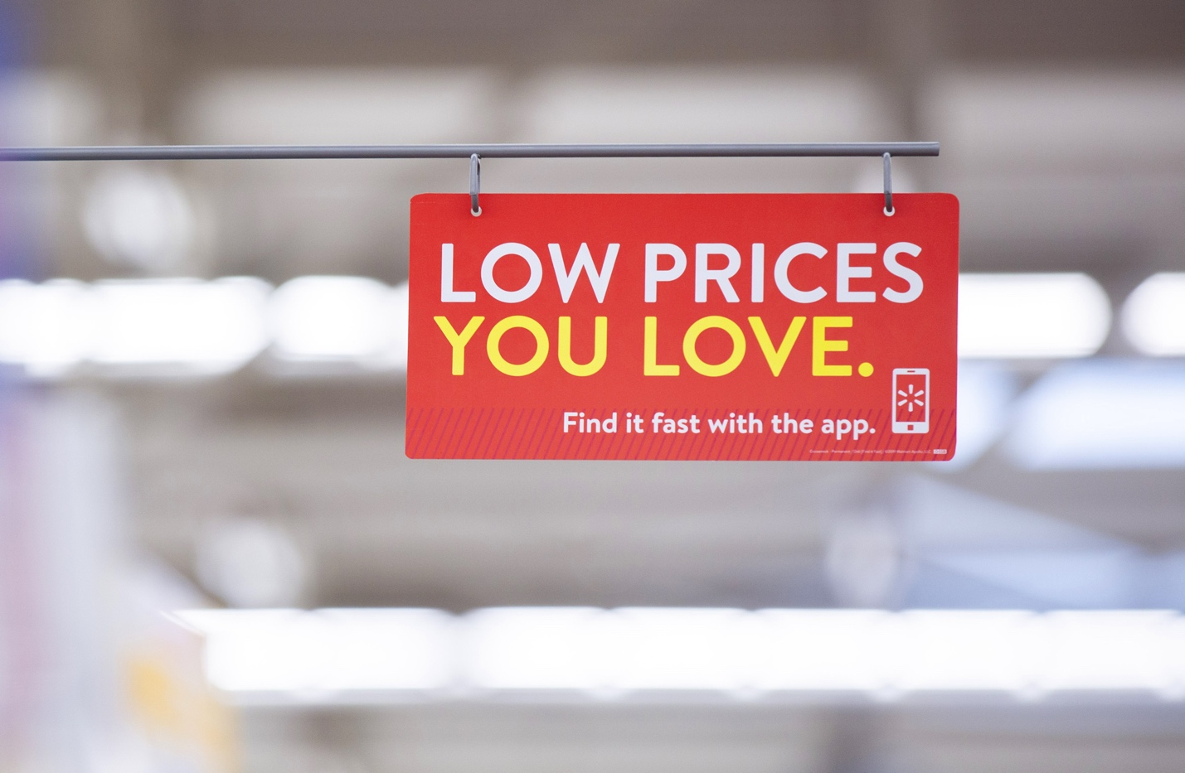
Figure 2 Low Price Strategy at Walmart (Corporate, 2020)
A main element of Walmart's culture is its long-standing emphasis on cost efficiency and frugality, which is reflected in its “Everyday Low Prices” strategy. This cultural aspect helps Walmart meet the external factor of customer demand for lower prices. Especially during economic downturns, whether inflation or recession, price sensitivity is common, and its cost leadership position enables Walmart to overcome this challenge and compete strongly (Ann, 2024). This advantage is due to its cost-cutting logistics improvements, tight supplier negotiations, and economies of scale.
Customer service is a key part of Walmart's culture, helping it to navigate the external environment to its advantage. It also supports adapting to evolving customer expectations. Customers demand convenience, whether it's online ordering, curbside pick-up, seamless returns, or friendly store experiences. This cultural focus enables strategic decision-makers to make informed choices by adapting service models (Corporate, 2020).
Walmart leverages its culture in how it treats and develops its workforce. Highlighting “respect for the individual," Walmart is consistently investing in human resources through the "Live Better U” programme for upskilling staff. Walmart pays for tuition, saving $730m for employees and books in collaboration with top academic institutions that can address the skill gap and prepare employees for in-demand roles. So far, 126,000 associates have participated in this programme, demonstrating how Walmart's culture is adapting to change (Corporate, no date).
Moreover, Walmart has invested significantly in diversity, equity, inclusion, and Belonging, which Walmart celebrates, supporting associate resource groups such as the Asian Pacific Associate Network, Black and African American Resource Group, the Latino Network, Disability Action Network, etc. (Walmart, no date). This allows Walmart to access insights into various customer segments and accordingly tailor outreach, marketing, and policy.
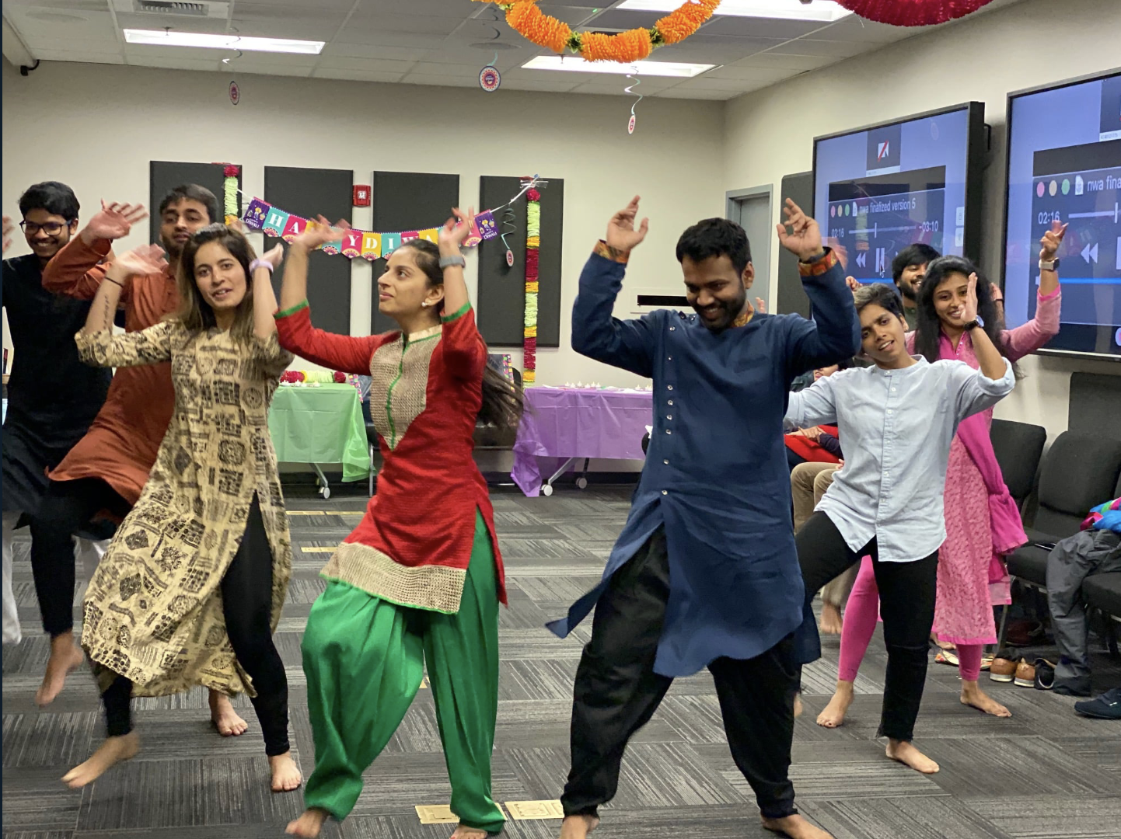
Figure 3 Asia Pacific Associates are dancing at Walmart (Loveall, no date)
What is incrementally advantageous for Walmart is that it is constantly adapting to technological disruption. Walmart describes itself as “people-led, tech-powered,” aiming to incorporate new tools such as AI, improved inventory systems, and digital customer interfaces while preserving human values. This is further enhanced by comprehensive training and communication efforts, with larger investments like $1 billion in career-focused training and development by 2026. (Walmart Corporate, 2023).
Overall, Walmart leverages its culture as a tool that not only stabilises and withstands external change but also serves as a dynamic force for adaptation, focusing on cost efficiency, customer service, human resource development, inclusion, and technology.
Now, the following section will impart deeper insights into how the Walmart culture can work as a barrier to effective functioning.

Culture as a Barrier to Effective Functioning
The culture at Walmart functions as a strength primarily for achieving organisational objectives. However, it also poses a threat to effective functioning. There are many instances where Walmart's culture has manifested friction, either internal or external, which has contributed to reducing effective performance. These are detailed below.

Resistance to Local Adaptation:
The German example previously demonstrated how Walmart's culture, rooted in the US, remains inconsistent when exported abroad. The “Walmart way” of cheerfulness, certain labour practices, and pricing strategies have contrasted with local customs in other countries, particularly in Germany and South Korea and Japan. In Germany, customers and staff responded negatively to practices such as enforced morning cheers and a routine friendliness that made them highly uncomfortable. As a result, this led to declining morale, poor public perception, and ultimately, Walmart's exit from Germany (Hamza and Nizam, 2016; Ecomclips, 2022).

Authoritarianism and Lack of Employee Voice:
In some cases, it was observed that Walmart’s culture has stifled communication. Even though it vouched for respect for the individual, which promotes inclusion in practice, many associates reported being unheard. Furthermore, a strong anti-union stance, a rigid top-down decision-making approach, and a culture that discourages different opinions can lead to employee concerns, operational issues, and associate-level innovations being overlooked (Ecomclips, 2022; Ugorji, 2022).

Employee Morale and Public Backlash:
Public protests by Walmart employees reflect concerns about the company's toxic culture. A Walmart employee in Alberta, Canada, used the store intercom to announce their resignation, criticising management for their treatment, including abuse of power, lack of respect, and disregard for employee well-being, pay, and working conditions (Brice-Saddler, 2018; Barbour, E.P., 2022). These events exemplify how corporate values are sometimes seen as disconnected from reality. This breakdown damages morale, erodes trust, and can harm the company's reputation.

Cultural Pressure and Stress:
High-performance targets, including excellence and cost efficiency, are what come with Walmart, which can lead to employee stress, especially when operating under staffing and pressure to deliver with a minimum amount of resources. “Wait with a smile” can strain associates, which is positive for customers, but it also causes stress for staff when there is a lack of support. High turnover rate amongst employees manifests how this stress and misalignment between cultural expectations and working conditions can undermine stability and effectiveness (Phúc, 2023; Thiam, 2024)
These aspects act as barriers to the effective functioning of Walmart. However, recognising these barriers is the first step towards addressing them, which leads the report to the final analysis of culture’s impact on performance and recommendations.

Impact on Performance and Recommendations for Improvement
Organisational culture can have both negative and positive impacts on its performance, which is also true in the case of Walmart. Operational practices guided by the Walmart culture have helped build Walmart’s retail dominance. However, sometimes the culture has undermined the performance as well. Assessing both sides can offer insights into areas of improvement (ICMR, 2003; Amanet, 2019; Ahmed, 2025b).

Positive Impacts on Performance
Sam Walton's founding principles, which promoted saving people money so they can live better, guided the overall culture of the organisation. This culture emphasised efficiency, uniform execution, customer focus, and low pricing. As a result, it provided a significant competitive advantage. Its cultural norms have led to the cost leadership strategy that offers operational excellence and continuous cost control. This has generated US$681 billion in revenue as of 31 January 2025, making it the largest retailer. It reflects how its culture can be instrumental in achieving high sales volume and a strong market share, including 21.2% in the US grocery market, where its overall retail market share is 6.04%. Moreover, Walmart holds roughly a 6.3% market share in US retail e-commerce (Shopping, 2025; Wildwood, 2025).
The “service to the customer” and “striving for excellence” drive a focus on customer satisfaction, loyalty, and quality service that friendly associates and a consistent store experience support. Additionally, the cultural commitment to integrity and ethics provides greater protection against damage to reputation, legal issues and financial penalties. Therefore, culture acts as a strategic asset that aligns Walmart’s vast workforce globally to execute actions, such as supply chain modernisation, global sourcing, and omnichannel growth with a shared purpose.

Negative impacts on performance
The cultural rigidity can negatively expose Walmart as it expands globally. The failure in Germany is a clear example that shows how trying to transplant US cultural practices, such as cheerfulness mandates, specific forms of customer greeting, and an anti-union stance, can backfire where German norms regarding formality, worker participation, and low power distance differ significantly. As a result, this led to poor morale and serious competitive disadvantages (Nizam, 2016).
Additionally, internal culture has been a reason to suppress employee voice. Even though they exist, the “respect for the individual” stance, many associates are found to report feeling unheard or undervalued,which led to pushing Walmart to raise wages and benefits in the late 2010s and 2020s (Sainato, 2021). Furthermore, hierarchical structures that stifle unionisation and low psychological safety limit feedback, potentially leading to operational issues more quickly. As a result, lower engagement, productivity, and higher turnover can ensue at Walmart.
Furthermore, public backlash also arose when culture did not align with values. Employees raised concerns about treatment, discrimination, or a gap between expectations and reality, which led to damage to morale and the employer brand. This, in turn, can worsen recruitment challenges for newer roles in e-commerce, tech, or innovation, where Walmart must compete with more flexible workplaces.

Recommendations for Improvement:
Walmart must consider the aspects that are critical to making the culture an asset rather than a liability. In this respect, the following recommendations are made for improvement:
- Walmart must align its values with its practices. In this regard, to ensure “respect for the individual”, it must improve wages, benefits, and working conditions. Regular employee surveys or culture audits should be conducted to identify gaps.
- Walmart needs to foster a culture that empowers employees and promotes bottom-up communication. Giving store managers and associates autonomy over customer service issues or local experiments is crucial, as it reflects decentralised decision-making.
- Improving cultural adaptability and sensitivity is another critical aspect that needs improvement at Walmart. As it operates globally and within diverse communities, it must invest in cultural intelligence training, especially for leadership. Walmart should adopt a “glocal” approach, where the core values remain stable, while local implementation is tailored and flexible.
- Enhancing diversity, equity, and inclusion is also vital. The growing representation of women in the workforce, now at 51.6%, reflects a current stance that needs improvement.
- Walmart offers a highly competitive and high-performing ecosystem, but this comes at a cost: burnout is common among staff due to the demanding standards. However, it must prioritise associate well-being. Expanding wellness programmes, healthcare, and staffing, along with adjusting targets, can support sustained high performance without burnout.
- Walmart must foster innovation and learning, and it needs to accelerate these efforts in the coming days. This includes upskilling and motivating staff to experiment at internal labs or incubators, to promote career development and organisational success.
With these recommendations, the following section will provide the conclusion of the report.

Conclusion
Walmart's culture has driven both notable success and occasional setbacks. The hierarchical, centralised system ensures consistency and control, enabling the global implementation of its low-cost, customer-focused strategy. Organisational culture frameworks, such as Schein’s, Hofstede’s, and Handy’s, demonstrate that Walmart’s deeply rooted rituals and shared values offer both strengths and risks, particularly when the culture fails to adapt to local norms or employee expectations.
When the culture emphasises efficiency, customer service, inclusion, workforce upskilling, and technology adoption that align with the external environment, Walmart thrives. However, when the culture conflicts with local customs and disregards associates’ voices, performance suffers.
Going forward, Walmart must adhere strictly to its core values, such as integrity, excellence, and customer service, so that its culture remains more than aspirational. Key changes include aligning actions with values, empowering employees, boosting openness and flexibility, embracing inclusion, and fostering innovation. These will ensure the sustainable performance of Walmart ahead.

References and Bibliography
Ahmed, T. (2025a) “WALMART’S COMPANY CULTURE: COMPANY PROFILE AND FINANCIAL FIGURE.”
Ahmed, T. (2025b) “WALMART’S COMPANY CULTURE: COMPANY PROFILE AND FINANCIAL FIGURE.”
Amanet (2019) Wal-Mart’s Culture Shock. Available at: https://www.amanet.org//articles/wal-marts-culture-shock/ (Accessed: September 13, 2025).
Ann (2024) “What is Everyday Low Pricing (EDLP)? Explained with Walmart,” MetricsCart, 26 March. Available at: https://metricscart.com/insights/edlp-walmart-pricing/ (Accessed: September 12, 2025).
Barbour, E.P. (2022) The trouble with Walmart: leaders tale. Available at: https://www.theworkpsychologists.com/post/walmart-culture-leadership-awareness (Accessed: September 12, 2025).
Brice-Saddler, M. (2018) Teenager filmed using intercom to quit job at Walmart: “Nobody should work here - ever” | The Independent | The Independent. Available at: https://www.independent.co.uk/news/world/americas/walmart-quit-video-teenager-intercom-loudspeaker-alberta-canada-jackson-racicot-a8682386.html (Accessed: September 12, 2025).
Corporate, W. (2020) We Mean It When We Say It: Every Day Low Prices - Anytime, Anywhere. Available at: https://corporate.walmart.com/news/2020/03/26/we-mean-it-when-we-say-it-every-day-low-prices-anytime-anywhere (Accessed: September 12, 2025).
Corporate, W. (no date) Live Better U, Live Better U. Available at: https://corporate.walmart.com/about/working-at-walmart/live-better-u (Accessed: September 12, 2025).
Corporate Walmart (2025) Leadership, Leadership. Available at: https://corporate.walmart.com/about/leadership (Accessed: September 12, 2025).
Databahn (2025) Walmart Organizational Structure Report in 2025, Databahn. Available at: https://www.databahn.com/pages/walmart-organizational-structure (Accessed: September 12, 2025).
Dauber, D., Fink, G. and Yolles, M. (2012) “A Configuration Model of Organizational Culture,” Sage Open, 2(1), p. 2158244012441482. Available at: https://doi.org/10.1177/2158244012441482.
Deal, T.E. and Kennedy, A.A. (1983) “Corporate cultures: The rites and rituals of corporate life: Addison-Wesley, 1982. ISBN: 0-201-10277-3. $14.95,” Business Horizons, 26(2), pp. 82–85.
Ecomclips (2022) Why Walmart Failed in Germany and Europe: The Main Reasons. Available at: https://ecomclips.com/blog/why-walmart-failed-in-europe-what-went-wrong-in-germany (Accessed: September 12, 2025).
Elliott, M., Golub, B. and Leduc, M.V. (2023) “Corporate Culture and Organizational Fragility.” arXiv. Available at: https://doi.org/10.48550/arXiv.2301.08907.
Hamza, S. and Nizam, I. (2016) “Why Walmart Fails in Germany? An Analysis in the Perspective of Organizational Behaviour.”
Handy, C.B. (2006) Understanding Organizations. London: Penguin Global.
Hofstede, G. (1980) “Culture and Organizations,” International Studies of Management & Organization, 10(4), pp. 15–41. Available at: https://doi.org/10.1080/00208825.1980.11656300.
ICMR (2003) The Good and Bad of Wal-Mart’s Culture|Human Resource|Organization Behavior|Case Study|Case Studies. Available at: https://www.icmrindia.org/casestudies/catalogue/Human%20Resource%20and%20Organization%20Behavior/HROB037.htm? (Accessed: September 13, 2025).
Jaques, E. (1951) “The changing culture of a factory. London,” Tavistock Institute, p. 28.
Lombardo, J. (2024) “Walmart’s Organizational Structure & Company Culture,” Panmore, 21 October. Available at: https://panmore.com/walmart-organizational-structure-organizational-culture (Accessed: September 12, 2025).
Loveall, A. (no date) “Associate Resource Groups.”
McGlauflin, P. (2024) How Walmart is upskilling its 2.1 million employees. Available at: https://www.hr-brew.com/stories/2024/09/27/walmart-upskilling-2-million-employees (Accessed: September 13, 2025).
Morgan, G. (1986) Images of Organization. SAGE Publications.
Mullins, L.J. and Christy, G. (2016) Management and Organisational Behaviour. Pearson.
Ng, P.K., Jee, K. and Anuar, N. (2012) “The Role of Cross-Functional Teamwork in Developing Creativity: A Review,” in.
Nguwi, M. (2020) Top Organisational Culture Definitions to Know, Human Capital Hub. Available at: https://www.thehumancapitalhub.com/articles/The-Best-Definitions-Of-Organisational-Culture- (Accessed: September 11, 2025).
Nizam, I. (2016) “Why Walmart Failed in Germany? An Analysis in the Perspective of Organizational Behaviour,” International Journal of Accounting & Business Management, 4, pp. 206–215. Available at: https://doi.org/10.24924/ijabm/2016.11/v4.iss2/206.215.
Nneji, N. and Asikhia, P. (2021) “Organizational Culture and Organizational Performance: A Review of Literature,” 3, pp. 361–372. Available at: https://doi.org/10.35629/5252-0301361372.
Pereira, D. (2025) Walmart Organizational Structure Analysis. Available at: https://businessmodelanalyst.com/walmart-organizational-structure-analysis/ (Accessed: September 12, 2025).
Phúc, N.T.H. (2023) VĂN HÓA DOANH NGHIỆP | PDF | Cost Of Living | Organizational Culture, Scribd. Available at: https://www.scribd.com/document/731146004/V%C4%82N-HOA-DOANH-NGHI%E1%BB%86P (Accessed: September 12, 2025).
Pioch, E.A. and Gerhard, U. (2014) “Organizational culture as differentiator in international retailing,” The Service Industries Journal, 34(8), pp. 729–749. Available at: https://doi.org/10.1080/02642069.2014.886194.
Ravasi, D. and Schultz, M. (2006) “Responding to Organizational Identity Threats: Exploring the Role of Organizational Culture,” Academy of Management Journal, 49(3), pp. 433–458. Available at: https://doi.org/10.5465/amj.2006.21794663.
Sainato, M. (2021) “‘You can’t pay bills on $12 an hour’: Walmart employees left out of raises,” The Guardian, 28 October. Available at: https://www.theguardian.com/business/2021/oct/28/walmart-pay-hourly-low-wages-working-conditions (Accessed: September 13, 2025).
Schein, E.H. (2010) Organizational culture and leadership. 4th ed. San Francisco: Jossey-Bass (The Jossey-Bass business & management series, 2).
Shopping, C.O. (2025) “Walmart Statistics (2025): Revenue, Customers & Market Share,” Capital One Shopping, 4 April. Available at: https://capitaloneshopping.com/research/walmart-statistics/ (Accessed: September 12, 2025).
Thiam, N.K. (2024) “Role Of Corporate Culture, Leadership and Strategy in Corporate Failures: A Case Study Analysis Approach.” Available at: https://uniselinus.education/sites/default/files/2025-03/Ng%20KokThiam.pdf.
Thomson, G.S. (2010) “High-Performance Organizations: The Wal-Mart Stores Inc. Case Study,” SSRN Electronic Journal [Preprint]. Available at: https://doi.org/10.2139/ssrn.1624245.
Ugorji, B. (2022) Walmart’s Organizational Culture, Communication, And Conflict Styles: #1 Research On How Decisions Are Made Inside Walmart. Available at: https://icermediation.org/walmart-organizational-culture-and-communication (Accessed: September 12, 2025).
Walmart (2025) Walmart Annual Report 2025. Annual Report. Available at: https://stock.walmart.com/sec-filings/all-sec-filings/content/0000104169-25-000059/0000104169-25-000059.pdf.
Walmart (no date) Culture of Belonging | Walmart Careers. Available at: https://careers.walmart.com//culture-of-belonging (Accessed: September 11, 2025).
Walmart Corporate (2023) corporate.walmart.com/content/dam/corporate/documents/about/working-at-walmart/live-better-u.pdf?utm_source=chatgpt.com. Available at: https://corporate.walmart.com/content/dam/corporate/documents/about/working-at-walmart/live-better-u.pdf (Accessed: September 12, 2025).
WalmartEthics (no date) Code of Conduct, Code of Conduct. Available at: https://publish-p149513-e1547978.adobeaemcloud.com/content/walmartethics/en_us/code-of-conduct.html (Accessed: September 12, 2025).
Wildwood, L. (2025) “20 Top Walmart Statistics For 2025 (Revenue, Market Share, And More),” Blogging Wizard, 8 July. Available at: https://bloggingwizard.com/walmart-statistics/ (Accessed: September 12, 2025).
Zhang, M. and Devi, S. (2024) “Toward a Theory of Motivation and Performance for Organizational Employees: A Case Study of a Walmart Store in the USA,” Public Administration Research, 13(2), p. 9. Available at: https://doi.org/10.5539/par.v13n2p9.

