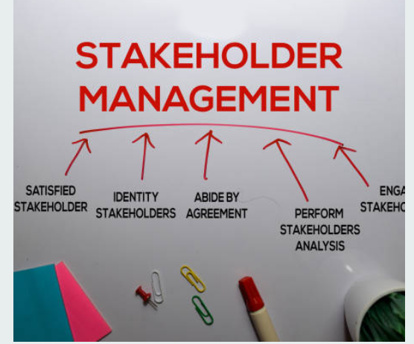
A definition of stakeholder is: “individuals and organisations who are actively involved in the project, or whose interests may be positively or negatively affected as a result. of project execution or successful project completion”. https://www.projectmanager.com/blog/what-is-a-stakeholder/

Blog 3
Project Management Tool
Stakeholder Analysis
Allison Cullen Student 2218746

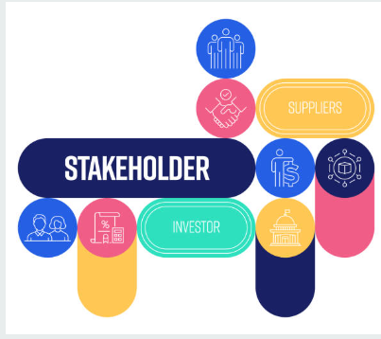
Conducting a stakeholder analysis for the charity hike project is not just a task but a collaborative effort that is crucial for several reasons. This analysis, which involves all stakeholders, including participants, sponsors, and local businesses, aims to raise funds for the Welsh Air Ambulance. It helps identify everyone's interests, potential conflicts, and critical needs, ensuring that all viewpoints are considered and valued.

Stakeholder analysis is a comprehensive process that extends beyond financial assessment. It encompasses social and community benefits, which are often overlooked, and provides a detailed overview of stakeholder relationships. This analysis is crucial in identifying potential partnerships between local businesses and charities, ensuring that all aspects are thoroughly considered.
It's crucial to understand that stakeholders assume different roles at various stages of the project, underscoring the value and significance of each one. For instance, sponsors and the Air Ambulance representative are pivotal during the conceptual phase for funding and alignment with the charity’s goals. Simultaneously, participants and volunteers have a more significant impact during the execution phase, ensuring the smooth running of the event.

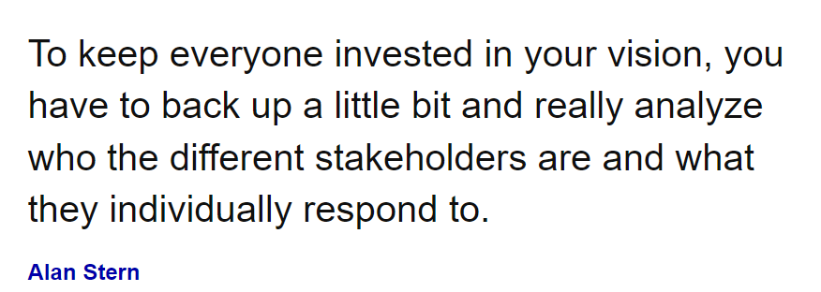
https://www.brainyquote.com/quotes/alan_stern_834913,/

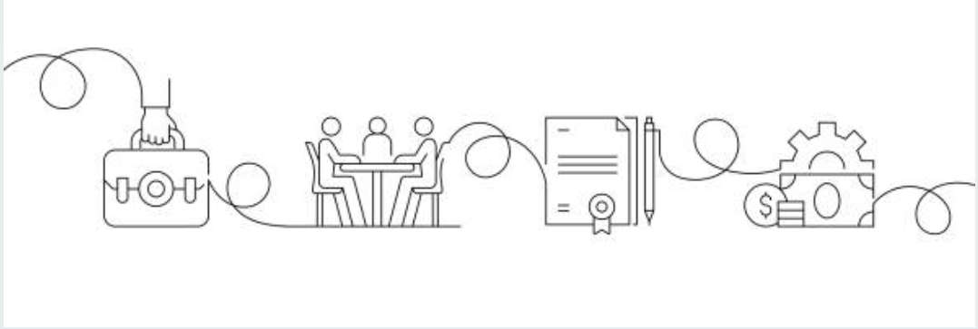

Reference
Alan Stern Quotes (2024) BrainyQuote.com, Brainy Media Inc. Available at: https://www.brainyquote.com/quotes/alan_stern_834913,/ (Accessed May 31st 2024).
Landau, P. (2022) ‘What is a Stakeholder Analysis’? ‘Everything you need to know’. Peter Landau Project Management [Blog]. 22 March. Available at: https://www.projectmanager.com/blog/what-is-a-stakeholder/ (Accessed: 29th May 2024).

