AI Statement

I confirm that I have not used any AI generated text as my own work. I confirm I have copies of my drafts, notes, and other resources I used before, and after the use of AI tools which I may be asked to provide in evidence.

Contents

- Section 1

- Section 2

- Section 3

- Section 4

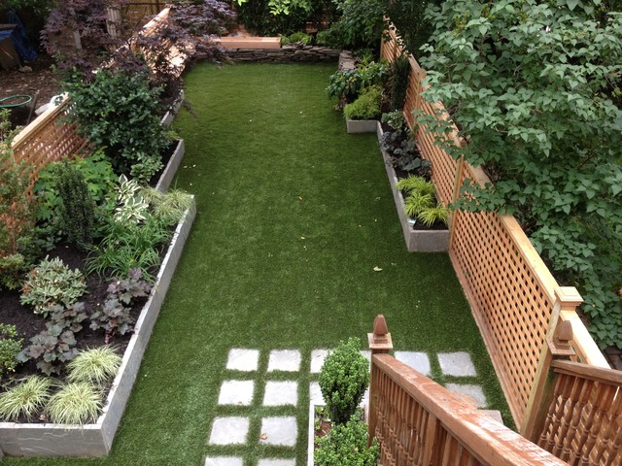
Source: Google Images

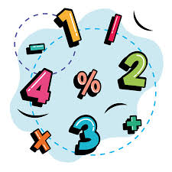

Welcome to the garden!! The number of children that will visit the garden will be ten who are all aged five, along with three adult practitioners. This garden site represents a structured outside garden zone including artificial grass, elevated plant-holders, a smooth path with square slates and fences on both sides that are made of wood. Such surroundings offer strong prospects meant for young children to

discover the physical realm and foster early scientific and mathematical intellect through up-front involvement. According to the Early Years Foundation Stage (EYFS, 2025), real understanding takes place whilst children participate within play that inspires effective discovery, reflecting and analysing. The outside garden therefore represents as a flexible learning area where children can trial run concepts, detect connectedness, determine modification and participate in review-constructed activities that attach intellectual ideas with perceptible occurrence. Within the outside garden area, open-ended resourcefulness, inspiring conversation and encouraging exploration can be utilised. Children transfer from (“the soil feels wet”) to profounder logic for instance (“it must have rained because the soil absorbs water”).
It must have rained because the soil absorbs water.
The soil feels wet!
t


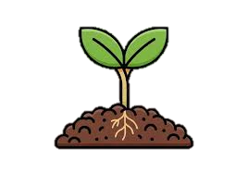

This setting therefore develops into a living classroom where children involve their minds and inquisitiveness to discover both mathematical and scientific ideas.

Scientific Learning Prospects within the Garden Setting

Observation and Classification

The upraised plant-holders on equal sides of the garden attract children to monitor, contrast and categorise living things. The children can classify plants according to structures such as the outline of a leaf, shade colour or consistency, leading to improving the children’s terminology such as stem, root and petal. This affiliates with EYFS objectives for Understanding the World, urging children to observe resemblances and differentiations amid living organisms. Utilising magnifying glasses or bug pots presents them to scientific instruments and processes (Waite, 2017)







Development and Change

Placing seeds or bulbs inside the high patches permits children to watch life cycles and comprehend in what way do living things govern by sunshine, water and soil. When the children examine plant growing, they come across important scientific concepts regarding modification over time and interconnection. Logging these surveillances throughout weeks strengthens longitudinal study and extrapolation. Such experiences exemplify the scientific procedure wherever discovery, prognostication and consideration shape the groundwork of primary science.
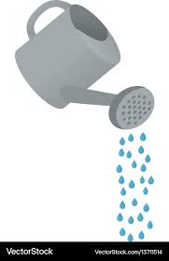

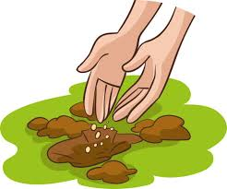


Forces and Materials

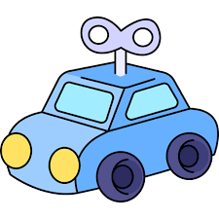
The multiplicity of surfaces for instance grass, slates and soil suggests prospects to examine forces for example gravity and resistance. Moving balls or toy cars on unusual consistencies promotes proportional reflecting for instance “The ball moves quicker on the slates than on the grass.” Children discover movement, surface resistance and physical properties during explicit occurrences. Adult practitioners can prolong this by means of supporting testing and trialling.
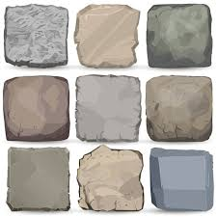
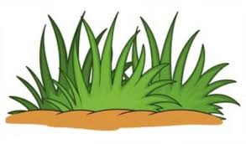



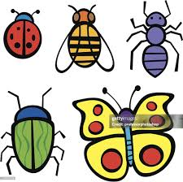

Environmental Consciousness and Sustainability


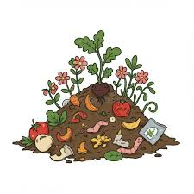
The garden site’s physical characteristics familiarise the children to ecological science. The children can talk about which plants draw insects such as bugs, pests, flies, beetles and general creepy-crawlies. They can also talk about in what way does composting assist the development of plants. Discovering worms and ladybirds cultivates understanding and stewardship for living things. Such rendezvous associates with Education for Sustainable Development principles (UNESCO, 2022) and the EYFS concentration on being concerned for the natural world.

Improving Scientific Questioning Abilities

Question-constructed education could be fostered because of urging children to pose queries and questions, create prognostications and try out philosophies. For instance, an adult practitioner may present a question such as “What do you believe will occur if we place one plant inside the shade and one more in the sunlight?” The children can determine, contrast and document results which will permit them to participate in unbiassed experimenting. According to Harlen (2014), these involvements improve the crucial scientific temperaments of inquisitiveness, perseverance of contemplation which are attributes that reinforce upcoming scientific literateness.





Mathematical Education Prospects within the Garden Setting.


Shapes, Space and Measurement


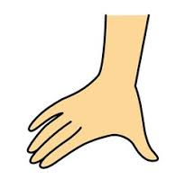
The symmetrical arrangement of the garden environment proposes several mathematical probabilities. The child could look at the rectangle plant holders, categorising and specifying shapes. Calculating the length and width by using rulers or atypical items such as hand span fosters awareness of dimension and judgment. Dimension task activities in important circumstances help children adopt conceptual mathematical perceptions.

Tallying, Organising and Number Identification

Children can perform one-to-one communication by counting plants, slates or stones. They can also categorise items by quantity. For example, placing five leaves in every individual pot strengthens primary adding and multiplying conceptions. Recurrence of such activity tasks within a lively location improves perception of numbers and categorisation, accomplishing EYFS arithmetic results for calculating consistently and distinguishing numbers.

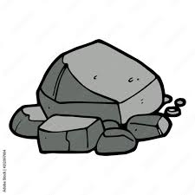
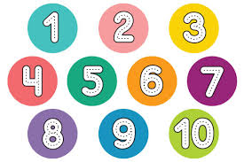
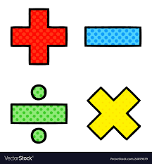

Configuration, Symmetry and Sequencing

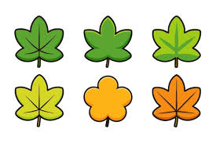
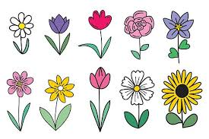

The well-proportioned design of the garden setting and the recurring patterns of the slates urge children to identify and construct configurations. The children can also create physical montages by using irregular leaves and petals or they can assemble pebbles in recurring colour shade arrangements.

Information Management and Demonstration


Documenting plant development growth or weather watching permits children to participate with primary statistics gathering. The children may calculate plant height every week and symbolise the findings on pictogram representations or bar graphs. This initiates information evaluation ideas inside a tangible background, connecting arithmetic to practical scientific questions.
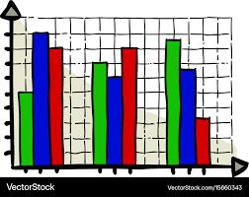




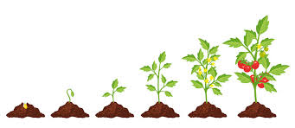



Problem Resolving and Spatial Reasoning




Unrestricted task challenges for instance “In what way can we create a new flower bed that measures amongst these two fences?” supports spatial reasoning plus analytical ideas. Children guess, arrange and try-out concepts, using ideas of space, boundary and location. Such involvements foster compliant thoughts and sustain later proficiency in geometry and problem solving.
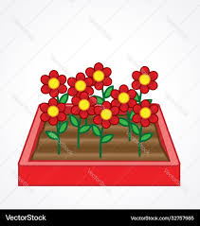


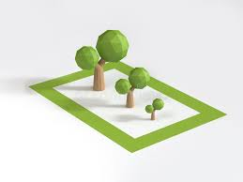


Incorporating Science and Maths Throughout Play



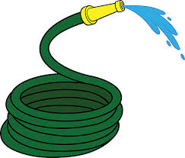
Inside good quality outside provision, science and maths are extremely interrelated. Task activities for instance a plant-development exploration, capacity and prognostication. Children hose down plants every day, determine development and log conclusions. Likewise, playing with water connects volume (mathematics) with properties of substances (science). Whilst adult practitioners embolden children to guesstimate for instance “How many scoops do you think will fill the pot?” - they connect mathematical reasoning to experimental testing.


The responsibility of the adult practitioner is critical. Practitioners demonstrate language, bring together new language and support questions through expanding children’s thinking (“Why do you think the soil feels warmer in the sun?”).


Outside education furthermore encourages teamwork and affiliation. Children working in small groups to calculate or log results discover to traverse responsibilities, distribute concepts and validate reasoning - these are vital groundworks for later science and maths communication. As Waite (2017)
observes, the outside environment puts forward both intellectual test and emotional welfare, improving engagement and resilience.






The garden setting presented in the photo demonstrates how outside spaces can cultivate introductory scientific and mathematical awareness in initial childhood. Throughout sensory discovery, research and societal communication, children participate in genuine inquiry that links theory with occurrence. Scientific knowledge appears as children watch living things, try-out theory and grow emotive mindfulness, mathematical knowledge develops as count, assess, contrast and document. Steered by adult practitioners who support and expand children’s thoughts, these involvements line up with the EYFS importance on play-constructed effective learning. Eventually, such surroundings foster inquisitiveness, self-assurance and analytical thinking – vital characteristics for ultimate engagement with science and maths.

RISK BENEFIT ASSESSMENT

Location / Activity: | Garden | Date: | October 1st 2025
Assessor: | Student name | Review date: | September 15th 2020

The boxes in the table below will expand as you type into them; pre-entered text is simply for illustration. You should delete irrelevant items and replace with text relevant to your circumstances.
Your overall risk rating – Low, medium or high – is based on your judgement about whether the BENEFITS of the activity or opportunity outweigh the RISKS.

Experience exploring outdoor space in photograph | How will young people BENEFIT from this activity? | Hazards and associated risks | Who is at risk? | PRECAUTIONS in place to reduce the risk of injury | Overall risk after precautions  RATING: L/M/H
Unequal floor or steps heading into the garden setting. | It creates a sense of steadiness, synchronisation and spatial consciousness. | Trips, slips, stumbles and falls. | Adults and children | Adult practitioner’s protection and observation; clear boundaries; urge children to grasp the barriers; make sure that floor is dry. | Medium
Exploring raised garden beds and tools | Promotes responsibility, fine motor skills, understanding of tool use. | Cuts, scrapes or misuse of gardening tools. | Adults and children | Use age-appropriate tools; demonstrate safe use; provide gloves; supervise during planting. | Medium
Exploring plants and soils | Promotes scientific observation, sensory learning and environmental care. | Allergic reactions, infestation of unsafe plants, hygiene concerns. | Adults and children | Identify and label non-toxic plants; wash hands after gardening and educate regarding safe handling. | Low
Exploring insects and wildlife | Teaches respect for living things, ecological awareness. | Bee stings or insect bites. | Adults and children | Educate children not to disturb insects; have first aid and allergy protocols. | Low
Exploring the weather (sun, cold, rain). | Encourages resilience, awareness of weather and seasonal change | Sunburn, dehydration, cold. | Adults and children | Require suitable clothing (hats, coats); apply sunscreen, provide shaded area; ensure hydration. | Medium
Exploring pathway and tile surface. | Develops hazard awareness and self-regulation | Slippery when wet | Adults and children | Use non-slip mats if needed; monitor conditions; restrict running during rain. | Medium
Exploring boundaries and fencing. | Supports understanding of safety limits and responsibility | Risk of climbing or splinters | Adults and children | Regular maintenance checks; discuss rules about safe boundaries. | Low
Exploring loose materials (pebbles, sticks) | Encourages creativity and fine motor play with natural materials. | Throwing or tripping | Adults and children | Model appropriate play; provide clear expectations for safe handling. | Low
Exploring group play dynamics | Develops social skills, teamwork and emotional regulation. | Collisions and disagreements | Adults and children | Maintain appropriate ratios; model turn-taking facilitate cooperative play. | Medium

The outside atmosphere poses an excellent background for growing children’s scientific and mathematical intelligence via discovery, questions and playing. Within the EYFS (2024), Understanding the World and Mathematics are known as important concepts of learning that foster wonder, reasoning and solving challenges. The picture selected for this portfolio which is an enclosed garden with high plant holders, grass and a cemented pathway demonstrates how a carefully created area could function as an interactive laboratory where young children join in real-life wonders. However, the value of outside education is influenced massively by the participation of the adult. Adults are not just administrators but implementers, investigators and linguistic representations who lead and expand children’s thoughts. For instance, Piaget (1951), suggested that children vigorously build information via practical involvement and communication through their atmosphere. The garden environment effortlessly simplifies this procedure through permitting children to discover interconnectedness, configuration, measurement and modification via upfront physical engagement. For instance, measuring the development of plants over time fosters logical-mathematical reasoning and scientific thinking. Adults that offer time, devices and flexible resources allow this empirical educating to thrive. Bruner (1961) developed this via the ideas of discovery learning, claiming that children absorb best whilst they are urged to examine and discover answers self-sufficiently. Within outside locations, adult practitioners can build prerequisites for children for innovation through recommending flexible tests for instance “Can you discover different methods to measure how tall the plants have developed?” This stimulates research and supports independence. Vygotsky’s (1978) sociocultural theory emphasises that education is fundamentally societal. Adults take the part of an important responsibility in helping children with their zone of proximal development (ZPD) the area connecting what they can do on their own plus what they can accomplish through leadership. Inside the garden, support might include demonstrating how to practice measuring tapes, showing information logging, or presenting scientific language for instance “absorb” and “evaporate”. Kolb’s (1984) empirical knowledge cycle including involvement, thinking and conceptualisation and application offers an additional beneficial structure. Outside education supports children to encounter pure wonders (e.g. rainfall, sunshine and development) ponder on their surveillances and theories and practise them. Adults lead this procedure via constructed ideas (“Why do you think that happened?”) fostering analytical thinking. Waite (2017) emphasises that the holistic advantages of outside education: cognitive, emotional and physical. Adults who distinguish this connection deliver stable experiences that grow not just science and maths intellect but additionally societal self-assurance and emotive strength. Adults play an important responsibility in demonstrating curiosity. Through articulating sincere attentiveness for instance (“I wonder why these leaves are different colours?”) adults show that requesting questions is important. According to Harlen (2014), curiosity is the groundwork of scientific thinking, and adults could develop it by promoting observation, prognostication and putting to the test. Within the garden location, adult practitioners can present crucial analytical methods, contrasting soil categories, discovery what plants magnetise insects, or watching differences after watering. Instead of providing responses, successful practitioners urge children to think critically “What do you think will happen if we move this pot to the sunshine?’ Such discussions construct theory development and investigational reasoning. The garden is a great background for demonstrating sustainability. Adult practitioners can lead children to look after living things, conversing why plants need sunshine or why insects are imperative. Waite (2017) proposes that ecological education fosters understanding and stewardship, nurturing constructive approaches concerning nature. Effortless adult-directed tasks such as constructing a compost container reprocessing rainwater assist children in comprehending ecologies and conservation. Such tasks likewise incorporate maths concepts for example measuring water accumulated or tallying compost levels. Outside settings cause conceptual maths ideas tangible. Gifford (2014) emphasises that maths turns out to be important whilst utilised to real-life scenarios. In the garden setting, adults can combine maths into everyday practise counting plants, calculating growth, contrasting measurements of leaves or guessing distances. For instance, when children use a ruler to measure a plant, practitioners could question “How much taller is than the previous week?” connecting numerical recognition with proportional reasoning. Measuring rainfall or temperature connects maths to science information gathering, urging children to view maths as an instrument for comprehending the planet. Adult practitioners demonstrate and expand maths language presenting terminologies for example more, less, equal, taller, heavier and symmetrical. Worthington and Carruthers (2013) claim that early exposure to maths terminology via play improves future mathematical ability. Throughout outside play, practitioners can effortlessly include such language: “Can you discover a leaf that is bigger than this one?” or “How many steps does it take to reach the fence?” This framework fosters both maths intellect and linguistic growth associating with EYFS communication and literacy objectives. Outside locations offer themselves to open-ended problems. Adults can test children to create a planting arrangement that matches a provide area, guess the number of slabs create the path or guess the number of spoons of soil will load the container. These tasks grow logical reasoning and spatial awareness. Through watching how children move towards such activities, adults can distinguish their tactics and thought configurations. According to Clements and Samara (2011), watching play up-close permits adults to offer “just-in-time” provision interfering only whilst required to expand perceptions without withdrawing agency. Child-guided adventure encourages independence and self-assurance. Adults perform as implementers, watching, enquiring and expanding knowledge whilst suitable. Froebel (1896) deemed play as the main method of learning, permitting children to communicate imagination and take on complicated concepts via movement. Inside the garden, whilst a child starts to water plants, the adult could expand knowledge through signifying measurement “Let us see how much water you have used.” These converts play into a question-built mathematical involvement.

Reference List

Allen, S. and Kelly, P (2015) Early Childhood Education and Care for Sustainability. London: Routledge.

Available at: https://www.houzz.co.uk/hznb/photos/geometrical-garden-with-synlawn-grass-modern-garden-new-york-phvw-vp~1150450 (Accessed: 1 October 2025).

Bruner, J. S. (1961) ‘The act of discovery,’ Harvard Educational Review, 31(1), pp. 21-32.

Clements, D. H. and Sarama, J. (2011) ‘Early Childhood Mathematics Learning’, in Handbook of Early Childhood Education. New York: Guilford, pp.217-239.

Department for Education (DfE) (2024) Statutory Framework for the Early Years Foundation Stage. London: DfE.

Department For Education (DfE) (2025) Statutory Framework for the Early Years Foundation Stage For group and school-based providers:

Froebel, F. (1896) The Education of Man. New York: Appleton.

Gifford, S. (2014) ‘Mathematics in Early Childhood’, in The Sage Handbook of Early Childhood Education. London: Sage, pp.467-480.

Harlen, W. (2014) Working with Big Ideas of Science Education. Cambridge: SEP.

Kolb, D. (1984) Experiential Learning: Experience as the Source of Learning and Development. Englewood Cliffs: Prentice Hall.

Little Miracle Designs (2025) Geometrical Garden with SynLawn grass.
Setting the standards for learning, development and care for children from birth to five. Available at: https://www.houzz.co.uk/hznb/photos/geometrical-garden-with-synlawn-grass-modern-garden-new-york-phvw-vp~1150450 (Accessed: 1 October 2025).

Vygotsky, L. S. (1978) Mind in Society: The Development of Higher Psychological Processes, Cambridge, MA: Harvard University Press.

Waite, S. (2017) Children Learning Outside the Classroom: From Birth to Eleven. 2nd edn. London: Sage.

Worthington, M. and Carruthers, E (2013) Children’s Mathematics: Making Marks,
Making Meaning. London: Sage.

