
E-Portfolio
Assessment 1
Digital Era

Vera Karakoleva
Student number:2232348
Digital Era (ACCA4025)
Mr.Matthew Brian

Task 1
Time management and how the development of such skills will support me in my chosen Career after my graduate.
(Martin, 2021)
Time management is determining what needs to be done by setting goals and deciding which tasks are most important by making a planning for completing the tasks (Stoilov, 2012).
The Stephen’s Coveys Matrix explaining this process.
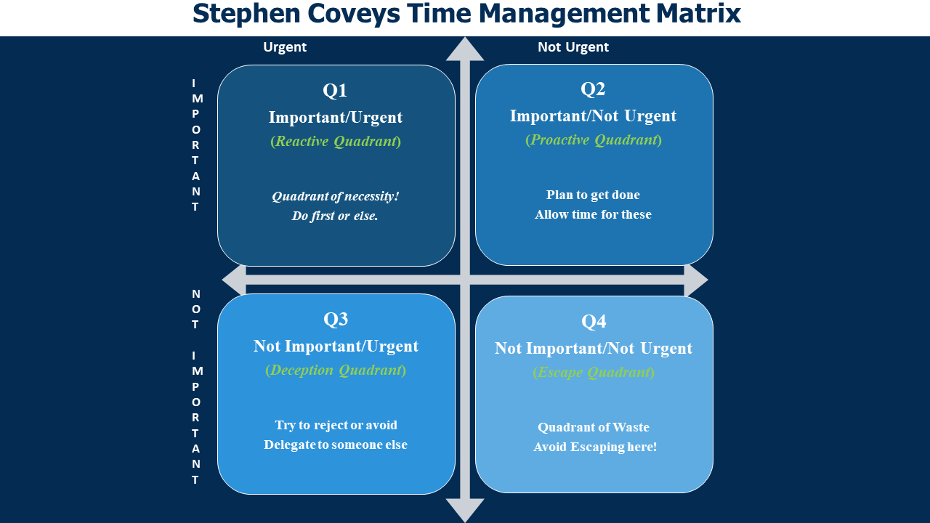
(Prior, September 2021)1)

SMART (Specific, Measurable, Achievable, Realistic, Timely) goals are a helpful tool for set clear, well-defined objectives that can be measured and achieved within a specific timeframe.
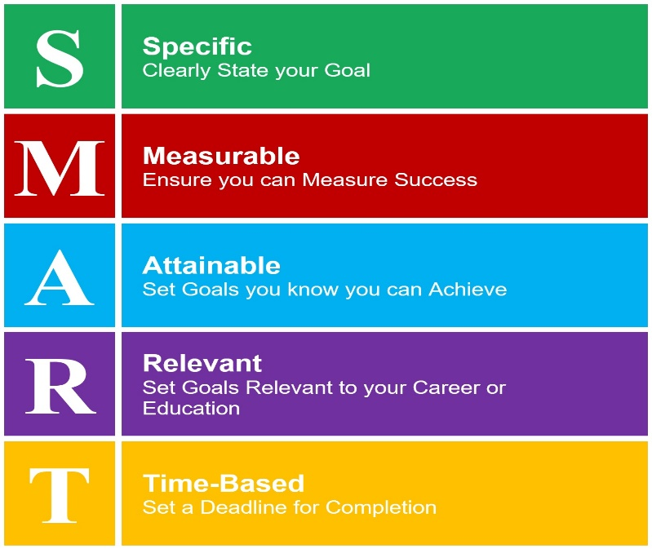
(Drew, 2022)
In my future career, I can use this method of time management when I want to complete a project. More specifically I want to create a mobile application for a company website. To make it easier for customers to access it. For this purpose, software must be developed. Measurable I am planning 35,000 site installs per year. Attainable are setting stages for the creation of the app. Relevant is to Improving customer access to the website. And for time (deadline) for app creation 6 months
In a RAC method we need write down everything we do during the day, analysing how we spend our time, we can pinpoint activities that are not contributing to our productivity. Once we have identified these activities, we can work to change our habits and replace unproductive behaviours with more productive ones.

In my future examination for project, I can use the RAC method to manage my time effectively and achieve my goal. Here is how I can apply the RAC method:
I will start by recording my actions and progress towards creating the app. I will create a plan research, design, coding, testing, and deployment.
After recording my actions and progress, I will analyse my data to identify any areas where I am not being productive or where I can improve my efficiency.
Based on my analysis, I will make changes to my plan and approach to app development. I may also need to revise my approach to research or testing to improve my efficiency and productivity.
The Pomodoro Technique involves dividing work into shorter time intervals called "Pomodoro," usually 25 minutes long, followed by short breaks.
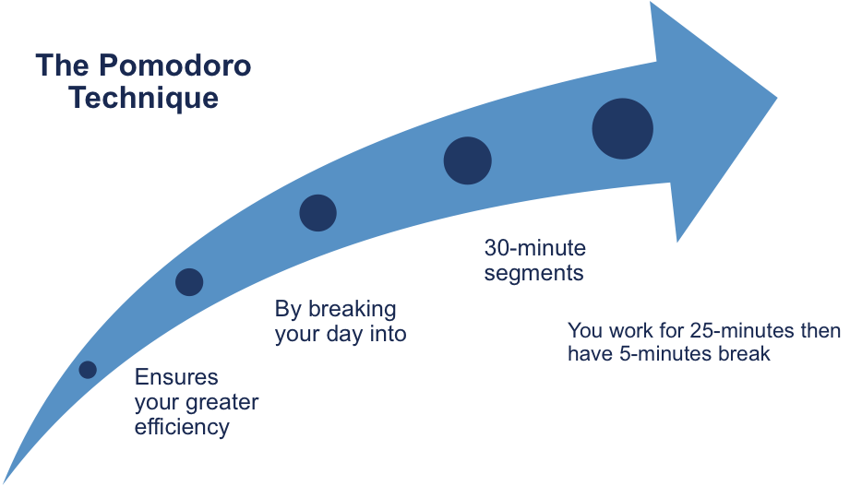
(http://www.free-management-ebooks.com/news/pomodoro-technique/)
Something similar is Salami Technique:
Big projects should be sliced into small slices. The tasks should be so simple that one can be finished in a few minutes.
All these methods and techniques are help us to be more productive and effectively to us our time.

How I may improve the similarity score
If my index for similarity is high and I want to reduce I will focus on the specific task or application that I am trying to improve the similarity score for. Is it may own words are not like the original text. Did I us correctly the Quotation marks. Am I use them around every quote and the source is cited. Did I not use to many quotations. I can use the filters to exclude the bibliography and direct quotes.
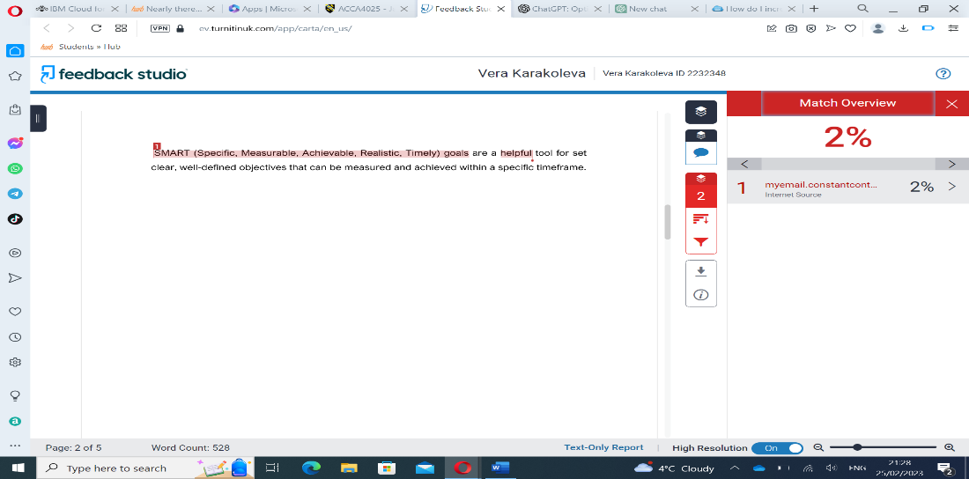
Figure 1: screenshot of my similarity score
Award myself
Based on my credible use of literature and accurate referencing, excellent comprehension of concepts, outstanding evaluation skills demonstrated through effective argumentation using evidence and sound judgement, as well as my exceptional ability to deploy appropriate solutions and work fluently both independently and in group settings, I have awarded myself a passing grade of 81,7%

Task 2
E-Portfolio creation
E-portfolio is a digital version of a traditional portfolio, which typically includes physical documents and artefacts. There is numerous software for creating websites on the market, each with its own unique features and capabilities. Sway is one of these platforms that you can create a e-portfolio. Microsoft Sway is a web-based digital storytelling app that allows users to create interactive presentations, reports, e-portfolios, and other types of content that can be accessed online. With Sway, users can combine text, images, videos, and other multimedia elements to create a visually compelling and interactive experience for their audience (Z, 2015). I used the Sway to create my e-portfolio.
Here is the link to my e-portfolio: https://sway.office.com/aHi52em386zrcBY4?ref=Link

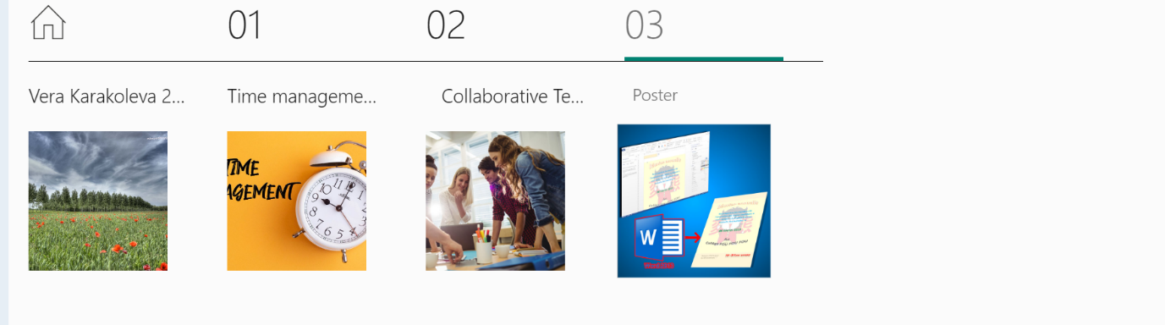

Task 3 Automatic Referencing tool
Referencing involve using citations within the text to direct the reader to the source of a particular fact, idea, or argument. The citation provides a reference to the source, which is then listed in full at the end of the document. The most used method of citing and referencing is the Harvard style (which uses the author-date method) a (Day, 2018).
An automatic referencing tool is a software program that assists in creating accurate citations and references for academic papers, essays, and other written works.
When creating a lengthy document that requires the use of multiple references, it may be beneficial to utilize reference management software, such as EndNote, Mendeley, Reference Manager, or Zotero. Mendeley can assist in organizing the citing and referencing process (Day, 2018).
Although reference management software can be helpful, it is not infallible, and it is important to recognize and address its limitations. This can only be done if we have a solid understanding of the rules and fundamentals of citing and referencing (Day, 2018).
Next few screenshots showing how did I use the Mendeley Automatic Referencing:
1 First I am search in Google for Mendeley Reference Manager
2 Next Download it.
3 After that I created account.
4 And start using.

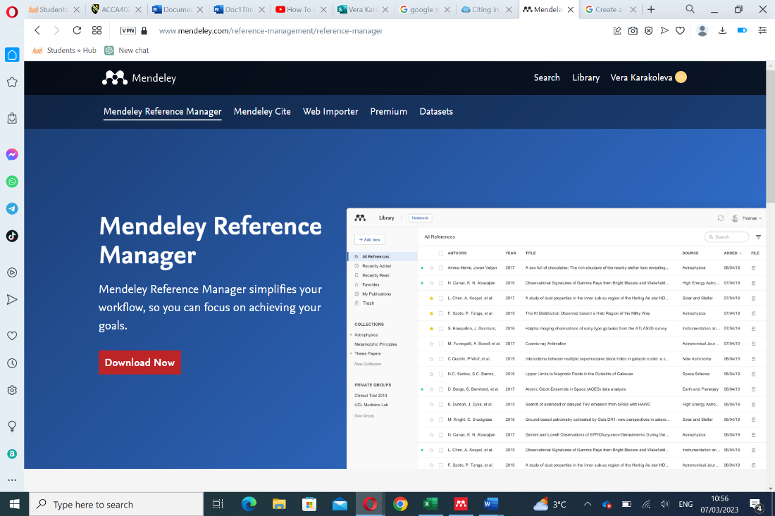
Figure 1: Download the Mendeley Reference Manager

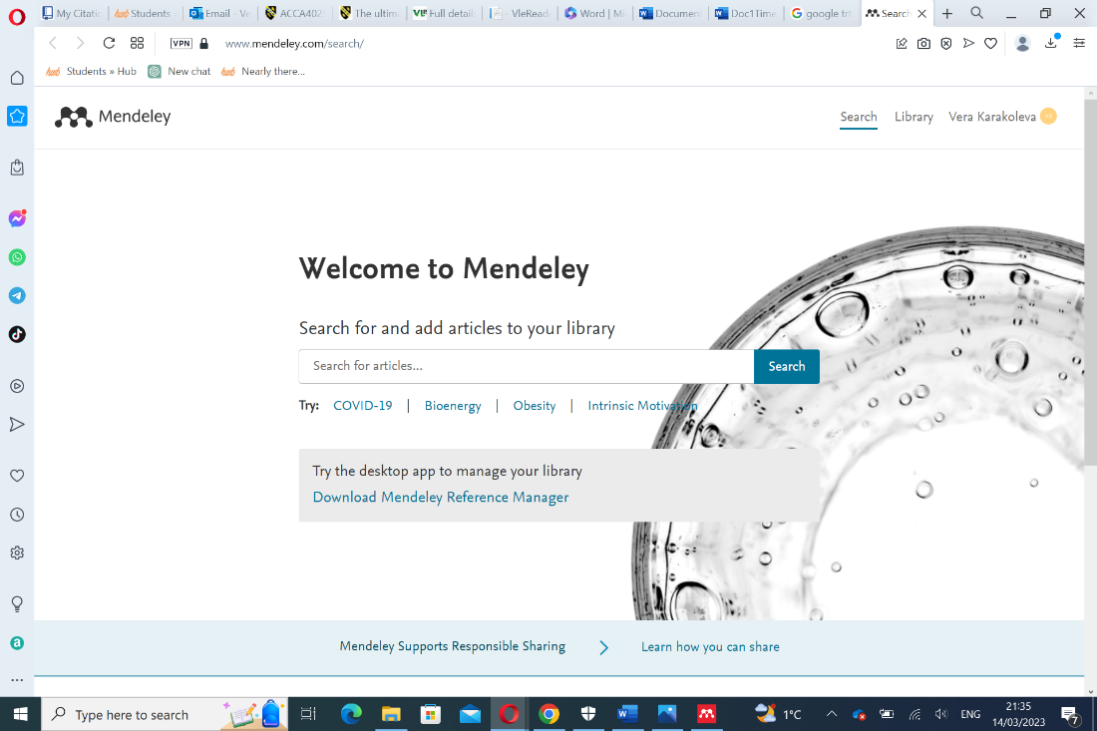
Figure 2: Just signing in account.

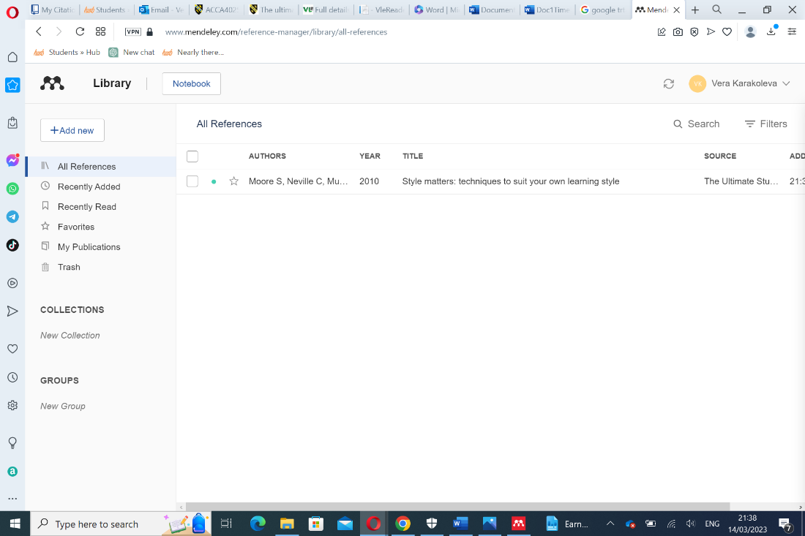
Figure 3: looking for a book reference.

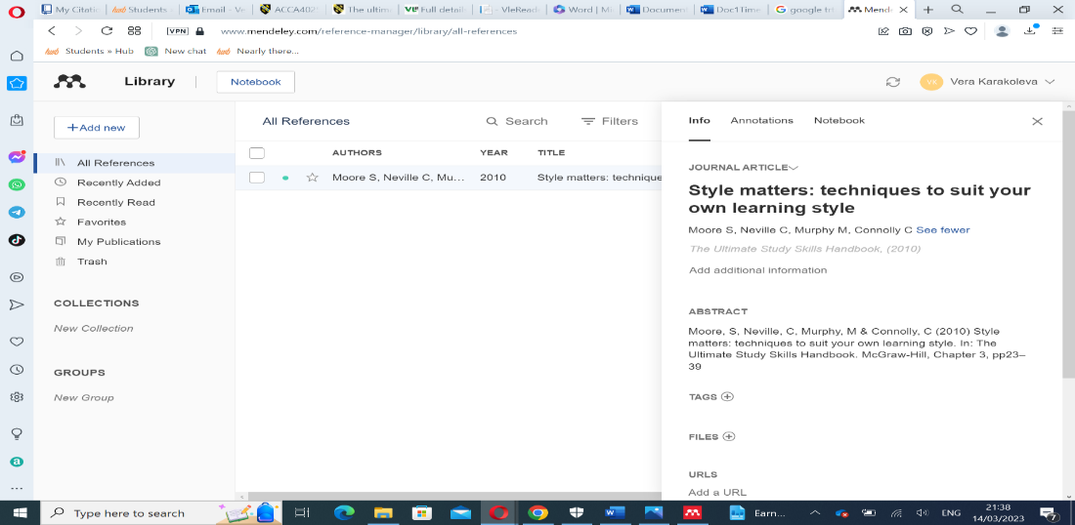
Figure 4: Book reference
Task 4. Collaborative Teamwork and Professional Academic Poster
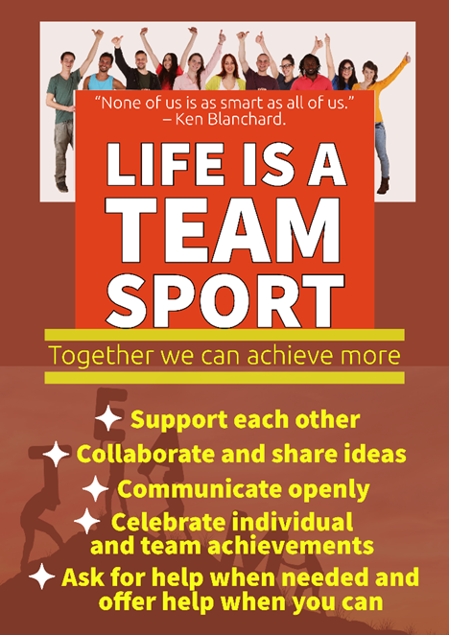
Professional Academic Poster
When designing a poster, it is important to keep the design simple yet elegant. A catchy title can capture the audience's interest, and the author's details should be included either at the top or bottom of the poster. Non-serif fonts are often used for light reading. The design of the poster should relate to the subject matter, using background images, unusual shapes for text boxes, flow diagrams, scans, or photos of examples to demonstrate concepts visually. We can use colour to set the tone and highlight key features. It best to use short sentences, bullet points, questions, quotes, photos, illustrations, graphs, charts, and summary tables to convey information in fewer than 500 words. We should not overcrowd the poster and leave clear spaces (Day, 2018).


Teamwork
‘Finding and keeping a good team’ is amongst chief executives’ most highly rated ingredients of success (Taylor and Humphrey, 2002).
A team is more than a collection of individuals. Any group could operate as a team if it is focused on being effective for the mutual benefit of all (Smith and Katzenbach (2003).
Naturally, when we embark on a team task, our attention is on the end point. To develop team skills well, is good to stand back and reflect on the process. Become more aware of how every aspect of teamwork is useful.
The way that each member of a team thinks, believes, feels, acts, desires, and is driven, all interact with each other to produce the team's dynamics, which impact both the energy levels of each individual and the team (Cottrell, 2021).
If a group is inclusive, each person is willing to make concessions regarding their personal interests, to reach the most optimal outcomes for the entire team (Cottrell, 2021).
It is not necessary for team members to have a personal liking or friendship with each other. Nevertheless, every individual should be able to anticipate common politeness and respect.
Showing kindness and respect towards others is a fundamental and straightforward lesson. However, it can be necessary to remind people that demonstrating respect is crucial in all situations, especially in a professional setting.
If each person takes responsibility for the well-being of others, promoting inclusivity becomes an easy task (Cottrell, 2021).
In our Team we were 3 members: Me, Nadejda Toma, and Alexei Nica. We create a group in a Microsoft Team and discussed task 4 of our assignment. We divided the work according to who felt good at what and well prepared. My task was to search information for poster creation, time work, and make the
answer of the task. I feel comfortable in searching for information, using references and forming the answer. We made a deadline for our project, and all of use was ready on time. I think we success to do really good job in our team.
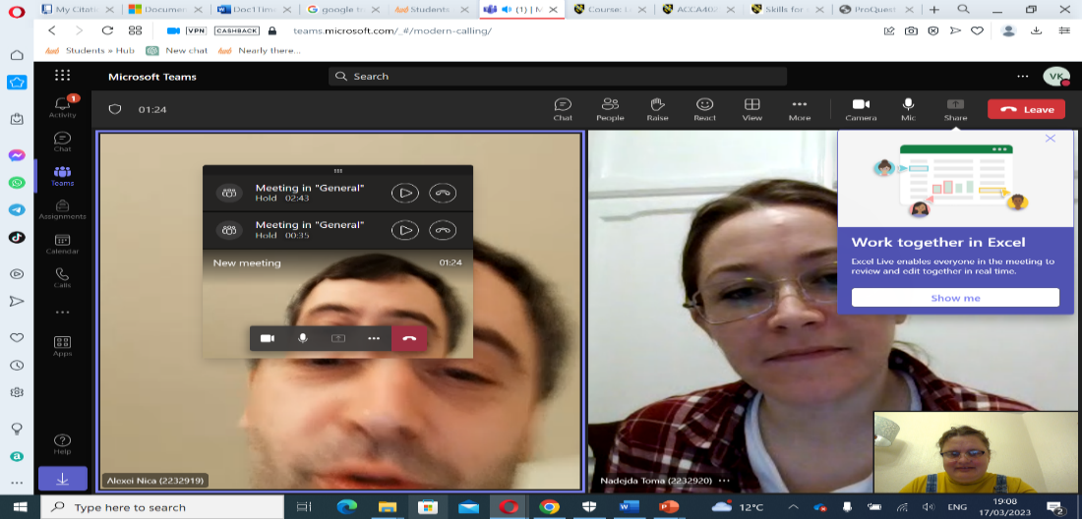

References:
1. Free Management (2023), The pomodoro technique - free management books (no date) Netline. Available at: http://www.free-management-ebooks.com/news/pomodoro-technique/ (Accessed: February 8, 2023).
2. GROUP, A. (2017) Effective time management, [online], Available at: https://www.unimy.com/article/mba-preparation/blog-interesting-time-management (Accessed February 8, 2023).
3. Martin, L. (2021) 10 rock-solid time management strategies to boost your productivity, Time Doctor Blog. Available at: https://www.timedoctor.com/blog/time-management-strategies/ (Accessed: February 25, 2023).
4. Prior, G. (2022) How prioritising using the time management matrix can improve productivity, Lingford Consulting. Available at: https://www.lingfordconsulting.com.au/productivity/how-prioritising-using-the-time-management-matrix-can-improve-productivity (Accessed: February 8, 2023)
5. Stoilov, & Stoilov, T. (2012). Time Management (Stoilov, Ed.). Intech Open.
6. Day, T. (2018) Success in academic writing. Second edition. London: Palgrave.
7. Taylor, R. and Humphrey, J. (2002). Fast Track to the Top: Skills for Career Success. (London: Kogan Page).
8. Smith, D.K. and Katzenbach, J. (2003). The Wisdom of Teams: Creating the High-Performance Organization. 3rd edn. (New York: HarperCollins).
9. Z, B. (2015) Microsoft Sway: A powerpoint alternative, Beth Ziesenis. Available at: https://yournerdybestfriend.com/2015/08/06/Microsoft-sway-a-PowerPoint-alternative/ (Accessed: March 18, 2023).

10. Cottrell, S. (2021) Skills for Success: Personal Development and employability. Red Globe Press.

