What happens when we perceive art?
An Exploration of Deconstruction Theory

Emily Scandone (P146286)
Dissertation Supervisor: Brendan Burns
Word Count: 4910
Course: BA(Hons) Fine Art: Studio, Site and Context

Contents
Introduction 2
Chapter 1. Theories of Deconstruction 5
Chapter 2. Artists 10
Chapter 3. Personal Practice 17
Conclusion 22
Key References 23

Introduction

Throughout my life I have found it hard to process information and articulate my own emotions and thoughts. I have felt intimidated by words and grammar. As a teenager, I was diagnosed with dyslexia and refused help provided to me. I naively tried to overcome this independently. In my bid to overcome dyslexia independently, I felt confined and unable to relate to others. Although dyslexia can be perceived as a negative, it has allowed me to view the world differently and in my own way. I have pursued additional help in university and I have overcome my vulnerability of words through the process of free writing. Free writing has enabled me to build upon my confidence and develop my own conceptual abilities. Free writing has enabled me to express my thoughts and feelings through the medium that I most feared. Capturing my thoughts effectively without the intimidation of grammar. Using theoretical deconstruction, I will use questions such as those below to challenge my own conceptual understanding of my practice. I have explored theories of perception using Derrida, which will allow for further progression in my personal visual language and acknowledge its development during recent years.

What happens when we perceive art? Think, assert similarities, look, listen, feel, embody to understand, deconstruct?
To deconstruct thought, to deconstruct me, to deconstruct the world.
The world is conditioned. I am a dissertation, a dissertation conditioned.
I am black and white all over, ready to deconstruct, ready to explode.

“It may take many years of patient practice to grasp some works fully, whereas others may require specific kinds of knowledge, before one can begin to attune oneself in art” (Bolla, n.d) Jacques Derrida was the founder of deconstruction. Derrida used language and communication to create his theory. Derrida was influenced by political institutions and studied the idea that deconstruction consisted of reforming the differences that separates self-consciousness, in an act to attempt to draw justice. Deconstruction is the act of exploring different concepts, as well as contexts, for a full understanding and acknowledgment of a piece of art or item being viewed. It is an ironic act of breaking down segments to perceive the full potential of the art work.
Perception is important to artists because it is the core of visual arts and is experienced in essence by the viewer and is communicated by the non-physical spiritual existence of the artwork. Perception forms the insight of the artist. In the same way that the artist controls their distribution of work to the world, controlling limitations of perception in artwork. By engaging in art, the viewer creates a deep and meaningful connection with the artist’s personal perspective. Concepts rely on an attitude dependant on one’s own suspicion, as art is only observed by the outlook of the viewer and the artist itself. Perception is something learnt and can only be witnessed when acknowledged.

The purpose of this dissertation is to investigate primary concepts in research and present deconstruction as a theoretical construct, that has been defined as a philosophical or critical method. As well as exploring Derrida’s theory of deconstruction, I will manipulate deconstruction and provide a non-methodological argument to understand and subjectively view art work. Understanding different forms of art work will develop a personal relationship which will depend on cultural and religious beliefs. I will present and juxtapose artists such as; Barnett Newman, Joseph Beuys and Rebecca Horn. These are artists that have previously explored the concept of deconstruction, alongside my own personal works.

Chapter 1. Theories of Deconstruction

Jacques Derrida founded the term deconstruction as we know it today, however, theories of deconstruction date back to times of Plato. Deconstruction is the act of finding what is not acknowledged (Willette, 2017). Metaphysics and Platonism contribute to deconstruction and are so complex within themselves. Metaphysics by definition, is a philosophical method which deals with the first principles of being: identity, time and space. Deconstruction is a “kind of formalism because it interprets as symptoms of a metaphysical syndrome…what are actually the internal reflections of the outer historical conditions of a texts production” (Tucker, 2010). Platonism explored the existence of abstract things as an object out of space and time, which creates a non-physical being. Abstract objects can be argued as non-spatiotemporal (Standford Encyclopaedia of Philosophy, 2004-2016). Platonism can be identified as structural components used in the methodology of deconstruction. Nevertheless, Derrida critiques Plato’s ideas that created the foundation of deconstruction and structural opposites (Standford Encyclopedia of Philosophy, 2004-2016; Ricoeur, 2006).

Derrida speaks of ‘metaphysics’ and ‘Platonism’. Within this, one’s position has more value than the other. By reversing the element of Platonism, it can create differences and a switch within importance. Derrida asserts meaning when a new reader engages with a script of text, whereas the theories of Plato asserts themselves when a translator is confronted (Sweetman, 1994). Examples can be shown in visible essence of appearance; between voice and writing; between body and soul; good and evil. It is possible that essence is more important than appearance, in deconstruction, the second rather than the primary aspect, is appreciated to be more important. This can be solved and acknowledged by the essence, depending on its appearance. Furthermore, meaning would imply that essence and appearance are not related and are not separated oppositional roles and may involve memory anticipation. Derrida speaks of the idea of relation (Philosophy, 2014), he then identifies similarities between texts. However, identifying similarities between texts does not make them equal or balanced, but a diversion of hierarchy with one term being more preferred than the other, determined by an emotional essence of the word. This paradoxical relationship ultimately leads to a discourse, and confusing theories around what deconstruction is. Plato and other philosophers talk about speech being privileged over writing, as spoken language creates a deeper truthfulness and authenticity, deriving from the relationship between word and idea. When listening to words conceived from a speaker, we grasp their true sense by an exchange of mind, language and reality. On the contrary, language can only imply shared conventions which articulate distinctive sounds and meanings (Norris, n.d). Derrida indicates that deconstruction only highlights what is already there and you need to apply and analyse the elements used to construct. Derrida’s work consisted of theoretical ideas and interpretations used in Western philosophical, literacy and artistic conditions. Derrida fabricated closed meaning that created new ideas for a creative imagination (Taylor, n.d).

Derrida believed that deconstruction cannot be under one single meaning and within his earlier findings he attempted to stimulate this from the 1960’s. Derrida created a strategy or methodological step, which he claimed to be impossible (Rolfe, 2004). Deconstruction is neither an analysis nor a critique. It is not a method and cannot be defined into one, it must also be made clear that deconstruction is not even an act or an operation (Derrida, 1991). This helps to understand why Derrida uses the act of deconstruction to find meaning through aspects of life and to understand and acknowledge the ‘now’. One speaks of using deconstruction as an act but in the context of, an act referred to not making judgment but in this dissertation due to the act of explaining rather than using it to break down, using it to look at circumstances rather than using deconstruction as an act.

Derrida asserts deconstruction with traditional culture, questioning that, to understand religion is impossible without uncertainty. How can one claim to know what God is? Yet we live in an age where major conflicts are happening, and believe that God is always on their side. Whereas, many people believed that Derrida threatened to break and tear apart the beliefs of God. Fortunately, Derrida taught us to have no certainty in God (Taylor.n.d).

The outcome of our perceptions, is to choose to judge a situation and deconstruction is just a view. However, research has shown that Derrida’s theory was not set in stone. Derrida has developed throughout an evolution of his work: “Of course not everyone agrees with deconstruction interpretations, and some people reject the whole idea of deconstruction, but most of us have run into it by now even if we didn’t realise it” (Merriam-Webster n.d.). It is critical that Derrida showed that there is no apparent moment when a decision has been made. Either it has not followed a requirement, meaning it is incompatible, or it has followed the requirements, which has no foundation then this means it is incompatible. To conclude, this shows that the use of deconstruction has forever changed and still is. If this piece followed its requirements, but in an incorrect manner then the case is still incompatible (Foucault, 2014). There is a strong acknowledgment that Deconstruction as a theory, is an enormous area of research and along with that, comes harsh criticism and debate. However, for the purpose of this dissertation, the definition of deconstruction as set out by Derrida, is used to explore the concept of perception within art. Most of Derrida’s theory, consist of interpretations from philosophers, for example; Plato, Martin Heidegger and Husserl of Western philosophy, literary and artistic traditions, creating closed meaning and new possibilities for imaginative expression.

This fluidity of deconstruction, as a result of his work and alongside other theorist’s ideas, Derrida was influenced by theorists like Heidegger who looked at the concept of metaphysics. Derrida said, “What I have attempted to do would not have been possible without the opening of Heidegger’s questions” (Raffoul, 2013). ‘Deconstruction’ is the main term that Derrida uses, derived from what we know as Heidegger’s book Destruction in Being and Time (Stanford Encyclopedia of Philosophy, 2014). Heidegger’s concept opens text to alternative meaning that resides out of the metaphysical tradition. This influences Derrida’s decision to “invent in your own language to give an understanding to my language” (Derrida, MO57). It is recognised that Derrida’s theory derives from philosophers intertwined with whomever, or whatever, he seeks to deconstruct. For example, Derrida critiques Edmund Husserl’s ‘now’ moment, constructed upon resources of the self- presence. Derrida concludes that Husserl failed to disavow any transcendental position, arguing that Husserl’s work fits into margins of philosophy rather than simply being philosophy. Deconstructive readings by Sigmund Freud drew attention to language and questioned the formation of the psyche. Derrida as a result, says the meaning in text shifts depending on the relationship to the subject and text, and can come from cultural and social world impacts. Deconstruction is the process of theoretical closed reading, that creates moments when philosophy attempts and fails (Norris, n.d). Previous philosophers have tried to create connections of truth, knowledge and the relationships with the art world. Deconstruction highlights that language is the core factor used to create a series of contradictions, so that deconstruction can be carried out. Artists, art critics, writers and architects have found resourceful insights that have in turn, strengthened through the arts and humanities, thanks to Derrida’s theory. Deconstruction interpreted into artwork, acknowledges the skills used to create and can be applied to the simple brush stroke on a canvas. This is translated into a very real and present understanding of how artwork can be misread, or indeed the artist’s intentions. Deconstruction presents language as an episode of physical elements that can be created in absence of the speaker. This is done by creating art which are thoughts communicated (Culler,1983). The outcome of perspective within art is to judge, deconstruction is just a view. Deconstruction is a critical analysis of art works, the viewpoint we choose to perceive and understanding is based upon our own knowledge and experiences. Simply creating ones understanding of its own discourse (Markovik, n.d.). In aspects of Fine Art, this formula is exposed more often and can attract emotion as we express thought. This is communicated directly into the mind of the viewer without the presence of the beginning and can redirect the thought of the art work. Due to art being subjective, it can be conceived in a personal interpretation.

To manage such a strong affective response within art, no matter what context the viewer is placed in, whether the viewer is informed of the context, can create a cultural subjective response and is often very intense. Walt Anderson creates a meaning for Derrida’s technique saying “Deconstruction goes well beyond saying right-you-are-if-you-think-you-are; its message is closer to wrong you are whatever you think, unless you think you may be wrong, in which case you may be right- but you don’t really mean what you think you do anyway” (Sweetman, 1994). Artists have interpreted theories of deconstruction, formulating a language from thoughts to form a personal perspective to take place. Artists may not fully comprehend deconstruction’s theoretical method, but include aspects in their practice. Deconstruction can be described as an embedded organic technique, inseparable from an artist.

Chapter 2. Artists

Using deconstruction, I will look at Barnett Newman, Joseph Beuys and Rebecca Horn, along with my personal work to establish where deconstruction can be seen, and an example that any artworks can be deconstructed.

In the Twentieth century artists explored abstraction as a narrative, by fragmenting spatial elements and removing notions of a figure. By working to reconfigure mark making, this creates a language reforming the relationship from canvas to the viewer or audience, and so-called picture plane. During the second decade of the Twentieth century, artists explored abstraction by creating canvases that contained as little as a single brush mark, or no more than a single colour. Interpretation of abstraction by artists, has been expressed affectively, visually and in written form. Expression is varied, some artists specifically identify how their work should be perceived, whereas others are less direct towards showing deconstruction in elements of their practice. Artists themselves may not necessarily refer to deconstruction, however, it is an embedded organic philosophy, which is a foundation for all artists’ perception. Art itself is varied. Artist’s interpretations of deconstruction differ, key themes and concepts can be seen throughout.

Barnett Newman

Barnett Newman’s painting ‘Vir Heroicus Sublimis’. Newman allows a space for the viewer to subjectively interpret deconstruction and personally break down aspects of the painting, to experience as well as interpret cultural effects into the perception of the art. This reaction is considered as there remains no set definition of what deconstruction is, but by acknowledging the factors that created the art itself.

How does one prepare for art? How can one create an experience to view art? How does one accept art? How does one prepare for art? By creating a relationship between the painting and the viewer to accommodate one’s presence in the painting, is to create an effective response by using the theoretical term deconstruction.
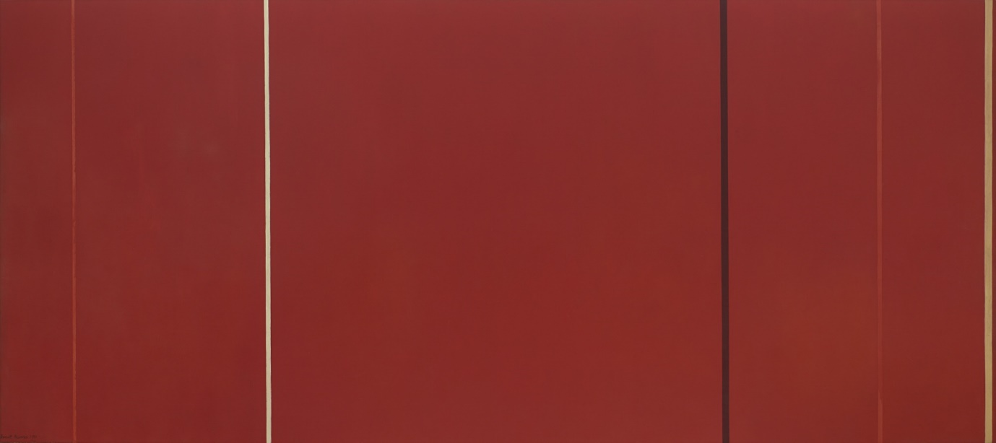
In his painting Vir Heroicus Sublimis showed in figure 1 below, Newman presents the viewer with the spiritual response.

Figure 1. Barnett Newman, Vir Heroicus Sublimis, 1950-1951, oil on canvas, 7' 11 3/8" x 17' 9 1/4"
(242.2 x 541.7 cm)
Newman highlights the experience of visual and affective aspects in art by saying “visual artworks come upon us, ready-made, so that our sense of perceiving something out there leaves a kind of imprint within the viewing experience” whereas “our affective experience gives us the sensation of becoming intimate with the work of art, closing the distance between it and ourselves.” (Bolla, n.d, p. 25). It is apparent that we only become instinctually aware of art work when one connects with it. It does not matter what the experience of the viewer is here while looking at visual art, the capacity to truly connect with the work is often extremely strong. By creating an effective response, we must acknowledge, deconstruct and create an initial perception to cause insight into the context of art. “On Occasion, this feeling may become so intense that we almost identify ourselves with the work, or colonize it, appropriate it.” Additionally, “How does it make me feel, what does it make me feel? What is the content of my affective response? Beyond these questions there lies the insistent murmur of all great art, the nagging thought that the work holds something itself.” (Bolla, p. 31)

As Newman creates art works for the intellect of accessibility, creating passion and an emotional connection, he expresses this experience through the use of colour and the creation of a deeply personal visual language within his paintings. These experiences are none the less the conceptualization of art, creating time for the viewer to enhance the act of ‘looking’. Creating connections between canvas and viewer and allowing questions, to break down the elements and to promote a structure of deconstruction. “Some viewers accustom to representational art find abstract art ‘inhuman,’ lacking a point of entry. According to a general philosophical account of the fragmentation of the modern subject, abstract art ‘re-presents’ the alienation of the modern world. This is too simplistic, and in the case of Newman precisely the opposite is true; abstraction is merely the formal language in which he paints and not the representational content of the image.” (Bolla, n.d, p. 36)

Joseph Beuys

Joseph Beuys creates art work by deconstructing; social, political and economic issues. He investigates the concept of art perception, creating a formula of art works to create a personal experience. Beuys makes art to inform and create a presence of being, publicly being performative highlighting the requirements of a situation. Displayed below in figure 2, Beuys creates a dialogue of thoughts, to produce a hypothetical gateway into the idea that the human realm is not the only realm that exists. Acknowledging animal materiality, a language to provoke feeling for the viewer. To generate an outer body understanding that the human world is not the only to exist.
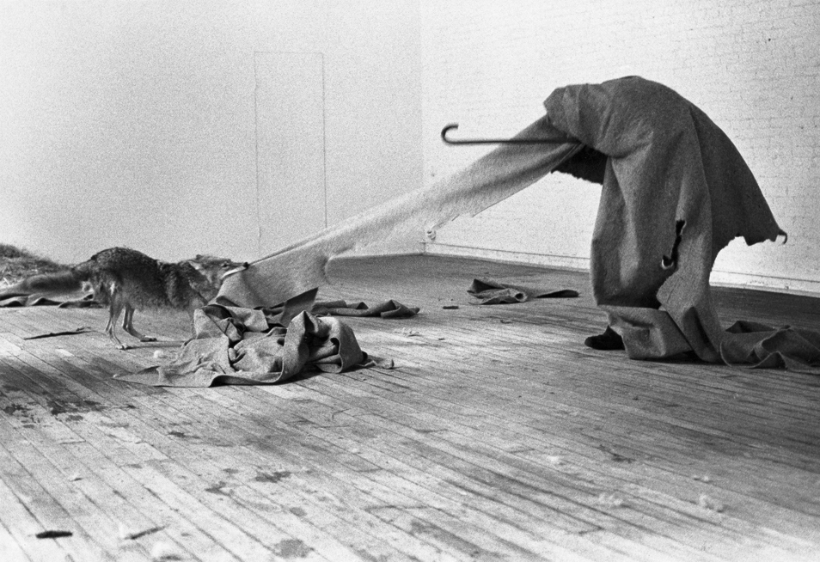

Figure 2. Joseph Beuys, Coyote I, 1980, Photograph, black and white, on canvas.
Support: 452 x 702 mm
frame: 660 x 908 x 85 mm
Beuys applies deconstruction upon the viewer in society, by strongly presenting the idea that every person made up of emotions and thought has clarity of also being an artist. He believed that if one were an artist, then one might be an artist everywhere, or in every context in which one finds oneself - the art studio, classroom and "street" offering equally advantageous circumstances for creative experience. “Each time another stick was added we tried to observe carefully whether anything changed in our feelings and experience and what direction this change took. From time to time each person sat in a different place. This made it possible to see that the way in which this person perceived the detailed relationships between things was independent of his or her physical position” (Beuys, 1986: 5). Beuys deconstructs life, not as an occupation, but rather as a deepened and intensified humanitarian attitude. In consideration, most situations conduct an advance in one’s life, which forms a platform of Beuys’ work, acknowledging a response in social commentary and political activism. Deconstruction is the element that constructs an artist’s view. By using deconstruction Beuys creates a logical thought provoking process. This breaks down the reality of life, to promote a definition of everyday truth through the process of highlighting the ‘normality’ of ‘social codes, of so-called ‘proper’ conduct. Beuys claimed that art should confront social, political and corresponding issues. He confirms that his political work doesn’t have the same response as others. He creates diverse and intimate art works that have deep meaning and may seem disrespectful. Beuys doesn’t feel that the expression of words must be literal, and in doing so would not seem suitable for the upbringing of political change. To conclude, Beuys controls his art works and finds more comfort in them, with the idea being portrayed subjectively rather than revealing the context directly. “I do not want to carry art into politics, but make politics into art” (Beuys, n.d).
Beuys’ influences were inspired by the world and its discomfort and dissatisfaction. Beuys finds confrontations within life, and uses these highlighted aspects to create art. They are problematic and we become conscious to those situations and create a response to these positions. Beuys is literal when describing the essence of making art and where one should start with a direct observation. “If you just describe what you see, you’ll be sure to get there, you’ll arrive in the sphere of the things I mean. People are not moved enough in their interior life, and therefore they don’t change. Your demand — art instruction should continue throughout one’s life, there should be an evolution — can only be achieved if art instruction invades all disciplines.” (Beuys, n.d.)

Rebecca Horn
It is obvious that there is a narrative behind each of Horn’s work, they create an emotional background and a growing feeling from within.
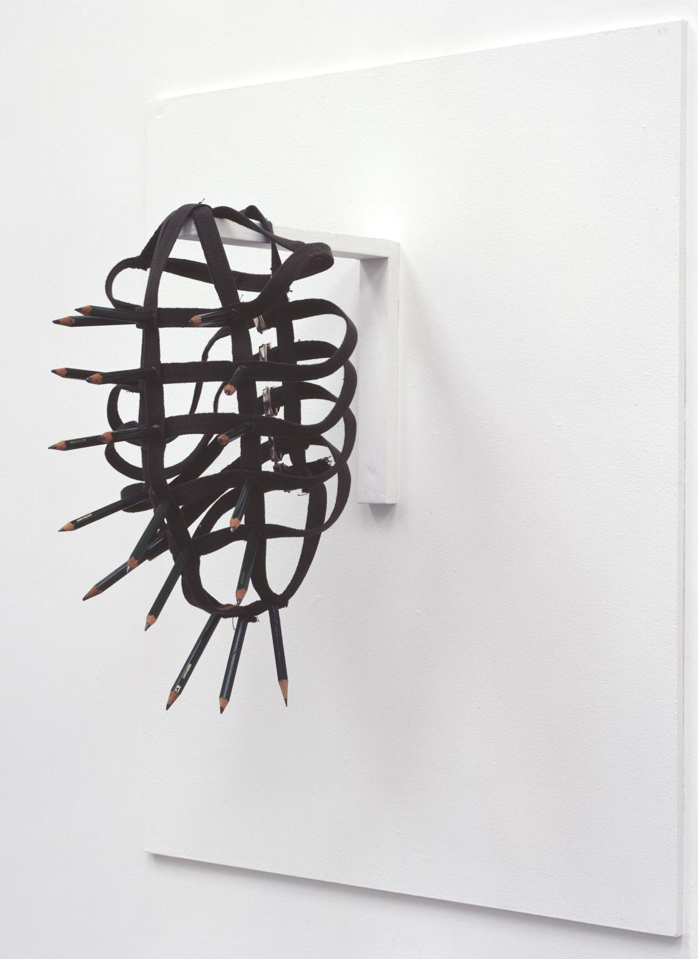

Figure 3. Rebecca Horn, Pencil Mask, 1972, Fabric, pencils and metal

The resemblance of the piece of work by Horn comes from a conditioned environment of which one cannot voice their opinion and outlook. Horn uses the sounds of the pencils to create an atmospheric surrounding allowing the performer to generate a serious discomfort and playfulness to emote protection and creation. Horn has created an environment of discussion to allow the concentration of deconstruction within the elements of space and body. Inventing a representation of mark making equipment, allowing a discourse of aura to arise from the original drawing method. Using the role of deconstruction to explore a different belief system in the act of capturing marks in drawing. Granting rhythmic movement of one’s body and allowing it to present itself as a movement of language, reflecting self-awareness and allowing a representation of internal thoughts reflected to create a performative habitat. Horn’s work requires response to space and establishes diverse and capturing art. Horn is woven into her bodily sculptural creations, operating them to become at one with her body. Finding difficulty in separating body from sculpture. Horn implies aspects of machinery in her performances, allowing connections of the body to deconstruct and find similarities within the two, responsively allowing limitations of space to acknowledge themselves within her work. Horn uses her own experiences to create conscious work, allowing a close relationship between artist and work. Horn safeguards her body whilst exposing it, allowing exposure generating new possibilities of ideas to reform organically.

Chapter 3. Personal Practice

I will now consider theoretical deconstruction, to subjectively understand my own art work, to break down and clarify my own intentions.
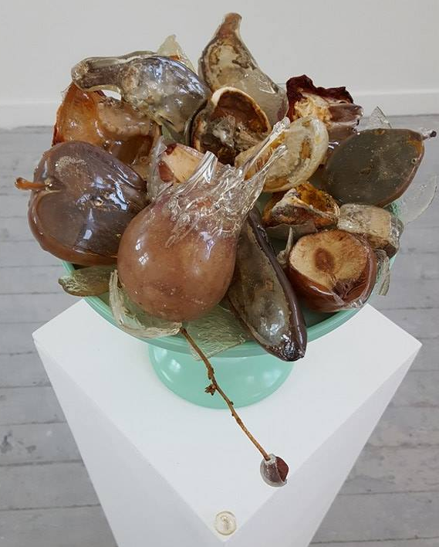

Figure 4. Emily Scandone, Still Death (2016)

I have explored elements of my own work, which encounter deconstruction and have highlighted these decisions. Firstly, it could be assumed that the literal notion of life and death, as the initial thought process would relate to decomposition. By using the act of deconstruction, other hypotheses emerge allowing multiple subjective meanings. Other interpretations could include the idea of grotesque beauty, or potentially the fragility of time, allowing an array of possible connotations. One may use this approach to underpin elements of art works. One may have missed, disregarded and overseen elements, which will not provide a full potential in the art works.
Art and philosophy have created a similarity in the act of searching for truth. Deconstruction is just a tool used to create a hypothesis which may act and reproduce as art works. Although deconstruction provides art works with the opportunity for more than one single meaning, these can often conflict depending on the context. Conflicting arguments can enable us to have an opinion. The opinion could be stated as political, cultural or social and can come from factors consisting of identity and cultural points of view.
It is important to promote personal attitude and refer to deconstruction to reform thoughts, to never have closed meaning and designate change to different aspects depending on the concepts. As an approach to underpin criticism, by discovering to recognise and puzzle out any undeclared speculation. Deconstruction has been used in one’s own personal practice to gather information to acknowledge and be respectful towards others art works.

Again, I will explore my painting ‘throwing pots’ and the materials used, to disclose proof of the act of deconstruction. Evidently, this is a visual representation of literal deconstruction.

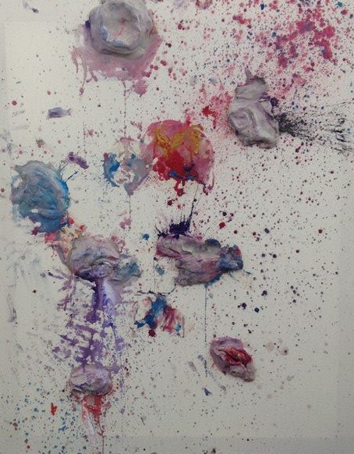

Figure 5. Throwing Pots, 2015, Ceramic wet clay and watercolour on canvas.

The conceptual idea displayed in figure 5 was heavily influenced by the act of deconstruction. ‘Throwing a pot’ is the correct terminology of creating a ceramic vessel on a pottery wheel. By deconstructing the name and process of method, I created a double entendre, with the notion of both a literal and lateral sense. On the other hand, deconstruction has been manipulated through an evolution of work, to go further than criticism. This has emerged reforming a reduced set formula, the threat here is that deconstruction has evolved into a formula taking away the subjective realness of its organic technique, missing the capacity to amplify a self-reflective operation.

Using deconstruction has broadened an awareness of one’s self-practice, reforming a way of seeing to grant aspects that may not have been noticed. Creating a path to decipher a reasoning of the world, creating a structured response to create art work, and any situations that may arise. Following this structure to create art works, finalising elements of ‘normality’ to create an artistic response. One finds delightfulness in trying to understand the non-understandable, as a form of contemplation on literal elements of ‘normality’. The act of deconstruction has been used for years in schools such as The Glasgow School of Art, and The Slade and Goldsmiths, these institutions have created a philosophical understanding of art through the context of theory and an embedded organic practice.
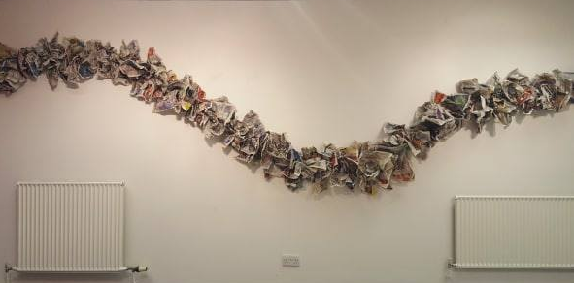
Deconstructing a conditioned world, conditioned by noise, by surrounding, hormones and non-natural coherent thought.

Figure 6. Untitled, 2017, Newspaper and staples.

In response to political constitutions and implications voting can bring, one can create a responsive installation requiring deconstruction to highlight these involvements. Distinguishing a responsive argument, by using newspaper which held the initial vote for Brexit, allowing a language of materials. Newspaper became the material, and informed us of a language, confessing the doubt and integrity of humanity. To deconstruct the use of newspapers from its original form into the essence of rubbish, reforming the management of newspaper to allow a dialogue in an installation. This control allowed an aesthetic presence in the act of crunching and manipulating it from its original presence. Exploring the notion of deconstruction, to find different elements to create a positive condition from a negative. Deconstruction can also be applied when acknowledging that the art works can be seen in a different surrounding and environment, creating a dialogue using materials, which can change depending on where the art is shown. By manipulating the area, it is shown it can create more possibilities of meaning using the act of deconstruction to involve the discourse of the context of the work.
There is no political correctness, nothing is right, nothing is concrete, nothing is correct.
“Art is not there to be simply understood, or we would have no need for art”.

Conclusion

I have found that whilst exploring the different elements that influenced theoretical deconstruction, as well as learning its constructs, I have been able to contextualise the content of Derrida’s findings. I have reformed and outlined subjectivity through deconstruction; I have related Derrida’s findings to acknowledge art. I have acknowledged three different artists and analysed the way that they use deconstruction in their work. Each artist analysed has provided a considerable different approach to apply deconstruction to their art works. However, each artist delivers a persistent analysis of thought supporting the un-thought of in the world.
Based on this study outcome, future research exploring theoretical deconstruction by Derrida, should consider the full capability of an art work to persist understanding. Furthermore, further research should include a conscious definition of personal emotions to imply a story of thought of one’s self. By introducing personal emotions to encounter a piece of work, it would be taken on a personal rollercoaster of new findings. Allowing cultural perceptions to enquire themselves on a piece of art and to not create a literal aspect of the work, but a personal narrative of own thoughts to create a lateral course of thinking.
In conclusion, I will use Derrida’s deconstruction to evolve my own thought processes and art creations to create a full potential of understanding, by weighing out all the different components in life whatever they may be. The main findings revealed that deconstruction is a fundamental element within art and has institutionalised in a way to understand the core factors that build art theory, and an understanding of a way of seeing.
While research into the field of deconstruction has given some insight into perception, it has also resulted in an accumulation of questions: Is deconstruction always happening? Was I was already deconstructing and analysing, like a mirror effect? If Derrida and deconstruction did not exist, would we still analyse and investigate art work anyway? Would we still break down, and try to have a spiritual connection with art? If one looks at a flat image and views an illustration, can be still deconstruct this image? Or is this just an encounter of ideas?
This requires additional and ongoing research to gain a more complete picture of deconstruction and perception, to an extent, I was always analysing and communicating with artwork, but more subconsciously than initially realised. Deconstruction will always remain a factor in my personal practice and will always be there, although this increased awareness allows me to comprehend its uses and presence.

Key References

- Barnett Newman image retrieved from: https://www.moma.org/collection/works/79250
- Brendan Sweetman (1998) The review of metaphysics, Review of Metaphysics, retrieved from:
https://search.proquest.com/docview/223458017?accountid=130472
- Christopher Norris/ Andrew Benjamin (1988) Deconstruction, Post-Modernism and the Visual Arts,Wiley.
- Dr Brendan Sweetman. (n.d.) Postmodernism, Derrida and Difference: A critique.
- Ellen Lupton (2004)
- Foucault (2005) retrieved from: https://plato.stanford.edu/entries/postmodernism/ [02/09/17]
- Gary Rolfe (2004) http://onlinelibrary.wiley.com/doi/10.1111/nup.2004.5.issue-3/issuetoc [10/08/17]
- Jacques Derrida (1991) retrieved from: https://pdfs.semanticscholar.org/7a98/7adda06c0268f8956ef1591f36755c2762d3.pdf [11/07/17]
- Jacques Derrida and Deconstruction/ Jeanne Willette (2014) http://arthistoryunstuffed.com/jacques-derrida-deconstruction/ [12/08/2017]
- Jason Powell (2006)Jacques Derrida, retrieved from: https://plato.stanford.adu/entries/derrida/ [13/07/2017]
- Jonathan Culler (1983) retrieved from: https://www.lrb.co.uk/v05/n13/ed-hirsch/derridass-axioms [12/07/17]
- Joseph Beuys (n.d.) retrieved from: https://www.flashartonline.com/article/joseph-beuys/ [12/10/17]
- Joseph Beuys image retrieved from: http://www.tate.org.uk/art/artworks/beuys-coyote-i-ar00695
- Joshua L. Kates (2003) Derrida, Husserl and the commentators: introducing a developmental approach. St. John’s College.
- Logocentrism (n.d.) retrieved from: https://www.merriam-webster.com/dictionary/logocentrism [31/07/17]
- Mark C. Taylor (2004) retrieved from: http://www.nytimes.com/2004/10/14/opinion/what-derrida-really-meant.html [15/08/2017]
- Patrick Bourgeois(1997)Art and Humanities, retrieved from: https://search.proquest.com/docview/205392584?accountid=130472
- Paul Ricoeur (2006) retrieved from: https://plato.stanford.edu/entries/derrida/ [20/09/17]
- Peter De Bolla (2003) Art matters, Serenity:Barnett Newman Vir Herocius Sublimis. Harvard University Press.
- Rebecca Horn image retrieved form: http://www.tate.org.uk/art/artworks/horn-pencil-mask-t07847
- Rudolf Arnheim (n.d.) Art and Visual Perception.
- Thomas Deane Tucker (2009) Derridada, Lexington Books.
- Tiffany Tsantsoulas (2014) Plato Exits the Pharmacy: An answer to the Derridean Critique of Phaedrus and Timaeus. Department of philosophy Faculty of Arts.
- Volker Harlan (2004) What is Art? Was ist Kunst? Clairview.

