Management and quality management in construction

Name of Student: Mark Robinson

Student ID: 0952289

Name of Award: HND Construction managment

Mode: Part Time

Table of Contents

Introduction 3
Construction Method statements 3
Method Statement One - Strip topsoil & reduce levels 3
Method Statement Two - Scaffold erection 5
Method Statement Three - Roof Tiling 7
Time Cost & Resource 9
Time 9
Resource & Cost 11
Critical Tasks / Critical Path 14
Reading list 16
Appendix 1 18
Appendix 2 20
Appendix 3 22
APPENDIX 4 23
APPENDIX 5 25
APPENDIX 6 27

Introduction
This report includes a Microsoft project Gantt chart that details the time, resource and cost for a project in SA1, Swansea. This Gantt chart represents the critical path of the project and breaks down all major activities. Three of the items have been broken down into further detail and discussed below.

Construction Method statements

Method Statement One - Strip topsoil & reduce levels
1: Introduction
E M G Construction has been contracted by the principle contractor to undertake the groundworks package for the new development in SA1.
2: Scope of works
Number of operatives per gang (per gang as minimum):
- 1 no Site manager
- 1 no 360 Excavator operator
- 3 no Groundworkers
Plant & materials
- 1 no 360 Excavator
- 1 no Forward tipping dumper
- 1 no Ride on roller
- Specified fill material and stone
- Specified Geogrid
Scope and Method of Works may change depending on conditions found on site, all changes made
will be listed within POWRA and approved prior to being re-briefed to the site team and the works
commencing.

EMG daily brief detail
Prior to works commencing the site supervisor / manager and operatives, who are to undertake the
work, will complete a point of work risk assessment (POWRA), this will remain valid for the duration
that they undertake this particular task, a new POWRA will be completed if a new task is started or if
something changes. The POWRA will reference the relevant SSW

Completing signing the POWRA displays that operatives have been brief or read, understood and
agree to work to the methodologies and control measures laid out within these documents.

The site manager will be responsible for ensuring that the information within the SSW is
communicated to the site team along with monitoring the task to ensure that the SSW remains
suitable and sufficient.

3: Prestart Information
See Appendix 1

4: Method of works

Topsoil strip
The 360 excavator, under the control of a banksman, will strip the topsoil. The topsoil will be loaded
into a dumper and stockpiled, in an agreed area, for re-use on site on completion. A pedestrian
exclusion zone is to be in place for all loading activities. All edges of the dig will be monitored to
maintain a batter at a suitable angle of repose.
The main aim when temporarily storing soil in stockpiles is to maintain soil quality and minimise
damage to the soil’s physical (structural) condition so that it can be easily reinstated. In addition,
stockpiled soil should not cause soil erosion, pollution to watercourses or increase flooding risk to the surrounding area.

Reduce level dig
Method 1- Dry non-elastic soils should be applied to soil that is in a dry and non-plastic state.

The aim is to create a large core of dry soil, and to restrict the amount of water that can get into the
stockpile during the storage period. Soil should be stored in an area of the site where it can be left
undisturbed and will not interfere with site operations. Ground to be used for storing the topsoil
should be cleared of vegetation and any waste arising from the development (e.g. building rubble and
fill materials). Topsoil should first be stripped from any land to be used for storing subsoil.

The soil is loose-tipped in heaps from a dumper, starting at the furthest point in the storage area and
working back toward the access point. When the entire storage area has been filled with heaps, a
tracked machine levels them and firms the surface in order for a second layer of heaps to be tipped.
This sequence is repeated until the stockpile reaches it planned height. To help shed rainwater and
prevent ponding and infiltration a tracked machine compacts and re-grades the sides and top of the
stockpile to form a smooth gradient.

It is important that, if there is a need to drive dumpers up onto stockpile platforms, there are suitable
bunds created to the side of the dressed access ramp and the top of the stockpile, to ensure that the
dumper does not fall from the stockpile. The dumper operator must also follow the dumper
manufacturer's guidance for direction of travel based on if the dumper is loaded or empty.

Method 2- Wet plastic soils should be applied if the construction programme or prevailing weather
conditions result in soil having to be stockpiled when wet and/or plastic in consistency.

This method minimises the amount of compaction, while at the same time maximising the surface
area of the stockpile to enable the soil to dry out further. It also allows the soil to be heaped up into a
'Method 1' type stockpile once it has dried out.

The soil is tipped in a line of heaps to form a 'windrow, starting at the furthest point in the storage
area and working back toward the access point. Any additional windrows are spaced sufficiently
apart to allow tracked plant to gain access between them so that the soil can be heaped up to a maximum height of 2m. To avoid compaction, no machinery, even tracked plant, traverses the
windrow.

Once the soil has dried out and is non plastic in consistency the windrows are combined to form
larger stockpiles, using a tracked excavator. The surface of the stockpile is then regraded and
compacted by a tracked machine to reduce rainwater infiltration.

To protect and maintain the stockpile once the stockpile has been completed the area should be
cordoned off with secure fencing to prevent any disturbance or contamination by other construction
activities. As operations continue the spoil heap should be shaped up at regular intervals.
Any material that is surplus or deemed unsuitable will be stock piled in an agreed area from where
muck away lorries can access. The lorries will be loaded by the 360 excavator, from the stock pile
and a banksmen will be in attendance if required and within a position of safety, to ensure that no
pedestrians enter the loading area pedestrian exclusion zone.

5: Safety & Environmental Conditions
See Appendix 2

Method Statement Two - Scaffold erection

1: Introduction

Scorpion ES has been contracted by the principle contractor to undertake the scaffolding works for the new development in SA1

2: Scope of works

Number of operatives per gang (per gang as minimum):
- 4 no Scaffolders

Plant & materials
- 1 no Flatbed Truck

The scaffold will include:
- Independent access scaffold supported with a rakers, to the perimeter cavity walls and internal dividing walls.
- All lifts will be fully boarded.
- Platforms to include double guardrails and toe boards and fully boarded at each lift.
- Internal guard rail wherever a risk of fall may be present.
- Internal single lift ladder access, protected with ladder gates.
- The scaffold will be physically secured as per TG20:21 specification.
- Progressively erected Loading bays at agreed locations, erected in strict accordance with the provided design drawing.
- Brick guards to be fitted to all working lifts.

3: Prestart Information
See Appendix 3

4: Work method
- Erection procedures will be as per the NASC Booklet SG4:15 and in accordance with the attached design.
- Scaffolding will be erected by our trained and competent employees, in accordance with the Work at Height Regulations 2005 and TG20:21.
- Adequate size timber sole boards and steel base plates will be positioned under all standards, on firm ground. Standards will not be positioned over manhole ducts/other, which could be liable to collapse.
- Sequence for independent Cuplok scaffold in accordance with Design Drawings

The first pair of standards will be positioned at a distance of 2.5m apart and founded on 150x150 adjustable base plates and timber sole boards. The main contractor to ensure existing ground can support the noted leg loads and that all underground services have been suitably checked. Ledgers will be placed into the right-angle Cuplok couplers, levelled and fixed to form the frame.

Bracing and transoms will then be fixed into position, using the Cuplok scaffold fittings. Intermediate transoms will be fitted at maximum centres of 1.2m. The frame will be checked at this stage to ensure that it is plumb. Additional standards will be fixed into position using right angle couplers, at the specified centres.

A temporary ledger will be erected at 950mm above ground level for the use of the scaffold step. The scaffold step will be fixed to the ledger to enable the scaffolder to climb up and fix a guardrail to the outside standards on the lift above, using right angle couplers.

Boards will be placed onto the transoms in a progressive manner, to form a working platform. Working platforms will be provided with intermediate rails, toe boards and, if specified, all working platforms will be fully brick guarded. If required by the nature of the works, the scaffold will be tied to the structure. Double internal guardrails will also be required as to off sufficient fall protection during the progressive demolition sequences. Access to the lifts will be via a secured ladder protected by a trap door inserted in to the lift. Ladder gates will be provided where required. Work to be repeated to form scaffold structure.

Completion
- On completion of our work, we will conduct a final inspection prior to completion of our Handover Certificate.
- We will ensure that the structure is in full compliance with the Work at Height Regulations 2005, TG20:21 and where provided, specific design.

Statutory Inspections
- Following handover, the responsibility for statutory inspections 18 of 23 will be handed over to the Hirer.
- Inspections are required at least every 7 days, following any adverse weather, substantial alternation or after any event likely to give cause for concern, e.g. flooding/being struck by a vehicle/suspended load etc.
- The results of all inspections must be recorded.

5: Safety & Environmental Conditions
See Appendix 4

Method Statement Three - Roof Tiling

1: Introduction
Hartleys has been contracted by the principle contractor to undertake the roofing works for the new development in SA1
2: Scope of works
Work will be undertaken during normal operating hours as agreed with the client
Please refer to COSHH Assessment for use of any chemicals and ensure all control measures are implemented.
On arrival to site, operative to report to main reception/designated contact and sign in visitors' book
Confirm scope of work to be carried out with designated site contact
Obtain required permits from client-supervisor to act as appointed person for permit
Operative to attend induction as required
Operative to ensure they are aware of the emergency procedures for the premises
A site visit has been carried out to review the environment, work required and identify foreseeable risks. If this risk assessment does not fully cover the hazards or risks or you are not happy with the working environment-stop work and either carry out a new job specific risk assessment or contact your Supervisor, Manager or Health and Safety Advisor for further advice.
Number of operatives per gang (per gang as minimum):
- 3 no Roofers
- 1 no Labourer

Plant & materials
- 1 no Flatbed Truck

3: Prestart Information
See Appendix 5

3: Work Method
Ensure that the scaffold has been erected to all elevations at roof line in compliance with TG 20:08, and an inspection certificate has been issued.
Access the scaffolding with appropriate ladder, ladder to be secured to scaffolding.
Check roof pitch and calculate batten fixing positions required for specified overlap dimensions.
Endure roof line has been completed prior to start.
Working from the bottom up fix breathable sarking membrane across the rafters and temp nail in position.
Fix by nailing 50mm x 25mm treated timber battens across the rafters over the top of the breathable membrane at spacings calculated in 4 above. Ensure battens are joined on the centre line of the rafters.
Roll out the next length ensuring the correct amount of lap 100mm for pitches of 35 degrees or steeper, 150mm for 15 degrees to 34 degrees and 225mm for 12.5 degrees - 14 degrees and temp nail in position.
Fix timber battens as above and work up the roof to the ridge on both sides.
Fix tiles in position by nailing into timber battens. See manufacturers fixing guide.
Prepare roof ridge and bed ridge tiles on cement mortar mix.
Point between ridge tiles, pack and point bed between ridge and roof.
Ensure eaves ventilation system and dry verge are fitted to manufacturers guidelines.
Check gutters are clear of debris and sarking membrane overlays edge of gutter.
Clear all tools and debris from scaffold.
Check roof is completed, rectify any defects before handing over to client.
Clear site of equipment, materials and waste for licensed disposal.
5: Safety & Environmental Conditions
See Appendix

Time Cost & Resource

Time

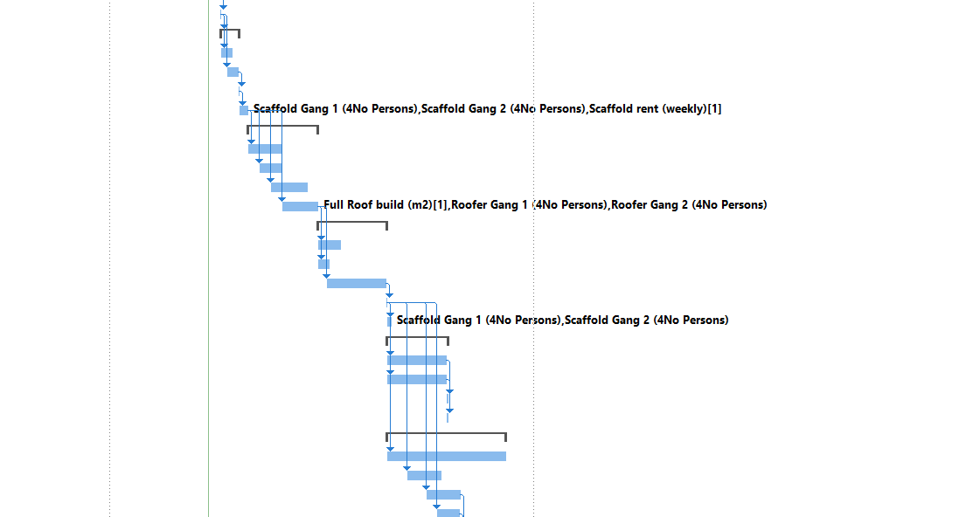
The Gantt chart for this project shows the critical path for constructing the 6 blocks (27 properties) located in SA1. Included in this chart is the pre-construction stages following the RIBA stages of work through the construction phase to completion. The chart shows the properties all being constructed as one large project with each task being offset so that gangs can move from one plot to another. For example trenches for the substructure will be dug one after another with a separate team concreting behind them and another separate team building footings up to DPC etc…
Figure 1: Gantt Chart
Figure 1 shows the relationship between different activities on site, the key areas are for scaffold erection, roof build and Scaffolding dismantle.

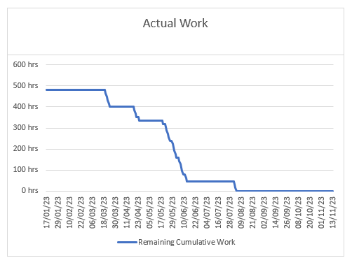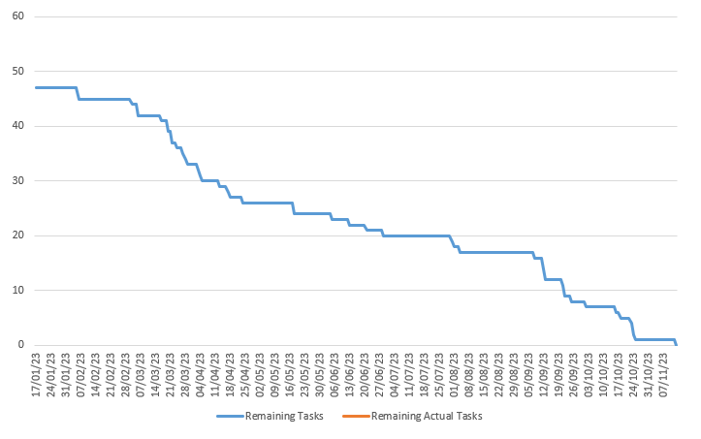Figure 2 shows the tasks of the project over time from pre-construction to completion and handover.
Figure 3: Hours over time
Figure 2: Tasks over time
Figure 3 shows total hours for the three nominated task over time from the start of the construction phase to the end. This shows a decrease in the time over the duration as their work is completed.

Resource & Cost
Ground workers
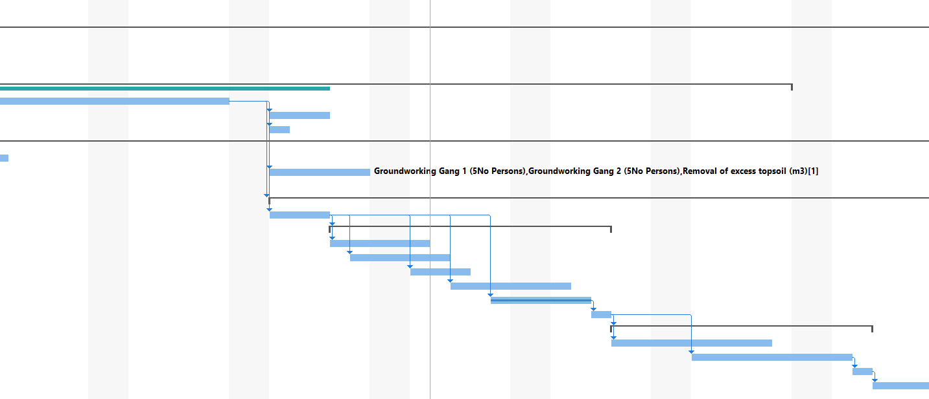
Figure 4: Ground workers Gantt

Task | Duration | Start date | Cost
Site preparation & levelling | 5 Days | Mon 20/03/23 | £8,422.00
Figure 5: Ground workers resource table
Figure 4 shows the ground working gang 1 & gang 2, their presence on site and its relation to the other tasks.
Figure 5 shows the duration of time that the ground workers will be on site and the total cost of their work including for materials and labour.

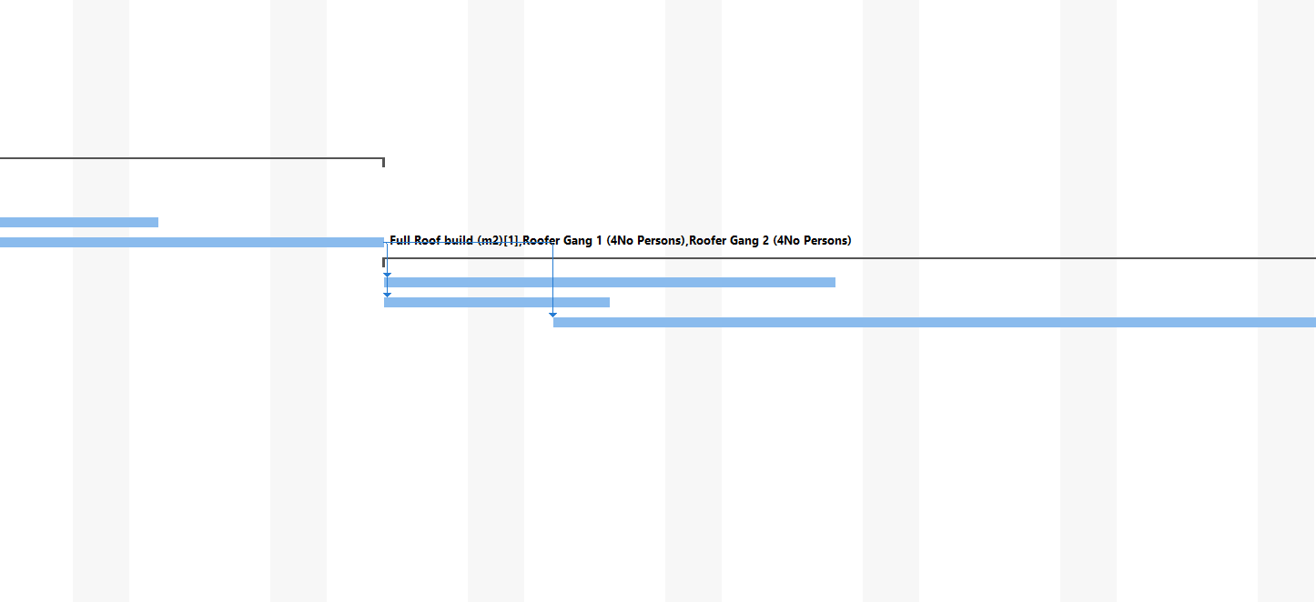Roofing Works
Figure 6: Roofers Gantt

Task | Duration | Start date | Cost
Roofing works | 18 Days | Fri 19/05/23 | £34,590.00
Figure 7: Ground workers resource table

Figure 6 shows the roofing gang 1 & gang 2, their presence on site and its relation to the other tasks.
Figure 7 shows the duration of time that the roofers will be on site and the total cost of their work including for materials and labour.

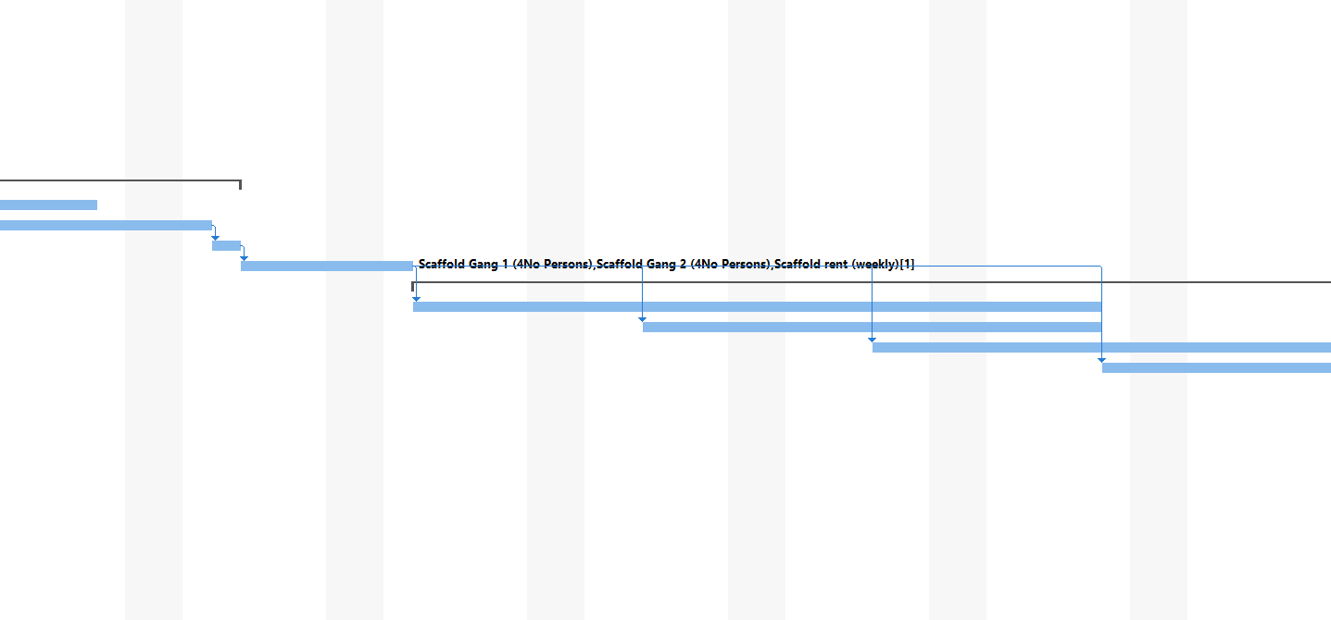Scaffolding
Figure 8: Scaffold Gantt

Task | Duration | Start date | Cost
Scaffold Erection | 4 Days | Wed 19/04/23 | £9,400.00
Scaffold Dismantle | 3 Days | Wed 02/08/23 | £4,800.00
Figure 9: Ground workers resource table

Figure 8 shows the scaffolding gang 1 & gang 2, their presence on site and its relation to the other tasks.
Figure 9 shows the duration of time that the scaffolders will be on site and the total cost of their work including for materials and labour.

Critical Tasks / Critical Path
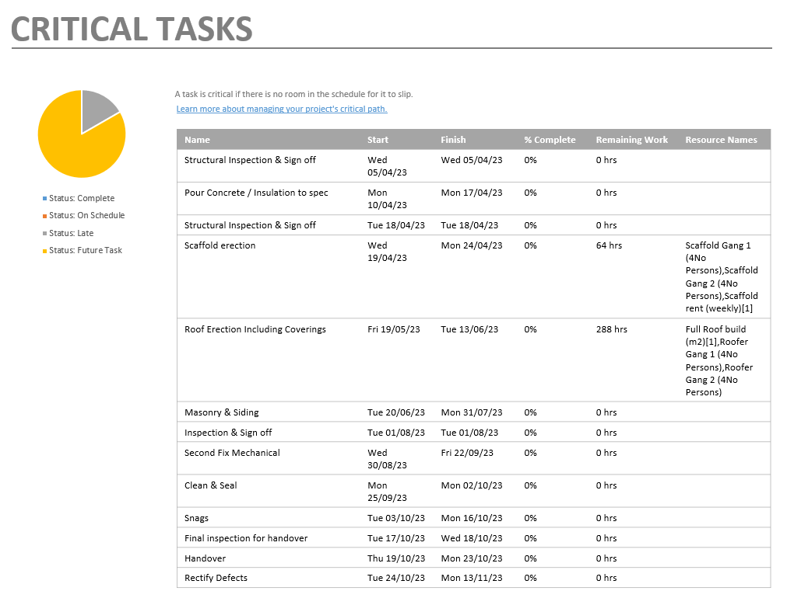
Figure 10: Critical Tasks 1

Figure 10 shows the critical tasks for a portion of the project as a percentage complete, the on-site construction started on the 6th March
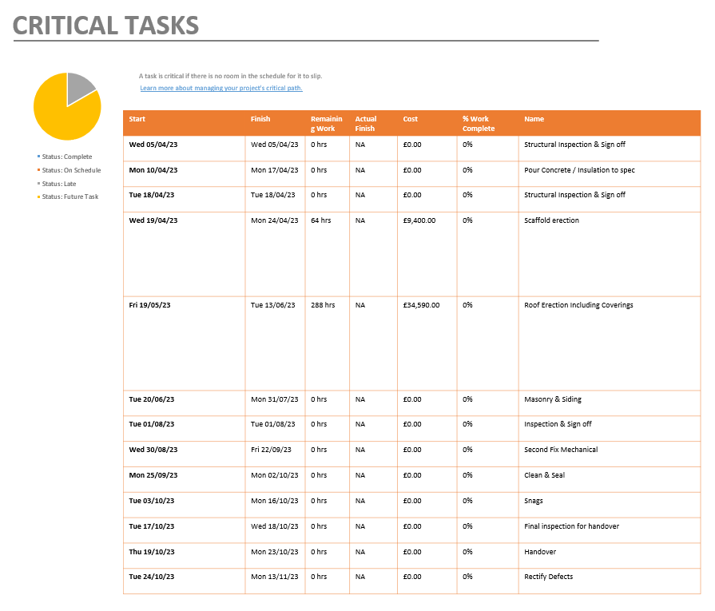
Figure 11: Critical Tasks 2

Figure 10 shows the critical tasks for a portion of the project in terms of cost and their percentage completion.

Reading list
AECOM, 2020. Spon's architects' and builders' price book 2021. One hundred and forty-sixth edition ed. Boca Raton: CRC Press.
Anon., 2022. Tradesmen Day & Hourly Rates 2022. [Online]
Available at: https://www.priceyourjob.co.uk/tradesmen-day-rates/
[Accessed 28 March 2023].
Anon, S., 2023. Cost of Scaffolding. [Online]
Available at: https://www.myjobquote.co.uk/costs/cost-of-hiring-scaffolding
[Accessed 28 March 2023].
Checkatrade, 2022. Cost of scaffolding. [Online]
Available at: https://www.checkatrade.com/blog/cost-guides/cost-scaffolding/
[Accessed 28 March 2023].
Checkatrade, 2023. How much do scaffolders make?. [Online]
Available at: https://www.checkatrade.com/blog/trade/grow-business/how-much-do-scaffolders-make/
[Accessed 28 March 2023].
Checkatrade, 2023. Roof replacement cost. [Online]
Available at: https://www.checkatrade.com/blog/cost-guides/roof-replacement-cost/
[Accessed 28 March 2023].
David Snell, 2020. How Much Will my Roof Cost?. [Online]
Available at: https://www.homebuilding.co.uk/advice/roof-cost-guide
[Accessed 28 March 2023].
For Dummies, a Wiley brand, 2016. Microsoft Project 2016 for dummies course. 11th Edition ed. Hoboken, New Jersey: John Wiley & Sons.
GeoConstruct, 2023. Groundworker. [Online]
Available at: https://www.goconstruct.org/construction-careers/what-jobs-are-right-for-me/groundworker/
[Accessed 28 March 2023].
Glassdoor, 2023. Scaffolder Salaries in United Kingdom. [Online]
Available at: https://www.glassdoor.co.uk/Salaries/scaffolder-salary-SRCH_KO0,10.htm
[Accessed 28 March 2023].
Homehow, 2022. Tradesman Rates Of Pay. [Online]
Available at: https://www.homehow.co.uk/costs/tradespeople-rates
[Accessed 28 March 2023].
Indeed, 2023. Groundworker salary in United Kingdom. [Online]
Available at: https://uk.indeed.com/career/groundworker/salaries
[Accessed 28 March 2023].
Payscale, 2023. Average Roofer Hourly Pay in United Kingdom. [Online]
Available at: https://www.payscale.com/research/UK/Job=Roofer/Hourly_Rate
[Accessed 28 March 2023].
Reed, 2023. Average Groundworker salary in the UK. [Online]
Available at: https://www.reed.co.uk/average-salary/average-groundworker-salary
[Accessed 28 March 2023].
RIBA, 2020. RIBA Plan of Work. [Online]
Available at: https://www.architecture.com/knowledge-and-resources/resources-landing-page/riba-plan-of-work
[Accessed 28 March 2023].
Skiphire, 2023. Skip Hire Prices – How much does skip hire cost?. [Online]
Available at: https://skiphire.services/prices/
[Accessed 28 March 2023].
Skiphirenetwork, 2023. Our simple guide to skip sizes. [Online]
Available at: https://www.skiphirenetwork.com/our-skip-sizes
[Accessed 28 March 2023].
Trademencosts, 2023. Scaffolding Hire Prices (for 2023). [Online]
Available at: https://tradesmencosts.co.uk/scaffolding-hire/
[Accessed 28 March 2023].
Trustedtrades, 2022. Cost guide: roofers. [Online]
Available at: https://trustedtraders.which.co.uk/articles/cost-guide-roofers
[Accessed 28 March 2023].

Appendix 1

Prestart Information: Topsoil Strip

3: Pre-start information

Site specific detail
All deliveries to follow Principle Contractor traffic management plan (to be made available at point of
contact). Where possible, all plant and vehicle movements will take place in pedestrian exclusion
zones, where this is not possible all plant movements in the working area will be under the control of
a banksman, ensuring that the banksman remains in a position of safety. In addition the movement of
lorries will be monitored by E M G Construction and Principle Contractor for the need for road sweeping.
Any delivered material and muck away lorries will be banked from the site and onto the roadways,
ensuring that the interface with non-site staff is also maintained.

The Principle Contractor shall ensure that all boundary fencing is erected, all work areas are safely accessible
and site security is maintained, E M G Construction will be responsible for all protection of their own works. All site access and egress will follow the site logistics plan.

The Principle Contractor site team will be responsible for the coordination and management of the various
contractors on site. The Principle Contractor project manager will be the point of contact for instruction and
in case of emergency.

Operatives are to be reminded that they must follow the SSW and ensure that if there is any doubt
over any situation or if circumstances change they are to stop works and consult with the site
manager and Principle Contractor, as required, to ensure that a suitable solution is found and that the
relevant documents are amended (POWRA).

The lifting of any materials and any manual handling will be reduced as far as possible, materials are
to be lifted mechanically using an excavator, ensuring that the materials do not exceed the SWL of
the excavator, wherever possible, following the lift plan. In addition, job rotation will reduce manual
handling exposure as far as possible.

Underground services
Prior to excavation, the Principle Contractor permit to break ground is to be completed, all of the exploratory
works information is to be referenced within the permit.

Prior to any excavation works, an E M G Construction operative will examine any existing services
drawings and ground penetrating radar scans (GPRS) issued by the Principle Contractor and then scan the ground with a suitable CAT & Genny to identify any services present, scanning will continue throughout the excavation works.

Mark the positions of existing cables and pipes using paint or other waterproof marking on the
ground. Look for signs of service connection cables or pipes, for example a gas meter or service
connection entry into a house or a streetlight. However, never assume depths, services may be found
at shallower depths.

All known or discovered services will be vacuum excavated if practical, if vacuum excavation is not
practical, they will be hand dug to expose and prove the location and type of any services that may
affect the works. Hand excavation is to be to the side of the traced line of the service, allowing it to
be exposed by cutting in horizontally - avoiding any excessive pressure directly over the service. No
mechanical excavation is to take place within 500mm of a known or located services line, to include
handheld mechanical tools. No pins of any type can be driven into the ground within the 1M exclusion
zone of known services.

Where electricity cables may be encountered during excavation work, the site supervisor should
consider whether the work justifies wearing clothing designed to protect against electric arc, or
flameretardant clothing.

Report any damage to a cable, pipe or pipe coating. Even if there is no immediate danger, damage
could cause danger at a later date, do not attempt repairs. In the event of a gas leak, evacuate the
area, do not smoke or cause a spark and contact the site manager and Principle Contractor immediately.

PPE
The Principle Contractor minimum PPE requirements will be adhered to all times (Hard hat, high-visibility vests,
suitable gloves, safety boots). Task specific PPE requirements are detailed in the attached Risk
Assessments.

Work area set up
The site engineer is to set out the extent of all reduce level dig works and subsequent road and plot
layouts and other hard standings. Below is an extract from the construction drawing showing the
layout and detail and work area images, if available:

Appendix 2

Topsoil Strip H&S
Safety and Environmental Conditions
- I can confirm that all of the briefed operatives are fit for work with no known medical conditions
that could affect their ability to carry out their activities.
- Operatives are to be pre-enrolled on the Morganstone online system, once available for the
project.
- All personnel undertaking the above tasks and working within the works area of the above
tasks will have read, understood and signed for this Method Statement, attached Risk
- Assessments & COSHH Assessments before undertaking the above tasks.
- All personnel undertaking the above tasks will hold valid CSCS, CPCS or other industry
approved trade cards.
- All Plant, Machinery and Tools will only be operated by trained personnel and be in good
working order, with no defects and hold valid certification where applicable.
- Valid plant/lifting equipment certificates will be provided with the machines upon their arrival on
site. Daily/weekly inspections will be carried out in accordance with PUWER and LOLER.
- All excavators are to use twin coupled, fully automatic quick hitches. Where this type of coupler
is not available the bucket is to be directly attached to the dipper arm. Operatives are not to
work directly beneath a machine with a quick-hitch system.
- All excavations will be fenced off with physical, crowd control barrier as a minimum.
- All loose materials and other debris will be cleared from site and placed into the skis provided
by the principle contractor.
- All vehicle movements on site, outside of pedestrian exclusion zones, will be controlled by a
banksman.
- Fuel for Tools and Plant will be stored in double bunded containers, fuel vaults will be used for
small fuel containers and double bunded bowsers will be used for bulk storage.
- A spill kit will be place besides all fuel storage areas. All tools and equipment with a fuel tank is
to be on a plant nappy whilst out on site and not in use, storage will then be within a bunded
area of the tool shed.
- Morganstone will provide site first aid cover and first aid kits, EMG site managers are also first
aid at work trained.
- The location of the nearest hospital is to be in theM organstone site office and
communicated to all site staff at induction.
- Morganstone to provide general fire arrangements & procedures to which EMG will be fully
compliant.
- Any water discharge from pumping of ground water will be directed to the outfall location, as
directed by Morganstone.
- A silt sock is to be used for all dewatering activities, ensuring that the quantities of water
are monitored.
- Waste segregation will be undertaken where possible and all waste materials reused or
recycled.
- Noise assessments will be carried out wherever there is a potential for the public to be exposed
to noise levels above the exposure action value, operator hearing protection will be identified by
the specific task / tools being used and noise sample taken if the level of hearing protection
does not reduce exposure below the action value.
- Whenever possible van sharing will be undertaken travelling to and from site to reduce
emissions.
- All plant will be turned off and keys removed when not in use.
- All working hour restrictions, as imposed by Morganstone will be followed at all times.
- All engineering and survey equipment will hold a current calibration certificate, which will be
available prior to being used.

Appendix 3

Prestart Information: Scaffolding

3: Pre-start information

To Erect and Dismantle Independent Access Scaffold and loading bays for the erection of brickwork masonry facades to the accommodation.
The scaffolding will be erected using a Cuplok System and done so in compliance with NASC scaffold technical guidance TG20:21 and bespoke design provided by TAD Scaffold Engineering.

The on-site distribution of materials will be assisted by our client Scorpion ES, who will provide a telehandler with an operator and banksman. All lifting equipment and accessories to be provided by Scorpion ES.
We will be represented on site by Peter Parker who will act as Site Supervisor(s).
The Supervisor will be responsible for ensuring that all works carried out are in accordance with this Method Statement, Health & Safety legislation, Codes of Practice/Industry Guidance and accepted safe systems of work.
Contact Number: Peter Parker: 07896 123456

Appendix 4

Scaffold H&S
Security of working areas
Due regard will be paid to the proximity of the Client’s staff/contractors who may be present or in the near vicinity.

- An assessment will be made of the existing control measures put in place by the Client.
- At least one scaffold operative will be positioned at ground level to ensure the safety of any person who may be in the vicinity. The operative will be in verbal contact with the scaffolders, should work need to cease.
- Due regard will be paid to members of the public who may be in the vicinity. Scaffold to be provided with end caps, foam tubing etc. as is deemed necessary to provide full protection.
EMERGENCY PROCEDURES / FIRST AID
4.1 The nearest Accident and Emergency Hospitals is located at:

Singleton Hospital,
Sketty Ln,
Sketty,
Swansea
SA2 8QA

In the event of an accident occurring, the Supervisor will summon the relevant emergency services via 999 or take the injured person directly to the hospital via our works vehicle, depending on the severity of the injury.

- The above will be coordinated with the Client’s existing procedures.
- Our Supervisor is nominated as the person responsible for First Aid.
- Slip, trip, falls at same level
- In the event of an accident to a scaffolder (following a slip, trip, fall at the same level, i.e. on the scaffold platform/ground level), the situation will be assessed by the Supervisor who will administer First Aid. If deemed necessary, the Emergency Services will be called.
- Fall of scaffolder – rescue where suspended by Safety Harness

Training
- All persons will be made aware of the contents of this Method Statement and will be instructed to work according to its requirements via a short training course given by our Supervisor, prior to the commencement of work.
- Our personnel will also attend Induction/other training courses provided by Scorpion ES Ltd. Site operatives will hold the relevant CSCS/CISRS card. (Scaffolder, Trainee, or labourer) Site supervisors will be identifiable by their Hi-Viz vest clothing.
- All operatives are to undertake an online induction as provided by AGCL prior to arrival on site.
- An induction issued by Amey, will be delivered on arrival to site.

Access to site, loading/unloading
- There is no parking available on site. Vans will need to be parked off site or in a provided contractor car park.
- We will inform relevant parties of our arrival and, if necessary, will advise of our intended work.
- Scaffold materials will be offloaded and temporarily stored at the most appropriate location.
- At least one scaffold employee will be provided for the loading/unloading of the lorry to ensure the safety of other persons who may be in the vicinity of the area.
- We will eliminate the need for persons to gain access to the back of the lorry.
- An exclusion zone will be set up.

Live services
- No live services have been identified within the footprint of the working area.
- Should services be observed; work will not commence until it has been confirmed by the Client/other competent person that it is safe to proceed.
- Where reasonably practicable to do so, exclusion zones to the perimeter of the work area will be established, using physical barriers to prevent unauthorised entry.

Safety signage
- Advance warning signs will be erected, stating “Warning - Men at Work” (or similarly worded) as part of establishing an exclusion zone to the perimeter of the working areas.

Fall prevention/fall arrest
Note: As per Valco Scaffolding Ltd policy, all scaffold operatives are to wear safety harnesses and lanyards at all times, regardless of what height works are taking place.
- The sequence of erection will be in accordance with the NASC Booklet SG4:15, with an advance guardrail being erected as soon as possible to temporarily constructed lifts, to provide a physical means of fall prevention.
- In addition, scaffold erectors will wear General Purpose Safety Harnesses (BS En 361) at all times and will attach the Lanyard (BS EN 354) and the energy absorber (BS EN 355) to a secured anchor point, where there is a risk of falling 4 metres or more. (The fall arrest system is ineffective at less than 4 metres).
- Where there is a risk of falls less than 4 metres the operatives will work in accordance to SG4:15 and provide for themselves with a ‘safe zone’, providing a fully boarded lift without gaps and a single guardrail (950mm) above the working platform.
- Where possible collective fall prevention measures will take priority over personal measures.
- Safety Harnesses, lanyards and inertia reels will be inspected daily by the user, with a record of the inspection being made at least every 7 days and entered into the harness inspection register on site.

Documentation
- A scaffold handover certificate will be issued on completion of the work and after substantial alteration.
- A “Scaff tag” system will be provided if requested.
- Copies of the Scaffolder’s proof of competency cards (CISRS, affiliated to the CSCS Scheme) will be carried by the scaffold erection team.
- Records of Safety Harness Inspections will be retained by the Supervisor.

Alteration and modification of method statement.
- Any alterations or modifications to this Method Statement will be communicated to any person who may be affected by those changes.

Appendix 5
Prestart Information: Roofing
3: Pre-start information

Deliveries to site compound prior to start date.

Accidents and Incidents
All accidents and incidents must be reported to Line Manager/Health and Safety Advisor/Client. First Aid boxes will be available in the operatives work vehicles.

Asbestos
Prior to any work commencing the Asbestos Register must be made available by the client and checks to be made by the supervisor to the areas where work is to be carried out to ensure there is no Asbestos Containing Materials (ACMs) present.

Hand Tools and Equipment
All tools and equipment must be in good working condition and regularly maintained. Operatives are trained in the safe use of work equipment and tools. Battery operated tools will be used where possible.

Welfare Facilities
Access to welfare facilities (client premises) will be made available. Operatives to respect all facilities and ensure they are left clean and tidy.

Working at Height
All working at height will be properly planned, organised and supervised. Only competent operatives will be allowed to work at height. Fixed scaffolding which will be provided by the client will be used to carry out the work. Scaffolding must be inspected by a competent and trained operative before first use and handover certificate/scaffolding register to be checked prior to first use. Further inspections to be arranged by the client for the scaffolding to be carried out by a competent person at intervals not exceeding 7 days thereafter (inspections to be recorded). re the scaffolding is safe for use.

Scaffolding
Scaffolding to be erected in line with TG20:21 and will be carried out by another contractor instructed by the client in advance of works commencing. Scaffolding will be erected and dismantled by trained and competent contractor. Site supervisor to carry out visual inspection of scaffolding at the beginning of each shift to ensure it is safe to use, where scaffolding has been tampered with or damaged due to extreme weather conditions the scaffolding contractor will be instructed to attend site and rectify the issue, re-inspect the structure and complete the scaffolding inspection register and

Scaff tag.
Waste to be removed from working areas and place within the skips Ensure all tools and equipment have been accounted for and area of work is left in a safe condition.

PPE
Gloves, High Visibility Vest, Safety Boots, Safety Visor/goggles, dust mask (Task specific)

Other
Return any issued permits to the permit issuer (client)

Sign out at main reception/desk as required

Appendix 6

Roofing H&S
Working environment
Barriers and signage to be set up prior to work commencing to prevent unauthorised access to working area Work will be carried out during normal operating hours as agreed with the client.
Work area to be assessed prior to carrying out work - any significant hazards must be addressed to ensure the work can be carried out safely.

Clothing to be worn for external working conditions.

Weather forecast to be checked prior to work being carried out - where extreme weather conditions (high winds, snow etc.) are forecast work may have to be re- scheduled.

All operatives are experienced and competent to carry out the work.

Fixed scaffolding will be provided by the client.

Only authorised personnel to use fixed scaffolding to access roof level to carry out work.

Permit to work to be issued by client (where relevant) Suitable clothing to be worn for external working.

Weather conditions to be monitored and in cases of extreme weather work shall be re-scheduled.

Operatives are aware of residents occupying properties and will conduct themselves in a professional and courteous manner.

All work will be planned in advance, and where applicable the Construction (Design & Management) Regulations will be complied with RAMS briefing will be carried out and all operatives carrying out the work will be required to attend and sign briefing record to confirm understanding of safe system of work and control measures required to be implemented.

Falls from height
All surfaces should be treated as fragile unless a competent person has confirmed otherwise. A structural survey may be required to confirm the strength and stability of roof membranes.

Fragile parts of the roof will be clearly identified e.g. roof-lights will be covered or suitably guarded.

All roofs constructed of fragile materials will be thoroughly surveyed before commencement of work.

At no time may anyone work on, from or pass over fragile materials unless platforms, coverings or other similar means are provided adequately support them. A written method statement will be prepared detailing how work on fragile roof will be carried out where applicable.

Materials will not be stored on fragile roofs.

Assume roof is fragile unless confirmation provided by client to state otherwise.

Appropriate warning signage to be used where fragile exist.

Ensure that platforms are wide enough and long enough to give adequate support across roof members and ensure that enough platforms are used.

Never walk along purling's or steel beams.

Hierarchy for work on fragile roofs is:
- Work from underneath the roof using a suitable working platform.
- Where this is not possible, consider using a Mobile Elevated Working Platform
- If access onto the fragile roof cannot be avoided, install perimeter edge protection and use staging to spread the load. Unless all the work and access are on staging or platforms that are fitted with guard rails, install safety nets underneath the roof or use a harness system: and

Where harnesses are used they need adequate anchorage points. They also rely on discipline, training and supervision to make sure that they are used consistently and correctly.

Fatality / personal injury
Safe access/egress to roof will be provided by means of scaffolding which will be provided and maintained by the client.

Scaffolding will be erected/dismantled by a competent scaffolding contractor appointed by the client to TG20:21 specification.

Edge protection (toeboards) to be in place to prevent materials/persons falling • Operatives are experienced, competent and trained to carry out roof works.

All work will be supervised throughout the duration of the job.

Operatives have access and reference to HSG 33 - Health and Safety in Roof.

Risk Assessment & Method Statement - Roof Work.

Safe method will be adopted when carrying/lifting work materials, equipment and tools to and from the roof level- 'bombing' of materials is forbidden and will lead to disciplinary action Well planned material handling to include minimising amount of time spent

Materials & Tools Falling from height
Working at height and reducing the amount of travelling around the roof to collect materials.

To prevent materials falling or being blown away the necessary precautions will be taken to secure the items.

Supervisor to be mindful of the 'sail' effect which large materials can produce. 'Sail' effect can be extremely hazardous, even in light winds.

Weather conditions to be checked and monitored during the works - extreme weather conditions may result in work being re-scheduled or temporarily stopped.

Tools to be tethered or operative to use a tool belt.

Where possible waste shoots to be used for the removal of waste materials

Control access by other trades when roof work in progress to prevent the risk of falling materials.

Slated and tiles pitched roofs
Properly constructed and supported roof ladder will be required when working on sloping roof

Full edge protection is required on all roof elevations to which access is required.

Scaffold platform at eaves level provides a good standard of edge protection, a working platform and storage space for materials.

Operatives should not walk directly on the tiles or slates unless additional measures are provided to prevent falls (e.g. roof ladder).

Roof ladders or crawling boards should be:
- Designed and fabricated to be fit for purpose.
- Strong enough to support workers when spanning across the supports for the roof covering .
- Long enough to span the supports (at least three rafters).
- Secured and placed to prevent accidental movement.

Do not use eaves gutters as a footing or to support a roof ladder unless they are of adequate strength.

Use of hand tools and equipment
Ensure hand tools & equipment is in good condition and fit for purpose.

Wear PPE at all times when carrying out work activities.

All work tools & equipment must be maintained, and any defects or damage to be reported and tools/equipment must not be used.

Never leave tools/equipment unattended-store away in work vehicle when not in use.

Operatives trained in the use of equipment and tools.

Slips, trips and falls same level
Always check work area for hazards and set up area using barriers (where required to prevent unauthorised access and allow sufficient space to carry out the work)

Good housekeeping to be maintained at all times.

No tools or equipment to be left unattended and must be returned to work. vehicle/storage area when not in use.

Keep walkways/fire exits clear of tools/equipment.

Manual handling
All operatives have received manual handling training.

Always use correct lifting technique when handling tools, equipment or materials Always assess the load, task and environment.

Never exceed individual capability - ask for assistance.

Materials, equipment and tools to be off-loaded as close to work area as possible to prevent having to manually handle over long distances.

Designers and specifiers should consider reducing the length of roof sheets to make them lighter and reduce their unwieldly nature, particularly against weather conditions when handled at height.

Access / Egress
Ladder access to scaffolding to be secured and should extend about 1m above the working platform.

Minimise openings in scaffolds that have been created for ladder access.

Scaffolding to be erected/dismantled by competent and trained scaffolder.

Scaffolding to be erected in line with TG20:21 and must be inspected prior to use and every 7 days thereafter in line with statutory requirements.

Ladder to be removed at the end of every shift to prevent unauthorised access.

Scaff tag, Scaffolding register to be checked prior to use to ensure statutory inspections have been carried out.

Biological Hazards
Good Personal hygiene to be maintained at all times.

Welfare facilities available to allow operatives to wash hands with soap and hot water.

Operative to wash hands before eating, drinking or smoking.

Cover cuts and abrasions with suitable impervious dressings.

Where large volume of pigeon droppings are present disposable overalls and over shoes shall be worn. These should be discarded upon completion of the work. Avoid inhaling pigeon dropping dust.

Do not use high pressure water to remove pigeon droppings.

Asbestos
For refurbishment work, refer to asbestos register/survey prior to commencing any work.

Should any asbestos containing materials be discovered all work is to stop immediately and Site Manager to be informed.

Principal Contractor to be informed if any ACMs are discovered No work is to commence until asbestos containing materials have been removed by a competent and licenced asbestos contractor.

Operatives have completed Asbestos Awareness training.

Lead
The following activities can expose operatives to lead:
- Carrying out hot work, cutting or joining lead materials.
- Removing or repairing old lead roofs.

Alternatives such as glass-reinforced plastic, PVC, felt and plastics to be used.

Exposure to be controlled and good welfare facilities to be provided which include access to hot water, soap and access to place to eat and drink away from the work area.

Operatives to be given instruction and training to ensure they understand the risks of working with lead.

Abuse/Assault

Operatives are trained to provide a good, polite service that takes account of customers and other's needs.

Staff trained in dealing with difficult and/or confrontational situations.

If confronted, use the walk and talk method until you are in an area of safety.

All incidents to be reported and fully investigated.

