

STUDENT NAME: ELSIE GRUBAT
STUDENT ID: 2508285
MODULE NAME: INTRODUCTION TO HEALTH AND
SOCAL CARE
MODULE CODE: LCHS4003
LECTURER NAME: MUHAMMAD ALIYU

CONTENT PAGE
COMMUNITY MENTAL HEALTH SERVICES……………………………….3
PHARMACY SERVICES………………………….……………………………5
REFERENCE LIST…………………………….……………………………….7

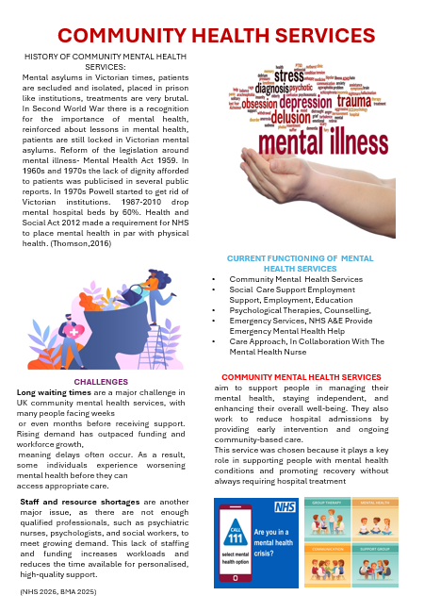

PHARMACY SERVICES
The origins of pharmacy can be traced to ancient Egypt, where early medicinal practices established the foundations of the profession. Zebroski (2015) notes that the term *pharmacy* derives from the Egyptian expression *ph‑ar‑maki*, meaning “granter of security”, reflecting the cultural value placed on healers. Archaeological findings further support this early development of pharmaceutical knowledge. Cockitt and David (2010, p. 74) report the discovery of prescriptions used by ancient Egyptians to treat dental conditions, demonstrating their practical engagement with medicinal formulations. These sources indicate that ancient Egyptians possessed a sophisticated understanding of natural substances and their therapeutic properties. Their use of plants, minerals, and other natural materials extended into beauty and self‑care practices, illustrated by enduring narratives surrounding figures such as Cleopatra, whose routines reportedly involved medicinal preparations. Thus, historical evidence positions ancient Egypt as a crucial point of origin for pharmaceutical practice and early conceptions of healing.
The historical development of pharmacy is shaped by a long tradition of safeguarding the effective use of medicines, emerging through cultural exchange, legal reform, and professional organisation. Early pharmaceutical practice can be traced to Antiquity, with Sumerian prescriptions recorded around 2700 BC (Anderson, 2005). According to Anderson (2005), between 50 BC and 1231 AD, figures such as Galen and Greek philosophers significantly influenced medicinal theory, while Arab practitioners established the first private drug stores in Baghdad, spreading pharmaceutical knowledge across Europe. Anderson (2005) also stated that a major turning point occurred with the Edict of Palermo in 1231, which formally separated pharmacy from medicine, followed by the rise of apothecaries as a distinct professional group and the establishment of the Society of Apothecaries in 1617. These developments demonstrate how pharmacy evolved from early medicinal preparation into a regulated profession shaped by legislation, education, and international exchange. Thus, pharmacy’s historical context underpins its modern identity as a scientifically grounded and professionally regulated discipline.
Pharmacy today operates as a dynamic and expanding profession, yet its effectiveness is shaped by the increasing complexity of patient needs and the evolving expectations placed on pharmacists. According to Paolini Albanese, Rouse and Schlaifer (2010) current practice spans a wide spectrum of clinical roles, including patient counselling, chronic disease management, immunisation, and broader public health services. Pharmacists now serve highly diverse patient populations and deliver increasingly complex interventions, supported by structured educational and credentialing standards for both pharmacists and pharmacy technicians. Contemporary analyses highlight that pharmacy practice is shifting towards a model driven by patient and population needs rather than traditional dispensing‑centred roles. Despite these advances, the profession continues to navigate challenges such as variable scope of practice, inconsistent integration within healthcare teams, and the need for clearer alignment between credentials and responsibilities. These issues influence the consistency and visibility of pharmacists’ clinical impact. Thus, pharmacy today functions as a crucial yet continually evolving profession, striving to establish a unified, patient‑centred standard of care.
Pharmacy plays a critical role in enhancing the quality of life of service users by delivering accessible, evidence‑based care that supports safe and effective medication use. Modern pharmacists contribute far beyond dispensing, providing counselling, chronic disease management, immunisation, and public health interventions. Their expertise enables them to optimise therapeutic, preventative, and rehabilitative outcomes for diverse patient populations. Contemporary pharmacy practice frameworks emphasise patient‑centred care, supported by structured educational and credentialing standards that ensure competence across increasingly complex clinical services. By addressing medication safety, improving adherence, and tailoring interventions to individual needs, pharmacists help reduce disease burden and prevent avoidable complications. Their involvement in monitoring clinical outcomes strengthens continuity of care and enhances the overall effectiveness of treatment. However, the impact of pharmacy is shaped by wider socio‑cultural, economic, and healthcare system factors, which influence access and service delivery.

Reference list
Al-Jumaili, A.A., Ameen, I.A. and Alzubaidy, D.A. (2020). Influence of Pharmacy Characteristics and Customer Quality of Life on Satisfaction of Community Pharmacy Customers. INNOVATIONS in pharmacy, [online] 11(1), p.13. doi. Available at https://doi.org/10.24926/iip.v11i1.2434. (Accessed 14 March 2026)
Albanese, N.P., Rouse, M.J. and Schlaifer, M. (2010). Scope of contemporary pharmacy practice: Roles, responsibilities, and functions of pharmacists and pharmacy technicians. Journal of the American Pharmacists Association, [online] 50(2), pp.e35–e69. Doi. Available at https://doi.org/10.1331/japha.2010.10510 (Accessed 14 March 2026)
Anderson, S. (2005). Pharmacy Practice. London: Taylor and Francis, pp.3–28. Available at: https://resource.odmu.edu.ua/chair/download/147113/Ylxhbz5Ri3HPANjbCefFhA/Pharmacy_Practice_%D1%83%D1%87%D0%B5%D0%B1%D0%BD%D0%B8%D0%BA.pdf#page=26 (Accessed 15 Mar. 2026)
BMA (2025). Mental health pressures data analysis. The British Medical Association. Available at: https://www.bma.org.uk/advice-and-support/nhs-delivery-and-workforce/pressures/mental-health-pressures-data-analysis (Accessed 14 Mar. 2026)
Cockitt, J. and David, R. (2010). Pharmacy and medicine in ancient Egypt. In: Proceedings of the conferences held in Cairo (2007) and Manchester (2008). [online] Oxford: Archaeopress. Available at: https://d1wqtxts1xzle7.cloudfront.net/32654099/Medicine___Pharmacy_in_AE_Conference-libre.pdf?1391095048=&response-content-disposition=inline%3B+filename%3DWere_the_dentists_in_ancient_Egypt_opera.pdf&Expires=1773575893&Signature=BoRR8cyyfq6zouM2UVoHZgaDUGJfF1SQO36hlpK9bibYon5XrvWwbrMFr2~TlYVZOOK7X2sSXAezoN~7OiieJvSPHY2RPV3G1GrzrC2zhZ0gAjHqEICpg2rTU2G~wOchf7puaK64VPAgx-knntRcxWGW-oomnu5Q3Y4qsy-5N4hvVvCjcEWoXpaShJ8HXhpCk985c4Wmshh6X4OqM5bbsXa285VDKFEhk55mIjCapwwqUhXdx8qcnx5SBeKa6w1N2XFkXRcFOpvSQ4wfQG7pzflCFuxe7augy4FRIEvnLJO9rxhcuwsF4P9J5YySXmyUwlDdenGyBjN2ey7-Vznc2w__&Key-Pair-Id=APKAJLOHF5GGSLRBV4ZA (Accessed 15 Mar. 2026)

NHS (2024). NHS Mental Health Crisis Response Service. Available at: https://www.elft.nhs.uk/sites/default/files/2024-02/111_mh_option_website_graphic_0.png (Accessed 15 Mar. 2026)
NHS England (2024). NHS England Community Mental Health Services. [online] England.nhs.uk. Available at: https://www.england.nhs.uk/mental-health/adults/cmhs/.(Accessed 14 Mar. 2026)
Thomson, M. (2016). Mental Health. [online] People’s History of the NHS. Available at: https://peopleshistorynhs.org/encyclopaedia/mental-health/ [Accessed 14 Mar. 2026].
Zebroski, B. (2015). A Brief History of Pharmacy. [online] New York: Routledge. Available at: https://ndl.ethernet.edu.et/bitstream/123456789/90491/1/A%20Brief%20History%20of%20Pharmacy_Humanity%20s%20Search%20for%20Wellness-Bob%20Zebroski-Taylor%20%26%20Francis-2016-1.pdf (Accessed 15 Mar. 2026)

