

Lab: IPv4, Subnetting, VLSM and IPv6 Addressing

- Understanding IPv4 and IPv6 addressing (word count 1000)
This part of lab worksheet require you research and write a report on “Features of IPv6”. You may discuss but not limited to structure, address types, advanced functionalities and security.

Features Of IPv6

History

As Of 2019, the function of organisations such as RIPE (UK/Europe), Arin (USA), AFRINIC (Africa), LACNIC (South America), APNIC (Australia) to allocate IPv4(Internet Protocol Version 4) addresses across the world is coming to an end [1]. The aforementioned organisations have almost depleted their supply of IPv4 addresses [2] due to the unforeseen prediction that end devices have multiplied since the creation of networked devices. IPv4 addresses are required for not only standalone computers but for phones, watches, baby monitors and many other hardware devices under the IOT(Internet Of Things) banner.

IPv4 Solution

The answer to the IPv4 exhaustion is the move to IPv6 (Internet Protocol Version 6). IPv6 allows for an ever-expanding networked world but is not compatible with IPv4 [3] so current IPv4 addressed devices will not be able to communicate with future devices allocated an IPv6 address without considerations. There are three ways for IPv4 to communicate with IPv6 [4]:

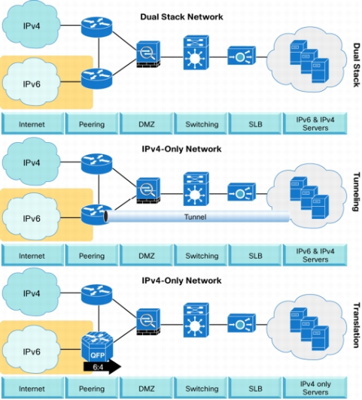
Available IPv4 to IPv6 communication techniques [5]

Dual Stack – where devices have both IPv6 and IPv4 addresses assigned to them at the same time [6]. This does require another layer of configuration because the organization now has to configure a network handling two separate protocols. This process does double up the configuration involved in network security.
Tunneling – an IPv6 packet is encapsulated inside an IPv4 packet [7], the network routers are then configured to deal with the translation between protocols.
Translation – where NAT64(Network Address Translation) is implemented as in the same case of NAT for IPv4 [8], the packets are translated from IPv6 into IPv4 packets and vice versa. This adds an overhead to the process of packet in IPv4 protocol.

There are 4,294,967,296 billion IPv4 IP addresses in the world today [9], IPv6 would permit 340 undecillion addresses worldwide [10]. To put both available IP address amounts into perspective:

IPv4 : 4,294,967,296
IPv6 : 340,282,366,920,938,463,463,374,607,431,768,211,456

IPv4 Structure vs IPv6 Structure

IPv4 structure consists of a 32 bit address range split into four, via dot notation, giving an 8 bit binary number converted to decimal for human readability [11]. The 32 bit address range is called an IP address, an example of this is 192.168.10.1 [1]. Converted into its 8 bit binary format:

192 = 11000000
168 = 10101000
10 = 00001010
1 = 00000001

The 192.168.10 is the network portion of the IP address where the host address, in this case 1, is the address of the actual end device allocated that IP address as an actual location. The subnet mask in IPv4 is used to identify the network and host portion of the IP address. IPv6 address structures differ in that instead of 32 bits to calculate an IP address the IPv6 IP address is derived from 128 bits. 64 bits are allocated to the Network information and the remaining 64 bits is the subnet mask
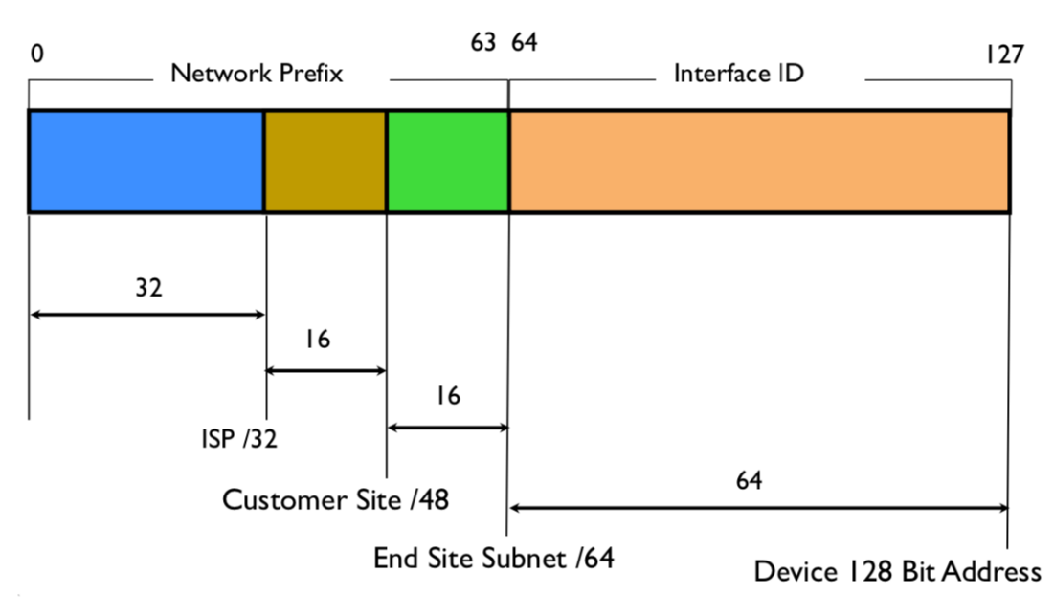
IPv6 Address Structure [12]

The IP address derived from128 bits is in the following format x:x:x:x:x:x:x:x. Where IPv4 is separated by dot notation in four octets, IPv6 is separated by eight hextets of 16 bit hexidecimal series of numbers and characters (e.g. 2001:0db8:0a0b:12f0:0000:0000:0000:0001). Converting decimal to hexadecimal is easier that decimal to binary due to its smaller range of convertible bits. For example the letter A in hexadecimal is 1010, which is a lot easier to remember than an 8 bit conversion. The IPv6 address also needs to follow certain rules:

Rule 1: initial address formatting 2001:0db8:0000:0000:0000:ff00:0042:8329
Rule 2: Remove leading zeroes 2001:db8:0:0:0:ff00:42:8329
Rule 3: Remove tailing zeroes 2001:db8::ff00:42:8329

These rules aid in representing the IPv6 address in an easier format for usage.

The first 64 bits in the IPv6 address are as follows:
- 2 – The unicast address for a network destination
- 001 – This will specify the region the IPv6 address has originated from such as RIPE (UK/Europe), Arin (USA), AFRINIC (Africa), LACNIC (South America) and APNIC (Australia).
- ODB8 – The local internet registry and Internet service provider such as Virgin, Sky, etc.
- AB00 – subnet allocated addresses.

IPv6 Advanced Features

IPv6 allows end to end connectivity, this is effectively removing the need for NAT(Network Address Translation) on a pure IPv6 network. NAT is the process whereby all external IPv4 addresses to a private network are translated via the networks packet destination, e.g. Class C 192.168.0.15 network packets to an external network are translated into the organisation IPv4 address and routed to their destination. Every single device on the private and public networks will have a single IPv6 address, this allows access beyond routing through NAT translation but will need to be managed by a router and switch as normal.

IPv6 is faster than IPv4 due to the way the packets on the network have to go through less checks across a network. The reasons for this are due to the simplified packet header in an IPv6 packet, which provide less of processing overhead than found in IPv4 packet headers. IPv6 also allows multicast, which is when a single packet can be sent simultaneously across a network to multiple recipients. IPv6 Unicast allows one to one distribution of packets within a network. IPv6 also supports Anycast for multiple devices with the same IP address, nearest device receives the data first and processes.

IPv6 Security

Security in IPv6 is not infallible and with new features opens itself up to new and imaginative attack positions from hackers looking to exploit loopholes in the newest protocol.

Firstly, the ability for an attacker to find a particular IPv6 address on a network is difficult due to the amount of subnet combinations available. It would take a single scan approximately 491,351 years to complete successfully [13], although if the address structure is known for a networked organisation it makes enumeration easier for attackers.

An organisations IPv4 security measures will need to consider current unknown IPv6 vulnerabilities. If there no servers configured to handle IPv6 requests but IPv6 is activated then this opens up the host to rogue external attackers servers that can respond to the requests and possibly bypass closed IPv4 ports [14].

Word Count: 1000

References

[1] | D. K. Radhakrishnan, “IP Addressing,” UWTSD, Swansea, 2019.
[2] | Unknown, “Ripe,” Ripe, 02 10 2019. [Online]. Available: https://www.ripe.net/manage-ips-and-asns/ipv4/getting-ready-for-ipv4-run-out. [Accessed 03 11 2019].
[3] | Unknown, “Ripe,” Ripe, 17 09 2019. [Online]. Available: https://www.ripe.net/manage-ips-and-asns/ipv6. [Accessed 03 11 2019].
[4] | Unknown, “introduction to networks version 6 cisco networking academy,” in introduction to networks version 6 cisco networking academy, Indianapolis, Cisco, 2017, p. 147.
[5] | Unknown, “Cisco,” Cisco, 12 09 2019. [Online]. Available: https://www.cisco.com/c/en/us/td/docs/voice_ip_comm/cucm/admin/11_5_1/sysConfig/11_5_1_SU1/cucm_b_system-configuration-guide-1151su1/cucm_b_system-configuration-guide-1151su1_chapter_01101.html. [Accessed 03 11 2019].
[6] | Unknown, “Cisco,” Cisco, 12 09 2019. [Online]. Available: https://www.cisco.com/c/en/us/td/docs/voice_ip_comm/cucm/admin/11_5_1/sysConfig/11_5_1_SU1/cucm_b_system-configuration-guide-1151su1/cucm_b_system-configuration-guide-1151su1_chapter_01101.html. [Accessed 03 11 2019].
[7] | Unknown, “Cisco,” Cisco, 31 06 2012. [Online]. Available: https://www.cisco.com/c/en/us/td/docs/ios-xml/ios/ipv6/configuration/15-2mt/ipv6-15-2mt-book/ip6-tunnel.html. [Accessed 03 11 2019].
[8] | Unknown, “Cisco,” Cisco, 27 04 2012. [Online]. Available: https://www.cisco.com/c/en/us/products/collateral/ios-nx-os-software/enterprise-ipv6-solution/white_paper_c11-676278.html]. [Accessed 03 11 2019].
[9] | Unknown, “What is my IP address,” What Is My Ip Address, 2019. [Online]. Available: https://whatismyipaddress.com/ipv4-shortage. [Accessed 03 11 2019].
[10] | Unknown, “Introduction to networks version 6 cisco networking academy,” in Introduction to networks version 6 cisco networking academy, Indianapolis, Cisco, 2017, p. 118.
[11] | Unknown, “What Is My Ip Address,” What Is My Ip Address, 2019. [Online]. Available: https://whatismyipaddress.com/ipv4-parts. [Accessed 03 11 2019].
[12] | J. Wei, “Apnic,” Apnic, 22 08 2019. [Online]. Available: https://blog.apnic.net/2019/08/22/how-to-ipv6-address-planning/. [Accessed 03 11 2019].
[13] | D. Holder, “Apnic,” Apnic, 18 03 2019. [Online]. Available: https://blog.apnic.net/2019/03/18/common-misconceptions-about-ipv6-security/. [Accessed 03 11 2019].
[14] | J. Anderson, “Dark Reading,” Informatech, 06 12 2018. [Online]. Available: https://www.darkreading.com/vulnerabilities---threats/weaponizing-ipv6-to-bypass-ipv4-security-/a/d-id/1331993. [Accessed 03 11 2019].

- Subnetting and VLSM
NOTE: To complete this part you would need full understanding of Lab 10 to 14.



Using the Network address 172.16.2.0/24, VLSM the network to support the following requirements:
Subnet A: 16 hosts
Subnet B: 2000 hosts
Subnet C: 6 hosts
Subnet D: 500 hosts
Subnet E: 60 hosts
Subnet F: 180 hosts and Serial links between routers

Table 1
Subnet | Hosts | Network Address | Subnet mask | First Address | Last Address | Broadcast Address
A | 16 | 192.168.0.0/27 | 255.255.255.224 | 192.168.0.0 | 192.168.0.31 | 192.168.0.32
B | 2000 | 192.168.0.0/21 | 255.255.248.0 | 192.168.0.0 | 192.168.7.255 | 192.168.7.256
C | 6 | 192.168.0.0/29 | 255.255.255.248 | 192.168.0.0 | 192.168.0.6 | 192.168.0.7
D | 500 | 192.168.0.0/23 | 255.255.254.0 | 192.168.0.0 | 192.168.2.63 | 192.168.1.255
E | 60 | 192.168.0.0/26 | 255.255.255.192 | 192.168.0.0 | 192.168.0.63 | 192.168.0.64
F | 180 | 192.168.0.0/24 | 255.255.255.0 | 192.168.0.0 | 192.168.0.254 | 192.168.0.255

