
University of Wales Trinity Saint David
LCHS4003
Introduction to Health and Social Care
Ambulance Services and Residential Care Homes in the UK: An Infographic Poster and Critical Essay

Component 1: Portfolio – Two Tasks
Student Name: Nadarajah Shanmugam
Student Number: 2531585
Lecturer: Muhammad Aliyu

Task 1: Poster

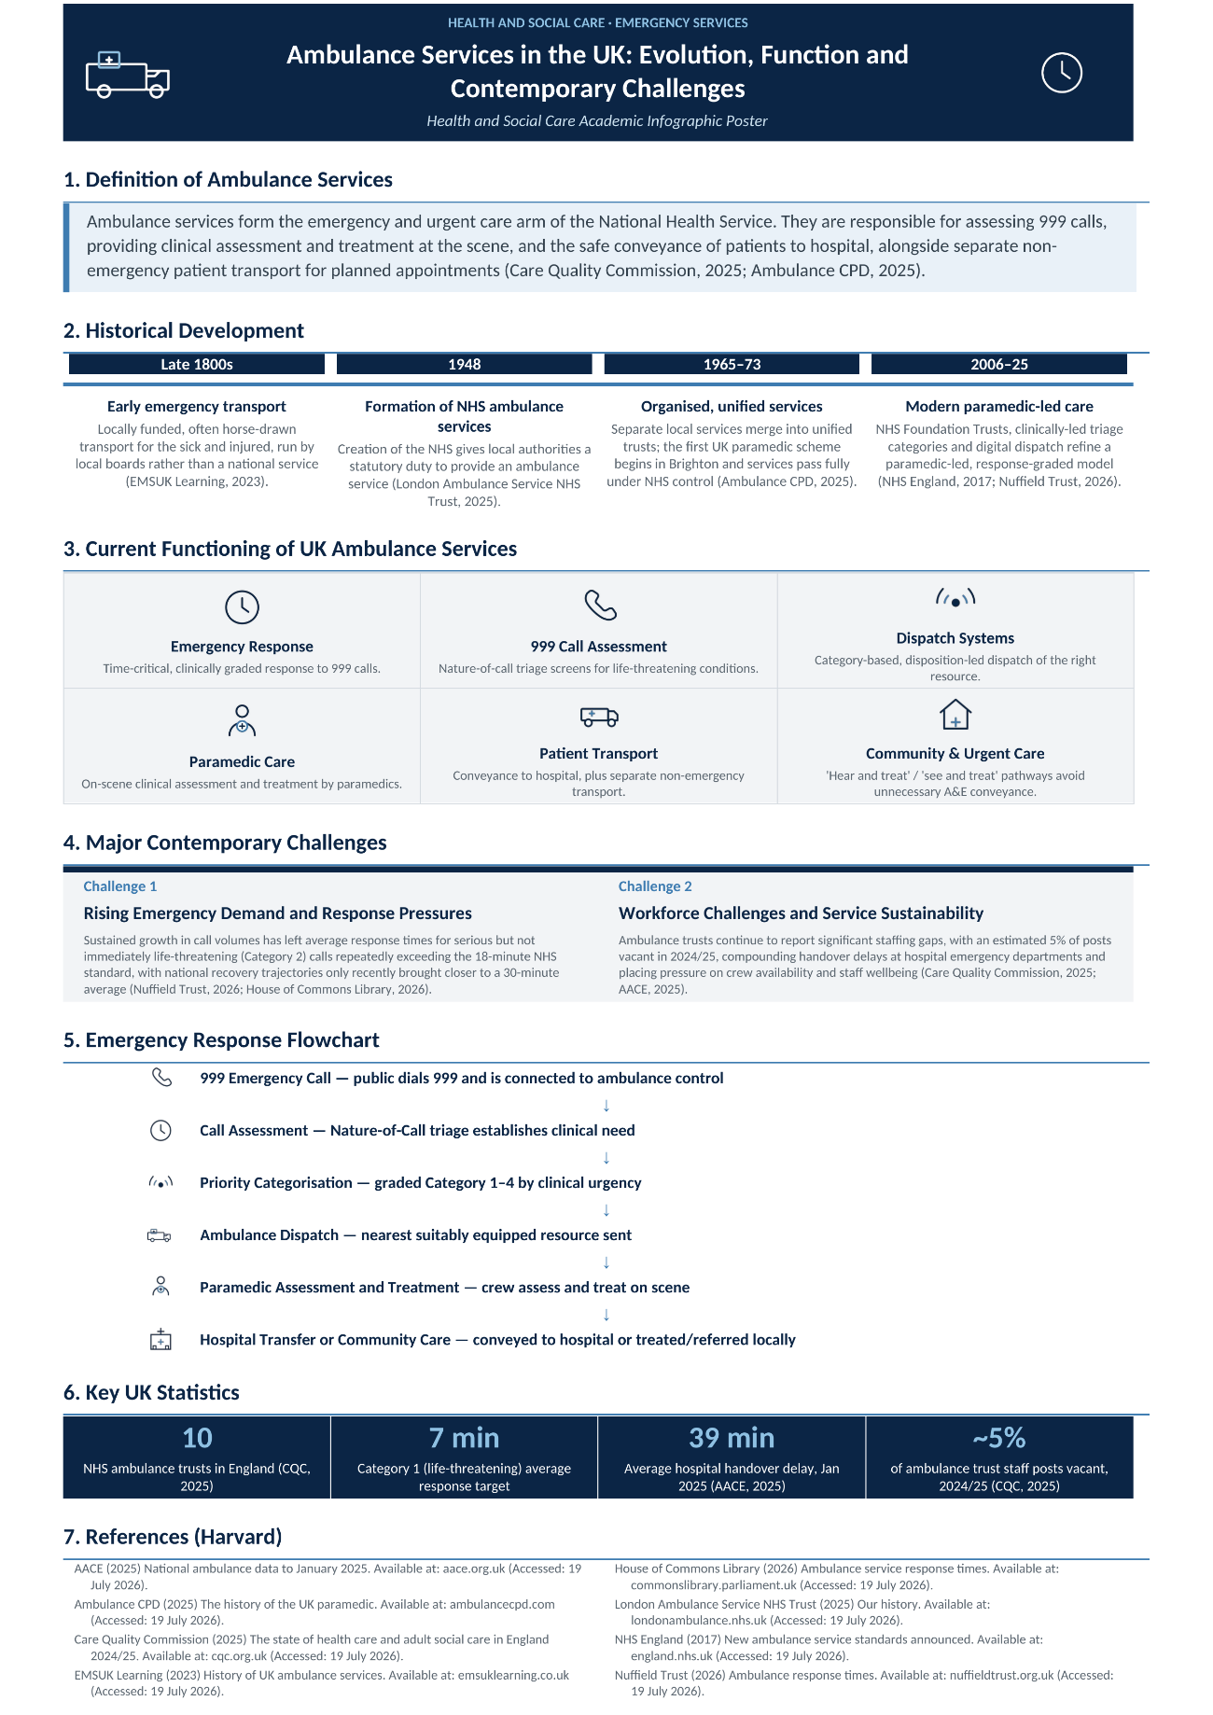

Task 2: Essay

Residential Care Homes in England: Historical Development, Current Provision and Contribution to the Quality of Life of Older People

1. Introduction
Residential care homes provide accommodation, personal care and support to older people and adults unable to live independently (Care Quality Commission, 2025). With England's ageing population growing fastest among the very old, demand for provision is a pressing policy concern (Centre for Ageing Better, 2025). This essay traces residential care's development from the Poor Law to today's person-centred model, arguing that despite substantial reform, funding, workforce and quality challenges mean its potential to safeguard dignity is not yet fully realised.

2. Historical Development
The origins of institutional care in England date to the Elizabethan Poor Law of 1601, later replaced by the harsher workhouse system under the Poor Law Amendment Act 1834 (Thomson, 1983). The Local Government Act 1929 transferred workhouses to local councils, and the National Assistance Act 1948 gave local authorities a statutory duty to provide residential accommodation, laying the sector's legislative foundation (Great Britain, 1948; Thomson, 1983).
Peter Townsend's 1962 study The Last Refuge exposed poor, institutionalised, workhouse-era conditions in many care homes, and helped establish dignity and individuality as guiding principles of residential care (Johnson, Rolph and Smith, 2010).
The sector expanded commercially in the 1980s, was reshaped by the NHS and Community Care Act 1990's needs-assessment requirements, and was consolidated by the Care Act 2014 into a single, rights-based, person-centred framework (Johnson, Rolph and Smith, 2010; Great Britain, 2014).

3. Current Functioning
Residential care in England is delivered mainly by independent and private providers, regulated by the Care Quality Commission (CQC) on safety, effectiveness, care, responsiveness and leadership (Care Quality Commission, 2025). Around 16,500 homes support some 441,000 residents, funded through a mix of local-authority and self-funded placements (carehome.co.uk, 2026). Since 2014, the Care Act's wellbeing principle has required providers to centre residents' views, dignity and outcomes in everyday practice (cpdonline.co.uk, 2025).

4. Critical Evaluation
Judged against CQC standards, residential care performs reasonably well, with around 82 per cent of services rated 'good' or 'outstanding' (The King's Fund, 2026). However, roughly one in six services is rated 'requires improvement' or worse, and quality varies by region and funding model rather than price, suggesting commissioning alone cannot drive improvement (Walsall Council, 2025).
A deeper weakness lies in funding: local authorities negotiate lower fees than providers consider sustainable, so homes cross-subsidise by charging self-funders around 41 per cent more than council-funded residents for the same care (Competition and Markets Authority, 2018, cited in Care Quality and Outcomes Research, 2025). This sits alongside workforce fragility, with Level 2 qualification rates falling to 38 per cent and median pay just £12 an hour, sustaining high turnover despite falling vacancy rates (Community Care, 2025).

5. Importance for Service Users' Quality of Life
Person-centred care is linked empirically to residents' quality of life. A Swedish study found it positively associated with quality of life and negatively with staff job strain, without raising costs (Sköldunger, Sandman and Backman, 2020), while a separate study found it to be an independent predictor of psychological wellbeing across care settings (Lorber et al., 2025).
For residents living with dementia, an estimated seven in ten occupants, consistent staffing and relational continuity are especially protective of dignity, whereas high turnover and rota instability undermine this continuity (carehome.co.uk, 2026; Care Quality Commission, 2025).
Goffman's (1961) concept of the 'total institution' captures the risk that understaffed, routine-driven care can erode residents' identity — a milder version of the conditions Townsend exposed decades earlier — underlining that person-centred values require adequate staffing and continuity to be realised in practice, not just stated in regulation.

6. Conclusion
Residential care in England has moved from the punitive workhouse system to a regulated, rights-based model built on the Care Act 2014's wellbeing principle. Genuine strengths — independent inspection and person-centred commitments — coexist with challenges around funding inequality and workforce sustainability. As demand rises, policy and investment must prioritise workforce stability and relational continuity so that person-centred values are consistently realised in residents' everyday lives.

References
carehome.co.uk (2026) Care home facts & stats: settings, population & workforce. Available at: https://www.carehome.co.uk/advice/care-home-stats-number-of-settings-population-workforce (Accessed: 19 July 2026).
Care Quality and Outcomes Research (2025) Resident funding and care home quality: a retrospective observational analysis of the impact of the two-tier care system in England. Available at: https://pmc.ncbi.nlm.nih.gov/articles/PMC12048780/ (Accessed: 19 July 2026).
Care Quality Commission (2025) The state of health care and adult social care in England 2024/25. Available at: https://www.cqc.org.uk/publications/major-report/state-care/2024-2025 (Accessed: 19 July 2026).
Centre for Ageing Better (2025) Our ageing population: the state of ageing 2025. Available at: https://ageing-better.org.uk/our-ageing-population-state-ageing-2025 (Accessed: 19 July 2026).
Community Care (2025) Proportion of care workers with basic qualifications hits new low following training cuts, shows report. Available at: https://www.communitycare.co.uk/2025/10/15/share-of-care-workers-with-basic-qualification-hits-new-low-following-training-funding-cuts-reveals-report/ (Accessed: 19 July 2026).
cpdonline.co.uk (2025) Care Act 2014 principles: wellbeing and safeguarding principles. Available at: https://cpdonline.co.uk/knowledge-base/care/care-act-2014-principles/ (Accessed: 19 July 2026).
Goffman, E. (1961) Asylums: Essays on the Social Situation of Mental Patients and Other Inmates. New York: Doubleday.
Great Britain (1948) National Assistance Act 1948, c.29, s.21. London: HMSO.
Great Britain (2014) Care Act 2014, c.23. London: The Stationery Office.
Johnson, J., Rolph, S. and Smith, R. (2010) 'Uncovering history: private sector care homes for older people in England', Journal of Social Policy, 39(2), pp. 235–253. Available at: https://doi.org/10.1017/S004727940999064X (Accessed: 19 July 2026).
King's Fund, The (2026) Social care 360: quality. Available at: https://www.kingsfund.org.uk/insight-and-analysis/long-reads/social-care-360-quality (Accessed: 19 July 2026).
Lorber, M., Mlinar Reljić, N., McCormack, B. and Kmetec, S. (2025) 'Person-centred care in association with psychological well-being of older adults', Healthcare, 13(12), 1379. Available at: https://doi.org/10.3390/healthcare13121379 (Accessed: 19 July 2026).
Sköldunger, A., Sandman, P.O. and Backman, A. (2020) 'Exploring person-centred care in relation to resource utilization, resident quality of life and staff job strain – findings from the SWENIS study', BMC Geriatrics, 20(1), article 439. Available at: https://doi.org/10.1186/s12877-020-01855-7 (Accessed: 19 July 2026).
Thomson, D. (1983) 'Workhouse to nursing home: residential care of elderly people in England since 1840', Ageing & Society, 3(1), pp. 43–69. Available at: https://www.cambridge.org/core/journals/ageing-and-society/article/abs/workhouse-to-nursing-home-residential-care-of-elderly-people-in-england-since-1840/7017A7AA3A8D48DB2FA13AA65B115B25 (Accessed: 19 July 2026).
Walsall Council (2025) Residential and nursing care market position statement 2025–2040: quality and cost. Available at: https://go.walsall.gov.uk/health-and-social-care/adult-social-care-commissioning/adult-social-care-market-position-statements/adult-social-care-market-position-statements/residential-and-nursing-care-market-position-statement-2025-2040/current-supply/quality-and-cost (Accessed: 19 July 2026).

