Tapi Matuwi (1503524)
[Company name] | [Company address]
Business Intelligence System – Assignment 2
[Document subtitle]

Table of Contents
1.0 Introduction 2
2.0 The data 2
3.0 Design 2
4.0 ETL Process 3
5.0 Update Queries 4
6.0 Entity Relationship Diagram 4
7.0 Star Schema 5
8.0 Reports 5
Expense Type 6
Expense Area 7
Suppliers 10
Dashboard 12
Data Governance Policy 13
8.1 Standards 13
8.2 Strategy 13
9.0 Data Quality 14
10.0 Privacy 14
10.1 Compliance 14
10.2 Security 14
11.0 Data Architecture 14
11.1 Data Integration 15

1.0 Introduction

This report will focus on how the data warehouse s created from the data acquired from the DECC. There will be a description of how the data was when it was acquired to when it goes through the ETL process where the data will go from a spreadsheet into a data warehouse. Within this report there will be an area showing reports that were created from using the data warehouse. There will be a dashboard example of what one could look like based on the report that has been created. There will be an area in the report that looks at the data governance and the impact it will have on DECC as an organisation and solutions for the problems that crop up. The problems will cover things like the policy, strategies, and standards. There will be other things that will be discussed like the quality of the data, privacy, compliance and security. The final stages of the report will look at data architecture and integration.

2.0 The data
The data that DECC is using is being kept in a spreadsheet. This information will be transformed into a data warehouse. The data that is in those spreadsheets contains information the departments and dates of when payment were made. There is also an expense type that shows which are of the company the payment was made and it shows the group that was responsible for the payment. Within the spreadsheet there is also a list of suppliers, transaction number which are taken note of when a transaction has been made and also shows the amount of money that was spent. All of this information will be used and converted into a data warehouse from the spreadsheet. The spreadsheet will act as a fact table and dimensions for different entities will be made. There will also be a measure within this data which will be the amount and it’s the only measure.

3.0 Design
For the design process a star schema diagram will be created. A star schema is seen as the easiest data warehouse schema. It has the name star schema because the diagram resembles a star, and it has points coming from the centre. A start schema has a fact table and the point coming from the centre are the dimension tables. A star schema has the fact tables in their third normal form whereas the dimensional tables are de-normalised. The fact tables in a star schema typically have two types of columns, the foreign keys that link to the dimension tables and measures that have numeric facts. There is a connection between a fact table and the dimensions and they are connected by a primary key, a primary key is a unique key that is found in each table. (1)

An ETL document was also created after the creation of the data warehouse. The ETL document contains a list of the dimensions and fact tables which are created from the data acquired from the star schema. The ETL will state where the data can be found and what happens to the data when it is added to the database. It also shows what to do when data is missing and where there is incorrect data. The ETL document is found in the Appendix.

A data warehouse is a collection of corporate information and data that is taken from operational systems and external data sources. A data warehouse is designed to help make business decisions by allowing data consolidation, analysis and reporting. (2) A data mart is a set of data that is sored within a data warehouse that be then used by a specified team, section or a department inside the organisation. (3) When the spreadsheet was added to the database a new row was also added to each table with a list of ID and that replaced the word within the fact table to the related ID number set in the table. In order to carry this out there were queries used in each of the new tables and the update query was made to change the word in the field with the ID number from the table that the data was from.

4.0 ETL Process
ETL stands for Extract, Transform, and Load, these are database function that are put together as one and uses as a tool that pulls data out of one database into another database. The first step is to extract, this processing consist of reading the data from the database. At this point the data is collected and this can be from many and different sources. The second part is transforming and in this process the extracted data is converted into a form that it needs to be in order for it to be moved to another database. Transformation is done by the use of rules or lookup tables or the combination of data with other data. The last process is the load process and this is the process of writing the data into the intended database.

In regard to the data obtained from the DECC the extraction part is where the data is gathered and out into a single spreadsheet and then it is cleaned once that is done. During the cleaning of the data it is important to make sure that all of the data is filled out and if it is not then the blanks would need filling or get rid of the missing data. There was some missing information in one from the spreadsheets provided and the empty fields where labelled as unknown. The process of cleaning the data it would need to be checked that every field in the table contains data and all the missing values are added and fields containing no information are removed in the spreadsheet but this depends on the data type in the ETL table. In the group entity there changes made from N/A to unknow because it would be better to display just in case there more fields that need to be entered this way. The supplier had many missing fields and these were replaced with unknow text. When the cleaning of the data was complete the main table transformed into a fact table. At this point the attributes in their own dimensions table has their own primary keys. The last part of this process was to transfer the data from the spreadsheet to the access database. When this was done the fact table was updated using queries to replace the fact table data with the primary key from the dimensions table. The payment table was being updated, the data type of the table was changed from date/time to number in order for the payment ID to override the dates that were shown.

5.0 Update Queries

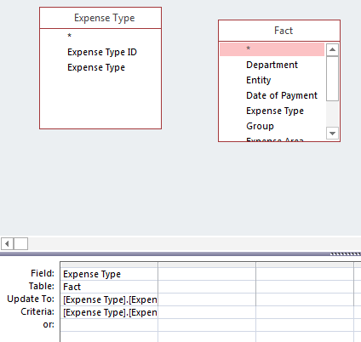
Update queries were used for every dimension table. In the image below ‘Figure 1’ the query that is shown is the image below changes the expense type field in the fact table after retrieving the data from the expense type table. The second image labelled ‘Figure 2’ show the results of a successful query after it has been ran. It reflects the number of rows that have been updated.

Figure 1: Query Example
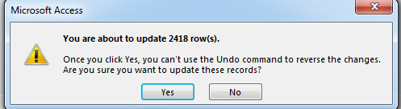

Figure 2: Query Update

6.0 Entity Relationship Diagram

An entity relationship diagram or ERD of the data ware house was created when all the data was put in to the database. The image below ‘Figure 3’ shows an example of the ERD that was created.

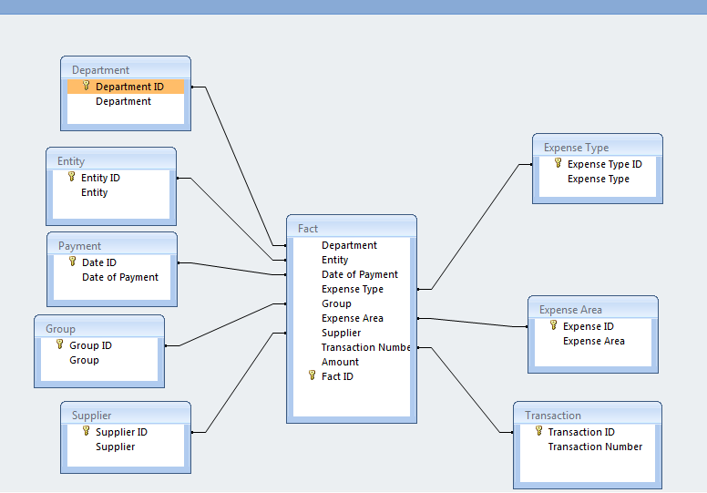
Figure 3: ERD

7.0 Star Schema

Star Schema design of the data ware house is shown in the image below ‘Figure 4’. The image shows the dimension tables and their relationship with the fact table.

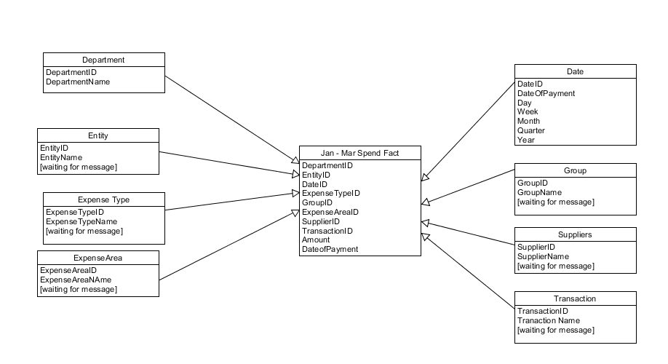
Figure 4: Star Schema Diagram

8.0 Reports

All the report that are going to be shown in this section of the report have been created using the tableau. The reports generated are the top 5 expense types for each quarter of the year using the months of January, February and March by amount. There will also be other reports done like this for the expense type and the suppliers. The first report that is generated is going to show the data on the top 10 expense types for each month and shows the spending as well. There will be filters added to the expense type and this will allow the graph to list only the top 10 expense types. The data of payment is applied as a filter to be able to see quarters and the months. The bars on the graph reflect the amount that was spent by the expense type during the time that was selected.

Expense Type

Figure 5 reflect on the amount spent during the quarter and the highest expense type was the Grant in aid payments at 859,675,563 and the lowest was the Cash Expenditure during the year – British Energy which was at 4,310,898.

When the quarter total spend the filter can be changed to show just the months on their own, this allows the user to see the data for that month alone. In the image below the January spend is shown along with the expense types. The graph shows that the highest amount in regard to the expense type for this month is 268,189,474, this is for the Grant In Aid Payment expense type. The lowest was at 230,654 which was the Grants to Overseas Expense type.

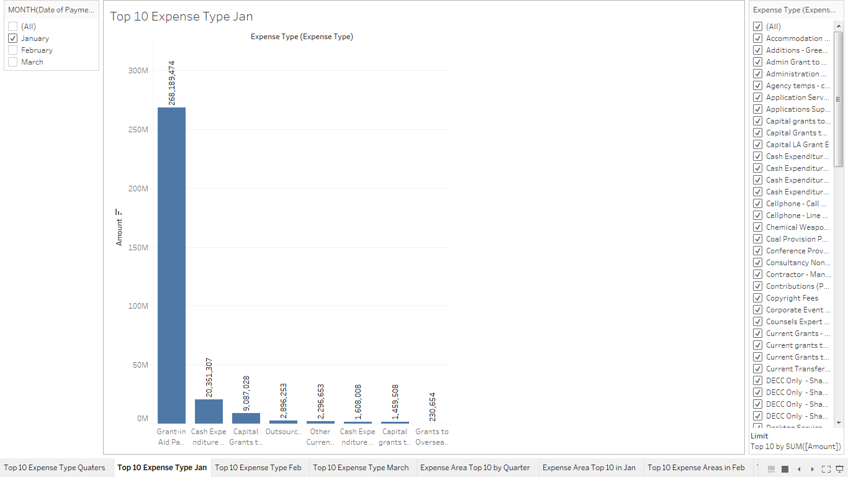

Figure 6: Top 10 Expense Type in January

In the month of February the highest amount was at 313,488, 596 which is a lot more when compared to the highest amount of January. After the 5th Expense type in February the amount was below 2,000,000 whereas in January is the first five were all above 2,000,000.
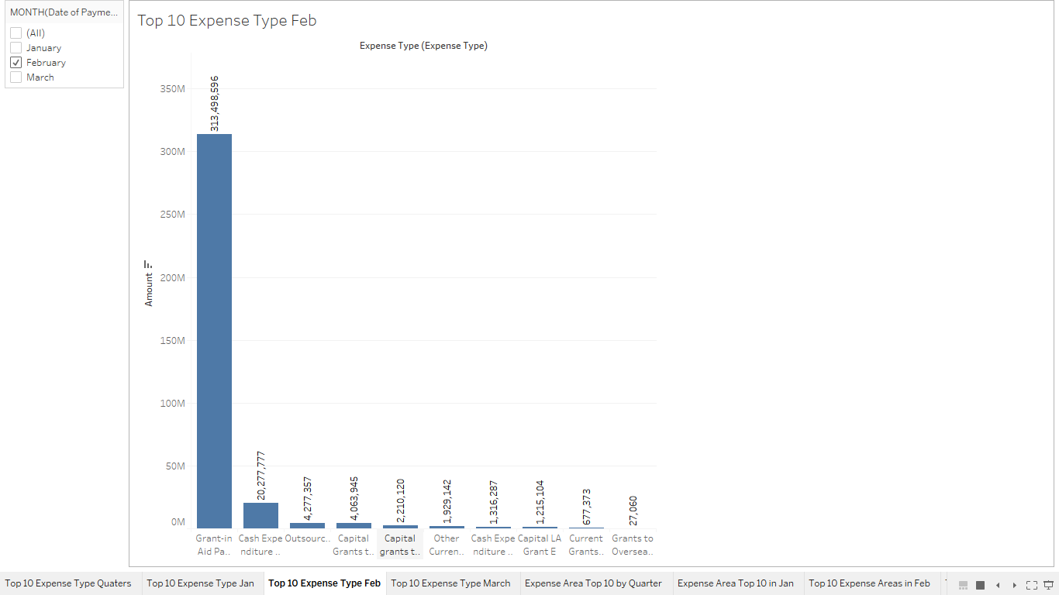

Figure 7: Top 10 Expense Type in Feb

In march the Grant in aid decreased to 277,987,483 compared to the 313,488, 596 that it was in the previous month of February. The month of March differs from all of the other months because the top 9 expenses are all above the amount of 2,000,000.

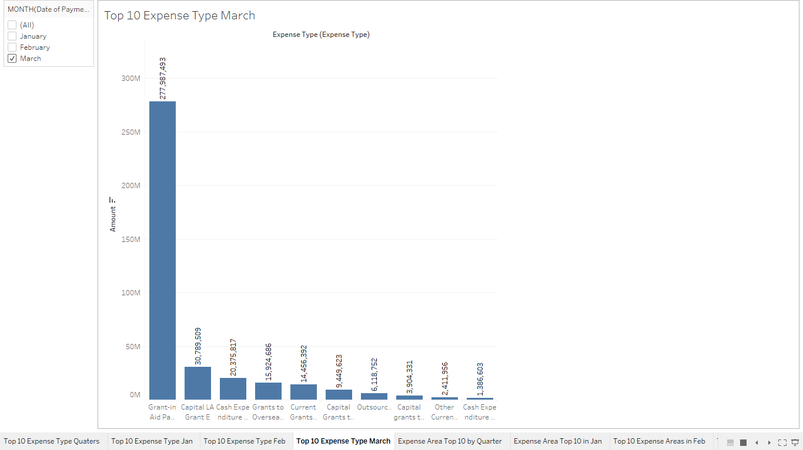

Figure 8: Top 10 Expense type in March

Expense Area

This image show the top 10 expense areas and the amount that was spent in the first quarter of the year. The top three expense area all stand out in comparison to the rest because of the amounts that they hold.

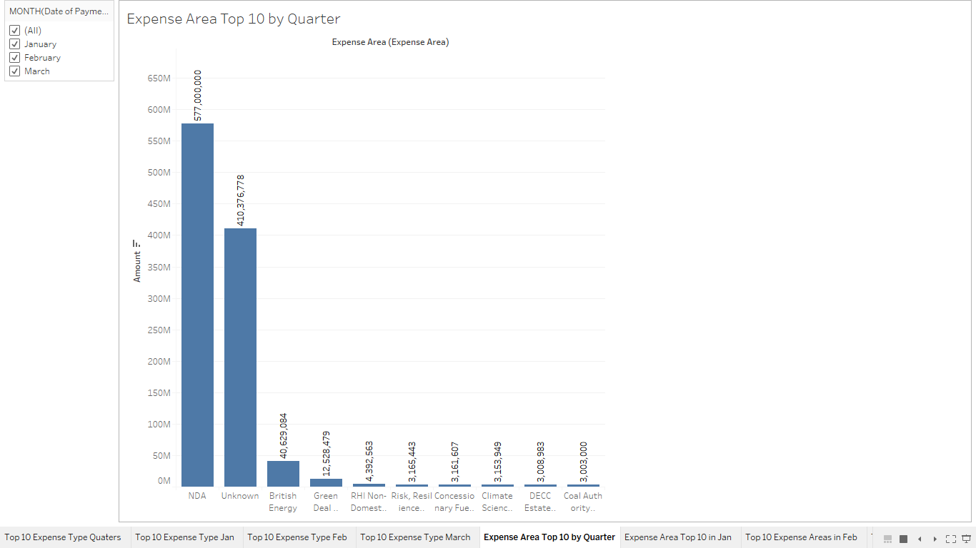
Figure 9: Top 10 Expense Area by Quarter

In the month of January in the expense are NDA holds the biggest amount with 266,000,000. Th rest of the expense areas decrease in amounts and they go below 2,000,000 after the top 3.
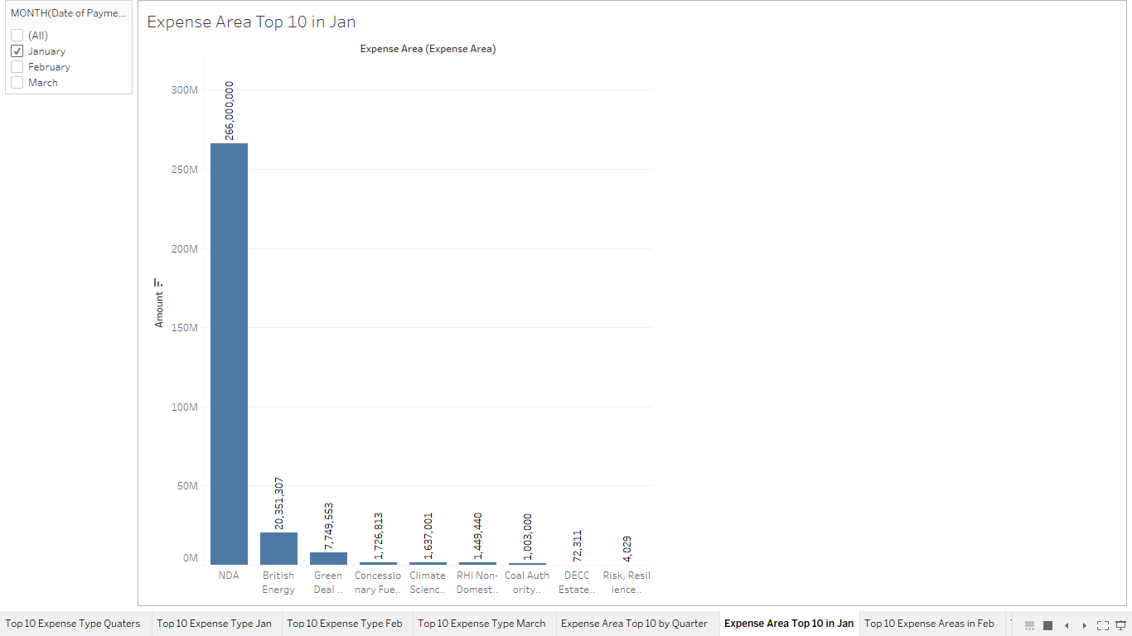

Figure 10: Top 10 expense Area in Jan

The month of February shows a lot more spending by NDA at 311,000,000 compared to the previous month.
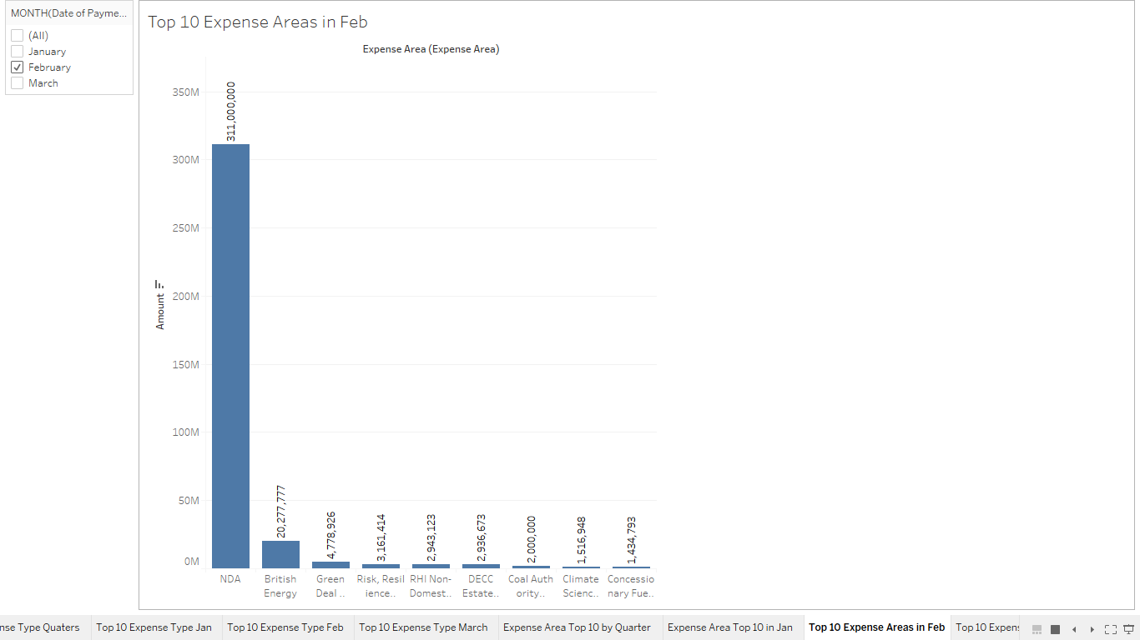

Figure 11: Top 10 expense Area in Feb

In march the name of the supplier wasn’t filled out in the database so it was given the name unknown. There was a payment of 410,376,778 in this month from an unknown expense area.
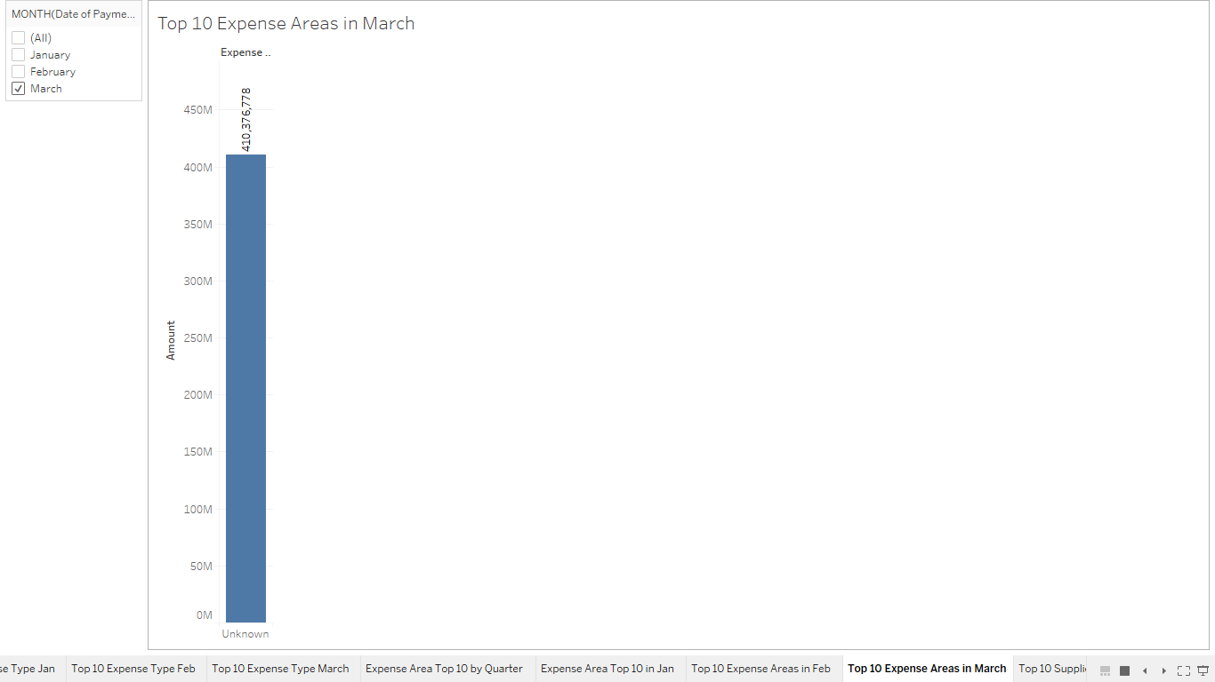
Figure 12: Top 10 expense Area in March

Suppliers
The final analysis that will be carried out will be on the supplier and the amount that was spent by each area in the first quarter. The highest amount from the top 10 of this quarter was 896,110,748 which was by the Nuclear Decommission supplier. This is a really high amount when compared with the rest of the suppliers because the rest are 14,000,000 and lower.
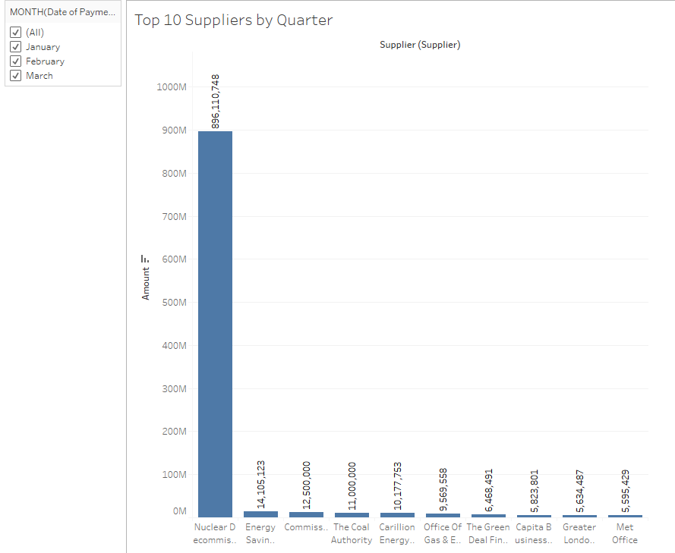
Figure 13: Top 10 Suppliers by Quarter

In the month of January the Nuclear Decommission supplier hold the largest amount at 286,427,992. Compared to the rest of the supplier this figure stands out because the rest of the supplier are below 6,000,000.

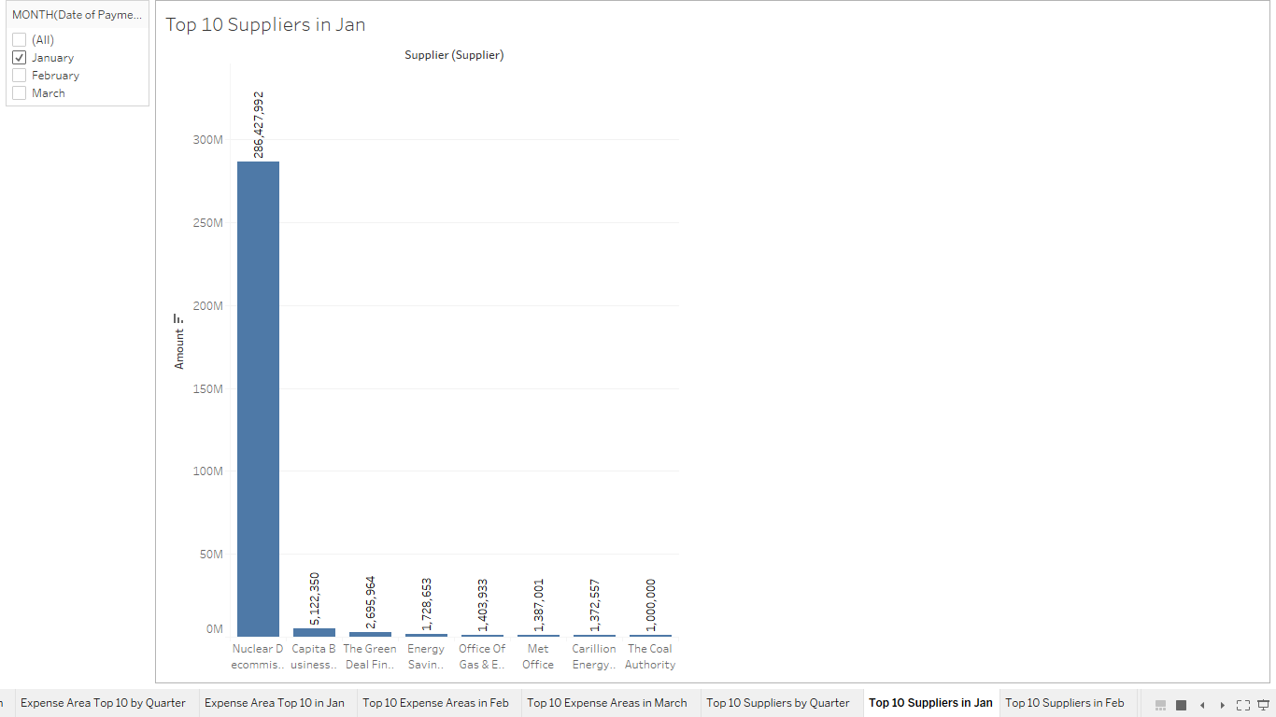
Figure 14: Top 10 Supplier in Jan

In the month of February the amount of the Nuclear Decommission supplier rises to 331,288,277. The rest of the supplier amount decreased to below 4,000,000.
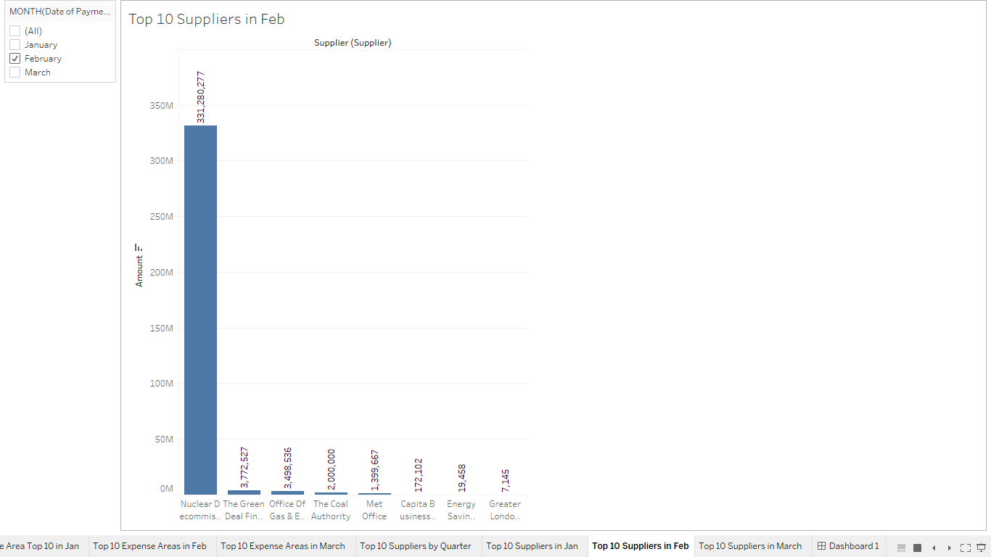
Figure 15: Top 10 Supplier in Feb

In march the was a slight decrease in the amount spent of the Nuclear Decommission supplier to 278,402,478. However there was an increase in the rest of the suppliers in terms of the amount of spend.
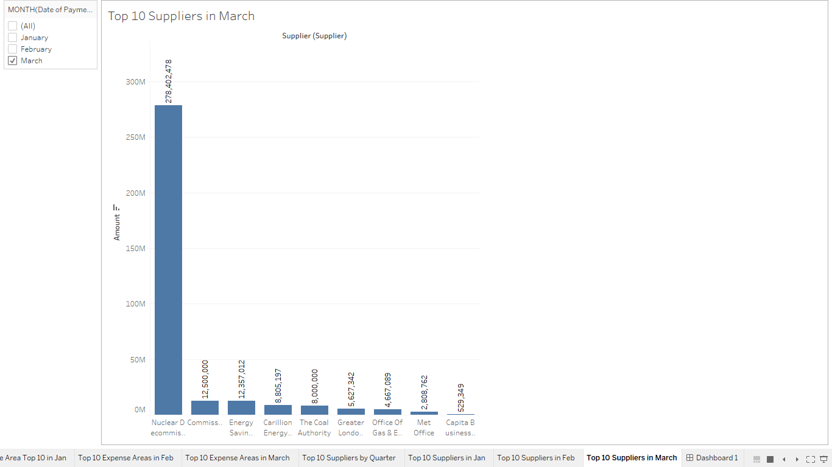
Figure 16: Top 10 Supplier in March

Dashboard

The dashboard is a combination of the three quarters and the three different area which are the expense area, expense type and the suppliers. All of this data is shown on one page as shown in the image below. Using the dashboard the use is also able to switch to different months of the quarter to show the data.
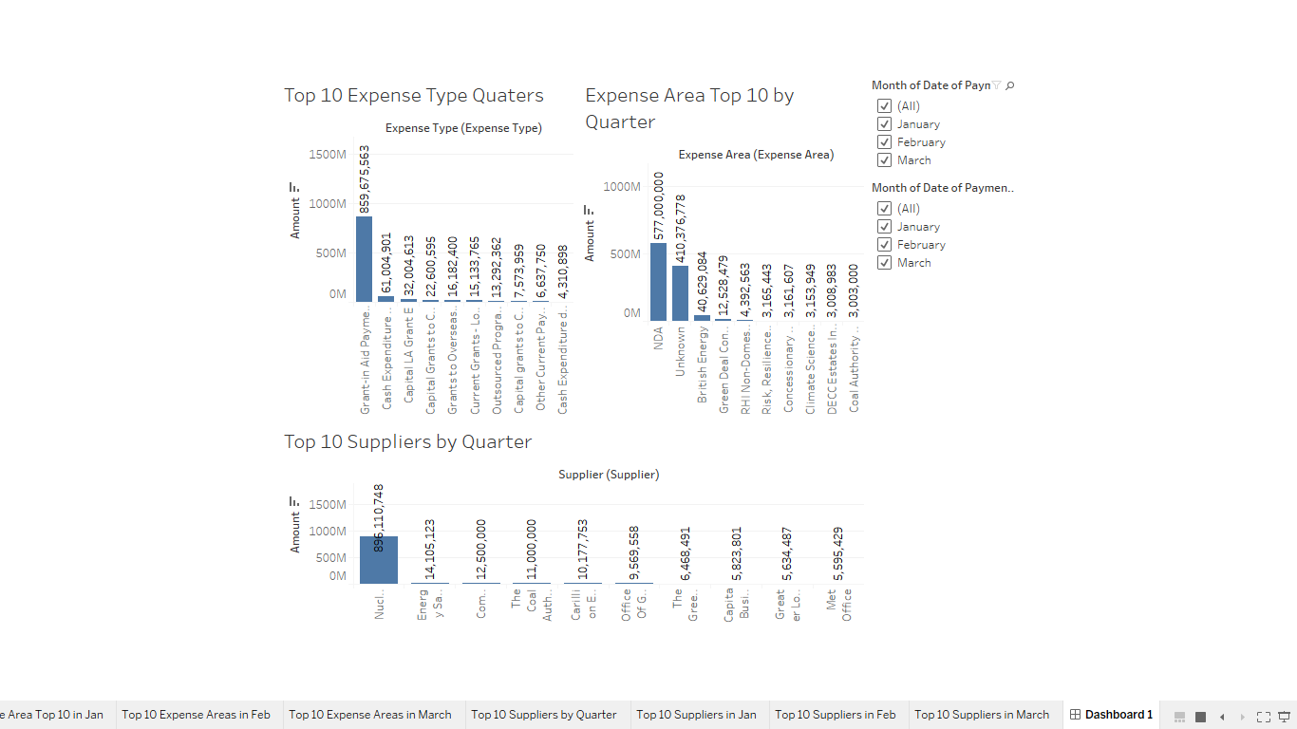
Figure 17: Dashboard

Data Governance Policy

The data governance policy is a document that contains guidelines that makes sure that the organisations digital information is managed properly. Such guidelines include policies for business process management and enterprise risk planning, they also include security, data quality and data privacy. The guidelines outline how business activity monitoring should be done so that the organisation data is correct, accessible, protected and consistent. The policy states the individual that is responsible for the information in different circumstances and see out what procedure should be done to manage it. (4)

Data governance is the management and oversight of an organisations assets to assist in giving the users of the business high quality data that they can access easily. Data governance looks at high level policies and procedures, data stewardship looks at tactical coordination and implementation. The role of a data steward is to carry out data usage and security policies as determined through the enterprise data governance initiatives, and it works as a link between the IT department and the business side of the organisation. (5)

DECC could use a data steward, with one in the organisation they are able to ensure that the information that is collected is accurate, consistent, protected and accessible. A data steward is also able to when they are collecting data they can look at what it is, how it is going to be acquired and what actions to take when there are issues and incorrections. The steward is able to help with ensuring that the all of the data that is being stored goes with what is in the data governance policy and they can also guide other employees on how to use the data.

8.1 Standards
Organisation standards are set in a company outline how the business should be conducted and govern what seen as acceptable behaviour in a workplace. An example of a standard in an organisation could be when the phone rings three times it has to be answered. A company will establish standards in relation to things like customer service, code of conduct or human resource issues. (6)
A set of standards can be established within DECC to make sure that the employees within the organisation follow the policies in order to protect the data that they are dealing with.

8.2 Strategy
A strategy is a type of methods that is made use of when looking to achieve a goal or to solve a problem. (7) DECC can put in a strategy into the business by making use of the data governance by putting up a mission statement that lists their aims and the things they would like to achieve as an organisation. The can also put in a strategy for different user to have access to different information so that certain users can only see the information they’re in need of. They can also make sure that they place a data steward in different departments to help others make use of the data they need.

9.0 Data Quality
Data quality is the assessment of how fit data is to see if it can serve its purpose in context. There are different aspect of data quality and they include things like accuracy, completeness, update status, relevance, consistency across data sources, reliability and accessibility. In DECC can upgrade their quality of their data by having a data cleanser and this finds any problems within the data. The could also have a data scrubber that is able to take away duplicated data so that it looks better when it is presented. (8)

10.0 Privacy

DECC have to ensure that the employees of the company have a method of taking away data that they no longer need or have it removed by the person or company making the request. A way they could carry this out is to a form to fill out in order to have data removed when requested. The data collected on a person or another company should not be passed on to another organisation or person without the holder of the data’s consent. For any data that is gathered there need to be reasons as to why that data is being used and what it is being used for.

10.1 Compliance
The General Data Protection Regulation must be completed before 25 May 2018, when it supersedes the UK Data Protection Act 1998. DECC will need to put in place policies and procedures that are clear and ensure that all the people involved agree. (9)

10.2 Security
Data security refers to protective digital privacy measures that are put in place to stop unauthorised access to computers, databases and website. Data security protects data from corruption as well. Data security is very important to IT within an organisation of any size and any type. (10) There are different way to secure data, DECC could assign different data accessibility for different user so that those user only see the data that they are supposed to see. Another way to secure data is to encrypt it.

11.0 Data Architecture
Data architecture deals with the designing and constructing data resource. Data architecture gives ways to design, construct and implement a fully integrated, business driven data resource that has real world objects and events. (11) For the data warehouse that was created earlier in the report there are images of the ERD and the star schema models that were used to make the data warehouse for DECC.

11.1 Data Integration
Data Integration is a combination of technical and business processes that are used to put together data from disparate sources into meaningful and valuable information . A complete data integration solution delivers trusted data from a number of sources. (11) DECC are able to combine their system with the data warehouse in order for all different areas of the company to be able to access the data. Data marts can be created for different areas of the company in order to do this, this can stop them accessing only what they need the system for.

12.0 Appendix

ETL Plan - Northwind Data Warehouse
Analyst(s):Tapiwanashe Matuwi
Database to data warehouse table mapping:

DATABASE TABLES | DATA WAREHOUSE TABLE
DECC Spreadsheet | Fact
DECC Spreadsheet | Department  Entity
DECC Spreadsheet | Payment Date
DECC Spreadsheet | Expense Type
DECC Spreadsheet | Group
DECC Spreadsheet | Expense Area
DECC Spreadsheet | Supplier
DECC Spreadsheet | Transaction Number

Database to data warehouse attribute mapping

Fact Table

TARGET ATTRIBUTE | SOURCE(S) | PROCESSING REQUIRED | MISSING VALUE? | INCORRECT VALUE?
Entry ID | PK | Auto
Department ID | DECC spreadsheet | Linked to department dimension PK | 1 ( = Unknown)
Entity ID | DECC spreadsheet | Linked to Entity dimension PK | 1 ( = Unknown)
Expense Type ID | DECC spreadsheet | Linked to Expense Type dimension PK | 1 ( = Unknown)
Group ID | DECC spreadsheet | Linked to Group dimension PK | 1 ( = Unknown)
Expense area ID | DECC spreadsheet | Linked to Expense area dimension PK | 1 ( = Unknown)
Supplier ID | DECC spreadsheet | Linked to Supplier dimension PK | 1 (= Unknown)
Transaction number ID | DECC spreadsheet | Linked to Transaction number dimension PK | 1 (= Unknown)
Amount | DECC Fact | None Required | -999 (= Unknown) | Refer to Human
Payment date ID | DECC spreadsheet | Linked to Payment date dimension PK | 1 ( = Unknown)

Entity Table

TARGET ATTRIBUTE | SOURCE(S) | PROCESSING REQUIRED | MISSING VALUE? | INCORRECT VALUE?
Entity ID | PK | Automatically generated
Entity Name | DECC spreadsheet Entity | none | “Unknown”

Department Table

TARGET ATTRIBUTE | SOURCE(S) | PROCESSING REQUIRED | MISSING VALUE? | INCORRECT VALUE?
Department ID | PK | Automatically generated
Department name | DECC spreadsheet Department_ | none | “Unknown”

Expense Type Table

TARGET ATTRIBUTE | SOURCE(S) | PROCESSING REQUIRED | MISSING VALUE? | INCORRECT VALUE?
Expense Type ID | PK | Automatically generated
Expense Type | DECC spreadsheet Expense Type | none | “Unknown”

Payment Table

TARGET ATTRIBUTE | SOURCE(S) | PROCESSING REQUIRED | MISSING VALUE? | INCORRECT VALUE?
Payment Date ID | PK | Automatically generated
Date of payment | DECC spreadsheet payment | none | “Unknown”

Group Table

TARGET ATTRIBUTE | SOURCE(S) | PROCESSING REQUIRED | MISSING VALUE? | INCORRECT VALUE?
Group ID | PK | Automatically generated
Group name | DECC spreadsheet Group | none | “Unknown”

Expense Area Table

TARGET ATTRIBUTE | SOURCE(S) | PROCESSING REQUIRED | MISSING VALUE? | INCORRECT VALUE?
Expense area ID | PK | Automatically generated
Expense area | DECC spreadsheet Expense area | none | “Unknown”
Transaction Number

TARGET ATTRIBUTE | SOURCE(S) | PROCESSING REQUIRED | MISSING VALUE? | INCORRECT VALUE?
Transaction number ID | PK | Automatically generated
Transaction number | DECC spreadsheet Transaction number | none | “Unknown”

Supplier Table

TARGET ATTRIBUTE | SOURCE(S) | PROCESSING REQUIRED | MISSING VALUE? | INCORRECT VALUE?
Supplier ID | PK | Automatically generated
Supplier name | DECC spreadsheet Supplier | none | “Unknown”

13.0 References

- Datawarehouse4u.info. (2018). Data Warehouse Schema Architecture - star schema. [online] Available at: http://datawarehouse4u.info/Data-warehouse-schema-architecture-star-schema.html [Accessed 3 May 2018].
- Techopedia.com. (2018). What is a Data Warehouse (DW)? - Definition from Techopedia. [online] Available at: https://www.techopedia.com/definition/1184/data-warehouse-dw [Accessed 3 May 2018].
- Sisense. (2018). What is Data Mart? - BI Glossary | Sisense. [online] Available at: https://www.sisense.com/glossary/data-mart/ [Accessed 3 May 2018].
- SearchCompliance. (2018). What is data governance policy ? - Definition from WhatIs.com. [online] Available at: https://searchcompliance.techtarget.com/definition/Data-governance-policy [Accessed 3 May 2018].
- SearchDataManagement. (2018). What is data stewardship? - Definition from WhatIs.com. [online] Available at: https://searchdatamanagement.techtarget.com/definition/data-stewardship [Accessed 3 May 2018].
- Sielearning.tafensw.edu.au. (2018). Organisational Standards. [online] Available at: https://sielearning.tafensw.edu.au/toolboxes/toolbox316/ip/ip_c21.html [Accessed 6 May 2018].
- Sielearning.tafensw.edu.au. (2018). Organisational Standards. [online] Available at: https://sielearning.tafensw.edu.au/toolboxes/toolbox316/ip/ip_c21.html [Accessed 6 May 2018].
- SearchDataManagement. (2018). What is data quality? - Definition from WhatIs.com. [online] Available at: https://searchdatamanagement.techtarget.com/definition/data-quality [Accessed 6 May 2018].
- Techopedia.com. (2018). What is Data Security? - Definition from Techopedia. [online] Available at: https://www.techopedia.com/definition/26464/data-security [Accessed 6 May 2018].
- Team, E. (2018). What is Data Architecture | Online Learning. [online] Learn.geekinterview.com. Available at: http://www.learn.geekinterview.com/data-warehouse/data-architecture/what-is-data-architecture.html [Accessed 7 May 2018].
- Ibm.com. (2018). Data Integration | IBM Analytics. [online] Available at: https://www.ibm.com/analytics/data-integration [Accessed 7 May 2018].

