Create a reflective personal development plan (PDP) that includes personal and professional aims to help develop your professional practitioner skills, including a personal reflection
What do I know already: Recording targets will highlight areas for improvement and help to identify the avenues needing to be taken to achieve them. Having targets improves practice.
What have I learnt so far: Realistic targets and time frames is essential.to complete successfully.
What do I want to develop: A deeper knowledge and delivery of each area for development.
My Professional working practices. Confidence within the Welsh language and Culture. Use of digital skills to support my work and practice.

Objective / Gwrthrychol | Actions (How will I achieve this objective/ what needs to be done?) | Resources (What support and resources are needed to achieve this objective?) | Target Date for achieving objective | Success criteria (How will I know I have achieved this goal, how will I review this?)
Manage my time in order to complete academic work for ongoing degree. | Form an effective routine to compliment my personal time and ensure completion of work is achieved.  Combine other effective study skills into practice to achieve target.  Organise work concisely. | Online calendar to highlight key dates for handing in work.  Make use of study time to plan what needs to be prioritised.  Seek out advise if finding that it is becoming difficult.  Source relevant materials to support academic work.  Moodle.  Hub.  Online library.  Podcasts platforms.  TED talk platforms. | July 2025 | Continuous review will need to take place to assess how effectively my time management skills are developing and being put into practice over the course of the 2-year degree (alter if necessary).  Displayed through quality shown in assignment grading, as well as overall degree grading.
Continue to develop my planning and delivery of lessons for current HLTA role in work. | Attend regular planning meetings to understand what needs to be included within lessons.  Regular team meetings to discuss any areas that require attention or development.  Follow policy and procedures to create appropriate planning documents  Regularly assess my personal planning documents. | Refer to planning policy.  Use most current planning documents.  Refer back to previous planning documents – to support further development of childrens learning.  Liase with colleagues to include a clear and hollistic approach.  Curriculum for Wales document  Four Purposes document.  AOLE documents.  Hwb | Ongoing for duration of current role. | Regular observations of my teaching – referring back to my planning documents to ensure all elements are included and accounted for.  Termly progress reports and monitoring.  Targets of learning being met and curriculum requirements included in planning.
Work alongside local consortia to complete my HLTA assessor accreditation | Attend assessor training to gain information of how to follow assessment protocol.  Positively implement training into assessing periods.  Attend regular update training to allow most current methods are being used within my practise.  Liaise with EAS practitioners to reflect on my progress and completion of the training, including the quality of my assessing ability. | Online training sessions.  Assessor guidence handbooks.  Documentation required for assing candidates.  Curriculum for Wales document.  Standards for assisting teaching document.  Four Purposes document.  AOLE documents.  Hwb | Ongoing for the duration of the role. | Confirmation of those leading the training.  Regular monitoring of my practise though National and Regional moderation sessions.  Reflecting on my practice, altering if necessary and staying up to date with current procedures.
Continue to develop my Welsh language knowledge and further implement it within my working role. Including broadening knowledge on Welsh culture. | Work alongside Welsh Co-Ordinator to ensure correct use of Welsh.  Seek out further courses to expand my Welsh language skills.  Become more involved with Welsh activities and events within the school.  Make links with the local and wider community to develop knowledge of Welsh culture. | Planning documents to inform my planning and delivery of Welsh sessions.  Up to date educational videos to ensure correct pronunciation of the Welsh language.  Attend refresher training courses.  Attend higher level training courses for continuation of progression.  Refer to Curriculum for Wales documents. Hwb. | Ongoing
Complete Team Teach training to support my responsibilities in my professional role. | Attend training to understand how to positively manage any challenging behaviours and how to safely work within my role.  Implement in professional role if necessary to ensure safety of children and colleagues. | Attend Team Teach training.  Seek support from colleagues to ensure correct use of training is implemented.  Seek advise to know when best to use training within my practice.  Policies and procedures ensuring correct use of training.  Correct recording of when, why and in what way the training is used. | December 2023 | Confirmation of course completion.  Reviewing team teach methods within my practice.  Safety and security needs of all children and adults accounted for.

Design a briefing paper that explores the importance of reflective practise within the early years and analyses different reflective models.
What is reflection and reflective practise?  (SCHUTZ, S 2007) hints that reflective practice is a key tool to support all practitioners within their current practice. Suggesting that by assessing, or identifying, areas for improvement and implementing those changes, can benefit and aid future practice. Further implying reflection is being self-critical and acknowledging that there may be aspects of your practise that requires attention.  The University of Hull (2023) highlights that “reflection is an important part of learning through experience.” Thus, giving the impression that you need to continuously look back to previous practice to critique the negative elements and refresh them into more positive modes of learning – progressing your knowledge of self-development. | Why is reflective practise important to EY practise?  (Brock, 2015) Suggests that for reflection to be used successfully, practitioners need to assess the needs of those in their care. Further suggesting that if those needs are not catered for then the use of reflection is null and void, resulting in poor personal practice. Children within Early years have revolving needs that grow as they do. Reflecting on those changes will allow the practitioner to suit learning experiences into the environments, influencing the first stages of a young child’s life.  (Education, 2021) Acknowledges this, relating the importance of reflective practice to achieving positive experiences for young children - suggesting that it provides them with desired developmental success.  Previously quoted, from The University of Hull (2023), further implies that reflective practice is important to achieve professional success – not only for personal accreditation but for the development and well – being of the children within your care. In Early years this can suggest that success presents itself as meeting providing young children with the opportunity to learn and develop without restrictions, as practice is continually revised and altered according to the child’s needs. This, resulting in the professional practitioner’s success within their role as well as the children’s well-being considered.
The theory of reflective practise:
The Open University (no date) outlines that there are many theories relating to reflective practise – all of which suggest that it is an essential part of a practitioner’s role. The Open University (no date) continues to suggest that the theories behind reflective practise require careful consideration as they pose some difficulties.
Schon’s theory (1983) cited in Iriss (no date) suggests that reflection should take place “in action and on-action.” He hints that this is the most effective way as you alter practice as you move through an experience to best suit the needs of whomever is involved, arguing the counter “on-action” provides opportunity to assess the outcome of the “in-action” reflection. Resulting in a continuous “improvement” of successful reflective practice method.
Whereas Dewey’s theory uses the notion that you “learn by doing.” Dewey (1933) cited in Structural Learning (2023). It suggests that we learn through experiences and consciously reflect on practice as it happens; supporting the benefits of reflective practice to cater to the environment or leaning experience.

Gibbs’ model  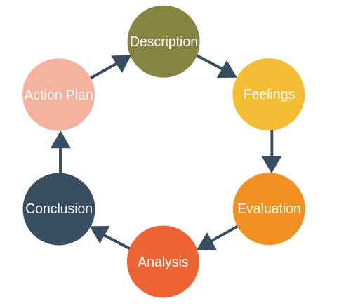  Gibbs’ Reflective Cycle (1988) | Jasper’s model  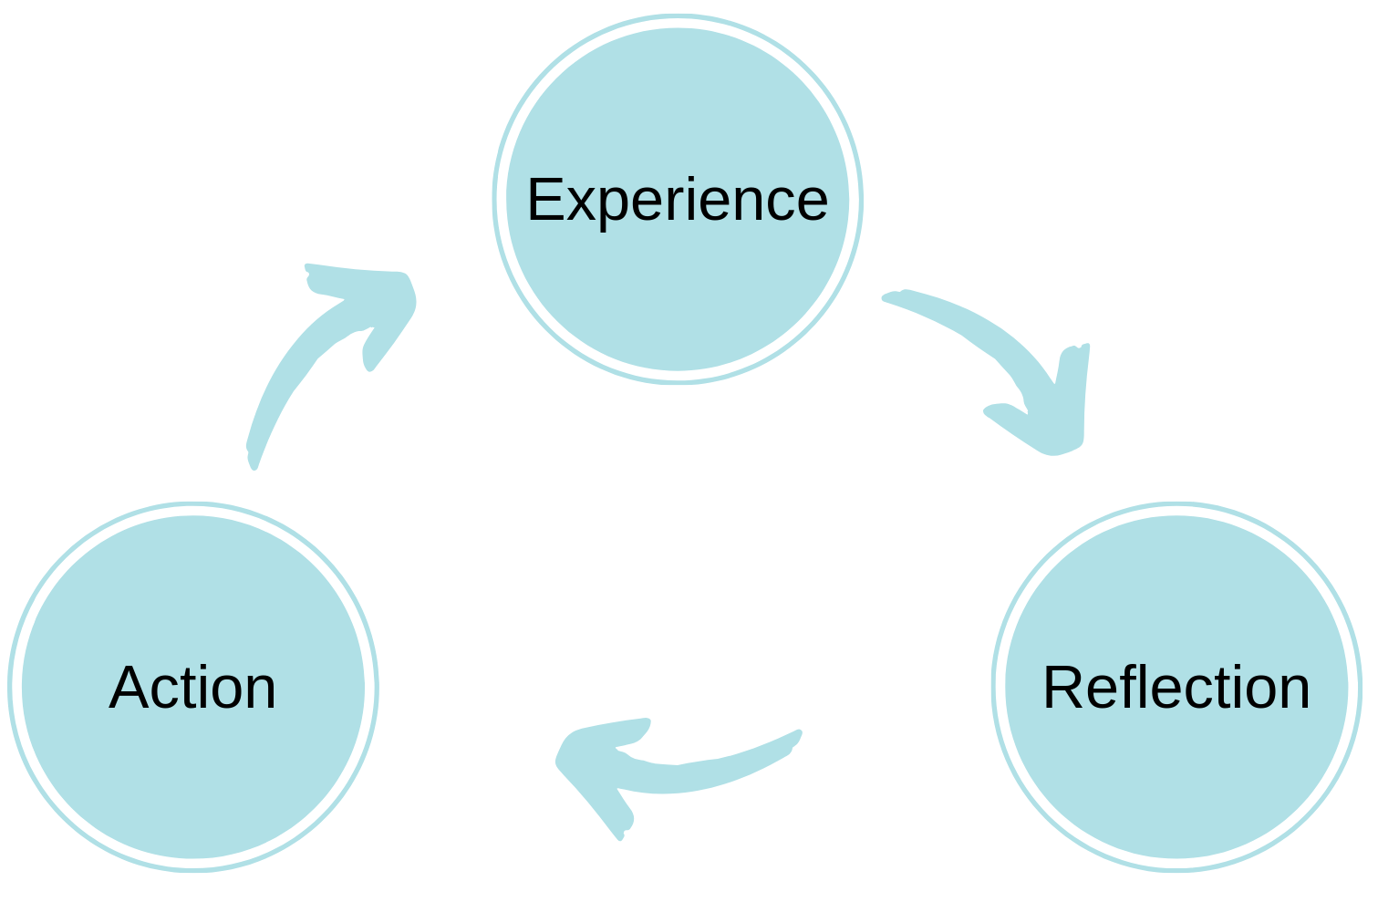  Jasper’s ERA Cycle (2013)
Analysis of models – compare/contrast/pros/cons:
The University of Edinburgh (2023) suggests that Gibbs’ model uses in-depth steps to identify each aspect of the reflective process and identifies that there is more need for critical thinking. Using each step supports identification of the experience itself, the emotions involved and how to encompass the next steps of learning. He suggests that practitioners look at every detail to make informed decisions on how best to overcome any hurdles or more positively, highlight areas of success, to be put into planning for the experiences to follow.

Jones (2023) suggests that Jasper’s ERA model is more simplistic compared to Gibbs’ theory. Continuing that individuals reflect on experiences whether significant or not. This implies that a simpler form of reflection can be completed swiftly and effectively - only a few steps would be taken to identify the key points and put into future practice.

Library Guides (2022) suggest that although all models are different, all pose positive and negatives. For example, some may argue that practitioners do not understand methods of reflection or experience itself under analysed and where key issues have been overlooked may hinder outcomes. Consequently, this may cause the reflective process to be ineffective. Library Guides (2022) Continues to suggest that practitioners may use a multitude of methods to inform practice and implement beneficial next steps.

Conclusion
University of Cambridge (no date) implies that, on the whole, reflective practise is encouraged and can maintain professional practice within Early Years. Although this can be a fluid journey when arranging self-critical models and should be personal to the practitioner – with strategies used to best suit personal preferences.

Reflection is a tool that is used consistently to sustain highly effective practise within the Early Years profession. However, when using reflective practise and models of reflection to support practice, …. Contradicts its success, suggesting that following a structured model of reflection may suppress the intended method of reflection. Steps may not always be able to be followed as rigorously as stated, resulting in practitioners needing in the moment flexibility to account for sudden changes in practise, which may not be relevant when moving forward.

Paige-Smith, A. and Craft, A. (2007) hint that reflection requires many elements to create the best outcome for all. They continue to suggest that it is not simply one action to be considered or changed, more so a collection of evidence and enquiry. Using legislation to support and enable challenge in practice shows the importance of reflection in all areas. They suggest that it will provide consistent development within personal practice, as well as providing the important flexibility to a child’s development.

Professional Association for Childcare and Early Years (2016) agrees that consequently, the quality of care within and for the setting will be of high standard – should reflection take place regularly and whilst using the most effective methods of reflection. Implying that multiple cohorts of children and professionals can reap the rewards of reflective practice.

The University of Nottingham (no date), suggests that although reflection is important, practitioners may use a holistic approach when defining their reflection strategies and base them on personal experiences and preferences – adapting a flexible and inclusive approach.

Recognise and analyse the significance of different aspects of professional practise and why these are important in meeting the individual and inclusive needs of children - including professional values, communication, multiagency work, observations, planning and the UNCRC.
Introduction – what is professional practise/ what is a professional?
Professional Practice is catering to children in your care with respect using a range of knowledge and curiosity to fully inform judgments on how best to consistently further their care and education. Hyson, M. & Biggar, H. (2014) support this by suggesting that professional practitioners need to continue to develop their own practice and take on new approaches to best form meaningful and effective relationships with children and their families. This implies that gaining a better understanding of all significant influences within a child’s life, personal as well as professional, is the only way to work towards benefiting the whole child.

National Day Nurseries Association (2023) agrees suggesting that it is everyone’s role as a professional practitioner, no matter their stage of care giving, to generate an enthusiasm and level of security to children. NDNA (2023) implies that this allows them to embark on an interchangeable development journey - showing that providing a high quality of professionalism to children and their families is paramount. NDNA (2023) imagine a professional practitioner to be presented through many different avenues. An example may consist of a qualification or gained status, outlining one’s professional successions. Equally, another professional may not hold a physical qualification however demonstrates a wealth of desired values, experience and knowledge in specific fields.

What values are important for a professional practitioner and why are values important to professional practise?
Booth (2005) cited in van Krieken Robson, J (2018) suggests a professional practitioner role would be expected to possess a range of core values that underpin their professional work ethic and demonstrate high standards of professionalism. This provides the security to children, allowing them to feel comfortable within the care environment. Without them, this may ultimately result in the child’s development being capped and potentially not thriving to their full potential.
Olser (2015) and UNESCO (2015) also cited in van Krieken Robson, J (2018) hints that implementing a range of values within practice supports objective choices you make for the children and their community. Thus supporting the notion that a professional within the Early Years sector can only provide the high level of care and educational experiences if they implement these specialised skills. A a professional practitioner presents themselves and their values positively and respectfully. Demonstrating inclusivity and a non-discriminatory approach needs much consideration within all values.
example values include:
- Respect - for children and the adults in their lives
- Consistency -to give confidence to others that knowledge and practice is secure
- Striving to be a positive role model – demonstrating effective and appropriate behaviours
- Open minded - hearing all viewpoints of others
- Objective - focus on task in hand to fulfil needs of young children within Early Years
- Hold a high level of enthusiasm towards development.

Why is communication and relationships important to professional practice and meeting the needs of children?
Teachers TV/UK Department of Education (2008) implies that strong meaningful relationships would need to be made between the practitioner, colleagues, outside agencies and, of course, the children and their families or adults that care for them at home in order for children to feel confident and secure within the practitioner’s care. Oberhuemer (2005) cited in Dyer (2018) supports this, implying that the practitioner needs to work to uphold good quality relationships to ensure the child’s development is at the heart of what they do and that it is a “key element of professionalism in early years”.

Gov.UK (2023) suggests that communicating effectively with those that are most significant in a young child’s life can show great professionalism – considering this can guide the way in which practice can thrive by accepting and working towards the needs of the child and their family without judgement.

Why is having an in-depth knowledge and understanding important to professional practice, including aspects of safeguarding?
The Children Act (1989), suggests that safeguarding of children and their families should be paramount among all practitioners involved within the Early Years environment and beyond. Implying everyone has shared responsibilities when ensuring the safeguarding of all children and their families and that a solid foundation of understanding of this should be at the heart of practice at all times.

Wales Safeguarding Procedures (2023) suggest that holding a deep understanding of these documents and legislations will encapsulate a child’s safety and well-being; offering full ethical accommodation for their development. This can only be achieved, however, through collaborative working. It requires action from all parties involved with a child to make proactive decisions. Effective communication of the way in the which these initiatives are understood is essential to identifying and meeting the needs of the children within an Early Years environment. Wales Safeguarding Procedures (2023) state that “this is essential in order to communicate concerns about harm in a meaningful way.”

Why is partnership and multi-agency working important to professional practice?
Inside Government (2020) acknowledges multi agency working to be highly effective in practise and can provide early intervention. In order to fully consider what is right for an individual child; a team of skilled individuals from a variety of professions are needed and by using assessments, observations and in-depth discussions, regarding a child, will result in the best possible outcome. Inside Government continues, stating “collaboration across services to improve outcomes for the children and young people they support.”

How does the observation and planning cycle inform professional practice and ensure practitioners are meeting the needs of children?
Observation within Early Years can be a rewarding element of professional practice. It can inform practitioners of areas for improvement or development; places a focus on aspects of the well-being of a child; provide assessment of a child’s emotional and social dispositions and may draw attention to any alterations within theirs and their families home life that can positively or negatively affect their needs. The Curriculum for Funded Non-Maintained Nursery Settings (CFNMNS) (2022) explains that observations “helps to build a picture of each individual child” and allows the staff and setting to “value the unique set of skills and knowledge each child brings”.

Ephgrave (no date) cited in Learning Journals (2011-2023) supports observation and planning, within Early Years, suggesting it can offer periods of time to collect a detailed profile of a child. It can highlight moments of when to support a child with or without interventions. For professionals in Early Years it will provide knowledge of when to provide extensions and include “teachable moments” to further learning. Children in the Early Years will learn best through real-life, authentic experiences that are planned in response to observations (CFNMNS, 2022).

How do the principles of the UNCRC inform professional practice and why is this important?
The National Society for the Prevention of Cruelty to Children (NSPCC) agree with principles of the United Nations Rights of the Child (1989), suggesting it underpin all aspects of working within the childcare and education industry and outline all children deserve to have their needs met.

The UNCRC (1989) informs professional practice within Early Years to cement strong and clear foundations of keeping a child happy and healthy from the very early stages of development. To positively engage with children, and their rights, in the early stages of a child’s life can dramatically frame their future and provide them with essential holistic approaches to support them as fully as possible.

Conclusion

A professional practitioner’s role within early years and beyond demonstrates the pinnacle of practice in hearing a child’s voice and using that to encompass the way in which they conduct themselves and use their wealth of knowledge of a child to inform their practice.

A professional practitioner can be one of the most important role models within a child’s early stages of development. The professional follows policies, procedures and formal initiatives to meet all aspects of a child stage of development and prepare them for their future.

A professional practitioner underpins all that is important when working within the Early Years. They keep a child safe and secure, ensuring all appropriate measures are in place for a child to thrive and have their rights implemented within practice.

A professional practitioner uses a range of strategies, legislation and initiatives to uphold a high standard within the Early Years environment and implements a wealth of knowledge in a variety of areas to fully support the development and well-being of all children and their families.

Brock (no date) links these ideas together in that the professional will seek to achieve a range of qualities to succeed which supports practice within Early Years.

