Mariela Hidalgo Jorge Hidalgo (2318489)

29th of Nov 2024, and words count: 1195

Managing Enterprise in 21st Century - BMSW4011

Business Plan

Table of Contents

Introduction 2
Task 1. Business Plan Name, Partnership (Pro and Cons) 3
Business Proposition 3
Legal Identity 3
PRO: 3
CONS: 3
Mission Statement, Aim and Objectives of business 3
Location and why? 4
Human Recourses Strategy 4
Marketing techniques 5
Market Research 5
Cash Flow forecast 6
Threats to success of the business and how to overcome it 7
Conclusion 8
References 9
Appendix 11

Introduction

As an aspiring entrepreneur I have a passion for business and I am committed in building the business, Eco Cleaning Services. This reflects my values, knowledge, and vision for a better future. This business plan outlines the steps that I will take to create a brand for a journey with dedication to excellence.
These days, environmental awareness is related to business. This is a very clear message. As customers across the world wish to live more sustainably. Furthermore, a lot of people believe that businesses have an equal responsibility to society as governments to promote positive change. (Close, 2021) This plan serves as roadmap for turning my dreams into reality and achieving financial independence.

Task 1. Business Plan Name, Partnership (Pro and Cons)

Business Proposition

Eco Clean Provisions is an environmentally friendly and professional service specializing in cleaning residential and commercial properties. This company offers environmentally friendly cleaning with products that can provide safe and non-toxic solutions.
The company will be distinguished by exceptional customer service, green certifications and a commitment to reducing the carbon footprint of its operations. (Sheykin, 2024b)

Legal Identity

Incorporate as a Limited Liability Partnership, this arrangement protects the assets of other partners by limiting personal liability, such as if one partner is sued for malpractice. (Kopp, 2024)

PRO:
- This limited liability partnership is made possible by the fact that an LLP is a legal entity that is completely distinct from its members.
- Most limited liability partnerships opt to document their internal policies and procedures in a written LLP agreement, which is a private contract.
- Because limited liability partnerships are "tax transparent," their profits are exempt from corporation tax. Rather, the tax system, the LLP and levies direct taxes on each member's portion of the profits.
- It would have limitless potential and be a distinct legal entity.
- Names of LLPs are protected.
- Easy to assemble.
- More prestige and credibility. (Kopp, 2024)

CONS:
- LLPs must fulfil more administrative duties than general partnerships.
- Like limited companies, LLPs must comply with the same disclosure requirements.
- Less tax efficient.
- Corporate status. (Kopp, 2024)

Mission Statement, Aim and Objectives of business

Mission Statement
‘’Our mission at Eco Clean Provision is to provide high-quality, environmentally friendly cleaning services that create a healthier living and working environment. We are committed to using sustainable practices and non-toxic products to ensure the well-being of our customers, their spaces and the planet.’’
“You need it, we got it’’ Help healing the planet.

Aim
Through personal service and attention to detail, we aim to exceed expectations and promote a cleaner, greater and greener future. Making the world a better place for future generations as well as for ourselves is the goal of this cleaning service. (Heath, 2019)

Objectives:
- Reach at least 95% on customers satisfaction on the first year.
- Training program where staff are skilled in eco-friendly products and cleaning techniques.
- Eco-friendly certificates to build credibility.
- Secure 50% 0f residential clients and 50% on commercial clients on the first year.
- Archive break -even point within 12 months by managing cost and services.
- Increase 10% sales monthly by upselling.
- 100% environmentally friendly and non-toxic cleaning products and educate at least 80% of the customers about their benefits. By working with environmental responsible suppliers. (Queensland Government, 2018)

Location and why?

Marketing will take place from home; it is easy and affordable to use online promoting and marketing. Local customers will be targeted to reduce the carbon footprint fo the business, aligning with our environmentally friendly ethos.
Business address would be:
Dudley Street, Cardiff. CF10
It is cost-effective as I will be able to reduce my utility and rent expenses. Additionally, it is practical for making appointments for the services we will provide. Small business owners all over the world now frequently use their home addresses as their business addresses. This is especially true if the business is small as it reduced high commercial rental costs, and everyone on the marketing team works from home. While this may come across as a convenient and long-term way to work, it may not be the best choice, but it will provide us with a starting point. (Eletto, 2021).

Human Recourses Strategy

- CEO and business partner would run HR initially.
- Recruit one person every month after the first four months of business.
- Recruitment will be made to candidates through advertisements on social media (Facebook, Instagram, etc) with a structure interview question.
- We will be hiring individuals with experience and knowledge on eco- friendly cleaning products Ideally.
- Foster a positive work ethic. Supporting environment for employees, Inductions (handbook on rules and regulations of the company), offering training and fair wages. (Lakes, 2014)

Marketing techniques

- Email marketing (Monkey mail) Using existing contacts.
- Also considering word of mouth (Between customers and friends)
- Creating a professional website
- Offer of special services or loyalty programs (Revenue is generated through one-off cleanings, subscription-based services and special packages for businesses).
- Social media (Instagram, Facebook, etc) (Appendix, page, 12).
- Flyers and business cards

Market Research

Concerns about contagions in 2020 and 2021 due to the coronavirus outbreak triggered an unprecedented focus worldwide on home hygiene to reduce the spread of harmful pathogens. Spending more time at home gave consumers more chances to adopt new household practices, particularly in the areas of cleaning and disinfection. (Mintel, 2021). The following information will be applied to our marketing techniques to draw in customers by homing in on the importance of health and hygiene.
- More eco-friendly household care products are being purchased by 35% of consumers than a year ago.
- Among consumers of household care products, 70% believe companies should offer more evidence to support their eco-friendly claims.
- 29% believe eco-friendly products should be more expensive
- 59% believe disinfection claims are now more significant than eco-friendly due to the COVID-19 pandemic. (Mintel, 2021)
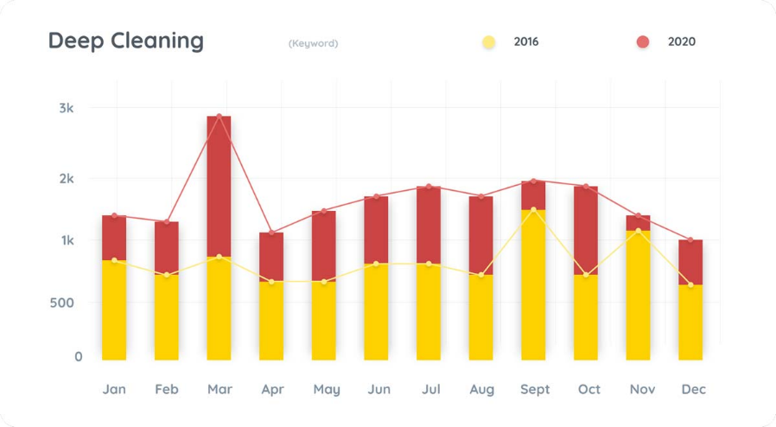
- As can be seen in the graph below, deep cleaning has always been popular, but never more so than in 2020. The term "Deep Cleaning" will be searched for 37% more frequently in 2020. Between 2016 and 2020, this search term increased by 97%, growing yearly over the previous five years. (Hedgehog Digital, 2022).

Cash Flow forecast

2025 | Jan | Feb | Mar | Apr | May | Jun | Jul | Aug | Sep | Oct | Nov | Dec | Totals
Income
Sales | £1600 | £2400 | £3200 | £4000 | £5200 | £6400 | £6700 | £6400 | £7600 | £8800 | £9100 | £8800 | £70200
Loans | £10000 |  |  |  |  |  |  |  |  |  |  |  | £10000
Total | £11600 | £2400 | £3200 | £4000 | £5200 | £6400 | £6700 | £6400 | £7600 | £8800 | £9100 | £8800 | £80200.
Expenditure
Expenses | £510 |  |  |  | £300 | £300 |  | £300 | £300
Wages | £960 | £1440 | £1920 | £2400 | £3120 | £3840 | £3840 | £4560 | £5280 | £5280 | £5280 | £5280
Rent | £0 | £300 | £300 | £300 | £400 | £400 | £400 | £400 | £400 | £400 | £400 | £400
Utilities |  | £50 | £50 | £50 | £50 | £50 | £50 | £50 | £50 | £50 | £50 | £50
Telephone |  | £20 | £20 | £20 | £20 | £20 | £20 | £20 | £20 | £20 | £20 | £20
Petrol | £90 | £80 | £80 | £80 | £80 | £80 | £90 | £80 | £80 | £90 | £80 | £80
Products | £100 |  |  | £100 |  |  | £100 |  | £100 |  | £100
Company  Insurance | £142.2 | £142.2 | £142.2 | £142.2 | £142.2 | £142.2 | £142.2 | £142.2 | £142.2 | £142.2 | £142.2 | £142.2
Nat. Ins. | £132 | £199 | £265 | £331 | £431 | £530 | £530 | £629 | £729 | £729 | £729 | £729
Loan repays |  | £280 | £280 | £280 | £280 | £280 | £280 | £280 | £280 | £280 | £280 | £280
Total | £1934.2 | £2511.2 | £3057.2 | £3703.2 | £4823.2 | £5642.2 | £5452,2 | £6461.2 | £7381.2 | £6991.2 | £7081.2 | £6981.2 | £62019.4
Net cash  Flow | £9665.8 | £-111.2 | £142.8 | £296.8 | £376.8 | £757.8 | £1247.8 | -61.2 | £218.8 | £1808.8 | £2018.8 | £1818.8 | £18180.6
Opening  Balance | 0 | £9665.8 | £9554.6 | £9697.4 | £9994.2 | £10371 | £11128.8 | £12376.6 | £12315.4 | £12534.2 | £14343 | £16361.8 | 0
Closing Balance | £9665.8 | £9554.6 | £9697.4 | £9994.2 | £10371 | £11128.8 | £12376.6 | £12315.4 | £12534.2 | £14343 | £16361.8 | £18180.6 | £18180.6

Threats to success of the business and how to overcome it

Potential threats | Strategies to overcome
1.- Online reviews or social media criticism (Adam, 2024). | 1.- Staff with eye for detail and experience
2.- Inadequate marketing efforts or low visibility in the market prospective. | 2.- The best way to overcome these threats is to identify and leverage the internal advantages that make our cleaning business unique.
3.- Inconsistency on quality of the service provided. | 3.- Qualified staff with extensive training and experience.
4.- Competition. New and established cleaning businesses. | 4.- Guarantee of 100% eco-friendly products.
5.- Compliance and Changes in Regulations. | - Providing cleaning plans to each customer's needs to increase customer satisfaction (Adam, 2024).

Conclusion

To conclude my research, cleaning services are significantly needed in both the residential and commercial sectors. Additionally, many cleaning businesses struggle with pricing competition, customer retention, and maintaining a competitive edge in the market. (Bebon, 2023).
A professional cleaning analysis helps businesses find areas for improvement and growth prospects, Consumers are becoming more environmentally conscious, society is becoming more aware of the importance of cleanliness and hygiene, and the demand for residential cleaning services is increasing. Cleaning companies must anticipate their clients' shifting preferences in addition to meeting their demands as the cleaning industry develops. (Business Conceptor, 2023)
Eco Clean Provision will demonstrate a dedication to improving the world for future generations as well as for us. (Greengage Solutions, 2024)

References

Adam (2024). SWOT Analysis for a Residential Cleaning Business (Example) - Sharp Sheets. [online] Available at: https://sharpsheets.io/blog/swot-analysis-residential-cleaning-business/.
Bebon, J. (2023). Top Trends and Challenges for Commercial Cleaning Providers - Facilities Management Advisor. [online] Facilities Management Advisor. Available at: https://facilitiesmanagementadvisor.blr.com/maintenance-and-operations/top-trends-and-challenges-for-commercial-cleaning-providers/ [Accessed 29 Nov. 2024].
Blue-breeze (2020). ECO FRIENDS | Cleaning Services and Cleaners in Cardiff. [online] Cleaning Services and Cleaners in Cardiff. Available at: https://blue-breeze.co.uk/eco-friends/.
Business Conceptor. (2023). Cleaning Company Business Plan. [online] Available at: https://businessconceptor.com/blog/cleaning-company [Accessed 27 Nov. 2024].
Chris (2015). Biological Cleaning by the Cardiff Cleaning Company. [online] Cardiff Cleaning Company. Available at: https://www.cardiffcleaningcompany.co.uk/blog/biological-cleaning-cardiff-cleaning-company [Accessed 11 Nov. 2024].
Cleaning Services and Cleaners in Cardiff. (2020). ECO FRIENDS | Cleaning Services and Cleaners in Cardiff. [online] Available at: https://blue-breeze.co.uk/eco-friends/ [Accessed 11 Nov. 2024].
Close, C. (2021). Eco-wakening: how consumers are driving sustainability. [online] World Economic Forum. Available at: https://www.weforum.org/stories/2021/05/eco-wakening-consumers-driving-sustainability/.
Eletto, J. (2021). Home address for business? [online] Usestable.com. Available at: https://www.usestable.com/blog/can-i-use-my-home-address-as-my-business-address [Accessed 27 Nov. 2024].
Green Fox. (2020). Green Cleaning - a new concept for some - learn here which it should be a top 3 priority for all cleaning companies! - Green Fox. [online] Available at: https://www.greenfox.co.uk/green-cleaning/ [Accessed 17 Nov. 2024].
Greengage Solutions. (2024). The importance of environmental sustainability for future generations. Greengage Solutions. [online] Available at: https://www.greengage.solutions/environmental-sustainability-for-future-generations/.
Heath, C. (2019). 10 Ways to Deliver Good Customer Service. [online] Helpscout.com. Available at: https://www.helpscout.com/blog/good-customer-service/.
Hedgehog Digital (2022). Commercial Cleaning Services Search Marketing Report - Hedgehog Digital. [online] Hedgehog Digital. Available at: https://www.hedgehogdigital.co.uk/cleaning-services-search-marketing-report/ [Accessed 23 Nov. 2024].
Kopp, C. (2024). Partnerships: What You Should Know. [online] Investopedia. Available at: https://www.investopedia.com/terms/p/partnership.asp.
Market, E. (2023). UK Household Care Market Size & Share | Trend Report 2032. [online] Expertmarketresearch.com. Available at: https://www.expertmarketresearch.com/reports/united-kingdom-household-care-market [Accessed 27 Nov. 2024].
Mintel (2021). The UK Green Household Care Consumer Market Report 2021 | Mintel.com. [online] store.mintel.com. Available at: https://store.mintel.com/report/uk-the-green-household-care-consumer-market-report.
Queensland Government (2018). Business Queensland. [online] Qld.gov.au. Available at: https://www.business.qld.gov.au/.
Seymour, E. (2024). 15 Eco-Friendly Cleaning Tips for Your Home. [online] Bambu Eco Cleaning. Available at: https://www.bambuecocleaning.co.uk/post/15-eco-friendly-cleaning-tips-for-your-home [Accessed 17 Nov. 2024].
Sheykin, H. (2024). How to Draft a Business Plan for Eco-Friendly Cleaning. [online] Finmodelslab.com. Available at: https://finmodelslab.com/blogs/write-business-plan/how-to-write-business-plan-for-sustainable-eco-friendly-cleaning-services [Accessed 11 Nov. 2024].

Appendix

Develop a Pricing Strategy Based on Costs and Market
Standard Services (Prices per hour)
Type of Premise | Home Size | Standard Cleaning | Moving Out Cleaning | Carpet Cleaning | Detailed Cleaning | Rubbish Removal | Condition Report
Commercial | 1-3 Bed | £18 | £20 | £60 | £20 | £15 | £15
Apartment | 1-3 Bed | £15 | £17 | £50 | £18 | £10 | £15
House | 1-3  Bed | £16 | £18 | £50 | £18 | £10 | £15
Office | 1-3 Bed | £18 | £20 | £60 | £20 | £15 | £15

Instagram
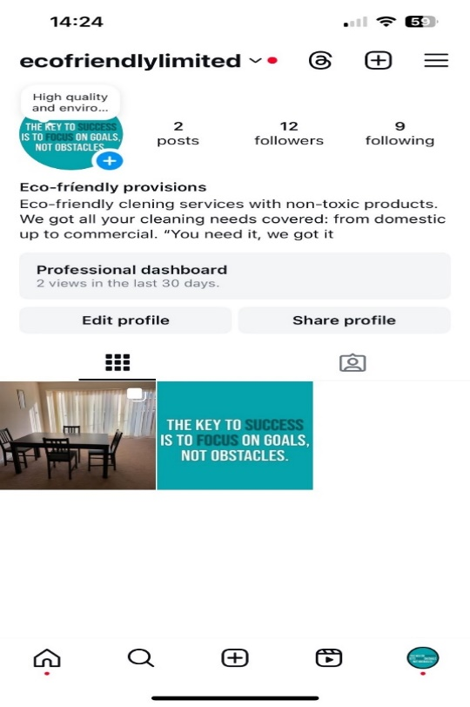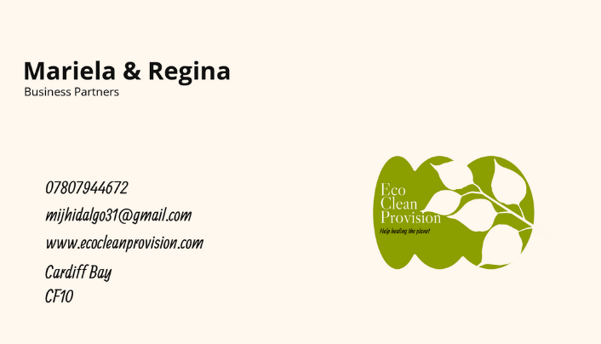
Business card

Managing Enterprise in 21st Century - BMSW4011

Student name: Mariela Isabel J Hidalgo

Student Number: (2318489)

Reflection on Business Plan

Considering launching a new environmentally friendly cleaning business is a thrilling endeavour that fits in with the rising demand for sustainable goods and services. This entails considering a number of business-related factors, including its operations, challenges, and purpose. Through my market research, I was able to determine the need for eco-friendly cleaning products and gain insight into the competitive market, growing demand, and trends in eco-conscious consumer behaviour. I gained knowledge about zero-waste packaging, biodegradable ingredients, and certifications like EPA Safer Choice and Green Seal in order to comprehend the environmental impact. Business Model Development: I chose to concentrate on cleaning services for homes and businesses with a refillable product subscription as well as marketing and branding. I investigated marketing tactics for environmentally conscious companies, such as using social media, content marketing, and collaborating with neighbourhood green projects. Financial Planning: I find about the costs of launching and operating an eco-friendly cleaning business, including labour, marketing, and product sourcing. Operational Planning as I researched eco-friendly cleaning methods and found equipment that supports my sustainability objectives, like energy-efficient vacuum cleaners and microfiber cloths. On building a Team, also grants and loans for green businesses, as well as the best ways to hire employees and teach them eco-friendly cleaning methods. To measure the business and environmental impact of my services, I looked into metrics and tools like financial performance, waste reduction statistics, and customer feedback.

Entrepreneurial Skills:

the capacity to identify market opportunities and analyse data. By analysing the market and determining the opinions of customers. Determining my niche has been greatly aided by my aptitude for data analysis and market opportunities. As an entrepreneur, I turned research into workable solutions by creating a line of products that are both environmentally friendly and easy to use.
Creativity and problem-solving skills. I was able to create a sustainable business model by adjusting my ideas to fit the demands of the market.
Teamwork and leadership. To assemble a cohesive team that shares my dedication to sustainability, my leadership abilities were essential.
Adaptability and analytical thinking: I have been able to improve my services and sustain customer satisfaction by analysing data and responding to feedback.
Flexibility and strategic thinking. Designing a sustainable business model was made possible by my ability to switch between concepts and match them with the demands of the market.
Both communication and creativity. My ability to think creatively enabled me to create an engaging brand narrative, and my ability to communicate effectively enabled me to engage with environmentally conscious consumers.
Effective resource management and meticulousness. By efficiently managing resources, I was able to keep my company economical and environmentally friendly.

Risk management and financial literacy. I was able to develop a reasonable budget and pricing strategy by comprehending cash flow and projecting expenses.

