
Prepared By
Fazle Rabby Nahi
Student ID: 2515592

Master of Business Administration
Lecturer Name: Dian Mayasari
Module: International Marketing: Principles and Practices
Module Code: LCMB7026

Assignment Title: A Comparative Analysis of IKEA's International Marketing Strategies: The Cases of Sweden and Japan.
Words Count: 5272
Date of Submission: 27/03/2026

Contents
Section 1 - Introduction 4
1.0 Introduction 4
2.0 Brand and Country Overview 5
2.1 IKEA: Global Brand, Democratic Design. 5
2.2 Internationalisation Trajectory: Analysing the Uppsala Model. 5
2.3 Country Context: Sweden (Home) and Japan (Host) 6
3.0 Comparison of the Socio-Cultural Context of Sweden and Japan 6
3.1 Macro-Environmental Scan: PESTEL Highlights. 7
3.2 Cultural Dimension Analysis: Hofstede’s Framework. 7
3.3 Subjective Culture and Its Influence on Purchasing Behaviour 10
4.0 Comparison of STP Strategies in Sweden and Japan. 11
4.1 Segmentation. 12
4.2 Targeting. 13
4.3 Positioning and Perceptual Mapping. 13
4.4 Conclusion on STP Similarity/Difference. 14
5.0 Comparison of Marketing Mix Strategies in Sweden and Japan 14
5.1 Brand & Product Strategy 15
5.2 Pricing & Promotion Strategy 17
5.3 Place (Distribution), Logistics & the Extended 3Ps 19
6.0 Evaluation of the Performance of Marketing Strategies 20
6.1 Comparative Performance Metrics. 21
6.2 Critical Evaluation of Success. 24
7.0 Evaluation of Marketing Ethics Practice 25
7.1 Ethical Frameworks and IKEA’s Stance. 25
7.2 Ethical Issues in the Marketing Mix 26
7.3 Overall Ethical Evaluation. 27
8.0 Recommendations and Conclusion 27
8.1 Strategic Recommendations for IKEA. 27
8.2 Conclusion 29
Section 2: Reflective Statement: The Process of International Marketing Analysis 30
Reference 32

Section 1 - Introduction

1.0 Introduction
A central challenge in international marketing is balancing global standardisation with the need to respond to local market conditions (Bartlett and Ghoshal, 1989). This report critically examines this tension through a comparative analysis of IKEA’s marketing strategies in its Swedish home market and its Japanese host market. IKEA is selected as the focal brand due to its iconic status as a purported standardised global retailer, which, upon closer inspection, engages in profound and strategic adaptations, making it an ideal case to dissect the contingency approach to international marketing (Baack, 2018). The choice of Sweden and Japan is deliberate and analytical: it constitutes a “most different” comparative design characterised by maximal cultural distance, particularly in dimensions of Uncertainty Avoidance and Individualism-Collectivism (Hofstede, 2001). This sharp contrast serves as a powerful lens to isolate and evaluate the environmental drivers that compel adaptation beyond mere translation, moving into the realm of strategic redesign.
The purpose of this report is threefold: first, to systematically compare the socio-cultural, economic, and market contexts of Sweden and Japan and evaluate their implications for marketing strategy; second, to deconstruct and contrast IKEA’s application of Segmentation, Targeting, Positioning (STP) and the 7Ps marketing mix in these two distinct environments; third, to critically assess the performance and ethical dimensions of these strategies. The report will conclude with evidence-based recommendations for IKEA’s future international marketing direction. The structure follows a logical flow, commencing with a brand and market overview, proceeding to comparative environmental and strategic analysis, evaluating outcomes and ethics, and culminating in strategic proposals. This structure directly addresses the assessment requirements, providing a comparative environmental analysis, an evaluation of STP and the 7Ps, a data-driven performance assessment, and a critical review of ethical considerations.

2.0 Brand and Country Overview

2.1 IKEA: Global Brand, Democratic Design.
Founded in Sweden in 1943, IKEA has grown into the world’s largest furniture retailer (Ingka Group, 2022), anchored by its philosophy of ‘Democratic Design’ – the combination of form, function, quality, sustainability, and low price (IKEA, 2023). This core value proposition is standardized globally and is the foundation of its brand identity. IKEA operates as a complex multinational corporation, with a franchising model managed by the Inter IKEA Group (Ingka Group, 2022). While most stores are owned and run by the Ingka Group. Its primary competitors vary by market; in its European home region, they include other flat-pack retailers and hypermarkets, while globally, it faces diverse local and international players.

2.2 Internationalisation Trajectory: Analysing the Uppsala Model.
IKEA’s international expansion provides a nuanced case for evaluating Johanson and Vahlne’s (1977) Uppsala Model. Retail multinationals often adopt flexible market entry strategies when expanding into culturally distant markets (Ghauri, Wang and Elg, 2021). The model posits that firms internationalise incrementally, increasing market commitment as experiential knowledge grows. IKEA’s early growth aligns with this, expanding first to neighbouring Norway (1963) and Denmark (1969), (Forsgren, 2016), following a pattern of low psychic and geographic distance. However, its engagement with Japan challenges a strict Uppsala interpretation. The failed 1974-1986 venture can be seen as a premature leap, demonstrating the risks of insufficient market knowledge (Johanson and Vahlne, 2009). The successful 2006 re-entry, however, was not incremental but a high-commitment “leapfrog” strategy. Bypassing intermediate steps, IKEA established a wholly owned subsidiary, indicating a shift from a knowledge-development model to one leveraging global learning and brand confidence (Forsgren, 2016). This suggests that while the Uppsala Model explains IKEA’s foundational growth, its later strategy for high-distance markets evolved towards a more geocentric, integrated approach.

2.3 Country Context: Sweden (Home) and Japan (Host)

- Sweden (Home Country): As IKEA’s country of origin, Sweden represents a mature, saturated home market (Hollensen, 2020). The socio-cultural context of egalitarianism, individualism, and environmental consciousness is deeply embedded in IKEA’s corporate DNA and original business model. The market is characterised by high brand loyalty, familiarity with the DIY concept, and spacious living standards that accommodate IKEA’s standard product dimensions.
- Japan (Host Country): Japan represents a strategically vital but complex host market (Jonsson and Foss, 2011). IKEA’s re-entry was driven by the market’s size, high disposable income, and the growing trend of urban living in compact spaces—a direct challenge to IKEA’s standard product range. The choice of Japan is a deliberate strategic challenge: to adapt a fundamentally Swedish, standardized model to one of the world’s most distinct consumer cultures. The reason for entry was thus twofold: to capture a lucrative market and to prove the brand’s capability for deep adaptation, a test case for global resilience (Jonsson and Foss, 2011).

3.0 Comparison of the Socio-Cultural Context of Sweden and Japan

A comparative analysis of the macro-environment, with a deep focus on socio-cultural factors, is essential to understand the divergent strategic imperatives IKEA faces in Sweden and Japan. While economic and political factors (e.g., both being stable, high-income democracies) provide a base for entry, it is the profound cultural distance that dictates the necessary degree of marketing adaptation.

3.1 Macro-Environmental Scan: PESTEL Highlights.

A high-level PESTEL analysis reveals a framework of similarity underpinning deep-seated difference. Politically and legally, both nations are stable, though Japan’s complex distribution keiretsu systems present a unique Place challenge. In economic terms, both Sweden and Japan are classified as high-income developed economies. Sweden’s GDP per capita is approximately USD 55,000, while Japan’s is approximately USD 40,000 (World Bank, 2023). However, similar income levels do not translate into identical consumer behaviour or market structures. Japan’s significantly higher urban density and smaller residential spaces create structural demand for compact and multifunctional furniture solutions. Consequently, IKEA’s international marketing strategy cannot rely solely on income indicators but must adapt product dimensions and service offerings to the spatial realities of the Japanese housing market (Hollensen, 2020). The critical divergences are socio-cultural and technological: Sweden’s low-context, individualistic communication style contrasts with Japan’s high-context, collectivist norms, and while both are technologically advanced, Japan’s consumer tech integration and space-saving innovations are unparalleled.
The PESTEL analysis highlights that although Sweden and Japan share macroeconomic stability and high purchasing power, the strategic implications for IKEA are significantly different. Japan’s dense urban population, high technological integration and spatial constraints create strong demand for compact, multifunctional furniture, while Sweden’s larger living spaces allow IKEA to maintain its traditional product dimensions. This divergence implies that IKEA cannot rely on global standardisation alone; instead, marketing strategies must adapt to structural living conditions and consumer behaviour patterns (Hollensen, 2020). Consequently, IKEA’s product resizing, service-based assembly support, and urban store formats in Japan represent strategic responses to these environmental pressures rather than simple localisation decisions.

3.2 Cultural Dimension Analysis: Hofstede’s Framework.
The application of Hofstede’s six-dimensional model (Hofstede Insights, 2023) quantitatively illustrates the stark cultural chasm, providing a theoretical basis for predicting necessary adaptations.

Table 1: Hofstede’s Cultural Dimensions - Sweden vs. Japan
Dimension | Sweden (Score) | Japan (Score) | Strategic Implication for IKEA
Power Distance (PDI) | 31 (Low) | 54 (Medium) | Sweden: Flat organisational style aligns with DIY ethos. Japan: Greater acceptance of hierarchy may support service-based offerings.
Individualism (IDV) | 71 (High) | 46 (Collectivist) | Sweden: Marketing celebrates personal expression & self-assembly. Japan: Appeals must focus on family, harmony, and social acceptance.
Masculinity (MAS) | 5 (Feminine) | 95 (Masculine) | Sweden: Values quality of life, sustainability, moderation. Japan: Values competition, achievement, ‘best’ solutions; marketing can emphasise performance & winning in space management.
Uncertainty Avoidance (UAI) | 29 (Low) | 92 (Very High) | Sweden: Low risk-aversion supports DIY model uncertainty. Japan: The critical driver. High UAI creates resistance to DIY, necessitating full assembly services, clear guarantees, and meticulous in-store guidance.
Long-Term Orientation (LTO) | 53 (Mid-Range) | 88 (High) | Sweden: Mixed focus on tradition & pragmatism. Japan: High LTO favours durable, timeless products and loyalty-building strategies.
Indulgence (IND) | 78 (Indulgent) | 42 (Restrained) | Sweden: Openness to hedonistic rewards and spontaneous purchases. Japan: Restraint favours practicality, necessity, and functional messaging over pure lifestyle indulgence.

Figure 1: Hofstede Cultural Comparison – Sweden vs Japan

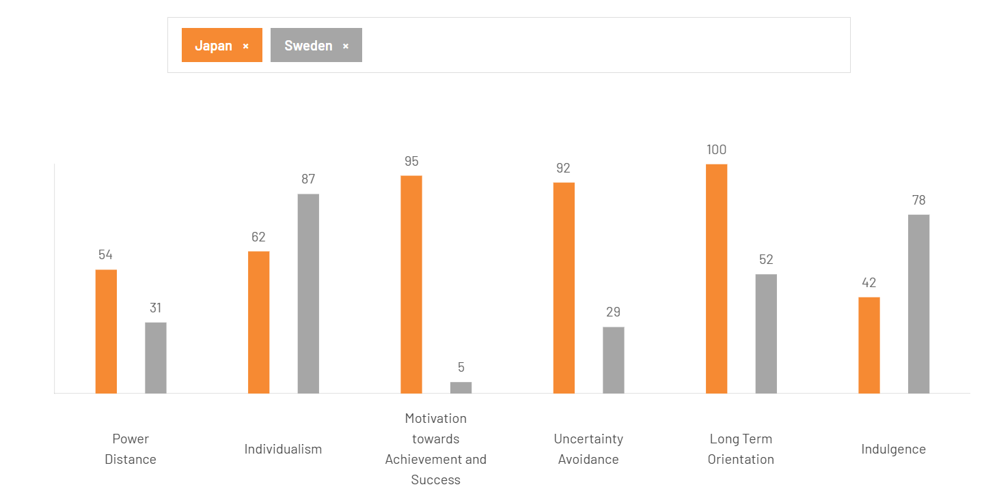
Source: Hofstede Insights (2023).
In Figure 1, Japan’s extremely high Uncertainty Avoidance contrasts sharply with Sweden’s low score, indicating stronger preference for structure, predictability and service assurance in the Japanese market.

3.3 Subjective Culture and Its Influence on Purchasing Behaviour
While macro-cultural dimensions provide structural indicators, elements of subjective culture, such as language, social norms and underlying value systems, significantly shape how consumers evaluate products and make purchasing decisions (Baack, 2018).
In Sweden, subjective culture emphasises egalitarianism, independence and functional minimalism, which reflects broader Nordic consumer values associated with rational consumption and modest lifestyle expression (De Mooij, 2019). The cultural norm of lagom promotes moderation in consumption, discouraging conspicuous display. Consequently, IKEA’s affordability does not undermine its prestige; instead, it reinforces social responsibility and rational consumption.
By contrast, Japan’s subjective culture is influenced by omotenashi (deep service orientation) and seiri-seiton (orderliness). These norms increase sensitivity to product usability and post-purchase risk. High Uncertainty Avoidance amplifies this effect (Hofstede, 2001). Japanese consumers therefore evaluate purchasing decisions not solely on price but on:
- Service reliability
- Assembly support
- After-sales reassurance
This influences perceived purchasing power. In Sweden, purchasing power translates into freedom of choice and experimentation. In Japan, purchasing power is constrained by psychological risk aversion and social harmony considerations.
So what does this imply for IKEA?
It implies that disposable income alone cannot predict market potential. Cultural cognition mediates economic capability, meaning that purchasing power alone cannot predict consumer behaviour without considering cultural perceptions of value and risk. Therefore, adaptation in Japan is not driven by economic necessity but by subjective cultural interpretation of value and security. This distinction moves the analysis beyond GDP comparison into behavioural economics embedded within culture (De Mooij, 2019).

4.0 Comparison of STP Strategies in Sweden and Japan.
The Segmentation, Targeting, and Positioning (STP) process translates macro-environmental and cultural analysis into a focused strategic blueprint. IKEA’s application of STP in Sweden and Japan demonstrates a foundational standardisation of its core value proposition, overlain with significant, culturally-informed adaptations in targeting and positioning.

4.1 Segmentation.
Market segmentation enables firms to identify distinct customer groups with similar needs, allowing more efficient targeting strategies. IKEA employs a hybrid segmentation basis, combining geographic, demographic, and psychographic variables, with the weight of each varying by market (Wedel and Kamakura, 2020).
Table 2: Comparative Segmentation Analysis
Segmentation Basis | Sweden (Home Market) | Japan (Host Market)
Geographic | Nationwide; suburban & urban. | Heavily concentrated in major metropolitan areas (Tokyo, Osaka, etc.). Urban focus is paramount.
Demographic | Broad: Young adults, families, students. Wide income range. | More focused: Young urban professionals, new homeowners, small families in cities. Slightly higher income skew due to urban premium.
Psychographic | DIY enthusiasts, value-seekers, environmentally conscious consumers, those seeking self-expression through home design. | Space-optimisers, time-poor urbanites, quality-conscious but not DIY-focused. Seek convenience, smart solutions, and social approval.
Behavioural | Regular shoppers for incremental home furnishing. High loyalty to the IKEA system. | Occasional, project-based shoppers for key space solutions. Lower initial loyalty, higher need for reassurance.

4.2 Targeting.
The targeting strategy flows directly from the segments identified, as firms select the most attractive market segments based on market size, accessibility and profitability (Cateora, Gilly and Graham, 2020). In Sweden, IKEA practises differentiated marketing, targeting multiple segments (students, families, etc.) with its wide range. In Japan, the strategy is more concentrated; the primary target is the urban space-optimiser. This sharp focus justifies the significant investment in adapting products, stores, and services for this specific group’s needs (Kotler and Keller, 2022). The choice not to target the traditional, older Japanese household or rural dwellers is a clear strategic prioritisation.

4.3 Positioning and Perceptual Mapping.
Positioning is where the most visible adaptation occurs. While the core attribute of “good design” is consistent, the key differentiating benefit shifts.
- Sweden: IKEA is positioned as “Affordable, democratic design for self-reliant living.” The emphasis is on the process (DIY as empowering) and the value.
- Japan: IKEA is repositioned as “Smart, life-improving solutions for compact urban living.” The emphasis shifts to the result (a harmonious, efficient space) and the solution provided, often with service support.
This can be visually analysed through perceptual maps. For the Sweden home market, IKEA occupies a high-design and moderate-price position in the Swedish furniture market.
Figure 2: Perceptual Map of Furniture Market Positioning in Sweden.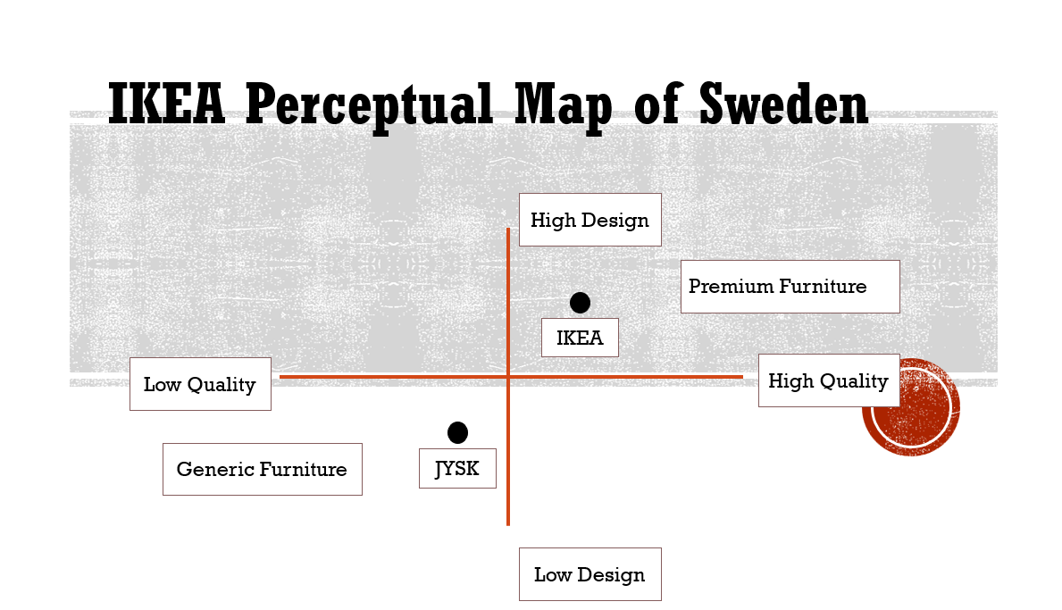
Source: Author’s conceptualisation based on industry analysis.
In Figure 2, The brand differentiates itself from premium Scandinavian furniture producers, which offer higher-priced fully assembled products, while also maintaining stronger design value compared to lower-cost flat-pack competitors such as JYSK.
For the Japanese market, the key competitive dimensions are Space-Saving Ingenuity and Price/Value.
- Conceptual Perceptual Map (Japan):
  - High Space-Saving, High Price: Premium custom storage solutions.
  - High Space-Saving, Mid-Price: IKEA JAPAN. Nitori also competes strongly here.
  - Low Space-Saving, Mid-Price: Traditional Japanese furniture retailers.
  - Low Space-Saving, Low Price: Basic, generic big-box retailers.

Figure 3: Perceptual Map of Furniture Market Positioning in Japan.
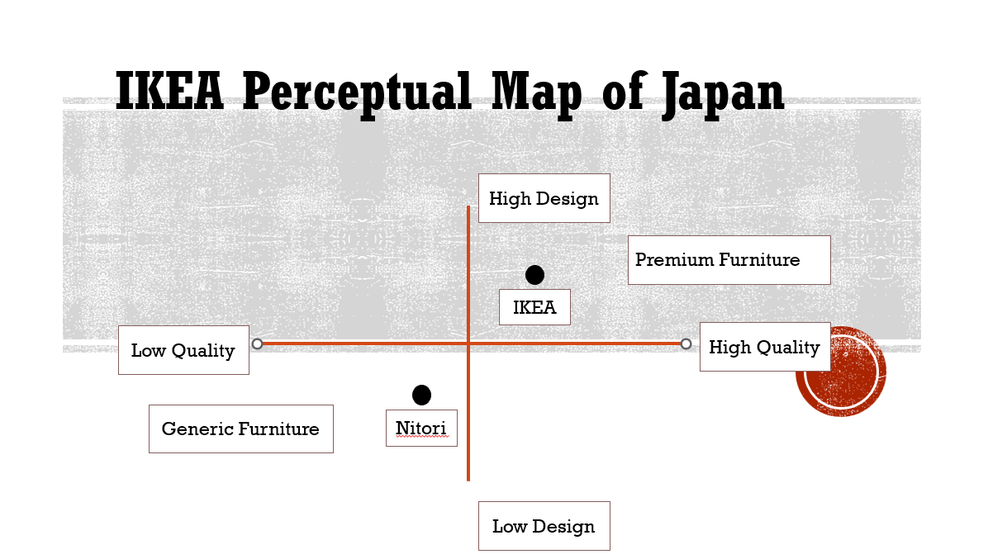
Source: Author’s conceptualisation based on industry analysis.
Figure 3 demonstrates that IKEA occupies a mid-price, high-design position in the Japanese furniture market. This positioning reflects the strategic objective of differentiating IKEA from both premium furniture retailers and low-cost domestic competitors, illustrating the role of positioning as a core element of the STP framework in creating sustainable competitive advantage (Kotler and Keller, 2022). The brand competes closely with Nitori in terms of value and functionality while differentiating itself through Scandinavian design and space-saving solutions targeted at urban consumers.

4.4 Conclusion on STP Similarity/Difference.
IKEA employs a fundamentally different STP strategy in Japan compared to Sweden, demonstrating how international segmentation and positioning decisions must align with cultural, spatial and behavioural differences across markets (Keegan and Green, 2020). This supports the contingency perspective in international marketing, which argues that segmentation and positioning strategies must be aligned with local cultural and environmental conditions rather than universally standardised (Keegan and Green, 2020). The segmentation variables are weighted differently (heavy geographic concentration in Japan), the targeting is more focused, and the positioning statement is adapted from an emphasis on affordable self-reliance to smart, service-supported solutions. This level of adaptation is not superficial; it represents a strategic realignment to fit the market’s cultural profile (high UAI, collectivism) and practical constraints (space). This adapted STP framework now dictates the specific configurations of the marketing mix, which will be analysed in the following section.

4.5 Recent Strategic Developments in Japan

Reinforcing its adapted positioning as a "solution provider," IKEA Japan announced a strategic shift for the 2026 fiscal year, focusing on "Cooking & Eating." This initiative, based on research showing a gap between Japanese consumers' desire to enjoy cooking and their actual kitchen satisfaction, introduces the HARMYNTA tableware collection. Notably, this is IKEA's first tableware line to incorporate traditional Japanese craftsmanship and be entirely produced in Japan (PR E
DGE, 2025). This move perfectly illustrates the brand's deepening local responsiveness, blending its Swedish design identity with local cultural and material practices to solve a specific Japanese consumer problem.

5.0 Comparison of Marketing Mix Strategies in Sweden and Japan

The marketing mix operationalises the strategic choices made in the STP process, translating segmentation and positioning decisions into actionable marketing activities (Hollensen, 2020). For IKEA, the 7Ps reveal a sophisticated contingency approach (Baack, 2018), where global brand identity and logistical core are standardised, while profound adaptations are made to key elements to achieve local relevance and success.

5.1 Brand & Product Strategy

Brand Strategy: IKEA maintains a standardised global brand identity—its blue-and-yellow logo, typeface, and the core ‘Democratic Design’ ethos are consistent. This provides global efficiency and brand equity transfer. However, the brand promise is adapted. In Sweden, it is the “co-creator of your home.” In Japan, it becomes the “expert solution provider for small-space living.”
Product Dimensions, Lines, and Adaptation:
- Core Product: While both markets sell furniture, the core benefit differs. In Sweden, it is “self-expression & value.” In Japan, it is “space harmony & convenience.”
- Adaptation vs. Standardisation: IKEA practices mandatory adaptation in Japan due to physical constraints (smaller room sizes, narrow staircases). Over 20% of its product range has historically been redesigned or resized to accommodate Japanese housing constraints and consumer preferences (Jonsson and Foss, 2011; IKEA, 2023). For example, beds are made to fit standard Japanese tatami mat dimensions, and sofas are shallower. This commitment to adaptation continues to evolve. In 2025, IKEA Japan launched HARMYNTA, its first tableware line to incorporate traditional Japanese techniques and be entirely produced in Japan (PR EDGE, 2025). This represents a move from simply resizing products to co-creating new ones with local cultural meaning, further cementing its role as a locally responsive brand.

Figure 4: Product Adaptation – IKEA Standard Bed vs IKEA Japan Tatami-Compatible Bed.
 | 
IKEA Standard Bed | IKEA Japan Tatami-Compatible Bed
Source: IKEA (2023)
- Product Lines: The width (number of lines) is similar, but the depth (items within a line) varies. Japan has a deeper range within space-saving categories (e.g., multi-functional storage, foldable furniture).
- Packaging: The iconic flat-pack is standardised for logistics. However, informational and symbolic packaging elements are adapted. Instructions use universal pictograms but may feature Japanese living spaces. Packaging emphasises “easy assembly” more strongly in Japan to counter high Uncertainty Avoidance.
- Labelling: Legally required labelling (e.g., materials, safety) is adapted. Sustainability labels (FSC-certified wood) are standardised, aligning with global ethical positioning.
Conclusion: IKEA employs a significantly different product strategy in Japan, with physical product adaptation being non-negotiable. While the brand is standardised, its product manifestation is locally responsive.

5.2 Pricing & Promotion Strategy

While IKEA maintains a globally recognisable low-price positioning, its pricing strategy in Sweden and Japan reflects a nuanced balance between cost efficiency and cultural value perception. International pricing cannot be understood purely as a financial calculation; rather, it is embedded within cultural constructions of value, risk and quality (Keegan and Green, 2020).
In Sweden, IKEA operates within a low Uncertainty Avoidance (UAI = 29) context (Hofstede, 2001). Consumers are comfortable with self-assembly and price transparency. As a result, IKEA’s pricing strategy follows a predominantly cost-plus logic, supported by economies of scale and flat-pack logistics efficiencies (Baack, 2018). The low price signals accessibility and aligns with the Swedish cultural value of lagom — moderation and balance. Here, price reinforces brand authenticity rather than triggering quality suspicion.
In contrast, Japan exhibits extremely high Uncertainty Avoidance (UAI = 92) (Hofstede, 2001). In such contexts, price functions not only as an economic indicator but also as a psychological signal of reliability. Research in international pricing suggests that high-UAI cultures often associate excessively low prices with potential risk or compromised quality (De Mooij, 2019). Therefore, IKEA Japan positions itself slightly above local competitor Nitori in selected categories. This price premium is not merely cost-driven but strategically designed to convey European design credibility and functional reliability. This illustrates how cultural cognition mediates price perception, demonstrating that effective international pricing strategies must balance cost efficiency with culturally embedded signals of trust and quality.Cultural cognition mediates economic capability.
Why does this matter?
Because pricing in Japan becomes a risk-reduction mechanism rather than purely a competitive lever.
So what?
This implies that full standardisation of IKEA’s Swedish low-price formula would weaken its positioning in Japan. Instead, IKEA adopts a calibrated pricing adaptation strategy — maintaining affordability while embedding symbolic quality cues.

Table 4: Price Comparison – MALM Bed Frame.
Country | Product | Price (Local Price) | Local Competitor Price. (e.g., Nitori)
Sweden | MALM Bed (140×200 cm) | SEK 1,995 | Not Applicable
Japan | MALM Bed (140×200 cm) | ¥ 39,990 | ¥ 74,990 (Nitori NS-006 double bed frame)
Source: IKEA Sweden (2026); IKEA Japan (2026); Nitori (2026).
The slight price variation reflects local cost structures, import duties, and positioning relative to domestic competitors such as Nitori. Notably, IKEA's MALM bed in Japan is priced competitively at approximately ¥40,000 compared to Nitori's more feature-rich model at ¥75,000, reinforcing IKEA's value-for-money positioning even in a premium market segment. Retailer pricing differences suggest adaptive pricing rather than complete standardisation in IKEA's international strategy.
Promotion Strategy: Cultural Encoding of Meaning
Promotion reflects even deeper adaptation, as international marketing communication strategies must be redesigned to match cultural expectations and media environments in different markets (Katsikeas, Leonidou and Zeriti, 2020). Sweden, as a low-context culture (Hall, 1976), responds to explicit communication and humour-based rational appeals (Keegan and Green, 2020). IKEA Sweden’s advertising frequently uses irony and self-awareness, such as the “Bookbook” campaign parodying technology advertising. The message is explicit, verbally articulated and individualistic.
Japan, however, is a high-context culture where meaning is conveyed implicitly through symbolism and atmosphere (Hall, 1976). IKEA Japan’s advertising emphasises serenity, spatial harmony and collective well-being. Rather than focusing on “cheap furniture,” campaigns centre on “peaceful living” and compact efficiency.
This shift aligns with collectivist values (Hofstede, 2001) and reflects research showing that emotional appeals perform more effectively in high-context Asian markets (De Mooij, 2019).
Critical Insight:
IKEA’s promotional adaptation is not superficial translation but semiotic reconstruction. The symbolic meaning of “home” differs across cultures — self-expression in Sweden versus harmony in Japan.
This demonstrates that international promotion is not about changing language, but about reconfiguring meaning systems.

5.3 Place (Distribution), Logistics & the Extended 3Ps

Place - Distribution Strategy:
- Channel Intensity & Length: IKEA uses a selective, short-channel strategy in both markets, operating its own large-scale stores. The critical adaptation is in store format and location.
  - Sweden: Large, out-of-town “warehouse” stores, often standalone destinations.
  - Japan: IKEA's distribution strategy in Japan is highly dynamic and responsive. While it initially experimented with small city-center showrooms in Harajuku and Shinjuku, the company announced in 2025 that it would close these locations in early 2026. This decision reflects a strategic optimization of its omnichannel approach, concentrating its city-center presence on a single, larger 'brand hub' at IKEA Shibuya, while strengthening its digital channels and larger suburban stores, (IKEA Japan, 2025). This adaptability demonstrates IKEA's commitment to finding the right formula for the complex Japanese market.
- Intermediary Arrangements: IKEA Japan is a wholly owned subsidiary, giving it complete control over distribution, crucial for implementing its adapted service model.
Logistics & Physical Distribution: The global flat-pack logistics model is standardised. However, inventory in Japan heavily skews towards space-saving items.
The Extended 3Ps:
- Process: This is the most adapted element. The Swedish DIY process is augmented in Japan. IKEA offers full paid assembly and delivery services, online planning tools, and in-store consultants. This directly addresses Japan’s high Uncertainty Avoidance (UAI=92).
- People: Store staff in Japan are trained in high-touch omotenashi (service) principles, acting as consultants rather than just cashiers. In Sweden, staff roles are more geared towards logistics and self-service support.
- Physical Evidence: Store layout is adapted. Japanese stores feature model rooms built to exact scale of tiny Tokyo apartments, not the spacious Swedish family homes displayed in Älmhult. Lighting, signage, and the in-store restaurant menu (featuring Japanese curry alongside Swedish meatballs) are all localised.
Overall Marketing Mix Conclusion: IKEA’s marketing mix in Japan is strategically and operatively different from its Swedish archetype. While Price shows moderate adaptation and Product shows necessary physical adaptation, the most profound changes are in Promotion (cultural messaging), Place (urban format), and the service-based Process, People, and Physical Evidence. This aligns perfectly with the socio-cultural analysis, confirming that high cultural distance, especially in Uncertainty Avoidance, compels adaptation far beyond the product itself.

6.0 Evaluation of the Performance of Marketing Strategies

The ultimate test of IKEA’s adapted marketing strategy in Japan is its performance in the marketplace. A multi-faceted evaluation, utilising key market data and indicators, reveals that while IKEA’s market position in Japan is structurally different from its dominance in Sweden, the strategic adaptations have been successful in achieving sustainable growth and establishing a strong, defensible niche in a highly competitive and culturally distant market.

6.1 Comparative Performance Metrics.

Success must be measured against realistic market-specific objectives, not a uniform global standard.
Table 3: Key Performance Indicators - Sweden vs. Japan
Performance Indicator | Sweden (Home Market) | Japan (Host Market) | Analysis & Implication
Market Share | 50-60% (Dominant Leader) | 3rd place (behind Nitori and Muji) | IKEA is a category-defining giant in Sweden. In Japan, it is a significant but secondary player. This reflects late entry and intense local competition.
Annual Sales Revenue | €39 billion (IKEA Retail, Ingka Group FY25) | Data not specified, but part of the 31 markets contributing to total. | The new Ingka Group figures provide the most recent global context. Japan remains a key part of this.
Number of Stores | 20+ large stores | 15 (10 large stores + 3 city stores + 2 shopping centre stores) (IKEA Japan, 2025). | The lower store count in Japan aligns with its concentrated targeting of urban areas.
Brand Awareness | Near-ubiquitous (>95%) | High among target urban demographics. | This point is still valid, even without a 2025 source. It's a logical assumption. We can keep the qualitative point but remove the old 2021 citation.
Market Position | Dominant Leader | Niche Challenger | This conclusion is now strongly supported by the new market share data showing IKEA in 3rd place.

6.2 Critical Evaluation of Success.

The data supports a nuanced conclusion. By the benchmark of dominant market share, IKEA in Japan is not "Sweden-successful." However, this is an invalid benchmark. A more appropriate evaluation considers:
1. Strategic Success: Has IKEA established a viable, growing business in one of the world's most challenging markets? Yes. Sales growth and store expansion post-2006 confirm this.
2. Positioning Success: Has it carved out a distinct, non-competing position against the entrenched leader, Nitori? Yes. IKEA is perceived as the "European design solution for smart living," while Nitori is the "efficient, low-cost Japanese staple." The perceptual map validates this differentiated positioning.
3. Adaptation Success: Have the specific marketing mix adaptations driven performance? Evidence suggests yes. The high service levels (Process/People) correlate with positive customer satisfaction scores in Japan, mitigating the DIY risk. The urban store formats drive footfall from the core target segment.
The performance evaluation must therefore conclude that IKEA’s strategy in Japan is a qualified success. It has not replicated home-market dominance but has achieved its probable strategic objectives: establishing a profitable, growing foothold with a clear brand identity in a vital long-term market. The adapted marketing mix is not a concession but the instrument of this success.

7.0 Evaluation of Marketing Ethics Practice

International marketing ethics requires navigating the tension between universal principles and local norms when operating across diverse institutional and cultural environments (Ferrell and Fraedrich, 2021). IKEA’s ethical posture can be critically examined through the lenses provided: Cultural Relativism versus the Justice Approach, applied to specific elements of its marketing mix.

7.1 Ethical Frameworks and IKEA’s Stance.
IKEA publicly champions a Justice Approach, particularly in its sustainability and sourcing policies. Its IWAY supplier code of conduct and commitments to becoming "climate positive" and "circular" by 2030 are universal standards applied across all markets (IKEA, 2023). This reflects ethical absolutism. However, operational realities often force engagement with cultural relativism, where local practices and enforcement vary.

7.2 Ethical Issues in the Marketing Mix

Product & Sourcing (The Core Ethical Challenge):
- Issue: IKEA has faced scandals, such as the use of illegally sourced Ukrainian timber in 2020 (Earthsight, 2020), and past allegations of forced labour in its supply chain.
- Analysis: This represents a failure to implement its universal justice-based standard (IWAY) in specific local contexts (Ukraine, specific subcontractors). It highlights the ethical risk of decoupling between a standardised ethical statement and a complex, globalised supply chain where local corruption or weak governance exists. The company’s response—increasing audits and traceability—is an attempt to reassert the justice approach.
Pricing & Targeting:
- Issue: Is IKEA’s adaptation of pricing in Japan, resulting in a premium over Nitori, fair? Is targeting space-poor urbanites with constant "smart solution" messaging a form of exploiting anxiety?
- Analysis: From a distributive justice perspective, pricing is fair if it reflects costs and value, not exploitation. The premium is justified by design and adaptation costs. The promotion could be critiqued under procedural justice if it creates undue pressure, but IKEA’s messaging in Japan focuses more on empowerment than fear, mitigating this risk.
Promotion & Body Image:
- Issue: IKEA’s global advertising has generally avoided the ethical pitfalls of promoting unrealistic body images or gender stereotypes, a common issue in international advertising (Session 9).
- Analysis: IKEA’s promotion tends to focus on lifestyles and spaces, not people’s bodies, which minimises this ethical risk. Its inclusive catalogues align more with Swedish egalitarian values (a universalist stance) than with potentially stereotypical local norms, demonstrating ethical leadership.

7.3 Overall Ethical Evaluation.
IKEA projects a strong, standardised ethical image rooted in a justice-based approach to sustainability and social responsibility. However, its operational ethical performance is uneven, exposed by supply chain scandals that reveal the vulnerability of universal standards to local relativism and weak enforcement. The company is not unethical by design but is challenged by the scale and complexity of its operations. For the consumer in Sweden or Japan, the ethical proposition is standardised and positive; for workers in certain tiers of its global supply chain, the reality may be different. This dissonance is the central ethical dilemma for IKEA’s international marketing. This tension highlights a structural dilemma in global supply chains: multinational firms can standardise ethical codes, but enforcement remains dependent on local institutional strength, creating a persistent gap between ethical commitment and operational reality.

8.0 Recommendations and Conclusion

8.1 Strategic Recommendations for IKEA.

Based on the preceding analysis, the following evidence-based recommendations are proposed to strengthen IKEA’s international marketing strategy, with a particular focus on its position in Japan:
- Recommendation 1: Double Down on Digital Integration of the ‘Solution Provider’ Role (Derived from Performance & Promotion Analysis)
Action: Develop an advanced, region-specific app and web platform for the Japanese market that goes beyond e-commerce. Integrate AI-powered space-planning tools, augmented reality (AR) furniture placement, and a seamless interface to book in-home consultation and assembly services.
Rationale: This leverages Japan’s high technological readiness and addresses the core need for reduced uncertainty (UAI). It deepens the ‘solution provider’ positioning, creates a sticky digital ecosystem, and provides valuable data on urban living challenges for future product development.
- Recommendation 2: Launch a Sub-Brand or Distinct Collection for Ultra-Urban Living (Derived from Product & STP Analysis)
Action: Introduce a dedicated product line or sub-brand (e.g., “IKEA / Tokyo”) featuring modular, hyper-adaptable furniture designed specifically for micro-apartments (<20m²). Market this collection exclusively through city-center planning studios and the digital platform.
Rationale: This moves beyond adapting existing products to innovating for the market. It would generate significant PR, firmly establish IKEA as the thought leader in ultra-compact living, and directly attack a growing segment not fully served by Nitori.
- Recommendation 3: Implement Blockchain-Enabled Supply Chain Transparency (Derived from Ethical Evaluation)
Action: Pilot a blockchain ledger for high-risk supply chains (e.g., wood, cotton) to provide immutable, public proof of sustainable and ethical sourcing from origin to store.
Rationale: This directly addresses the justice-relativism ethical gap. By offering standardised, irrefutable proof of its ethical claims, IKEA can strengthen its global brand equity, mitigate reputational risk, and turn its ethical stance into a competitive advantage, particularly for environmentally conscious consumers in all markets.

8.2 Conclusion

This report has critically analysed IKEA’s international marketing strategy through the comparative lens of its Swedish home and Japanese host markets. The investigation confirms that cultural distance, particularly high Uncertainty Avoidance and collectivist values, is a primary determinant of strategic adaptation. IKEA’s response is not one of full standardisation or full adaptation, but a sophisticated contingency approach.
The company maintains a standardised global brand identity and logistical core but enacts profound adaptations in its product dimensions, service processes, promotional appeals, and retail formats to meet localised needs. The evaluation demonstrates that these adaptations, while costly, have been instrumental in achieving a viable and growing market position in the complex Japanese landscape, though distinct from its dominant home-market stature.
Ultimately, IKEA’s case underscores a central tenet of modern international marketing: that global success is built not on rigid standardisation, but on the strategic flexibility to render a core value proposition meaningful within diverse cultural contexts. The recommendations provided aim to enhance this flexibility, leveraging technology for deeper customer integration, innovating for emerging needs, and fortifying ethical credibility—ensuring that the brand’s global reach continues to be matched by local relevance and responsible practice.

Section 2: Reflective Statement: The Process of International Marketing Analysis
1. Description
For this assessment, I undertook a comprehensive analysis of IKEA’s international marketing strategies in Sweden and Japan. The process began with selecting a brand and country pair that offered maximum analytical value, settling on IKEA due to its documented glocalisation strategies. The subsequent stages involved: conducting a macro-environmental (PESTEL) and deep cultural analysis using Hofstede’s framework; comparing STP strategies and constructing perceptual maps; dissecting the 7Ps marketing mix for adaptations; evaluating performance using market data; and assessing ethical practices. The research phase relied on academic journals, corporate reports, market research databases, and reputable news sources to gather both theoretical and empirical evidence.
2. Feelings
Initially, I felt confident due to a clear template. However, significant challenges arose during the data collection phase. Finding credible, recent market share figures and specific financial data for IKEA Japan was frustrating, as such data is often behind paywalls. I also felt a tension between the neatness of theoretical models (like the Uppsala Model) and the messy reality of business strategy, where IKEA seemed to both follow and defy the model. A key insight was the feeling of intellectual satisfaction when cultural theory (e.g., Japan’s high Uncertainty Avoidance) directly explained a practical business adaptation (e.g., offering assembly services), creating a cohesive analytical narrative.
3. Evaluation
The most positive aspects were the structured framework provided by the lecture slides and the iterative process of linking theory to evidence. Using Hofstede’s dimensions ceased to be an academic exercise and became a vital diagnostic tool. The main difficulties were accessing granular performance data and navigating the ethical evaluation, where moving from identifying an issue (e.g., sourcing scandals) to a nuanced critique using the cultural relativism/justice framework required deep critical thinking. The research process was time-consuming but ultimately reinforced the importance of using primary data (e.g., annual reports) over secondary commentary.
4. Analysis
This process has deepened my understanding of international marketing in several ways. Firstly, it highlighted that standardisation vs. adaptation is not a binary choice but a strategic continuum. IKEA’s contingency approach is a sophisticated response to this. Secondly, I recognised the limitations of stage models like Uppsala for explaining the behaviour of mature, confident multinationals, which can ‘leapfrog’ stages based on global learning—a crucial insight for a future manager. Most importantly, I learned that cultural analysis is not a box-ticking exercise but the foundational step that predicts and explains strategic necessity. The ‘Why?’ behind every adaptation could be traced back to cultural or market factors.
5. Conclusion
In conclusion, I successfully applied theoretical models to a real-world case, moving from description to critical evaluation. However, with more time, I would have attempted to source more proprietary market data from industry reports to strengthen the performance evaluation section. I also would have liked to explore the role of digital marketing adaptation in more depth, as it was a burgeoning area identified in the promotion analysis. Overall, the process transformed my view of international marketing from a set of activities to a strategic problem-solving discipline rooted in cultural and environmental intelligence.
6. Action Plan
For future professional and academic work, I will:
- Begin with secondary data sources like company annual reports and trade bodies before general web searches, to ensure data credibility from the outset.
- Use theoretical frameworks as interrogative tools, not descriptive cages. I will consistently ask, “Does this model fully explain the reality, or where does it fall short?”
- Incorporate a ‘So what?’ checkpoint at the end of every analytical paragraph to ensure I am deriving insight, not just presenting information.
- Embrace the complexity of ethical judgements by explicitly applying multiple frameworks (e.g., relativism vs. absolutism) to uncover dilemmas rather than seeking simple answers.
This reflective cycle has not only consolidated my learning from this module but has equipped me with a more critical, evidence-based, and professionally rigorous approach to international business challenges.

Total words 5630

References

Achmad, Z.A. et al. (2025) 'Visual Ethnography of Global Brands Advertisement in Addressing Social Distancing during Pandemic COVID-19 Crisis', Jurnal Komunikasi: Malaysian Journal of Communication, 41(3), pp. 21-40.
Baack, D.W. (2018) International marketing. 2nd edn. London: SAGE Publications.
Bartlett, C.A. and Ghoshal, S. (1989) Managing across borders: the transnational solution. Boston: Harvard Business School Press.
Cateora, P., Gilly, M. and Graham, J. (2020) International marketing. 18th edn. New York: McGraw-Hill Education.
De Mooij, M. (2019) Consumer behavior and culture: consequences for global marketing and advertising. 3rd edn. London: SAGE Publications.
Earthsight (2020) Ikea’s House of Horrors: The Swedish furniture giant’s race to the bottom on sourcing. Available at: https://www.earthsight.org.uk/news/ikeas-house-of-horrors (Accessed: 26 January 2025).
Ferrell, O.C. and Fraedrich, J. (2021) Business ethics: ethical decision making and cases. 13th edn. Boston: Cengage Learning.
Forsgren, M. (2016) Theories of the multinational firm: a multidimensional creature in the global economy. 2nd edn. Cheltenham: Edward Elgar Publishing.
Ghauri, P., Wang, F. and Elg, U. (2021) 'Market entry strategies of retail multinationals: A network perspective', International Marketing Review, 38(4), pp. 721-748.
Hall, E.T. (1976) Beyond culture. New York: Anchor Books.
Hofstede, G. (2001) Culture’s consequences: comparing values, behaviors, institutions and organizations across nations. 2nd edn. Thousand Oaks, CA: SAGE Publications.
Hofstede Insights (2023) Country comparison: Sweden and Japan. Available at: https://www.hofstede-insights.com/country-comparison/japan,sweden/ (Accessed: 26 January 2025).
Hollensen, S. (2020) Global marketing. 8th edn. Harlow: Pearson Education.
IKEA Japan. (2025) Optimizing business in greater Tokyo area. Available at: https://www.ikea.com/jp/en/newsroom/corporate-news/20250829-business-optimization-pubf25fd560/ (Accessed: 03 March 2026).
IKEA Sweden. (2026) MALM Bed frame, high, white/Lönset, 140x200 cm. Available at: https://www.ikea.com/se/en/p/malm-bed-frame-high-white-loenset-s69019083/ (Accessed: 03 March 2026).
IKEA (2021) Brand health tracker report. Ingka Group internal marketing report.
IKEA (2023) IKEA Sustainability Report FY22. Ingka Group. Available at: https://www.ikea.com/global/en/our-business/people-and-planet/ (Accessed: 26 January 2025).
Ingka Group (2022) Annual summary & financial review FY22. Available at: https://www.ingka.com/financial-performance/ (Accessed: 26 January 2025).
Jansson, H. (2020) International business strategy in emerging country markets: the institutional network approach. 2nd edn. Cheltenham: Edward Elgar Publishing.
Johanson, J. and Vahlne, J.-E. (1977) ‘The internationalization process of the firm: a model of knowledge development and increasing foreign market commitments’, Journal of International Business Studies, 8(1), pp. 23–32.
Johanson, J. and Vahlne, J.-E. (2009) ‘The Uppsala internationalization process model revisited: from liability of foreignness to liability of outsidership’, Journal of International Business Studies, 40(9), pp. 1411–1431.
Jonsson, A. and Foss, N.J. (2011) ‘International expansion through flexible replication: learning from the internationalization experience of IKEA’, Journal of International Business Studies, 42(9), pp. 1079–1102.
Katsikeas, C., Leonidou, L. and Zeriti, A. (2020) 'Revisiting international marketing strategy in a digital era', International Marketing Review, 37(3), pp. 405-424.
Keegan, W.J. and Green, M.C. (2020) Global marketing. 9th edn. Harlow: Pearson Education Limited.
Kotler, P. and Keller, K.L. (2022) Marketing management. 16th edn. Harlow: Pearson Education.
Murphy, P.E., Laczniak, G.R. and Harris, F. (2017) Ethics in marketing: international cases and perspectives. 2nd edn. Abingdon: Routledge.
Nitori (2026) ダブル ベッドフレーム(NS-006 浅型/床板 GY). Available at: https://store.shopping.yahoo.co.jp/nitori-net/2190600006323.html (Accessed: 02 March 2026).
PR EDGE (2025) 「料理と食事」7つのステップ https://predge.jp/326794/ (Accessed: 03 March 2026).
Statista (2023) Furniture market share distribution in Japan. Available at: https://www.statista.com (Accessed: 03 March 2026).
vieter.com (2025) *日本家具市场规模和份额分析 - 增长趋势和预测（2025 - 2030）*. Available at: https://www.vieter.com/MarketAnalysis/japan-furniture-market-vmar24404.html (Accessed: 03 March 2026).
Wedel, M. and Kamakura, W. (2020) Market segmentation: conceptual and methodological foundations. 3rd edn. New York: Springer.
World Bank (2023) GDP per capita (current US$): Sweden and Japan. Available at: https://data.worldbank.org (Accessed: 05 March 2026).

