Finley Perry

2501009

Computer Science (Networking and Cybersecurity)

Networking and Operating Systems

Table of Contents

Introduction 3
Key Functions of Operating Systems 4
Use of Windows CLI Commands 11
Use of Linux CLI Commands 16
Use of Windows OS scripts 22
Use of Linux Commands scripts 23
Conclusion 24
Append 24
Refs 25

Introduction

Operating systems pieces of computer software that manage computer hardware, software resources, and user interaction. Modern operating systems such as Microsoft Windows, Linux, and macOS provide graphical user interfaces, command line tools, process management, file systems, networking, security controls, and scripting features. The purpose of this report is to explore the key functions of general purpose operating systems and demonstrate the use of command line interfaces and scripting
languages in both Windows and Linux environments. The report also highlights practical administration tasks including process
management, file handling, network testing, user administration, and task scheduling. Screenshots will be added throughout the report to provide evidence of practical activity and command execution.

Key Functions of Operating Systems

There are many different types of Operating Systems used today. One of these are General Purpose operating systems, like Linux, which is a lightweight distro that is used by more advanced computer users, or Windows that is more user friendly and has more features. (1) Apple’s MacOS is also used, it is a Unix based operating system that is used on Macintosh only. There are also Mobile OSs like Apple’s iOS, which is used on iPhone and iPad, it is a very secure locked down operating system. There is also Google’s Android, which is a more open mobile operating system that lets users have more customizability, but it is less secure. It is used on phones from Samsung, Huawei, Honor etc. Network operating systems are also used for users on a network to share resources, there’s OSs include Windows Server and FreeBSD. Large data servers will use this type of operating system.
Users at home are more likely to use windows as their operating system because it is common and well known. Although, it is not free and requires a license key. But windows offers many features like advanced personalization, gaming and more. (2) Linux is also used at home by some users, but these users are likely more technologically advanced as it is heavily focused on using the “Terminal” to do things like install applications, although Linux is really great for computers that do not have the best specs. Android is the most common OS for mobiles as a wide range of smartphones use it. Only Apple’s iphone’s and ipad’s use IOS, while Android is open for any phone manufacturer to use. Windows Server is very commonly used in servers.
Operating systems are generally designed for computers to manage the computers hardware and provide services for the user. These systems share several core functions that enable computers to operate efficiently and securely.

One of the most important functions is process management. (3) The operating system controls running applications and background services by allocating processor time and memory resources. In Windows, Task Manager allows users to monitor CPU usage, memory
consumption, and active processes. Linux systems provide similar functionality through commands such as top or htop.

System monitoring is important because it could help understand why your PC is running slow, or if there are any misbehaving applications, for example one having a memory leak. It can also help users understand how capable their computer is and see their computer specifications.

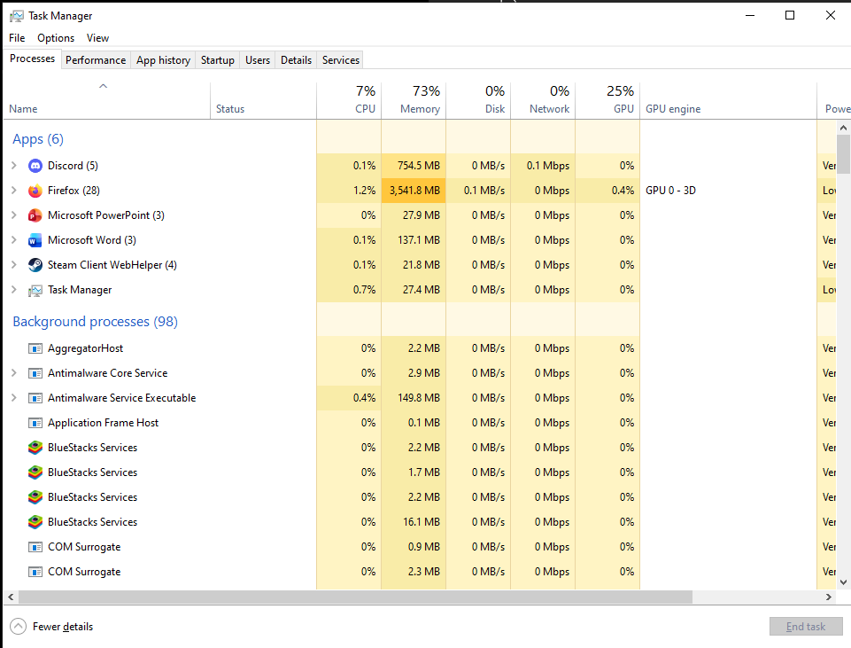
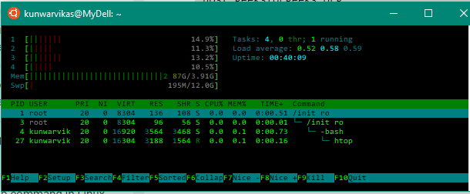

Operating Systems come with file and directory management applications. This enables users to store, organise, retrieve, and protect stored files, like photos and documents. Files for example can be moved to different areas on the drive, renamed, and deleted. Windows uses NTFS file systems, while Linux commonly uses ext4. File systems support permissions, encryption, compression, and storage allocation. Graphical tools such as Windows File Explorer and Linux file managers help users manage directories and make it easier to use, while command line tools may provide advanced administration features, but is usually more complicated.

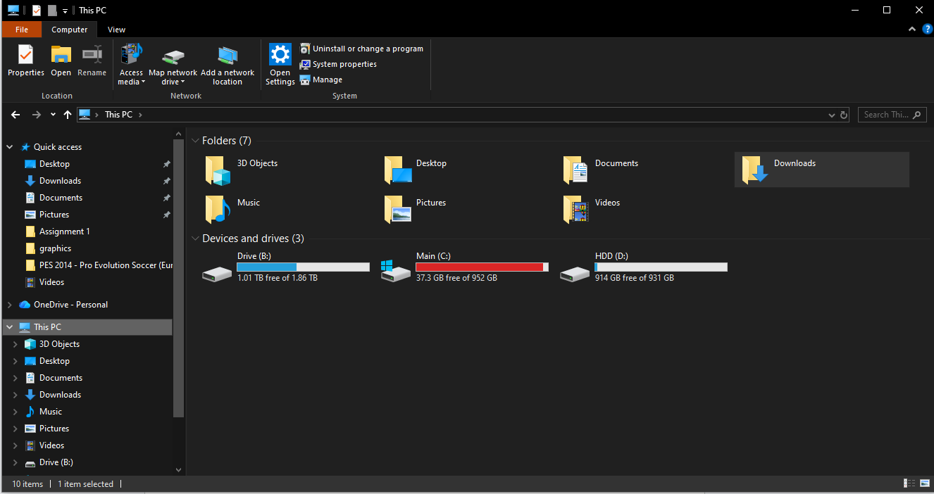

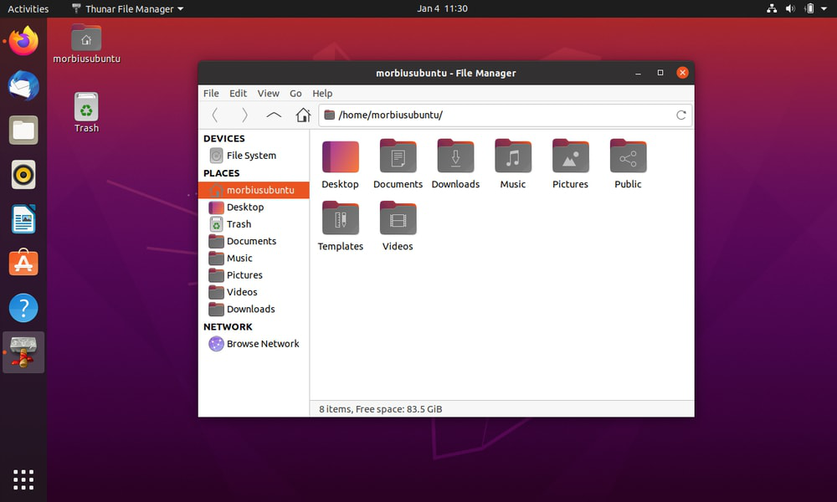

Device management allows the operating system to communicate with hardware devices including printers, storage drives, network cards, and USB peripherals like keyboard and mice. With device management software, devices may be able to be deleted, find drivers for and more. Device drivers act as communication bridges between the OS and hardware and to help functions of the devices work correctly. Windows Device Manager and Linux utilities such as lsusb and lspci allow administrators to monitor connected hardware.

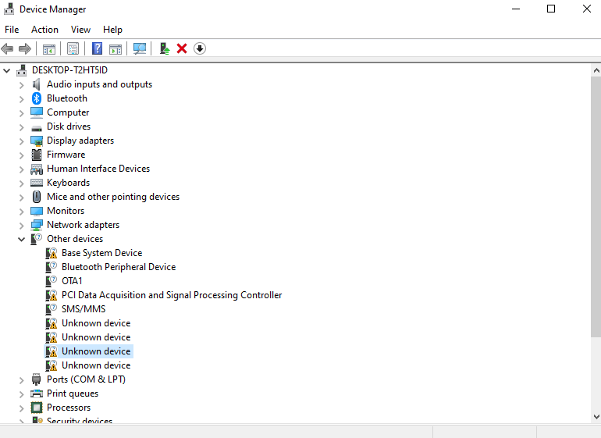

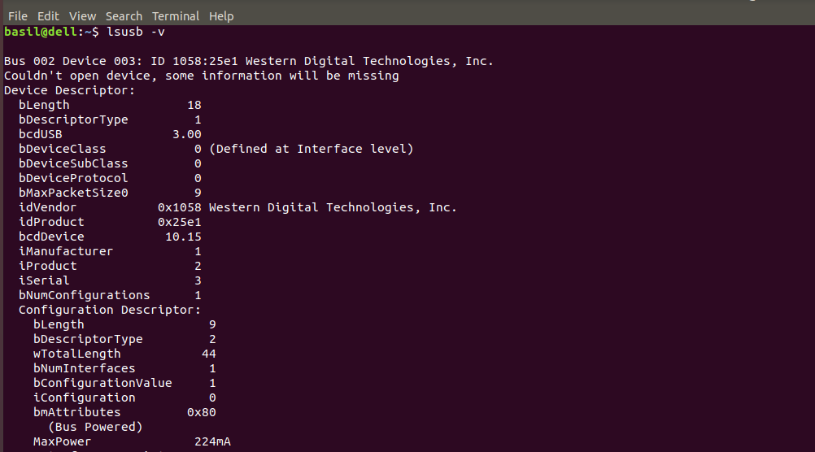

System performance monitoring programs exist on Operating Systems to help users help deal with errors or issues with their computer. For example, on Windows Reliability History, it will show past errors of applications the OS itself, helping understand how stable the computer is.

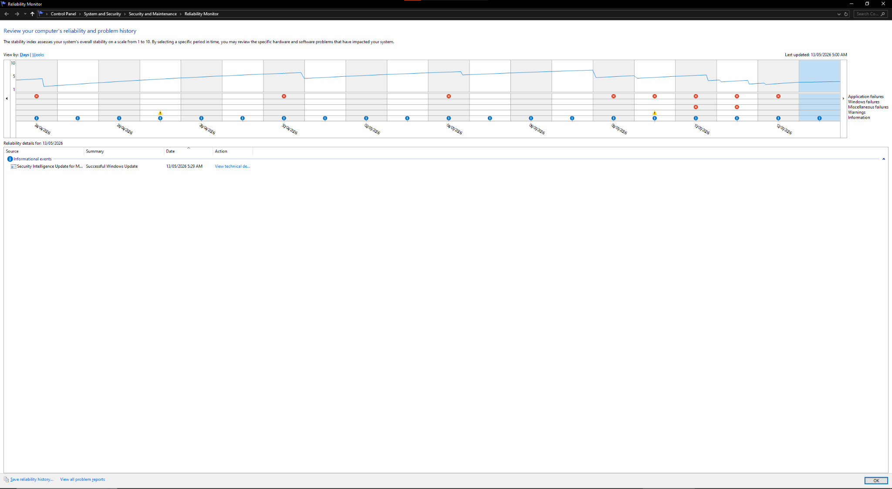

One of the most important part of an Operating System is it’s security features.(4) Applications like anti viruses and adblockers help users catch viruses that may infect their device. There is many types of computer viruses, like malware, but all are harmful and may cause issues like devices being slowed down, theft of personal info, and more. Operating Systems have built in security features like a generic antivirus, firewall, and services like UAC (User-Account Control). Security is especially important for businesses as they have a lot of sensitive info.

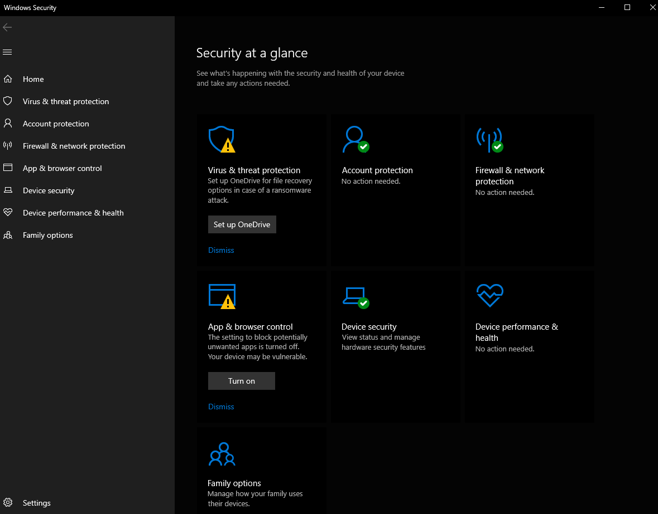

Use of Windows CLI Commands

Windows operating systems provide both Batch and PowerShell command line environments for system managing and administration. These following commands demonstrate process management, file handling, network monitoring, user administration, and task scheduling.

For process management, we can use commands such as:

Tasklist

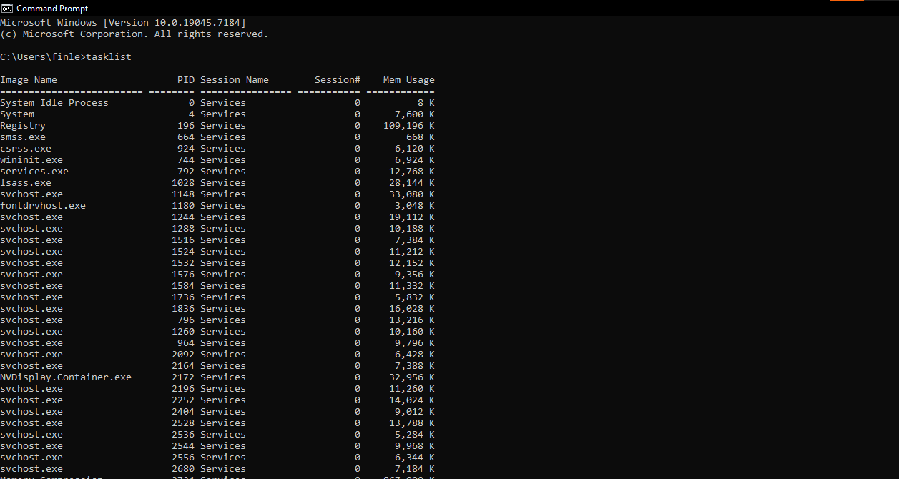

Tasklist can be a useful command, as it shows what is currently being run on the computer and how much memory it is using. It can help ensure you know what programs are running and if they’re using too much memory.

Taskkill
Taskkill can be a great command to use, as it will terminate any program of selection. This means if a program is not behaving, or will not close by itself, this can be used. Ensure not to terminate any crucial running programs to the Operating System.

For file directory management, we can use:

Dir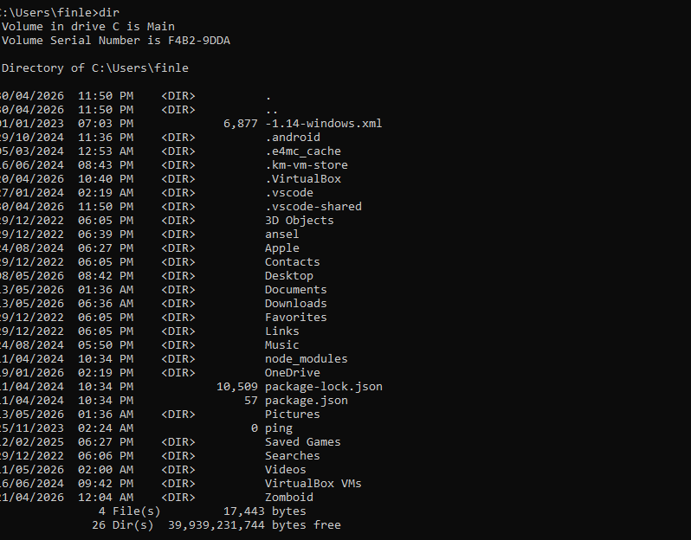

The dir command will display every directory and subdirectory on the computer. This will help understand how your file system is setup, and help you navigate through the file system on the CLI.

Mkdir

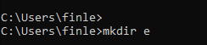

The mkdir command stands for Make Directory, so it will create a new directory with the requested name. This is useful for file system managing when you want to make new directories to store files in.

For network testing commands, these can be used:

Ipconfig
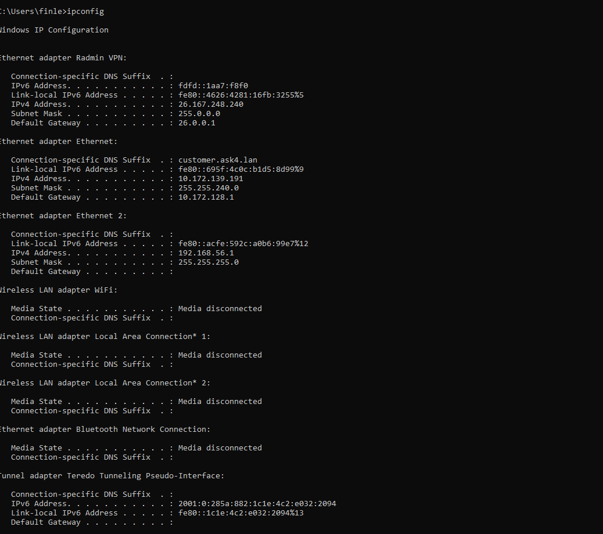

Ipconfig is a very popular and useful command in windows. It will show a lot of information about your network, like what wifi adapters are currently on your PC, and its information. It will show IP addresses, subnet masks and the default gateway. This is useful if you need network information for your computer.

Ping
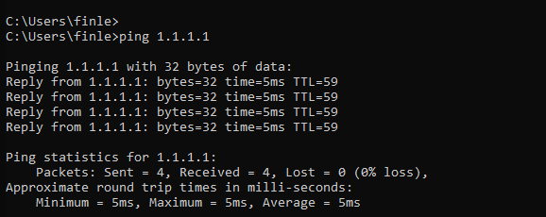
The ping command is a command that will, by default, send 4 packets of data to the requested IP and report on its success or failure on reaching the destination. This is useful as it will show if your pc is having network issues, as some or all packets will fail to ping. It also helps identify issues with whatever IP you are trying to send to, like checking if it’s online.

Netstat
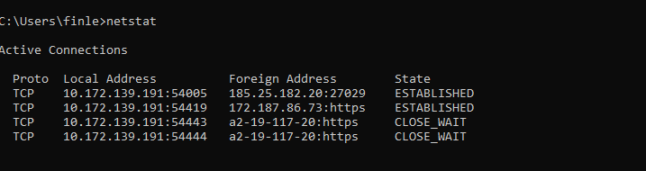

The netstat command in Windows displays active TCP connections, listening ports, ethernet statistics, and IP routing tables. It’s great for troubleshooting network issues and monitoring network activity.

Netuser

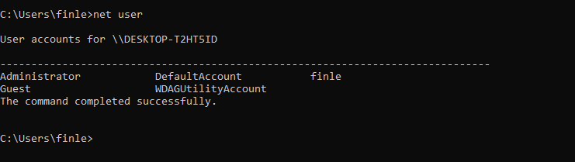

The netuser command on windows will allow administrators to create, modify, delete, and view user accounts. It is a powerful tool for managing local and domain accounts

User management commands are also useful, one example is:

Whoami

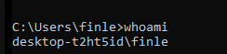

The whoami command on windows is useful for telling what user is currently logged in. This ensures users are logged onto the correct account.

For task scheduling, you can use this:

Schtasks

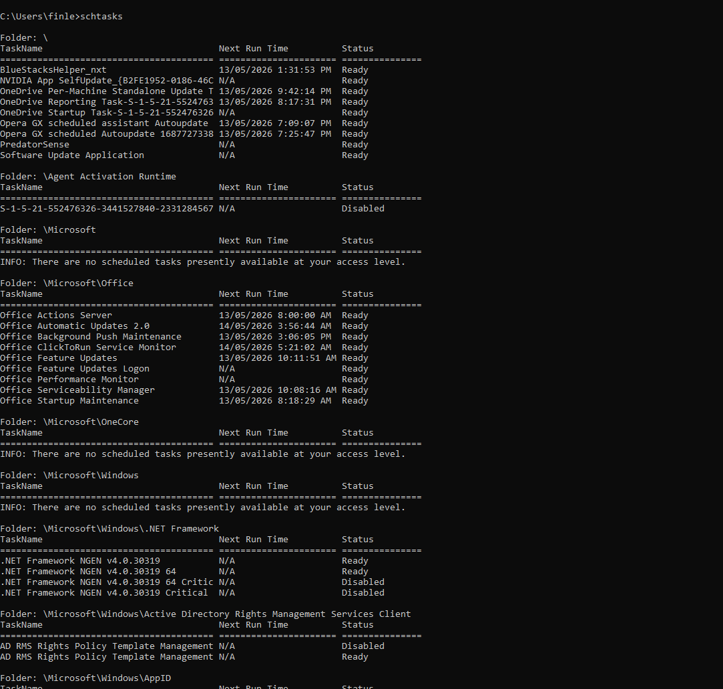

The schtaks command in Windows enables administrators to create, delete, query, change, run, and end scheduled tasks on local or remote systems. It is essential for automating scripts and programs.

Use of Linux CLI Commands

Linux systems rely heavily on Bash command line tools for administration and troubleshooting, and also just general use. These following commands demonstrate
important Linux administration functions.

Process management commands include ps aux for viewing active processes and kill for terminating processes.

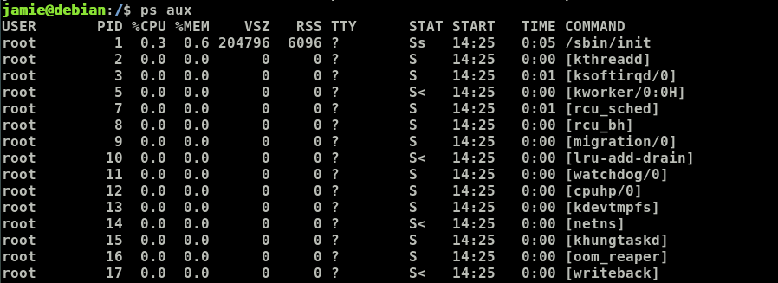
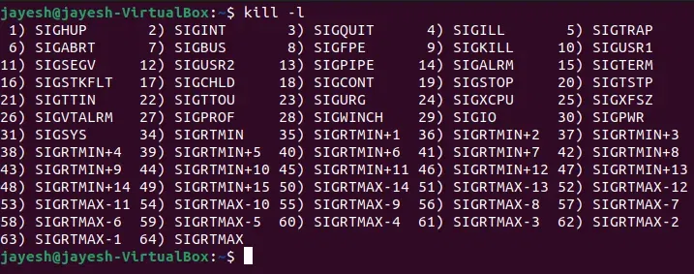

These two commands are useful for managing open processes, seeing their usage and stats, and terminating them.

The top command provides real-time monitoring of CPU and memory usage.
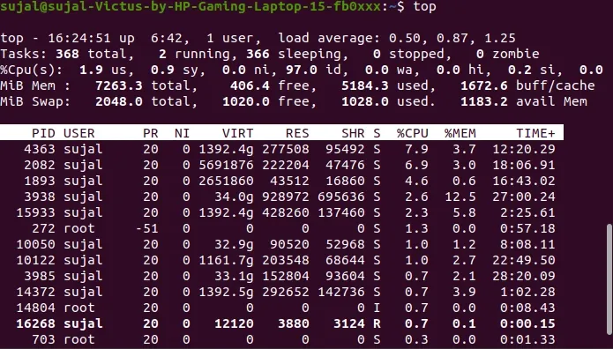
This is useful for seeing how much system resources is being used by what apps.

File and directory management commands include ls for listing files with permissions, mkdir for creating directories.

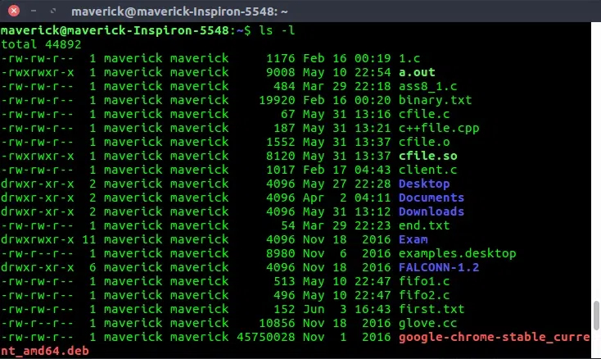
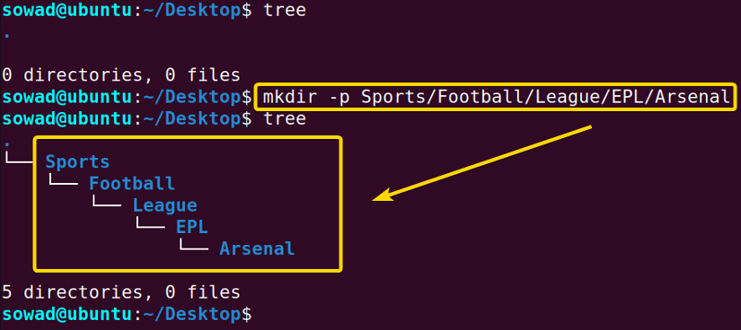
These commands are useful for managing your files, as you can view your currently directories and make new ones.

The cp command is used for copying files and rm for deleting directories recursively.
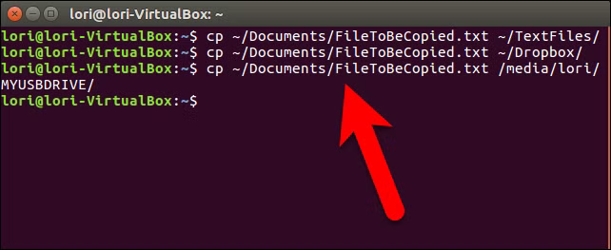
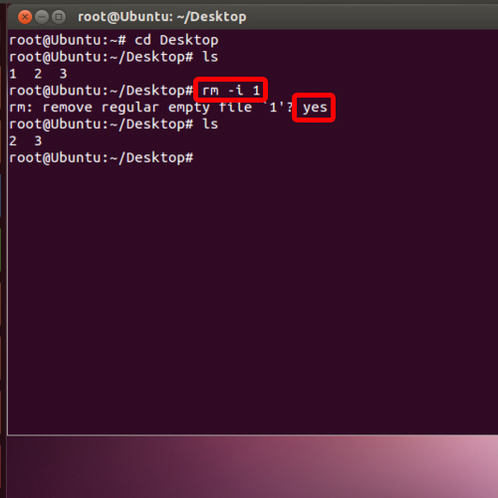
These commands are useful for managing the file system.

Network administration commands include ifconfig for displaying network configuration, ping for connectivity testing,
and netstat for viewing listening ports and active services.
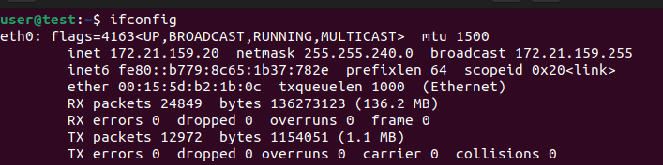
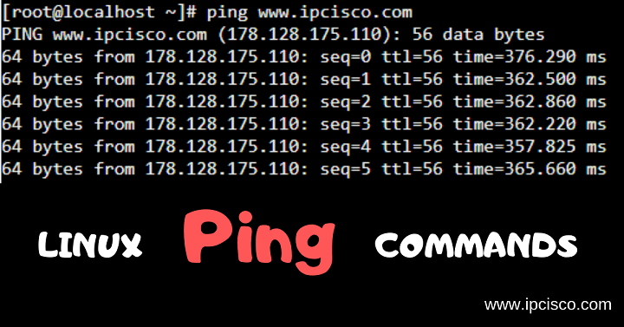

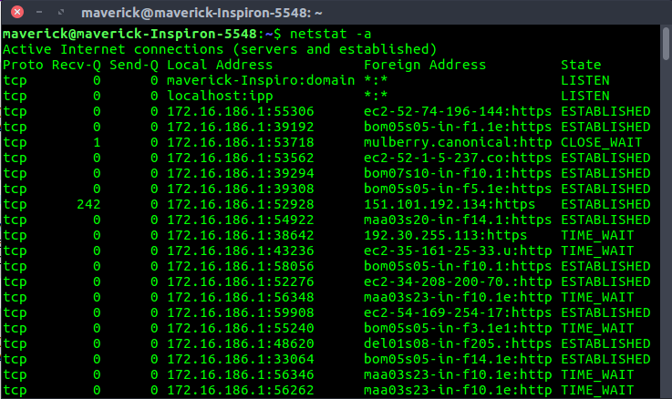

These commands are useful for identifying issues with networks and managing the networks on the computer.

User management commands include useradd for creating users and passwd for setting passwords, and whoami
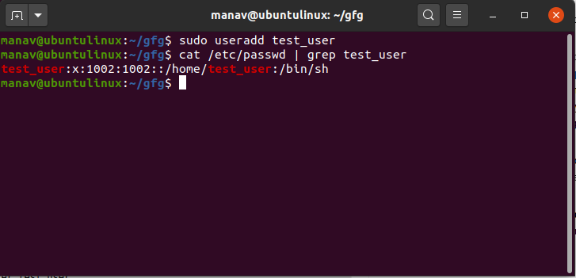

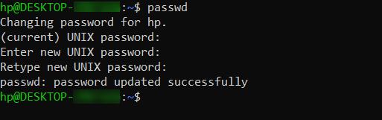
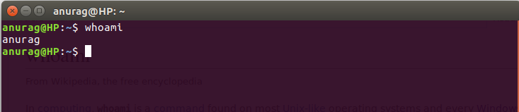

These commands are useful for managing users on the system.

Use of Windows OS scripts

Windows scripting can be performed using Batch files or PowerShell scripts. PowerShell is commonly used because it combines command line administration with scripting features and object oriented processing.
The following example PowerShell script demonstrates variables, loops, conditions, and output commands:
$users = Get-LocalUser
foreach ($user in $users) {
if ($user.Enabled -eq $true) {
Write-Output $user.Name
}
}
This script retrieves local user accounts and displays enabled accounts only. The Get-LocalUser cmdlet collects user account objects, while the foreach loop processes each object individually. The if statement checks whether the account is enabled.
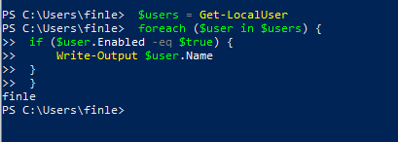
Another useful PowerShell example creates directories automatically:
$folder = "C:\Reports"
if (!(Test-Path $folder)) {
New-Item -Path $folder -ItemType Directory
}
This script checks whether a directory exists before creating it. Such automation scripts save time and reduce human error.
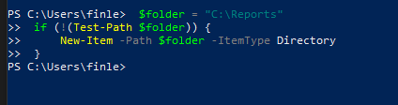
Batch scripting can also automate tasks:
@echo off
echo Backup Started
xcopy C:\Data D:\Backup /E /Y
echo Backup Complete
The xcopy command copies directories and files, while switches such as /E and /Y include subdirectories and suppress overwrite prompts.
Windows scripting is essential for automation, system configuration, and administration.

Use of Linux Commands scripts

Bash scripting is a powerful feature of Linux operating systems that allows administrators to automate repetitive tasks and manage systems efficiently.
The following Bash script demonstrates variables, loops, and conditions:
#!/bin/bash
for user in $(cut -d: -f1 /etc/passwd)
do
echo "User account: $user"
done
This script extracts usernames from the /etc/passwd file and displays them one by one using a for loop.
Another example demonstrates conditional statements:
#!/bin/bash
DIR="/home/student/reports"
if [ -d "$DIR" ]; then
echo "Directory exists"
else
mkdir $DIR
fi
The script checks whether a directory exists and creates it if necessary. The -d operator tests directory existence.
A backup automation example:
#!/bin/bash
tar -czf backup.tar.gz /home/student/documents
echo "Backup complete"
The tar command compresses and archives files into a backup package.
Bash scripting is widely used in Linux server administration, DevOps, cybersecurity, and cloud computing because it provide efficient automation and system control.

Conclusion

This report explored the key functions of modern operating systems and demonstrated the use of command-line interfaces and scripting tools in both Windows and Linux environments. Operating systems perform essential tasks including process management,
memory allocation, device communication, networking, file management, and security enforcement. Windows and Linux both provide powerful command line environments that support system administration and troubleshooting.

The report also demonstrated how scripting languages such as PowerShell and Bash can automate repetitive tasks, manage users, create backups, and improve administrative efficiency. CLI tools and scripting are essential skills for IT professionals because
they allow greater control over systems compared with graphical interfaces.

Operating systems are fundamental to modern computing and provide the platform on which applications, networks, and digital services operate. Understanding command line tools and scripting enhances productivity, supports troubleshooting, and
prepares students for careers in networking, cybersecurity, cloud computing, and systems administration. (5)

Append

OS types from Tutorial 1
General purpose OS like Windows
Mobile OS like android
Network OS like FreeBSD
Real time OS like an an ATM OS
Embedded OS like ones used in cars
Ai OS

Refs

[1] https://www.facebook.com/GeekomUK/about, “Linux vs. Windows: Why Most Choose Windows? – GEEKOM UK,” GEEKOM UK, Oct. 27, 2025. https://www.geekom.co.uk/linux-vs-windows
‌[2] Computer Hope, “What are the features of Microsoft Windows?,” Computerhope.com, 2019. https://www.computerhope.com/issues/ch001967.htm
[3] Kannan N, “Process Management in Operating Systems — A Comprehensive Guide,” Medium, Jun. 23, 2024. https://medium.com/@Kannan91/process-management-in-operating-systems-a-comprehensive-guide-4a2007b66756
[4] GeeksforGeeks, “Operating System Security,” GeeksforGeeks, Jan. 05, 2023. https://www.geeksforgeeks.org/operating-systems/operating-system-security/
‌[5] N. Garg, “6 Reasons you should be learning CLI,” Medium, Aug. 16, 2025. https://medium.com/@codenaveen/6-reasons-you-should-be-learning-13a85c321cc1
‌

‌

‌

