

Series Hybrid Vehicle CW1

ACEA7007: Hybrid Powertrain and Control

Student: 2109787 (Jaimishkumar V. Navadiya )

Lecturer: Mr. Mark Sandford

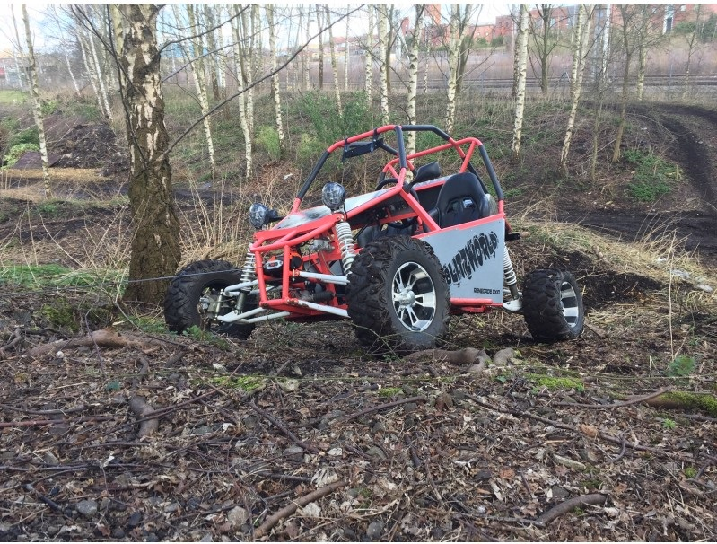

Content
- Abstract ………………………………………………………………………….……….3
- Introduction…………………………………………………………………….………….3
- Dual purpose course track…………………...…………………………………….…………4
- Calculations…………………………...………………………….……………………….4
  - Assumptions………………………………………………………………….………...4
    - Gear ratio……………………………………………………………………….4
    - Masses…………………...………………………………………….…………5
      - Test mass……………………………………………………………………5
      - Wheel assembly………………………………………………………………5
      - Reduced mass…………………………………..………………….………...5
    - Frontal area………………………………………..………….………………...6
    - Coefficient if Aerodynamic drag………………………………………….…………6
  - Forces acting on the course…………………………………………………….………….6
    - Aerodynamic resistance ……………………………...……………….…………...7
    - Rolling resistance……………………………………...……………...……...…...7
    - Gradient resistance…………………………………………………….……….....7
    - Inertia resistance………………………………….……...…………………….....8
  - Traction Force………………………………………………….….……...…………… 8
  - Engine Torque…………………………….……...…………………………………… 8
  - Brake Specific Fuel Consumption (BSFC) ………….……………...………………………..9
  - Fuel Consumption……………………………………………..…….…………………..9
- Results…….……………………………………………………….……………………10
  - Dyno chart ……………………….…………………………………………………...10
  - Velocity ……………………...…………………………….………………………...10
  - Acceleration & Deceleration……………………..…….….……...…...…………………11
  - Resistance Force…………….………………………………………….……………...11
  - Net Resistance Force…………………………………………………………………....12
  - Power………………………………….……………...……………………………...12
  - Work done……………….……...............................................................…………….12
  - Fuel Flow Rate……………….….............................................................…………….13
  - Total Fuel Consumption…………...............................................................…………….13
  - Energy Dissipation…….............................................................................…………13
- Results…………………….…………………………………………………………….14
- Conclusion……………………………………………………………………………….15
- References………………………………..…………...…………………………………16
- Appendix……………………………………………...…………………………………17

- Abstract
In this simulated study, the duty cycle of the off-road buggy (renegade dx 10C) over a dual-purpose racecourse is generated to analyze the fuel consumption and vehicle performance. The course is a combination of 3 different surfaces, designed to utilize optimum performance of torque-oriented power trains that consists of a total climb of 20 meters. To analyze the dynamic behavior of the buggy, the document will explore the resistance forces acting on buggy and fuel consumption for one lap.

2. Introduction
The overall purpose of a buggy is to efficiently accelerate in different course irregularities such as bumps, surface conditions, and transfer torque for a hassle-free enduring experience without compromising on the agility of the vehicle. The geometry with extremely low center of gravity helps the vehicle to perform in tricky weather conditions. The primary objective of this test is to obtain the fuel consumed under maximum performance, using appropriate calculations regarding the dynamic processes experienced throughout a lap, to output a simulated lap time for Renegade Dx-10C.Secondly, obtaining maximum fuel consumption for a full tank of gasoline gives the maximum fuel efficiency of the buggy. Mapping the track layout is the first step into creating the model and categories the circuit into a series of straights and corners, with which the dynamic processes can be split into steady state cornering, acceleration, and braking.

3. Dual purpose course track
I consider waterfront visitors car parking as course track. I assume that the layout in this experiment for Renegade dx 10c consisted of four different surfaces of tracks. The whole track is 1971m long.
The course track layout considered by me for experiment is shown in below figure (1).

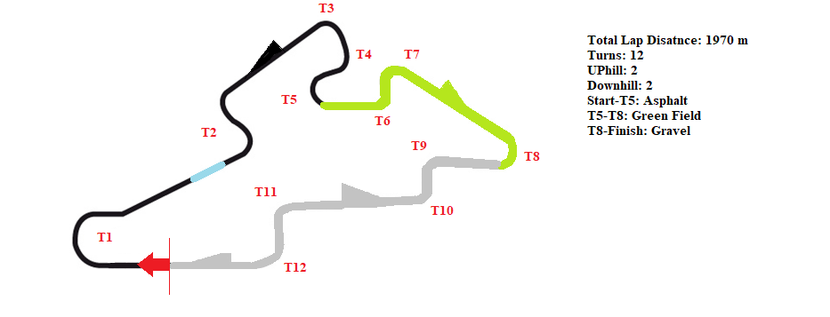
Figure 1: Course Track Layout

4. Calculations
4.1 Assumption
4.1.1 Gear Ratio
Renegade Dx-10c consists of a CVT transmission assembly where an infinite number of gear ratio possible. But for simulation we assume that convention gear transmission is used in this vehicle which has 3 speed gearboxes. The gear ratio we used in this experiment is shown in the following table 1.

Gear | Input | Output | Gear Ratio | Overall Ratio | Top Speed(m/s) | Top Speed (km/h) | Top Speed (mph)
1st | 11 | 29 | 2.636363636 | 22.72922078 | 7.602753669 | 27.36991321 | 17.00690379
2nd | 15 | 29 | 1.933333333 | 16.66809524 | 10.36739137 | 37.32260892 | 23.19123244
3rd | 21 | 31 | 1.476190476 | 12.72687075 | 13.57793837 | 48.88057813 | 30.37303346
Final Drive | 15 | 51 | 3.4
Primary Drive | 28 | 71 | 2.535714286
Table 1: Gear Ratio

4.1.2 Masses
4.1.2.1 Test Mass
Kerb weight of renegade was mentioned in the specifications data. The buggy was assumed to be tested with a fuel of 10 liters, pouring 1.5 liters of oil and a passenger for prime dynamics at challenging sectors during corporate event. The values of lubricant and fuel in kg are considered by multiplying the available quantity in liters with the density of respective liquid.
Driver + Passenger Weight (kg) | 144
Fuel + Oil Weight (kg) | 16.11
Kerb Weight (kg) | 345
Total Weight (kg) | 521.71
Table 2: Test Mass

4.1.2.2 Wheel Assembly
The wheel and tire masses are assumed by converting the relevant tire specifications 24*8*12 to 175/60R12. The more mass an object has the more energy it takes to accelerate. To accelerate a rolling object such as wheel, we must both accelerate its mass plus overcome its rotational inertia.
Tires Mass (kg) | 10.2
Wheels Mass (kg) | 6.4
Total Assembly Mass (kg) | 16.6
Table 3: Wheel and Tire Mass
(http://the-welters.com/racing/rotational.html)

4.1.2.3 Reduced Mass
$$Reduced Mass=Total test mass+4*\left(\frac{Wheel Inertia}{{Wheel Radius}^{2}}\right) +Engine Inertia*{\left(\frac{ Gear Ratio}{Wheel Radius}\right)}^{2}$$
(https://en.wikipedia.org/wiki/Reduced_mass) …………… (1)
Equation 1 depicts that reduced mass is directly proportional to the gear ratio. So the different gear ratio has different reduced mass. A reduced mass with respect to all 3-gear ratio is given in table 4.

Equivalent Mass in Gear 1 | 575.2066326
Equivalent Mass in Gear 2 | 568.9254141
Equivalent Mass in Gear 3 | 565.8780235
Table 4: Reduced Mass

4.1.3 Frontal Area
Renegade Dx-10c buggy has drag effects on 2 tires, wide outside the body panel as it is open to longitudinal acceleration. From specifications, the frontal area of the tire can be calculated by considering it as a rectangular area of cross section from front view. Driver and passenger should experience the drag. The frontal area can be calculated as the sum of Frontal area of driver, passenger and panel, tires.
Frontal area = 1.151 m²

4.1.4 Coefficient of Aerodynamic Drag
As per given data, we can measure frontal effective area of vehicle. In this experiment, frontal area is measured as 1.151 m². The drag coefficient for renegade had to be assumed as 0.7 which is an average of values of drag coefficient of Open top convertible vehicle and flat plate (face on flow). The assumption is made from https://www.engineersedge.com/fluid_flow/aerodynamic_drag_13632.htm .

4.2 Forces acting on the course
There are four resistive forces acting on moving vehicles. There are Aerodynamic force, Rolling force or Friction force, Gradient force, and Inertia force.
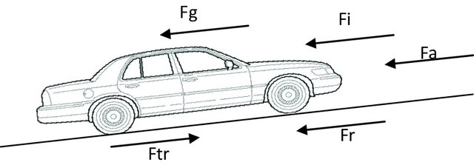
Figure 2: Forces acting upon moving vehicle

4.2.1 Aerodynamic Resistive Force (F_{a})
$F_{a}= \frac{1}{2} ρA_{f}C_{d}({V_{car}±V_{wind})}^{2 }$………………….. (2)
F_{a}= Air Resistance (N)​
ρ= Air Density (kg/m³)​= 1.167 kg/m³
A_{f} = Car frontal area (m²)​= 1.151 m²
C_{d} = Coefficient of Aerodynamic Resistance (drag coefficient)​= 0.7
V_{car} = Car velocity (m/s)​
V_{wind} = Wind velocity (m/s)​
(+) with head wind, the wind velocity opposite the car velocity direction​
(-) with tail wind, the wind velocity in the same direction of car velocity

https://slidetodoc.com/12-tractive-effort-and-tractive-resistance-nazarin-b/

4.2.2 Rolling Resistance (F_{r})
F_{r} = μ_{R} W; ​…………… (3)
F_{r} = μ_{R} mg​ ……………… (4)
​
F_{r}= Rolling resistance (N)​
μ_{R} = Coefficient of rolling resistance
W= Car weight (N)​
M= Car mass (kg)​
g= acceleration due to gravity = 9.8 m/s²

 | µ_{R}
Rolled gravel | 0.200
Concrete Asphalt | 0.013
Standing water | 0.155
Field | 0.100
​​Table 5: Rolling coefficient

4.2.3 Gradient Resistance (F_{g})
F_{g} = ±W Sinθ …………… (5)
F_{g} = Gradient resistance (N)​
W = Car weight (N) = mg (kg m/s²)
θ= Gradient angle < 2.3° for highways​
5.7°: 6.9° for local road​
11.5° max grad​
(+) with car going up to hill (ascending) {Resistance effort}​
(-) with car going down to hill (descending) {Tractive effort}​

Sinθ1 (slop 1 uphill) | 0.13864
Sinθ2 (slop 1 downhill) | 0.20372
Sinθ3 (slop 2 uphill) | 0.11803
Sinθ4 (slop 2 downhill) | 0.16229
Table 6: Gradient values

4.2.4 Inertia Resistance (F_{i})
IR = ± ma = ± (m_{car} + m_{eq}) a​ ………………. (6)

​
m= Car mass + Equivalent mass of rotating parts (kg)​
a= Acceleration (m/s2)​
From 0 to 100 km/h in 6 seconds a= 4.63 m/s²​
10seconds a= 1.543 m/s²
(+) with car in acceleration (Tractive resistance)​
(-) with car in deceleration (Tractive effort) ​

​​

4.3 Traction Force

Traction force can be calculated by equation 7.

$Traction Force =Traction Coefficient ×\sum_{ }^{ }{Resis}\tan{c}e Forces$ ………. (7)

Traction Coefficient (Asphalt) | 0.85
Traction Coefficient (Gravel) | 0.7
Traction Coefficient (Field) | 0.6
Traction Coefficient (Water splash) | 0.3
Table 7: Traction coefficients

4.4 Engine Torque

If traction force is known, then we can calculate required torque at wheel by equation 8.

$Torque at wheel = Traction force × Rear wheel effective radius$ …....……. (8)

From wheel torque, we can calculate engine torque by equation 9. Gear ratios are calculated in table 1.

$T_{w}= T_{e}×i_{g}×i_{f}×η$ …...……. (9)

4.5 Brake Specific Fuel Consumption (BSFC)
Table (7) is considered as BSFC data. I use mean method to find BSFC for changing of every 500 rpm.
Table 8: BSFC

4.6 Fuel Consumption
The fuel usage per metre and across the whole lap was calculated using equation (14). From the simulated data buggy consumes around 2.65 litres of fuel in one complete lap, considering performance with torque utilisation in competitive terrains. The fuel usage is strictly dependant on the driver where a professional sportsperson is considered to drive the lap. For calculations density of petrol is taken as 0.755 kg/cm³.
If the specific consumption in g/kW·h is known, we can calculate fuel consumption in liter per hour by equation (14).
$Q= \frac{BSFC × P_{e }}{ρ}$ …………………………. (7)
Q = maximum theoretical fuel consumption in grams per 1 hour of engine operation at maximum power [in liter/hour],
P_{e} = Engine power [in hp],
ρ = Fuel density [in kg/m³]

5. Results
Data to analyze the performance of renegade dx-10c in distinct parts of the simulated track conditions are follows.

5.1 Dyno chart
Graph (1) Dyno chart
Power and torque are related to each other in every increment of rpm to that of gear ratios. According to the higher gear ratios used for the simulation of renegade dx-10c the torque is more than power until 6500 rpm where both power and torque curves intersect as obtained in Graph (1).

5.2 Velocity (mph)
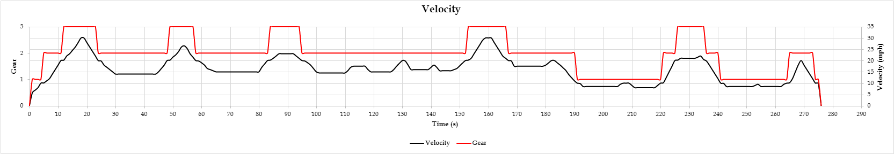Graph (2) Velocity and Gear
Graph (2) demonstrates the velocity pattern followed by vehicle in particular gear selection by buggy. As per graph, it is seen that maximum velocity of vehicle does not exceed more than 30 mph. Gear selection is also shown in this graph which is also satisfied for velocity. Maximum velocity for gear 1 selection does not exceed more than 17 mph. For gear 2, maximum velocity can be achieved is 23mph, while for gear 3 it is 30mph.

5.3 Acceleration (m/s²) & Deceleration (m/s²)
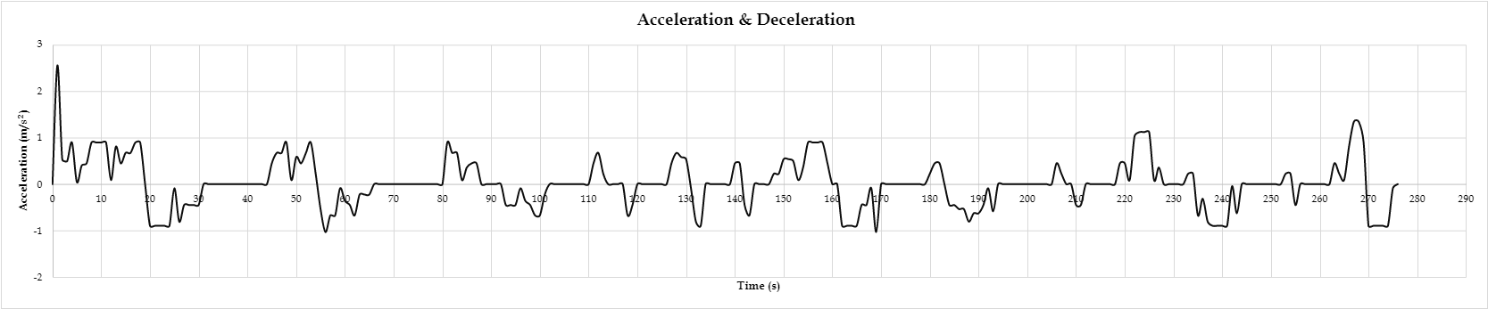Graph (3) Acceleration & Deceleration
Graph (3) depicts acceleration and deceleration of buggy during course. It is seen that maximum acceleration is 2.54 m/s² is due to an initial inertia resistance force.

5.4 Resistance Forces (N)
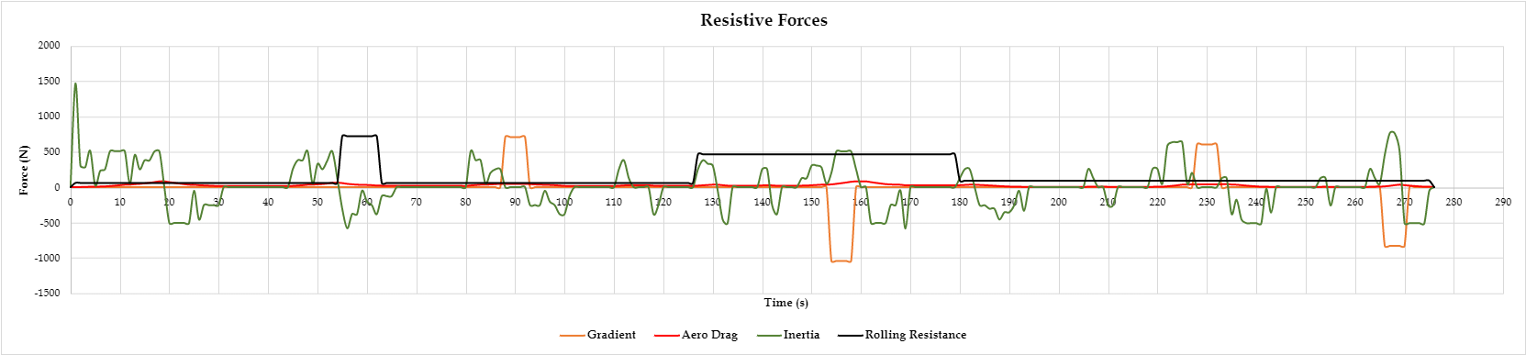Graph (4) Resistance Forces
Graph (4) shows all 4 resistive forces throughout travel. Inertia resistance depends on acceleration and deceleration of vehicle, so it changes throughout the course. Where buggy accelerate, force will be positive and resist to accelerate the vehicle. Where the vehicle decelerates, the resistance force will be negative. Rolling resistance only depends upon friction coefficient, and so in distinct terrain has constant rolling resistance force and it is always opposite the motion of vehicle. Gradient resistance force only changes when gradient changes. Gradient resistance will be either positive or negative. When a vehicle is acceding uphill, it resists motion and so it will be positive. While a vehicle is descending downhill, it becomes supportive force and helps to increase motion of a vehicle. It will not resist motion of vehicle so it will be negative. Aero drag force directly proportional to the square of velocity. When velocity increases aero drag will increase. It is only zero when a vehicle is not moving. Here, we do not consider wind velocity in this simulation. That means we only consider vehicle speed.

5.5 Net Resistance Force (N)
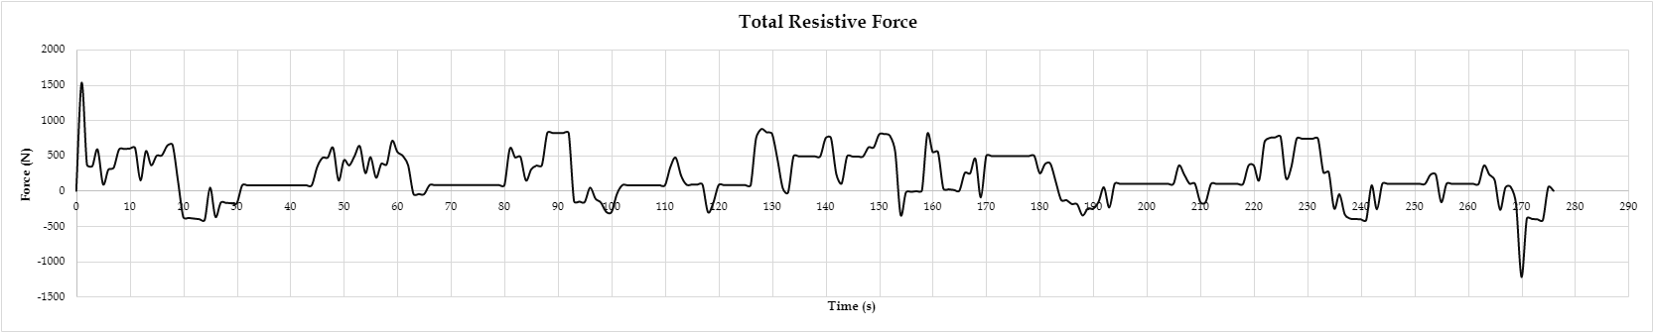Graph (5) Net resistance force
Graph (5) illustrates total resistive forces acting on buggy.

5.6 Power (kW)
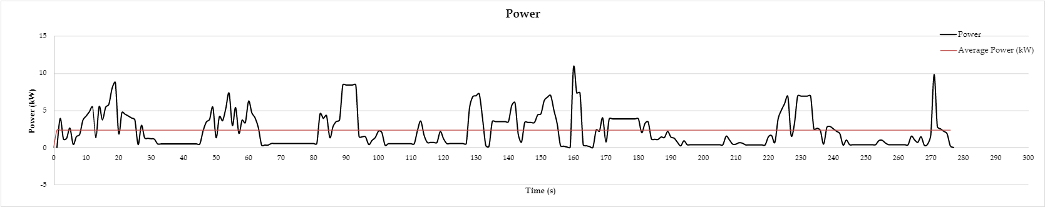Graph (6): Power
Graph (6) shows power in kilowatts that we exert from engine throughout the course. The power is highest while a buggy is moving at maximum velocity and while ascending the uphill. Throughout the course, a vehicle used average 2.328972913 kW/s. During travelling uphill and maximum speed, if any additional power is given to a vehicle, it is beneficial to decrease fuel consumption and engine load.

5.7 Work done
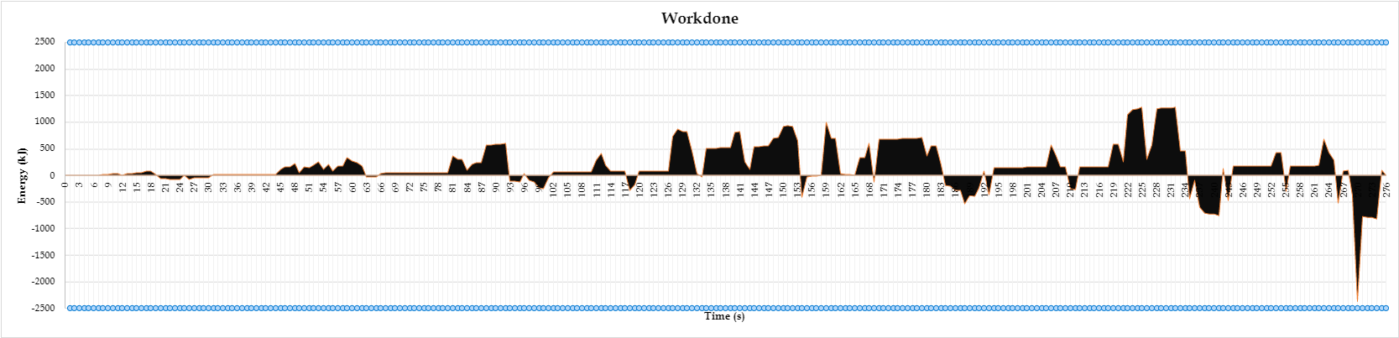Graph (7): Work done
Vehicles need to work for continuous motion throughout the track. As shown in graph (7), areas under positive curse, it depicts that during this time engine need to produce power or can say that propeller need power to move a vehicle. But areas under the negative curve, we can say that during this time the vehicle does not need to produce power, or we do not need to throttle to the engine. It is time when net resistive forces will be negative. Because work done can be calculated by Force multiply by distance.
5.8 Fuel Consumption (g), Total Fuel Burned (L)
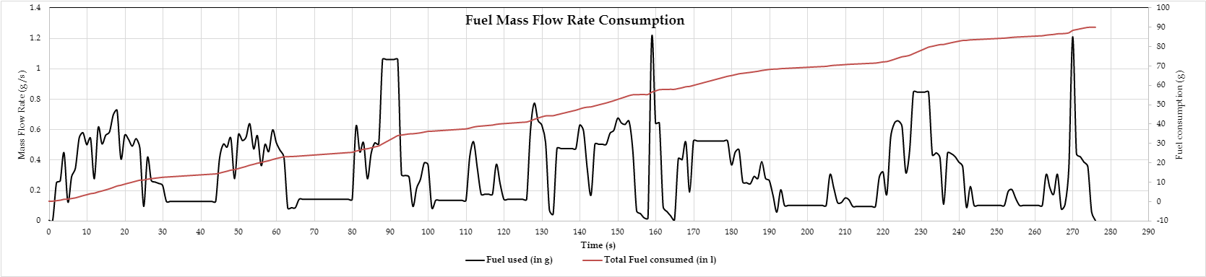Graph (8) Fuel consumption
Graph (8) gives information about fuel mass rate per second as well as total fuel burn during completion of one lap. Fuel mass flow rate can be calculated by equation 14. Brake Specific Fuel Consumption (BSFC) is taken from table 7. It is seen that during max speed and uphill, a vehicle burns maximum fuel due to work done by engine. For complete one lap, a vehicle consumed 89.76-gram fuel which equals to approximately 0.12 liters. That means a vehicle can travel 16.42-km per liter. Suppose fuel tank capacity is 29 liters, then a buggy can travel approximately 216 complete laps.

5.9 Energy Dissipation (kWh)
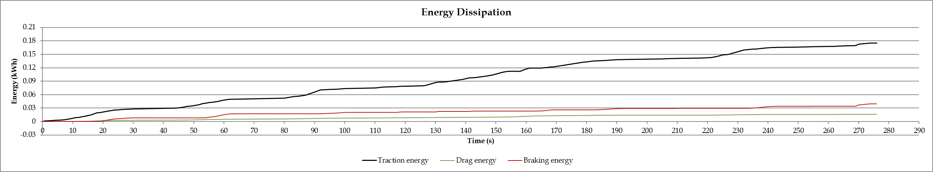Graph (9): Energy Dissipation
Graph (9) shows total traction energy, drag energy and braking energy during one lap. Total traction energy used by a vehicle is approx. 0.175 kWh while braking energy is 0.039 kWh which is 23% of traction energy.

6. Result
Lap Distance (km) | 1.97
Fuel consumed (l) | 0.119995787
Fuel consumed (g) | 89.7568485
Liters per km | 16.41724308
Maximum speed (mph) | 30
Maximum speed (km/h) | 48.28023997
Average speed (km/h) | 25.62571052
Maximum lap possible with full tank | 216.67
Total traction energy (kWh) | 0.175221095
Total energy consumed by Drag (kWh) | 0.016510405
Total energy consumed by Braking (kWh) | 0.039608906
Braking energy percentage (%) | 23%
Time taken for one lap | 4:36
Table 9: Lap result
A vehicle takes 4 minutes 36 seconds to complete one lap. Total lap distance is 1.97 kilometers. To complete one lap, a vehicle consumes 0.119 liters of fuel or 89.76 grams. A vehicle can gain a maximum of 30 mile per hour speed. If we consider the fuel tank to be full, then a buggy can travel 216 complete 216 laps.
Maximum Engine Speed (RPM) | 6500
Maximum Engine Torque (Nm) | 22
Maximum Power Develop by Engine (W) | 14967.33333
Maximum Power Developed by Engine (HP) | 20.06344951
Effective Frontal Area (m²) | 1.151
Front Wheel Radius (mm) | 304.8
Rear Wheel Radius (mm) | 254
Front tyre Radius (24*8-12) (m) | 0.307692308
Rear tyre Radius (23*10.5-12) (m) | 0.294871795
Driver + Passenger Weight (kg) | 144
Fuel + Oil Weight (kg) | 16.11
Kerb Weight (kg) | 345
Total Weight (kg) | 521.71
Drag Coefficient | 0.7
Wind Speed (m/s) | 2.23
Air Density (kg/m³) | 1.167
Rolling Coefficient (μ_{R}) Asphalt | 0.013
Rolling Coefficient (μ_{R}) Gravel | 0.02
Rolling Coefficient (μR) Standing water | 0.155
Rolling Coefficient (μR) Field | 0.1
Traction Coefficient ( Asphalt) | 0.85
Traction Coefficient ( Gravel) | 0.7
Traction Coefficient ( Field) | 0.6
Traction Coefficient ( Water splash) | 0.3
Wheelbase (mm) | 1940
Height of COG from Ground (mm) | 488
Distance of COG from Front Wheel Centre (mm) | 1070
Distance of COG from Rear Wheel Centre (mm) | 870
Angle of Buggy Lifted (Degree) | 18
Angle of Buggy Lifted (Radians) | 0.314159
tan(18°) | 0.32491
Load on Rear Wheel (kg) | 207
Load on Rear Wheel while Lifted (kg) | 193
YCOG | 769.737977
XCOG | 521.696752
Tires Mass (kg) | 10.2
Wheels Mass (kg) | 6.4
Total Assembly Mass (kg) | 16.6
Radius of Gyration Front Wheel (K_{front)} | 0.27432
Radius of Gyration Rear Wheel at 6500rpm 1st Gear | 0.2286
Inertia of Front Wheel | 1.249174276
Inertia of Rear Wheel | 0.867482136
Inertia of Engine | 0.17
Equivalent Mass in Gear 1 | 575.2066326
Equivalent Mass in Gear 2 | 568.9254141
Equivalent Mass in Gear 3 | 565.8780235
Table 10: Specifications and Data

7. Conclusion
This report has shown the Renegade dx 10c characteristics on a dual-purpose terrain course across a lap. Considering the design of renegade to driver characteristics the test was conducted by a professional sportsperson to obtain maximum fuel consumption for the given engine specifications. Looking for the wide perspective of Renegade users there are long distance tourer and adventure seekers who want to serve the purpose where terrain and weather challenges need to be considered. The test was conducted in dry conditions. The wet conditions would be difficult to obtain the maximum efficiency where the real performance should have been tested to ensure the reliability of Renegade in outdoor conditions.
Rolling resistive and gradient resistive forces are acting on Renegade dx 10c influence on the buggy performance. Introducing adventure tires which can accumulate a vast volume of terrain surface between the grooves can improve the rolling characteristics in different terrains. Due to the absence of front wheel drive, buggy finds it hard to negotiate with the gradient and drive conditions, introducing an electric motor drive for the front wheel drive can improve the efficiency of the renegade on real world terrain conditions.
The quantity of fuel used by the renegade is a considerable amount at maximum performance considering the brake specific fuel consumption generated. The CVT transmission of buggy can save a considerable amount of fuel loss due to gear shifting. Meanwhile introduction of all wheel drive can have supplementary improvement in fuel efficiency.
8. References

- http://the-welters.com/racing/rotational.html &
https://view.officeapps.live.com/op/view.aspx?src=http%3A%2F%2Fthe- welters.com%2Fracing%2Frotational.xls&wdOrigin=BROWSELINK , March 17, 2002

- Aleksander UBYSZ
http://transportproblems.polsl.pl/pl/archiwum/2010/zeszyt1/2010t5z1_04.pdf (2010)
- https://en.wikipedia.org/wiki/Reduced_mass
- https://www.engineeringtoolbox.com/rolling-friction-resistance-d_1303.html
- https://buildingclub.info/calculator/g-kwh-to-l-h-online-from-gram-kwh-to-liters-per-hour/
- https://slidetodoc.com/12-tractive-effort-and-tractive-resistance-nazarin-b/
- http://www.thecartech.com/subjects/auto_eng/car_performance_formulas.htm
- https://www.engineeringtoolbox.com/car-acceleration-d_1309.html

9. Appendix
Table (1) Gear Ratio
Table (2) Test Mass
Table (3) Wheel and tire mass
Table (4) Reduced Mass
Table (5) Rolling Coefficient
Table (6) Gradient values
Table (7) Traction coefficients
Table (8) BSFC
Table (9) Lap Results
Table (10) Specifications and Data
Graph (1) Dyno chart
Graph (2) Velocity and Gear
Graph (3) Acceleration and Deceleration
Graph (4) Resistive forces
Graph (5) Net resistance force
Graph (6) Power
Graph (7) Work done
Graph (8) Fuel consumption
Graph (9) Energy dissipation
Equation (1) Reduced Mass
Equation (2) Aerodynamic Resistive Force
Equation (3) Rolling Resistance
Equation (4) Rolling Resistance
Equation (5) Gradient resistance
Equation (6) Inertia Resistance
Equation (7) Traction force
Equation (8) Torque at wheel
Equation (9) Engine Torque
Equation (10) Fuel mass flow rate
Figure (1) Course Track Layout
Figure (2) Forces acting upon moving vehicle

