Question 3:
“If ever one art movement consumed the entire illustration genre, it was Surrealism” (Heller and Chwast, 2008, p.70). Discuss with reference to contemporary illustration.

2005076 (Rhian Powell)
BA Illustration - Research in Context (ADAD5003)
Word count: 2605 words

Delyth Lloyd-Evans
The landscape of modern illustration is one peopled with a diversity and individualism that cannot be classed under one style or derivation. As publishers and customers alike demand more colour and intrigue from what they see, buy, and digest, it has become the illustrator’s duty to be versatile and expressive. Nevertheless, a connection can be drawn between these illustrators and art movements of the past. Heller and Chwast (2008, p.70) argue: “If ever one art movement consumed the entire illustration genre, it was Surrealism”, and in this essay I plan to not only corroborate this statement, but additionally home in on a particular branch of the discipline that I feel best demonstrates the Surrealist influence at work: children’s book illustration.

Many consider artists like Dalí and Magritte as the founders of Surrealism, but it was in fact André Breton who kickstarted the movement in 1924. Riding on the coattails of the dying Dadaist Movement, Breton sought to cumulate like-minded artists of all disciplines who rejected the “reign of logic” that he observed the world to be living under (1924). References to childhood and the limitless creativity of the youthful mind are abundant in his manifesto, evidencing the original intentions of the Surrealist movement:
It is perhaps childhood that comes closest to one's "real life"; […] childhood where everything nevertheless conspires to bring about the effective, risk-free possession of oneself. Thanks to Surrealism, it seems that opportunity knocks a second time.
(Harrison and Wood, 2003, pp. 878-8)
Given that the Movement was conceived in the tumultuous environment of a post-war world, one could assume that it was a form of escapism, a retreat from the dismal uncertainty of existence; this, however, is quite far from the truth. The Surrealist aim was not to create an alternate, bizarre world separate from the real one, but to reveal to others the true absurdity of reality. The movement was in essence a critique of the Enlightenment ideology sweeping the nation during the 19th century, a frame of mind that claimed rationality above all. As written in Anxious Visions (Stich, 1990, p. 130): “The surrealists aimed to provoke a radical change in thinking about human nature”, and they achieved this by pushing the importance of the human mind. Breton’s fascination with the untapped power of the subconscious and dream interpretation became the driving force behind the art and studies produced; Automatism was one of the staples behind said work, a practice involving writing or drawing free of inhibition or control in the hopes of capturing the inner workings of the mind in its most concentrated form. Imagination therefore played a key role in early Surrealism that rippled through the movement right until its disbandment in the 1960s.

The theme of childlike wonderment is obviously significant to Breton’s vision of the Surrealism movement, but this sentiment was only a small piece of a bigger complaint: that adulthood kills imagination. His manifesto is rich with talk of man’s submission to the tedium of working life, devoid of the childlike whimsy and creativity that we all bountifully possessed in our youth. In fact, a 2011 study by Kyung Hee Kim on the creativity levels of schoolchildren found that as children progressed through the grades, their ability to generate new and innovative ideas steadily decreased - up until adulthood, where it drops off completely - validating Breton’s statement. Kim proceeds to suggest that the reason for this deterioration lies in how adults do not receive as much creative stimulation as children do, as well as the added psychological deterrents like fear of failure and critical awareness (Land, 2011); this leaves adults no choice but to abandon a sizeable portion of their creativity in favour of conformist thinking and logical rationality.
Whether educational institutions are sufficiently providing young children with the capacity to be creative has been a contentiously debated topic for years (Morley, 2021, pp. 28-9; Robinson, 2006), but it has never been a question of whether creativity is important in the first place. Not only is it linked to heightened problem-solving skills, attention span, and memory recall, but it has also been observed to reduce negative character traits in children such as depression, behavioural problems, and shyness (Fancourt and Steptoe, 2019). And of course, creatively inclined children grow into visionaries and trailblazers that are not exclusively limited to the arts; it is an unerring fact that many of the greatest innovations have been at the hands of creative minds. Therefore, picture books, being at the forefront of children’s entertainment, almost have a duty to provide the readers with evocative and vivacious imagery not just to hold the attention of the child, but crucially, challenge their imagination.

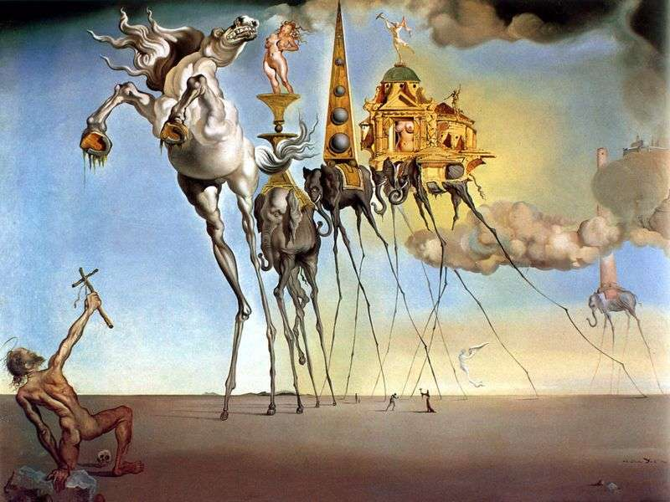
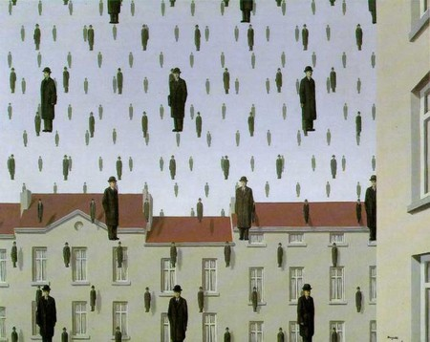
Attempting to explain Surrealist work is somewhat of an oxymoron, however, analysing works from the past will serve the purpose of understanding where modern illustrators today have derived their influence from. Two artists who have been instrumental in boosting the reputation of the Surrealist movement are René Magritte [Fig. 1] and Salvador Dalí [Fig. 2], thus two of their more popular works, Golconda (1953) and The Temptation of St. Anthony (1946) respectively, are worth analysing.
Fig. 1 - Magritte, Golconda (1953)
Fig. 2 - Dalí, The Temptation of St. Anthony (1946)

Fig. 1 is a rounded summation of Magritte’s style, displaying many recurring stylistic choices of his in this one piece. Most notably is the appearance of bowler-hatted men and blocks of houses, said to be inspired by the staid existence of middle-class suburbia (Powers, 2021). The flatness of the houses against the pallid slate grey of the sky paints this scene as candid and inconspicuous, though there also lies a simultaneous sense of abnormality coming from the perspective of the houses being in perfect profile. Disturbing this backdrop of normalcy are the hundreds of identically dressed men vanishing into the distance. Suspended in the air, with equal possibility of them rising from the ground or raining down from the sky, they populate the vicinity of the image in an oddly gridded formation. The figure’s drab clothes conjure ideas of a businessman which, along with the repetition and aforementioned rectilinear composition of the scene, really drives home its monotonous, average aura. Of course, the style complements the substance; he lays down the oil paint in such a smooth and considered way, adding just enough tonal value to give it depth. This style of realistically rendering implausible concepts was integral to Magritte’s artistic endeavour, which is very in-line with Surrealist thinking; this is summed up best by Herscovici:
Magritte's great talent was to help people dream about the world they live in, and this is as current a need today as it was in the 1920s when he painted his first surrealist images.
(Valerio, 2000)
There is something to be said about reframing reality as a surreal and transcendental plane - where familiar objects are recontextualised and transformed outside the realm of possibility, yet uncannily rendered as to make it feel believable - and the appeal the human mind finds in it. It stimulates our imagination, which can be defined not only as the invention of unique, non-existent ideas, but also the “possibility of restructuring existing systems and producing the new” (Huppauf and Wulf, 2009, p. 21).
Fig 2 is leaning towards the more fanciful end of the Surrealism spectrum, boasting resplendent colours and subjects of grandiose presence, very dissimilar tonally to Fig. 1. The subject matter of the piece is an interpretation of Anthony the Great’s run-in with the supernatural manifestation of temptation (Zavistovski, 2017). Said temptation is represented in Dalí’s painting with various thin-legged animals carrying miscellaneous buildings and structures through the clouds across an expansive plane. To the bottom left of the image we see the saint in question, righteously baring his cross at the parade heading his way. Here again we observe the decision to situate the subjects of the painting in a sparse landscape, which was a popular trend at the time among Surrealists; depicting landscapes as "boundless expanses" was not just a reflection of the turbulent aftermath of the two world wars (Stich, p. 12, 1992), but also an interpretation of the inside of the mind - expansive and thirsty for ideas. The chief anomaly in this painting is the extreme elongation of the animal’s legs. Stretched impossibly slender, one cannot help but wonder in amazement as to how they operate, never mind carry buildings and women on their backs. This is called a “suspension of disbelief” (Oxford Reference, n.d.), and it occurs when a piece of media is so enthralling, that we as the audience disregard logic and accept what we see as true. This phenomenon is crucial to Surrealists, as it ties into their philosophy of not creating a new world but re-envisioning the current one.
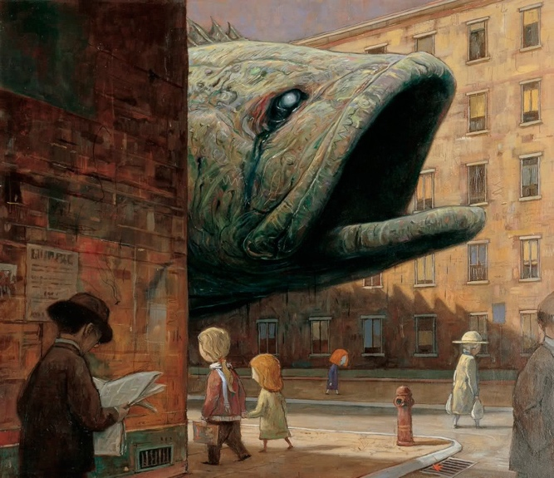

Fig. 3 - Tan, Darkness (detail) (2000)

With the core characteristics of Surrealist art acknowledged and analysed, it is clear that they have not been lost to the passage of time but instead rekindled within the modern picture book illustrator. One such example is Shaun Tan, an Australian artist with an eye for the conceptual. Fig 3 is a page from his book The Red Tree (2000), a story covering pessimism and sadness in young children. The main character solemnly walks down a preoccupied street in the shadow of a monolithic rotting fish, providing a commentary on the paradoxical overwhelming and invisible presence of depression. This explains away the apparent nonchalance of the townspeople but, from another viewpoint, it is resurrecting the Surrealist affinity for making ludicrous concepts seem normal and commonplace. Again, this is aided by Tan’s style, in particular the realistic lighting and soft colour palette. The strange correlation between a fish and the concept of depression is another technique inherited somewhat from Surrealists - perhaps not juxtaposing opposite concepts like they so often did (Breton, 1924), but still forcing the imagination to work by bringing together two disparate concepts. This is Tan’s exact intention, stating that he avoids using ideas that can be easily related due to the pre-existing associations we already possess: “It's almost like you have to displace the emotion to examine it” (Gaiman, 2011). Applying this thought process, there are many unconventional links you can make using just this image: imagining the unpleasant stench of a decomposing fish as the lingering and overpowering feeling that hangs around a depressed person or interpreting the oil leaking from its eye as a teardrop. Stretching the imagination is as much of a necessity for children’s book illustrators as it was to the early Surrealists 100 years ago, and Shaun Tan clearly inhabits both worlds.
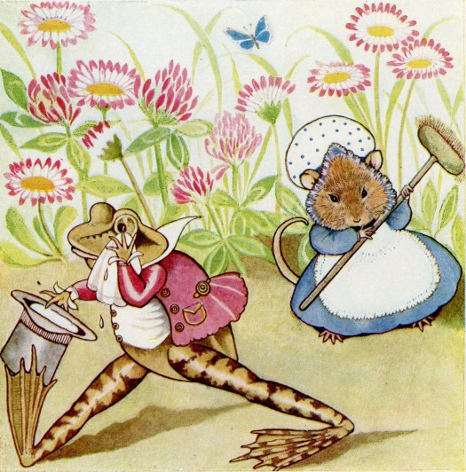

Fig. 4 - Ellerby, Millicent Mouse and her Funny Wee House (1927)
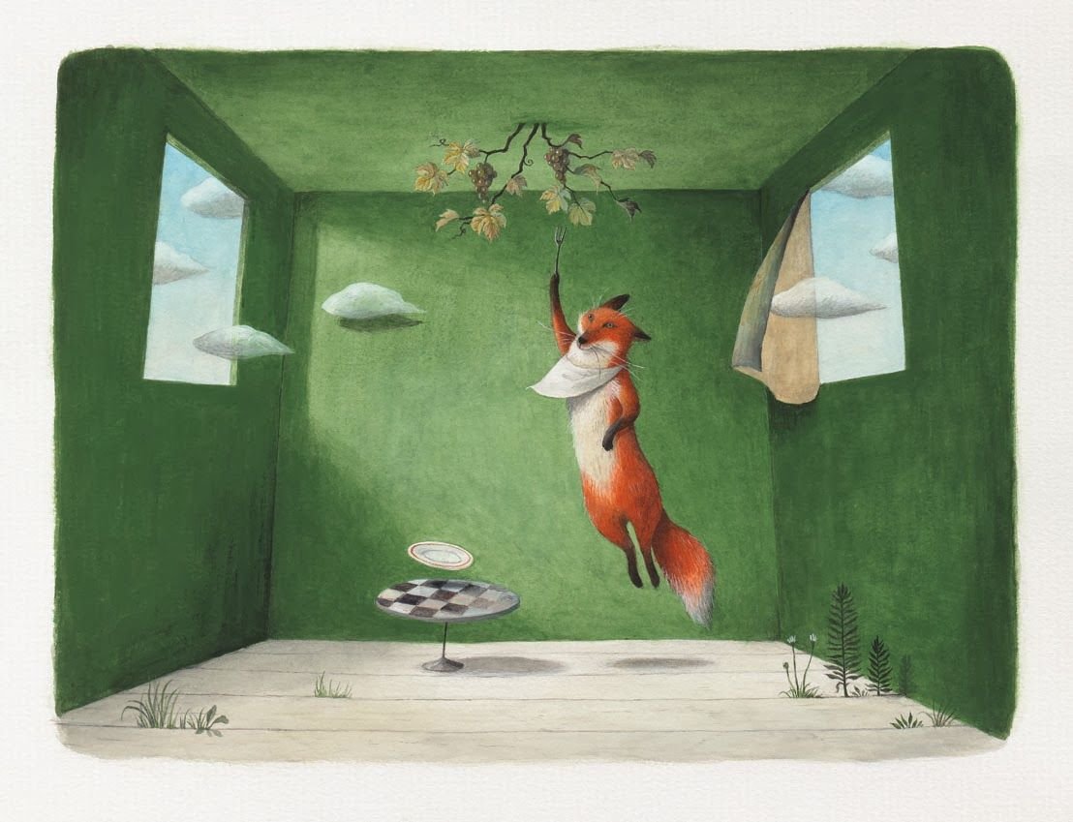
In discussing the link between Surrealism and modern children’s book illustration, it would be remiss not to discuss the anthropomorphism art style that is still widely used today. Anthropomorphism is an artistic device that attributes humanoid features and mannerisms onto animals, and the illustration seen in Fig. 4 features an example of this in the context of children’s books. Straying from the nightmarish interpretation of human-animal hybrids found in certain Surrealist paintings (Ernst, 1940), the animals in this book instead act like and wear the clothes of human beings in a purely innocuous and playful fashion. The appeal and consequent recurrence of humanised animals in children’s books can be understood not only as a display of high imagination, but also as a vehicle for humour. Playing on preconceived ideas of joke structure, Surreal humour aims to shock and confuse by breaching such principles, leaving the comedy element to arise out of sheer absurdity and illogic of the outcome. Examples of surreal humour involve manipulating proportion to bizarre degrees (Oring, pp.21-2, 2003) and the recontextualization of objects into unexpected scenarios (Johnson, 2013), both of which are demonstrated in anthropomorphism.

Fig. 5 - Imai, The Fox and the Grapes (2012)

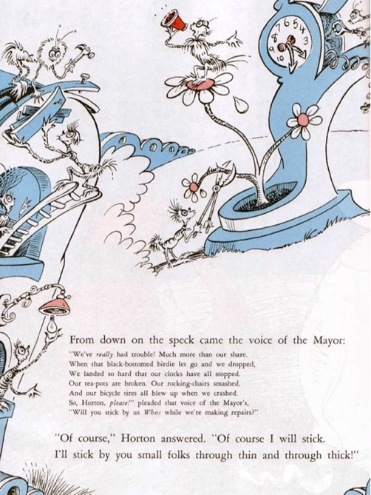
Fig 5 is an illustration from a modern retelling of Aesop’s Fables by author-illustrator Ayano Imai, which has its roots firmly planted in the Surrealist genre. The subject of the piece is a bib-wearing fox holding a fork with its paw, a clear use of the anthropomorphism mentioned above. The bib around his neck particularly inspires the surreal humour in this image, considering he is eating something as small and sterile as a grape. Abnormalities like the suspension of objects and subject in mid-air and the clouds floating their way into the foreground are very reminiscent of Magritte’s work, and the tree sprouting from the ceiling of an ambiguous, bare room adds the element of unreality that gives it true surrealism status. Note that the style is done in a realistic manner, with this dramatic but soft shading that provokes the uncanny feeling of looking at a bizarre composition in such a lifelike light.
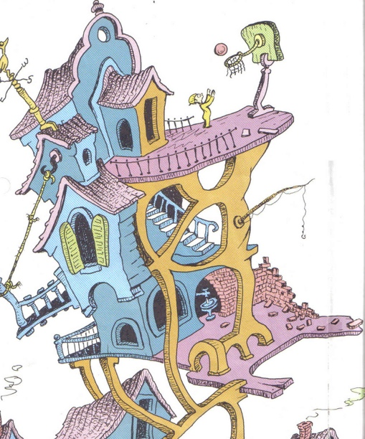

Fig. 7 - Geisel, Oh, the Places You’ll Go! (1990)
Fig. 6 - Geisel, Horton Hears a Who (1954)

Dr. Suess (formally known as Theodor Seuss Geisel) was a favourite of parents and children alike for his wacky and fantastical illustrated stories that have left a lasting impact on the world at large (Pombire, 2018). Living and working during the zenith of the Surrealist movement, Geisel contributed his own whimsical paintings alongside the greats, but not before his successful venture into the world of children’s book illustration. As seen in Fig. 6, he is renowned for his elaborate world-building that catches and holds the eye, leading it around unapologetically lively imagery. While the style is a far cry from the ironically realistic, dimensional technique of what we know Surrealist art to look like, the amalgamation of random objects and architecture held up by impossibly shaped scaffolding is incredibly Surrealist, even Dalí-like. While the incongruence between the objects on their own are glaring, the placement and intermingling of them in the context of his fabricated worlds give them a rejuvenated purpose; a grandfather clock can be repurposed as a flowerpot, a coat hook can hold up a balcony, as seen in Fig. 6 and Fig. 7. In doing this, Geisel is activating the child’s imagination, encouraging them to find connections in the most unassuming of objects and putting forward to them that anything is possible; “I like nonsense, it wakes up the brain cells. Fantasy is a necessary ingredient in living” (Nel, p. 38, 2004).

Children are more visually perceptive than ever before, especially in our current tech-involved climate where they are introduced to screens at an exceedingly early age. Imagery informs the child as much as spoken language does, so to ensure they develop and retain the creativeness that many of us tend to shelve in later life, it is important to expose them to whimsically charged material - of which they will mostly experience through picture books. Out of all the art movements to accommodate this, the Surrealist movement has proved superior. With a strong stance on the importance of childlike abandon and stimulating the imagination, the Surrealists share the same sentiment of today’s most accomplished children’s books illustrators. The transformation of reality into an iconoclastic version of itself, the anthropomorphism of animals, the implementation of surreal humour, the suspension of disbelief, the recontextualization of objects…these are all prolific examples of the ways in which Surrealism and children’s picture book illustration are visually linked. Even though it is true that the profession book illustration is where its influence really gets to shine, the entirety of the genre is consumed with Surrealist fever as Heller and Chwast state; This is because the craft is so involved with real world affairs, and this can only be reflected accurately through the absurdist lens of surrealism.

Reference List and Bibliography:
List of figures:

Figure 1: Magritte, R. (1953). Golconda [oil on canvas]. Available at: https://www.renemagritte.org/golconda.jsp (Accessed 1 December 2021).
Figure 2: Dalí, S. (1946). The Temptation of St. Anthony [oil on canvas]. Available at: https://www.dalipaintings.com/temptation-of-saint-anthony.jsp (Accessed 1 December 2021)
Figure 3: Tan, S. (2000) Darkness (detail) [acrylic and oil on canvas]. Available at: https://www.shauntan.net/red-tree-book (Accessed 3 December 2021)
Figure 4: Ellerby, J. M. (1927). Millicent Mouse and her Funny Wee House. Available at: https://www.slaphappylarry.com/mice-in-childrens-literature/ (Accessed 28 November 2021)
Figure 5: Imai, A. (2012). The Fox and the Grapes. Available at: http://draakonkuu.blogspot.com/2013_10_01_archive.html (Accessed 1 December 2021)
Figure 6: Geisel, T. S. (1954) Horton Hears a Who [illustration]. Unavailable source (Accessed 3 December 2021)
Figure 7: Geisel, T. S. (1990) Oh, the Places You’ll Go! [digital]. Available at: https://seuss.fandom.com/wiki/Oh,_the_Places_You%27ll_Go! (Accessed: 3 December 2021)

Deliotte (2021) The Future of the Creative Economy. London: Deloitte LLP. Available at: https://www2.deloitte.com/content/dam/Deloitte/uk/Documents/technology-media-telecommunications/deloitte-uk-future-creative-economy-report-final.pdf (Accessed 23 November 2021)
Fancourt, D. and Steptoe, A. (2019). ‘Effects of Creativity on Social and Behavioral Adjustment in 7‐ to 11‐year‐old Children’, Annals of the New York Academy of Sciences, 1438(1), pp. 30-39. Available at: https://nyaspubs.onlinelibrary.wiley.com/doi/full/10.1111/nyas.13944 (Accessed 23 November 2021)
Ernst, M. (1940) Robing of the Bride [oil on canvas]. Available at: https://utopiadystopiawwi.wordpress.com/surrealism/max-ernst/robing-of-the-bride/ (Accessed 26 November 2021)
Gaiman, N. (2011) ‘In conversation: Neil Gaiman talks to Shaun Tan’, The Guardian, 2nd December. Available at: https://www.theguardian.com/books/2011/dec/02/neil-gaiman-shaun-tan-interview (Accessed 23 November 2021).
Geisel, T. S. (1954) Horton Hears a Who. New York: Random House.
Geisel, T. S. (1990) Oh, the Places You’ll Go! New York: Random House.
Harrison, C. and Wood, P. (2003) Art in Theory 1900-1990: An Anthology of Changing Ideas. Malden, MA: Blackwell.
Heller, S. and Chwast, S. (2008) Illustration: A Visual History. Abrams: New York.
Hemphill, T. (2017) Looking Back to Look Forward: Illustration Styles of the Past 30 Years [website]. Available at: https://creativecloud.adobe.com/discover/article/looking-back-to-look-forward-illustration-styles-of-the-past-30-years (Accessed 2 December 2021).
HISTORY.com Editors, (2021) Enlightenment [website]. Available: https://www.history.com/topics/british-history/enlightenment (Accessed 26 November 2021)
Hüppauf, B. and Wulf, C. (2009). Dynamics And Performativity of Imagination: The Image Between the Visible and The Invisible. London: Routledge.
Imai, A (2012) Aesop’s Fables. Hong Kong: Minedition.
Johnson, A. (2013) ‘How Many Surrealists Does It Take to Screw in a Light Bulb? A Fish: The Most Highbrow Jokes in the World’, The Independent, 5th July. Available at: https://www.independent.co.uk/news/science/how-many-surrealists-does-it-take-to-screw-in-a-light-bulb-a-fish-the-most-highbrow-jokes-in-the-world-8691191.html (Accessed 23 November 2021)
Kim, K. H. (2011) ‘The Creativity Crisis: The Decrease in Creative Thinking Scores on the Torrance Tests of Creative Thinking’, Creativity Research Journal, 23(4), pp. 285-295. Available at: https://www.tandfonline.com/doi/abs/10.1080/10400419.2011.627805 (Accessed 2 December 2021)
Morley, C. (2021) ‘Work of Art’, Teach Primary, pp. 28-9.
Nel, P. (2004) Dr. Seuss: American Icon. New York: Continuum.
Oring, E. (2003) Engaging Humor. Baltimore: University of Illinois Press.
Oxford Reference, (n.d.) Suspension of Disbelief [website]. Available at: https://www.oxfordreference.com/view/10.1093/oi/authority.20110803100544310 (Accessed: 25 November 2021)
Pombiere, L. (2018) ‘Celebrating Dr. Seuss's Legacy’, Pembroke Observer. 3rd March, p. 4.
Powers, S. (2021) René Magritte Artist Overview and Analysis [website]. Available at: https://www.theartstory.org/artist/magritte-rene/ (Accessed 1 December 2021).
Stich, S. (1990) Anxious Visions. Berkeley: University Art Museum.
Tan, S. (2000) The Red Tree. Sydney: Hodder Children's Books.
TEDTalks, (2006) Sir Ken Robinson—Do Schools Kill Creativity? [video] Available at: https://www.ted.com/talks/sir_ken_robinson_do_schools_kill_creativity/transcript (Accessed 25 November 2021)
TedX Talks, (2011) TEDxTucson George Land The Failure Of Success [video]. Available at: https://youtu.be/ZfKMq-rYtnc (Accessed 1 December 2021).
Valerio, W. (2000) This is an Apple: An Interview with Magritte's Heir [website]. Available: https://web.archive.org/web/20000816163551/http://www.museumnetwork.com/entertainment/_talking_points/magritte_herscovici/magritte_herscovici_home.asp (Accessed 28 November 2021)
Zavistovski, K. (2017) Now at LACMA: Dalí's "The Temptation of St. Anthony" [website]. Available at: https://unframed.lacma.org/2017/11/20/now-lacma-dal%C3%ADs-temptation-st-anthony (Accessed 1 December 2021)

