
Skills for the Workplace
Module Assignment Submission
Student Name: | Leah Thomas
Student Number: | 2121772
Module No: | BMSK4002
Module Title: | Effective Team working and communication. Part 2

Statement of Confirmation of Authenticity
By the act of making this submission, the student declares that this is the work of the student named above. The work has not, in whole or in part, been knowingly presented elsewhere for assessment, or where assessment has been built on a previous assessment, this has been identified. Where materials have been used from other sources it has been properly acknowledged. If this statement is untrue, the student acknowledges that an assessment offence has been committed.
Attention is drawn to the plagiarism and unfair practice policies of both the University and of ILM..

Table of Contents
Introduction: 3
What is communication and why it is needed: 3
Shannon-weaver model: 3
Schramm model of communication 5
Albert Mehrabian's model of communication: 8
Assessing my own communication skills 9
Feedback.. 9
Appendix 1 10
Presentation feedback evaluation form 11
References 12

Introduction:

Communication is about listening effectively, taking the time to practice active listening. You need to be paying attention to what the other person has to say or how they use their preferred, selected form of communication. So with this I will be explaining some of the different models, ideas, and theories associated with effective communication.

What is communication and why it is needed:
There are various components to the answer. It's the means of sending or receiving information whether it be speaking,writing or using another medium. When you communicate effectively, it means that your thoughts and concepts are heard and acted upon. It also implies that you can listen to, comprehend, and act on what others say. This is how an individual , department, team, or corporation achieves success by knowing what needs to be done and executing it. Because there are so many ways to interact today, good communication is harder than in the past. You'd think that making your point would be easier, but that's not the case. There are so many alternatives with texting, email, instant chat, Slack, Teams, and cell phones. Keeping track of and responding to so many sources makes the process more difficult. Furthermore, the tendency of multitasking has entirely derailed effective listening abilities, as people pay significantly less attention when attempting to execute many tasks. Communication helps humans to function orderly and productively.

Shannon-weaver model: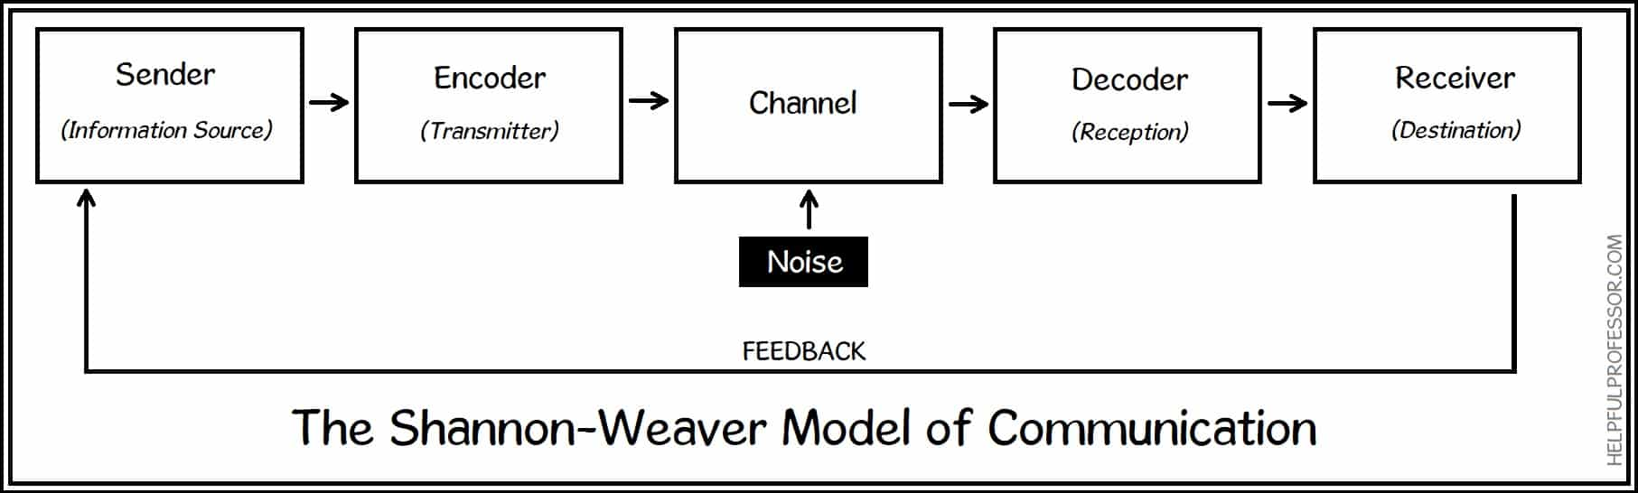

The shannon-weaver model is the most well known and influential model of communication. It was developed in 1949 by Claude Shannon and Warren Weaver.
Oxford Reference. 2022. Shannon and Weaver's model. [online] Available at: <https://www.oxfordreference.com/view/10.1093/oi/authority.20110803100459436> [Accessed 3 April 2022].

The model was specially designed by these two people to develop effective communication between the sender and the receiver through encoding. The model proposes that all types of communication should include these 6 elements:

A source: a source or a sender is one of the basic concepts of communication. It can be an individual,a group or an organisation. These are the ones that initiate communication.
An encoder: the encoder is where the sender puts together their intended message they will then turn it into a communicable message using words, symbols, pictures and sounds.
A message: the message is the information that will be passed on through the communication process. This is where the message will connect the sender to the receiver.
A channel: the encoded message now needs to reach its destination via its message channel. It is intended to reach its audience through a medium
A decoder: in essence, a Decoder is a combinational logic circuit that translates coded input to coded outputs when both of these are distinct. The term "decoder" refers to a device that converts coded data from one format to another. As a result, the input code has less bits than the output code word.
A receiver The individual or group of people who receives the message delivered by the sender is known as the receiver. This individual is also known as the information's recipient or destination. The receiver is in charge of deciphering the communication. Before the message can be absorbed and received by the brain, the recipient must decode the message's meaning in a new window. An action can only be taken when the recipient has decoded the message and acquired what he or she understands from it.
feedback:
A receiver's response to a communication is known as feedback. It is an indication of whether or not communication was successful. Feedback might be nonverbal such as a grin or a head nod or spoken (a comment related to the message). Any reaction, even if it isn't one, is feedback.The end result of any communication process is feedback (also known as the receiver's reaction). It verifies that the message was successfully interpreted by the recipient. One of the purposes of corporate communication is to get the right response from the receiver. You can reach this aim by:
- Inquiring about the response either directly or indirectly.
- Assist the recipient with their response.
In emergency situations, the sender may request that the receiver repeat the message and explain how he or she comprehended it. When conversing with, A sender can get feedback from a group by observing the audience, asking questions, or administering an evaluation .By offering clear and complete feedback, receivers help to strengthen the communication process. One of the most effective strategies to improve understanding in the business sector is to paraphrase the sender's message with comments like "Let me attempt to explain that in my own words."
The following are characteristics of feedback:
- It ensures that the process of communication continues.
- It indicates if the communication was received correctly or incorrectly.
- It motivates the sender and receiver to communicate more.
- It guarantees that communications are changed in the future to avoid misunderstandings.
- It gives the sender of the message the opportunity to seek for clarification if the message was unclear.

Schramm model of communication

The Schramm model views communication as a process that takes place between a sender (transmitter) and a receiver: there will also be a message, and a medium through which the message can be transmitted (Schramm, 1948).

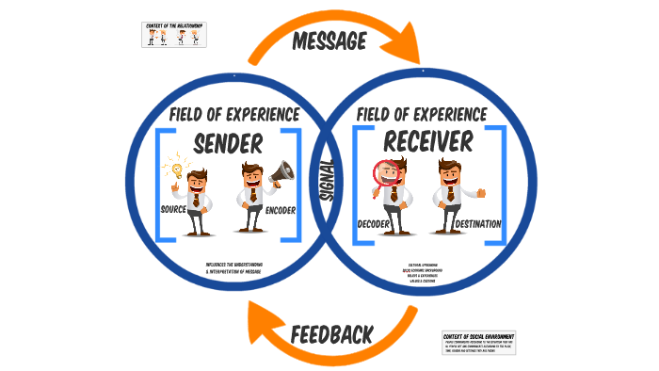

- The sender is the individual who is known as the sender of the message.
- The encoder is the one who turns the message into codes for transmission. To communicate our ideas to the message receiver we must consider the appropriate phrases and the order in which we send our messages.
- The decoder receives the encoded message that's been delivered and turns into a language that the receiver can comprehend.
- The interpreter is the individual who works to understand and analyse the communication is known as the interpreter, after interpretation, the message is received. The receiver and interpreter are the same individual.
- The receiver The message's recipient is the individual who receives it. The actual message is decoded and interpreted by him. The sender's data and the information received by the receiver are known as the message.
- The message The sender's data and the information received by the receiver are referred to as the message.
- Feedback The process of a receiver acknowledging a message received is known as feedback.
- Medium or media The route through which the message is sent is referred to as the medium or media.
- Noise Interference and disruptions occurring during the procedure are referred to as noise. Semantic Noise is formed when the intended meaning of a communication conveyed by the sender differs from the meaning understood by the receiver.

Albert Mehrabian's model of communication: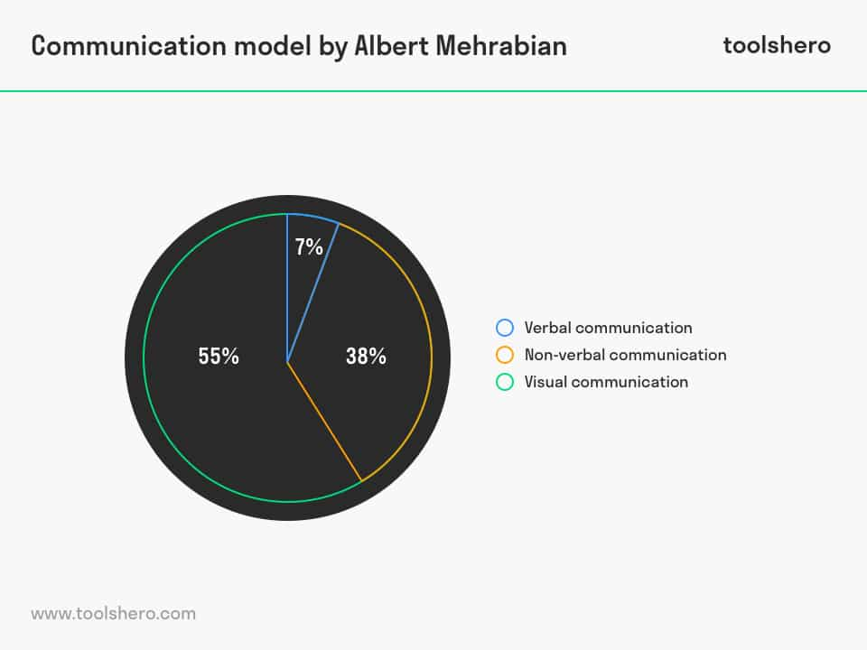
According to Albert Mehrabian this model he has come up with consists of 7% verbal communication; this is words that are spoken, 38% non verbal communication is your voice and the tone that you use. The remaining 55% is visual communication which is your body language.
Verbal vs non verbal:
- Verbal communication is what we say
- Non verbal is what we don't say

Both of these forms of communication are important and can say different things. It is also important to be aware of our own and others forms of communication. The complete body, facial emotions, and tone of voice are all used in nonverbal communication. A phone call, a face-to-face chat, loudspeakers, audio recordings, are other forms of verbal communication.

paralinguistics :

paralinguistics is the speed of speech, the volume, the pitch and intonation. it is also the change and modulation. This is the part of communication outside of the words themselves. This is also important as it makes the communication more accurate.

Assessing my own communication skills
My communication skills in my opinion can be very good in the workplace. I have a lot of experience in dealing with people where I have to talk professionally. In my role I like to keep formal communication with customers although a lot of my customers have become good friends where I can then use informal communication. I adapt my communication skills to the individual. I will always listen to work colleagues and customers when they are communicating with me, this I find helps to build trust and form relationships which can be both formal and informal. I have a lot of empathy which goes a long way, An example of this is when we employed a new member of the team who was very nervous, On her first day she was having trouble communicating with customers and picking up how to use the till so I used the time I had spare to stay with her and comfort her, I then went through step by step of how the till works until she became confident enough to carry on independently. Having said all this there are times where I feel my communication could be improved. I get moments where I feel anxious , especially in a large group and I feel my confidence can sometimes let me down. I am forever learning new coping mechanisms to help tackle this, I am using online meditation and attending yoga sessions as often as I can. Personally I find these very helpful in overcoming my confidence and anxiety issues.

Feedback..

During this course I was asked to produce a presentation on effective team working. Looking at my feedback sheets that were handed out and the results, I have learned that my body language came across as very nervous and shy. Although there were some good points to my presentation skills there are a few factors that I need to work on. These are my eye contact, confidence and body language. The good points that were mentioned were the tone of my voice and the content of the presented slides. Overall I am happy with the feedback and will do my best to improve on the areas that are needed.

Appendix 1

Personal development plan (PDP)

Objectives | Tasks | success criteria | time frame | resources
To work on my confidence | to put myself forward for different roles | To become a shift manager | 1 year | Team meetings in the workplace
Improve body language | move out of my comfort zone | attend courses | 2-3 months | online teams
limit stressful situations i put myself in | Avoid procrastination | do assignments and course work in plenty of time | 1-2 months | library

Presentation feedback evaluation form

- Very poor
- Poor
- Satisfactory
- Good
- Very good

directions: Please complete this feedback sheet by highlighting each chosen number.

Content:
Did the person presenting use adequate content on each slide?

1 | 2 | 3 | 4 | 5

Body language
Did the person presenting use the appropriate body language?
1 | 2 | 3 | 4 | 5

Eye contact
Did the person presenting use good eye contact with the audience?

1 | 2 | 3 | 4 | 5

Speech/language
How did you find the presenter's tone of voice and choice of words?
1 | 2 | 3 | 4 | 5

In this space below please provide any additional feedback that you think could benefit the presenter.

References
The Schramm Model of Communication (2009).
Laurie Brown Communications. 2022. What Is Effective Communication?. [online] Available at: <https://lauriebrown.com/guides/communication-skills/what-is-effective-communication/> [Accessed 3 April 2022].
Ifioque.com. 2022. Ifioque.com | Online Hub for Educational Resources. [online] Available at: <https://www.ifioque.com/miscellaneous/receive> [Accessed 3 April 2022].
Medium. 2022. Communicate Efficiently With Albert Mehrabian 7% Communication Model. [online] Available at:
<https://medium.com/age-of-awareness/communicate-efficiently-with-albert-mehrabian-7-communication-model-c88b569a98fe> [Accessed 3 April 2022].
2022. [online] Available at: <https://helpfulprofessor.com/shannon-weaver-model/> [Accessed 3 April
2022].prezi.com. 2022. Schramm's Second Model of Communication. [online] Available at: <https://prezi.com/dfcpl95e4ix1/schramms-second-model-of-communication/> [Accessed 3 April 2022].
Oxford Reference. 2022. Shannon and Weaver's model. [online] Available at: <https://www.oxfordreference.com/view/10.1093/oi/authority.20110803100459436> [Accessed 3 April 2022].

