Title of Research
An Evaluation of the Awareness and Purpose of the Shirt Sleeve Sponsor at Swansea City AFC
Background
Football, or soccer, is one of the world’s most popular and renowned sports with clubs attracting fans in the thousands weekly and millions watching on broadcast. A continuously rapid growing business involving “considerable amounts of money” (Naidenova et al, 2016) allows for companies to increase their public and brand image through sponsorship deals. The Premier League has a claim as one of the oldest football l eagues across the globe with its television coverage playing a huge role in enticing and keeping loyal fans of the sport on a weekly basis, both locally and foreign (Puri et al 2016), exemplifies the increased attention by businesses to promote themselves. For a football club such as Swansea City AFC, sponsorships regarding the team shirts, stadium naming rights and other related ventures provide “crucial revenue” for the parties involved (Kelly et al, 2016).
Research Question, Hypothesis or Aim
The main questions this study will be looking into are:
- Are Swansea City AFC fans aware of the clubs’ new sleeve sponsor?
- The fans who are aware, are they familiar with the company who sponsor Swansea City AFC? Background, products, brand, etc.
Research Aims
The overall aim of this study is to determine the public awareness of the sleeve sponsor at Swansea City AFC as well is the companies purpose regarding the sponsorship deal and the club involved. Concluding with the importance of said sponsorship deal and the value of the perception and understanding the Swansea City AFC community have with this sponsor.
Research Objectives
To achieve the aim previously mentioned, I will be using the following objectives throughout this study:
- Gathering information on current sponsorship deals and sponsors.
Reviewing existing literature and information on sponsorship deals, specifically the new sleeve sponsorships, within the premier league, allowing for analysis and comparison with the current sleeve sponsorship of Swansea City AFC.
- To gather and analyse data based on primary findings and data gathering, based on the awareness of the Swansea City AFC sleeve sponsor.
This will be done primarily by using surveys for the public. By gathering data from a wide range, allowing for unbiased and general views rather than a niche. Surveys are more applicable than other forms of data gathering due to their, quick and concise questioning, as well as the small number of questions that will need to be asked.
- Investigate gathered data and literature and make appropriate recommendations based on findings.
With the findings from the current literature and data gathered through primary research, we will be able to analyse trends in public knowledge, the awareness of the Swansea City AFC sleeve sponsorship and the purpose and importance of said sleeve sponsorship; allowing for suitable recommendations.
The Proposed Research Rationale
Sleeve sponsorships for football clubs have been utilised globally specifically with football clubs in South America who have showed multiple shirt sponsors for years. This Premier League season marks the first in history where Premier League clubs have declared sleeve sponsorships of their own with Swansea City AFC declaring Silicon Valley based Barracuda networks as their sponsor for the current Premier League season back in June (SwanseaCity, 2017). It became a popular trend after Manchester City declared Korean company Nexen Tire as their sleeve sponsorship in March of this year (ManCity, 2017) and several Premier League clubs followed in the months after.
Despite their popularity in California and Asia and Barracuda Networks boasting an impressive revenue figure of $114,067,000 (NASDAQ, 2017), themselves and Nexen Tire are examples of companies relatively unknown to an average UK based football fan, allowing for an in-depth study on the awareness and purpose of these businesses in relation to followers of the sport, specifically with the local communities in Swansea with Swansea City AFC.
Literature Review/Contextual Analysis
Sponsorships have become a vital part of a sports team, specifically a football club, to remain financially secure and competitive within their respective leagues. The importance of sponsorships and new sleeve sponsorship deals have grown significantly due to the increase in revenue and money involved in the global football market within today’s economy. Football clubs can become differentiated and unique to their competition due to the appeal and recognisability of their sponsors to the point where it becomes a defining characteristic of that club. E.g. Arsenal Football Club and Emirates.
Due to its current popular and topical trend, sleeve sponsorships have become a talking point throughout the football industry, specifically due to the incredible sums of money it brings to the already wealthy Premier League, with revenues rising 9% in the previous season (Wilson, 2017). Due to the growth in sponsorship deals and the high surge of popularity for the Premier League on a global basis, it’s important for football clubs such as Swansea City to make correct decisions in choosing businesses to promote and bring appropriate levels of awareness towards them. Bolton Wanderers received backlash from fans in 2013 due to the company QuickQuid being their primary sponsor with similar repercussions surrounding Newcastle United the year prior with Wonga loans (Murray, 2013). It’s of the upmost importance that football clubs choose appropriate companies with ethical purposes as their sponsors whilst generating the correct amount of public awareness towards these businesses.
Mintel (2002) states that the total value of sponsorships within the United Kingdom hit almost £849 million in 2000. Regarding this total, it’s specified that approximately 50% of this figure was devoted to sports sponsorships with a heavy emphasis on football with "exposure to high-profile television coverage driving most of the money to a few selected sectors like football" (Mintel, 2000). The growth and importance of football sponsorships today is exemplified further, with 50% of £849 million being the figure in the early 2000s compared to the €1.5 billion generated by English Premier League clubs in today’s market as indicated in the 2017 annual report for football clubs across the globe (Deloitte and Touche, 2017).
There are numerous definitions regarding sponsors and sponsorships. The table below simply conveys a few of these definitions with one specifically applicable to sports, applying theory to that market:
Sponsor; “A person or organization that pays for or contributes to the costs involved in staging a sporting or artistic event in return for advertising.” | (Oxford Dictionary, 2017)
Sports sponsorship; “a cash or in kind deal under which a sponsor pays a sponsorship fee to a sports entity (athlete, league, team, event) to support overall organizational objectives and promotional strategies” | Sports Marketing: A Strategic Perspective (Shank and Lyberger, 1999).
Sponsorship; “Financial support given by a sponsor” | (Collins Dictionary, 2017)

By analysing these definitions, it’s clear to see that the application of sponsorship roles differ in football to other markets. While companies and businesses can sponsor events and shows, with football, companies tend to operate in a fashion which involves them being displayed on a team’s shirt (with continents like South America displaying several sponsors on their shirts) or stadium for brand awareness and public image.
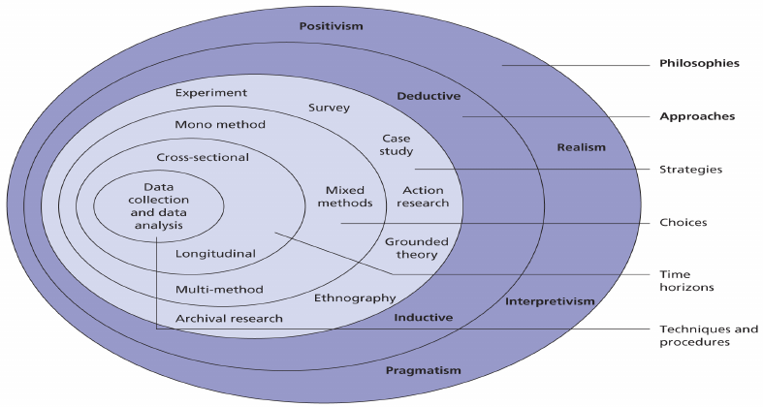
Proposed Research Methodology

Figure 1: Saunders’ Research Onion
Research is defined by Saunders et al (2007) as “something that people undertake in order to find things out in a systematic way, thereby increasing their knowledge”. The Research Onion, as displayed above, was also created by Saunders which shows the methodology involved in research consists of numerous layers and variations of data gathering.
Philosophy
Research philosophy, which forms the outside layer of the research onion, is explained as the method research that “will underpin your research strategy and the methods you choose as part of that strategy” (Saunders et al, 2009). These initial steps of research allow for development but applicable findings to further study while progression continues through the research onion.

Approach
The research approach is whether your own research will be deductive, in which you develop theories and hypothesis which results in designing strategy to test said hypothesis, or the inductive method in which you will collect data and findings then base theory on the results of these findings (Saunders et al, 2009). This particular study will involve an inductive approach to its research, revolving around gathering information and forming theory using the analysis from the data.
Strategy
The general purpose of research strategy is to choose applicable methods to best help the research answer its overlying questions and meet its necessary objectives (Saunders et al 2009). This particular study will primarily use desk research and surveys to gather the information required.
This study will conduct a survey spreading across a wide variety of local people within the Swansea area, asking questions about the awareness of Swansea City AFC’s new sleeve sponsor for the current Premier League season. The questions will revolve around if they are aware Swansea City AFC has a sleeve sponsor, if they’re aware of the name, if they’re aware of what the business does in terms of its services offered or products sold and how they feel about the addition of sleeve sponsors to the Premier League. The sample this study will look at will be approximately 100 people over the age of 18 with a varied interest in football and Swansea City AFC. Surveys “allow the collection of a large amount of data from a sizeable population in a highly economical way. Often obtained by using a questionnaire administered to a sample, these data are standardised, allowing easy comparison” (Saunders et al, 2009).
Choice
The objectives mentioned prior will be achieved using the following methods:
- Objective 1: Desk Research.
- Objective 2: Survey.
- Objective 3: Desk Research, comparing data.
Time Horizon
Saunders et al (2009) refer to the two variations of time horizon as a “snapshot”, taken at a particular time (cross-sectional) or “diary” (longitudinal). Cross-sectional involves data being gathered at one specific time whereas longitudinal has data being gathered across a period of time in which perception and answers may change. This study will be cross-sectional due to the topical and current behaviour of the study and time constraints.
Research Plan
Resources required:
- Access to a computer with Word, for processing dissertation and data.
- Microsoft Excel to perform analysis on survey results.
- Internet access to for initial findings and data on current Premier League and Swansea City AFC data. Sponsorships, finances, etc.

Timings
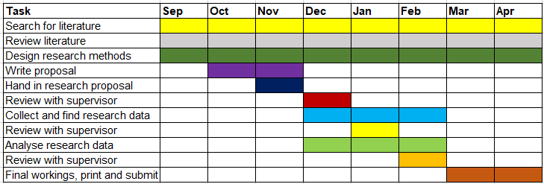
Bibliography
Collins Dictionary (2017). Definition of ‘sponsorship’ [Online] Available at: https://www.collinsdictionary.com/dictionary/english/sponsorship (Accessed 11th November 2017)
Deloitte and Touche (2017), Annual Review of Football Finance, Deloitte and Touche Sport. Manchester.
Kelly et al (2016). It Works Two Days: Impacts of Sponsorship Alliance upon Sport and Sponsor Image [Online] Available at: http://web.b.ebscohost.com.ezproxy.uwtsd.ac.uk/ehost/pdfviewer/pdfviewer?vid=1&sid=d6d9dbd3-f74e-4d7f-8e0b-82166fce97af%40sessionmgr120 (Accessed 11th November 2017)
ManCity (2017). Nexen Tire Partnership [Online] Available at: https://www.mancity.com/citytv/features/2017/april/nexen-partnership (Accessed 10th November 2017)
Mintel (2000), Sponsorship 2000, Mintel International Group Limited, London.
Mintel (2002), Sponsorship 2002, Mintel International Group Limited, London.
Murray (2013). Bolton fans launch online petition against QuickQuid sponsorship deal [Online] Available at: https://www.theguardian.com/football/2013/may/30/bolton-fans-petition-quidquick-sponsorship (Accessed 11th November 2017)
Naidenova et al (2016). Does football sponsorship include company performance? [Online] Available at: http://web.b.ebscohost.com.ezproxy.uwtsd.ac.uk/ehost/pdfviewer/pdfviewer?vid=1&sid=18911f4c-0159-49a2-a910-e0a8579c8cc9%40sessionmgr103 (Accessed 11th November 2017)
NASDAQ (2017). Barracuda Networks Inc (Cuda) IPO – Financials and Fillings.[Online] Available at: http://www.nasdaq.com/markets/ipos/company/barracuda-networks-inc-694838-73636?tab=financials (Accessed 10th November 2017)
Oxford Dictionary (2017). Definition of sponsor in English [Online] Available at: https://en.oxforddictionaries.com/definition/sponsor (Accessed 11th November 2017)
Puri et al (2015). Foreign soccer spectator support motives: A twocountry comparison of the English Premier League (EPL). African Journal for Physical, Health Education, Recreation and Dance, November (Supplement 1), 209-225.
Saunders, Lewis and Thornhill (2007). Research methods for business students. 1st ed. Harlow, Prentice Hall.
Shank and Lyberger (2015). Sports Marketing: A Strategic Perspective. Milton Park, Abingdon, Oxon: Routledge
SwanseaCity (2017). Swans Sign Barracuda as First Sleeve Sponsor. [Online] Available at: https://www.swanseacity.com/news/swans-sign-barracuda-first-sleeve-sponsor (Accessed 10th November 2017)
Wilson (2017). Premier League kicks on to record revenues of £3.6bn. [Online]
Available at: http://www.bbc.co.uk/news/business-40555593 (Accessed 10th November 2017)

