MARKETING MANAGEMENT FOR TESLA



DECEMBER 2022

MODULE NAME: MBA Marketing Management (BMMB7012)

LECTURER NAME: Daniela Hellyer

STUDENT NAME: Lei Liu

STUDEND ID NUMBER: 2216376

TABLE OF CONTENTS

1. EXECUTIVE SUMMARY - 1 -
2. INTRODUCTION TO THE CONTEXT - 2 -
3. MAIN FINDING BASED ON TESLA’S ANALYSES - 4 -
3.1 MACRO AND MICRO ENVIRONMENTS - 4 -
3.1.1 PESTEL ANALYSIS - 4 -
3.1.3 PORTER'S FIVE FORCES - 5 -
3.1.3 SWOT ANALYSIS - 7 -
3.2 TESLA’S SEGMENTATION, TARGETING AND POSITIONING (STP) APPROACHES - 4 -
3.2.1 Market segmentation - 7 -
3.2.2 Market targeting - 8 -
3.2.3 Market positioning - 9 -
3.3 TESLA’S MARKETING MIX - 9 -
3.3.1 Product - 10 -
3.3.2 Price - 10 -
3.3.3 Promotion - 11 -
3.3.4 Place - 12 -
3.3.5 People - 12 -
3.3.6 Process & Physical Evidence - 12 -
4. CONCLUSIONS - 13 -
5. RECOMMENDATIONS - 14 -
6. REFERENCES - 14 -

LIST OF FIGURES

FIGURE 1 - Common EV brands in China market 3
FIGURE 2 - Tesla’s Shanghai Gigafactory 3
FIGURE 3 - Global Top 5 EV Brands’ Sales Share, Q3 2022 6
FIGURE 4 - Gross Profit Margin trends of Tesla 11
FIGURE 5 - Tesla Flagship Store in Incheon, South Korea 13
- EXECUTIVE SUMMARY
TESLA, the legendary EV carmakers in the industry with so many stories to tell. This report has conducted three steps in investigating of Tesla’s marketing situations - Marco and Micro Environment Analysis including PESEL, Porter’s Five Forces and SWOT Analysis, follower by Tesla’s Segmentation, Targeting, Positioning (STP) analysis and Tesla’s Marketing Mix. Conclusions has been clearly outlined:
- Tesla’s premium pricing strategy is good enough for maintaining its relatively high profit margins as a cash cow, but might impede in contending more market shares.
- Tesla’s marketing positioning still remain highly, while its vast majority of targeted customers are middle class, who are also pursuing something pragmatic.
- Although Tesla had claimed to be innovative on future technologies, but when basic safety as necessity cannot be guaranteed, it might backfire on the credibility.
Recommendations has been given for the discoveries:
- Moderately bringing down its marketing positioning and pricing scheme on some of its product lines might be ideal solution to respond intense marketing environment. However, the route of adjustments need to be diligently planned and pretested in avoidance of brand image collapse.
- Middle class customers’ needs represent mainstream of the market, but might vary regionally. So be considerable of the different needs of targeted middle class customers in different regions becomes quite a challenge, whereas also a good approach to differentiate in EV market more deeply.
- Handling bad news about credibility is a ‘double sided sword’, it might provide clues leading to perfection of products and services. In Tesla’s case, proactive attitudes and activities will work as a good sign as showing customers its aspiration and determination of evolution.
- INTRODUCTION TO THE CONTEXT
TESLA, the famous electronic vehicle (EV) brand which was founded in 2003 by Martin Eberhard and Marc Tarpenning in San Carlos, California. Used to be named ‘Tesla Motors’ till 2017 when the current name replaced it. Elon Musk, the man usually links to Tesla’s brand, had joined Tesla in 2004 when he invested $30 million to be the chairman of Tesla’s board of directors (Reed, 2020).
Tesla is neither the first nor the sole pioneer in EV history. While GM EV1 was the first commercialized electric vehicle which was ideally in everyday use, however because of intricate realities such as short mileage and lacks of charging facilities back to late 1990s (Anderson, 2022), EV1 didn’t go for mass production and distribution, whereas its successes on technology implementation exhibited the right direction to followers like Tesla.
Tesla’s brand image is built in high end of technology oriented and premium prices. Since the first product of the brand - Tesla Roadster was introduced into market, Tesla rapidly captured mindsets of interest in potential car buyers who were seeking for something new, hence entered the high end EV market successfully in advance of others. Tesla had adopted a ‘top-down’ marketing strategy: firstly occupying top end market where customers are more willing to pay premium prices, then reinvest all cash flows from the sales of existing products in R&D as well as development of a new model and distribute the new model into market as soon as possible, by using heavily invested advanced technologies to raise the mass productivity and lower the unit price in order to expand market shares in short interval then move on again (Baer, 2014). By doing so, Tesla has established its dominance in EV market especially high end domain that empowered brand of Tesla with premium values.
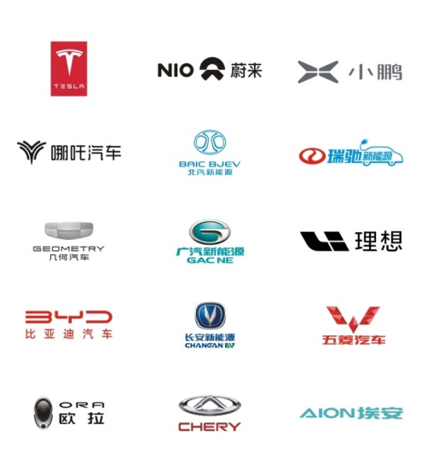
Figure 1: Common EV brands in China market (nicpic.com, 2021)

While it seems Tesla’s strategy went on steadily, the revolution of China market had become a variate to Tesla’s prospect of kingship. In contrast of highly demand on automotive with serious environmental issues - pollution of air, emission of greenhouse gas etc., China government announced massive EV purchasing subsidies to encourage consumption of plug-in electric vehicles (EV) rather than conventional internal combustion engine (ICE) vehicles since 2009, and followed by imposing a mandate on automotive manufacturers in China after 2020 to raise the sales of EVs up to 40% of all vehicles sales till 2030 (Stauffer,2020). These policies stimulated the development of China’s EV manufactures, not merely transformed the conventional carmakers to EV makers but also drew attentions of new market pioneers into EV market such as BYD who has become the strongest rival of Tesla nowadays.

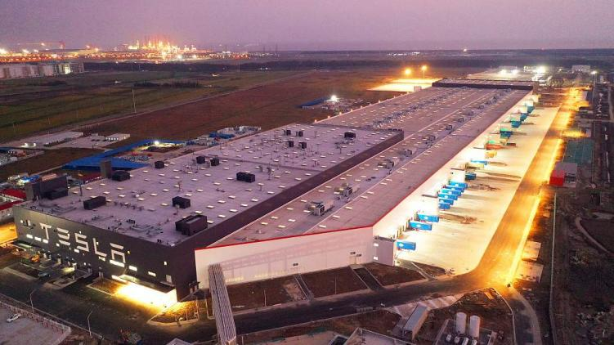
Figure 2: Tesla’s Shanghai Gigafactory (CGTN, 2019)

With growingly intense competition, Tesla chose to confront the challenges by deploying countermeasures including US $2 billion direct investment on Shanghai gigafactory which is the first gigafactory outside of US (Project Management Institute,2020), demonstrating its ambition of sustaining and enhancing marketing position in China market. Unfortunately, negative news including vicious car accidents accused of product defects such as braking system failure (Global Times, 2022) that has accompanied Tesla’s China campaign throughout, triggered disputes on whether Tesla’s products are no longer in high quality and clouds to Tesla’s brand image both in and out of China market.
This report will focus on the Tesla’s marketing activities incorporating development of technologies and artificial intelligence, in order to evaluate the success and failure of Tesla’s marketing activities and explore potential improvements for Tesla.

- MAIN FINDING BASED ON TESLA’S ANALYSES

3.1 MACRO AND MICRO ENVIRONMENTS
The combination of PESTEL, Porter’s Five Forces and SWOT analysis are widely used to identify the marco and micro market environment, here are some highlights of points which are exhibited in capsule form.
3.1.1 PESTEL ANALYSIS
OPPORTUNITIES |  | THREATS
- Both incentive government policies in US and China, including tax exemptions and rebates, supportive on charging stations constructions, funding R&D on EV, volume procurement etc. (Lu, 2018) | P | - China - US trade wars (Murray, 2019)
 | E | - Deceleration of global economic growths due to COVID19 and supply of bottleneck (Quaglietti and Wheeler, 2022).  - Depreciation of RMB to US dollars
- Rapidly growing middle class population in China(China-United States Exchange Foundation, 2013)  - Climbing urbanization rate in China | S
- Innovation on battery technologies and implementation of AI (Autopilot) | T | - Fast catching-up competitors with diminishing technological gap
- Environment sensitive concerns increase demand of EV | E
 | L | - Lawsuits against Tesla in series of consumer rights protection (Shen, 2020).

3.1.2 PORTER’S FIVE FORCES
- Competitive Rivalry is high.
As Figure 3 below is showing, the EV market is concentrating in sales share albeit new players keep showing up. Other factors such as high fixed costs and high exist barriers are also driving the competitive rivalry to high level.

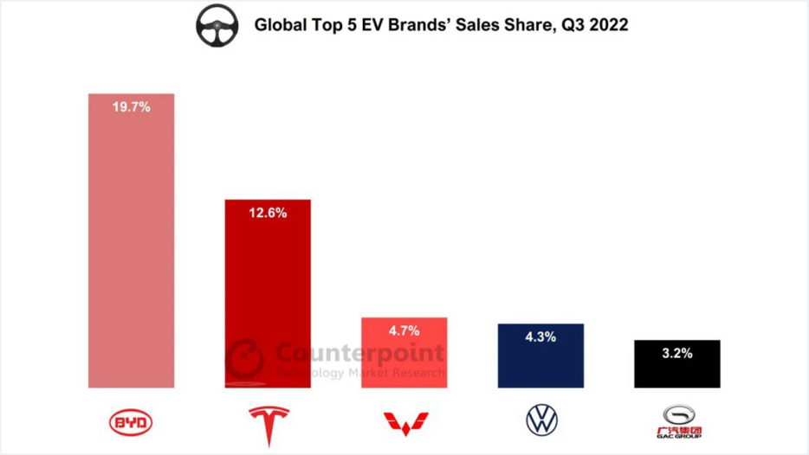
Figure 3: Global Top 5 EV Brands’ Sales Share, Q3 2022 (Mukherjee, 2022)

- Bargaining Power of Suppliers is medium.
One of tech ways Tesla has adopted in the industry is ‘Manufacturing improvement using large scale die casting’, which significantly reducing the parts required for a car assembly is also a smart way of vertical integration (Blanchette,2020). But Tesla is facing realities with specific supply chain issue such as computer chip, that implies some suppliers still own bargaining power to Tesla (Supply Chain Game Changer,2022).
- Bargaining Power of Buyers is low to medium.
Tesla is targeting segmented market consists of middle class buyers and high income buyers. In other words, Tesla’s market positioning is high end, which means buyers are willing to pay premium prices. However, more competitors are entering the high end EV segmented market means Tesla’s marketing position is facing challenges.
- Threats of New Entrants is medium to high.
With bated technological barrier, numbers of new entrants to the market are rapidly growing.
- Threats of Substitutes is medium to high.
Tesla is quickly losing its market shares even in US, from 79% peak to current 65% and expect to be under 20% in 2025 (HT Auto Desk, 2022), reflects the customers’ options are diversifying. For example, hydrogen vehicle is expected to be possible substitute of EV in near future.

3.1.3 SWOT ANALYSIS
- Strengths: Tesla’s strengths are mainly in technological advances and high end brand perception.
- Weaknesses: Limited products to offer when the market is fulfilled with increasing new products from increasing new competitors.
- Opportunities: EV markets refresh as promising blue ocean market globally due to stringent ecological regulations and increasing potential profitability; incentive government policies etc.
- Threats: Fast catching-up competitors with diminishing technological gap; incoming economic downturn etc.

3.2 TESLA’S SEGMENTATION, TARGETING AND POSITIONING (STP) APPROACHES
Prior to determining Tesla’s marketing mix, a STP approach which comprises market segmentation, targeting and positioning is necessarily pivotal to navigate grouped customers with diverse requirements to be met through Tesla’s initialization and customization of products (Jobber and Ellis-Chadwick, 2020, p. 450).

3.2.1 Market segmentation
When Tesla was founded, two engineers founders had gifted this brand some special genes, one of them was looking at the industry in the eyes of technological innovator rather than conventional carmakers, thus also brought Tesla different viewing angles onto the market segmentation.
In the three general groups of segmentation criteria - behavioral, psychographic, and profile, Tesla had chosen variables wisely and precisely to form its targeted customer group. One of example came from the Tesla Roadster which was the first product of the brand in 2008 (Reed, 2020), the initial buyers of this electric sport-car was classified as innovators under purchase behaviour variable, who was likely to try the new thing and willing to take unknown risks of purchase (Jobber and Ellis-Chadwick, 2020, p.461).
Additionally, Tesla used other behavioral segmentation which consists perceptions, attitudes, beliefs and values for seeking segmented customer groups, who believed Tesla Roadster ‘will be the future’, ‘be full of charms of technology and mystery’, ‘dedicated for someone suitable’ and ‘save the planet in a luxurious style’ etc. By identifying these ‘tags’ as known as values, Tesla might used profiling system such as values and lifestyles (VALS) framework to link customers in value groups with their demographic profiles, then target them more accurately.
Psychographic segmentation is another way of grouping customers, while Tesla’s customers are mainly in refined, exotic, independent, and green lifestyles, with personalities like optimistic, farseeing, and receptive to new etc., that Tesla’s attributes successfully match with them.
After all, profile segmentation variables could be used to manifest concrete customer groups in demographic, socioeconomic or geographic segmentations which the best ways of reachable communication media were revealed(Jobber and Ellis-Chadwick, 2020, p.468). For example, a study said Tesla’s potential customers were becoming young and successful in US, that are more likely to have annual income level between $150,000 to $175,000 in ages of 35-44 (Elmerraji, 2018). However there are no apparent evidences showing that Tesla is considering market segmentation in the geographical variables which might possibly cause conflicts in the ‘big’ segmentation logic when applied in different regional markets.

3.2.2 Market targeting
Targeting is another essential process in order to choose which markets segments are more valuable to serve. Back to Tesla’s early age, the EV market was totally blue ocean market that very few pioneers had tested water of it. Tesla was keenly aware of the huge opportunities in the potential EV market but came up with problems of capabilities shortages, Tesla in its early phase lacks of enough capabilities such as technological advantages and managerial capabilities to eat up the whole EV market. As mentioned previously, Tesla initiated a ‘top-down’ marketing strategy to target individual segmented market started from high end EV sport car differentiated market where Tesla Roadster belonged to, and hence this strategy generated specific marketing mix for this differentiated segment. In the similar way, when Tesla moved on to cultivate new product such as Model 3, a new marketing mix is planned. One of smart things Tesla have done was prioritized targeting high end market, from niche market to broad market, as a solution to its early market expansion.

3.2.3 Market positioning
By completing market segmentation and targeting, part of market positioning has already been accomplished (Jobber and Ellis-Chadwick, 2020, p.490). The missing part is differential advantage which mean something Tesla must offer better than others could do, the edge cutting technology definitely worth one count for that. But in achieving successful positioning, four ‘Cs’ need special attentions - clarity, consistency, credibility, and competitiveness. Tesla’s slogan: “Accelerating the World's Transition to Sustainable Energy (Tesla,2022a)” is illustration of clarity, consistency and competitiveness, which brought tech advanced and high end perception to strengthen its brand image.
Credibility is the only skeptical one, that Tesla is critiqued to be “over-promising and under-delivering (HT Auto Desk,2022)” for instance. Coincidentally more negative news in these years had created continuous impacts on Tesla’s credibility as well as its brand image.

3.3 TESLA’S MARKETING MIX
Marketing mix or in another word marketing tactics was created by Jerome McCarthy in 1960, which comprises 4Ps: Product, Price, Promotion and Place (Fahy and Jobber, 2022), but with some shortcomings due to aging issue , there are two regenerative frameworks derived from 4P frameworks - ‘7Ts’ which is adding service and brand, splitting promotion into incentives and communication, replacing place with distribution (Chernev, 2014) and ‘7Ps’ which is adding Process, People and Physical as supplementary. In determining Tesla’s marketing mix, 7Ps is used as main tool and specific component from 7Ts will replenish.

3.3.1 Product
Product contains many possible elements like Design, Technology, Branding, Values etc., which may be classified into three levels - Core product, Actual product and Augmented product. Core product of Tesla, is doubtlessly its innovative technologies and customer perception based on the brand-name which inherited from the great scientist - Nikola Tesla; Actual product comprise design, function & features, and quality; Augmented product are additional value such as brand values and warranties etc. Tesla is differentiating its products in all three levels intending to deliver its ‘technologically equipped, fascinating designed, multi-functional’ EVs with definitely high brand values.

3.3.2 Price
Price as source of revenues plays fairly critical role in 7Ps while other Ps are sources of costs. While price usually decides the profit margins as costs stay relatively fixed, the pricing strategy of Tesla was premium (high price and high quality) compare with others in market, thus provisioned Tesla stable gross profit margins in past pace as shown in Figure 2.

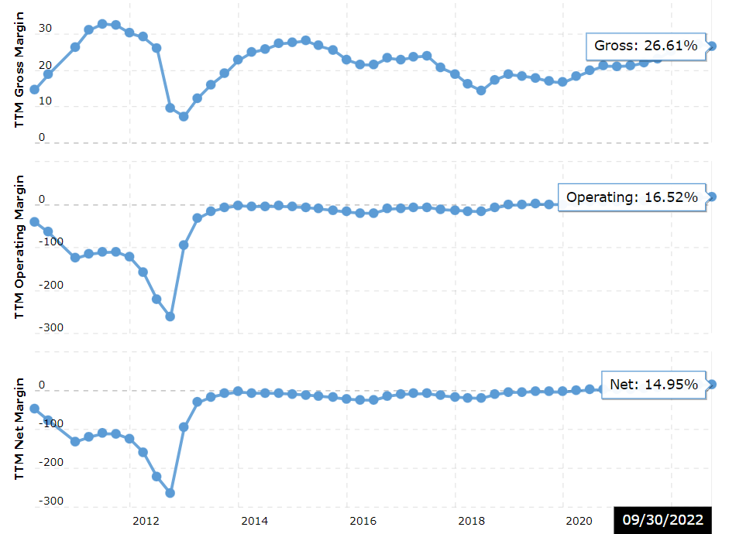
Figure 4: Gross Profit Margin trends of Tesla (Macrotrends, 2022)

Nevertheless, due to economic slowdown and competing pressures from China market, Tesla’s marketing share is retreating and its price strategy on some models may turn to skim (Prices drop from high initials).

3.3.3 Promotion
Promotion generally include incentives and communications which are independent components in 7T framework. Incentives including price promotions, trade promotions etc., which seems irrelevant to Tesla due to its long-lasting premium price strategy, whereas Tesla did announce price drops on particular models like Model 3 and Model Y as countermeasure to intensified rivalry.
Communications contain advertising, public-relations (PR), social media, direct and digital marketing are key elements for Tesla’s mix. One interesting fact is Tesla’s advertising expenditures per car sold stayed $0 (Khandelwal, 2022) which implied advertising is not ideal choice of communication for Tesla. On the other side, Tesla is adopting direct and digital marketing by setup website in concise-style, which are comfortably for most of its targeted customers to visit directly, either custom order on various models or schedule a test-drive instead of visiting offline shops (Tesla, 2022b).
Unfortunately, due to increasing amount of lawsuits against Tesla, especially a series of car accidents which had been accused of Tesla’s product defects (McFarland, 2022), generating more concerns on safety of Tesla’s products. PR as part of communication is doubtless under pressure in handling these unfavourable events.

3.3.4 Place
Place involves location of outlets or stores where products are sold and channels of distribution as well as production. Tesla opens more than 100 offline stores and galleries across US and 24 in China and more worldwide, in forming a sales and service network coverage over its major global markets, that reversely support its online channel. Besides, Tesla used direct investment overseas to build new gigafactory, including the one in Shanghai with annual production capacity of 150,000 cars (Project Management Institute,2020), and another build-in-progress gigafactory located in Germany. Tesla tends to implement strategies of keeping its supply chains possibly short and close to targeted customers.

3.3.5 People
For a technology oriented brand focused on production of tangible goods like Tesla, people is less weighted in brand image rather than those service oriented brands. Nevertheless, the after-sales service is still contributing a vast proportion of the products reputation, therefore sophisticated and well-trained services personnel will be consider an indispensable assets in providing personalized and decent customer experience (Bacon, 2017).

3.3.6 Process & Physical Evidence
While Process stands for the interactions between customers and business that are more commonly seen in service-oriented company, Tesla had its membership system in managing owners’ profiles and requirement for services such as “Self-Driving Capability subscriptions (Tesla, 2022c)”.
Physical Evidence is another element which is commonly implemented by service oriented brand who may use décor, furnishings and lighting to create ambience of eye-catching splendidness, whereas Tesla had borrowed some ideas in the decoration of offline stores in rendering highness to its brand image.

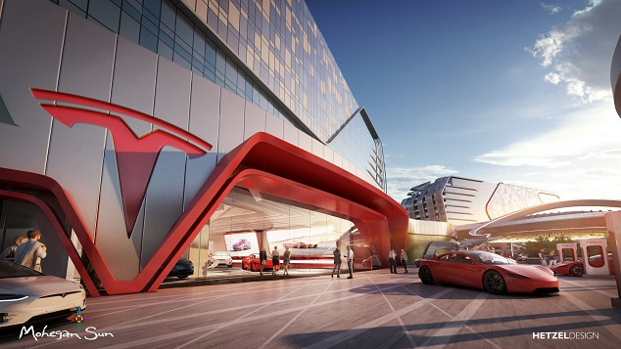
Figure 5: Tesla Flagship Store in Incheon, South Korea (Hetzel Design, 2020)

- CONCLUSIONS
By identifying Tesla’s marketing mix, the entire map of Tesla’s marketing activities exhibits after all. Honestly, Tesla had created a legendary era which is eligible to be named with it, a brand started from nothing to be the giant and leader in the industry. Any failure or deficiency of marketing activities could be compensated with its success in more broad domains. Indeed, some negative news and consequences are impairing Tesla’s high end brand image, but just like one Chinese proverb “欲戴王冠必承其重”, which means ‘whoever wish to put on king’s crown, must withstand the heavy weight’. In general, Tesla’s marketing strategies have a few shortcomings as listed below:
- In an increasingly intense competition environment, Tesla’s premium pricing strategy is good enough for maintaining its relatively high profit margins as a cash cow, but might impede in contending more market shares.
- Tesla’s marketing positioning still remain highly, while its vast majority of targeted customers are middle class, who are also pursuing something pragmatic. Tesla is not matching their 100% needs especially in different regional markets.
- Sustaining pop-ups of negative news might impair Tesla’s brand image. Although Tesla had claimed to be innovative on future technologies, but when basic safety as necessity cannot be guaranteed, it might backfire on the credibility.

- RECOMMENDATIONS
- Moderately bringing down its marketing positioning and pricing scheme on some of its product lines might be ideal solution to respond intense marketing environment. However, the route of adjustments need to be diligently planned and pretested in avoidance of brand image collapse.
- Middle class customers’ needs represent mainstream of the market, but might vary regionally. So be considerable of the different needs of targeted middle class customers in different regions becomes quite a challenge, whereas also a good approach to differentiate in EV market more deeply.
- Handling bad news about credibility is a ‘double sided sword’, it might provide clues leading to perfection of products and services. In Tesla’s case, proactive attitudes and activities will work as a good sign as showing customers its aspiration and determination of evolution.

- REFERENCES
- Anderson, B. (2022) The Real Story Behind The GM EV1. Available at: https://www.hotcars.com/real-story-behind-gm-ev1/ (Accessed: 6 Dec 2022)

- Bacon,N. (2017) Tesla Service- I felt like the most important customer in the world. Available at: https://www.tesla.com/en_GB/customer-stories/tesla-service-the-most-important-customer-in-the-world (Accessed: 9 Dec 2022)

- Baer, D. (2014) ‘The Making Of Tesla: Invention, Betrayal, And The Birth Of The Roadster’ ,Business Insider, 11 Nov 2014.

- Blanchette, B. (2020) Three Ways Technology Innovations are Propelling Tesla Forward. Available at: https://www.thirdstage-consulting.com/three-ways-technology-tesla/ (Accessed: 6 Dec 2022)

- CGTN. (2019) Tesla Shanghai factory begins trial production ahead of schedule. Available at: https://news.cgtn.com/news/2019-10-25/Tesla-Shanghai-factory-begins-trial-production-ahead-of-schedule-L4loavalkQ/index.html (Accessed: 6 Dec 2022)

- Chernev, A. (2014) Strategic Marketing Management. 8th edn. USA:Cerebellum Press.

- China-United States Exchange Foundation. (2013) Chinese Middle Class to Triple by 2022; New Study by US and Chinese Luminaries Charts Opportunities for Bilateral Economic Growth. Available at: https://www.prnewswire.com/news-releases/chinese-middle-class-to-triple-by-2022-new-study-by-us-and-chinese-luminaries-charts-opportunities-for-bilateral-economic-growth-208380651.html (Accessed: 6 Dec 2022)

- Elmerraji, J. (2018) What Tesla's Typical Shopper Looks Like (Hint: They Like Mickey Mouse). Available at: https://www.thestreet.com/investing/what-tesla-typical-shopper-looks-like-14673100 (Accessed: 7 Dec 2022)

- Fahy, J. and Jobber, D. (2022) Foundations of marketing. 7th edn. London:McGraw-Hill Education

- Finbox. (2022) Gross Profit Margin for Tesla, Inc. Available at: https://finbox.com/nasdaqgs:tsla/explorer/gp_margin (Accessed: 8 Dec 2022)

- Global Times. (2022) Tesla accident causing 2 deaths and 3 injuries in S.China under investigation with identification data still pending: media. Available at: https://www.globaltimes.cn/page/202211/1279388.shtml (Accessed: 6 Dec 2022)

- Hetzel Design. (2020) Tesla Flagship Store at Inspire Resort, Incheon. Available at: http://entertainment.hetzeldesign.com/portfolio/tesla-flagship-store/ (Accessed: 9 Dec 2022)

- HT Auto Desk. (2022) Tesla losing ground in this major EV market, claims study. Available at: https://auto.hindustantimes.com/auto/electric-vehicles/tesla-losing-ground-in-this-major-ev-market-claims-study-41669972599935.html (Accessed: 6 Dec 2022)

- Jobber, D. and Ellis-Chadwick, F. (2020) Principle and Practice of Marketing. 9th edn. London:McGraw-Hill Education

- Khandelwal, R. (2022) Here's the Secret Behind Tesla's Industry-Leading Margins. Available at: https://www.fool.com/investing/2022/04/25/heres-the-secret-behind-teslas-industry-leading-ma/ (Accessed: 9 Dec 2022)

- Lu, J. (2018) Comparing U.S. and Chinese Electric Vehicle Policies. Available at: https://www.eesi.org/articles/view/comparing-u.s.-and-chinese-electric-vehicle-policies (Accessed: 6 Dec 2022)

- Macrotrends LLC. (2022) Tesla Profit Margin 2010-2022 | TSLA. Available at: https://www.macrotrends.net/stocks/charts/TSLA/tesla/profit-margins (Accessed: 9 Dec 2022)

- McFarland, M. (2022) Tesla Autopilot’s safety questioned after latest fatal motorcycle crash. Available at: https://edition.cnn.com/2022/10/17/business/tesla-motorcycle-crashes-autopilot/index.html (Accessed: 9 Dec 2022)

- Mukherjee, A. (2022) BYD Widens Gap with Tesla in Q3 2022, Leads Global EV Market. Available at: https://www.counterpointresearch.com/global-ev-sales-q3-2022/ (Accessed: 9 Dec 2022)
- Murray, S. (2019) Tesla Hit Hard In US/China Trade War. Available at: https://www.hotcars.com/tesla-us-china-trade-war/ (Accessed: 6 Dec 2022)

- Nipic.com (2021) New energy vehicle brands’ logo. Available at: https://www.nipic.com/show/34262456.html (Accessed: 6 Dec 2022)

- Project Management Institute. (2020) Most Influential Projects 2020. Available at: https://www.pmi.org/most-influential-projects-2020/50-most-influential-projects/tesla-gigafactory-shanghai (Accessed: 6 Dec 2022)

- Quaglietti, L. and Wheeler, C. (2022) These 5 charts reveal the global economic outlook for 2022. Available at: https://www.weforum.org/platforms/centre-for-the-new-economy-and-society/articles/global-economic-outlook-5-charts-world-bank (Accessed: 6 Dec 2022)

- Reed, E. (2020) History of Tesla: Timeline and Facts. Available at: https://www.thestreet.com/technology/history-of-tesla-15088992 (Accessed: 6 Dec 2022)

- Shen, J. (2020) Tesla is facing 10 civil lawsuits in China. Available at: https://technode.com/2020/05/15/tesla-is-facing-10-civil-lawsuits-in-china/ (Accessed: 6 Dec 2022)

- Stauffer, N.W. (2020) China’s transition to electric vehicles - Benefits will come, but at what cost? Available at: https://energy.mit.edu/news/chinas-transition-to-electric-vehicles/ (Accessed: 6 Dec 2022)

- Supply Chain Game Changer. (2022) Tesla Supply Chain Issues and Lessons!. Available at: https://supplychaingamechanger.com/drawing-lessons-from-teslas-supply-chain-issues/ (Accessed: 6 Dec 2022)

- Tesla. (2022a) Tesla - About Us. Available at: https://www.tesla.com/about (Accessed: 7 Dec 2022)

- Tesla. (2022b) Tesla home page. Available at: https://www.tesla.com/ (Accessed: 8 Dec 2022)

- Tesla. (2022c) Full Self-Driving Capability Subscriptions. Available at: https://www.tesla.com/support/full-self-driving-subscriptions (Accessed: 9 Dec 2022)

