BMSW6104
Strategic Management For SME’s
Nicoleta Baltaret – student ID: 2107487
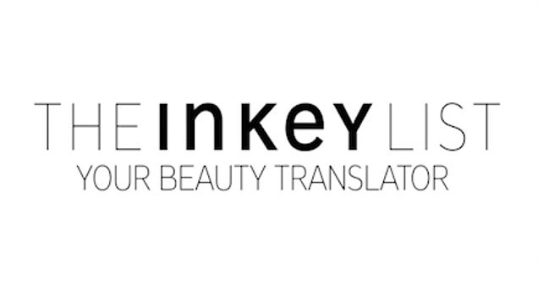
Table of Contents
i. Introduction 2
i.i. The Inkey List Current strategy Direction 2
i.ii. Internal analysis 3
Table 1- SWOT Analysis The Inkey List 3
i.iii. External analysis 4
Table 2- PESTLE Analysis for The Inkey List 4
i.iv. Stakeholders Analysis 5
Table 3- image Mendelow Matrix for The Inkey List 5
i.v. The opportunity of the growth strategy 6
Table 4- The Inkey List Ansoff Matrix 7
i.vi. Recomandation of further strategy and implementations 7
ii. Conclusion 8
References 9

Introduction
The Inkey List is a UK-based skincare brand founded in 2018 by Colette Laxton and Mark Curry. They are known for their affordable, ingredient-focused skincare products that aim to simplify skincare and make it more accessible. The company's mission is to empower consumers with knowledge about ingredients, enabling them to build personalized routines (The Inkey List, 2024). The Inkey List offers a wide range of products, including serums, cleansers, and moisturizers, all at a low price point. They have gained a loyal following for their transparent approach, effective formulas, and commitment to making skincare understandable for everyone. According with their LinkedIn website, the company size is between 51-200 (The INKEY List | B Corp, 2024). This report aims to comprehensively examine The Inkey List's current strategic direction, analyse its internal and external environment, assess stakeholder expectations, and propose a sustainable growth strategy for the long-term future of the organization (Taylor, 2004).

i.i. The Inkey List Current strategy Direction
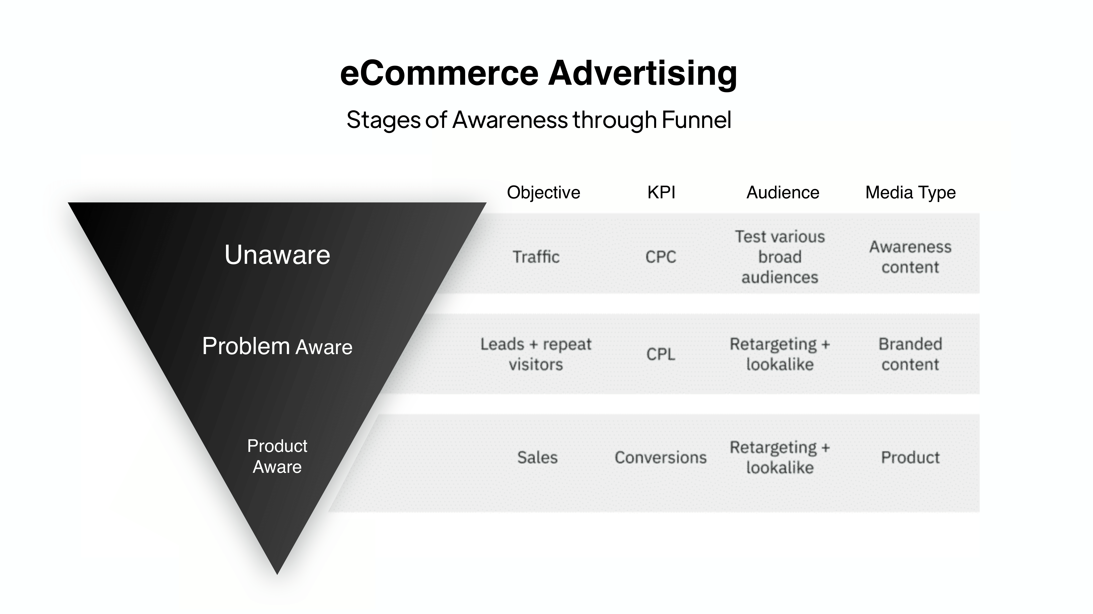
The Inkey List's current business model is primarily direct-to-consumer (DTC), capitalizing on the accessibility and global reach of e-commerce platforms. Their online store serves as the primary point of sale, allowing them to maintain control over branding, customer experience, and data collection (McKee, 2023). This DTC approach enables them to cultivate a direct relationship with their customers, fostering brand loyalty and facilitating feedback loops for product improvement. However, The Inkey List is not exclusively online. Recognizing the importance of a multi-channel strategy, they have formed strategic partnerships with select retailers like Sephora and Cult Beauty, expanding their reach to a broader audience. These partnerships have been instrumental in increasing brand visibility and credibility, as association with established retailers can signal quality and trustworthiness to consumers. Forword, the company digital marketing strategy is heavily reliant on social media platforms, particularly Instagram and TikTok, where they have amassed a substantial following. Leveraging the power of influencer marketing, they collaborate with skincare experts, bloggers, and celebrities to create authentic content that resonates with their target audience. This approach not only increases brand awareness but also fosters a sense of community and trust among consumers. Also the brand's emphasis on product innovation and efficacy further solidifies its competitive position. They continuously introduce new products that address specific skin concerns, utilizing cutting-edge ingredients and formulations backed by scientific research. This commitment to staying ahead of the curve ensures their continued relevance and appeal in the ever-evolving skincare market. But The Inkey List's current business model, while primarily DTC, is complemented by strategic retail partnerships and a robust digital marketing strategy (AL LAWATI, 2021).
Their competitive advantage lies in their transparency, educational approach, affordability, and commitment to product innovation, allowing them to carve out a unique and sustainable niche in the highly competitive skincare industry.

i.ii. Internal analysis
The company environment can be affected by internal and external factors that influence the direction further. Continuing the analysis tools such as SWOT analysis has been use for the internal analysis which plays a crucial role in strategic planning and decision-making for any organizations, including The Inkey List. In more words It serves as a framework for identifying and evaluating internal strengths and weaknesses, as well as external opportunities and threats that could impact the company's performance and growth.

Table 1- SWOT Analysis The Inkey List
Strength | Opportunities
- Strong brand reputation  - Innovative Products  - Affordable Pricing  - Direct-to-Consumer Model  - Strong Online Presence  - Ingredient-Focused Approach  - Cruelty-Free | - Expansion into New Markets  - Development of New Product Lines  - Increased Focus on Sustainability  - Partnerships and Collaborations Physical Retail Presence
weaknesses | Threats
- Limited Product Range  - Potential for Imitation  - Reliance on Online Sales  - Limited Brand Awareness  - Potential for Misuse | - Intensifying Competition  - Rising Costs of Raw Materials  - Changing Consumer Preferences  - Economic Downturns Regulatory Changes

The Inkey List boasts a strong brand image known for transparency, affordability, and education, which resonates with consumers seeking simple and effective skincare solutions. They regularly introduce innovative products with cutting-edge ingredients, appealing to a wide audience with their accessible price points. Their direct-to-consumer model allows them to maintain control over branding and customer experience, while their effective use of social media and influencer marketing further bolsters brand awareness and engagement. The ingredient-focused approach simplifies skincare and educates consumers, aligning with the growing demand for transparency in the beauty industry (Rakhmansyah, 2022). Their commitment to cruelty-free products also resonates with ethical consumer preferences. However, The Inkey List faces challenges such as a limited product range compared to larger competitors, making them vulnerable to imitation due to their relatively simple formulations. Their heavy reliance on online sales could limit their reach to consumers who prefer in-store experiences, and their brand awareness, while growing, is still not as strong as some established competitors. The single-ingredient focus could potentially lead to misuse or layering of incompatible ingredients by consumers who may lack expertise in skincare. Despite these challenges, The Inkey List has significant opportunities for growth. Expanding into new markets like Asia and Latin America, where demand for affordable and effective skincare is increasing, could significantly expand their customer base. Developing new product lines, such as haircare or body care, would cater to a broader range of consumer needs. Embracing sustainability and eco-friendly practices could align with growing consumer expectations and enhance brand image. Partnerships and collaborations with other brands or influencers could further boost brand awareness and reach, while establishing a physical retail presence through stores or pop-ups could enhance customer experience and brand visibility. Never the less The Inkey List must also contend with threats such as intensifying competition from both new and established brands in the affordable skincare market. Rising costs of raw materials could impact profitability, and changing consumer preferences could affect demand for certain products. Economic downturns could lead to decreased consumer spending, and potential changes in cosmetic regulations could necessitate reformulation or relabelling of products, leading to increased costs. The company has a strong foundation with significant growth potential. By capitalizing on their strengths, addressing their weaknesses, and proactively managing potential threats, they can continue to thrive in the ever-evolving skincare industry (AL LAWATI, 2021) (Lv, 2022).

i.iii. External analysis
Same as the internal factors, the external factors can also influence the company strategic direction. The PESTLE analysis plays a critical role in strategic planning and decision-making for organizations like The Inkey List by providing a comprehensive framework to evaluate external factors that can significantly impact the company's operations and future trajectory. The Inkey List, as a prominent player in the skincare industry, is subject to various external factors that can significantly influence its operations and strategic direction. A PESTLE analysis helps to illuminate these factors:

Table 2- PESTLE Analysis for The Inkey List
Political Factors | Economic Factors | Social Factors | Technological Factors | Legal Factors | Environmental Factors
-Regulations  -Brexit  -Political Stability | -Inflation | -Current Trends  -Social media Influence | -E-commerce Growth  -Advancements in Skincare | -Cosmetic Regulations  -Consumer protection Law | -Sustainability rends  -Environment concerns

Politically, The Inkey List must navigate the complex landscape of cosmetic regulations, which can change and evolve over time. These regulations dictate everything from ingredient safety to labeling requirements, and non-compliance can result in costly fines and reputational damage. Additionally, Brexit poses a unique challenge, potentially affecting the company's supply chain and access to European markets. Political stability in key markets is also crucial, as economic and political uncertainties can dampen consumer confidence and spending. Economically, The Inkey List is vulnerable to fluctuations in the global economy. Economic downturns can lead to reduced consumer spending, especially on non-essential items like skincare. Exchange rates can impact the cost of raw materials sourced from overseas, affecting profitability and pricing strategies (Ramcharran, 2013). Inflation, if not managed carefully, can erode profit margins and necessitate price increases, potentially alienating price-sensitive consumers. Socially, The Inkey List is well-positioned to capitalize on the growing demand for clean beauty, transparency, and ethical sourcing. Consumers are increasingly conscious of the ingredients in their skincare products and are seeking brands that prioritize transparency and ethical practices (Łopaciuk, 2013). The Inkey List's emphasis on education and ingredient transparency aligns well with this trend. Additionally, social media platforms have become powerful tools for shaping consumer preferences and purchasing decisions, offering The Inkey List ample opportunities to engage with their target audience and build brand awareness. The increasing focus on health and wellness also presents a promising avenue for growth, as consumers seek skincare products that promote overall skin health. Technologically, The Inkey List can leverage the continued growth of e-commerce to reach a wider audience and expand their market share. Embracing new technologies and platforms for online sales and marketing can help them stay ahead of the curve. Advancements in skincare ingredients and formulations present opportunities for product innovation, allowing The Inkey List to maintain its competitive edge. However, they must also adapt to changes in social media algorithms, which can impact their visibility and reach on these crucial platforms. Legally, The Inkey List must ensure strict adherence to cosmetic regulations to avoid legal issues and maintain consumer trust. Protecting their intellectual property, including their unique formulations and brand name, is vital to prevent imitation and safeguard their competitive advantage. Compliance with consumer protection laws is also essential to avoid legal disputes and maintain a positive brand reputation. Environmentally, The Inkey List needs to address growing consumer concerns about sustainability and the environmental impact of their products and packaging. Adopting sustainable practices throughout the supply chain, such as using eco-friendly packaging and responsibly sourcing ingredients, can enhance brand image and appeal to environmentally conscious consumers (Yun, 2015). Climate change and its potential impact on raw material availability and costs are also factors that The Inkey List needs to consider in their long-term planning. The Inkey List operates in a dynamic and complex environment influenced by a wide range of political, economic, social, technological, legal, and environmental factors. Understanding and proactively addressing these factors is crucial for the company's continued success and sustainable growth in the competitive skincare market (Naradda Gamage, 2020).

i.iv. Stakeholders Analysis
The Inkey List operates within a complex network of stakeholders, each with distinct interests and levels of influence. Understanding and managing these relationships is crucial for the company's continued success and growth (Ziraga, 2015). Due to that the matrix of Mendelow has been used to analyse The Inkey List stakeholders.

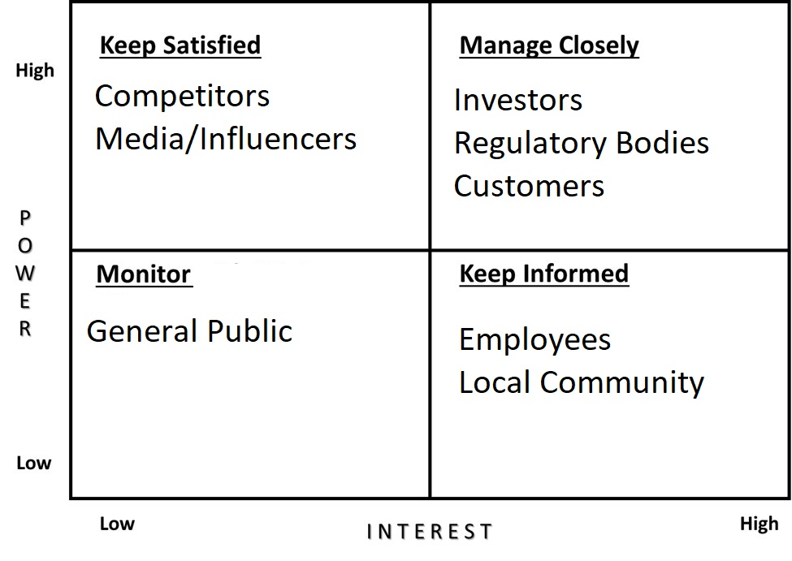
Table 3- image Mendelow Matrix for The Inkey List

The above matrix state that as the primary consumers of The Inkey List's products, customers hold immense power. Their satisfaction with product quality, efficacy, affordability, and transparency directly impacts sales and brand reputation. Their feedback and preferences shape product development and marketing strategies, making them a critical stakeholder for The Inkey List. The Inkey List's employees are invested in the company's success as it affects their job security and career development. They value a positive work environment, fair compensation, and opportunities for growth. Their productivity, innovation, and customer service directly influence the company's performance and reputation. The Inkey List relies on its suppliers for high-quality, ethically sourced ingredients and packaging materials. Maintaining strong relationships with suppliers is crucial for ensuring a consistent supply of materials and maintaining product quality. Suppliers, especially those offering unique or rare ingredients, can exert some bargaining power over pricing and terms. Investors: Investors provide the financial resources that fuel The Inkey List's growth and development. They are naturally concerned with financial returns and the company's overall growth trajectory. Their investment decisions and expectations can significantly influence the company's strategic direction and priorities. Further, regulatory bodies like the FDA and MHRA have a significant impact on The Inkey List's operations. Their stringent regulations regarding ingredient safety, labelling, and marketing claims dictate how The Inkey List develops and markets its products. Non-compliance can lead to legal issues and reputational damage, making it crucial for The Inkey List to maintain a strong relationship with these bodies. Also influencers and media outlets, through their reviews, recommendations, and coverage, can shape public opinion and influence consumer behavior. Their endorsement or criticism can significantly impact The Inkey List's brand image and sales. Therefore, building positive relationships with these stakeholders is essential for maintaining a positive brand image and generating buzz around new products. The competitive landscape in the skincare industry is constantly evolving. Competitors are always seeking to gain market share and can put pressure on The Inkey List through pricing, marketing, and product innovation. Staying ahead of the competition requires The Inkey List to constantly monitor and respond to their competitors' strategies and offerings. The Inkey List's stakeholders are a diverse group with varying levels of interest and influence. By understanding and effectively managing these relationships, The Inkey List can create a collaborative and supportive environment that fosters innovation, growth, and long-term success (Varvasovszky, 2000) (AL LAWATI, 2021).

i.v. The opportunity of the growth strategy
The Ansoff Matrix is a strategic tool used to identify and assess growth opportunities for businesses by considering new and existing products and markets. It provides a framework for evaluating different growth strategies and their associated risks. For The Inkey List, the Ansoff Matrix offers several potential avenues for sustainable growth. The Inkey List, as a growing SME in the skincare industry, can strategically navigate its growth trajectory using the Ansoff Matrix as a guiding framework. The matrix presents four distinct pathways for growth, each with varying levels of risk and potential reward as it can be seen in the table 4 below. Market penetration, the first quadrant, focuses on increasing sales of existing products within the current market (Navarro, 2012). For The Inkey List, this could involve intensifying marketing efforts, exploring new pricing strategies, expanding distribution channels through additional retail partnerships, and enhancing customer service to foster loyalty and word-of-mouth recommendations. Market development, the second quadrant, entails introducing existing products into new markets. The Inkey List has significant potential for geographic expansion, particularly in emerging markets like Asia and Latin America, where demand for affordable and effective skincare is burgeoning. Tailoring marketing campaigns to different demographics and exploring new sales channels, such as subscription boxes or direct sales, can also facilitate market development (Putri, 2019).

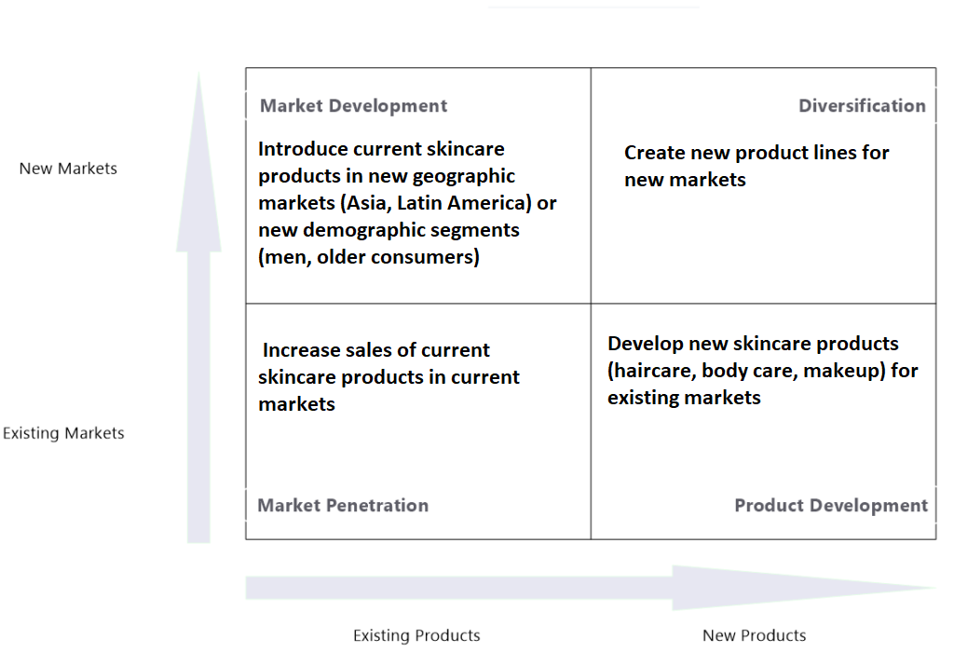
Table 4- The Inkey List Ansoff Matrix

Product development, the third quadrant, involves creating new products for existing markets. This strategy aligns with The Inkey List's core competency of developing ingredient-focused formulations. They could expand their product range by introducing new categories like haircare and body care or developing innovative formulations with cutting-edge ingredients. Personalized skincare routines, tailored to individual needs and preferences, could also attract a wider range of consumers. Diversification, the fourth and riskiest quadrant, involves entering new markets with new products. While this strategy offers the highest potential for growth, it also carries the most significant risks due to unfamiliarity with new markets and product categories. The Inkey List could explore diversification through strategic partnerships or acquisitions, or by leveraging their expertise in ingredient-focused formulations to develop products for other industries like health or wellness. Considering The Inkey List's strengths and the current market landscape, a combined approach of market development and product development seems the most promising for sustainable growth. Expanding into new geographic markets and introducing new product lines aligns with their brand values and addresses identified opportunities in the market. This strategy leverages their existing strengths in ingredient transparency and affordability while minimizing the risks associated with diversification. To ensure sustainability, The Inkey List should integrate eco-friendly practices into product development and packaging, aligning with the growing consumer demand for sustainability. Continued investment in digital marketing and strategic partnerships with local retailers and influencers can further accelerate growth in new markets.

i.vi. Recomandation of further strategy and implementations
Key strategic recommendations for The Inkey List's future development involve a multi-faceted approach that capitalizes on their strengths while addressing the challenges inherent to being an SME. Primarily, they should prioritize market development and product development. This means expanding into new geographic markets with untapped potential, such as Asia and Latin America, while simultaneously developing new product lines like haircare and body care. These endeavors require thorough market research to understand local preferences and tailor product offerings accordingly, as well as significant investment in research and development to create innovative and unique formulations that resonate with consumers.

To support these growth initiatives, The Inkey List should enhance their digital marketing efforts and further solidify their brand awareness. This can be achieved by continuing to leverage social media platforms like Instagram and TikTok, creating engaging content, collaborating with influencers, and utilizing targeted advertising. Additionally, they should focus on producing educational content that demystifies skincare ingredients and routines, empowering consumers to make informed choices and building trust in the brand. Fostering a sense of community through online forums and interactive events can further enhance customer engagement and loyalty. Further, embracing sustainability is another key recommendation. This involves transitioning to eco-friendly packaging materials, reducing waste in the supply chain, prioritizing ethically and sustainably sourced ingredients, and communicating these efforts transparently to consumers. Such initiatives not only appeal to environmentally conscious consumers but also contribute to a positive brand image and long-term sustainability. Moreover expanding distribution channels is also essential for reaching a wider audience. This can be achieved by building strategic partnerships with key retailers in both existing and new markets, increasing product visibility and accessibility (Opoku, 2014). The Inkey List could also explore opening physical stores or pop-up shops in key locations to offer a more immersive brand experience. Additionally, leveraging online marketplaces like Amazon and Tmall can significantly expand their reach to a global audience. Investing in talent and technology is equally important for sustaining growth. Attracting and retaining top talent in areas like product development, marketing, and e-commerce is crucial for driving innovation and staying ahead of the curve. Embracing technology solutions for inventory management, customer relationship management (CRM), and data analytics can streamline operations, enhance efficiency, and provide valuable insights into consumer behaviour. However, implementing these strategies as an SME presents unique challenges. Limited resources, both financial and human, can hinder the execution of ambitious growth plans. Resistance to change from internal stakeholders may also arise, requiring effective communication and change management strategies. Additionally, the competitive landscape can be daunting, demanding differentiation through unique offerings and strong brand identity. To overcome these challenges, The Inkey List should prioritize initiatives based on available resources and focus on those with the highest potential return on investment. Seeking external funding or partnerships can provide additional resources for growth. Clearly communicating the benefits of the proposed strategies to employees and stakeholders can help foster buy-in and ensure smooth implementation. And by staying true to their brand values of transparency, education, and affordability, The Inkey List can continue to differentiate themselves in the market and maintain a loyal customer base. By addressing these challenges and implementing these recommendations, The Inkey List can pave a sustainable path for future growth. Their strong foundation, coupled with strategic foresight and adaptability, positions them well for continued success in the dynamic and ever-evolving skincare industry (Naradda Gamage, 2020).

Conclusion
The Inkey List's success in the competitive skincare market stems from its strong brand identity, innovative products, and consumer-centric approach. By prioritizing transparency, education, and affordability, they have disrupted the industry and gained a loyal following. Market and product development, coupled with sustainability and digital innovation, are key strategies for future growth. While challenges exist, The Inkey List's strong foundation and adaptability position them well for continued success. By staying true to their core values and adapting to consumer needs, they are poised to become a leading player in the global skincare market.

References
AL LAWATI, M. a. T. V., 2021. Business Intelligence as a market driver for the personal care brands: Case of the Middle East. Asian Journal of Advances in Research,, 4(1), pp. 1366-1381.
Łopaciuk, A. a. Ł. M., 2013. Global beauty industry trends in the 21st century. n Management, knowledge and learning international conference, pp. 19-21.
Lv, Y., 2022. Analysis on Consumer Behavior of Domestic Skin Care Products. Frontiers in Business, Economics and Management, 5(1), pp. 164-168.
McKee, S. S. S. P. J. a. C. J., 2023. The evolving direct‐to‐consumer retail model: A review and research agenda. International Journal of Consumer Studies, 47(6), pp. 2816-2842..
Naradda Gamage, S. E. E. A. G. P. R. J. J. a. R. P., 2020. A review of global challenges and survival strategies of small and medium enterprises (SMEs). Economies, 8(4), p. 79.
Naradda Gamage, S. E. E. A. G. P. R. J. J. a. R. P., 2020. A review of global challenges and survival strategies of small and medium enterprises (SMEs). Economies, 8(4), p. 79.
Navarro, J. C. J. a. B. B., 2012. Forms of growth: How SMEs combine forms of growth to achieve high growth 18(1), pp.81-97.. Journal of Management & Organization, 18(1), pp. 81-97.
Opoku, A. a. A. V., 2014. Embracing sustainability practices in UK construction organizations: Challenges facing intra-organizational leadership. Built Environment Project and Asset Management, 4(1), pp. 90-107.
Putri, F. J. R. a. C. H., 2019. Strategic planning of Indonesian skincare clinics. Russian Journal of Agricultural and Socio-Economic Sciences, 90(6), pp. 203-215.
Rakhmansyah, M. W. T. S. A. a. G. I., 2022. Small and medium enterprises (SMEs) with SWOT analysis method. International Journal for Applied Information Management, 2(3), pp. 50-57.
Ramcharran, H., 2013. E-commerce growth and the changing structure of the retail sales industry. International Journal of E-Business Research (IJEBR), 9(2), pp. 46-60.
Taylor, M. a. M. A., 2004. SMEs and e‐business. Journal of small business and enterprise development, 11(3), pp. 280-289.
The INKEY List | B Corp, 2024. LinkeIn The Inkey List profiel. [Online]
Available at: https://www.linkedin.com/company/be-for-beauty/?originalSubdomain=uk
[Accessed 06 30 2024].
The Inkey List, 2024. OUR MISSION. [Online]
Available at: https://uk.theinkeylist.com/pages/knowledge-powers-change#:~:text=Our%20Mission%3A&text=We%20will%20always%20use%20KNOWLEDGE,Inkey%20List%20changemakers%20are%20created.
[Accessed 01 07 2024].
Varvasovszky, Z. a. B. R., 2000. A stakeholder analysis. Health policy and planning, 15(3), pp. 338-345.
Yun, J. J. W. a. Y. J., 2015. Knowledge strategy and business model conditions for sustainable growth of SMEs. Journal of Science & Technology Policy Management, 6(3), pp. 246-262.
Ziraga, T. a. W. H., 2015. Strategic assessment of Indonesian furniture industry. Journal of Business and Management, 4(6), pp. 645-648.

