NAME - VIJAY KUMAR
STUDENT NUMBER- 1918986
MODULE TITLE- LCMB7001
ASSIGNMENT TITLE- MKM_A1
LECTURE’S NAME- TUSHARA BALENDRAN

Contents
INTRODUCTION 3
MAIN BODY 3
Communication 3
Communication Model 4
Integrated Marketing Communication 5
Promotions Currently used by Organization 6
Recommended Promotion Processes 7
Branding and Brand Equity 8
Aaker’s Brand Equity Model 9
Customer Journey Map 11
Total Engagement Model 13
CONCLUSION 14
REFERENECES 15

INTRODUCTION
Marketing management is considered as the process of organizing, planning, controlling and implement various processes, strategies, tactics and methods to improve demand of company products in a market place. Marketing department is one of the most important functional department in a business organization. Main function of marketing department is to promote the products and services that are provided to the customers (Hollensen, 2019). The objective of marketing management is to improve the operations of marketing department to increase the reach of the company to the customers and develop better relationship with them. This report is about Sainsbury’s Supermarket which is considered as the top supermarket in UK. Sainsbury’s was founded by John James Sainsbury’s in year 1869 at Holborn, London, UK. Sainsbury’s is a supermarket chain that is operating in United Kingdom. There are total 1425 Sainsbury’s stores in UK and the number is increasing. This report is mainly explaining the importance of specific strategies, processes and methods that can be used by an organization to improve the performance of marketing department in a target market to increase profit of a company in a market place.
Importance of communication will be discussed in study with the help of a communication model. Concept of integrated marketing communication will be discussed in report. Different promotion strategies that are used by Sainsbury’s will be analysed in report and some other promotion process will also be suggested in report that can be used by organization to improve the marketing process of company. Concepts like brand equity and branding will be evaluated in report using brand equity model. Customer journey map also will be explained for specific product of a company. Total engagement model will be analysed in study to understand importance of a customer engagement.

MAIN BODY

Communication
Communication is considered as the process of exchanging information using speaking, writing and using different signs. For marketing all these processes are used in order to convey proper information to the customers. Marketing communication can be explained as fundamental and most complex part of a company’s marketing function (Kotabe and Helsen, 2020). Marketing communication process includes various processes and methods like advertising, branding, direct marketing and online presence of organization, printed advertisements and packaging of company products. These all types of processes are used by the company for the marketing process.

Communication Model
Shannon and Weaver Model
This model was proposed by Shannon and Weaver in an year 1948. This model was explained as Bell System Technical Journal and it is known as Mathematical Theory of Communication or Shannon and weaver Model. Main objective of this model is to develop effective communication and data transfer between sender and receiver. Noise factors in the communication process has been discussed in model as factors that can affect the communication process. Shannon and Weaver model is considered as one of the best communication process for field. There are different concepts that are included in Shannon and Weaver Model are- Sender, Encoder, Channel, Decoder and receiver and noise.
Sender- Sender is considered as source and originator of information or selector of message. Sender is considered as starting of communication process.
Encoder- Encoder is an electronics device that is used to convert messages and data into electrical transferable system. Data is encoded in form of wave or binary system (Keegan, 2017). These converted data is transferred through cables or wireless network.
Decoder- Decoder can be explained as electronics device or circuit which is used to convert binary or wave signal into readable form. This is considered as the reverse process of encoding process. Without decoding process receiver cannot understand the encoded message
Receiver- Receiver is considered as the end point of the end point of the communication process. This is the destination where sender intended to send information for a specific purpose.
Noise- In the process of data or information transfer a channel is used to communicate information between sender and receiver. This channel contents messages and information in the form of electronic signal that can be affected by other physical factors. For example thunder storm, radio signals and other physical errors. These factors can affect effectiveness of the channel and cause damage to the signal that is carrying message.
This model can be used by the Sainsbury’s to use a field and internal communication system with in an organization to manage effective communication with different branches in an effective manner.
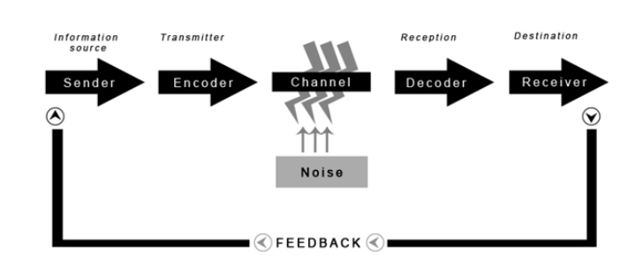
Figure 1Shannon and Weaver Communication Model
(Source : Communication Theory, 2019)

Integrated Marketing Communication
Integrated marketing communication is a concept which is used by the business organization to improve the effectiveness of a marketing process. There are different communication process can be used in the communication process. In normal process organization uses individual communication process separately for the marketing process but in integrated communication process all communication process are used by an organization in integrated manner to improve the marketing operation of organization (Deepak and Jeyakumar, 2019). Various forms of communication are used by the organization to communicate with customers. All promotional tools can be used by the organization with concept of integrated communication process to improvise effectiveness of marketing operations that are used by Sainsbury’s in a market place. Mainly the tools that are used in the promotional mix are used together in an integrated marketing communication process to gain high productivity with marketing operations. There are different type of Integrated Marketing communications that can be used by an organization in the communication process. For example horizontal integration, vertical integration, data integration, internal integration and external integration.
This is how various Integrated Marketing Communication processes can be used by an organization to improve marketing process.

Promotions Currently used by Organization
There are different promotional processes used by Sainsbury’s in order to promote products and services which are offered by them in a market place. Some of the process that are currently used by an organization in marketing process are mainly focused on the marketing mix strategy. Marketing process of Sainsbury’s are mainly focused on the elements of the marketing mix. Various changes and innovations are implemented by company in the promotion process. The element of the marketing mix that are focused by organization are- Product price, promotion and people. These elements are focused by the organization to improve the marketing process. There are many brands are added in the supermarket to provide better experience to the customer and attract different levels of customers to buy products and services for Sainsbury’s (Gupta and Nair, 2020). The prices that are offered to the customer are based on concept of effective low cost in which products and services that are offered to the customers at effective low cost and high perceived quality. There are different promotion processes used by Sainsbury’s to address customers and make them aware of the products and services that are available in a company. This can help company to reach to larger audience. For example digital marketing processes are used by the organization to promote their products and services in a market place. People of the organization are mainly the stakeholders that are connected to the organization in different personal interests. Mainly employees are targeted in this process. They are provided with different trainings and development sessions in order to improve their skills and knowledge. This process can help employees to perform work in supermarket of Sainsbury’s with high productivity. These are current processes that are used by Sainsbury’s to improve the marketing of products and services of a company.
Current promotion techniques that are used by Sainsbury’s are related to marketing mix. Company is considering elements of marketing mix to develop better result market place. Effective distribution strategy are used by the organization to attract more customer to buy their products and services. They are promoting their 24*7 services to attract more customers. Sainsbury’s is also effectively using the marketing strategies like Above the Line and Below the Line promotional strategy. Main objective of this strategy is to improve the brand image of company in target market. Company also has sponsored different sports events to develop better image in market. Different digital marketing strategy are also used by company to get attention of customers.

Recommended Promotion Processes
Market trends are changing with time and various innovations are involved in the promotional processes that are used by business organization to promote their products and services in a market place. There are different promotional processes can be used by the organization to improve the marketing process.
Contests as promotional process
This is highly important for the organization to engage the customers in an effective way to make customers effectively aware of the products and services that are sold by a company. Organization can engage the customers in various events that can allow them to make communication with company (Pasquier and Villeneuve, 2017). By this process Sainsbury’s can develop effective and loyal customer base. Contests like quizzes and competitions can be used by the marketing department of company to interact with customers.
Social Media Promotion
Social Media Promotions are the most effective and highly trending processes that can be used by the organization to promote the products and services of a company. A larger audience is connected with social media platform and organization can used these social media platforms, this can be used by the company to engage larger customer base within a short time and less efforts. Various social media platforms like Facebook, Instagram, Twitter and LinkedIn can be used by Sainsbury’s to promote their products and services on these platforms in order to target larger audience in a cost effective way.
Product Giveaway sample
As an organization launch a new product in market place and customer do not know about these products. To make customer aware of quality and quantity that is offered by the company products samples can be provided to the customers for free. Through this process company can provide product experience to the customers (Mix and Brand, 2017). This process can help Sainsbury’s to develop loyal customer base and perform long term business with high marginal profit.
Customer Appreciation Events
This is the most important part of marketing process that is used by the organization. Customer Appreciation events can be organized by the company to praise the customers. For example organization can provide gift hampers and rewards to their regular and loyal customer to attract more customers to buy products from their retail stores. This is how customer appreciation can help organization to increase the size of customer base.
These all processes can be used by the organization to improve the marketing process and make higher reach to more customers in an effective way.

Branding and Brand Equity
Branding
Branding is considered as the process which is used by an organization to improve the image of organization in a market place. There are different aspects of the company that are promoted in the market place to improve the awareness of the customers regarding name, logo, services and product of a company. This process is mainly focused on developing larger and loyal customer base. This is also considered as process which is used by the company to represent the company and its products along with services that are offered to the customers. Branding process allows the organization to make customer to differentiate products and services from other organizations. This is how organization can improve their brand image in a market place (Naudé and Sutton-Brady, 2019). This reputations and brand image can help Sainsbury’s to create much larger customer base.
Brand Equity
Brand equity of the organization is considered as the value that is derived from the perception of a customer regarding products and services that are offered by the organization to customers. Brand equity is considered as a term that can be used by the organization to describe the value of an organization in a market place. The value of the organization is derived from the perception of the customers. If the awareness of the customer is good about company and they are able to differentiate their products and services in range of products. If the brand equity of the organization is high then it can be considered that the brand value is very high in a market place. This is how brand equity is one of most important factor for an organization.

Aaker’s Brand Equity Model
This is the main objective of the business organization to build powerful brand in a market place. This model can be used by Sainsbury’s to develop powerful brand in a market. According to this model there are different factors that can influence the effectiveness and strengths of an organization’s products and services. Aaker’s Brand Equity model is based on the mixture of the brand awareness, brand loyalty and brand association. This process is used by the organization to improve the value of the products and services that are offered to the customers (Kotler, 2019). There are various components that are used in the Aaker’s Brand Equity model. Through this process organization can get out of competition and focus on brand development. There are five main components considered in Aaker’s Brand Equity Model. Components of this model are- Brand Loyalty, Brand Awareness, Perceived Quality, other Proprietary Assets and Brand Association. All these assets are connected to the brand value of a company in a market place. Aaker’s Brand Equity model can be used by Sainsbury’s to improve brand value in market place.
Brand Loyalty
The level of customer’s loyalty is expressed in this component. For example it is cost effective for the organization to perform business with loyal customer because they do not need to spent capital in the marketing process. Loyal customers help the organization to generate constant revenue in a business process. Loyal customers also perform marketing for an organization and they make other people aware of quality of services and products that are sold by an organization in a market place. Loyal customers reduce the competitive threat of an organization in a competitive market.
Brand Awareness
This component is regarding the information that is possessed by the customer regarding company. This component can be considered as the ability of the customer to differentiate products and services of an organization within range of products and services. There are various factors recognize by customer (Bojanic and Reid, 2017). For example company logo, name and products. This can increase the awareness of organization and help them to recognize organization in a market place. Better relationship with customer can help the organization to improve the awareness of customer base. At the time of purchase the consideration of company can also improve the awareness of an organization in a market.
Perceived Quality
The quality of service of products provided to the customer is measured in this process. Quality of product and service is measured because quality offered to the customer is the main reason for the customer to buy the company product. It also help organization to make customer to differentiate their products with other products of competitive organizations. Price of the product is also considered to analyse the perceived quality of organization’s product. The sales channels of a company can state the quality of product that is sold by Sainsbury’s in a market place. Availability through different channels can increase the brand value of an organization in a market place. Number of brand extensions and number of lines also make the customer to evaluate the quality of services that are provided by the company.
Other Proprietary Assets
Various assets like patents, copy rights, trademarks, intellectual property and trade secrets can improve the brand equity of an organization in a market place. All these assets provides advantage to the organization in a market place and improve their sales in a market.
Brand Association
This is considered as the degree to which the product or services are recognized by the customer. There are different processes that can be considered by the organization to evaluate the brand association for Sainsbury’s. It can be considered as the degree to which brand name can be used to process or retrieve the association from the mind of customer (Chang, McAleer and Wong, 2018). How the company name drives the customer to buy product. This is also about how the organization has made positive value in mind about organization. More extensions and opportunities also can lead Sainsbury’s to improve the brand association.
Advantages
- This model can be used at different stages of marketing.
- It can help the customers to increase the loyalty of customers.
- Also support organization to differentiate their products and services.
- Improve the brand awareness.
Disadvantages
- Need to develop better research and market analysis to implement this model.
- This is also required to perform real time assessment for effective performance of company in a marketing process.
This is how all these five components can be considered by Sainsbury’s to improve the brand value of organization in target market.

Customer Journey Map
Customer journey map is considered as the process in which the interaction with the customer in an organization can be visualised in a supermarket. This can also be explained as the process that is used by the organization to represent the movement and behaviour with in the purchasing process. This process can help management of Sainsbury’s to analyse the perspective of the customer regarding organization. For example a customer want to buy groceries from supermarket, he needs to follow a specific journey in order to complete the purchasing process. The journey of customer starts with the advertisement of organization in a market. Online search made by the customer to get more information on the social media. After collecting all information customer reach to the supermarket front. As the customer enters the store, first task of the customer is to locate the position of grocery in a supermarket. After locating the grocery in store it is required to select the specific item to buy and load it into the shopping basket (Johnsen, 2018). After this customer needs to find billing counter. Counter representative collect the goods that is selected by the customer and all the grocery products are scanned by the counter manager to prepare the bill. After billing is complete total is provided to the customer. After this payment is made by customer through card or cash. Post billing process packed products are provided to the customer. After this process customer can go out of the supermarket.
Stages of Customer Journey
Awareness- The need of the Customer is to buy grocery for the daily use. For this they look for the grocery stores nearby the location.
Evaluate and Consideration
At this stage online research is made by the customer to find the location of store in the locality. As customer is ready to buy products from the store and process of shortlisting process performed by customer. Listing of goods can be considered in evaluation and consideration process.
Decision
At this stage customer ready to buy product in Sainsbury’s store. As per the needs customer make final decision to buy it from the supermarket.
Retention Stage
In this stage customer evaluate the effectiveness of services that are provided by the Sainsbury’s supermarket. If satisfaction level of customer is high then it will increase the chances of high customer retention.
Advocacy
After becoming loyal customer of an organization customer starts advocate for the company. For example after becoming loyal customer of company they start promoting products and services of an organization.
Customer Touchpoints
Customer touchpoints are considered as number of times customer interacted with company. For the grocery purchasing process touch points for customer are- Before purchase, during purchase and post purchase. Before purchase – Online advertisement and research can be considered as before purchase touch points. During purchase- Visit to the store, conversation with customer executive and product pick up and billing process is considered as during purchase touch points. At the end post purchase touchpoints for customer are- billing, using grocery buy from Sainsbury’s.
Benefits of Customer Journey Map-
- Help the organization to understand customer perspective.
- Help the organization to find challenges that are faced by customers.
- Provide opportunities to organization to find various solutions to a company.
- Improve the services that are provided to the customer.

Analysis of the customer journey map is required in terms of the strengths and weaknesses of certain touchpoints used at different stages in the customer journey.

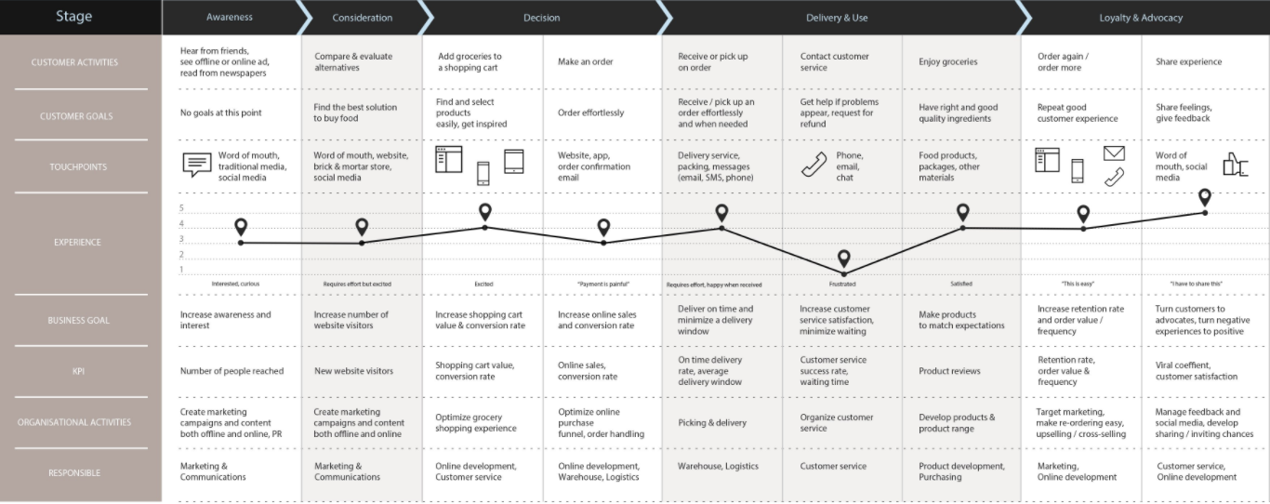

Total Engagement Model
This is highly important for the organization to effectively engage their customers in order to improve their awareness about organization. Through this engagement process organization can improve their relationship with customers in order to run business efficiently for long term (Reic, 2016). There are different processes that can be used by the organization to engage the customers in an effective way. By making interaction with customer and by engaging them, organization can improve their relationship with consumers. Total engagement model is used by the organization to align all element of the customer value proposition, culture, brand advertisement and customer experience.
Customer Value Proposition- Customer value proposition is considered by the organization to improve the customer experience in an organization. This is the reason why the customer should buy products from an organization.
Brand Effectiveness- The products and services that are provided by the organization to the customers. Brand value of an organization can help organization to effectively engage customer in an effective manner. Culture refers to the internal aspects of an organization. Goals, values and behaviour of the organization. This process can help the organization to provide better services to the company.
Customer
Different type of physical and emotional support is needed to be provided to the customers to make them loyal to the organization.
By improving brand advertisement, internal culture of organization and customer experience need to be focused in order to achieve maximum customer experience.
Recommendations
- Develop better Value proposition to build strong customer base.
- Brand advertisement should be based on brand advertisement
- Deliver the services and products that are promised to customer.
These processes can be used by the organization to engage the customer in an effective way.

CONCLUSION
This report is concluding importance of marketing management in order to improve the performance of marketing department with in organization. Various aspects related to the marketing process has been analysed in report. Important of communication and integrated marketing communication has been discussed in report. Various strategies that can be used by an organization to improve the marketing process has been evaluated in report. Branding and brand equity has been discussed for Sainsbury’s Supermarket. Brand equity model has been explained in order to understand these concepts in an effective manner. Customer journey map and total engagement model has been analysed in report that can be used by Sainsbury’s to improve the business process of organization. Organization can reduce the issues in the customer journey map to improve their sales in a market place. Company can use digital technology to reduce the product finding time for customer. Sainsbury’s also can use smart transaction process to reduce the complexity in buying process. Better directions can be provided to improve the client satisfaction.

REFERENCES
Books and Journals
Bojanic, D.C. and Reid, R.D., 2017. Hospitality marketing management. Wiley.
Chang, C.L., McAleer, M. and Wong, W.K., 2018. Big data, computational science, economics, finance, marketing, management, and psychology: connections. Journal of Risk and Financial Management. 11(1). p.15.
Chernev, A., 2018. Strategic marketing management. Cerebellum Press.
Deepak, R.K.A. and Jeyakumar, S., 2019. Marketing management. Educreation Publishing.
Gupta, C.B. and Nair, R., 2020. Marketing Management, CB Gupta & N. Rajan Nair. Sultan Chand & Sons.
Hollensen, S., 2019. Marketing management: A relationship approach. Pearson Education.
Johnsen, T.E., 2018. Purchasing and supply management in an industrial marketing perspective. Industrial Marketing Management. 69. pp.91-97.
Keegan, W.J., 2017. Global marketing management. Pearson India.
Kotabe, M.M. and Helsen, K., 2020. Global marketing management. John Wiley & Sons.
Kotler, P.T., 2019. Marketing management. Pearson UK.
Mix, M. and Brand, C.B., 2017. Marketing management.
Naudé, P. and Sutton-Brady, C., 2019. Relationships and networks as examined in Industrial Marketing Management. Industrial Marketing Management. 79. pp.27-35.
Pasquier, M. and Villeneuve, J.P., 2017. Marketing management and communications in the public sector. Routledge.
Reic, I., 2016. Events marketing management: A consumer perspective. Taylor & Francis.
Online
Communication Theory, 2019. [Online]. Available Through. < https://www.communicationtheory.org/shannon-and-weaver-model-of-communication/>.

