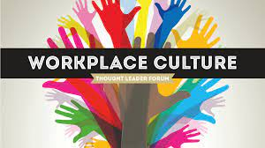  Workplace Culture and its impact on Organizational Efficiency  Academic Report | Katalin Fodor: 1908947  Lecturer Name: Hossein Shokri

Table of Contents

Executive Summary 2
Starbucks brief introduction, history 2
Organisational Culture 2
Starbucks’ Organizational Culture 3
The impact of Covid-19 on the culture and business of Starbucks 5
Starbucks performance 7
Models and Theories 8
Pestle Analysis 11
Porter’s Five Forces: 12
References 14

Executive Summary

In this report, will be discussed the workplace culture, values, beliefs, and sustainability of an organization of Starbucks. Also, will be a brief introduction/ history of Starbucks, and the growth how become popular. Will be underpin the key management theories/ models and also evaluation the workplace culture for Starbucks. PESTLE analysis will be provided, also Porter’s Five Forces as the knowledge of environmental and cultural tools and models. Will be critically evaluating organization of Starbucks corporate culture. The impact of Covid-19 on the culture and business of Starbucks.

Starbucks brief introduction, history

According to IBC Centre for Management Research (2005) Starbucks first location was opened in Seattle, USA, 1971 and today is very popular and well -known companies everywhere in the world. In 1981, the current CEO Howard Schultz, and Jerry Baldwin the founder collaborated. With their work the Starbucks expanded in Italy, Japan, Singapore, and began to expand Starbucks brand too In 2010 the company with its high-quality coffee and products, affordable prices, also value morals and good business practices they have been voted one of the most ethical business by Ethisphere magazine (‘’Starbucks’’). Starbucks as a company and its brand is popular all around the world. When the coffee come to people’s mind, Starbucks is everywhere. With its 30.000 stores in more than 80 markets all around the world. (Starbucks, 2020). People return to coffee shops because they feel comfortable there and secure. However, Starbucks and its customers build based on loyalty. Starbucks’ legacy continues to expand, without doubts is the most recognized brands around the world.

Definition of Organisational Culture

Description of organizational culture can be a basic statement or a shared statements where the organization learnt deal with the environment and resolve problems of external acceptance and internal integration that comes from new members (Park et al.,2004). Deal and Kennedy (1982) addressed culture is short as ‘’the way we do things around here’’. Organizational or corporate culture is the model of values, norms, beliefs, attitudes, and assumptions. There is another definition about organization culture from different researcher, saying that the culture of an organization refers to the unique configuration of norms, values, beliefs, and ways of behaving that characterize the way groups and individuals, combine to get things done (Eldridge and Crombie, 1974). According to Deal and Kennedy defining the culture is a system of informal rules that can show how people behave time to time. However, Furnham and Gunter (1993) claim about culture hold beliefs, values and attitudes that can find in the organization. Culture is very important component to any organization, as it will define how the unique social and psychological environment of an organization formed. The other definition about organisations, like nations, have cultures’ (Francesco and Gold, 2005). The meaning of Culture is changing over the years form different aspects such as behaviours and norms within organizations.

Starbucks’ Organizational Culture

Starbucks produces, markets, and retails the coffee as its key product though as a policy they promote the culture the culture where they say that they are not in the business of selling coffee, but they are in the business of selling experience. By 2017 they had more than 10.000 physical facilities managed under it (Business insider.com), also, the company had more than 346.000 employees and sales of USD 26B, from operations spread in more 75 counters (Forbes)
For Starbucks, the size maintaining means a consistent culture throughout the organizer and every level of hierarchy within organization is a managerial challenge. The value asset for the company is to giving people importance and considering them. Starbucks company joined the list of the top companies, where showed it had a strong commitment by invest more its health care plane rather invest more in coffee. Starbucks culture based on inclusion of employees, diversity, and equality. These values are the key for Starbucks culture and respected throughout the organization. A strong culture can shape the firm and impact the company more than a weaker and less managed culture. Strong culture must be deliberately planned and created (Schein, 1985). The company has a strong corporate culture and well communicated, visible in working of its day-to-day functions. The company called their workers or employees ‘’ Partners’’ which is a strong emphasis on employees. The other thing what the Starbucks does, is their ‘partners’ engaged in working and their voice are heard with seriousness and followed through. Allowing them to give new ideas about operations and items. This fact is not only a strong employee motivation but based on personal diversity, the company able to generate new and diverse idea from their employee base. This culture of innovation has created by the company and employee engagement as well. The employees and the domestic the key figures in the company what can lead the company succeed. At Starbucks, the relationships help create a friendly and comfortable environment where all the employees happy also connected to each other as a friend and that make clients satisfied and feel care of them. And because of the company has a strong communication network that helps employees work together as a team and collaborate to fulfil tasks and operational competences. These competences are necessary for a coffee house to be a better service quality, enhanced customer experience and innovation. Openness is also important for the company, promote free flow of information and encourage employees to speak and ask questions without hesitating or without their concern also, share ideas with their supervisors or seniors. Starbucks also weighs heavily on the Inclusion and Diversity in its corporate environment. This feature shapes Starbucks’ organizational culture is its anti-discrimination policy which prohibits any form of discrimination based on gender, race, ethnicity, sexual orientation, religion, age, cultural backgrounds, life experiences, thoughts, and ideas. The company has a culture to hire people with special needs or disabilities and provide them with technologies to help them in their job and accommodate their short comings. Starbucks partners that are how they call their employees, collectively work to enhance the model of employee inclusion, based on different backgrounds of its partners, the employees, who are employed with a clear view of diversification. The company wants to make sure every employee from manager to the person who serves coffee feel they are part of the organization. Starbucks functions more than 75 countries, which add value and diversity in its employee base, making the organization dynamic and diverse. The Starbucks can create innovativeness and higher satisfaction with its culture, also with its friendly manner the result was employee turnover, which was a quite surprising especially in retail-based business (Glassdoor.com). Starbucks culture that promotes inclusion of employees, enable to build trust, and connect with employees. With high moral at work can result better performance and better service to customers, resulting in customer loyalty and improved organizational performance, also, true for Starbucks as well. According to Kembell, (2002) success of Starbucks’ the appropriate and strong communication and the culture. Starbucks prioritized what its employees required and made sure they get what they wanted to learn or expand their knowledge. (Alvarado et al., 2007). Starbucks provide trainings and give learning opportunities for employees. The result of training is better performance and highly motivated employees. George and Jones (2012). For Starbucks called the partners rather than employees are like critical asset (IBC Centre for Management Research, 2005). Also, Starbucks is an example of retail company, who provide motivating financial benefits and perks to its partners, even to part time employees as well. Starbucks strategy is to recover or develop business performance with its strong culture and assist employees to understand the core values of the organization.

Conclusio

The impact of Covid-19 on the culture and business of Starbucks

Covid-19 pandemic has a massive impact on companies, where business try to survive, and Starbucks is no exception. Starbucks company deals with the impact of Covid-19 and applies the effects on their business. According to Levine (2020) Starbucks Company was affected by Covid-19 and made sales drop what was not seen since 2008-2009.Levine also called as a financial disaster. Levine (2020) described that the loyalty of customers the main advantage of Starbucks such as 44% of its business profit come from loyalty program members.
According to Starbucks, the software app what the company uses became quite popular and its clients using quite often to buy their coffee or pastries through online service. (Starbucks Stories and News). Khan, Sarwar and Tan (2020) suggest that consumer buy intention is positively influenced by cosmetic safety. However, studies have examined the impact of Covid-19 quarantine on the consumer buying intention. Loyalty customers of Starbucks assisted the company quality the best. In 2020, Starbucks has more than 30,000 locations worldwide in 80 countries. But Covid-19 forced the company to look for another or new strategy and alternatives to run its business efficiently. The companies have been affected by the pandemic and Starbucks in includes too. In some areas the negative impact felt where strict quarantine measure restricts production and consumption and convey warnings to managers and stakeholders (Shen et.al, 2020). Unfortunately, the negative impact what Covid -19 caused was quite serious. Shen (2020) claimed, many industries have been hit by the pandemic. Levine (2020) stated the loyal customers of Starbucks the main advantage, also explained more than 44% business profit comes from its loyalty program members. Starbucks is a good example of how developed its brand image through simple way, without advertising was able to be sold of its product and make profit. The pandemic challenges organizations’ ability adapts. The company provide their online system service on the internet. However, the company did not anticipate this pandemic. Lots of companies had to turn their business through online services fully or partially. As Restaurants, fast food chains already had apps before, so they offered this option to their customers and take their products online. The World Health Organization (WHO, 2020) addressed that wear mask could minimize the spread of Covid-19; people less likely contract the virus if they wear masks in public places. Starbucks issues the policy and asks employees and customers must wear mask or face shield when they enter the coffee shops or just visiting the company. This policy not just try to prevent the virus, but also assist the cooperation keep its image amongst its customers. Most restaurants, fast food chains and cafes closed their location because of the pandemic and only operated their items through ordering or delivery (Rizou, et. al, 2020). However, Starbucks using its app and makes the customer easy to buy products without visiting the coffee shop. The pandemic caused issues not just employees but customers at Starbucks, and because of that delayed the customer satisfaction. Because of that risk most employees work in the coffee shop but they happy with the salary what the get after their work. Also, Starbucks guaranteed to its employees will be covering the medical fees if they need to be in quarantine (Starbucks, 2020). This state was implemented several countries and that helped Starbucks grow its reputation among customers. Also washing hands, before eating the consumers strongly advised (WHO, 2020). The other thing what the World Health Organization (2020) suggest that the virus can be transmitted via metals, utensils, and surfaces, and because of that recommended for restaurants and catering industries extra care and proving their customers how clean their stores. Starbucks company provide hand sanitizers all its branches, furthermore, carefully understand the hygienic procedures when creating the products (Starbucks, 2020). If one of the employees of Starbucks suffer or have contracted Covid-19 or had a close relationship with someone in their store, the company offers some helpful payment, or for older people offers disaster pay.

Starbucks performance

Millions of people all around the world walk into Starbucks and getting their cup of coffee, because what Starbucks give to people is a friendly environment and helpful staff who assist customers in any questions or issues they might have with the coffee or with the service. People like purchase from Starbucks because represent something to them and the symbol comes along with. In 2011 Starbucks became a global brand and the leader with more than $10 billion in revenues. Starbucks by managing its corporate culture has been accomplished and is an economic asset. Starbucks business requires significant changes around the world as quickly and dynamically as possible to be able to meet their customers, partners and communities needs during the Covid-19 pandemic. Using the ritual of connecting over coffee to uplift the everyday experience and drive deeper human connection. Starbucks want to continue and examine how the company can most responsively and constructively serve their communities and the planet going forward. Starbucks tries to its best to take care of the world and each other too. Understanding the interdependency of the health of humanity and the health of the planet. The company feel the threat of greater economic disparity in the future, as COVID-19 is often impacting socioeconomically disadvantaged communities more than others. According to George and Jonas (2012) saying that organization’s culture checking the employees responds and the way how to perceive information around them, also how to make decisions. The company with its Organizational culture created a competitive advantage and improved a consumer population of loyal to Starbucks. Robbins and Judge (2013) define organizational culture as a system of shared meaning held by members that distinguishes the organization from other organizations.

Models and Theories

As the Global markets increasing international competition for managers necessary to understand the domestic culture but the host country culture too. Cross-cultural management is important and need to understand the cultural differences will become essential. Globalisation is around businesses and life too. Comes with strengths, advantages, weakness, and threats. Some researcher thinking about global weakness is basically form of global financial crisis, by shaken markets in the world for instance, led Iceland into bankruptcy (Amadeo, 2008; Cline, 2010). With Bhawuk (2008) words need to understand the people from different culture how to interact and communicate in the globalization and rapid changes. ‘Various business model exists; the principles and structure of Starbucks is a good model to follow.
To evaluate the Corporate Culture of the Starbucks the Model of Developed will be used by Cameron and Quinn, called Competing Value Framework (CVF), which measure and monitor organizational culture (Cameron and Quinn, 1999). This model measures the culture in two-dimension matrix. The first one is flexibility and employee freedom and engagement and the second one is stability and rigid control. If we talk about culture all organizations have values, cultures what influence the people behaviour, or how to treat customers, influence the performance etc. Corporate culture what Starbucks has is the sixth component of the Organisation Evolution Framework. Also, Starbucks has servant leadership which significantly characterizes the company’s organizational culture.

Culture with the organization Evolution framework.

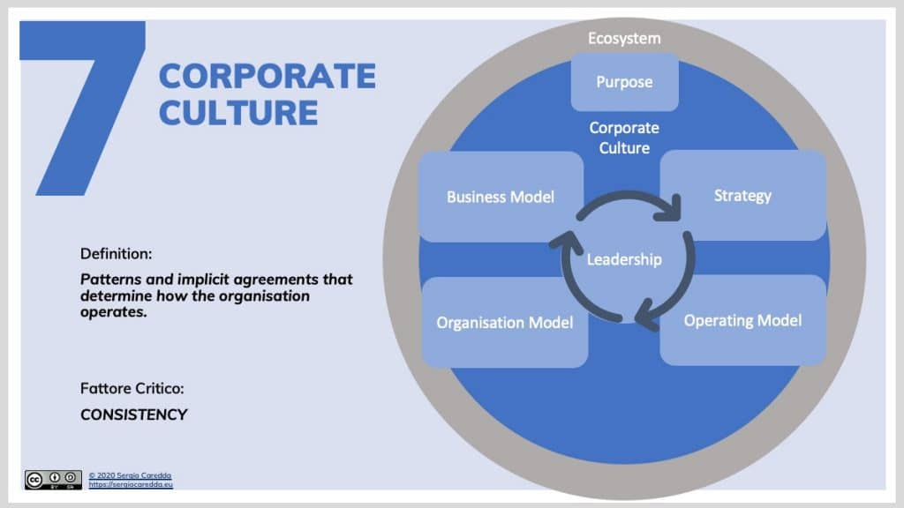
Corporate Culture | Organisation Evolution Framework

Hofstede Model of Organisational Culture is a world- known expert in culture, developing model that identified several components in the so called six-dimension model Hofstede, 1985).

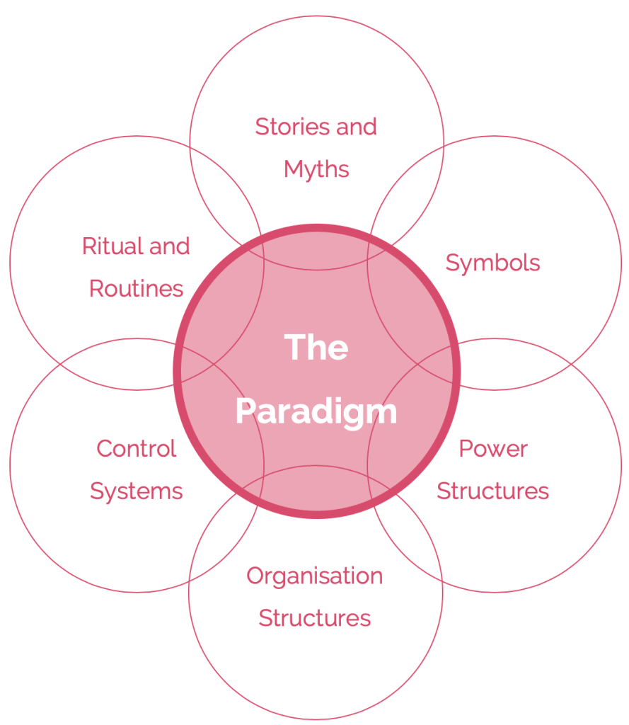
Cultural Web Model. Source: BusinessBall

One of the Cultural models by Johnson and Scholes called the’’ paradigm’’ and has six elements such as the stories and myths where we could mention the first Starbucks in 1971, Seattle, USA. The mission of Starbucks was to inspire and nurture the human spirit. Or other thing we could mention the tradition Italian coffeehouse tradition was brought to US in 1983 by Howard Schultz. On the symbols section could be the logo what was a naked woman with a brown background (in 1971). The logo was changed in 1989 where the woman was covered, and the background was green. The other changed happened in 2011 where the Starbucks name was removed from logo and use beans as a decoration tool in stores. In Power Structures section can be such as challenges of the company, or everyone is responsible to get the business going. The respect and dignity were a power of the company, also the quality of delivering. The Starbucks organization section can be the annual meeting of the shareholders. The control section could be the market control to evaluate incomes and losses. Or uses unbranded stores as laboratory for Starbucks stores. Rituals and Routines such as bonuses and team awards, number of recognition rewards, celebrating the employee’s success. For instance, daily rewards, yearly rewards. And the Paradigm Section the strong culture of Starbucks by focusing on the quality, people orientation, value of customers. The organizational culture which Bureaucratic control and Standardization franchising.

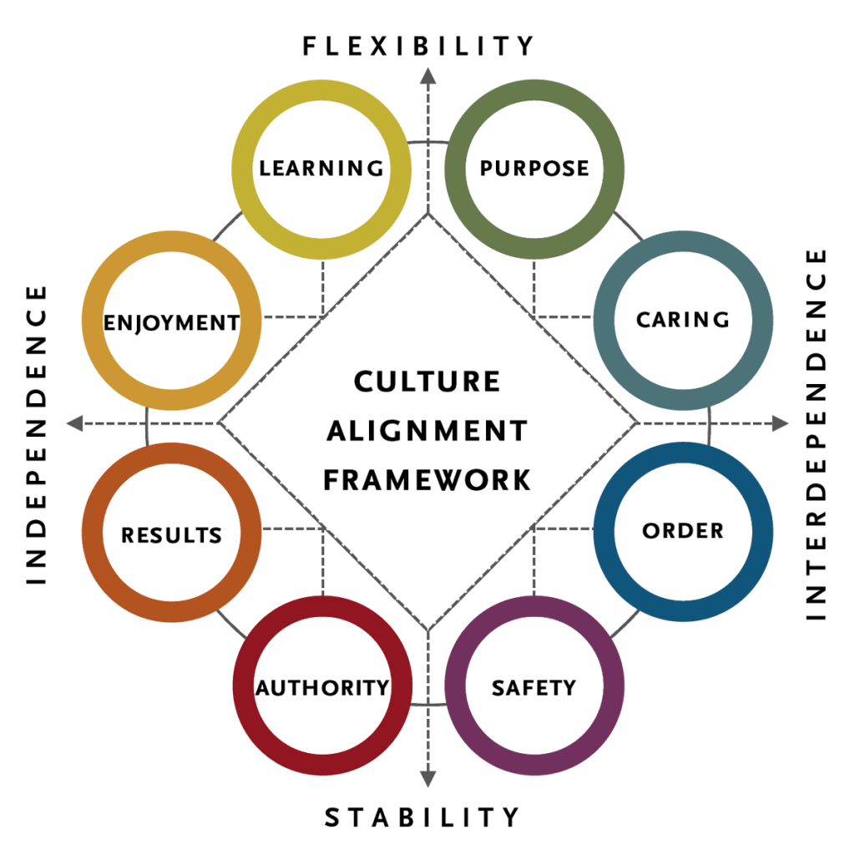
The Organisational Culture Framework. (Singh and Mark, 2017) Source: Spencer & Stuart

Pestle Analysis

PESTLE analysis framework identifies the impact of governments on business. Starbucks experiences some political external factors which are the regional integration of markets which is an opportunity for Starbucks to globally expand. The other things which that can be an opportunity for Starbucks is an improving governmental infrastructure, can access more markets and suppliers. The bureaucratic red tape persist can be a threat for Starbucks as makes business expand more difficult.
Economic factors high growth that can be an opportunity for Starbucks to gain more power.
Social factors can be a growing coffee culture which is an opportunity for Starbucks to increase its revenue based on increasing demand for speciality coffee. The other factor which is another opportunity for Starbucks is to widen its array of more healthful products to attract health-conscious consumers.
Technological factor and related trends are identified such as rising mobile purchases especially during covid the mobile app and linked services increased and gained more revenues. Also, the other opportunity was shown to improve its supply chain based on new technologies coffee farmers use. Also, a threat affects Starbucks by using this home -use coffee machines.
Economic factors can be the business sustainability trends which is an opportunity. Starbucks has an opportunity to enhance its performance growing popular support for responsible sourcing, also for environmentally friendly products.
Legal Factors for Starbucks is to improve its performance by satisfying products safety regulations and regulations on ingredients from genetically modified organisms (GMOs). However, increasing staff regulation in developing country can be a threat for Starbucks Coffee’s access to the work market.

Porter’s Five Forces:

Forces Inspired by Michael E. Porter who realised the competition what companies face dependent on five forces which are: Potential Entrants, Suppliers, Substitutes, Buyers, and Industry.
- Potential Entrants
Entering the market easily to compete business. Of course, they are obstacles such as high-cost requirements, strong brand etc. In Starbucks case the barrier of entry is not very high, as the initial capital and assets are low. For the users, who want to change new coffee brands is not difficult either if they offer lower prices. However, Starbucks with its strong branding allow to retain a good amount of kits market share.
Suppliers

Suppliers decide the final product of the price. There are many suppliers in the market, however there is a competition among them. Starbucks with its strong branding and large market size comes with the competitive edge especially when accessing new suppliers or materials. It has not high costs when switching to another suppliers, because of the coffee farmers and suppliers abundant.
- Substitutes
The threat of customers substituting to other products, services. If close substitute products exist in a market customers switch to substitute increases. There are various factors such as product differentiation, competitors’ profits. Starbucks has many substitutes in the market, different coffee brands. Different types of drinks. The Branding for Starbucks is a pivotal strategy for many years and is known all over the world.
- Buyers
The prices of products and services reduces what buyers must deal with. For instance, if a business depends on a small consumer base, the buyers have power to control prices. Starbucks’ customers with internet availability, buyers more informed about choices that they have. Not just buyers but Starbucks’ clients are able to switch brands with little or no cost.
- Industry
Starbucks company operates in the market in high level of Saturation. The Competitors such as McDonalds, who creates McCafé try hard to attract customers. However, Starbucks gained retain 40% of the market shares in the US.

References

Alvarado, S. M. D. M. R. a. W. F., 2007. “Starbucks Corporation”. St. John’s University.. [Online]
Available at: Retrieved from http://www.stjohns.edu/media/3/1777fbd1bc794c54adc4265a33eea786.pdf
Anon., 2017. Thought Leader Forum: Workplace Culture. [Online]
Available at: https://www.bizjournals.com/portland/news/2017/06/09/thought-leader-forum-workplace-culture.html
[Accessed 9 June 2017].
Anon., n.d. Glassdoor. [Online]
Available at: https://www.glassdoor.co.in/Reviews/Starbucks-New-York-City-Reviews-EI_IE2202.0,9_IL.10,23_IM615.htm?filter.defaultEmploymentStatuses=false&filter.defaultLocation=false
Brewer, R., n.d. Starbucks (SBUX). [Online]
Available at: https://www.forbes.com/companies/starbucks/#73b8f5f28acb
Cameron, K. a. Q. R., 2005. . Diagnosing and Changing Organizational Culture: Based on the Competing Values Framework. John Wiley & Sons., s.l.: John Wiley and Son.
CAREDDA, B. S., 2020. THE ORGANISATION EVOLUTION FRAMEWORK. [Online]
Available at: https://sergiocaredda.eu/organisation/organisation-design/corporate-culture-the-theory-and-the-practice/#Handy_Model_of_Organisational_
[Accessed 26 November 2020].
Company, S. C., 2015. Company information- Starbucks Coffee Company. [Online]
Available at:
Daisy Mui Hung Kee, M. F. S. A. L. A.-A. M. M. H. A. A. K., 2019. Navigating Through the COVID-19 Crisis: A Case Study of Starbucks. [Online]
Available at: file:///C:/Users/katal/Downloads/1030-2112-1-SM.pdf
FERGUSON, E., 2019. Starbucks Corporation’s Organizational Culture & Its Characteristics. [Online]
Available at: http://panmore.com/starbucks-coffee-company-organizational-culture
[Accessed 20 Februar 2019].
George, J. &. J., 2012. Understanding and managing organizational behavior.. 6 ed. New Jersey: Prentice Hall.
George, J. a. J. G., 2012. Understanding and managing organizational behavior. 6 ed. New Jersey: Prentice Hall.
H, C., 2019. Starbucks in the World. HOLISTICA, Journal of Business and Public Administration, Volume 10(3), pp. 99- 110.
Hofstede, G., 1985. Culture’s Consequences : Comparing values, behaviors, institutions, and Organizations across Nations. Thousand Oaks, Calif.: Sage.. 1 ed. Thousand Oak :California: Sage.
Johnson, S. :. K., 2019. GLOBAL SOCIAL IMPACT REPORT. [Online]
Available at: https://globalassets.starbucks.com/assets/38b8ab8576d24aa78170e46fd2a51acc.pdf
Kembell, B. M. H. S. K. L. P. a. L. O., 2002. “Catching the Starbucks Fever”. Missouri State University. [Online]
Available at: Retrieved from: http://www.academicmind.com/unpublishedpapers/business/marketing/2002-04-000aag-catching-t
[Accessed April 2002].
Khan, N., Sarwar, A. & Tan, B., 2020. Determinants of purchase intention of halal cosmetic products among Generation Y consumers.. In: M. J. Islam, ed. [CrossRef]. s.l.:Cross Ref, pp. 1-21.
Kotter, J. &. H. J., 1992. Corporate Culture and Performance.. s.l.:s.n.
Management, P. I. B., 2015. Starbucks Coffee Company’s organizational culture.. [Online]
Available at: [Accessed 22/9/2016] Retrieved from http://panmore.com/starbucks-coffee company- organizational-culture
[Accessed 2015].
Managment, P. I. B., 2015. Starbucks Coffee Company's organizational culture. [Online]
Available at: http://panmore.com/starbucks-coffee-company-organizational-culture
[Accessed 22 09 2016].
McDermott, R. a. O. C., 2001. ''Overcoming cultural barriers to sharing knowledge''. Journal of Knowledge Management, Volume 5, pp. 76-85.
Minkov, G. H. &. G. J. H. &. M., 2010. Cultures and Organizations. In: Cultures and Organizations. s.l.:s.n.
Morcos, M., 2018. ORGANISATIONAL CULTURE: DEFINITIONS AND TRENDS. [Online]
Available at: https://www.researchgate.net/publication/329140215_ORGANISATIONAL_CULTURE_DEFINITIONS_AND_TRENDS
[Accessed 2018].
News, S. S. a., 2019. Starbucks Backs Restaurant Tech Company in Creation of End-to-End Digital Platform.. [Online]
Available at: Available online: https://stories.starbucks.com/press/2019/Starbucks-Backs-Restaurant-Tech-Company-in-Creation-of-End to-End-Digital-Plat
[Accessed 2020].
Park, H. R. V. a. S. W., 2004. '' Critical attributes of organizational culture that promote knowledge managment implementaion succes''. Journal of Knowledge Management, Volume 8, pp. 106-17.
Pitchspot, 2020. Using the Porter’s Five Forces Framework for Industry Analysis. [Online]
Available at: https://medium.com/pitchspot/using-the-porters-five-forces-framework-for-industry-analysis-d0221a8f4fe1
[Accessed 2020].
Research, I. C. M., 2005. Starbucks 'human resource managment policies and the frowth challenge. [Online]
Available at: http://www.icmrindia.org/casestudies/catalogue/Human Resource and Organization Behavior/HROB068.htm
[Accessed 12 09 2016].
Robbins, S. &. J. T., 2013. Organizational behavior.. 15 ed. USA: Prentice Hall.
RTTNews, 2018. Starbucks To Change Organizational Structure. [Online]
Available at: https://markets.businessinsider.com/news/stocks/starbucks-to-change-organizational-structure-1027560305
[Accessed 24 September 2018].
Schein, E. H., 1985. Organizational culture and leadership. San Francisco: Jossey-Bass .
SMITHSON, N., 2017. Starbucks Coffee PESTEL/PESTLE Analysis & Recommendations. [Online]
Available at: http://panmore.com/starbucks-coffee-pestel-pestle-analysis-recommendations
[Accessed 31 January 2017].
Starbucks, 2020. Starbucks: About us. [Online]
Available at: https://www.starbucks.co.uk/about-us
Work, M. E. P., n.d. Five Forces Model. [Online]
Available at: https://cdn2.hubspot.net/hubfs/125770/Michael_E._Porters_Five_Forces_Model_E-Book_From_Wikipedia.pdf?t=1446668543121

