

University of Wales Trinity Saint David
School of Engineering

Manufacturing Processes and Defects

Materials and Introduction to Processing
ACAM4000
Connor Hooper
2418021
22/12/2025

Abstract
This report investigates three everyday objects—a cast-iron wrench, a PET plastic water bottle, and a porcelain coffee mug—to explore how material selection and manufacturing processes influence performance, cost, and sustainability. Each object represents a different material class: metal, polymer, and ceramic. The study compares their mechanical and thermal properties, evaluates their manufacturing processes, and examines lifespan and degradation mechanisms. Alternative materials and processes are proposed to improve durability and environmental impact. The findings highlight the importance of aligning material behaviour with manufacturing constraints and product requirements.

Contents
1 Abstract ii
2 Figures List iv
2.1 Tables List iv
3 Introduction iv
4 Research and Discussion iv
4.1 Selection and Description iv
4.1.1 Material 1 – Cast-Iron Wrench v
4.1.2 Material 2 – PET water bottle v
4.1.3 Material 3 – Porcelain Coffee Mug v
4.2 Manufacturing Method Comparison vi
4.2.1 Method 1 – Sand Casting of Cast Iron Wrench vi
4.2.2 Method 2 – Injection Blow Moulding of a water Bottle vi
4.2.3 Method 3 – Slip casting of Porcelain mug vii
4.3 Comparison vii
4.4 Mechanical and Thermal Properties Comparison vii
4.5 Lifespan and Cost Analysis viii
4.5.1 Material 1 – Cast-Iron Wrench viii
4.5.2 Material 2 – PET Water Bottle viii
4.5.3 Material 3 – Porcelain Coffee Mug ix
4.6 Material Selection and Alternative Choices ix
4.6.1 Material 1 – Cast-Iron Wrench ix
4.6.2 Material 2 – PET Water Bottle ix
4.6.3 Material 3 – Porcelain Coffee Mug ix
5 Conclusion ix
6 References x
7 Appendix x

Figures List
Figure 1: Sand casting process
Figure 2: Injection stretch blow moulding sequence
Figure 3: Slip casting process overview

Tables List
Table 1: Comparison of manufacturing methods
Table 2: Material Property comparison

Introduction
Engineering design depends on selecting materials and manufacturing processes that meet performance, cost, and sustainability requirements. This report examines three everyday objects—a cast-iron wrench, a PET plastic water bottle, and a porcelain coffee mug—to explore how different material classes behave under mechanical and thermal conditions, how they are manufactured, and how they perform throughout their lifespan. The analysis highlights the relationship between material structure, processing methods, and real-world functionality. It also considers degradation mechanisms and environmental impacts, which are increasingly important in modern engineering. Finally, alternative materials and processes are proposed to demonstrate how engineering decisions can be optimised when balancing durability, manufacturability, and sustainability.

Research and Discussion

Selection and Description
Material selection requires understanding how metals, polymers, and ceramics behave under different conditions. Metals such as cast iron are valued for strength, stiffness, and compressive performance, making them suitable for tools and structural components (Ashby, 2019). Their crystalline structure allows them to be cast or forged, although brittleness can be a limitation depending on composition and cooling rate (Callister, 2020). Cast irons, in particular, contain graphite in various forms, which strongly influences mechanical behaviour.
Polymers like PET consist of long-chain molecules that can be melted and reshaped, making them ideal for high-volume processes such as injection moulding and blow moulding (Strong, 2018). Their low density and transparency make them suitable for packaging, although they have lower strength and thermal resistance than metals. PET’s ability to undergo molecular orientation during processing is a key advantage, improving stiffness and impact resistance.
Ceramics such as porcelain are characterised by ionic and covalent bonding, giving them high hardness, chemical resistance, and thermal stability (Kingery et al., 2018). However, their brittleness limits their ability to absorb impact. Despite this, ceramics remain essential where thermal resistance and surface hardness are required. Their long service life under normal use makes them suitable for household items.
By reviewing these material classes, it becomes clear that the performance of an object is closely linked to the inherent characteristics of its material. This literature foundation supports the detailed analysis of the three selected objects in the following sections.

Material 1 – Cast-Iron Wrench
Grey cast iron is commonly used for low-cost wrenches due to its excellent castability and ability to fill moulds with minimal defects. Its graphite flake microstructure provides good compressive strength but reduces tensile strength and impact resistance. This makes cast-iron wrenches suitable for steady loads but vulnerable to brittle fracture if dropped or overloaded. Cast iron also offers good wear resistance, although it is susceptible to corrosion. Its low cost makes it attractive for budget toolkits, even though higher-performance materials exist.

Material 2 – PET water bottle
PET is widely used for beverage bottles due to its low density, clarity, and good barrier properties. The polymer can be stretched during processing, improving strength through molecular orientation. PET bottles are inexpensive and easy to transport, but they soften at relatively low temperatures and degrade under UV exposure. Although recyclable, global recycling rates remain low. PET’s combination of manufacturability and low cost explains its dominance in the packaging industry.

Material 3 – Porcelain Coffee Mug
Porcelain is a high-quality ceramic material composed primarily of kaolin, feldspar, and quartz. When fired at high temperatures, these minerals form a dense, vitrified structure that provides excellent hardness, chemical resistance, and thermal stability. Porcelain mugs are widely used because they retain heat effectively and do not react with food or drink. Their smooth glazed surface is easy to clean and resistant to staining. However, the same microstructure that gives porcelain its hardness also makes it extremely brittle. Even minor impacts can cause chipping or catastrophic fracture. Despite this limitation, porcelain remains a popular choice for household and commercial drinkware due to its aesthetic qualities and long lifespan when handled carefully.

Manufacturing Method Comparison

Method 1 – Sand Casting of Cast Iron Wrench
Sand casting involves compacting sand around a pattern to form a mould cavity, into which molten cast iron is poured. Once solidified, the mould is broken apart to release the casting. The process is economical and suitable for metals with good fluidity, such as cast iron. However, it produces relatively rough surfaces and may require machining. Cooling rates can influence microstructure and may introduce defects such as porosity. Despite these limitations, sand casting remains one of the most cost-effective ways to produce metal tools in large quantities.
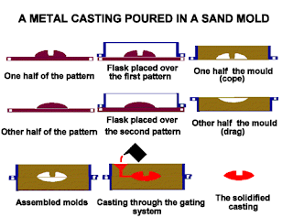
Figure 1 Sand casting Process, Bernier Cast Metals Inc, 2014, https://bernierinc.com

Method 2 – Injection Blow Moulding of a water Bottle
Injection stretch blow moulding (ISBM) is used to produce PET bottles at high speed. A preform is injection-moulded, reheated, and stretched inside a blow mould. Stretching aligns polymer chains, improving strength and clarity. ISBM is highly automated and efficient, although it requires precise temperature control to avoid defects such as uneven wall thickness or weak spots. The process is optimised for mass production, enabling billions of bottles to be manufactured annually.
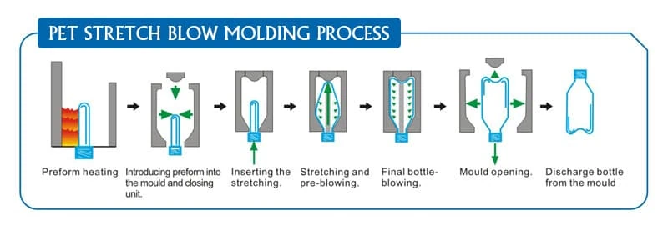
Figure 2 PET Blow Moulding Xometry pro, 2018, https:xometry.pro

Method 3 – Slip casting of Porcelain mug
Slip casting uses a liquid clay mixture poured into a porous mould. Water is absorbed, leaving a solid layer that forms the mug’s shape. After drying, the mug is fired, glazed, and fired again to achieve its final properties. Slip casting allows complex shapes but has slower production rates and high energy consumption due to firing. The process is well suited to ceramics because it accommodates shrinkage and produces smooth surfaces.
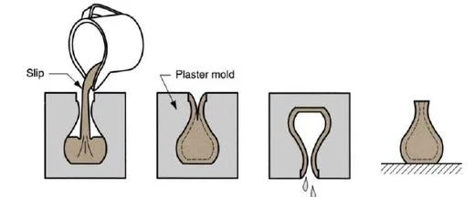
Figure 3 Porcelain Slip Casting Process, Decopot Ltd, 31.01.20.25, decopot.co.nz

Comparison
Sand casting is economical but less precise. ISBM offers exceptional production speed and consistency, making it ideal for disposable packaging. Slip casting provides excellent control over ceramic shapes but is slower and more energy-intensive. Each method aligns with the material’s behaviour and the product’s intended use, demonstrating the importance of matching process capabilities to design requirements.
Table 1 Comparison of manufacturing methods

Mechanical and Thermal Properties Comparison
Cast iron has high compressive strength but low tensile strength due to its graphite flake microstructure, making it brittle under impact. It withstands high temperatures and maintains dimensional stability, which is why cast iron is used in engine blocks and cookware as well as tools.
PET is ductile and lightweight, with good impact resistance when oriented, but softens at relatively low temperatures and degrades under UV exposure. Its low thermal conductivity makes it unsuitable for hot liquids, but ideal for cold beverages.
Porcelain has high hardness and compressive strength but is extremely brittle and vulnerable to thermal shock. It performs well under repeated heating cycles, making it suitable for hot beverages. Its insulating properties help maintain drink temperature.
These differences illustrate how material properties influence product performance and limitations.
Table 2 Material Property comparison

Lifespan and Cost Analysis

Material 1 – Cast-Iron Wrench
Cast-iron wrenches can last many years under moderate use. They resist wear but are prone to corrosion and brittle fracture. Production costs are low due to inexpensive materials and simple casting processes. Cast iron is recyclable, although recycling rates vary. For occasional users, cast-iron tools offer good value, but professionals often prefer tougher materials.

Material 2 – PET Water Bottle
PET bottles are designed for single use, although some consumers reuse them. Their lifespan is limited by deformation, microbial growth, and UV degradation. PET is inexpensive to produce, but environmental concerns arise due to low recycling rates and plastic waste. The short lifespan of PET bottles contrasts sharply with their long environmental persistence.

Material 3 – Porcelain Coffee Mug
Porcelain mugs can last for years if handled carefully. They resist staining and maintain stability under repeated heating. However, brittleness reduces lifespan if dropped. Production costs are moderate due to energy-intensive firing. Porcelain is not recyclable in standard waste streams, but its long service life offsets this limitation.

Material Selection and Alternative Choices

Material 1 – Cast-Iron Wrench
Forged steel is a stronger alternative to cast iron, offering higher tensile strength and impact resistance. Drop forging refines the grain structure, improving durability. Although more expensive, forged steel wrenches provide superior performance for demanding applications. This alternative demonstrates how material upgrades can significantly improve tool reliability.

Material 2 – PET Water Bottle
Aluminium offers a more sustainable alternative to PET. It is lightweight, corrosion-resistant, and fully recyclable. Deep drawing and ironing (DWI) can produce thin-walled aluminium bottles suitable for repeated use, reducing environmental impact. Aluminium’s recyclability makes it attractive for circular-economy systems.

Material 3 – Porcelain Coffee Mug
Stainless steel provides a durable alternative to porcelain. It resists impact, is fully recyclable, and can be formed using metal spinning or deep drawing. Although less aesthetically traditional, stainless-steel mugs offer superior longevity. Their durability makes them suitable for travel and outdoor use.

Conclusion
This report examined three everyday objects to explore how material properties and manufacturing processes influence performance, cost, and sustainability. Cast iron provides strength but suffers from brittleness, PET offers convenience but raises environmental concerns, and porcelain delivers thermal stability but is vulnerable to impact. Manufacturing processes such as sand casting, ISBM, and slip casting were compared, showing how each aligns with material behaviour. Alternative materials including forged steel, aluminium, and stainless steel were proposed to improve durability and sustainability. The study highlights the importance of balancing performance, manufacturability, and environmental impact in engineering design.

References
Ashby, M. (2019) Materials Selection in Mechanical Design. 6th ed. Oxford: Elsevier.
Callister, W. (2020) Materials Science and Engineering: An Introduction. 10th ed. New York: Wiley.
Kingery, W., Bowen, H. and Uhlmann, D. (2018) Introduction to Ceramics. 2nd ed. New York: Wiley.
Plastics Europe (2022) Plastics – the Facts 2022. Brussels: Plastics Europe.
Strong, A. (2018) Plastics: Materials and Processing. 4th ed. London: Pearson.

Appendix
Appendix A: Additional material property charts
Appendix B: Manufacturing process flow diagrams

