Individual Written Business Plan

Enterprise and Entrepreneurship (LCLM4006)
Student name: Mohammad Mustafa Choudhry
Student no.: 2508098
Certificate in Higher Education Business Skills for the Workplace

Lecturer: Mrs. Fouziya Farheen

Executive Summary:
Sweet Retreat is a proposed business which sells famous desserts, aiming to provide high-quality food as well as services. Desserts include milkshakes, doughnuts, cookie doughs, waffles, cakes and various other types of drinks. The business offers both a dine-in as well as takeaway.
It will be located towards the side town centre, so many, including students, shoppers, workers etc would cross by it. In order to give it an edge over its competitors, it would have social media pages on several platforms, posting engaging content with viewers.
With a loyalty program, the company can build trust and reputation amongst their customers. A detailed PESTEL analysis was done to assess the external factors which can have an impact on the business. The start-up cost would be around £10,000, with the projected income for the first month estimated being around £25,000, giving a net profit of £1,400, which would rapidly increase over time due to less costs.
Overall, the business is expected to be a huge success considering its location, target market, and other factors. By consistently making a net-profit, the business will be able to establish self-sustainability, helping it prosper and expand.


Table of Contents
Executive Summary: 2
Overview of the business idea: 3
Legal format: 4
Unique Selling Point: 5
Management Structure: 5
Market Research: 6
PESTEL Analysis: 6
Local competition: 7
Direct Competitors: 7
Marketing Communications: 7
Financials: 9
References: 10

Overview of the business idea:
Business idea: Sweet Retreat
The proposed business idea is a dessert shop, which would serve as a market gap in the town of Walsall. It would centre its menu around traditional British desserts, such as cakes, ice-creams, milkshakes, waffles, crepes, doughnuts and various other options. It would serve as a eat-in shop as well as take-out, offering flexible dining options to cater for all. A suitable location for it would be on the suburbs of the town centre, as it is not as busy there, although many people would travel by it. It would also have a customer car-park, giving them an ideal solution which is often not met by other competitors.
The intended target market would consist of individuals aged between 16-34, as research indicates that they have more of an appetite for these foods as compared to (Mintel Store, 2025). By designing a modern, exceptional dining area, the public would feel comfortable and welcome to the place, establishing an attraction to the place, thus inviting them to come again.

Legal format:
The business would operate as a sole-trader, considering that the owner would retain complete ownership of the business, which include its operations and decisions. Furthermore, it is much easier to set-up as compared to other company formats, which tend to have further complicated processes. Although funding can sometimes be a challenge for this specific format, the money would be obtained as a loan from close relatives. This approach effectively reduces interest rates had it been from elsewhere. Also, personal funding will be a considerable inflow source, cutting the amount of money which is acquired through loans. Due to inflation, many SMEs struggle to return their loans, putting them into further risk of collapsing. (Bank of England, 2024)

Unique Selling Point:
To make this business supersede others, a social media content creator would be hired, producing engaging content, showcasing the premium service and dedicated team we have, developing a unique relationship between us and the customers. Most businesses are behind in this aspect, so it would have a significant impact on the bond of the business with the community.

Management Structure:
The following structure would be suitable for the business:

Owner

Finance Manager
Marketing Manager

In-store Manager (Operations)

Chefs
Cashiers & Servers

This structure is effective for this business as there is a clear line of communication between employees and the owner. All the relative people who need to communicate with each other have a direct way of conversing. Should the workers have any issue, they would go to the operations manager. All 3 managers have direct communication with each other as well as the owner.

Market Research:

PESTEL Analysis:
Political | Economic | Social | Technological | Environmental | Legal
Food safety Act 1990 (Food Standards Agency, 2018) | Rise in chocolate prices (Fairtrade, 2025) | Growing demand in sugar-free products | Online Purchasing Platforms | Packaging sustainability | Regulation on deforestation-free Products (European Commission, 2023)
Health & Safety at Work (GOV.UK, 2024) | High inflation costs customers spend less (due to economic unpredictability | Vegan foods / Gluten-free | Cashless payment devices | Energy footprint | Natasha’s Law (GOV.UK, 2019)

These are some of the key external (macro) factors that the business has limited or no control over. The government has introduced legislations which protect both the consumers as well as the employees. The food safety act ensures that the food is edible, and that the company does not conceal any ingredients. Likewise with the workplace; the business must ensure that the environment is safe and secure for all employees to work in. If not, it could potentially develop hazards which can have drastic consequences; health-wise and financially, plundering the business into a self-made crisis.
Globally, the market has seen a shift in customer preferences towards sugar-free products (Kerry, 2025). Additionally, many incline towards vegan products, so it is essential that these customers are also catered for.
The Natasha’s Law, named after a teenager who succumbed to her injuries from an allergic reaction, was constituted in 2021. It requires food outlets to display all ingredients on pre-packed food (PPDS), as well as the allergens being clearly highlighted (BSACI, 2021). The business must ensure that it adheres to these regulations and maintain transparency to help establish a sense of trust and reliability between the company and the customers.

Local competition:
The competition based in Walsall is monopolistic. In other words, it refers to those companies who sell similar products, but not the same product. (Investopedia, 2025)
There are a few similar shops based in Walsall. But most of these shops are close to each other, so there are some areas which have no dessert shop near them, causing them a disruption of travelling. By opening it in these types of areas helps support the local people, as they would find it much more accessible rather than travelling to more distant places.
Another way to beat the local competition is by having a unique selling point (USP). Amongst them is that the shop will consist of a modern, extravagant dining area. This can further support the community by having a place to enjoy together.

Direct Competitors:
These are those competitors who compete to sell an identical product. One heavy competitor could be ‘Heavenly Desserts’ which trade the same products as this proposed business. They are famously known for their waffles and milkshakes, as well as unique service. They also have a lavish layout in their shop. However, they fall short on their social media. Likewise, there is ‘Coco’s dessert factory’, which is in the centre of town. This location is ideal due to the commuting of people in that area. They also have gluten-free options. However, it is seen that they also lack in their social media, as well as a car park, so there can be an issue for customers in relation to parking restrictions, especially considering its location.

Marketing Communications:
One of the main modes of communication would be introduced is a loyalty program. For example, after a certain amount of money spent, the customer is eligible for a free product. It can be operated via an application which involves the customers signing up through their phone numbers and email address. Not only does this assure customers returning and preferring this business over others, but you can even send them marketing directly on their phone as well. This provides a huge opening for a business as they have direct communication with a customer.
Another technique would be through content marketing on different platforms like Instagram, Snapchat, etc., which could consist of ‘behind the scene’ vlogs, or general humorous content. This is unique to this proposal in the area, considering others don’t have such, giving it a boost. Its benefits are not just limited to building awareness; rather, you start to create a feeling of conviction inside the heart of a potential customer.

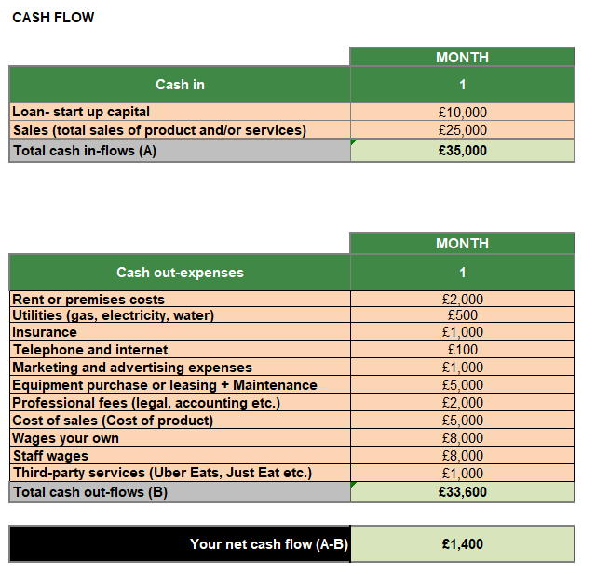
Financials:

The expected sales in the first month are expected to reach around £25,000, especially because many would want to go and test out the new shop. The advertising costs are currently at £1000, of which majority would go towards purchasing the equipment for it, like a camera, mic, etc.
Many of the expenses mentioned would reduce in the second month onwards. For example, the advertising expenses, equipment purchases. The total inflow amounted to greater than the outflow, helping to create a viable financial plan. Over the course of the months, the outflow would decrease, because in the first month, the main costs go towards purchasing the actual machines, whereas later, the main costs are for the maintenance.

References:
Mintel Store. (2025). UK Sugar & Gum Confectionery Market Report - Market Growth. [online] Available at: https://store.mintel.com/report/uk-sugar-and-gum-confectionery-market-report.
Bank of England (2024). How are higher borrowing costs affecting debt-servicing pressures for small businesses? [online] www.bankofengland.co.uk. Available at: https://www.bankofengland.co.uk/bank-overground/2024/how-are-higher-borrowing-costs-affecting-debt-servicing-pressures-for-small-businesses
Food Standards Agency (2018). Key regulations. [online] GOV.UK. Available at: https://www.gov.uk/government/publications/key-regulations
GOV.UK (2024). Health and safety at work - GOV.UK. [online] www.gov.uk. Available at: https://www.gov.uk/browse/employing-people/health-safety
Fairtrade (2025). Fairtrade.net. [online] Fairtrade.net. Available at: https://www.fairtrade.net/uk-en/get-involved/resources/blog/why-are-chocolate-prices-increasing.html
European Commission (2023). Regulation on Deforestation-free Products. [online] European Commission. Available at: https://environment.ec.europa.eu/topics/forests/deforestation/regulation-deforestation-free-products_en
GOV.UK (2019). Natasha’s legacy becomes law. [online] GOV.UK. Available at: https://www.gov.uk/government/news/natashas-legacy-becomes-law
Kerry (2025). Sweet Progress: Evolving Sugar Reduction into Sweetness Optimisation | Kerry. [online] Kerry.com. Available at: https://www.kerry.com/insights/kerrydigest/2025/sugar-reduction-into-sweetness-optimisation
BSACI (2021). Natasha’s Law comes into effect on 1st October 2021. [online] BSACI. Available at: https://www.bsaci.org/natashas-law-comes-into-effect-on-1st-october-2021/
Investopedia (2025). Monopolistic competition: Definition, how it works, pros and cons. [online] Investopedia. Available at: https://www.investopedia.com/terms/m/monopolisticmarket.asp

