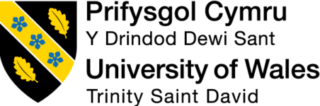

Programme: Master of Business Administration
Module Name: Marketing Management
Module Code: LCMB7024
Lecturer’s Name: Dr Laila Maazouz (London)
Assignment Title: Assessment component 2: Marketing Portfolio

Student Name: Md Forhad Hossen Rony
Student ID: 2433472
Word Count: 2733
Date of Submission: 17 December 2025

Table of Contents
Introduction 3
Element 1: STDP Analysis for Voyage one 4
Company Overview and New Brand Concept 4
STDP Analysis for Voyage One 5
Segmentation 5
Targeting 6
Differentiation 6
Positioning 7
Element 2: Marketing Mix for Voyage one 7
Product 8
Price 9
Place 10
Promotion 10
Element 3: Marketing Strategy Pitch 12
Element 4: Reflection 13
Conclusion 15
References 16
Appendices 18

List of Figures
Figure 1. Voyage One logo……………………………………………………………………04
Figure 2. STDP Analysis………………………………………………………………………05
Figure 3. Marketing Mix (4Ps)…………………………………………………………………08
Figure 4. Promotional Strategy of Voyage One……………………………………………..11
Figure 5. Gibbs Reflective Cycle……………………………………………………………..13

Introduction
This is a marketing portfolio of the new travel planning engine, Voyage One, which is an AI based travel planner created by Microsoft. The technology is based on high-end development means of generative intelligence that designs the process of consumer experience design and management of the travelling process. The report analyses the market opportunities based on segmentation, targeting, differentiation and positioning, and a critical review of marketing mix. The increasing demand of personalised digital travel tools across the world and the booming growth of AI technologies shows promising opportunities to Microsoft. This discussion explains the ways in which Microsoft can use its technological advantages to make Voyage One a category leader.

Element 1: STDP Analysis for Voyage one

Company Overview and New Brand Concept
Microsoft Corporation is a worldwide technological company that has experienced expertise in artificial intelligence, cloud computing, and enterprise software solutions and has annual revenues of over $211 billion. Voyage One will be a strategic brand extension into a highly growing travel technology industry, using the core AI capabilities of Microsoft to fulfil the increasing consumer need of intelligent travel planning capabilities (Bang et al., 2025).
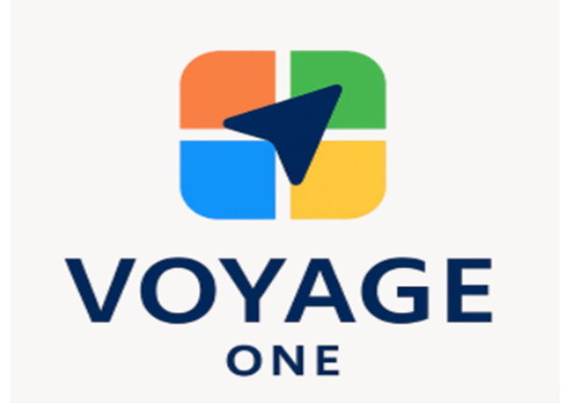
Figure 1: Voyage One logo
Source: Self-made
The Voyage brand is the expression of the democratised AI technologies of Microsoft as it applies them to consumers. In contrast to other travel booking platforms in the classic inventory aggregation model, Voyage One represents a novel multi-agent Large Language Model models that generate genuinely personalised travel experiences. This is a radical change in terms of reactive booking systems to proactive travel intelligence systems (Liu et al., 2025). Voyage one makes use of cloud-Capability, an Azure Version offered by Microsoft, which is scaled, reliable and secure at competitive cost frameworks. This technological base offers substantial entry barriers to those competitors who do not have similar AI development abilities.

STDP Analysis for Voyage One
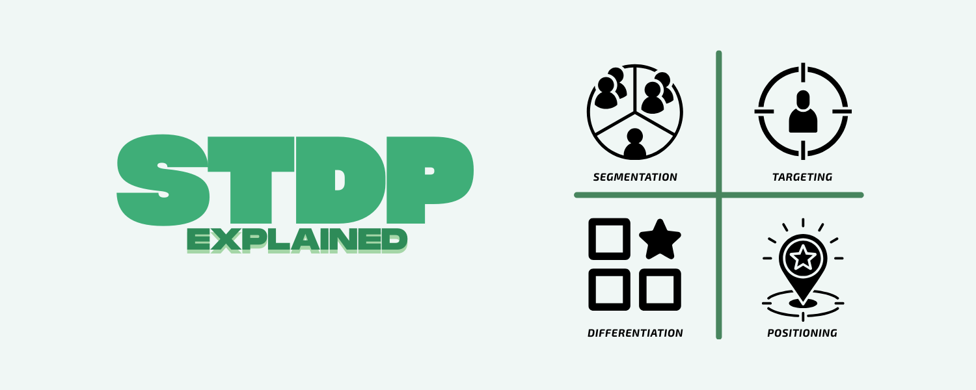
Figure 2: STDP Analysis
Source: (Diamondopoulos, 2020)

Segmentation
Voyage One uses advanced multi-dimensional segmentation policies to recognise and penetrate the best consumer groups in the wide travelling planning market:
Demographic Segmentation: The main segments include tech enthusiastic professionals aged 25-45 who have middle to shop disposable incomes and who are strong adopters of AI and are time conscious consumers. The secondary segments include business travellers aged 30-55 who need efficient corporate travel options and cost-aware travellers aged 18-35 who are interested in AI-generated cost optimization (Hajli, N. et al., 2020).
Geographic Segmentation: Voyage One will prioritise highly digitalized and developed travel infrastructure markets, specifically focusing on key metropolitan markets in North America, Europe and Asia-Pacific. Micro-markets that are especially appealing due to a concentration of early adopters and regular travellers include technology hubs, financial centres, and university cities (Saqib, 2020).
Psychographic Segmentation: The target market focuses on the experience-seeking customers who value an individualised experience rather than a standard travel package. Professionals who appreciate time and the environmental friendliness of travelling using AI-optimised routes are the key segments.
Behavioural Segmentation: The key targets are a frequent traveller who uses digital planning tools, a last-minute planner who wants their itinerary created quickly with AI, and an early AI adopter who wants new solutions to penetrate the market first and build advocates.

Targeting
Microsoft focuses on digitally native consumers who exemplify the use of AI powered service and have a high purchasing power base to utilise premium travel planning services. The core segment will include urban professionals between the age of 25-40 that are dependent on technology to make their lives more efficient and willing to pay more to get better user experiences. Another high value segment is the business travellers since they are frequently travelling, time sensitive and they have company funded travel budgets. They focus on reliability, speed and smart travelling administration (Mordor Intelligence, 2025). The strategy also accounts geographic differences in AI adoption by starting with technologically advanced markets to support digital payments and then widening the scope to emerging markets with digitally maturity.

Differentiation
Voyage One can differentiate itself by the way it combines efficient AI technology with an established technological system at Microsoft. Compared to conventional travel booking platforms that basically just sum up what is already available, Voyage One designs smart travel experiences by leveraging advanced machine learning technologies that can comprehend individual tastes, finances, and travelling goals (Veluru, 2023).
Technological Differentiation: The multi-agent LLM framework of the platform allows conversational travel planning which dynamically transforms to meet varying user needs and external conditions including weather, locals, and prices. This technological advancement generates justifiable advice that instils user trust due to the transparent steps made during decision-making.
Ecosystem Integration: Voyage One stands out due to its flawless connexion with the wider ecosystem that Microsoft has to offer such as Outlook calendar, Teams meetings scheduling, and security-oriented cloud-based protection. Such integration generates high switching cost to business users and offers superior functionality not found on isolated travel solutions.
Predictive Capabilities: Advanced predictive analytics will allow Voyage One to predict price changes, determine the best booking windows, and suggest alternative travel dates that maximise value and schedule flexibility. These features mark a great improvement when compared to the olden day raw booking tools (Aaker and Moorman, 2023).

Positioning
Voyage One brands itself as the Future of Intelligent Travel Planning - the AI-driven solution to high-end travellers that require custom, effective, and economical travel experiences. This positioning focuses on technological innovation but specifies on practical advantages that appeal to the priorities of target consumer (Hajli, N. et al., 2020). Voyage One is differentiated by positioning strategy as an AI-first (not yet traditional travel agency), and by pure technology platforms as an emphasis on complete optimization of travel experience. Enterprise technology brand credibility translates to consumer travel applications as Microsoft has the brand credibility immediately and other competitors in the startup market cannot match. The market positioning considers the increasing consumer demand of AI-aided services and ensures concerns on complexity of technology by simplifying the interface design and using conversational interaction paradigm. The platform makes AI a facilitator of enhanced travel experiences as opposed to human judgement and preferences.

Element 2: Marketing Mix for Voyage one
The marketing mix optimally integrates product, price, place and promotion factors to facilitate intelligent travel positioning of Voyage One as well as issues of market viability that hover around Microsoft entry into the competitive travel technology market.
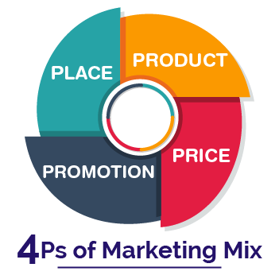
Figure 3: Marketing Mix (4Ps)
Source: Kotler et al. (2020)

Product
Voyage One is a holistic AI-driven travel planning ecosystem that will reengineer all sides of the travel experience, beginning with inspiration to compensation. The main product leverages advanced multi-agent LLM platforms that interpret natural language queries and provide an individualised travelling advice depending on their preferences, budgetary limits, timetable needs, and current market changes (Chernev, 2025).
Core Product Functionality: The smart itinerary generation options of the platform generate optimised travel plans that make trade-offs between various goals such as minimising costs, time, maximising experiences, and considering sustainability. Dynamic pricing prediction algorithms assist users to pick the best booking windows and alternative date suggestions allow flexible travellers to save a considerable amount of money without losing enjoyment.
Expanded Product Services: Voyage One is not content with offering simple booking options, but it also offers complete travel services, such as real-time flight tracking, automatic rebooking in case of disruptions, local suggestions rooted in AI analysis of user preferences, and post-travel services suggestions on future travel (Marion and Fixson, 2021).
Product Development Strategy: Ongoing learning algorithms will make sure that the recommendations of Voyage One will be refined throughout time as new users will be able to feed their feedback and analyse the patterns of the behaviour. New features are regularly introduced with updates to the platform without affecting platform stability or customer user experience.

Price
Voyage One uses a cost-based approach of freemium pricing, keeping prices based on cost of developing the platform, cloud resources, deployment of AI models and continued service maintenance whilst remaining competitive in the global travel technology sector. Being a Microsoft supported platform, Voyage One will have scaled cloud economies of scale and can offer fewer marginal costs per user than smaller competitors (Kotabe and Helsen, 2022).
Freemium Foundation: The freemium level will be zero-priced to maximise the user base acquisition and is supported by minimal variable costs per additional user. In comparison, TripIt is a free planner in the basic plan, but the premium plan vents hardly USD 49 a year, which includes data integration costs, alerts, and support services. Voyage One has a similar rationale, providing basic price comparison and core AI itinerary planning at low cost to show value.
Premium Subscription Levels: The premium tier is one that is set on a higher pricing parameter, which will indicate higher expenses based on the high-level processing of AI data, predictive analytics in real time, and concierge services. Good examples include Expedia and Google Travel, which earn substantial income on the service fees, and premium access to inventory of services and advertising, respectively. The subscription fee of Voyage One integrates these industry rates in addition to proprietary AI development and customisation of service delivery.
Transaction-Based Revenue: Transaction-based commissions are designed in such a way that they recoup partner integration and operational expenses. According to industry statistics, online travel agencies usually have a commission of 10 to 25 percent, and Voyage One follows this pattern, staying within the industry and yet being profitable (Chernev, 2025).

Place
The distribution strategy of Voyage One uses the broad digital ecosystem at Microsoft as it builds strategic partnerships to increase market access and expand service capacity. The omnichannel strategy guarantees availability at various touchpoints and similarity of user experience levels (Saqib, 2020).
Digital-First Distribution: The direct sales are primarily done via dedicated web and mobile apps that are fully functional with smooth user interfaces. Connecting to the existing Microsoft platforms such as Outlook, Teams, and Microsoft 365 establishes access to natural channels of distribution in a preexisting user workflow.
Partnership Network: The presence of strategic alliance with airlines, hotels, car rental firms, and destination management organisations extends inventory availability, as well as offers Voyage One users preferred pricing and exclusive services. Such alliances bring on competitive advantages and attract more revenue because of referral deals.
Corporate Sales Channels: Direct sales teams are aimed at business travel managers and procurement departments to achieve overall implementation of the business travel optimization of Voyage One. Corporate channels offer premium customers with reliable line of revenue and vast utilisation patterns (Sezen et al., 2024).

Promotion
The promotional campaign of Voyage One is focused on educational advertising that shows the opportunities of AI with establishing credibility in the travel technology skills of Microsoft. The multi-channel approach is focused on various customers using the right message and media (Kotler et al., 2020).
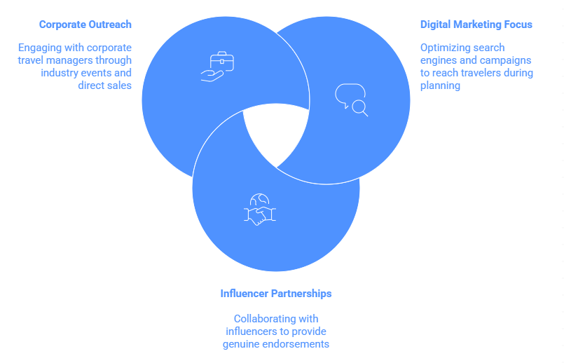
Figure 4: Promotional Strategy of Voyage One
Source: Self-made
Digital Marketing Focus: Optimising the search engines and conduct campaigns with focus will reach the travellers in the active stages of planning when they are most likely to convert. The use of travel guides, AI technology explanations and destination suggestions as content marketing makes Voyage One a reliable travel resource and demonstrates platform possibilities.
Influencer Partnerships: Generate genuine endorsements in conjunction with travel influencer, technology reviews, and business trips gurus as they illustrate real-life use cases. Such alliances give third party attestation of platform functionality and third-party value to users.
Corporate Outreach: B2B marketing communication consists of corporate travel managers with industry publications, trade shows, and direct sales talks that show cost-saving, improved performance, and increased satisfaction of travellers that is possible in AI-powered travel management (Marin et al., 2018).

Element 3: Marketing Strategy Pitch
Voyage One by Microsoft: Revolutionizing Travel Through Artificial Intelligence
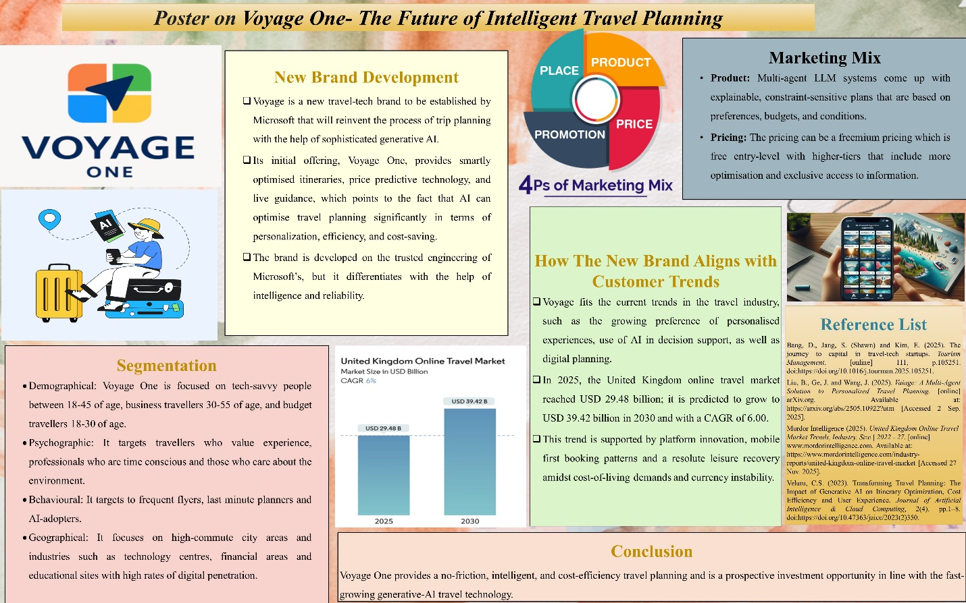
Voyage is a new travel-tech brand by Microsoft that launches with its first product Voyage One which is an AI-based travel planning platform that is intelligent, effortless, and highly personal. Voyage One is a Microsoft’s reliably engineered app that uses the strength of generative AI to create optimized itineraries, dynamic price predictors, and live travel guidance. Recent studies have shown that generative AI can enhance trip planning much more personalized, optimized, and cost-effective (Veluru, 2023).
The company is differentiated based on intelligence. Multi-agent LLM frameworks (such as the recent academic systems) are used in Voyage One to customize itineraries to budgets, time, weather and user intent providing explainable, conversational planning and constraint guarantees through hybrid planning techniques (Liu et al., 2025).
Microsoft’s platform will relate to booking providers, local operators, and sustainability information, and it will provide a green option where it is possible. We have freemium, premium subscription, and referral models of go-to-market that are supported by the Microsoft’s brand and cloud infrastructure (Bang et al., 2025). Investors can leverage the growth of travel-techs: the generated AI travel market is estimated to grow at a high pace.

Element 4: Reflection
This reflection observes my learning experience in crafting the marketing strategy of Voyage One critically with the help of Gibbs Reflective Cycle in analysing the strategic development process and areas that can be improved in the future.
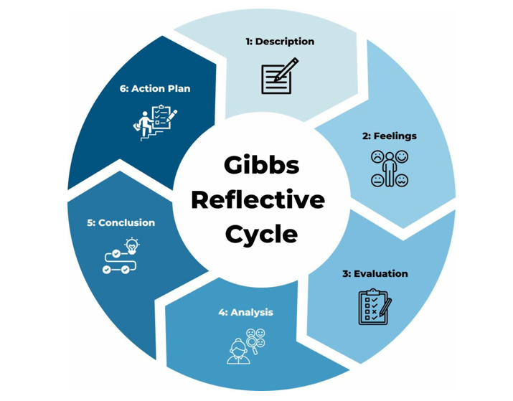
Figure 5: Gibbs Reflective Cycle
Source: (Oviawe, 2020)
Description
This reflection is informed by the creation of a marketing strategy pitch using the example of Voyage One, an AI powered travel planning application created by Microsoft. The assignment entailed the development of an elaborate marketing strategy based on STDP analysis and the marketing mix. There was a lot of market research, and analysis of consumer behaviour and competitive positioning to rationalise segmentation decisions, prices, and promotional tactics. The result was the presentation of the pitch in a structured manner which would convince the stakeholders of the strategic and commercial feasibility of Voyage One.
Feelings
At the onset of the project, I was enthusiastic and thought-provoking when I had to work on an innovative solution of artificial intelligence and travel planning. However, I too had a feeling of frustration when trying to juggle the enterprise focused brand image of Microsoft with that of the consumer market. The fact that complex AI capabilities would be translated into the simple and easily relatable consumer benefits generated doubt as to whether my positioning worked. Nevertheless, the final pitch was made with confidence since I was able to translate research findings into convincing and consistent business cases (Oviawe, 2020).
Evaluation
There are a few things that in the project that turned out to be successful. The STDP analysis has effectively recognised the target segments including tech aware professionals who would harbour a personalised travel experience. The freemium pricing model was a right fit in both accessibility and generation of revenue. But deficiencies could also be seen. I was not adequately looking at the external implementation threats, i.e. regulatory limitations in travel industry and potential competitive backlash of the existing platforms. Moreover, there was a lack of focus on consumers who can be opposed to the AI-driven travel planning.
Analysis
This experience showed that brand extensions need viable ability transfer by the parent brand to achieve success. Although analytical frameworks were utilised to organise decisions, they should be supported by flexibility and market testing (Dutta et al., 2023). I also realised a close partnership between the product capabilities, pricing, and promotion messages. More than anything, the struggle of conveying hi-tech technology supported the importance of customer-oriented positioning over technology focused storeys.

Conclusion
Overall, the project enhanced my strategic marketing, analytical and presentation abilities. Nevertheless, it demonstrated the weaknesses in my risk evaluation and consumer perception validation strategies, which decreased the strength of the suggested strategy. It is necessary to fill these gaps to enhance the future strategic work.
Action Plan
In any subsequent project, I would emphasise primary consumer research to refute assumptions regarding technology adoption. I will also prepare competitive response and stages of market entering to control risk in a better way. The measures will be useful in evidence-based recommendations and are likely to promote stakeholder trust (Aaker and Moorman, 2023).

Conclusion
Voyage One would provide Microsoft with an excellent chance to be also in the lead of intelligent travel services by plugging the gaps in smart planning solutions. The marketing mix makes market entry based on a freemium strategy, internet distribution and alliance. The keys to success lie in ease of use, market acuity and product dynamism. Despite the complexities established by the travel industry, Microsoft has an opportunity to gain trust by transforming its AI capabilities into user value. Through targeted action, Voyage One can provide novel expansion and diversify Microsoft consumer portfolio.

References
Aaker, D.A. and Moorman, C., 2023. Strategic market management. John Wiley & Sons.
Aljumah, A.I., Nuseir, M.T. and Alam, Md.M. (2021) ‘Traditional marketing analytics, big data analytics and big data system quality and the success of new product development’, Business process management journal, 27(4), pp. 1108–1125. Available at: https://doi.org/10.1108/BPMJ-11-2020-0527.
Bang, D., Jang, S. (Shawn) and Kim, E. (2025) ‘The journey to capital in travel-tech startups’, Tourism management (1982), 111. Available at: https://doi.org/10.1016/j.tourman.2025.105251.

Chernev, A., 2025. Strategic marketing management. Cerebellum Press.
Diamondopoulos, J., 2020. The STDP theory of financial crises (Doctoral dissertation, Birkbeck, University of London).
Dutta, S., He, M. and Tsang, D. (2023) ‘Reflection and peer assessment to promote self-directed learning in higher education’, Journal of Educational Research and Reviews, 11(3). Available at: https://doi.org/10.33495/jerr_v11i3.23.111
Hajli, N. et al. (2020) ‘Understanding market agility for new product success with big data analytics’, Industrial marketing management, 86, pp. 135–143. Available at: https://doi.org/10.1016/j.indmarman.2019.09.010.
Kotabe, M.M. and Helsen, K., 2022. Global marketing management. John Wiley & Sons.
Kotler, P., Armstrong, G., Harris, L. C., and He, H. (2020). Principles of Marketing Eight European Edition. Uk: Pearson.
Liu, B., Ge, J. and Wang, J. (2025). Vaiage: A Multi-Agent Solution to Personalized Travel Planning. [online] arXiv.org. Available at: https://arxiv.org/abs/2505.10922?utm [Accessed 2 Sep. 2025].
Marin, L., Ruiz De Maya, S. and Rubio, A. (2018) ‘The Role of Identification in Consumers’ Evaluations of Brand Extensions’, Frontiers in psychology, 9, p. 2582. Available at: https://doi.org/10.3389/fpsyg.2018.02582.
Marion, T.J. and Fixson, S.K. (2021) ‘The Transformation of the Innovation Process: How Digital Tools are Changing Work, Collaboration, and Organizations in New Product Development’, The Journal of product innovation management, 38(1), pp. 192–215. Available at: https://doi.org/10.1111/jpim.12547.
Mordor Intelligence (2025). United Kingdom Online Travel Market Trends, Industry, Size | 2022 - 27. [online] www.mordorintelligence.com. Available at: https://www.mordorintelligence.com/industry-reports/united-kingdom-online-travel-market [Accessed 27 Nov. 2025].
Marion, T.J. and Fixson, S.K. (2021) ‘The Transformation of the Innovation Process: How Digital Tools are Changing Work, Collaboration, and Organizations in New Product Development’, The Journal of product innovation management, 38(1), pp. 192–215. Available at: https://doi.org/10.1111/jpim.12547.
Natasha Saqib (2020) ‘Positioning – a literature review’, PSU research review, 5(2), pp. 141–169. Available at: https://doi.org/10.1108/PRR-06-2019-0016.
Sezen, B., Pauwels, K. and Ataman, B. (2024) ‘How do line extensions impact brand sales? The role of feature similarity and brand architecture’, Journal of marketing analytics, 12(3), pp. 537–550. Available at: https://doi.org/10.1057/s41270-023-00265-z.
Veluru, C.S. (2023). Transforming Travel Planning: The Impact of Generative AI on Itinerary Optimization, Cost Efficiency and User Experience. Journal of Artificial Intelligence & Cloud Computing, 2(4), pp.1–8. Available at: https://doi.org/10.47363/jaicc/2023(2)350.

Appendices

