Mohamed Sesay
BMSW4002_Lon
Lecture Name: Molly Jack

Introduction: Define Teamwork and Explain it importance

This report will be looking at communication and the importance of it in a team work is the collective effort of a group to achieve a common goal or complete a task in the most effective and collective way. This concept is seen within the greater framework of a team, which is a group of independent individuals who work together towards a common goal. The basic requirements for effective teamwork are an adequate teamwork. The importance of teamwork is production of an efficient work and good idea sharing which can produce best result.
Communication is important tool for teamwork, it as to be understood and good communication must be exercise (leadersinstitute.com 2019)

Define Communication and Explain Its Importance at the workplace

Communication is the act of conveying information from one place, person or group to another. Every communication involves at least one sender, a message and a recipient (www. Skillsyouneed.com2011)
Communication is important in the workplace because it helps the managers to perform the basic functions of management such as planning, organising, leading and controlling. Communication helps managers to perform their jobs and responsibilities (managementstudyguide.com 2015)
I work for an organisation call Uber which is an international taxi company providing taxi services for its customers across the globe. The taxi-hailing app Uber has expanded rapidly since it’s; launch six years ago and has gained popularity with users as fares are generally cheaper. In this organisation communication is important because it connects customers to drivers via the app.

2.0 Types of Communication

There are four main types of communication; verbal, nonverbal; written and visual communication.

2.1 Verbal communication

Verbal communication is the use of sounds and words to express yourself especially in contract to using gestures or mannerisms. An example of verbal communication is saying “No” when someone asks you to do something you don’t want to do (yourdictonary.com). In my workplace verbal communication is use mainly by the office base staff who interact directly to one and other. Verbal communication with drivers and management is very rare unless if they are invited to the office when something goes wrong for example if a customer makes a complaint. Verbal communication between drivers and customers is when drivers pick customers and ask them to confirm their details as per their bookings. Furthermore Verbal Communication can be looked at in different ways through different religion and culture, some culture can see some ways of communication widely offensive than others.
In some work place a high stand verbal communication is needed, example working in the airport where all announcement of flight details need to be clear and accurate.

2.2 Nonverbal communication

Nonverbal communication is where people communicate without using language. Examples include gestures, facial expressions, tone of voice, eye contact, body language, and posture (thebalancecareers.com). In my workplace nonverbal communication between staff and management is not common. Nonverbal can be via a form of letter, email in which people transmit message, in terms of work place, Most common Nonverbal communication is mostly via channel such as email or and letters.
Nonverbal communication such as letters can carry some seriousness or threat to some people, Example receiving a letter or Bill with red writing or underline can show seriousness of the issue or carry some form of threat to the receiver.
Working in a finance department or Admin you need a good Nonverbal communication in order to send emails or letter to individuals or company when appropriate.
This is a good skill to attain during academic years for student before they go into employment

3.0 Theories of Communication
Three models of communication that I know are
- Berlo’s Model of communication
- Shannon and Weaver model of communication
- Schramm’s model of communication

3.1Shannon and Weaver Model of Communication

Shannon and weaver Model of communication suggests that a message actually originates from the person who gets the thought or has the information. The sender is also called the source of information or the information source. The information then gets communicated from the brain to the mouth and other disturbances. The recipient then further passes on the message to the final destination or other minds of other individuals (Oxfordreference.com). In the workplace this model of communication can be used from the superiors to the subordinates. Example, the director of a directorate decided to implement ways of providing the best customer service, he/she will bring this up in a team meeting where the responsibilities of the tasks will be assigned to the managers who will in turn delegate to their subordinates. During the course of the implementation of these responsibilities, incorrect messages maybe passed to others involve there by causing some errors which will later be pick up and rectified. Shannon and Weaver’s Model of communication is simply how information flows from top management to subordinates. Furthermore this is the channel of Shannon and Weaver’s Model of communication (Communication theory.org 2017)
Sender: The main sources of the message where the communication starts
Encoder: Where the form of message takes its transaction into the form of a signal
Channel: The Channel in which the message was sent example electronic mail, Letter or telephone
Noise: The tone in which the message is sent
Receiver: Assistant of the message

Example of how Shannon and Weaver model of communication in diagram form is below.

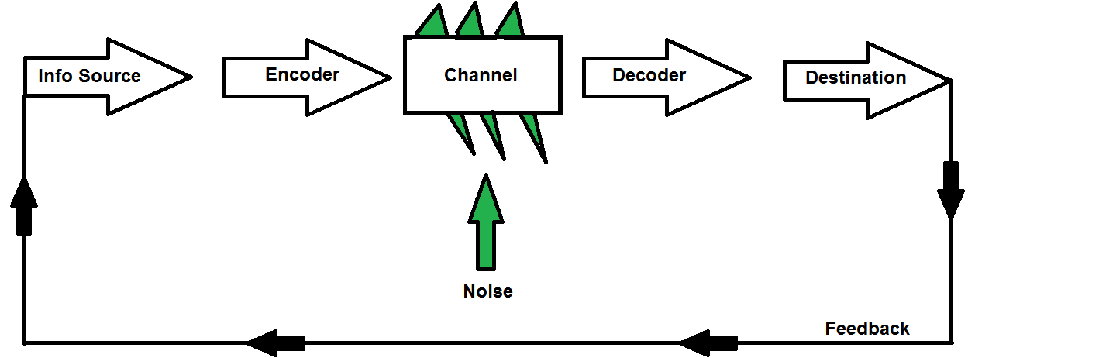
Reference Bring .comimage.com

3.2 Berlo’s Model of communication

Berol’s Model of communication is an expansion of Shannon and Weaver’s Model of Communication. Berlo’s Model takes into account the emotional aspect of the message. This model of communication operates on the SMCR Model. In the SMCR Model, S stands for source M stands for message, C stands for channel and R stands for receiver (Baird L. L. 1983)) Berlo’s communication method is a simple submission for person-to-person communication which include communication source, encoder, message channel, decoder, and communication receiver. Berlo’s model attempts to outline the different components needed for effective communication. According to David Berlo, there are three major components required for effective communication, the sender, the message and the receiver. According to Berlo communication can be used at the workplace by top management passing information to the lower management in a way it is properly received, understood and act on. Staff would have to have the proper training and understanding of information that is passed on them in order for the communication process to be effective. Explanation of Berol’s communication is shown on diagram.
Source (praxisframework.org 2019)

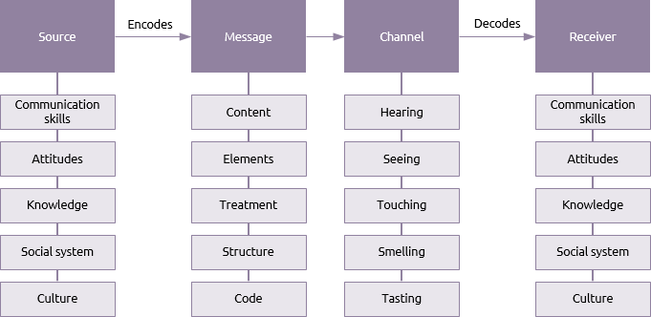

3.3 Schramm’s Model of Communication

The Schramm model views communication as a process that takes place between a sender (transmitter) and a receiver, there will be also a message and a medium through which the message can be transmitted (Schramm 1948). Schramm suggested that communication is a two way process where both sender and receiver take turns to send and receive a message. Schramm’s model can be used in the workplace for example between a manager and their staff. The manager sending message to the staff to do something and the staff doing what is asked of him and sending back the feedback to his manager. It will be a two way communication until the issue is resolved.

This diagram illustrates how the Schramm’s model Communication works.

Source:(sagepub.com)

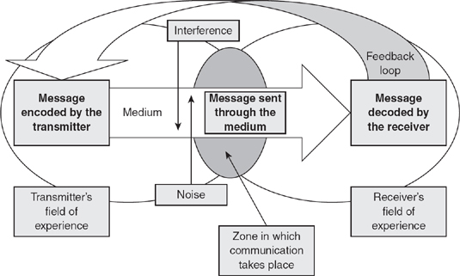

4.0 Conclusion

In this report I have looked at teamwork and its importance, I have also looked at communication, its importance and the different types of communication. I have also looked into the three modes of communication and they are used in the workplace. I have referenced myself as needing more development in terms of where I see myself in relation to where I am as regards to communication at my workplace. It is clear from this report to note that both teamwork and communication in the workplace are very important tools for the success and smooth running of an organisation. Good communication can come from non-verbal and verbal communication depending on how its channel by the sender and the receiver. I can confidently say that communication is a means spreading news and a vital tool for our day to day life, weather it may be in our modern day life or in a work place, however good communication is vital at work place.
Communication can be taught within each other or in some cases it is taught by some one regarding a certain aspect.

Reference

Communication theory (2019) Shannon and weaver model of communication [Online] Available at: https://www.communicationtheory.org/shannon-and-weaver-model-of-communication/ Accessed at 5 December 2019

Leaders institute (2019) communication is a key to teamwork [Online] available at: https://www.leadersinstitute.com/communication-is-a-key-to-teamwork Accessed at 5 December 2019

Management study guide (2015) qualities of a leader [Online] Available at: https://www.managementstudyguide.com/qualities_of_a_leader.htm Accessed at 6 December 2019

Oxford reference (2020) view/10.1093/oi/authority [Online] Available at: https://www.oxfordreference.com/view/10.1093/oi/authority.20110803100459436 Accessed at 6 January 2020

Praxis framework (2019) library berlo [Online] Available at: https://www.praxisframework.org/en/library/berlo Accessed at 5 January 2020

Sage pub (2020) concepts-in-marketing [Online] Available at: https://sk.sagepub.com/books/key-concepts-in-marketing/n46.xml Accessed at 1 January 2020

Skills you need (2016) communication skills [Online]
Available at: https://www.thebalancecareers.com/nonverbal-communication-in-the-workplace-1918470 Accessed at 2 January 2020

The balance career.com (2019) nonverbal communication in the workplace [Online]
Available at: https://www.thebalancecareers.com/nonverbal-communication-in-the-workplace-1918470 Accessed at 28 December 2019

Your Dictionary.com (2020) Communication [online]
Available at: https://www.yourdictionary.com/communication Accessed at 2 January 2020

