

Student name: Josephine Taller
Student ID: 2431097

Module name: Protecting and Supporting Families in Health and Care
Module code: BMHP5021
Lecturer name: Shaila Hussain
Submission Date: August 14, 2026
2:00 pm

Assessment (REPORT): An examination and analysis of how the ‘Early Help’ system is signposted to UK families by their local authority website.

Table of Contents
1. Introduction 3
2. Early Help System 4
3. Multi-agency Working 5
4. Evaluation of Leicestershire County Council Website 6
5. Evaluation of Norfolk County Council Website 8
6. Evaluation of Staffordshire County Council Website 10
7. Comparative Analysis of the Three Council Websites 12
8. Conclusion 14
9. Recommendations 15
References 16

1. Introduction
Early Help is a crucial component of child-centered safeguarding and family support in England. Its primary function is to detect problems early and offer the best form of assistance in a timely manner before they compound. Children benefit from early help, family relationships are enhanced and statutory child protection services are avoided. Local authorities have a key role to play in ensuring that families have easy access to information about services available and about referrals. A clear and accessible website provides families with information about where help is available and how to get it (ref).
This report looks at how the Early Help system is communicated via the Leicestershire County Council, Norfolk County Council and Staffordshire County Council websites. The report gives an explanation of what the Early Help system is and why multi-agency work is important before exploring each council website. A comparative analysis highlights the key strengths and weaknesses of each website and establishes which council is communicating the best Early Help and family support services.

2. Early Help System
Early Help is there to assist the children, young people and families right at the start if there are any concerns. The main objective is that the problems don't escalate and that guidance, help and coordinated services are provided. Early help can deal with issues of attendance at school, family or relationship issues, money issues, physical issues, behavior and emotional issues. It is crucial to understand that early intervention can be offered to help families cope with their problems before any intervention becomes necessary (Department for Education, 2022).
Early Help intervention is based on the understanding of children's needs and taking an overall picture of the whole family. Through assessment, the strengths and needs will be identified to deliver the service. It may result in more effective outcomes because of building resilience, increasing parents' and children's skills, and good development of children (HM Government, 2023).
It is also important that there is effective communication within an Early Help system. All families have easy access to referrals and contact information for all services, and eligibility is readily available. So is the local authority website, as it has a huge impact on improving access to the right support for parents, carers and professionals. Good online information is well structured, aids to promote awareness of services offered, aids to make earlier referrals and minimizes confusion in families seeking support. Accessible information is also helpful to professionals and will inform them of the various resources and referral processes in the community. (Department for Education,2022)

3. Multi-agency Working
The concept of multi-agency working is where several agencies work together with respect to information and plan to ensure the safety and well-being of a child and the family. A wide range of specialist knowledge is brought by each education, health, social care, police and voluntary organization to ensure that all the needs of children are identified and met effectively. According to the Department for Education (2026), Collaborative working will ensure that services respond more quickly and there is a reduced risk of important issues being missed.

Regular communication, clear definitions of professional roles and sharing of information in a timely manner are essential to effective partnership working. The evidence each organization brings together helps to give a picture of the situation for a child. This coordinated approach enhances decision-making and enables support plans to cater for the needs of the whole family, not just individual issues (Children Act, 2004).
The sharing of information with families and professionals on local authority websites enables multi-agency work. Referral information and contacts, eligibility criteria and descriptions of services ensure practitioners can make appropriate referrals, and family members are aware of services. Information that is accessible online, therefore reinforces working together between agencies and enhances access to Early Help services.

4. Evaluation of Leicestershire County Council Website
Leicestershire County Council have their own section on the website dedicated to Early Help, organized for both families and professionals. Information is displayed in such a manner as to make it easy for the user to find out what services are available, referral options and contact information, without having to do much searching. Leicestershire County Council give information about what Early Help is and how families can get help before issues get more serious. (Leicestershire County Council, 2026)
One of the most important benefits of the website is its logical structure. Information is organized by topics and it's easy to navigate for different audiences of users. Language used to deliver guidance is simple in order to minimize barriers to support for families. The website also offers some helpful details regarding children's centers, family support, education services, and safeguarding, which is helpful for users to understand the type of assistance they can get.
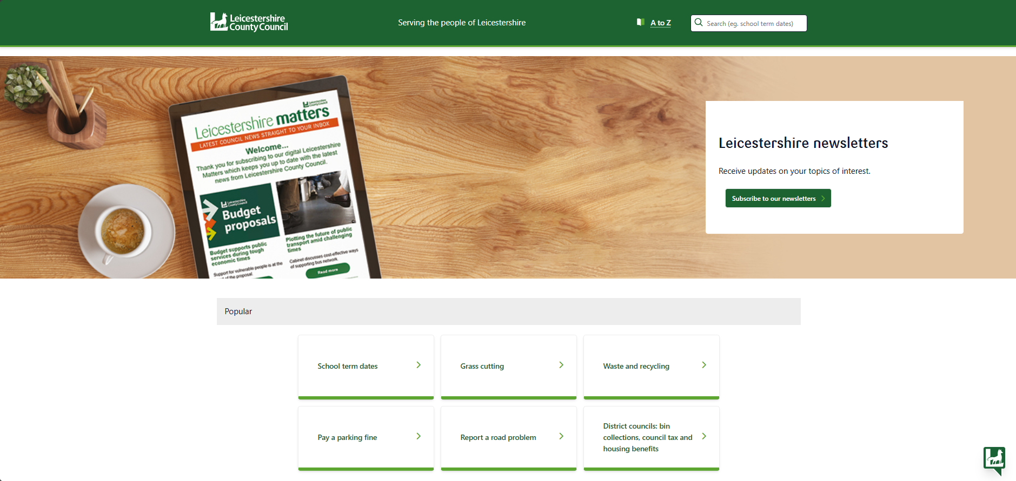
Figure 1: Leicestershire County Council Website
Source: (Leicestershire County Council, 2026)
The referral process is well-defined and provided with guidance for professionals and families. Users can easily find contact information and online resources to determine the most suitable service. This makes it more accessible and helps people to access support sooner.
A few sections, however, have vast amounts of information which might include further reading that must be done outside the document before the user can determine which service is the most relevant. There may be opportunities for adding more visual materials, summary pages or interactive navigation, which may further enhance accessibility for families presenting with immediate concerns. Overall, the information and communication of Early Help services are good.

5. Evaluation of Norfolk County Council Website
Norfolk County Council's website has a section of its site dedicated to family support services and a description of the services available, eligibility and how to refer for Early Help. Information has been organized to help users to understand when Early Help might be required and to take them through various stages of support (Norfolk County Council, 2026).
One of the great features of the site is its family-oriented content. Clear and simple writing, with a focus on practical help for children, young people and parents. The website offers immediate access to guidance on emotional wellbeing, education, parenting support and community services. The wide array of information allows users to draw out the right services depending on the needs of each family.
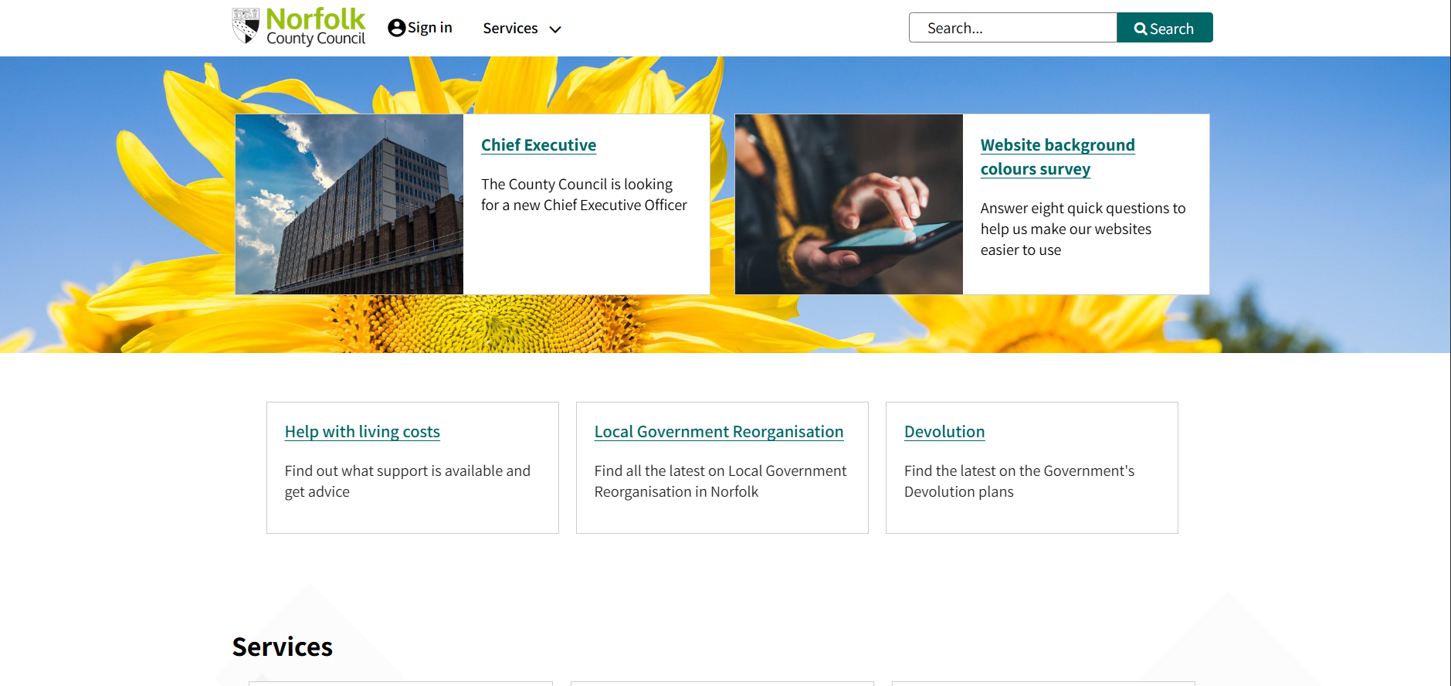
Figure 2: Norfolk County Council Website.
Source: (Norfolk County Council, 2026)
One can also find information about referral arrangements and contact details for relevant services on the website. Resources and information for professionals are differentiated from information designed for families to make navigation more efficient for different user groups. This organized system facilitates self-referral and referral by professionals.
While the service strengths are acknowledged, some service information is spread over several webpages, and further navigation is needed before users are presented with detailed guidance. Families who are not familiar with the services offered by the local authorities might need more time to find a particular piece of information. It would be useful for an Early Help page to be more centralized and with direct links to all related services, thus making it more accessible and less time-consuming to search. The website is excellent at conveying information on Early Help and provides detailed information for families and professionals.

6. Evaluation of Staffordshire County Council Website
There is an Early Help page provided by Staffordshire County Council on their website, where they explain the reasons why this program has been introduced, the support they provide, and how people can access it. Their website offers guidance not only for families but for professionals as well; everybody can get information relevant to them (Staffordshire County Council, 2026).
One of the strengths of the webpage is clearness of the whole process of Early Help service provision. Information about identification, assessment and managing the concerns is provided; there is also information about the role of the practitioner, and the importance of partnership work is highlighted. It will help families to know what to expect from using the Early Help services.
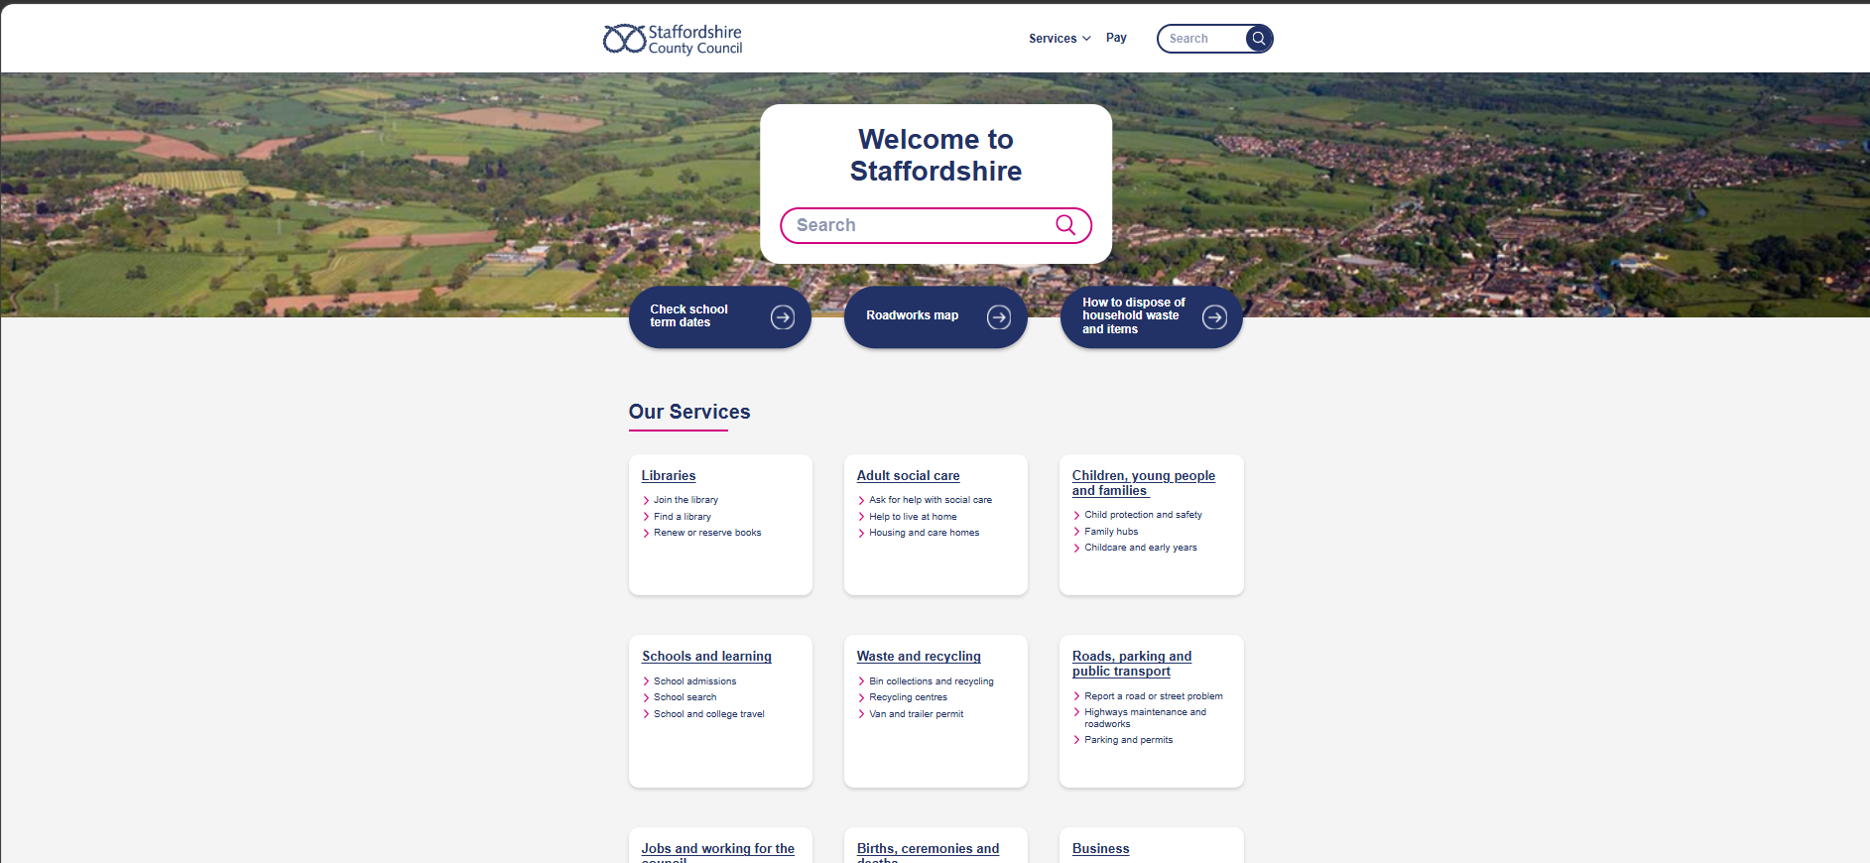
Figure 3: Staffordshire County Council Website.
Source: (Staffordshire County Council, 2026).
The site offers links to assessment forms, professional resources and contact information, and has clear referral guidance. Information is broken down into distinct areas and users can easily navigate between relevant services – Early Help, safeguarding and children's services. Downloadable resources are also provided to help professionals when making referrals.
sparagraphs of information, and this might not be helpful to families who seek quick information. Adding more visual aids and commonly asked questions might make the document user-friendly. However, the website manages to achieve this, despite this limitation, and it is very good at communicating Early Help and providing full information.

7. Comparative Analysis of the Three Council Websites
All 3 council websites are clear about the purpose of Early Help and information about what help services are available to help. Each website contains information for families and practitioners to read, and information on how to refer children for services and how to access children's services (Daniel et al., 2011). There are variations in structure, layout and communication of information, however.
Leicestershire County Council has a good hierarchy and structure to their site; they have logical navigation and organization of the site. The different areas are provided to assist easy access to Early Help guidance in clear and concise language. Family support information is communicated well, enabling the website to be accessible by professionals and the public. One of the disadvantages is the lack of accessibility since some pages have a considerable amount of information in the text, which could be difficult for those who want a quick answer (Leicestershire County Council, 2026).
Norfolk County Council's focus is on a family-centred approach and there are a number of services and information about Early Help available. Useful information on education, parenting, emotional well-being and community services is available on the Website. This gives clarity to the help that the families receive (NSPCC, 2024). Nevertheless, crucial information may be found on various web pages, and one may need to make some additional efforts to get access to detailed information.
Staffordshire County Council provides in-depth professional advice, guidance and public information. The website is more than clearly marked on how to refer and has some useful resources for practitioners. This will help to coordinate services and boost professional involvement. There are also pages that are very text-heavy and families can find it difficult to locate the key information they need quickly.
Overall, however, all three councils provide excellent promotion of the services of Early Help – both use their strength well, and they do this in general. The performance of Leicestershire is quite high, especially regarding the easy use of websites and the easy navigation on websites. Norfolk and Staffordshire are the best scorers both in terms of being family-friendly and in their presentation of support services as well as in professional guidance. Leicestershire County Council are the best-balanced council with regards to the accessibility, clarity and communication of Early Help services in User-experience. According to the Local Government Association (2023), the council has a user-friendly and well-organized website that offers families and professionals easy-to-understand language on the use of the services.

8. Conclusion
The evaluation shows all three local authority websites are useful and have information about the Early Help system and support offered to children and families. Each site provides information on how to be referred and how to get services before the issues get worse. However, there are differences in the ways that websites are communicated, accessed and organized. The most effective website is provided by Leicestershire County Council as it is easy to navigate, has organised information and uses simple language. Such information helps the families and professionals identify information on Early Help.

9. Recommendations
The three councils should focus on improving accessibility by enhancing the navigability and eliminating excess information from their Early Help websites. Useful information could be made available via summary pages, diagrams, and FAQs for easy identification by families. A better integration of Early Help, safeguarding, educational, and health services could be beneficial to the users. The council can periodically review its website content depending on feedback provided by both families and professionals.
ss

References
Children Act 2004. (2004) Chapter 31. London: HMSO.
Daniel, B., Wassell, S. and Gilligan, R. (2011). Child Development for Child Care and Protection Workers. Jessica Kingsley Publishers.
Department for Education (2022) Early Help System Guide. London: Department for Education.
Department for Education (2026) Working Together to Safeguard Children. London: Department for Education.
HM Government (2023) Children's Social Care National Framework. London: HM Government.
Leicestershire County Council (2026) Early Help. Available at the council website (Accessed: 15 July 2026).
Local Government Association (2023) Children's services guidance. London: Local Government Association.
Norfolk County Council (2026) Early Help. Available at the council website (Accessed: 15 July 2026).
NSPCC (2024) Early intervention and safeguarding resources. London: NSPCC.
Staffordshire County Council (2026) Early Help. Available at the council website (Accessed: 15 July 2026

