11/18/2025
anitaaddo8414@gmail.com

Psychology in Health and Social Care
Student Name: Anita Addo
Student number :2423859
Module code: LCHS4010
Module Lead: Neale Haddon
Context
This assignment focuses on older adults aged 65 and over living in a residential dementia care home. Dementia is a neurological condition that loses its cognitive function, thinking, remembering and reasoning to such an extent that it interferes with a person’s daily life and activities. Some people with dementia cannot control their emotions and their personalities may range. Dementia ranges in severity from the mildest stage, when it is just beginning to affect a person functioning to the most severe stage when the person must depend completely on other for basic daily activities. (What Is Dementia? Symptoms, Types, and Diagnosis, 2022). Residents in this setting often experiences confusion, difficulty understanding, expressing their thoughts and disorientation. The care staff provide support with personal care, mobility, companionship and enjoy the community. The care home responsibilities Is to provide person centred care so as holistic approach to their service user, therapeutic activities and maintaining their rights and dignity but also to empower the individual. (Admin, 2025) To understand the two Psychosocial theories relevant to later adult hood will give us the idea why some elderly with dementia may be facing. In this essay I will be exploring the Eriksons Psychosocial Theory and Bandura’s Social Learning theory and show how these can be applied within a dementia care home both psychological and behavioural needs.



Detailed Overview of Two Psychological Theories
Eriksons PsychosocialTheory stages
Eriksons theory outlines eight stages of Psychosocial development. The first stage was the Trust vs Mistrust (0-18 Months) infants are dependent developing trust based on the dependability quality of the child caregivers. They are dependent upon adult caregivers for food, love, warmth and safety. Next were the Autonomy vs Shame (1-3 years) and Doubt here toddlers develop independence through exploring, choosing and tasks. Too much control can lead to shame. Stage 3 is the initiative vs Guilt (3-6 years) children begin to assert their power and control over the world through directing play and other social interactions. Stage 4 is the industry vs inferiority (6-12 years) children develops skills, confidence through social interaction and school. Identity vs confusion (12-18years) takes place during adolescence year where they begin to develop a sense of personal identity, explore their beliefs and values. The next stage is the intimacy vs isolation in this stage young adults form intimate, loving relationships with other people. Failure leads to loneliness and emotional isolation. Generativity vs Stagnation (40-60 years) middle adulthood, create or nurture things that will outlast them this include having children or positive change that benefits other people. Lack progress leads to stagnation. The final stage is the Integrity vs Despair(65+years) individuals reflect on their life. A sense of fulfilment leads to integrity while regret result in despair. (MSEd, 2025)

Eriksons PsychosocialTheory (Integrity vs Despair)
In this assignment we will be focusing on the Integrity vs Despair(65+years) in later adulthood during this stage individuals reflect on their life experiences and attempt to make sense of their achievements, relationships, failures and identity. Those who take pride in their accomplishments will feel a sense of integrity where an individual feels a sense of purpose and fulfilment. Completing this phrase means looking back with few regrets and general feeling of satisfaction. These individuals will attain wisdom, even in the face of death. (Psychology, 2023)
However, if an older adult feels that their life was unfulfilled, unsuccessful, bitterness or marked by unresolved conflict they may experience despair. People feeling despair might see their lives as unproductive or wasted this leads to feelings of regret, low self-worth or possibility fear of death. Knight (2017). Illness, isolation and mental health issues also play a part. It is key to understand despair in late adulthood to help people at this stage. By tackling the root causes and offering mental health support, meaningful relationships. This can help them to find peace and integrity in their later years. Individuals with dementia may struggle to recall important life events or feel frustrated when they cannot access their memories due to memory loss and cognitive decline this can lead to despair.
Bandura Social Learning Theory Stages
There are four key components that comprise Banduras Social Learning Theory. First is the attention referring to the learner’s ability to focus on the behaviour of the model. A model can be a parent, teacher, celebrity, peer it is crucial because without it learning cannot occur. Next is the retention storing the information for later use. It involves the storing the observed behaviour in memory, it is vital because it allows the individual to later recall and reproduce the behaviour even in the absence of the model. It depends on serval factors including cognitive abilities. Third component is the reproduction: imitating the observed behaviour this is the physical or mental replication of the observed behaviour. The learner should have the ability to reproduce the behaviour, which often requires other abilities. Last component is the Motivation; Reinforcement and willingness to Imitate, it refers to the learner’s reason or desire to adopt the observed behaviour. This is determined by motivation if the learner will exhibit that behaviour. (Arcoven, 2024)

Bandura Social Learning theory
A psychological theory called the social learning theory describes how people pick up new skills through modelling, imitation and observation. Albert Bandura developed this theory in the 1960s as he highlights the importance of paying attention to the attitudes, behaviours and result of other people’s actions. Bandura identified four key processes involved: attention, retention, reproduction and motivation. Individuals must first notice the behaviour to be able to remember it, physically replicate it and motivated to repeat it. This theory is crucial when working with older adults especially those vulnerable with dementia, Alzheimer’s because they are heavily influenced by the behaviour and communication patterns of people around them. Individuals with dementia often relies on social interaction and environment to guide them.
An example of this if their care staff has a angry, upset facial expression and their tone of voice is sharp a dementia patient may copy this action and exhibit that to other residents in the care home this can lead to serious issues like conflict. However, is the care staff is happier, calm this can promote calmness within the residents. Dementia individuals constantly need routines this is also highlighted in the social learning theory. The consistent routines will make them feel more comfortable as they know and have learnt the routines. An example of this is repeatedly showing them where the toilet is, how to use cutlery to cut their food or where they clothes may be or participate in group activities.


Application in the health and social care Context
Applying Eriksons Theory to Demenita Care.
Using Eriksons stage of integrity vs Despair helps professionals understand the emotional and psychological need of older adults. Dementia causes a cognitive decline and their memory. So, it is crucial in a dementia care home staff must have strategies that promotes their independence, dignity and empower them.
Ways to support integrity is encouraging life review and reflection in the care home. It doesn’t mean dwelling on the past but rather examining one’s life story with curiosity and compassion. This might involve activities like writing memoir, sharing stories. Fostering meaningful relationships and social engagement is key when someone has dementia as this could help strengthen existing family bonds but also help them to remember, rekindling old friendships or forming new community activities. So, getting the individuals in the dementia care home to go out volunteer work to keep their minds busy it will give them a sense of belonging. Another to support is through reminiscence therapy this encourages people with dementia to share memories from the past. The treatment can be done by staff, family members it includes allowing the patient to revisit positive memories using photography, familiar music or their life story books. This can help them to connect with their past, loved ones to enhance their emotional wellbeing. An example of this is a dementia patient listening to music played at their wedding which could take them back in time or a resident who was a doctor talk about their career to make them feel proud. Senior (2023b)
Companionship and emotional support from staff play a huge role in dementia care support. Being respectful and compassionate to the patient may make them feel valued and not judged. Staff who validate residents’ feelings than challenging or correcting them can reduce distress and sadness.
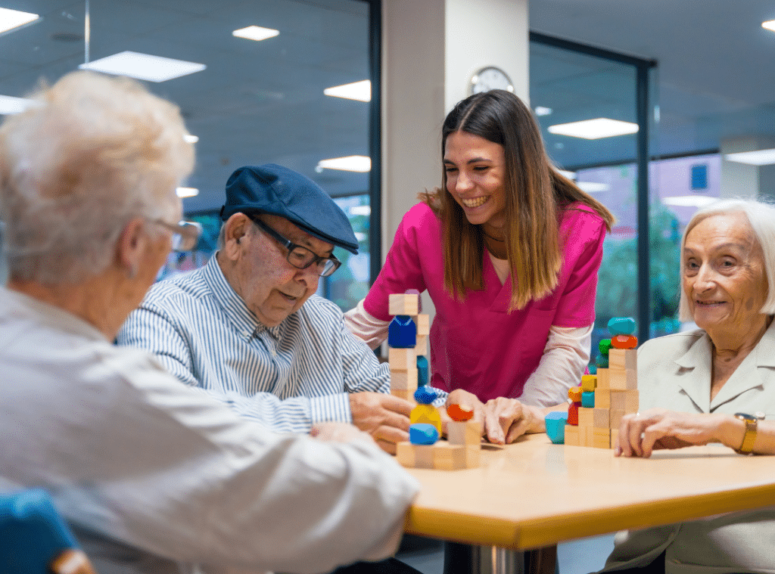

Applying Social Learning Theory to Dementia Care
Social learning theory is important in dementia care because residents often rely on watching other on how to behave then exhibit the same behaviour.
An example of this is when a staff is calm, speaking slowly, has an open body language and is making eye contact it shows that they are being valued and are being listen to. It also makes dementia patient feel safe and supported. Staff showing patience during personal care such as bathing, dressing can cause the patient to cooperate with them calmly. However, if a care assistant appears rushed or hurried it may trigger confusion and anxiety in the patients which may make is harder for them to co-operate and challenging behaviour.
Routines are crucial for dementia patients, the same consistent routines can make them feel comfortable. For an example a resident may learn to wash their hands, button shirt or cut food so a carer would demonstrate the step repeatedly. Promoting group activities such as singing, gentle exercise often requires repletion and imitation.
Bandura’s theory highlights the important of staff behaviour, constant routines and repletion of actions can reduce confusion and challenging behaviour.
Critical Evaluation Challenges and Strategies
Challenges when Applying Eriksons Theory
One challenge is that dementia interferes with memory and self-reflection so it can be harder for individuals to think, evaluate about the past and their life clearly, Thia can lead to frustration within and confusion resulting in feelings of despair. If they are questioning them self it can lead to them being constantly stressed and worried. Strategies are using reminiscence activities focused on emotions, encourage and reassure them that is it okay if they don’t understand or remember something. Promote the patient to be patient in small task to promote their dignity but also to empower them so that they don’t always feel dependent.
One Criticism about Eriksons Psychosocial theory was the lack of empirical evidence that was supporting his claims. There was a lack of scientific research to validate the specific stages and outcomes proposed by the theory. Another weakness was that theory was criticized for overemphasizing the role of adolescence in identity formation, and neglecting other developmental life stages like later adulthood. It highlights a limitation in the theory applicability to diverse age groups and life experiences. Erikson does not take into account of cultural influences for an example someone who grows up in a culture where it is shameful to be independent may develop feelings of inferiority even if they are successful in other areas. TherapyMantra (2023)

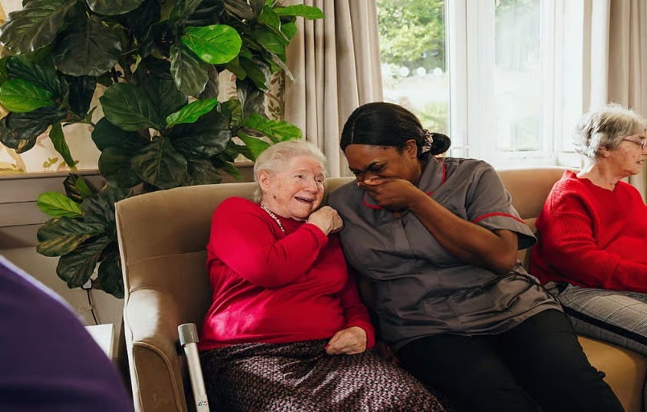

Challenges when applying Social Learning Theory
Individuals in dementia care homes may struggle with attention or retention making it difficult to consistently imitate behaviours. Residents may forget to stick to their routines so its is important for staff to always be going through with them. If the staff modelling is inconsistent due to different ways of communication or staff shortages, Strategies is ensuring that staff are properly trained in dementia so that they have the knowledge to tackle situation but also how they communicate with residents. Maintaining structed routines to support learning through repetition and use clear demonstration of tasks.
One criticism of Social cognitive theory is the limited focus on biological and genetic factors. While Bandura acknowledges the importance of cognitive processes and environmental influences his theory places little emphasis on how genetic predisposition and biological mechanisms contribute to personality. Another criticism is the potential overemphasis on the influence of the social environment in shaping personality. The theory view individuals as somewhat passive agents who respond to their environment rather than exploring the deeper psychological process that could shape personality. (Kumar, 2025b)

Conclusion
Both Eriksons Psychosocial theory and Bandura Social Learning Theory provides a crucial insight into supporting older adults living in dementia care. Eriksons emphasises on identity, dignity and emotional support in later life, especially when dementia takes a person’s independence and memory. Bandura theory emphasis on communication, role modelling and routines which is essential in supporting individuals who rely on observational learning. Staff giving person centred care, training can enhance the psychological and emotional wellbeing of residents. As we understand these theories it will help health and social care professionals to find strategies, deliver high quality and holistic care towards their patients.

Reference
MSEd, K. C. (2025, November 13). Erikson's Stages of Development. Verywell Mind. https://www.verywellmind.com/erik-eriksons-stages-of-psychosocial-development-2795740
Knight ZG. A proposed model of psychodynamic psychotherapy linked to Erik Erikson's eight stages of psychosocial development. Clin Psychol Psychother. 2017 Sep;24(5):1047-1058. [
What is dementia? Symptoms, types, and diagnosis. (2022, December 8). National Institute on Aging. https://www.nia.nih.gov/health/alzheimers-and-dementia/what-dementia-symptoms-types-and-diagnosis
Admin. (2025, August 11). Responsibilities as a carer in the UK: Complete guide - Cream Home Care. Cream Home Care. https://creamhomecare.co.uk/responsibilities-as-a-carer/
Psychology, P. (2023, October 11). Integrity vs Despair (Psychosocial Stage 8). Practical Psychology. https://practicalpie.com/integrity-vs-despair/
Senior, C. (2023b, May 1). Remembering the Past: What is Reminiscence Therapy for Dementia? Legacy Oaks of Azle Senior Living. https://www.civitasseniorliving.com/legacy-oaks-of-azle/reminiscence-therapy-for-dementia/
Arcoven, H. (2024, October 18). What are the 4 Stages of Social Learning Theory? - School Drillers. School Drillers. https://www.schooldrillers.com/4-stages-of-social-learning-theory/
Baltes, P., & Baltes, M. (1990). Psychological Perspectives on Successful Aging: The Model of Selective Optimization with Compensation. In: P. Baltes, & M. Baltes (Eds.), Successful Aging: Perspectives from the Behavioral Sciences (pp. 1-34.). New York: Cambridge University Press.http://dx.doi.org/10.1017/CBO9780511665684
TherapyMantra. (2023, April 15). Erikson’s Theory of Psychosocial Development: TherapyMantra. Therapy Mantra - Online Therapy Counseling. https://therapymantra.co/therapy-types/eriksons-theory-of-psychosocial-development/#Criticism_of_Erikson8217s_Eight_Stages
Kumar, P. (2025b, October 16). Evaluating Bandura's Social-Cognitive Theory: Strengths and Criticisms • Psychology Town. Psychology Town. https://psychology.town/personality-theories/evaluating-banduras-social-cognitive-theory/

Pictures
Senior, C. (2023, May 1). Remembering the Past: What is Reminiscence Therapy for Dementia? Legacy Oaks of Azle Senior Living. https://www.civitasseniorliving.com/legacy-oaks-of-azle/reminiscence-therapy-for-dementia/
Communities, S. (2025, March 10). 7 Tell-Tale Signs of End-Stage Dementia (2025 Update). Sunflower Communities. https://sunflowercommunities.org/end-stage-dementia/
ConversionFormula. (2025, August 1). Nursing home activity ideas: fun and therapeutic activities. Westmont Living. https://westmontliving.com/blog/westmont-of-cypress/fun-and-therapeutic-nursing-home-activity-ideas
Midwest, A. H. (2025, August 11). Personal Hygiene Checklist for the elderly. Assisting Hands Home Care | Chicago, IL and WI. https://www.assistinghands-il-wi.com/blog/elderly-people-personal-hygiene-checklist/
Specialist Nursing Care Homes | Award winning Lovett Care. (2025, November 12). Lovett Website. https://lovettcare.co.uk/services/nursing

