

The Impact of customer satisfaction and brand image
on brand loyalty: A Study on Apple.

Student Name: Marina Drumea
Student ID: 2125126
Submission Date: 13.02.2024
Supervisor: Ms Tushara Balendran

Dissertation Project
Module Code: LCMB7020

Declaration

Master’s Degrees by Examination and Dissertation
Declaration Form.
1. This work has not previously been accepted in substance for any degree and is not being concurrently submitted in candidature for any degree.
Signed: Marina Drumea Date 20/01/2024
2. This dissertation is being submitted in partial fulfilment of the requirements for the degree of Master in Business Administration.
Signed: Marina Drumea Date 20/01/2024
3. This dissertation is the result of my own independent work/investigation, except where otherwise stated.
Other sources are acknowledged by footnotes giving explicit references.
A bibliography is appended.
Signed candidate: Marina Drumea Date: 20/01/2024
4. I hereby give consent for my dissertation, if accepted, to be available for photocopying, inter- library loan, and for deposit in the University’s digital repository
Signed (candidate): Marina Drumea Date 20/01/2024
Supervisor’s Declaration.
I am satisfied that this work is the result of the student’s own efforts.
Signed: …………Tushara Balendran…………………………………………………………
Date: ………………23/01/2024…………………………………………………………….....

Abstract

This dissertation examines how customer satisfaction, brand perception, and customer loyalty all affect each other in Apple Inc. To come up with its goals, the study went through a lot of theoretical ground by using well-known models and frameworks and reading considerable literature. The study looked at how satisfied Apple customers are with the company as a whole, how people feel about the Apple brand, and how customer satisfaction is related to brand image and brand loyalty. A study of fifty different Apple customers using surveys with a mixed-methods approach yielded much helpful information. Descriptive statistics showed that customer satisfaction, brand perception, and loyalty were all complex, but correlation analyses showed strong links between them.
According to the research, product quality significantly affects brand loyalty. Like other marketing research, this study emphasised how important customers think about innovation, customer service, and brand reputation. A correlation analysis showed the link between brand image, customer loyalty, and satisfaction. When customers are happy, they are more likely to recommend Apple, buy from them again, and come back. The respondents' preferred brand image was strongly linked to measures of loyalty.
This study shows how customer satisfaction, brand perception, and loyalty all affect each other in Apple's case. This has an impact on how people behave in the tech industry. This study aims to discover how product quality, new ideas, good customer service, and a good brand reputation help build long-lasting customer relationships. The dissertation makes the case that Apple should make a plan to improve both customer satisfaction and the brand's image. The study's authors are aware of its limitations and suggest more research to get a fuller picture of how customers behave in a field where technology is changing rapidly.

Acknowledgement

This academic project has been both rewarding and educational, and I want to thank everyone who helped me finish my dissertation.
I want to express my deep gratitude to Prof. Thushara Balendran for her invaluable guidance and support throughout my research project. Her advice, feedback, and insights have been instrumental in shaping the direction of my research.
The people who participated in the survey provided honest answers that are crucial to this research project. Therefore, I would like to express my gratitude for your valuable contribution.
In addition, I would like to express my sincere gratitude for the constant support and motivation provided by my family and friends. Their presence in my life is invaluable.
Finally, I thank the University of Wales Saint Trinity Saint David for providing the necessary resources and facilities for this research.

Table of Contents
Declaration 2
Abstract 3
Acknowledgement 4
Table of Figures 8
List of Tables 9
Chapter – 1: Introduction to the Research 10
1.1 Introduction 10
1.2 Background of the Research 10
1.3 Background of the Company 11
1.4 Problem Statement 12
1.5 Rationale of the Study 13
1.6 Research Aim, Objectives, and Questions 14
1.6.1 Research Aim 14
1.6.2 Research Objectives 14
1.6.3 Research Questions 14
1.7 Chapter Summary 14
1.8 Structure of the Dissertation 15
Chapter – 2: Literature Review 17
2.1 Introduction 17
2.2 Introduction to Customer Satisfaction, Brand Image, and Brand Loyalty 17
2.2.1 Customer Satisfaction 17
2.2.2 Brand Image 17
2.2.3 Brand Loyalty 18
2.3 Customer Satisfaction in the Context of Consumer Electronics 18
2.4 Brand Image in Consumer Electronics 19
2.5 Brand Loyalty in Consumer Electronics 20
2.6 The satisfaction of Apple consumers with their overall experience, as well as how they feel about the company's products and customer service. 22
2.7 The brand perception of Apple and essential characteristics and associations that affect how customers view the company. 22
2.8 To analyse the impact of customer satisfaction and brand image on the brand loyalty of Apple customers. 23
2.6 Literature Gap 24
2.7 Theoretical Framework 26
2.7.1 Expectancy-Disconfirmation Theory 26
2.7.2 Keller's Customer-Based Brand Equity (CBBE) Model 27
2.7.3 Loyalty Frameworks 29
2.7.4 Synthesizing the Theoretical Framework 30
2.8 Chapter Summary 32
Chapter – 3: Research Methodology 34
3.1 Introduction 34
3.2 Research Philosophy 35
3.3 Research Approach 36
3.4 Research Strategy 38
3.5 Methodological Choice 39
3.6 Type of Investigation 41
3.6 Timeframe of the Research 42
3.7 Methods and Techniques 43
3.7.1 Sampling Method and Sample Size 43
3.7.2 Data Collection Method 44
3.7.3 Data Analysis Method 45
3.8 Ethical Considerations of the Research 46
3.9 Chapter Summary 47
Chapter – 4: Data Analysis, Findings and Discussion 48
4.1 Introduction 48
4.2 Findings from Data Analysis 48
4.2.1 Demographic Overview of the Dataset 48
4.2.2 Descriptive Analysis 49
4.2.3 Correlation Analysis 70
4.3 Discussion 71
4.4 Chapter Summary 73
Chapter – 5: Conclusion and Recommendations 74
5.1 Conclusion 74
5.2 Recommendations 76
5.3 Limitations of the Study 78
5.4 Scope for Future Research 78
References 80

Table of Figures
Figure 1: Expectancy-Disconfirmation Theory 26
Figure 2: Keller's Customer-Based Brand Equity (CBBE) Model 27
Figure 3: Loyalty Ladder Model 29
Figure 4: Theoretical Framework of this Research 31
Figure 5: Participants’ Satisfaction with Apple’s Product Design/Source: (Author) 51
Figure 6: Participants’ Satisfaction with Apple’s Product Performance/Source: (Author) 52
Figure 7: Participants’ Satisfaction with Apple’s Customer Service/Source: (Author) 54
Figure 8: Participants’ Satisfaction Regarding Overall Experience as an Apple Customer/Source: (Author) 55
Figure 9: Participants’ Opinion Regarding Apple’s Brand Image/Source: (Author) 57
Figure 10: Participants’ Opinion Regarding Whether Apple Reflects Contemporary Way of Life/Source: (Author) 59
Figure 11: Participant’s Opinion Regarding Whether Apple's brand is associated with high quality/Source: (Author) 60
Figure 12: Influence of Apple’s Brand Image on Participants’ Purchasing Decision/Source: (Survey Data) 61
Figure 13: Product Quality as Factor Contributing to Participants’ Loyalty to Apple/Source: (Author) 64
Figure 14: Innovation as Factor Contributing to Participants’ Loyalty to Apple/Source: (Author) 65
Figure 15: Customer Service as Factor Contributing to Participants’ Loyalty to Apple/Source: (Author) 67
Figure 16: Brand Reputation as Factor Contributing to Participants’ Loyalty to Apple/Source: (Author) 68

List of Tables
Table 1: Structure of the Dissertation/Source: (Author) 15
Table 2: Duration of Participants as Apple Customers/Source: (Survey Data) 48
Table 3: Descriptive Analysis Concerning Variables Associated with Satisfaction of Apple Customers/Source: (Survey Data) 49
Table 4: Participants’ Satisfaction with Apple’s Product Design/Source: (Survey Data) 51
Table 5: Participants’ Satisfaction with Apple’s Product Performance/Source: (Survey Data) 52
Table 6: Participants’ Satisfaction with Apple’s Customer Service/Source: (Survey Data) 53
Table 7: Participants’ Satisfaction Regarding Overall Experience as an Apple Customer/Source: (Survey Data) 55
Table 8: Descriptive Analysis Concerning Variables Associated with Brand Image/Customer Perception of Apple/Source: (Survey Data) 56
Table 9: Participants’ Opinion Regarding Apple’s Brand Image/Source: (Survey Data) 57
Table 10: Participants’ Opinion Regarding Whether Apple Reflects Contemporary Way of Life/Source: (Survey Data) 58
Table 11: Participant’s Opinion Regarding Whether Apple's brand is associated with high quality/Source: (Survey Data) 60
Table 12: Influence of Apple’s Brand Image on Participants’ Purchasing Decision/Source: (Survey Data) 61
Table 13: Descriptive Analysis for Variables Connected with Customer Loyalty of Apple/Source: (Survey Data) 62
Table 14: Product Quality as Factor Contributing to Participants’ Loyalty to Apple/Source: (Survey Data) 63
Table 15: Innovation as Factor Contributing to Participants’ Loyalty to Apple/Source: (Survey Data) 65
Table 16: Customer Service as Factor Contributing to Participants’ Loyalty to Apple/Source: (Survey Data) 66
Table 17: Brand Reputation as Factor Contributing to Participants’ Loyalty to Apple/Source: (Survey Data) 68
Table 18: Correlation Among Different Variables/Source: (Survey Data) 70

Chapter – 1: Introduction to the Research

1.1 Introduction
This chapter marks the beginning of the investigation into the intricate interrelationships between brand loyalty, customer satisfaction, and brand image, with a specific concentration on the singular domain of Apple Inc. This chapter focuses on the importance of a wider understanding of these dynamics within the ever-evolving industry of consumer electronics. The researcher lays the groundwork for an all-encompassing investigation by locating and fixing a significant gap in the existing corpus of literature as part of the process of laying the foundation for an all-encompassing study. In the introduction, the researcher presents a condensed overview of the research objectives, highlighting the study's practical value for strategic decision-making in the highly competitive technology business.

1.2 Background of the Research
According to Susiang et al. (2023), businesses are becoming more conscious of the crucial relevance of factors such as customer satisfaction, brand image, and brand loyalty as indicators of long-term success and sustainability. This occurs even though the global business environment is dynamic and constantly changing. As a result of technological process development, the consumer electronics market is marked by a particularly cutthroat level of competitiveness. According to Saarikko, Westergren and Blomquist (2020), businesses in this industry strive not only to offer last-generation products but also to build and maintain strong relationships with their clientele. Apple Inc., a well-regarded company in this industry, is known for its groundbreaking innovations, visually beautiful designs, and constant focus on offering an amazing user experience. According to Chan, Selden and Pun (2020), the success of Apple can be attributed not just to its advanced technological capabilities but also to the significant influence it has on the attitudes and feelings of its customer base. Apple products are known for their innovative designs and user-friendly interfaces.
According to Shuja et al. (2023), customer satisfaction is a vital aspect of the success of any organisation. Customer satisfaction refers to the overall experience and sense of fulfilment that a consumer derives from using a service or purchasing a product. In addition, according to Patro, Chaudhry and Sharma (2022), the idea of the brand image comprises the associations and ideas that customers acquire with a specific brand as a result of their encounters with the brand, the marketing materials associated with the brand, and the way the brand is presented in its entirety. Customer satisfaction, brand image, and the creation and maintaining of brand loyalty are all gathered in a connection known as brand loyalty. It goes beyond merely making repeated purchases and involves an innate devotion to the preference for a particular brand (Ferrell, Hartline and Hochstein, 2021). Therefore, understanding the interplay between customer satisfaction, brand image, and brand loyalty related to Apple is not only intellectually engaging but also holds important practical repercussions and consequences for businesses working towards flourishing in an industry with an exceptionally high level of competition.
In the course of this inquiry, the investigator has carried out unique research in order to determine the extent to which Apple's customer loyalty is affected by factors such as customer satisfaction and brand image. The researcher conducted a quantitative study as an essential part of the primary investigation. During this study, the researcher will collect data on the factors that customers consider to be most important when it comes to determining whether or not they are satisfied with Apple as a brand, as well as their perceptions of the brand's image and the other dimensions of brand loyalty. This study proposes to evaluate the relationship between the abovementioned factors, namely customer satisfaction and brand image, and the third variable, consumer loyalty towards the brand in question. In order to collect information for this study, a data collection survey will be conducted among a sample of fifty Apple customers. To analyse the relationship between the variables that are the focus of this study, the researcher will proceed with statistical analysis, such as correlation analysis and descriptive analysis once the data have been acquired. These analyses will be performed to investigate this study's subject matter.

1.3 Background of the Company
Apple Inc., a multinational technology conglomerate company with its main office in Cupertino, California, was established on April 1, 1976, by Steve Jobs, Steve Wozniak, and Ronald Wayne (Apple, 2022). Apple has gained a loyal customer base and established benchmarks in the industry by introducing revolutionary products including the Macintosh, iPod, iPhone, and iPad, which are emblematic of the company's dedication to innovation and design (Global Data, 2022). The integrated ecosystem, harmonious hardware-software integration, and renowned retail locations that Apple has established have all contributed to its pioneering status in the consumer electronics industry (Primavesi, 2022). Apple's prominent position in the technology industry and the wider business world is further emphasised by its social responsibility and financial strength (Global Data, 2022). Apple is also a leader in sustainable and ethical business practices. Recognising the intricacies of customer satisfaction and brand loyalty in the specific context of Apple Inc. is imperative as the company continues to influence the trajectory of technology.

1.4 Problem Statement
A thorough comprehension of the determinants that impact brand loyalty is imperative in the consumer electronics sector, which is distinguished by swift technological progress and fierce market rivalry (Negmeldin, Heshmat and Eltawil, 2021). There is a research void concerning the interrelated dynamics of customer satisfaction and brand image as they pertain to brand loyalty within the context of Apple Inc., a corporation renowned for its commitment to user-centric design and innovation. Previous research has focused on customer satisfaction and brand image in isolation (Wolter et al., 2019; Keller and Brexendorf, 2019). However, in order to fully comprehend the interplay between these variables as they pertain to consumer electronics, it is essential to conduct a comprehensive analysis of the Apple ecosystem.
Incorporating state-of-the-art technology and aesthetically pleasing designs into its products has unquestionably contributed to Apple's success (Primavesi, 2022). Apple's technological prowess competence and meticulously cultivated brand identity are both indicative of the iconic status of its products, including the iPhone and MacBook (Moorman, 2023). Despite this, it is crucial to evaluate the influence of customer satisfaction on brand loyalty as the industry progresses and consumer demands change. Concerns are raised regarding the sustainability of consumer loyalty in a competitive environment due to the need for in-depth research examining this interaction specifically within the Apple brand.
Additionally, the present significance of examining the complexities of customer satisfaction and brand image to brand loyalty for Apple is underestimated by emergent challenges, including heightened competition from Android-based devices and evolving consumer preferences (Bradley, 2022). In addition to contributing to the academic discourse, this study intends to provide businesses navigating the ever-changing consumer electronics landscape with actionable recommendations based on empirical findings that address this critical deficiency.

1.5 Rationale of the Study
A comprehensive comprehension of the complex interconnections among customer satisfaction, brand image, and brand loyalty is imperative in the consumer electronics sector, which is characterised by constant innovation and ever-changing consumer preferences (Vollero, Sardanelli and Siano, 2023). The present study fills a significant void in the existing body of literature by analysing the combined influence of brand image and customer satisfaction on brand loyalty within the context of Apple Inc., an industry leader. Due to the dynamic aspects of technology, the escalating market competition, and the constantly shifting consumer expectations, this inquiry is extremely important.
Extensive scholarly works have recognised the significance of customer satisfaction in cultivating brand loyalty. The notion that contented customers are more inclined to demonstrate loyalty to a brand is essential to scholarly discourse, as it establishes a foundation for enduring clientele. Furthermore, a brand's enduring prosperity must comprehend the distinct elements that contribute to customer satisfaction in the fiercely competitive and rapidly evolving consumer electronics industry, characterised by short product life cycles and an abundance of substitutes (Vollero, Sardanelli and Siano, 2023).
Consistently documented is the impact that brand image has on consumer loyalty and perceptions. According to Keller and Brexendorf (2019), an advantageous and unique brand image not only garners consumers' attention but also cultivates a feeling of connection and loyalty. Apple has established an influential and recognisable brand image through its iconic design, effective marketing strategies, and overall brand presentation. Even with this, the present study endeavours to address the research void concerning the intricacies of the relationship between this image and customer contentment, which ultimately impacts brand loyalty in Apple's particular context.
Recognising the intricate interconnections among customer satisfaction, brand image, and brand loyalty emerges as a critical factor in ensuring the consumer electronics industry's long-term viability in the face of shifting consumer preferences and intensified competition (Li, Zeng and Stevels, 2015). The investigation will research the subject from two points of view to fill up the gaps in the academic literature and offer advice for future businesses operating in the same industry. As a result of these recommendations, it will be easier to readjust the strategies for decision-making for managerial and operational activities.

1.6 Research Aim, Objectives, and Questions

1.6.1 Research Aim
This research aims to examine the impact of customer satisfaction and brand image on the brand loyalty of Apple customers.

1.6.2 Research Objectives
To achieve the primary aim of this research, the following objectives have been determined to be achieved in the completion of the study.
- To evaluate how satisfied Apple consumers are with their overall experience, as well as how they feel about the company's products and customer service.
- To assess Apple's brand perception and pinpoint the essential characteristics and associations that affect how customers view the company.
- To analyse the impact of customer satisfaction and brand image on the brand loyalty of Apple customers.

1.6.3 Research Questions
The questions to be addressed and answered to develop the perceived knowledge from this study are as follows-
- How satisfied are Apple consumers with their overall experience, as well as how they feel about the company's products and customer service?
- What is brand perception and what are the factors affecting the brand perception of customers?
- How do customer satisfaction and brand image affect the brand loyalty of Apple Customers?

1.7 Chapter Summary
To sum up, the investigation of the interrelationships between Apple Inc.'s brand image, brand loyalty, and customer satisfaction is given a solid path in the introductory chapter, which lays the groundwork for that investigation. This outlines the significant deficit in the current body of literature and emphasises how important it is to understand these dynamics within the consumer electronics industry, which is continually evolving. The significance of connecting theoretical and practical knowledge is emphasised throughout the chapter as it outlines the objectives of the study to be conducted. By providing a condensed review of both the history of the industry as a whole and the history of Apple as a company, the introduction lays a solid foundation for the subsequent parts of this book. Because of this, the study is now seen as an essential contribution to academic studies and commercial strategy. In the next chapter, which is the product of a wider analysis of the relevant body of literature, the researcher provides an overview of the present knowledge and comprehension of the research issue.

1.8 Structure of the Dissertation

Table 1: Structure of the Dissertation/Source: (Author)
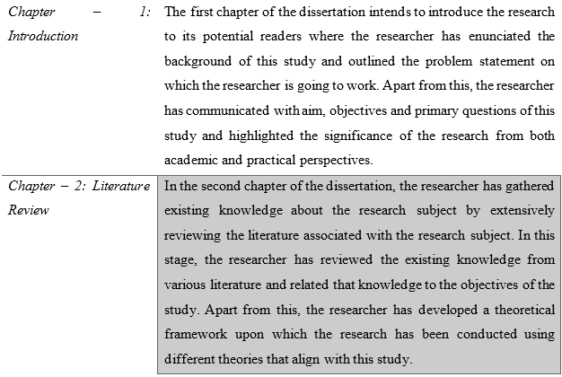
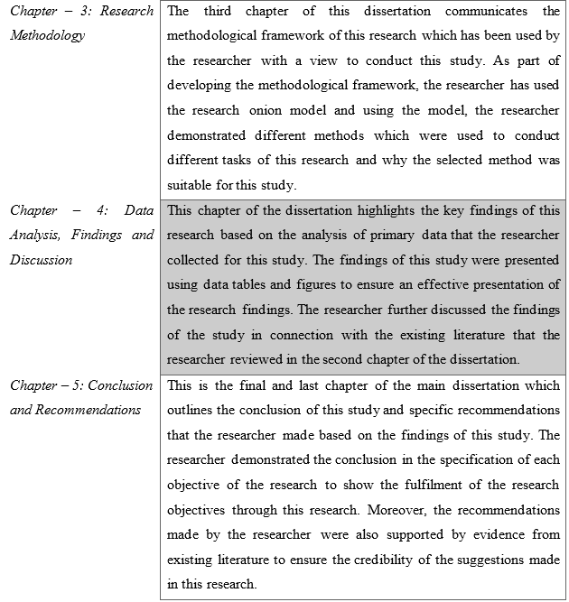

Chapter – 2: Literature Review

2.1 Introduction
The literature review chapter introduces marketing's fundamental notions of customer-brand connections. Keller's CBBE and Loyalty Ladder Models are thoroughly discussed in this chapter. Keller's approach details the journey from mistrust to client advocacy, focusing on the complex interplay between perceived brand performance, consumer expectations, and disconfirmation. The Loyalty Ladder Model shows how customer satisfaction and brand reactions affect brand loyalty from prospects to client advocates. The literature provides a thorough study of how initial-stage brand views, as defined in Keller's model, affect the succeeding stages of the Loyalty Ladder. This preface emphasises the need to fully understand these models and their interdependencies, laying the groundwork for the chapter's detailed investigation. The accompanying discourse integrates these models to provide a comprehensive structure that accounts for shifting customer-brand interactions. This study seeks to expand theory and practice to understand better how to improve the customer journey to build brand loyalty.

2.2 Introduction to Customer Satisfaction, Brand Image, and Brand Loyalty
Customer satisfaction, brand image, and loyalty are closely studied in marketing literature. Huang and Dev's 2020 research found that this triangle is essential to understanding customer behaviour and affecting business strategy. In addition to their conceptualisations, definitions, and theoretical frameworks that underpin their study, this section will summarise each principle.

2.2.1 Customer Satisfaction
Dhiman and Kumar (2023) define customer satisfaction as a customer's happiness and fulfilment after using a product or service. According to Xie and Sun (2021), customer happiness is flexible and affected by many factors. Effectiveness, pre-purchase expectations, and consumer feedback all matter. The disconfirmation paradigm posits that satisfaction occurs when performance matches or exceeds expectations. Xie and Sun (2021) say this creates happiness.

2.2.2 Brand Image
Sharma, Patro, and Chaudhry (2022) define the brand image as the consumer's pre-existing associations and views of the brand, shaped by its marketing, physical presence, and experiential features. Plumeyer et al. (2019) describe a brand image as brand associations, personality, and user imagery, highlighting its complexity. This highlights brand image complexity. Consumer impressions are influenced by personal experiences, word-of-mouth, and advertising (Keller and Brexendorf, 2022). Cognitive and emotive mechanisms combine to shape brand image.

2.2.3 Brand Loyalty
Malek and Dave (2023) define brand loyalty as an innate attachment and preference for a brand, not only repeated purchases. Diallo, Moulins, and Roux (2021) examined brand loyalty's affective, conative, and cognitive characteristics. The researchers stressed emotional attachment, cognitive commitment, and behavioural consistency. Jacoby and Kyner's behavioural loyalty model states that brand loyalty is based on habitual purchasing or inertia (Dawes, 2022). This approach claims that inertia drives brand loyalty through repeat purchases.

2.3 Customer Satisfaction in the Context of Consumer Electronics
Li, Zeng, and Stevels (2015) state that customer satisfaction is crucial in the consumer electronics business, which is marked by fierce market competition and rapid technological innovation. Uzir et al. (2021) and Reina et al. (2020) have shown the importance of customer satisfaction in consumer electronics. As products become more complicated and feature-rich, Reina et al. (2020) suggest that companies must satisfy and exceed customer expectations to succeed. According to Uzir et al. (2021), satisfied electronics customers are more likely to show brand loyalty, which can help build a sustainable customer base.
Internationally renowned for its creativity and design, Apple Inc. derives much of its success from customer satisfaction. Studies like Kim, Lee, and Lee (2020) show that Apple's outstanding user experience boosts customer pleasure and brand loyalty. The association between satisfied customers and loyal brand followers is especially strong in the tech business. Sun, Foscht, and Eisingerich (2021) found that satisfied customers are more likely to spread favourable word-of-mouth and influence others to adopt the brand. Nugroho and Harjanto (2020) state that consumer electronics market share must be maintained by building a loyal client base. The study also shows that product quality and efficacy of technology-dependent industries affect consumer happiness. Thus, good interactions with modern items like laptops and telephones boost happiness and make it easier to attach emotionally to the brand.
Gil-Gomez et al. (2020) emphasise the importance of customer satisfaction in business performance by providing a great user experience. Haleem et al. (2022) found that simpler appearance, user-friendly interfaces, and hardware-software integration boost customer satisfaction. Mostafa and Kasamani (2021) stressed the importance of positive Apple product experiences for brand loyalty and consumer satisfaction. Understanding the complex relationship between customer satisfaction and brand loyalty in the consumer electronics business, especially Apple's unique circumstances, is crucial.

2.4 Brand Image in Consumer Electronics
Mao et al. (2020) found that many elements influence the brand image. In the consumer electronics business, novel product design significantly impacts brand reputation. Shahid et al. (2022) found that unique and appealing designs boost a company's reputation. This is especially important for Apple Inc., which is known for its stunning and innovative product designs like the iPhone and MacBook. According to Moorman and 2023, Apple's minimalism and sophisticated design style have helped build its positive and distinct brand image. According to Karampournioti and Wiedmann (2022), the perception of a brand can be improved when customers have a pleasant experience that is highlighted by user-friendly interfaces and the seamless incorporation of features. According to Nooney (2023), Apple's ability to integrate its hardware and software as well as its focus on providing a user-centric design significantly contributes to the company's strong brand image. According to Keller (1993), the effectiveness of a company's marketing and brand communication tactics has a considerable bearing on the impact that a brand's image has. According to Belk (2013), Apple's marketing methods, which are well-known for their transparency and emphasis on the merits of the goods, contribute to the company's positive reputation in the industry. For instance, Apple's "Think Different" campaign worked to bolster the company's reputation as a bold and forward-thinking brand. This contributed to Apple's success in the market.
According to Keller and Brexendorf (2019), cultivating a positive brand image leads to the perception of improved product quality as well as increased dependability. Akoglu and Ozbek (2022) found that positive quality evaluations affect consumer preferences and brand loyalty. According to Sohaib, Mlynarski, and Wu (2022), Apple's devoted customers are drawn to its high-quality, reliable brand. Based on research by Coelho, Bairrada, and de Matos Coelho (2020), brand images are crucial for developing emotional relationships with clients. Besides its functionality, the brand has these attributes. In Fournier and Alvarez's (2019) study on consumer-brand connections, customers use a brand's products and identify with its values. The research also shows that this emotional attachment creates brand loyalty by making customers happy and brand champions. Mao et al. (2020) highlighted, once again, the significance of brand image in terms of its role in the formation of consumer identity and self-concept. Customers are more likely to demonstrate brand loyalty when the brand integrates into their personal expression (Sanjaya, Asdar and Munir, 2020). Customers who identify with the attributes above—sophistication, originality, and a contemporary way of life—and whose brand image corresponds with these perceptions are more likely to purchase the brand. The authors contend that Apple products are more than just instruments; instead, they function as representations of a particular personality and a particular way of life.
According to Essamri, McKechnie and Winklhofer (2019), developing a firm's brand image is an essential component of the organisation's success. Dam and Dam (2021) once more argue that a unique and positive brand image has resulted from a company's attention to imaginative design, user-centric experiences, and consistent brand messaging. In order to maintain its success in the intensely competitive consumer electronics sector, Apple must get insight into how this image influences consumers' behaviours and perceptions. In the case of Apple Inc., gaining an all-encompassing knowledge of client behaviour can be accomplished by combining research on customer happiness with research on the brand's image.

2.5 Brand Loyalty in Consumer Electronics
According to Azizan and Yusr (2019), brand loyalty in the consumer electronics market is affected by several factors that influence consumer preferences and behaviours. Perceptions of a company's product quality and performance determine brand loyalty, according to Lee (2023). As per the findings, reliable and effective products are able to boost consumer loyalty. Sanjaya, Asdar and Munir (2020) found that Apple's capacity for creating creative, high-quality products in the fast-paced technology industry, where consumers want the latest features, affects the level of consumer brand loyalty. They also claim that this ability keeps Apple customers loyal. Zarei, Feiz, and Moradi (2020) say that user-centric design and usability are key to brand loyalty in consumer electronics. Goodwill is built with brands that prioritise customer satisfaction. According to Sanjaya, Asdar, and Munir (2020), a brand may keep user loyalty by delivering intuitive interfaces, elegant designs, and seamless hardware and software integration to improve the user experience.
Huang et al. (2020) state that building customer loyalty involves extensive brand image management. The study found that buyers are more loyal to brands with unique identities, positive connotations, and values that match theirs. According to Sohaib, Mlynarski, and Wu (2022), Apple's image, which is closely tied to creativity, innovation, and a modern lifestyle, fosters a strong sense of identity and loyalty in consumers. Fournier and Alvarez (2019) found that an integrated ecosystem where products work together to achieve a goal boosts brand loyalty. Because people use several devices, Morgan-Thomas, Dessart, and Veloutsou (2020) say a unified ecosystem in the technology sector boosts consumer loyalty and ease. Siti Fatonah and Nani Irma Susanti (2023) found that Apple's ecosystem, which links devices via iCloud and a common operating system, boosts customer satisfaction and loyalty. Excellent customer service is crucial to brand loyalty, especially in a technologically complicated industry. Huang et al. (2021) found that customers are more loyal and confident in organisations with good customer service reputations. Apple's Genius Bar and online support show its dedication to customer care (Bradley, 2022). These strategies enhance Apple's customer experience and brand loyalty. In a fast-changing technological context, Abror et al. (2020) found that a company's dedication to product improvement and innovation drives consumer loyalty. The survey found that customers are more loyal to companies that constantly provide new features. Apple's long-term brand loyalty is due to its frequent product introductions and relentless innovation, according to Sohaib, Mlynarski, and Wu (2022).
To continue making success, it is essential to understand the elements that drive customer loyalty to a brand and to capitalise on those characteristics. A favourable brand image, an integrated ecosystem, excellent customer service, high-quality products that prioritise the requirements and wishes of users, and a dedication to ongoing innovation are all components that contribute to Apple's customer loyalty. These elements are all part of the entire assembly of factors that contribute to Apple's brand loyalty. In the ever-changing consumer electronics sector, it will be essential for Apple to ensure that its business plans are compatible with the aforementioned factors if it wishes to maintain and expand its customer devotion to its brand.

2.6 The satisfaction of Apple consumers with their overall experience, as well as how they feel about the company's products and customer service.
In this section of the literature review, the researcher has focused on the customer satisfaction of Apple Inc., which has been emphasised by Lee, Kim and Lee (2020) as the critical evaluation of the perception, and experience regarding the products/services or after-sales service of the product/service, and overall, the customer experience has been emphasised as a crucial component to understand the behaviour of customers. Concerning the customer satisfaction of Apple Inc., the study by Haleem et al. (2022) outlined that the leadership of Apple in the consumer electronics industry bear evidence of Apple’s parallel delivery of quality products and services to its customers. Again, drawing from the observation of Haleem et al. (2022) and aligning with the concept of Lee, Kim and Lee (2020), it can be said that Apple's excellent product and service delivery contributes significantly to achieving extended customer satisfaction.
Again, a strong positive correlation between customer satisfaction and loyalty of those customers to a brand in the consumer technology industry has been found by Sun, Foscht, and Eisingerich (2021). Moreover, it has been found in the study of Nugroho and Harjanto (2020) that enhanced customer satisfaction, and brand loyalty facilitates the connection between the customers and the brand and hence contribute to the overall lifecycle of the customers with the brand. Again, in connection to the factors that contribute to the satisfaction of Apple customers, Sanjaya, Asdar and Munir (2020) have provided that various factors attributes to the contentedness of Apple customers including product quality, the efficacy of its products, efficient hardware and software integration and user-friendly interfaces of its products and services. Therefore, based on the evidence that Apple is currently leading the consumer electronics market (Haleem et al., 2022) and the sales of the company’s products are increasing eventually (Statista, 2023), it can be said that the customers of Apple are satisfied with the products or services of the company.

2.7 The brand perception of Apple and essential characteristics and associations that affect how customers view the company.
As long as the brand image of an organisation is concerned, it has been defined by Sharma, Patro, and Chaudhry (2022) as the combination of existing feelings and impressions of the customers concerning the brand. The preexisting impression of customers towards a brand was further highlighted by studies such as Coelho, Bairrada, and de Matos Coelho (2020) that impressions of a customer towards a brand may exist even before someone is an existing customer of a brand. The perception of existing customers towards the brand and other factors such as product price, reviews or opinions from others, engagement of the brand to its customers, after-sales services, etc., can influence the perception of those who still need to be a customer of the brand. For example, Apple is perceived as a brand whose products fall in the high-price category compared to other brands. Again, as was highlighted by various studies like Moorman (2023); Nooney (2023); and Shahid et al. (2022) the satisfaction and loyalty of customers to Apple products is high, indicating that it will have a positive impression on those who are not existing customers of Apple.
As per the observation of Shahid et al. (2022), the appeal of products and services of a brand, especially brands with high-price category products and services, relies on the uniqueness of the product that creates unique value for money of the product. Concerning the popularity of consumer electronics products, Koetsier's (2023) report provided that several Apple iPhone models were at the top of the list of most popular smartphones globally. Again, the study of Plumeyer et al. (2019) highlighted that brand associations, personality, identity, and engagement significantly affect customers' perception of the brand. In connection to Apple, Fournier and Alvarez (2019) provided that Apple has a solid and unique identity in the market due to its unique hardware and software integration, unique product quality and efficacy, extended after-sale services, etc. Based on the evidence of the high popularity of Apple products and the engagement and loyalty of its customers towards the brand, it can be said that Apple has a strong brand image in the market, which aligns with the findings of literature such as Mostafa and Kasamani (2021); Sohaib, Mlynarski, and Wu (2022).

2.8 To analyse the impact of customer satisfaction and brand image on the brand loyalty of Apple customers.
As of the points made in the previous sections, it has been established that high satisfaction exists among Apple's customers, and the company has a strong brand image in the specific industry in which it is operating. As long as the impact of customer satisfaction and brand image on the loyalty of customers of a company is concerned, several studies such as Li, Zeng, and Stevels (2015); Nugroho and Harjanto (2020); Huang et al. (2021) has found that customer satisfaction and brand image is positively correlated with customer loyalty. With regard to discussing the components of brand loyalty, Abror et al. (2020) and Dhiman and Kumar (2023) pointed out several factors that contribute to increasing the loyalty of customers towards a brand including quality products and services, better communication and engagement with customers, providing the desired value to the customers degree of responsibility of the brand towards various stakeholders etc. Aligning these factors with the factors of customer satisfaction, as discussed earlier, various common factors contribute to enhancing both customer satisfaction and customer loyalty which also goes for brand image.
Now concerning the measurement metrics of customer loyalty towards a brand, the study of Diallo, Moulins and Roux (2021) pointed out several matrices such as sales and revenue of the company, the customer life cycle of the brand, customer retention and repetitive customers etc. Based on the previous evidence provided by Koetsier (2023) and Statista (2023), it is evident that Apple is leading the consumer electronics market, and the number of sales and revenue of the company is increasing, hence the number of Apple customers as well. Factors like increased revenue and customer and popularity of products in a specific market segment indicate a higher possibility of increased customer loyalty to the brand. Drawing from the literature of Fournier and Alvarez (2019), Keller and Brexendorf (2019), and Mao et al. (2020). which provides that factors contributing to customer satisfaction and brand loyalty are almost similar to factors affecting customer loyalty, it can be said that increased customer satisfaction and brand image has lead Apple to have increased customer loyalty which aligns with the findings of Li, Zeng, and Stevels (2015); Nugroho and Harjanto (2020); Huang et al. (2021) demonstrating a positive correlation between customer satisfaction and brand image with customer loyalty.

2.6 Literature Gap
The literature still needs a significant examination of the reciprocal and dynamic relationships between Keller's CBBE Model and the Loyalty Ladder Model, which are integrated into the combined theoretical framework to offer a comprehensive understanding of the customer journey from brand awareness to advocacy. Noting the nuanced interactions that occur as customers progress through various stages, the existing literature frequently considers these models as independent constructs. The existing body of literature needs to be revised to examine the comprehensive impact that customer expectations and disconfirmation have on the various tiers of the Loyalty Ladder, as delineated in Keller's CBBE Model. Further investigation is warranted to explore how succeeding stages—including customer satisfaction, repeat purchases, and brand advocates—are influenced by initial brand perceptions, which are formed during the suspect and prospect stages.
By conducting an in-depth analysis of the interaction between Keller's CBBE Model and the Loyalty Ladder Model, the proposed research intends to fill this void in the literature. The research will contribute to the existing body of knowledge in the following ways. The research will offer a more comprehensive framework that mirrors the ever-changing nature of customer-brand relationships by empirically examining the connections between disconfirmation, customer expectations, and subsequent phases in the Loyalty Ladder. The results of this study will provide practical implications for marketers and brand administrators. Gaining insight into the manner in which loyal customers perceive a brand during its initial phases can provide valuable knowledge for making strategic decisions and facilitate the creation of branding and marketing initiatives that are more successful. The study aims to provide insights into pivotal moments throughout the customer journey where customers' loyalty outcomes are notably influenced by brand perceptions. Gaining this knowledge can provide businesses with guidance on how to optimise these touchpoints to strengthen brand loyalty and elevate the overall consumer experience. The research enhances the theoretical advancement of Keller's CBBE Model and the Loyalty Ladder Model through the empirical validation and expansion of the proposed integrated framework. To address the current shortage of scholarly work that has been carried out, the primary objective is to offer a more all-encompassing perspective on the connections that exist between consumers and brands. Additionally, it enhances the understanding of marketing and brand management professionals and academics.

2.7 Theoretical Framework

2.7.1 Expectancy-Disconfirmation Theory
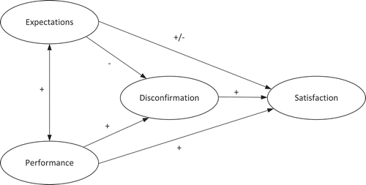
Figure 1: Expectancy-Disconfirmation Theory
Source: (Grimmelikhuijsen and Porumbescu, 2017)
Hwang et al. (2021) state that Oliver was the one who first presented the Expectancy-Disconfirmation theory in 1980, which demonstrates that customer satisfaction and brand loyalty are inextricably linked. Consumers are content when the performance of a product or service meets or exceeds their initial expectations. According to Liu et al. (2020), brand loyalty is influenced by the extent to which a consumer's actual brand experiences differ from their initial expectations. Grimmelikhuijsen and Porumbescu (2017) suggest that elevating customer expectations on a recurring basis results in heightened levels of customer loyalty and satisfaction.

2.7.2 Keller's Customer-Based Brand Equity (CBBE) Model
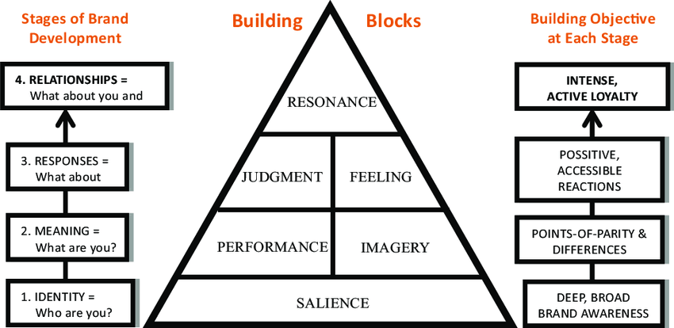
Figure 2: Keller's Customer-Based Brand Equity (CBBE) Model
Source: (Tsui-Hsu Tsai, Jing Lin and Y. Li, 2014)
Keller's CBBE model offers a comprehensive perspective on the satisfaction of consumers, their loyalty to brands, and their perceptions of those brands. There are four stages of brand development under this model, including brand identity, brand meaning, brand response and brand relationship (Tasci, 2021). The brand identity stage involves the construction of a distinct and captivating brand identity comprising symbolic, linguistic, and visual components (Keller, 2016). Apple has a distinctive brand identity characterised by its minimalist design, sleek products, and the iconic Apple logo (Apple, 2022). This identity is immediately recognisable, contributing to brand recall and awareness. The perceptions and associations of consumers with a brand are influenced by its meaning (Baalbaki and Guzmán, 2016). Beyond mere functionality, it underscores the affective and symbolic values of the brand. This phase endeavours to engrain the brand with purpose and significance for the intended demographic. Apple goes beyond product features; it embodies a lifestyle. The meaning associated with Apple products includes innovation, creativity, and a seamless integration of technology into everyday life (Mao et al., 2022). Customers perceive Apple as a symbol of status and sophistication. The examination of consumer reactions constitutes brand response (Tasci, 2021). They assess the credibility, quality, and relevance of the brand. Additionally, consumer sentiments and brand perceptions are assessed. Consumer responses to Apple are often emotional. The anticipation and excitement surrounding product launches, such as the iPhone or MacBook, demonstrate users' strong emotional connection with the brand. Positive reviews and testimonials further reinforce brand response (Hokky and Bernarto, 2021). The establishment of a robust brand-consumer connection constitutes the brand relationship stage (Keller, 2016). It inspires confidence, loyalty, and comprehension. The company is currently perceived by consumers as a lifestyle companion, as opposed to merely a provider of goods or services. Apple has successfully created a resonance with its customers. The ecosystem it offers, with devices seamlessly working together through iCloud and a unified operating system, fosters a sense of belonging and loyalty (Mao et al., 2022).
According to this model, a consumer's knowledge of the brand, which includes the consumer's awareness of the brand as well as the consumer's perception of the brand, influences the consumer's responses and behaviours. According to Huang et al. (2020), having positive experiences has a beneficial impact on brand image, which in turn strengthens brand loyalty. Oliver (1999) discovered components of brand loyalty that correspond to the emotional and cognitive dimensions of the CBBE model. These features were categorised as affective, conative, and cognitive.

2.6.2.1 Advantages of Keller's CBBE Model in Connection to this Research:
Keller's CBBE Model is detailed and rigorous, helping one understand customer-brand interactions and perceptions (Avaremy, 2013). This makes the model ideal for studying complex customer-brand connections. The model concludes with brand partnerships (Keller, 2016). The phases can be systematically analysed using this approach. The study's goal is to examine how early brand perceptions affect brand loyalty, hence this serial methodology is used. Keller's customer-centric model prioritises consumer feedback (Tasci, 2021). This supports the study's focus on brand loyalty, customer satisfaction, and brand image in consumer electronics.

2.6.2.2 Disadvantages of Keller's CBBE Model in Connection to this Research:
The approach may oversimplify consumer behaviour and brand-consumer interactions in the fast-changing consumer electronics market by ignoring nuanced factors that affect customer loyalty (Shafi and Madhavaiah, 2014). The framework includes several phases; however, it may not fully account for their interdependencies, such as how early brand perceptions affect later phases (Tasci, 2021). A more dynamic technique may alleviate this issue. Keller's approach may be too static to account for consumer-brand dynamics, according to Avaremy (2013). This constraint may prevent studying brand loyalty dynamics.

2.7.3 Loyalty Frameworks
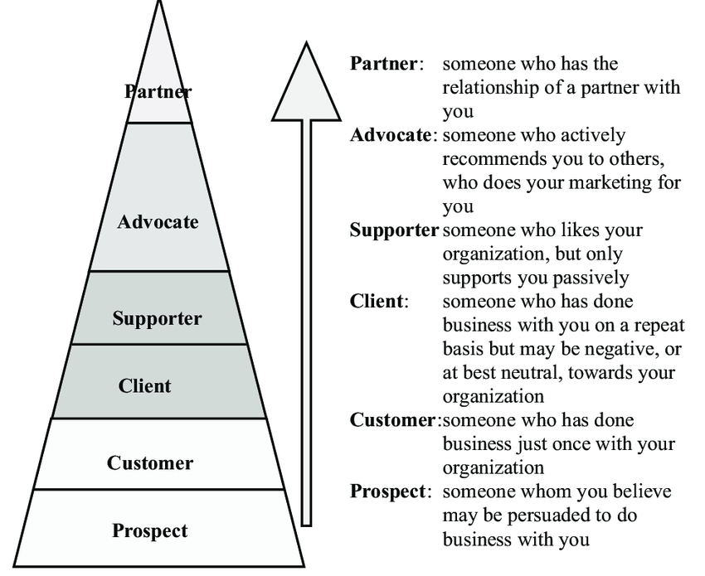
Figure 3: Loyalty Ladder Model
Source: (Kachniewska, 2006)
Dick and Basu's 1994 "loyalty ladder" helps explain the dynamic relationship between brand loyalty, consumer satisfaction, and brand image (Richardson, 2022). This conceptual framework states that customers' brand loyalty progresses from conative loyalty (observable purchasing behaviour) to affective loyalty (pleasant attitudes and preferences) to cognitive loyalty (awareness and knowledge). Positive experiences increase emotional and cognitive attachment, therefore customer pleasure is crucial to this process. Manyanga (2022) states that this is the case. In addition, the behavioural loyalty model developed by Jacoby and Kyner (1973) sheds light on the connection between satisfied customers and their continued patronage of a business (Gonjari, 2020). According to this approach, inertia and habitual conduct are two of the most crucial factors that determine customer loyalty. According to Agrawal and Agrawal (2019), brand loyalty may be increased by regular purchase behaviour, which can be developed as a result of positive experiences and a sense of contentment with the product or service. When developing an all-encompassing theoretical framework, it is therefore necessary to have a solid understanding of the behavioural component.
Apple's marketing and iconic product launches ensure high awareness (Hokky and Bernarto, 2021). The Apple logo and product names are instantly recognisable globally. Customer satisfaction is often high due to Apple's focus on user experience, product quality, and customer service (Mao et al., 2022). Satisfied customers are more likely to move up the loyalty ladder (Richardson, 2022). Preference for Apple products is evident as users actively choose Apple over competitors. Factors like design aesthetics, ecosystem benefits, and positive past experiences could drive this. Customers who consistently choose Apple and recommend its products to others demonstrate a high level of loyalty. This loyalty extends to multiple product lines. Apple enthusiasts often become brand advocates, promoting Apple products in their social circles. This advocacy results from the positive experiences, satisfaction, and loyalty they have developed (Manyanga, 2022).
Focusing on customer satisfaction can further elevate Apple's position in the preference and loyalty stages. Encouraging customer advocacy through loyalty programs or user-generated content can strengthen Apple's market position. The rapidly evolving tech industry poses challenges in maintaining high satisfaction and loyalty levels (Mao et al., 2022). External factors, such as economic shifts or technological disruptions, can impact brand perceptions and loyalty. In summary, both Keller's CBBE Model and the Loyalty Ladder Model provide valuable frameworks for understanding Apple's brand dynamics. Integrating these models into your research will likely offer a nuanced view of the intricate relationships between customer satisfaction, brand image, and brand loyalty for Apple Inc.

2.7.4 Synthesizing the Theoretical Framework
The theories discussed earlier have been incorporated into the framework of the present study's theoretical investigation in order to shed light on the relationships between customer happiness, brand loyalty, and brand image in relation to Apple Inc.
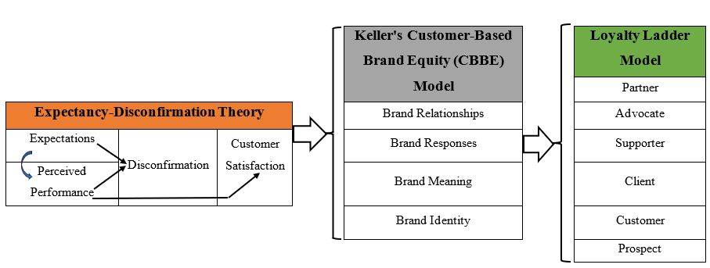
Figure 4: Theoretical Framework of this Research
Source: (Author)
The basic assumptions of the theories incorporated in the theoretical framework of this study are summarised below.
Expectancy-Disconfirmation Framework (Yüksel, A. and Yüksel, 2001):
- The use of positive disconfirmation has a beneficial effect on the level of customer satisfaction.
- The practice of regularly implementing positive disconfirmation helps to support the development of customer loyalty to a business.
Keller's CBBE Model (Keller, 2016):
- The expansion of a brand's awareness and reputation can be attributed to the expansion of customer satisfaction.
- A positive brand image encourages customer loyalty to the brand by positively affecting the way customers respond to the brand.
Loyalty Ladder Model (Mascarenhas, Kesavan and Bernacchi, 2006):
- The progression from the level of awareness to the stage of allegiance is depicted by the loyalty hierarchy as an ascending trend.
- Customers go further up the loyalty hierarchy as their level of satisfaction and continued patronage increases.
The Loyalty Ladder Model and Keller's CBBE Model share similarities and distinctions. Both models acknowledge the sequential development of the customer-brand relationship. The Loyalty Ladder Model progresses from awareness to advocacy, whereas Keller's CBBE Model encompasses brand identity to resonance (Yu, Zhao, and Wang, 2008). Both models emphasise the influence of consumer perceptions on brand loyalty. The focus of Keller's model is on fostering favourable brand associations, while the Loyalty Ladder illustrates the progression of consumer sentiments from satisfaction to advocacy (Wang, Wei, and Yu, 2008). There are both similarities and distinctions between these models. The CBBE Model proposed by Keller encompasses four key elements: brand identity, meaning, reaction, and resonance.
In contrast, the Loyalty Ladder Model is specifically concerned with the phases of loyalty (Yu, Zhao, and Wang, 2008). Resonance and brand response are investigated in Keller's model (Tasci, 2021). Richardson (2022) highlights the significance of observable loyalty stages without brand connotations.
This model provides an all-encompassing perspective on the ways in which customer happiness and brand image interact to form brand loyalty. It accomplishes this by combining the two concepts, "customer satisfaction" and "brand image." The researcher utilised this theoretical framework to gain an understanding of the connection that exists between customer happiness (according to the definition provided by the Expectancy-Disconfirmation theory) and customers' perceptions of brands (according to the guidelines provided by Keller's Model). In addition, the research looked into the relationship between customer loyalty (as determined by the Loyalty Ladder Model) and this perception of, and level of, discontent.

2.8 Chapter Summary
The literature review chapter extensively examines the existing theoretical foundations in the marketing domain, focusing specifically on Keller's Customer-Based Brand Equity (CBBE) Model and the Loyalty Ladder Model. Detailed analyses of both models are provided in this chapter. The suspect stage, the Expectancy-Disconfirmation Theory, and the influence of perceived performance on brand perceptions are examples of these fundamental elements. An investigation into the Loyalty Ladder Model is being conducted concurrently. The stages comprising this model are as follows: prospect, client satisfaction, brand reactions, and client advocacy. The proposed research aims to address this knowledge gap by examining the dynamic connections that exist between disconfirming experiences, consumer expectations, and the various stages of brand loyalty. This chapter emphasises the criticality of embracing a comprehensive viewpoint regarding the consumer journey. It provides marketers with actionable insights and strategic knowledge to enhance critical touchpoints. The chapter also includes a comprehensive outline of the consumer voyage.
Furthermore, the study makes a significant theoretical contribution to the advancement of both models by establishing a comprehensive and intricate framework that illuminates the inherent complexities of the relationships between brands and consumers. The chapter devoted to the literature review provides a comprehensive foundation for the following chapter, which focuses on the empirical investigation. This is achieved through the process of situating the research within the established body of knowledge and elucidating the potential scholarly contributions that the research may make.

Chapter – 3: Research Methodology

3.1 Introduction
This chapter gives empirical guidance for exploring Apple Inc.'s complicated customer-brand relationships. The chapter covers research onion model essentials for methodological rigour and ethical integrity. Since it uses positivist research philosophy, the study has a solid epistemological foundation. The deductive research method is used to study consumer loyalty, brand image, and satisfaction. To objectively quantify client perceptions, a monomethod quantitative design is chosen. The chapter's schedule, methodology, and ethical implications stress ethical research practices. This chapter lays the groundwork for a rigorous and principled study of modern customer-brand interactions.
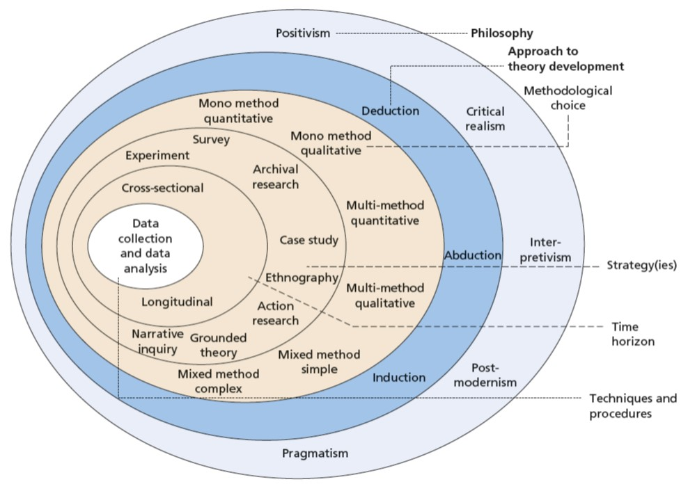
Figure 5: Research Onion Model
Source: (Saunders, Lewis and Thornhill, 2019)

3.2 Research Philosophy
Research philosophy is the base of the research onion model (Saunders, Lewis and Thornhill, 2019). This provides the foundation for the entire research process. Scholars interpret their universe discoveries through this prism. Realism, interpretivism, and positivism determine study design and methods at this stratum (Bell, Bryman and Harley, 2022). Positivism, which holds that reality is objective, emphasises precise observation and quantifiable phenomena (Bougie and Sekaran, 2019). It seeks patterns and regularities using quantitative data and statistical analysis. Interpretivism acknowledges reality's subjectivity, unlike positivism (Hair, 2016). It uses qualitative approaches like interviews and observations to understand how people value their experiences. Although perception is subjective, realism holds that reality exists (Sekaran and Bougie, 2019). To expose the fundamental structures and mechanisms that regulate these phenomena.
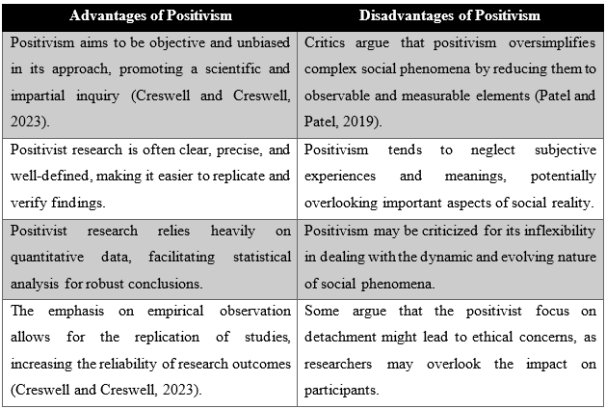
Positivism believes empirical methods may determine objective truths and facts (Saunders, Lewis, Thornhill, 2019). The research questions, which entail quantitative analysis of customer-brand interactions, justify positivism. Positivism is suitable for quantifying consumer loyalty, brand image, and satisfaction elements. The research seeks objective customer-brand patterns and links, in line with positivism's emphasis on objectivity. Positivism helps identify causal linkages, which is needed to understand how brand perceptions affect brand loyalty (Melnikovas, 2018). Replicability is valued in positivist research (Baker, 2016). Standardised data acquisition procedures enable this in the study. This study uses a positivist perspective to experimentally comprehend the complicated relationship between customers and brands, providing a solid foundation for data analysis.

3.3 Research Approach
The research approach is closely entwined with data collecting, processing, and interpretation procedures in the research onion model (Bell, Bryman, and Harley, 2022). This approach, a lynchpin of research philosophy, defines research inquiries, orchestrates method choices, and draws conclusions. This intriguing research approach features two primary research methodologies, each with its choreography. Debouge and Sekaran (2019) use the deductive method to empirically examine hypotheses and theories. Specific observations onto the stage of scientific investigation to confirm or disprove the grand assumptions that claim generalisation.
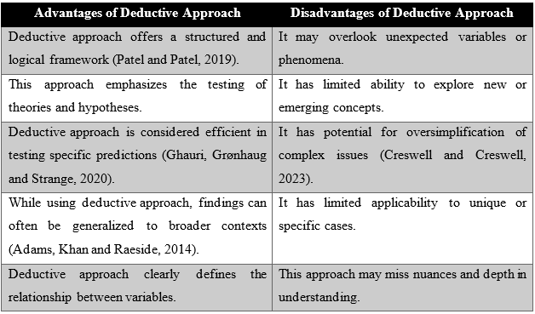
In contrast, the induction process is an interpretative ballet of specific observations and patterns that create new hypotheses or expand categories (Hair, 2016). This technique moves from data to theory, weaving insights. The work weaves pre-existing ideas and models into deductive reasoning and hypothesis testing in the mosaic of knowledge formation. The deductive method excels at systematic, theory-based research, according to Bathin et al. (2019). Each brick in Keller's Customer-Based Brand Equity (CBBE) Model and Loyalty Ladder Model is closely placed. Deductive reasoning, a precise maestro, conducts a formal symphony, testing ideas and shedding light on brand loyalty, customer happiness, and brand image. The study uses deductive reasoning to analyse, validate, and examine customer-brand assumptions in consumer electronics.
Bell, Bryman, and Harley (2022) agree that deductive reasoning clarifies hypotheses for rigorous testing and interpretation. This study's deductive tapestry goes beyond mere scrutiny to methodically analyse the intricate relationship between crucial variables, improving the understanding of consumer electronics' customer-brand nexus. This study illuminates marketing and brand management's unexplored territories using logical reasoning. Through this rigorous journey, the researcher hopes to find insights and shape them into beacons for future explorations of consumer-brand interactions.

3.4 Research Strategy
A detailed research approach outlines data collection and analysis methods (Adams, Khan and Raeside, 2014). It is in the research onion model. It helps resolve research inquiries and achieve research goals. Researchers use action research, grounded theory, experimentation, and questionnaires depending on the study (Coghlan and Shani, 2018). Experiments involve variable manipulation to see effects and establish causal linkages. Surveys collect data from a representative sample to generalise and draw conclusions about a group. A case study examines a specific event, often in real life, to acquire insight into more significant phenomena (Berg and Lune, 2018). Action research uses iterative cycles of preparation, activity, observation, and reflection to transform a context. Grounded theory develops new theories from carefully collected and examined evidence (Kruger and Mitchell, 2019). Surveys were used in this investigation. This consumer electronics customer-brand connection study analyses a heterogeneous population. Surveys provide a representative and thorough sample of public attitudes (Schindler, 2019).
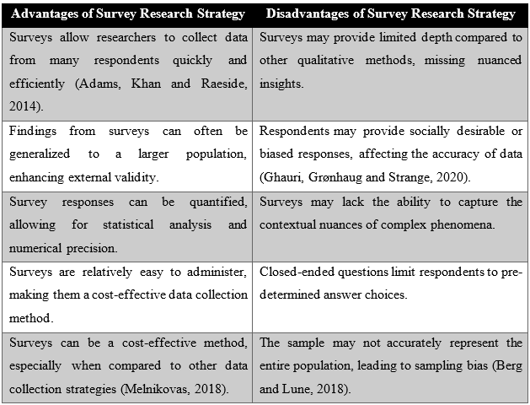
Organising and quantifying data for statistical analysis is simplified. Surveys save time and resources, making them suitable for large-scale research (Gray, 2020). Theories like Keller's CBBE Model and the Loyalty Ladder Model can be tested using surveys (Weathington, Cunningham and Pittenger, 2012). This research shows consumer electronics sector patterns that can be applied broadly. Easterby-Smith et al. (2021) Statistical hypothesis testing requires quantitative survey responses. This survey will objectively assess customer satisfaction, brand image, and brand loyalty. Survey data allows systematic comparisons between variables to reveal consumer perception patterns and correlations (Berg and Lune, 2018). Per the research objectives, the survey research strategy is chosen to examine consumer electronics customer-brand relationships in a succinct, rigorous, and quantitative manner. Surveys give a systematic framework for accurate measurement. The research design matches the strategy, which improves the systematic empirical investigation of identified phenomena.

3.5 Methodological Choice
Methodological choice, a crucial stratum of the research onion model, involves choosing research methodologies and approaches for data collection and analysis (Saunders, Lewis and Thornhill, 2019). After choosing the research philosophy, approach, and design, it strongly influences research execution. Numerous elements affect the study methodology. Research characteristics and categories determine method selection (Coghlan and Shani, 2018). Different methods may be needed to investigate different questions. The researcher's interpretivist, pragmatic, or positivist worldview influences method selection (Schindler, 2019). The study's scope, context, and aims affect the selection of appropriate research methodologies. Financial resources, data availability, and time constraints affect research technique feasibility (Kruger and Mitchell, 2019). Researchers can use multi-method, mixed-method, or mono-method approaches in the research onion model (Grey, 2020). Mono-method research collects and analyses data using one method, usually qualitative or quantitative. Multi-method techniques use numerous quantitative or qualitative research methodologies to understand better the study problem (Weathington, Cunningham and Pittenger, 2012). Schindler (2019) combining qualitative and quantitative methods in a study allows for a more complete analysis of the research topics. This mono-methodological study collects and analyses data using quantitative methodologies.
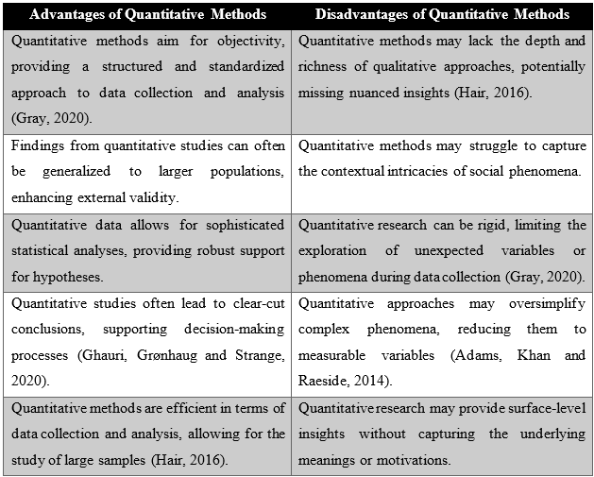
In consumer electronics, the main goal is to study brand image, customer satisfaction, and brand loyalty. Quantitative approaches are suitable for hypothesis testing and numerical analysis, according to Coghlan and Shani (2018). This study builds on Keller's Customer-Based Brand Equity Model and the Loyalty Ladder Model, both quantitative theories. Empirical research and statistical verification are needed. Quantitative methods improve efficiency in the consumer electronics business, where data collected from a large sample size is time-consuming but necessary for generalizability. This study aims to draw statistically significant conclusions about variable relationships. According to Saunders, Lewis, and Thornhill (2019), quantitative approaches offer reliable statistical tools for classification and interpretation. Quantitative data helps identify trends and compare variables for a more systematic and unbiased examination (Bell, Bryman and Harley, 2022). The quantitative (uniform) approach is justified by the need for systematic and statistical study of consumer electronics interactions. The study topics, objectives, and focus on numerical data support the goal of providing marketing and brand management with evidence-based insights.

3.6 Type of Investigation
Primary research involves the collection of original data directly from individuals or groups for a specific research purpose (Kruger and Mitchell, 2019). In the context of this dissertation, primary research is conducted through a survey targeting Apple consumers.
Advantages of Primary Research | Disadvantages of Primary Research
Researchers can customise questions to directly address research objectives, ensuring relevance (Gray, 2020). | Conducting primary research can be resource-intensive in terms of time, money, and personnel (Goddard and Melville, 2020).
Provides specific and targeted insights into customer perceptions, satisfaction, and loyalty related to Apple (Quinlan et al., 2019). | Responses may be influenced by the wording of questions, leading to potential bias (Quinlan et al., 2019).
Researchers have control over the research process, questionnaire design, and data collection methods (Quinlan et al., 2019). | Findings may be specific to the surveyed population and may not be easily generalized to a broader context (Quinlan et al., 2019).
Generates current and firsthand data, reflecting the most recent consumer sentiments (Gray, 2020). | Low response rates can impact the reliability of the data collected (Coghlan and Shani, 2018).
Researchers can design questions to capture nuanced aspects relevant to the research topic. | Primary research, particularly surveys, can take a considerable amount of time to plan, administer, and analyse (Coghlan and Shani, 2018).

Secondary research involves the scrutiny and assessment of data and information that has been collected by others in the past (Gray, 2020). The secondary research conducted for this dissertation is achieved through a complete literature review.

Advantages of Secondary Research | Disadvantages of Secondary Research
Reduces time and cost associated with primary data collection (Goddard and Melville, 2020). | Relies on the quality and accuracy of existing data, which may vary (Quinlan et al., 2019).
Provides quick access to a vast amount of information without the need for data collection. | Existing data might not precisely align with the specific needs of the current research.
Allows researchers to examine historical trends and patterns. | Researchers have limited control over the design and collection methods of existing data (Kruger and Mitchell, 2019).
Provides access to a wide range of sources, including academic journals, books, and industry reports (Coghlan and Shani, 2018). | Some sources may contain outdated information that is not reflective of the current context.
Can inform and support the development of primary research questions. | The original purpose of the data might introduce bias not aligned with the current research objectives (Goddard and Melville, 2020).

This dissertation uses primary and secondary research to examine how customer happiness and brand image affect Apple Inc.'s brand loyalty. A survey of Apple customers gathers primary data, while a literature study expands on existing information and theoretical frameworks.

3.6 Timeframe of the Research
The research onion model incorporates the study's time range (Kruger and Mitchell, 2019). This method includes choosing the best data-gathering time and research timetable. Cross-sectional timeframes collect data quickly to capture a phenomenon. Easterby-Smith et al. (2021), Data must be collected continuously to follow changes and advancements over time.
Cross-sectional methods are effective for reading customer views, brand image, and loyalty in the ever-changing consumer electronics market. According to Scheindler (2019), longitudinal research involves tremendous mental and financial investment. This study can be cross-sectional due to resources. This study advances consumer electronics customer-brand relationships. Kruger and Mitchell (2019) state cross-sectional data processing and interpretation are quick. Current consumer loyalty, brand image, and satisfaction dynamics are studied. For timely goal achievement, a cross-sectional time frame is ideal. Cross-sectional data allow instantaneous analysis by comparing consumer categories and spotting trends (Quinlan et al., 2019). Due to fast change, consumer electronics companies need swift results. Cross-sectional time frames boost findings dispersion, allowing industry professionals to make informed decisions (Gray, 2020). Overall, cross-sectional time frames fit the consumer electronics sector's customer-brand interactions, resources, and study goals. It guarantees realism, efficacy, and research aims.

3.7 Methods and Techniques

3.7.1 Sampling Method and Sample Size
Samples are taken from the population under study. Sampling method and size matter in research (Blumberg, Cooper and Schindler, 2014). These parameters ensure that the results are generalisable and representative of the population. Scholars recruit volunteers using various sample methods depending on the research's goals (Quinlan et al., 2019). Coupler and Schindler (2014) list convenience, snowball, random, stratified, purposive, and other well-known sampling methods. Everyone in the population has an equal chance during random sampling. In stratified sampling, rational samples are randomly selected from each demographic grouping. According to McCurney and White (2019), convenience sampling selects participants based on availability. In snowball sampling, existing participants recruit new ones. Purposive sampling uses specified criteria to pick research subjects that meet study goals (Goddard and Melville, 2020). Researchers used random sampling in this study. A random sample of 50 Apple users participated in this study. Random sampling improves sample representativeness by giving all Apple consumers an equal chance. Making conclusions applicable to all Apple users is crucial. Objectively, results should be generalised to all Apple customers. According to Blumberg, Cooper, and Schindler (2014), random sampling allows for extrapolation beyond sample participants. Random sampling aids statistical analysis. Thus, the study's findings are more reliable and valid. A 50-person sample size balances research resources, data depth, and representativeness. This dimension allows detailed inspection without over-complication. The samples reflect the research's focus on Apple Inc.'s customer-brand partnership. Apple customers are important stakeholders. Given the quantitative investigation, 50 samples are sufficient for statistical analysis. Adams, Khan, and Raeside (2014) imply that larger samples may require more resources but not improve study precision. More significant sample numbers may increase costs and logistical issues (Quinlan et al., 2019). Pragmatically chosen within the inquiry, the sample size is practicable. The study's representation, statistical rigour, efficiency, and feasibility were examined in the selection process, which included a random sample of 50 participants and Apple consumers. These decisions ensure considerable insights into Apple's customer-brand connection by maximising the study's resources.
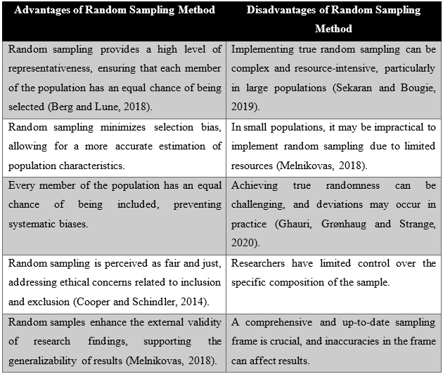

3.7.2 Data Collection Method
Data gathering is a crucial part of the research onion model (Adams, Khan and Raeside, 2014). This phase involves choosing data sources that match the technique and study goals. Questionnaires use structured questions to acquire quantitative or qualitative data from respondents (Berg and Lune, 2018). Extensive dialogues with participants constitute interviews, which yield qualitatively rich insights. The systematic observation and documentation of phenomena, behaviours, or events is referred to as observation. To observe results and verify hypotheses, experiments are controlled environments. (Cooper and Schindler, 2014) Case studies denote an exhaustive examination of a specific instance or case.
A questionnaire was used to collect data for this investigation. The study aims to quantify consumer electronics industry customer loyalty, brand image, and perceptions. Questionnaires with structured questions help collect quantitative data (Mcburney and White, 2019). Surveys efficiently collect data from many participants. Given the scope of the research, a questionnaire is a practical way to gather data from a varied sample. Questionnaires ensure data consistency since responders answer the same questions (Quinlan et al., 2019). Standardisation improves research reliability and validity. The questionnaires' organised nature aids statistical analysis by revealing data patterns, correlations, and trends. Questionnaires eliminate interviewer bias by ensuring that all respondents interpret and answer questions similarly (Ghauri, Grnhaug and Strange, 2020). Sphericalness improves with outcomes. Technology has made online surveys and questionnaires easier to administer and complete for both researchers and respondents (Gray, 2020). A questionnaire's quantitative findings match the research objectives of consumer satisfaction, brand image, and loyalty. The questionnaire is selected as the data collection method due to its efficacy in handling a large sample, standardisation, statistical analysis, objectivity, congruence with research objectives, and fit for the quantitative focus of the study.

3.7.3 Data Analysis Method
Involving the organisation and interpretation of gathered data in order to extract significant insights, data analysis is an essential phase of the research procedure (Cooper and Schindler, 2014). The research inquiries, objectives, and characteristics of the gathered data dictate which data analysis technique is selected. In the realm of data analysis methodologies, two primary categories exist: qualitative and quantitative. The latter encompasses additional subcategories. In contrast to inference-making, descriptive analysis succinctly summarises and characterises the principal attributes of a given dataset (Goddard and Melville, 2020). Inferential analysis utilises a sample to derive conclusions and form generalisations regarding a population. Patterns or associations are identified through the examination of correlational analysis between variables. By determining the effect of changes in one or more independent variables on a dependent variable, regression analysis investigates the relationship between them (Ghauri, Grønhaug and Strange, 2020). Qualitative analysis examines non-numerical data, including texts, in order to discern themes, patterns, and meanings (Blumberg, Cooper and Schindler, 2014). Various categories of quantitative analysis methods have been discussed thus far.
This study's statistical methodology uses descriptive and regression analysis to determine relationships and predict results. Surveys collect numerical data for the research. Statistical analysis is ideal for quantifying this dataset's linkages and patterns. The mean and standard deviation are objective measurements in descriptive statistics (Babin et al., 2019). These statistics summarise essential data clearly and appealingly. This method reveals recurring trends in variable correlations, helping one understand the complex dynamics between prospects and brands. Regression analysis is essential for discovering brand loyalty-affecting variables. This remark supports the study's goal of understanding Apple Inc.'s consumer loyalty factors. Statistical methods strengthen the analysis's resilience to support significant conclusions (Goddard and Melville, 2020). This strategy improves the study's reliability and accuracy. Statistical analysis verifies survey quantitative data and lends credibility to the research (Detterman, 2019). The recommended methodologies reveal customer-brand interaction dynamics by illuminating patterns and linkages and describing data. This methodology enhances the research's validity and helps understand Apple Inc.'s customer loyalty factors. The researcher utilised SPSS to analyse the dataset and generate conclusions from it using data tables and graphs.

3.8 Ethical Considerations of the Research
The researcher carefully considered ethical issues throughout this study to protect study participants. The following ethical concerns must be made throughout the study.
The researcher prioritised participant well-being by developing survey queries to minimise harm. To avoid psychological or emotional risks from participants' engagement, non-intrusive and sensitive questions were created. The researcher informed all participants of the research's goals, methods, and potential consequences, emphasising the need for voluntary participation. Every participant gave informed consent before starting the study, allowing them to withdraw without penalty.
To protect participant data, strict processes were in place. Researchers used anonymisation to keep responses private. Data storage was secured with strict processes. These measures protected participants from unauthorised access or disclosure. The researcher followed strict academic and professional standards to maintain research integrity. Maintaining unbiased analysis and honesty in findings disclosure was crucial. The researcher described the study's goals and maintained transparency and honesty during data collecting and analysis.
The investigator received university ethics approval to begin the research. The research design and technique were thoroughly assessed to ensure conformity with academic institution ethics. The researcher cared for participants, protected data, and kept research integrity while adhering to ethical standards. Ethical permission and informed consent showed the researcher's commitment to a moral study.

3.9 Chapter Summary
The research methodology chapter has meticulously laid the framework for a rigorous and ethical study of brand-customer relationships, concentrating on Apple Inc. By using a deductive research technique, positivist research philosophy, and a mono-method quantitative strategy using surveys, the study may analyse the complex relationship between customer happiness, brand image, and brand loyalty. The study is more rigorous due to statistical data analysis, cross-sectional time frame, and random sampling. Harmlessness, informed consent, data protection, and ethical approval stress the researcher's commitment to ethical research. The research uses this methodological approach to improve consumer electronics customer-brand understanding.

Chapter – 4: Data Analysis, Findings and Discussion

4.1 Introduction
In the chapter devoted to data analysis, findings, and discussion, the experiences, attitudes, and brand loyalty of Apple consumers are examined in depth. This chapter is essential in transforming raw research data into valuable insights. It uses meticulous interpretation and statistical analysis to uncover patterns and correlations within the dataset. The demographic overview provides the necessary context, including participant characteristics. In descriptive statistics, various facets of satisfaction, product evaluation, and brand perception are analysed. Correlation research shows the complex relationships that exist among brand image, customer satisfaction, loyalty, and frequency distributions, which reflect customer sentiment.

4.2 Findings from Data Analysis

4.2.1 Demographic Overview of the Dataset
This chapter section outlines the demographic overview of the participants who participated in the research survey.
Table 2: Duration of Participants as Apple Customers/Source: (Survey Data)
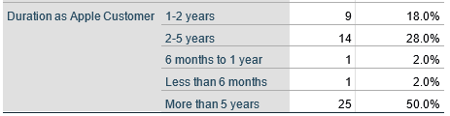

Duration as Apple Customer | The degree of brand loyalty exhibited by a significant proportion of respondents (50.0%) indicates that they have been Apple customers for a duration exceeding five years. Individuals with two to five years of service constitute the second most significant cohort (28.0%). A minority of participants (2.0%) reported having purchased Apple products for less than six months, suggesting that the sample consisted of both novice and experienced consumers.

In its entirety, the demographic summary provides insights into the composition of the sample population. The results indicate that the age distribution of the study's participants is diverse; however, a gender disparity should be considered. Moreover, the temporal span of Apple customer engagement indicates a heterogeneous composition, comprising both loyal, longstanding advocates and individuals who have only recently engaged with the organisation. The attitudes and opinions towards Apple may be influenced by various demographic characteristics, which could potentially impact the research findings.

4.2.2 Descriptive Analysis

4.2.2.1 Satisfaction of Apple Customers
Table 3: Descriptive Analysis Concerning Variables Associated with Satisfaction of Apple Customers/Source: (Survey Data)
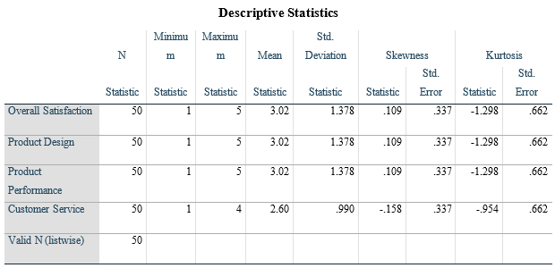
Overall Satisfaction: The participants' overall satisfaction is generally positive, as indicated by the average score of 3.02, which is slightly higher than the midpoint of the 5-point scale. The considerable variability in participant contentment levels is evident from the relatively high standard deviation (1.378). This variation potentially signifies individuals' heterogeneous viewpoints and experiences regarding Apple products and services. The distribution of overall contentment scores exhibits symmetry, as evidenced by the near-zero skewness value (.109). The kurtosis value of 0.337 indicates a regular distribution featuring a moderate apex, which falls within the acceptable range. This shows that the distribution of overall satisfaction scores is relatively normal.
Product Design and Product Performance: The presence of descriptive statistics that correspond to product performance and design indicates that participants consistently evaluate these aspects. The mean and standard deviation for product design and performance (1.378) are comparable to those for overall satisfaction (3.02), indicating a consistent level of satisfaction and variability. These dimensions' similar skewness and kurtosis values indicate that the data is symmetrical and routinely distributed.
Customer Service: When comparing overall satisfaction (2.60) to customer service, the average score for customer service is comparatively lower, indicating a diminished level of satisfaction in this specific domain. When comparing customer service scores to overall satisfaction, it is evident that the former exhibits less variability. This is supported by the minor standard deviation (.990), which indicates a more consistent collection of responses. Negative skewness (-.158) indicates a slightly biased distribution to the left, indicating that more participants reported higher customer service satisfaction levels. The kurtosis value indicates a moderately skewed distribution, which is analogous to gross satisfaction.
Descriptive statistics provide valuable insights into the variability and distribution of satisfaction ratings. The detailed customer service analysis results indicate that the satisfaction level among participants is comparatively low. However, the substantial variability in overall satisfaction demonstrates that there are a variety of perspectives. Further research should be conducted by scholars to identify the factors that influence customer service opinions and develop strategies for improvement based on these findings. In addition, the relatively normal distribution of scores across dimensions enhances the dependability of the data collection.

Please rate your satisfaction with Apple's Product Design.
Table 4: Participants’ Satisfaction with Apple’s Product Design/Source: (Survey Data)
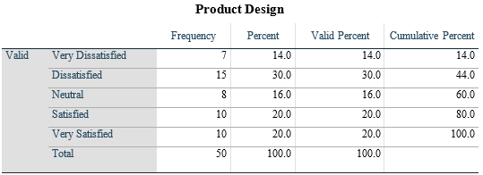
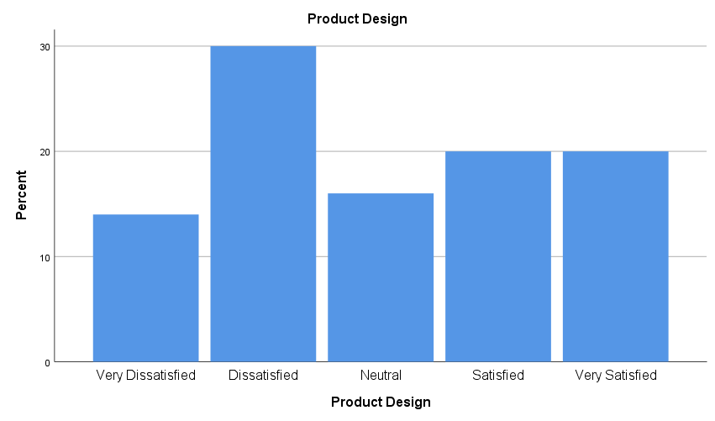
Figure 5: Participants’ Satisfaction with Apple’s Product Design/Source: (Author)
Interpretation: Only 14.0% of interviewees expressed profound dissatisfaction with the product's design. A significant proportion of thirty percent asserted dissatisfaction with the product design. Approximately 16.0% of participants expressed no opinion regarding the product design, indicating a state of neutrality where they neither felt satisfied nor unhappy. 20.0% of the participants indicated satisfaction with the product's design. Twenty percent of the participants expressed a significant level of satisfaction with the product design. The satisfaction about the product design component is evenly spread, with a substantial number of individuals expressing favourable and unfavourable opinions. Significant is the proportion of participants who indicated dissatisfaction (very dissatisfied and unsatisfied), indicating potential areas for improvement in product design. A considerable fraction of survey participants have expressed their dissatisfaction with Apple's product design.
Please rate your satisfaction with Apple's Product Performance.
Table 5: Participants’ Satisfaction with Apple’s Product Performance/Source: (Survey Data)
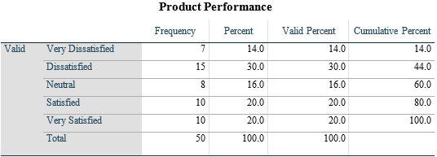
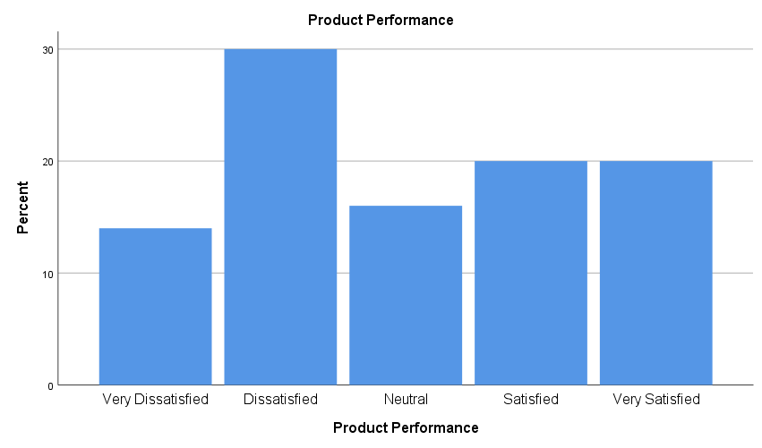
Figure 6: Participants’ Satisfaction with Apple’s Product Performance/Source: (Author)
Interpretation: An analysis of product performance evaluations reveals that respondents provided various responses. Out of the 44.0% who expressed displeasure, 14.0% were highly dissatisfied, while 30% were dissatisfied. Eighty percent of the participants conveyed satisfaction in a positive light (20.0% satisfied, 20.0% satiated). Surprisingly, the responses regarding the product's efficacy are distributed relatively evenly across the satisfaction spectrum. This suggests that while a considerable proportion of consumers express satisfaction with the product's efficacy, many do not. A significant portion of the participant group expressing discontentment indicates a substantial disparity in the performance of the brand's products.
Please rate your satisfaction with Apple's Customer Service.
Table 6: Participants’ Satisfaction with Apple’s Customer Service/Source: (Survey Data)
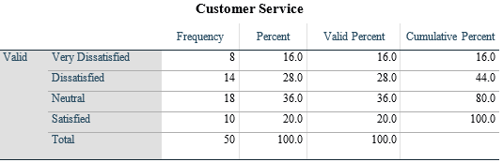
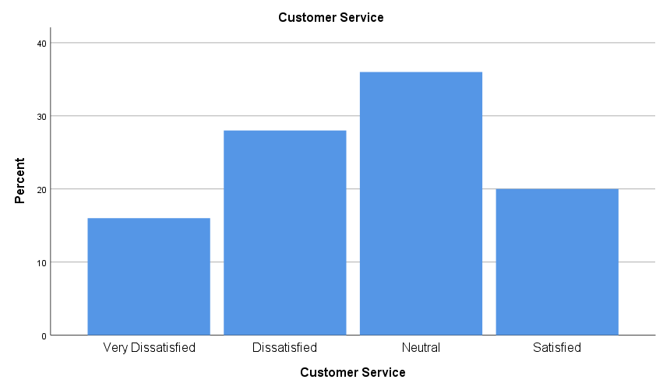
Figure 7: Participants’ Satisfaction with Apple’s Customer Service/Source: (Author)
Interpretation: The examination of customer service evaluations unveils a diverse array of perspectives expressed by the respondents. A total of 44% of the participants voiced discontent, with 16.0% indicating significant dissatisfaction and 28.0% stating dissatisfaction. Nevertheless, twenty percent of respondents indicated satisfaction, and twenty percent said they were extremely satisfied. The most excellent cohort (36.0%) expressed a lack of stance regarding customer service. This distribution suggests that a considerable proportion of customers express dissatisfaction with the customer service; however, a substantial segment also maintains a positive attitude towards it. This implies that Apple has a substantial opportunity to enhance the quality of its customer service to augment consumer satisfaction.

How satisfied are you with your overall experience as an Apple customer?
Table 7: Participants’ Satisfaction Regarding Overall Experience as an Apple Customer/Source: (Survey Data)
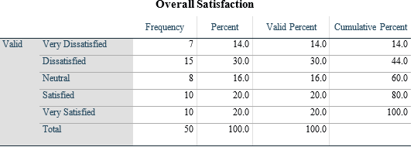
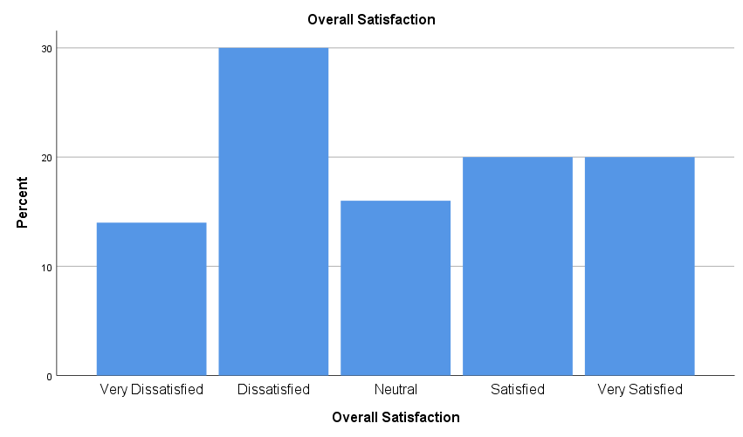
Figure 8: Participants’ Satisfaction Regarding Overall Experience as an Apple Customer/Source: (Author)
Interpretation: An examination of the total satisfaction ratings of the participants reveals a diverse array of reactions. It is worth mentioning that 44.0% of the participants conveyed discontent, with 30.0% indicating dissatisfaction and 14.0% expressing extreme sorrow. Forty percent of respondents positively indicated gratification, with twenty percent saying they were content and twenty percent saying they were extremely satisfied. In addition, 16.0% maintained a neutral stance. The data indicates that clients hold a varied perspective, as a considerable proportion express dissatisfaction and an equally substantial proportion express satisfaction.

4.2.2.2 Brand Image/Customer Perception of Apple
Table 8: Descriptive Analysis Concerning Variables Associated with Brand Image/Customer Perception of Apple/Source: (Survey Data)
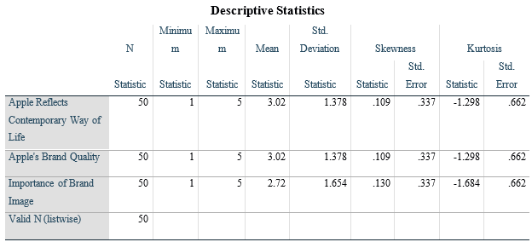
The descriptive statistics regarding brand perceptions of Apple provide thought-provoking insights. "Apple reflects a contemporary way of life," as rated by 3.02 out of 5 participants on average, is the viewpoint expressed. The 1.378 standard deviation demonstrates a moderate degree of variability in the responses. Kurtosis and skewness values suggest a platykurtic distribution characterised by a slightly negative skewness; these parameters are indicative of a distribution that is generally normal. Likewise, the average rating assigned by the participants to "Apple's brand quality" is 3.02 out of 5, accompanied by a standard deviation of 1.378. Spikyness and kurtosis values indicate that the distribution is platykurtic and marginally negatively skewed. In contrast, the topic "Importance of brand image" exhibits a marginally lower mean score of 2.72 out of 5 and a significantly higher standard deviation of 1.654. The distribution may contain outliers or asymmetry, as suggested by the negative skewness and relatively greater kurtosis. This study's findings indicate that while most respondents associate Apple with contemporary living and premium quality, perspectives regarding the brand's significance are more diverse. Further analysis of the qualitative feedback provided by the participants, along with investigation into the factors that influence these viewpoints, could provide valuable insights for brand management strategies.
How would you describe Apple's brand image?
Table 9: Participants’ Opinion Regarding Apple’s Brand Image/Source: (Survey Data)
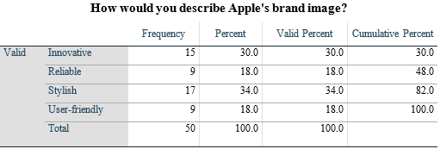
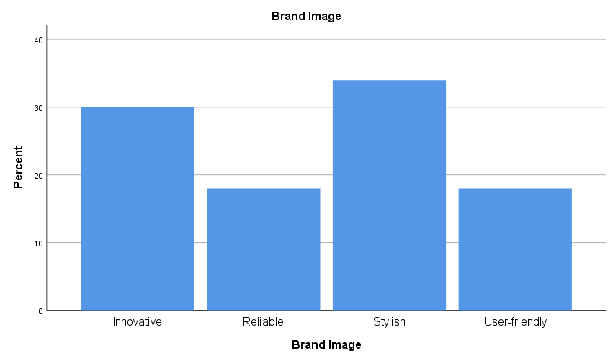
Figure 9: Participants’ Opinion Regarding Apple’s Brand Image/Source: (Author)
Interpretation: The participants' perceptions of Apple's brand image are eclectic. A significant majority of 30% characterises Apple as "Innovative." This indicates that a substantial proportion of the participants perceived Apple as an innovator in emerging technologies. "Stylish" is another component of Apple's brand image, as 34% of the respondents indicated. This emphasises the influence of visual appeal and design aesthetics on brand perception. 18% of the participants characterised Apple as "reliable" due to its consistent performance and dependability. Apple's brand image is ultimately characterised as "user-friendly" by 18% of respondents. This demonstrates that simplicity of use and a positive user experience impact the perception of Apple among specific individuals. The information presented indicates that the brand is associated with innovation, flair, dependability, and usability. Apple has evidently developed an all-encompassing corporate identity that caters to a diverse range of consumer values.
To what extent do you agree with the statement: Apple Reflects Contemporary Way of Life
Table 10: Participants’ Opinion Regarding Whether Apple Reflects Contemporary Way of Life/Source: (Survey Data)
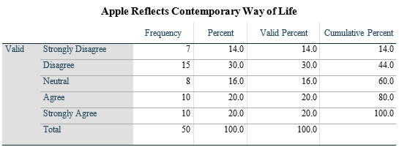
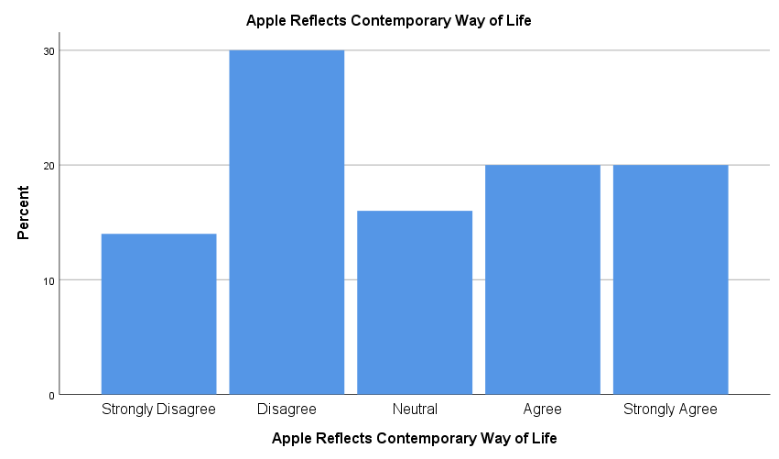
Figure 10: Participants’ Opinion Regarding Whether Apple Reflects Contemporary Way of Life/Source: (Author)
Interpretation: The participants' opinions regarding whether Apple embodies contemporary lifestyles are diverse. A significant proportion of the respondents (30%) express disagreement with this statement, indicating that Apple is not considered emblematic of contemporary lifestyles. 20%, on the other hand, "Strongly Agree" or "Agree" that Apple represents contemporary living. This indicates that numerous respondents consider Apple to be compatible with contemporary lifestyles. The proportion of participants who selected "Neutral" (16%) may suggest a state of ambivalence or an absence of conviction regarding this aspect of the Apple brand. In summary, many respondents expressed dissent regarding the notion that Apple embodies contemporary lifestyle trends, whereas others perceived congruence. This diversity of opinions demonstrates the subjectivity of brand perceptions and how consumers assess the cultural significance of a brand.

To what extent do you agree with the statement: Apple's brand is associated with high quality?
Table 11: Participant’s Opinion Regarding Whether Apple's brand is associated with high quality/Source: (Survey Data)
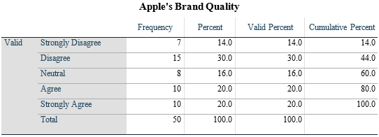
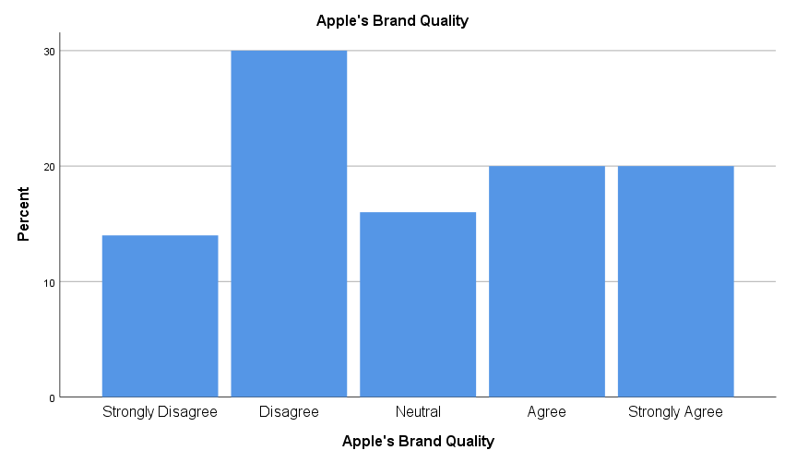
Figure 11: Participant’s Opinion Regarding Whether Apple's brand is associated with high quality/Source: (Author)
Interpretation: Participants rate Apple's brand differently. The most significant percentage "disagrees" that Apple has a positive brand at 30%. A large percentage of respondents are unhappy with the brand's quality. Twenty percent of "Strongly Agree" or "Agree" believe Apple is a good brand. This suggests that many participants value Apple's brand. The "Neutral" 16% may be undecided regarding Apple's brand integrity. Finally, opinions on the Apple brand vary. This variant shows customers' brand quality ratings and impression subjectivity.
How important is Apple's brand image in your purchasing decisions?
Table 12: Influence of Apple’s Brand Image on Participants’ Purchasing Decision/Source: (Survey Data)
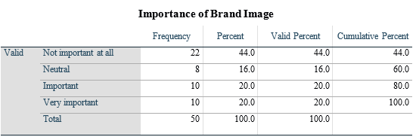
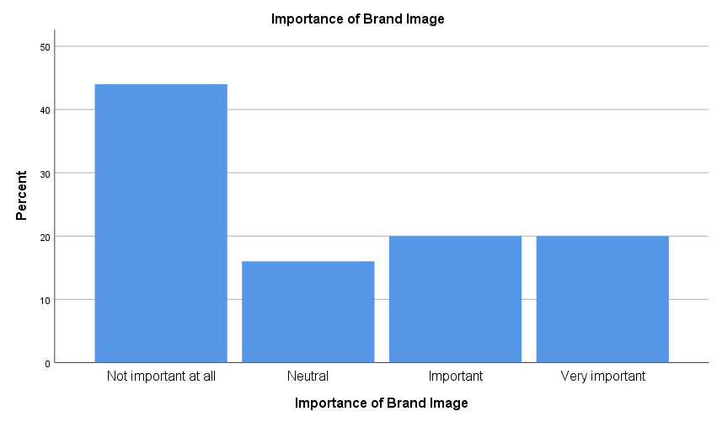
Figure 12: Influence of Apple’s Brand Image on Participants’ Purchasing Decision/Source: (Survey Data)
Interpretation: Participants have different views on Apple's brand. 44% consider brand image "completely unimportant." This suggests many participants ignore Apple's brand image when assessing or drawing judgments. 16% of participants rated Apple's brand "Neutral". Twenty percent think the brand's image is "Important" or "Very important" . This suggests that many people value Apple's brand. The findings show that some highly appreciate Apple's brand image, while others esteem it little. This shows how the brand image is subjective and affects consumer perceptions.

4.2.2.3 Customer Loyalty of Apple
Table 13: Descriptive Analysis for Variables Connected with Customer Loyalty of Apple/Source: (Survey Data)
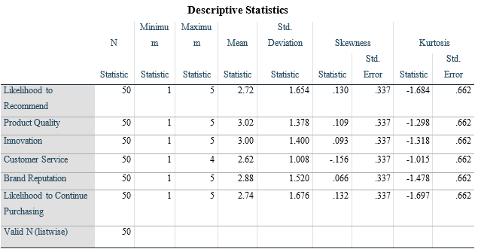
A descriptive examination of aspects of Apple customer loyalty discloses participants' perceptions. The favourable mean score of 2.72 indicates a moderate level of assurance regarding the likelihood of recommending Apple. The slightly right-skewed distribution suggests that a proportion of the respondents take pleasure in endorsing Apple. According to the research, positive recommendations can increase brand loyalty and attract new customers. The average participant rating for product quality is 3.02. The symmetrical distribution suggests that Apple's product quality continues to be acknowledged. This positive sentiment aligns with research on brand loyalty, as it is generally observed that consumer satisfaction and loyalty are enhanced with high-quality products. Innovation is an additional asset of Apple, as evidenced by its mean score of 3.00. The near-normal distribution indicates that participant responses are equitable. This substantiates the research aim that examines the impact of innovation on brand loyalty. Apple's reputation for innovation is crucial in the highly competitive consumer electronics market. A mean customer service rating of 2.62 signifies a satisfactory level of service, albeit not exceptional. The distribution exhibits a minor leftward skew, indicating that some respondents hold a favourable opinion regarding Apple's customer service. Customer service is crucial because it influences consumer satisfaction and brand loyalty.
A brand reputation score of 2.88 on average signifies a favourable perception. A skewness near zero indicates a pattern of equitable responses. The establishment and sustenance of brand loyalty are contingent upon a favourable brand reputation; these discoveries assist in elucidating the phenomenon of Apple customer loyalty. The probability of continuing to purchase Apple products is moderately high, as indicated by the mean score of 2.74. A positive skewness signifies a cluster with a greater likelihood of further purchases. A positive skewness signifies a cluster with a greater likelihood of further purchases. In conclusion, the descriptive analysis lends support to the brand loyalty research concerning Apple. Intent to purchase, product quality, innovation, and brand reputation contribute to increased brand loyalty. The utilisation of skewness values to emphasise participant attitudes enhances the comprehension of the dynamics of Apple customer loyalty.
Please rate the factors that contribute to your loyalty to Apple: Product Quality
Table 14: Product Quality as Factor Contributing to Participants’ Loyalty to Apple/Source: (Survey Data)
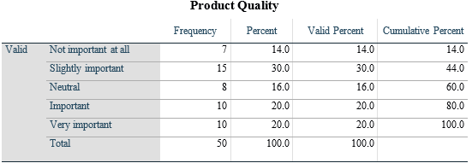
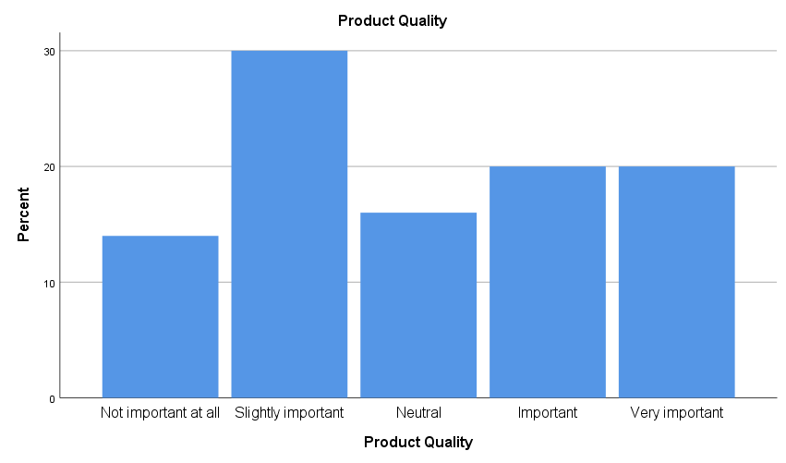
Figure 13: Product Quality as Factor Contributing to Participants’ Loyalty to Apple/Source: (Author)
Interpretation: The participants' perspectives regarding the standard of Apple's products reveal intriguing patterns. 70% of respondents deem product quality to be either marginally, significantly, or highly essential. This implies that they base their evaluations of Apple's products on the excellence of the products. Notably, 20% of respondents place a high value on product quality, emphasising the significance of premium products to customer loyalty and satisfaction with the Apple brand. This conclusion corroborates the marketing literature that stresses the significance of product quality in fostering brand loyalty. A lack of importance is attributed to product quality by 14% of responses. In their decision-making process, this group might place lower importance on product quality than other criteria. Gaining insight into the rationale behind this viewpoint could unveil the preferences and attitudes of customers. The participants' views range from "completely unimportant" to "extremely important," as indicated by the distribution. Apple must accommodate this variation, as a one-size-fits-all approach might prove ineffective. Apple ought to modify its strategy in accordance with consumers' product quality priorities. The results of this study underscore the significance of product quality in shaping consumer perceptions as it relates to brand loyalty. It is probable that Apple's consistent delivery of high-quality products will increase consumer satisfaction, positive word-of-mouth, and brand allegiance.
Please rate the factors that contribute to your loyalty to Apple: Innovation
Table 15: Innovation as Factor Contributing to Participants’ Loyalty to Apple/Source: (Survey Data)
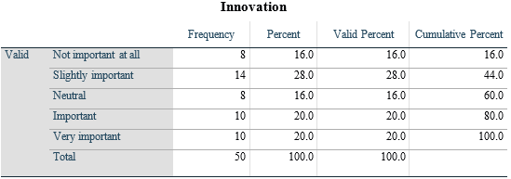
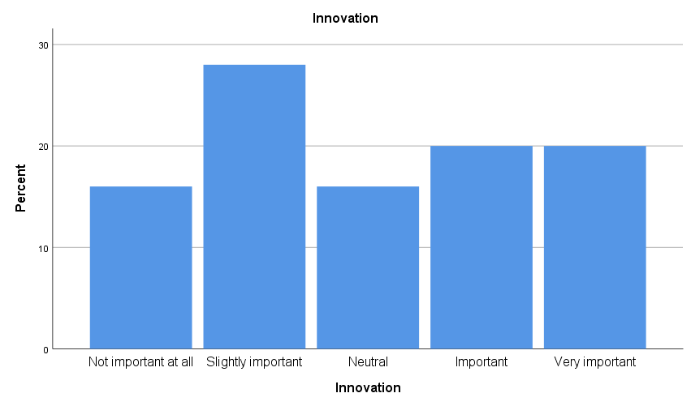
Figure 14: Innovation as Factor Contributing to Participants’ Loyalty to Apple/Source: (Author)
Interpretation: The significance that customers attribute to innovation when assessing Apple's offerings is demonstrated by the participants' assessments. With viewpoints ranging from "completely unimportant" to "extremely important," the sample is comprehensive. Thirty-six percent of respondents perceive innovation to be either insignificant or marginally significant. This demonstrates that for most individuals, decision-making can be impacted by factors other than innovation. Apple can tailor its strategies to accommodate diverse consumer needs through a comprehensive comprehension of the interests and objectives of each segment. Nevertheless, forty percent of respondents consider innovation to be highly or critically essential, indicating that Apple's brand evaluations place a significant emphasis on cutting-edge technology. The historical record of Apple as an innovator underscores the imperative to remain at the forefront of technological advancements in order to satisfy consumer demands. In addition to maintaining its reputation for innovation, Apple must ensure that consumers who place importance on other aspects of the product or brand experience are also content. Apple's success is contingent on the company's ability to convey innovation without alienating those with distinct values. The aforementioned studies underscore the significance of innovation in fostering brand loyalty. Although not consistently given precedence, the division that places a premium on innovation could potentially be critical to Apple's brand reputation and customer loyalty.
Please rate the factors that contribute to your loyalty to Apple: Customer Service
Table 16: Customer Service as Factor Contributing to Participants’ Loyalty to Apple/Source: (Survey Data)
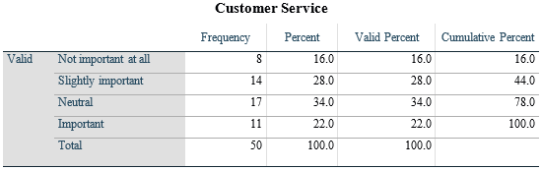
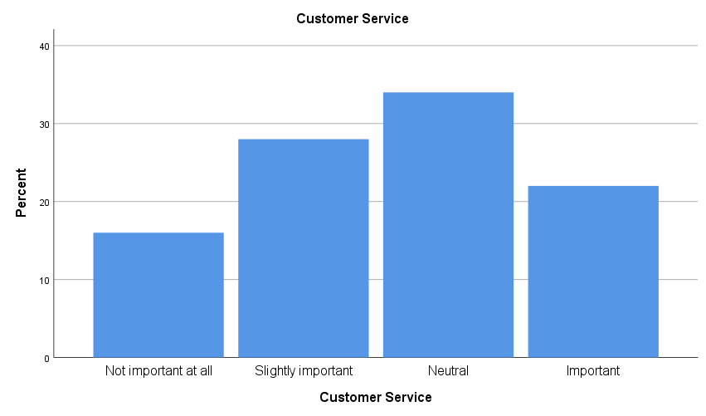
Figure 15: Customer Service as Factor Contributing to Participants’ Loyalty to Apple/Source: (Author)
Interpretation: Consumers' perceptions regarding the significance of customer service when assessing Apple's offerings demonstrate how service quality influences consumer attitudes. Varying in importance from "not at all significant" to "critical," the opinions of the sample are diverse. It is worth mentioning that fifty percent of the respondents perceive customer service to be of little or no importance. This finding indicates that many participants might make decisions relying on factors other than customer service. Apple can tailor its strategies to accommodate diverse consumer needs through a comprehensive comprehension of the interests and objectives of each segment. 56% of respondents consider customer service neutral or significant, suggesting that the quality of service substantially impacts their brand perceptions of Apple. As a result, the significance of providing exceptional customer service to the vast majority of clients is underscored. Apple is faced with the challenge of upholding a positive customer service reputation while accommodating individuals who place varying importance on distinct facets of the product or brand experience. While maintaining other standards, enhancing customer service is vital to Apple's continued success. The results above underscore the significance of customer service in fostering brand loyalty. The customer service-oriented category has the potential to enhance Apple's brand reputation and foster customer loyalty through the dissemination of positive word-of-mouth.
Please rate the factors that contribute to your loyalty to Apple: Brand Reputation
Table 17: Brand Reputation as Factor Contributing to Participants’ Loyalty to Apple/Source: (Survey Data)
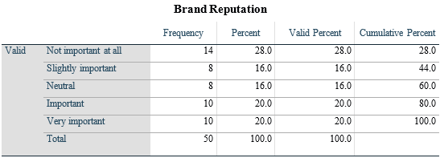
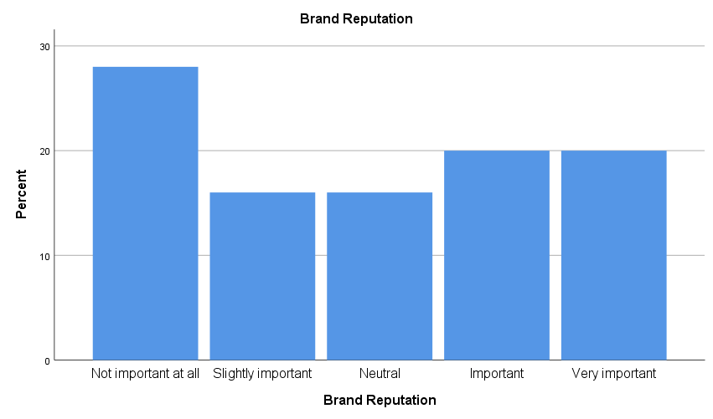
Figure 16: Brand Reputation as Factor Contributing to Participants’ Loyalty to Apple/Source: (Author)
Interpretation: Respondents' perceptions regarding the significance of brand reputation in assessing Apple's products provide insights into attributes associated with consumer loyalty. The perspectives of the sample range from "completely unimportant" to "extremely important." Significantly, 44% of the participants considered brand reputation to be of slight or no importance. This suggests that many respondents might not rely on brand reputation when making purchasing decisions. Apple can tailor its strategies to cater to different consumer segments by discerning their particular interests and priorities.
Conversely, a significant proportion of participants (60%) consider brand reputation to be either apathetic or critical, thereby indicating a substantial impact on how Apple is perceived. Preserving a favourable brand perception is essential for satisfying the demands of a significant portion of the clientele. In emphasising the complexities of brand reputation management, these viewpoints are balanced. Apple is faced with the challenge of maintaining a positive reputation while simultaneously meeting the demands of consumers who place importance on unique product or brand attributes. The success of Apple is contingent upon brand reputation strategies that consider additional factors.

4.2.3 Correlation Analysis
The correlation analysis is performed to understand the relationship between customer satisfaction, brand image, and brand loyalty of Apple customers based on the responses of the survey participants. In this regard, the researcher has included various variables that reflect customer satisfaction (overall satisfaction), brand image (importance of brand image) and brand loyalty (purchase frequency, likelihood to continue purchasing and likelihood to recommend the products of the brand).
Table 18: Correlation Among Different Variables/Source: (Survey Data)
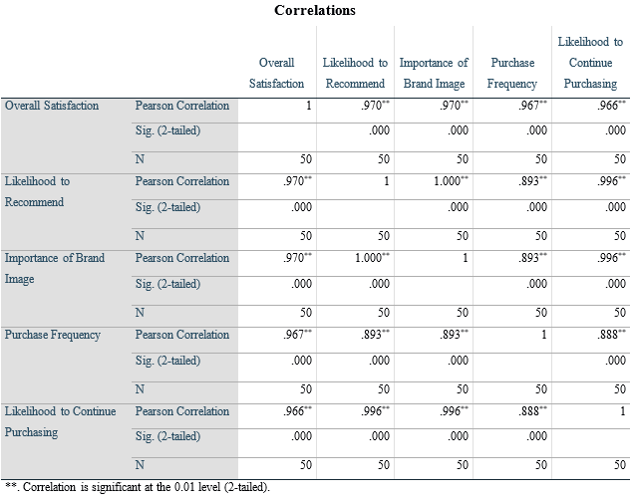
Interpretation: Correlation research illuminates brand image, customer loyalty, happiness, and Apple customers. Significant correlation coefficients suggest strong and trustworthy links between variables. The Pearson correlation coefficient of 0.970 reveals a strong positive correlation between overall satisfaction and Apple product recommendations. This shows that satisfied Apple customers are likely to endorse the company. This association is important for Apple since word-of-mouth recommendations can change brand perception and attract new customers. Consumers' perception of the importance of Apple's brand image and overall satisfaction are positively correlated at 0.970. This suggests that Apple product fans value the brand's reputation. Apple's good brand reputation and customer satisfaction show how these elements influence consumer perceptions.
The frequency of purchases is strongly correlated with total satisfaction (0.967). This shows that delighted customers are likelier to promote Apple and buy more. This emphasises the importance of customer happiness in building loyalty and income for Apple through repeat purchases. This link supports the substantial positive association (0.966) between consumer loyalty, happiness, and future purchases. Satisfied clients are more loyal to Apple, further strengthening its extensive client base. A perfect correlation (1.000) exists between brand image importance and recommendation likelihood. This suggests that Apple endorsers value the brand's reputation. Brand image is substantially correlated (0.996) with continued purchases. Brand image has a lasting impact on customer loyalty. The correlation analysis shows strong links between consumer loyalty, brand image, and satisfaction. Apple's ability to satisfy customers and build a strong brand image boosts loyalty, repeat purchases, and referrals. The results show that Apple must prioritise brand image and customer satisfaction to maintain and grow consumer loyalty.

4.3 Discussion
In this section of the dissertation, the researcher has answered the research questions set for this study based on the findings from data analysis.
Research Question 1: How satisfied are Apple consumers with their overall experience, and how do they feel about the company's products and customer service?
Data studies show that Apple users have diverse opinions about their overall experience, product, and service satisfaction. Overall satisfaction was assessed on a five-point scale with a maximum of 5. A mean satisfaction rating of 3.02 denotes a relatively positive experience. This supports technological customer satisfaction surveys that emphasise meeting consumer expectations to create happy experiences (Uzir et al., 2021). Product design and performance average 3.02 ratings when measuring product satisfaction. The ratings' homogeneity suggests customers rate these qualities similarly. According to Diputra and Yasa (2021), product design significantly impacts consumer happiness and brand experience. The average satisfaction rating for Apple's customer service is 2.60, slightly lower than product-related satisfaction. These findings support Alzoubi et al. (2020), who found that customer service strongly impacts brand impression and satisfaction.
Research Question 2: What is brand perception, and what are the factors affecting the brand perception of customers?
Customers' perceptions of a brand's traits, attributes, and reputation are called brand perception (Iglesias et al., 2019). The survey examined Apple's brand perception, including its image as a modern lifestyle, product quality, and customer priority. Based on the data, consumers regard Apple as representing a contemporary way of life, as indicated by the average rating of 3.02. This indicates a moderate agreement among the participants. The literature highlights that a brand's ability to connect with contemporary lives can significantly boost its attractiveness and relevance (Jiménez-Marín, Sanz-Marcos, and Tobar-Pesantez, 2021). The average score for Apple's brand quality was 3.02, which aligns with the overall satisfaction results. This indicates the uniformity in which consumers view the brand's quality and their general contentment with its items. Upon evaluating the level of importance that customers assign to Apple's brand image, the mean score of 2.72 indicates that it is somewhat significant. This aligns with the academic literature that highlights the multifaceted character of brand image and the significant impact that customer perceptions and behaviours can exert on brand image (Park and Namkung, 2022). The significance of the brand image is further validated by the correlation study, which reveals a robust positive link between overall satisfaction and the importance of brand image (Dam and Dam, 2021).
Research Question 3: How do customer satisfaction and brand image affect the brand loyalty of Apple customers?
The study found that Apple customer loyalty is strongly influenced by customer satisfaction and brand image. Consumer loyalty was assessed by analysing purchase frequency, repeat purchases, and referrals. The high positive correlations (0.970, 0.967, and 0.966) between total customer happiness and tendency to recommend, buy frequency, and probability to continue purchasing emphasise the importance of customer satisfaction in brand loyalty. According to the expectation disconfirmation model (Ozkan et al., 2020), customer enjoyment drives loyalty and positive behaviour. Data shows a substantial correlation (1.000) between customers' faith in Apple's brand image and their willingness to recommend the product. This correlation suggests that brand-conscious people are more likely to endorse Apple items. Other research shows that positive brand impressions strongly influence customer advocacy (France et al., 2020). Additionally, brand image importance is substantially correlated (0.996) with repeat purchases. This study suggests that Apple brand loyalists tend to stick to their buying patterns. This supports previous studies linking favourable brand perception to customer retention and attraction (Mehta and Tariq, 2020).
The research shows how Apple customers' satisfaction, brand loyalty, and brand perception are linked. The theoretical framework provides a prism for analysing and understanding these outcomes. Consumer happiness, brand image, and brand allegiance studies achieve this. The research adds to understanding by demonstrating how Apple customers' satisfaction, brand image, and brand loyalty are affected.

4.4 Chapter Summary
The chapter titled "Data Analysis, Findings, and Discussion" thoroughly examines the collected research data, providing valuable insights into the attitudes and satisfaction levels of Apple users. The demographic overview offers context by giving the participants their age, gender, and duration of their Apple customer status. Descriptive statistics provide a thorough understanding of several aspects such as customer satisfaction, product perception, and brand image by precisely outlining the mean, minimum, maximum, skewness, and kurtosis. Frequency distributions aid in examining response distributions, allowing for the identification of noticeable trends in the evaluations of customer service, product design, and performance provided by the participants. Correlation analyses break down the complex linkages between customer pleasure, brand perception, and loyalty by thoroughly understanding their interconnections. The chapter concludes with a thorough discussion that connects the suggested theoretical framework and the previously examined findings. This chapter thoroughly explains the factors that influence the satisfaction, perception of the brand, and loyalty of Apple customers by combining real-world data and theoretical viewpoints.

Chapter – 5: Conclusion and Recommendations

5.1 Conclusion
Throughout the whole study, the impact of customer satisfaction and the brand image of Apple Inc. on the loyalty of its customers towards the brand was examined. The study's primary aim was to assess how Apple’s customers' satisfaction and the customers' perception of the brand affect the customers' loyalty to the brand. This section of the research concludes the overall findings, demonstrating the achievement of the overall objectives of the study through the research findings.
Objective 1: To evaluate how satisfied Apple consumers are with their overall experience, as well as how they feel about the company's products and customer service.
The significance of customer satisfaction in terms of shaping customer loyalty was highlighted by both Uzil et al. (2021) and Diputra and Yasa (2021). This is in line with the findings of this study, where the researcher found that improved customer satisfaction of Apple Inc. contributes positively to enhancing the loyalty of Apple's customers. According to the survey result, the mean score of the participants' satisfaction level concerning the overall experience regarding Apple products and services was 3.02, indicating moderately high satisfaction among Apple customers. Again, the findings of this study concerning the satisfaction of participants regarding product design and product performance were quite similar, contributing significantly to the satisfaction of customers regarding their overall experience. This finding aligns with the study of Diputra and Yasa (2021) which provides that factors such as the quality of products and customer services contribute highly to enhancing the overall satisfaction of customers. Therefore, based on the findings of this study and supporting evidence from the literature, most Apple customers are satisfied with Apple's products and services. Although there is a slight discrepancy in the satisfaction level of customers regarding Apple's customer service, with a mean score of 2.62, Apple still has some scope of development in its customer service department to ensure higher satisfaction among its customers.
Objective 2: To assess Apple's brand perception and pinpoint the essential characteristics and associations that affect how customers view the company.
With reference to Iglesias et al. (2019), the term ‘Brand perception’ is a complex term comprising factors such as the brand's reputation and image among its customers. Participants perceived Apple to represent a modern way of life that was perfectly in sync with these theoretical frameworks (Jiménez-Marn, Sanz-Marcos, and Tobar-Pesantez, 2021). Dam and Dam (2021) discovered a strong correlation (r=0.970) between customer happiness and the perceived importance of Apple's brand image, bolstering theoretical foundations and emphasising the mutually beneficial relationship. The dissertation discussed both the complexities of brand reputation management and the importance of Apple adapting its strategies to meet the diverse tastes of its customers (Park and Namkung, 2022). Much of the literature echoed the complex debates about how product design, performance, and customer priority influence brand perception.
Objective 3: To analyse the impact of customer satisfaction and brand image on the brand loyalty of Apple customers.
Previous research has mentioned the link between happiness, how people perceive a brand, and loyalty (Ozkan et al., 2020; France et al., 2020). Overall satisfaction and the likelihood of making a recommendation were found to be positively correlated (0.970, 0.967, 0.966), providing empirical support for these links. With reference to the study of Ozkan et al. (2020), the satisfaction of customers in terms of the brand's products and services has a crucial impact on shaping positive consumer behaviour and the customers' long-term loyalty towards the brand. Various studies including that of France et al. (2020) have found a strong positive relationship between the perception of customers towards the brand and their loyalty to the brand as a customer, which ultimately indicates that brand image is highly crucial for companies in terms of forming brand loyalty among customers. According to this study, a strong positive link was also found between customer satisfaction, Apple brand image, and customer loyalty. Research and the literature show that customer satisfaction and Apple's brand image positively affect customer loyalty.
Above all, by putting together empirical data and theoretical insights that are referred to in specific citations, the study now better understands the impact of customer satisfaction and brand image on brand loyalty from the perspective of Apple Inc. The dissertation's survey of satisfaction, brand perception, and brand loyalty shed light on the complicated relationships between businesses and customers. These results have effects that go beyond the world of education. They can help Apple and other companies learn more about handling their brands and what customers want. This dissertation could help businesses build lasting connections with customers in a world where technology and customer needs constantly change. It sheds light on the mysterious world of Apple customers and their unwavering devotion to the brand.

5.2 Recommendations
This study looked at Apple Inc. to see if there was a link between customer loyalty and how happy customers were with the company and its image. Based on the study's results, this part gives specific advice to Apple Inc. management on how the company can improve the effectiveness of its customer satisfaction and brand image management to keep customers coming back.
- Investing in Service Excellence: Based on the real-world data from this study, Apple's customer service gets a slightly lower satisfaction rate (2.62 points) than its competitors. This brings up a crucial issue that must be dealt with immediately. This point of view is supported by earlier research that shows how vital customer service is for building positive brand associations and getting people to buy more (Alzoubi et al., 2020). Most people agree that the quality of service dramatically affects how people feel about a brand and how loyal they are to that company. Customers who are happy with a product or service are more likely to tell others about it, according to the study by Dalal and Aljarah (2021). Apple, which is known for making stylish and cutting-edge goods, needs to realise how important customer service is becoming in this age of complete customer satisfaction. Improving customer service has far-reaching consequences because it affects not only customer satisfaction but also customer perception and loyalty to the brand. Consumers who have positive experiences with a brand's service are more likely to recommend the brand to others and have a significant amount of positive thoughts about the brand, according to Bakri, Krisjanous, and Richard (2020). According to Shin et al. (2020), this practice strengthens customers' emotional connection with the product, increasing their brand loyalty. As a result, the overarching goal of providing Apple customers with a positive and comprehensive brand experience is consistent with the investment in service excellence.
- Innovation Communication Strategy: Although innovation is one of Apple's strengths, the research indicates that a significant number of participants do not place a high priority on innovation when making decisions. Thirty-six percent of respondents consider innovation to be either unimportant or slightly important. Because of this, it is necessary to have a strategic communication method that emphasises innovation while also considering other aspects of the interaction with the brand or product. Previous studies (for example, Rachbini et al., 2023) have demonstrated that it is essential for brand messages to align with the values and preferences of customers. This finding lends credence to the necessity of employing efficient communication strategies. By implementing a communication strategy for innovation, Apple can expand its reach to a broader range of demographics due to its commitment to developing cutting-edge technology. Apple can attract a larger audience by emphasising innovation while excluding individuals who value other aspects more. Specifically, Wang et al. (2021) state that this strategic alignment has an effect not only on the decisions that consumers make regarding their purchases in the short term but also on how they perceive and relate to the brand in the long term. Implications for enhancing the brand's image and fostering customer loyalty include implementing a communication strategy for more sophisticated and flexible innovations.
- Tailoring Brand Image Strategies: The study's findings show that people's perspectives on the importance of a brand's reputation vary greatly. Sixty percent of respondents believe it is neutral, important, or essential to their brand, while forty-four percent believe it is unimportant. When it comes to managing its brand image, Apple could benefit from a more personalised approach. This is due to the fact that customers place varying degrees of importance on various aspects of the product or their experience with the brand. According to existing literature (e.g., Park and Namkung, 2022), a thorough understanding of customer preferences is essential for managing the brand image. A thorough understanding of various customer demographics' unique wants and needs is required to develop successful brand image strategies. Muchenje, Mtengwa, and Kabote (2023) argue that Apple can use market segmentation strategies to tailor its messages and highlight the brand aspects that are most appealing to each segment. It is believed that this new idea will improve Apple's brand reputation and its ability to meet the needs of a wide range of customers. When this approach to customisation is used, customers give positive feedback, such as higher levels of happiness and brand loyalty.
Implementing these suggestions could significantly impact Apple's market performance. Apple can increase customer loyalty by listening to feedback, improving innovation communication, and changing its brand image. Long-term brand perception, consumer loyalty, and competitiveness are affected beyond customer satisfaction. Excellent service meets immediate needs and boosts brand image, encouraging customers to return and recommend the business, as the findings of the study show. Apple must effectively communicate its innovative technology to diverse consumer segments to maintain its industry innovator status. Customised brand image strategies strengthen customer relationships by aligning the brand with the individual's values and preferences. Finally, these research- and theory-backed suggestions show Apple how to boost customer satisfaction and reputation. In the competitive tech industry, customer loyalty and brand perception are more important than short-term gains.

5.3 Limitations of the Study
Although this study provides valuable insights and employs sound methodology, it is essential to note that it has some limitations. To begin with, tracking how customers' opinions evolve is complicated because this study used a cross-sectional design, which only captures their views at one point in time. Furthermore, introducing response bias and social desirability into surveys that rely on self-reported data can endanger the reliability of consumer evaluations. The findings may not apply to a broader audience because of the study's narrow demographic and geographic focus on Apple customers. Some findings may also be time-sensitive due to the dynamic nature of the technology industry, which causes customer tastes and opinions of brands to change quickly. Even though the research contributes significantly to understanding Apple's customer dynamics, these limitations highlight the need for ongoing research and adaptability in the tech industry.

5.4 Scope for Future Research
The findings of this study on Apple's customer satisfaction, brand perception, and loyalty dynamics can significantly benefit future research. To begin, longitudinal studies have the potential to shed light on how consumers' attitudes change over time, tracking shifts in satisfaction and brand loyalty in the face of technological progress. Investigating cultural differences in consumer tastes and brand opinions worldwide could be a promising area for future research. How new technologies like AR and AI influence consumer experiences and brand opinions is an area that needs to be researched further. Studying the effects of these technologies on customer satisfaction and brand loyalty as they relate to Apple products could provide Apple with strategic insights. As part of this, it may be necessary to dig deeper into Apple's marketing strategies, social media accounts, and customer engagement efforts. Finally, future research could build on this by taking a longitudinal approach, examining how different cultures interact, how new technology changes things, and how well Apple's marketing works in the volatile technological industry.

References
Abror, A., Patrisia, D., Engriani, Y., Evanita, S., Yasri, Y. and Dastgir, S. (2020). Service quality, religiosity, customer satisfaction, customer engagement and Islamic bank’s customer loyalty. Journal of Islamic Marketing, 11(6), pp.1691-1705.
Adams, J., Khan, H.T.A. and Raeside, R. (2014). Research methods for business and social science students. 2nd ed. Los Angeles: Sage.
Agrawal, S. and Agrawal, B. (2019). Customer delight: An antecedent of brand loyalty in online shopping. South Asian Journal of Marketing & Management Research, 9(8), pp.55-63.
Akoglu, H.E. and Özbek, O. (2022). The effect of brand experiences on brand loyalty through perceived quality and brand trust: a study on sports consumers. Asia Pacific Journal of Marketing and Logistics, 34(10), pp.2130-2148.
Alzoubi, H., Alshurideh, M., Kurdi, B. and Inairat, M.J.U.S.C.M. (2020). Do perceived service value, quality, price fairness and service recovery shape customer satisfaction and delight? A practical study in the service telecommunication context. Uncertain Supply Chain Management, 8(3), pp.579-588.
Apple (2022). Business. [online] Apple. Available at: https://www.apple.com/business/ [Accessed 11 Nov. 2023].
Avaremy (2013). Brand Equity. [online] ava remy. Available at: https://avaremy.wordpress.com/2013/11/09/brand-equity/ [Accessed 28 Nov. 2023].
Azizan, N.S. and Yusr, M.M. (2019). The influence of customer satisfaction, brand trust, and brand image towards customer loyalty. International Journal of Entrepreneurship, 2(7), pp.93-108.
Babin, B.J., Zikmund, W.G., Quinlan, C., Carr, J.C. and Griffin, M. (2019). Business Research Methods. 2nd ed. Andover: Cengage Learning.
Baker, L. (2016). Research Methods. Baltimore: Johns Hopkins University Press.
Bakri, M., Krisjanous, J. and Richard, J.E. (2020). Decoding service brand image through user-generated images. Journal of Services Marketing, 34(4), pp.429-442.
Bell, E., Bryman, A. and Harley, B. (2022). Business Research Methods. 6th ed. Oxford: Oxford University Press.
Berg, B.L. and Lune, H. (2018). Qualitative Research Methods. Boston: Pearson.
Blumberg, B.F., Cooper, D.R. and Schindler, P.S. (2014). Business Research Methods. 4th ed. London: McGraw-Hill Education.
Bougie, R. and Sekaran, U. (2019). Research methods for business: a skill-building approach. 8th ed. Hoboken, Nj: John Wiley & Sons, Inc.
Bradley, T. (2022). Embracing Apple In The Enterprise: Benefits And Challenges For IT Teams. [online] Forbes. Available at: https://www.forbes.com/sites/tonybradley/2023/07/27/embracing-apple-in-the-enterprise-benefits-and-challenges-for-it-teams/?sh=47b2cca55d83 [Accessed 11 Nov. 2023].
Chan, J., Selden, M. and Pun, N. (2020). Dying for an iPhone: Apple, Foxconn, and the Lives of China's Workers. Haymarket Books.
Coelho, F.J., Bairrada, C.M. and de Matos Coelho, A.F. (2020). Functional brand qualities and perceived value: The mediating role of brand experience and brand personality. Psychology & Marketing, 37(1), pp.41-55.
Coghlan, D. and Shani, A.B. (2018). Conducting action research for business and management students. Los Angeles: Sage.
Cooper, D.R. and Schindler, P.S. (2014). Business Research Methods. 12th ed. New York, Ny: Mcgraw-Hill/Irwin.
Dalal, B. and Aljarah, A. (2021). How brand symbolism, perceived service quality, and CSR skepticism influence consumers to engage in citizenship behavior. Sustainability, 13(11), p.6021.
Dam, S.M. and Dam, T.C. (2021). Relationships between service quality, brand image, customer satisfaction, and customer loyalty. The Journal of Asian Finance, Economics and Business, 8(3), pp.585-593.
Dawes, J. (2022). Factors that influence manufacturer and store brand behavioral loyalty. Journal of Retailing and Consumer Services, 68, p.103020.
Detterman, D. (2019). Research Methodology. Norwood, N.J.: Ablex.
Dhiman, N. and Kumar, A. (2023). What we know and don’t know about consumer happiness: three-decade review, synthesis, and research propositions. Journal of Interactive Marketing, 58 (2-3), pp.115-135.
Diallo, M.F., Moulins, J.L. and Roux, E. (2021). Unpacking brand loyalty in retailing: a three-dimensional approach to customer–brand relationships. International Journal of Retail & Distribution Management, 49(2), pp.204-222.
Diputra, I.G.A.W. and Yasa, N.N. (2021). The influence of product quality, brand image, brand trust on customer satisfaction and loyalty. American International Journal of Business Management (AIJBM), 4(1), pp.25-34.
Easterby-Smith, M., Jaspersen, L.J., Thorpe, R. and Valizade, D. (2021). Management and business research. Sage.
Essamri, A., McKechnie, S. and Winklhofer, H. (2019). Co-creating corporate brand identity with online brand communities: A managerial perspective. Journal of Business Research, 96, pp.366-375.
Ferrell, O.C., Hartline, M. and Hochstein, B.W. (2021). Marketing strategy. Cengage Learning.
Fournier, S. and Alvarez, C. (2019). How brands acquire cultural meaning. Journal of Consumer Psychology, 29(3), pp.519-534.
France, C., Grace, D., Lo Iacono, J. and Carlini, J. (2020). Exploring the interplay between customer perceived brand value and customer brand co-creation behaviour dimensions. Journal of brand Management, 27, pp.466-480.
Ghauri, P., Grønhaug, K. and Strange, R. (2020). Research methods in business studies. Cambridge University Press.
Gil-Gomez, H., Guerola-Navarro, V., Oltra-Badenes, R. and Lozano-Quilis, J.A. (2020). Customer relationship management: digital transformation and sustainable business model innovation. Economic research-Ekonomska istraživanja, 33(1), pp.2733-2750.
Global Data (2022). Apple Inc: Overview. [online] www.globaldata.com. Available at: https://www.globaldata.com/company-profile/apple-inc/ [Accessed 11 Nov. 2023].
Goddard, W. and Melville, S. (2020). Research Methodology. 2nd ed. Kenwyn, South Africa: Juta & Co., Repr.
Gonjari, S. (2020). Personality Traits and Brand Loyalty: An investigation in the light of Human Body Morphology. Journal of Business, Management & Administrative Sciences (JBMAS), 1(1), pp.11-22.
Gray, D.E. (2020). Doing research in the business world. Los Angeles Sage.
Grimmelikhuijsen, S. and Porumbescu, G.A. (2017). Reconsidering the expectancy disconfirmation model. Three experimental replications. Public Management Review, 19(9), pp.1272-1292.
Hair, J.F. (2016). Essentials of business research methods. New York: Routledge.
Haleem, A., Javaid, M., Qadri, M.A., Singh, R.P. and Suman, R. (2022). Artificial intelligence (AI) applications for marketing: A literature-based study. International Journal of Intelligent Networks.
Hokky, L.A. and Bernarto, I. (2021). The role of brand trust and brand image on brand loyalty on Apple iPhone smartphone users in DKI Jakarta. Enrichment: Journal of Management, 12(1), pp.474-482.
Huang, L., Wang, M., Chen, Z., Deng, B. and Huang, W. (2020). Brand image and customer loyalty: Transmitting roles of cognitive and affective brand trust. Social Behavior and Personality: an international journal, 48(5), pp.1-12.
Huang, M.H. and Dev, C.S. (2020). Growing the service brand. International Journal of Research in Marketing, 37(2), pp.281-300.
Hwang, J., Choe, J.Y.J., Kim, H.M. and Kim, J.J. (2021). Human baristas and robot baristas: How does brand experience affect brand satisfaction, brand attitude, brand attachment, and brand loyalty?. International Journal of Hospitality Management, 99, p.103050.
Iglesias, O., Markovic, S., Singh, J.J. and Sierra, V. (2019). Do customer perceptions of corporate services brand ethicality improve brand equity? Considering the roles of brand heritage, brand image, and recognition benefits. Journal of business ethics, 154, pp.441-459.
Jiménez-Marín, G., Sanz-Marcos, P. and Tobar-Pesantez, L.B. (2021). Keller's resonance model in the context of fashion branding: persuasive impact through the figure of the influencer. Academy of Strategic Management Journal, 20 (6).
Kachniewska, M. (2006). Tourism quality management. Warszawa: Wydawnictwa Uczelniane Wyższej Szkoły Handlu I Finansów Międzynarodowych Im. Fryderyka Skarbka.
Karampournioti, E. and Wiedmann, K.P. (2022). Storytelling in online shops: the impacts on explicit and implicit user experience, brand perceptions and behavioral intention. Internet Research, 32(7), pp.228-259.
Keller, K.L. (2016). Reflections on customer-based brand equity: perspectives, progress, and priorities. AMS review, 6, pp.1-16.
Keller, K.L. and Brexendorf, T.O. (2019). Strategic brand management process. Handbuch Markenführung, pp.155-175.
Kim, J., Lee, H. and Lee, J. (2020). Smartphone preferences and brand loyalty: A discrete choice model reflecting the reference point and peer effect. Journal of Retailing and Consumer Services, 52, p.101907.
Koetsier, J. (2023). The Top 10 Selling Smartphones Of 2023 Are All From Just 2 Companies. [online] Forbes. Available at: https://www.forbes.com/sites/johnkoetsier/2023/08/29/top-10-selling-smartphones-all-from-2-companies-apple-and-samsung/ [Accessed 1 Jan. 2024].
Kruger, F. and Mitchell, B. (2019). Research methodology. Oxford: Oxford University Press.
Lee, D.H. (2023). The trinity of extended service quality, distinct perceived value, and customer loyalty facilitators. Asia Pacific Journal of Marketing and Logistics, 35(5), pp.1262-1287.
Li, J., Zeng, X. and Stevels, A. (2015). Ecodesign in consumer electronics: Past, present, and future. Critical Reviews in Environmental Science and Technology, 45(8), pp.840-860.
Liu, F., Lim, E.T., Li, H., Tan, C.W. and Cyr, D. (2020). Disentangling utilitarian and hedonic consumption behavior in online shopping: An expectation disconfirmation perspective. Information & Management, 57(3), p.103199.
Malek, N. and Dave, S. (2023). Exploring Customer Satisfaction and Loyalty in the Telecommunications Industry: A Comparative Review. International Journal of Management, Public Policy and Research, 2(4), pp.95-107.
Manyanga, W. (2022). Mediating effects of customer satisfaction and word-of-mouth intention on the relationship between customer experience and loyalty: evidence from the banking sector in Zimbabwe (Doctoral dissertation, CHINHOYI UNIVERSITY OF TECHNOLOGY).
Mao, Y., Lai, Y., Luo, Y., Liu, S., Du, Y., Zhou, J., Ma, J., Bonaiuto, F. and Bonaiuto, M. (2020). Apple or Huawei: Understanding flow, brand image, brand identity, brand personality and purchase intention of smartphone. Sustainability, 12(8), p.3391.
Mascarenhas, O.A., Kesavan, R. and Bernacchi, M. (2006). Lasting customer loyalty: a total customer experience approach. Journal of consumer marketing, 23(7), pp.397-405.
Mcburney, D. and White, T.L. (2019). Research methods. Belmont, Ca: Wadsworth Cengage Learning.
Mehta, A.M. and Tariq, M. (2020). How brand image and perceived service quality affect customer loyalty through customer satisfaction. Academy of Marketing Studies Journal, 24(1), pp.1-10.
Melnikovas, A. (2018). Towards an Explicit Research Methodology: Adapting Research Onion Model for Futures Studies. Journal of futures Studies, 23(2).
Moorman, C. (2023). Why Apple Is Still A Great Marketer And What You Can Learn. [online] Forbes. Available at: https://www.forbes.com/sites/christinemoorman/2018/01/12/why-apple-is-still-a-great-marketer-and-what-you-can-learn/?sh=1960a9ac15bd [Accessed 11 Nov. 2023].
Morgan-Thomas, A., Dessart, L. and Veloutsou, C. (2020). Digital ecosystem and consumer engagement: A socio-technical perspective. Journal of Business Research, 121, pp.713-723.
Mostafa, R.B. and Kasamani, T. (2021). Brand experience and brand loyalty: is it a matter of emotions?. Asia Pacific Journal of Marketing and Logistics, 33(4), pp.1033-1051.
Muchenje, C., Mtengwa, E. and Kabote, F. (2023). Building a Strong Brand: Future Strategies and Insights. In Sustainable Marketing, Branding, and Reputation Management: Strategies for a Greener Future (pp. 238-257). IGI Global.
Negmeldin, M.A.A., Heshmat, M. and Eltawil, A. (2021). A system dynamics approach for strategic planning of consumer electronics industry in developing countries: the case of the television manufacturing industry in Egypt. South African Journal of Industrial Engineering, 32(2), pp.133-149.
Nooney, L. (2023). The Apple II Age: How the Computer Became Personal. University of Chicago Press.
Nugroho, M.A. and Harjanto, R. (2020). Impact of brand life cycle to extend product’s life cycle. International Journal of Management (IJM), 11(8).
Park, C.I. and Namkung, Y. (2022). The effects of instagram marketing activities on customer-based brand equity in the coffee industry. Sustainability, 14(3), p.1657.
Plumeyer, A., Kottemann, P., Böger, D. and Decker, R. (2019). Measuring brand image: a systematic review, practical guidance, and future research directions. Review of Managerial Science, 13, pp.227-265.
Primavesi, C. (2022). Analysing the sustainability of Apple’s competitive advantage (Doctoral dissertation).
Quinlan, C., Babin, B., Carr, J., Griffin, M. and Zikmund, W. (2019). Business Research Methods. 2nd ed. Hampshire: Cengage Learning Emea.
Rachbini, W., Soeharso, S.Y., Nugroho, A.S., Evi, T. and Rahmawati, E. (2023). The Impact of Brand Society and Narrative Branding on Brand Image and its Implications on Consumer Purchase Behavior: A Case Study of Luxury Fashion Brands in Jakarta. Journal of Law and Sustainable Development, 11(7), pp.e1387-e1387.
Reina, G., Childs, H., Matković, K., Bühler, K., Waldner, M., Pugmire, D., Kozlíková, B., Ropinski, T., Ljung, P., Itoh, T. and Gröller, E. (2020). The moving target of visualisation software for an increasingly complex world. Computers & graphics, 87, pp.12-29.
Richardson, N. (2022). How new sustainability typologies will reshape traditional approaches to loyalty. Italian Journal of Marketing, 2022(3), pp.289-315.
Saarikko, T., Westergren, U.H. and Blomquist, T. (2020). Digital transformation: Five recommendations for the digitally conscious firm. Business Horizons, 63(6), pp.825-839.
Sanjaya, W., Asdar, M. and Munir, A.R. (2020). The Effect of Brand Image, Brand Experience and Brand Loyalty towards Purchase IntentionOn Apple Smartphone in Makassar. Hasanuddin Journal of Business Strategy, 2(3), pp.74–82.
Saunders, M., Lewis, P. and Thornhill, A. (2019). Research Methods for Business Students. 8th ed. United Kingdom : Pearson.
Schindler, P.S. (2019). Business research methods. New York, Ny Mcgraw-Hill/Irwin.
Sekaran, U. and Bougie, R. (2019). Research Methods for Business: A Skill-building Approach. 8th ed. Chichester, West Sussex, United Kingdom: John Wiley & Sons.
Shafi, S.I. and Madhavaiah, C. (2014). Defining customer-based brand equity: An evaluation of previous studies. Srusti Management Review, 7(2), p.34.
Shahid, S., Paul, J., Gilal, F.G. and Ansari, S. (2022). The role of sensory marketing and brand experience in building emotional attachment and brand loyalty in luxury retail stores. Psychology & Marketing, 39(7), pp.1398-1412.
Sharma, A., Patro, S. and Chaudhry, H. (2022). Brand identity and culture interaction in the Indian context: a grounded approach. Journal of Advances in Management Research, 19(1), pp.31-54.
Shin, M., Back, K.J., Lee, C.K. and Lee, Y.S. (2020). Enhancing customer-brand relationship by leveraging loyalty program experiences that foster customer-brand identification. International Journal of Contemporary Hospitality Management, 32(12), pp.3991-4016.
Shuja, M., Raj, R., Jayaraj, P., Naqvi, S.R., Shaikh, Z. and Reddy, P.V.K. (2023). Impact Of Store Attributes and Store Brand Loyalty on Customer Satisfaction; A Mediation Role. Journal of Informatics Education and Research, 3(2).
Siti Fatonah and Nani Irma Susanti (2023). Behavioral Analysis of ‘Iphone’ Brand Loyalty From Brand Experience Mediated by Brand Trust in Surakarta. West Science Interdisciplinary Studies, 1(07), pp.437–454.
Sohaib, M., Mlynarski, J. and Wu, R. (2022). Building Brand Equity: The Impact of Brand Experience, Brand Love, and Brand Engagement—A Case Study of Customers’ Perception of the Apple Brand in China. Sustainability, [online] 15(1), p.746.
Statista (2023). Apple - Statistics & Facts. [online] Statista. Available at: https://www.statista.com/topics/847/apple/#editorsPicks [Accessed 1 Jan. 2024].
Sun, X., Foscht, T. and Eisingerich, A.B. (2021). Does educating customers create positive word of mouth?. Journal of Retailing and Consumer Services, 62, p.102638.
Susiang, M.I.N., Suryaningrum, D.A., Masliardi, A., Setiawan, E. and Abdillah, F. (2023). Enhancing Customer Experience through Effective Marketing Strategies: The Context of Online Shopping. SEIKO: Journal of Management & Business, 6(2), pp.437-447.
Tasci, A.D. (2021). A critical review and reconstruction of perceptual brand equity. International Journal of Contemporary Hospitality Management, 33(1), pp.166-198.
Tsui-Hsu Tsai, T., Jing Lin, A. and Y. Li, E. (2014). The effect of philanthropic marketing on brand resonance and consumer satisfaction of CSR performance: does media self-regulation matter?. Chinese Management Studies, 8(3), pp.527-547.
Uzir, M.U.H., Al Halbusi, H., Thurasamy, R., Hock, R.L.T., Aljaberi, M.A., Hasan, N. and Hamid, M. (2021). The effects of service quality, perceived value and trust in home delivery service personnel on customer satisfaction: Evidence from a developing country. Journal of Retailing and Consumer Services, 63, p.102721.
Vollero, A., Sardanelli, D. and Siano, A. (2023). Exploring the role of the Amazon effect on customer expectations: An analysis of user‐generated content in consumer electronics retailing. Journal of Consumer Behaviour, 22(5), pp.1062-1073.
Wang, H., Wei, Y. and Yu, C. (2008). Global brand equity model: combining customer‐based with product‐market outcome approaches. Journal of Product & Brand Management, 17(5), pp.305-316.
Wang, S., Liao, Y.K., Wu, W.Y. and Le, K.B.H. (2021). The role of corporate social responsibility perceptions in brand equity, brand credibility, brand reputation, and purchase intentions. Sustainability, 13(21), p.11975.
Weathington, B.L., Cunningham, C.J. and Pittenger, D.J. (2012). Understanding business research. John Wiley & Sons.
Wolter, J.S., Bock, D., Mackey, J., Xu, P. and Smith, J.S. (2019). Employee satisfaction trajectories and their effect on customer satisfaction and repatronage intentions. Journal of the Academy of Marketing Science, 47, pp.815-836.
Xie, C. and Sun, Z. (2021). Influence of perceived quality on customer satisfaction in different stages of services. Nankai Business Review International, 12(2), pp.258-280.
Yu, C., Zhao, P. and Wang, H. (2008). An empirical evaluation of a customer-based brand equity model and its managerial implications. Frontiers of Business Research in China, 2(4), pp.553-570.
Yüksel, A. and Yüksel, F. (2001). The expectancy-disconfirmation paradigm: a critique. Journal of hospitality & tourism research, 25(2), pp.107-131.
Zarei, A., Feiz, D. and Moradi, H. (2020). Promoting consumer loyalty and resilience to negative information through brand identity sub-components: an empirical investigation in the luxury electronics goods. Journal of Islamic Marketing, 12(9), pp.1820–1834.

Appendix: Survey Questionnaire

Survey Questionnaire: Understanding Customer Satisfaction, Brand Perception, and Brand Loyalty in the Consumer Electronics Industry
Dear Respondent,
Thank you for participating in this survey. Your feedback is valuable for this research on customer satisfaction, brand perception, and brand loyalty in the consumer electronics industry. Please answer the following questions honestly and to the best of your knowledge.
Section 1: Demographic Information
- Age?
- 18-24
- 25-34
- 35-44
- 45-54
- 55-64
- 65 or older

- Gender?
- Male
- Female
- Prefer not to say.
- How long have you been a customer of Apple Inc.?
- Less than 6 months
- 6 months to 1 year
- 1-2 years
- 2-5 years
- More than 5 years

- How satisfied are you with your overall experience as an Apple customer?
- Very dissatisfied
- Dissatisfied
- Neutral
- Satisfied
- Very satisfied

- Please rate your satisfaction with the following aspects of Apple's products:
 | Very Dissatisfied (1) | Dissatisfied (2) | Neutral (3) | Satisfied (4) | Very Satisfied (5)
Product design
Product performance
Customer service

- How likely are you to recommend Apple products to others?
- Not likely at all
- Slightly likely
- Neutral
- Likely
- Very likely

- How would you describe Apple's brand image?
- Innovative
- Reliable
- Stylish
- User-friendly
- Other (please specify)

- To what extent do you agree with the following statements about Apple:
 | Strongly Disagree (1) | Disagree (2) | Neutral (3) | Agree (4) | Strongly Agree (5)
Apple products reflect a contemporary way of life.
Apple's brand is associated with high quality.

- How important is Apple's brand image in your purchasing decisions?
- Not important at all
- Slightly important
- Neutral
- Important
- Very important

- How often do you purchase Apple products?
- Rarely or never
- Occasionally
- Frequently
- Very frequently

- Please rate the factors that contribute to your loyalty to Apple:
 | Not important at all (1) | Slightly important (2) | Neutral (3) | Important (4) | Very Important (5)
Product Quality
Innovation
Customer service
Brand reputation

- How likely are you to continue purchasing Apple products in the future?
- Not likely at all
- Slightly likely
- Neutral
- Likely
- Very likely
Thank you for taking the time to complete this survey. Your input is greatly appreciated!

