Student Name:Bianca Anamaria Chirita
Student Number: 1815749
Teacher’s name: Molly Jack
Course name:Project Management
Assignment title:End of Project Report

Executive Summary
This report enhances focus towards implementing different concepts related to PRM along with EPO and enhancing their significant on the PM execution. It also discusses different forms of challenges and identifies a proper project scope while analysis different criterion that is related to achieve its objectives and targets. Along with the proper type of "Cost-Benefit Analysis", it also helps for enhancing an appropriate analysis of project for making a comprehensive understanding of different challenges along with benefits that are further derived through the project.

Table of Contents
1. Introduction 4
1.1 PRM 4
1.2 EOP 4
2. Project Description 4
3. Smart Objectives and Achievement 6
4. Expected and Unexpected Benefits 7
5. Project Scope 9
5.1 Time Description 9
5.2 Tolerance and Budget 10
6. Project Changes and Impacts 10
7. Evaluation and Recommendations 11
8. Risk Analysis 12
8.1 Identification Factors 12
8.2 Prevention Factors 12
9. Conclusion 15
Reference List 16

1. Introduction

1.1 PRM
“Project Relationship Management (PRM)”, is further a process related to enhancing a process towards cultivating along with establishment and maintenance of various project-associated form of relations. It also is maintained between different stakeholders, along with the other kind of group members. This has further established a crucial role in "Project Management". It enhances the fact that this potentially helps in building a stronger relationship with different project deliverables that can fulfil proper project outcomes. An appropriate analysis of active involvement is analysed for enhancing relevant performance standards related to the project. This is further exhibited through a project group with increasing exerting a level of influences through different project performance in marketing dynamics.

1.2 EOP
“Evaluation of Project", enhances a potential systematic method towards improving a proper evaluation for determining if different project consequences can help in fulfilling aim along with objectives of a particular project. It also enhances a detailed analysis related to varying forms of concerns such as scrutinising various stakeholders along with associating it with whisk letter referred to "Project Management" (Lock, 2020). Along with the proper type of "Cost-Benefit Analysis", it also helps for enhancing an appropriate analysis of project for making a comprehensive understanding of different challenges along with benefits that are further derived through the project.

2. Project Description
“Project Management”, which is subjected towards a business entity, is further one of the most significant methods of renovation that helped in internal along with external change management in organisational standards. Proper program management is a complex action and further needs different forms of practical knowledge concerning various aspects. This further involves correct client demands along with "logistics management" and different ways of establishment of budgets (Radujković and Sjekavica, 2017). This also enhances proper controlling and monitoring of the entire method. Proper program management is evaluated through marking appropriate success extent in potentially fulfilling different expectations such as time, standards, opportunities along with various forms of actions along with multiple activities and operations.
However, a project needs to be served at its authentic standards within an efficient and active committee, which further concentrates a proper establishment of useful and different forms of efficient functioning. It also enhances an appropriate "project management process", which needs a decent, systematic, and comprehensive understanding along with analysis that relates to the project management method, which requires a fundamental knowledge associated with an external organisational standard.
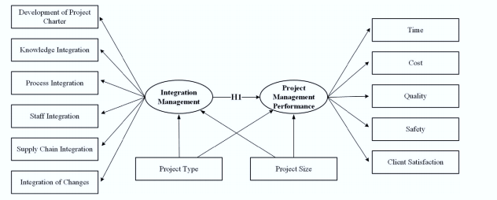
Figure 1: Project Management types
(Source: Demirkesen and Ozorhon, 2017)
This also enhances a proper “planning organisational activities” that help in monitoring and controlling proper functions for improving better project outcomes. This also helps in strengthening an improvement in management scenario, thereby enhancing proper management tools like "PRINCE 2", which enables the establishment of precise facilitated deliveries of efficient planning, which in return, provides adequate development and management approach (Martens and Carvalho, 2017). This also helps in enhancing proper methodology and tools for enabling the project execution.
"PRINCE 2", is further a methodology that is utilised in a successful execution of the project as this enables in further enhancing different forms of comprehensive and knowledgeable guidelines, and helps in creating a proper direction for the project for delivering it to further their clients as well as various potential customers. This also helps in enhancing proper and efficient form of monitoring of the process for evaluating along with successfully identifying any lacking gaps that can lead towards risk factor concerning this project (Derenskaya, 2018). This type of abnormalities in the establishment of a project are effectively analysed by "PRINCE2" and helps in mitigating different forms of risk factors that are further present there, for enhancing highest along with standard organisational services in marketing dynamics.

3. Smart Objectives and Achievement
Specific | This report enhances an objective towards facilitating the structure along with the shape of the project for strengthening the proper transformation process.
Measurable | It also enhances for analysing along with measuring different advantages that are concentrated with “matrix organisational structure” (Esteki et al. 2020).  It will also help in analysing and measuring project outcomes and measuring the statistics between the expected and actual project outcomes.
Achievable | It will further enable a proper balance between different form of traditional guidance along with functional advice for enhancing better project outcomes (Gomes and Romão, 2016)  It also enhances a strategic approach towards the managerial supervisor for marking proper project guidance at the time of its execution in different marketing dynamics.
Relevance | It enhances proper advantages related to different forms of “matrix organisations” that enhances the project for fulfilling different stakeholder’s requirements.  It also helps in enhancing proper team cooperation and coordination for bringing out the best possible project outcomes.
Time | It is a strategic approach of this project for enhancing a specific deadline that enhances a proper form of project planning (Gomes and Romão, 2016)  It also helps in improving adequate decision-making in the early phases of the project initiative. It also reinforces a relevant fact that proper timeline helps in driving strategic factors for enhancing better time management while improving the project delivery.
Table 1: SMART Objectives

4. Expected and Unexpected Benefits
“Project Management", in a business entity is subjected to different forms of expected along with unexpected benefits. This also concentrates on various kinds of functional and significant PM related to matrix operation. The focus related is for enhancing proper execution of the work while involving the project manager along with the technical manager in organisational standards within "Cross-Functional Guidance" (Gupta and Thakkar, 2018). This also marks the fact that different forms of expected benefits are further allocated with attaining proper ideologies along with enhancing proper involvement of the employees in the project. It also includes various types of potential innovation along with enhancing proper establishment incorporation in organisational standards. This also enhances establishment communication skills and help in progressing with a possible form of "leadership management".
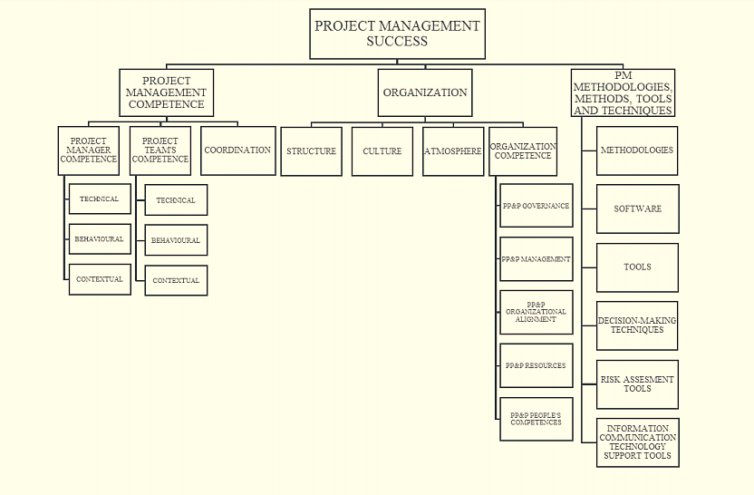
Figure 2: PM Success
(Source: Tereso et al. 2019)
This also enhances the fact that different expected forms of benefits are further enhanced with the PM program to attain practical strategic approaches related to the organisational standards implementing PRINCE2 methodology.
Through implementing this method in the project execution, it further enhances different forms of planning decisions in the project. This is also segmented into different potential groups, which also helps the "Project Manager”, for enhancing proper management related to different project consequences.
There are also different unexpected benefits that are subjected to this project management in business dynamics (Islami et al. 2018). It further enhances various forms of improvement in the "Productive Communication Skills" and increase in communication standards between functional and the project manager. It also helps in upholding a proper strategic approach towards enhancing adequate execution of the project and enables proper teamwork related to the project execution. It also helps in creating value in attaining the different potential project objectives.

5. Project Scope

5.1 Time Description
PM often involves "Program Evaluation Review Technology (PERT)", for enhancing a proper project schedule. Implementation of this strategic approach also enhances four prime phases related to attaining precise aim along with objectives. This project will also improve the involvement of the "PRINCE2"; however, regardless of its strategic and potential approaches, the project outcomes to meet their goals have been highly unlikely.
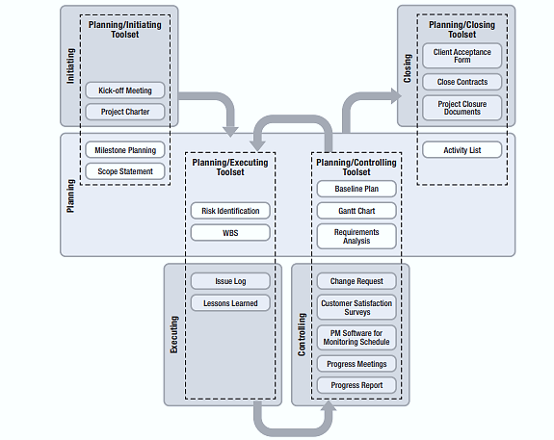
Figure 3: PM Tool
(Source: Tereso et al. 2019)
This also relates to the fact that when different forms of information along with knowledge issue is addressed, then the project cannot be completed related to the expected time (Kononenko and Lutsenko, 2018). With the discussion, it can be further explained that scope cannot remain at an original form of range. It enhances the fact that time cannot be adequately measured, and PM team cannot stay at their actual range. However, it needs to be completed before 25th December 2020, for enhancing a proper timeline for the project.

5.2 Tolerance and Budget
When the project has been initiated the project manager along with the CEO of the organisation further has enabled a proper calculation related to the estimated expense, which is further needed for this project execution through appropriate measurement.
- It is also to be noted that PRINCE2 methodology further enhances a complicated process for the team, and it increases the requirement of much time for improving a complete analysis and project execution.
- This is also subjected to the fact that the budget cannot exceed 150 pounds. The budget further is broken down to three different stages (Naldi et al. 2016).
- The first stage comprises of the resource cost such as planning along with unusual material expense.
- Various HR expenses and internal environment expenses further follow it. Other fees involve rent cost and other insurance expenses.
It also enhances the fact that his further indicate towards higher variables related to nature and finance towards stable PM in business dynamics. Project tolerance is further increased for lack of potential forms of resource management along with the timeline associated with the execution of the project as a subject to the business organisational standards. This further enhances the fact that it increases a curve, which also has demonstrated towards project opportunities that are not met through comparison of expected outcomes, concentrated towards the beginning project phase.

6. Project Changes and Impacts
This project consists of different kinds of changes resulting in different project execution. These are described as each form of initial project planning along with deciding the different way of PM that also enhances the pricing criteria that needs to be presented with a report. The report can be a document or an online form of documentation. Due to the strategic approach related to the breakdown structure, related to the project cannot be properly developed. This is because of the lack of ‘work, breakdown structure’; the proper project outcomes cannot be properly measured (Radujković and Sjekavica, 2017). It is to be noted that different responsibility related to members of the PM team incorporates a potential “Project Time Scale Management” change that can also result in changing the resource management strategic approach of the project related to changing of the different forms of execution of the project.
These changes can relate to adversely affecting different project consequences. This is because of the lack of project report that is further enhanced through “project manager, finance manager and facility manager”, in the process of decision-making (Vaníčková, 2017). It also can lead to affecting different PM teams that further implements different unavailability concerning WBS. It also can influence different standards of the project consequences and results. Changes can also be found in different forms of resource management along with increase in time and project expenses.

7. Evaluation and Recommendations
“Project Management”, is considered one of the abundant area of execution subjected to business dynamics, which needs to be a sufficient form of knowledge along with understanding related to each phase. This is also effective for creating a proper understanding along with establishment of effective knowledge concentrated towards PM.
- It is also to be noted that “best-suited methodologies” as well as proper service management methods also helps in enhancing individual for developing proper preparation effectiveness and efficiency and enhancing proper planning and presentation for establishing project work in marketing dynamics (Gupta and Thakkar, 2018).
- Along with this, incorporation of “PERT” also helps in enhancing a comprehensive understanding related to fundamental process for enhancing an utilisation towards constructing proper planning of the project and enhancing “Budgetary system”.
- It also helps in properly enhancing a comprehensive effectiveness related to “PRINCE2” model concerning the process. This also enhances the work of proper associated participants towards attributing towards research outcomes.
- It also enhances understanding of the "project team" that involves proper individuals that needs a proper overall plan (Gupta and Thakkar, 2018).
It also enhances the fact that "Project team Committee", and proper teamwork management that is essential and crucial process for enhancing an effective project implementation. It also enables knowledge about changes in the project taskforce and increasing utilisation of virtual and digital “manageable software”, which illustrates a fundamental influence in proper PM process.

8. Risk Analysis

8.1 Identification Factors
One major risk faced by business venture includes time constraints as reliable source of data fails to be obtained within desirable source of time. As stated by Glendon, Clarke and McKenna (2016), there are different factors that can be sued for identification of time constraint issues that includes implication of checklists and reviewing documentation in a profound manner. In addition, other factors includes conduction of brainstorming and SWOT analysis can be widely used by a project implementers as it aids in eliminating time constraints within a project.
Other risk that is faced by project management while conducting operation of a project includes financial constraints. This type of risk arises as most of the journals articles, newspaper and websites are in premium version- that means money is required for accessing them and gathering information. Financial risk arises in a project when manager fails to set appropriate budget and fails to draft proper planning process that are known to accelerate expense. Apart from that, other risk that is faced by this project includes implication of operational risk that is known to hamper motivational policies. In words of Hopkin (2018), this type of risk can be identified by ineffective implementation of production sector and lack of distribution in foreign market. It can also be identified by using high level of competition within market and high rate of interest.

8.2 Prevention Factors
Preventive factors of a project can be discussed with usages of a risk matrix analysis that can be discussed as:
Type of risk | Different preventive measures | Negligible | Minor | Moderate | Major | Catastrophic
Time constraint | It can be prevented by a project manager on implication of an effective time management strategies | Moderate | High | Low | Moderate | Low
Financial constraints | This type of risk can be prevented or mitigated by diversification of investment policies. It can also be prevented by diversifying level of investment | High | Moderate | Low | Moderate | High
Operational risk | This form of operational risk can be prevented by having adequate level of insurance, managing failure of equipment in a profound manner. | Moderate | High | Low | Moderate | Low
Table 2: Analysis of Risk matrix
(Source: Created by author)
Based on information gained from Hubbard (2020), operation risk is a major risk that is faced by project manager that are known to hinder productivity level on gathering information. Management can prevent this type of risk by maintaining effective relationship with other business and managing failures of different types of equipment. On other hand, financial risk can be prevented within a project by promoting stability and loss that occurred due to loss in financial market along with analysing movement based on stock prices. Lastly, time constraints can be prevented by mastering internal triggering process, completing project within specified deadline. Thus, in order to gather reliable source of information above-mentioned risk need to be mitigated by using an effective planning strategies. Planning and implication of budget need to be effectively managed as it aids in mitigating credential of long-term risk.

9. Conclusion
This report enhances a proper conclusion that illustrates that the “project management team” faced different kind of issues related to the “project execution” because of different gaps in comprehensive understandings of the “PRINCE2 Methodology”. It has also implemented different concepts related to PRM along with EPO and enhancing their significant on the PM execution. It also discusses different forms of challenges and identifies a proper project scope while analysis different criterion that is related to achieve its objectives and targets.

Reference List
Book
Lock, D., 2020. Project management. Abingdon: Routledge.
Journals
Demirkesen, S. and Ozorhon, B., 2017. Impact of integration management on construction project management performance. International Journal of Project Management, 35(8), pp.1639-1654.
Derenskaya, Y., 2018. Project scope management process. Baltic Journal of Economic Studies, 4(1), pp.118-125.
Esteki, M., Gandomani, T.J. and Farsani, H.K., 2020. A risk management framework for distributed scrum using PRINCE2 methodology. Bulletin of Electrical Engineering and Informatics, 9(3), pp.1299-1310.
Glendon, A.I., Clarke, S. and McKenna, E., 2016. Human safety and risk management. United States: Crc Press.
Gomes, J. and Romão, M., 2016. Improving project success: A case study using benefits and project management. Procedia Computer Science, 100, pp.489-497.
Gupta, V.K. and Thakkar, J.J., 2018. A quantitative risk assessment methodology for construction project. Sādhanā, 43(7), p.116.
Hopkin, P., 2018. Fundamentals of risk management: understanding, evaluating and implementing effective risk management. United Kingdom: Kogan Page Publishers.
Hubbard, D.W., 2020. The failure of risk management: Why it's broken and how to fix it. United States: John Wiley & Sons.
Islami, X., Mulolli, E. and Mustafa, N., 2018. Using Management by Objectives as a performance appraisal tool for employee satisfaction. Future Business Journal, 4(1), pp.94-108.
Kononenko, I.V. and Lutsenko, S.Y., 2018. Evolution of the generalized body of knowledge on project management. Bulletin of NTU" KhPI". Series: Strategic Management, Portfolio, Program and Project Management, 1(1277), pp.10-17.
Martens, M.L. and Carvalho, M.M., 2017. Key factors of sustainability in project management context: A survey exploring the project managers' perspective. International Journal of Project Management, 35(6), pp.1084-1102.
Naldi, M., Nicosia, G., Pacifici, A. and Pferschy, U., 2016. Maximin fairness in project budget allocation. Electronic Notes in Discrete Mathematics, 55, pp.65-68.
Radujković, M. and Sjekavica, M., 2017. Project management success factors. Procedia engineering, 196, pp.607-615.
Radujković, M. and Sjekavica, M., 2017. Project management success factors. Procedia engineering, 196, pp.607-615.
Tereso, A., Ribeiro, P., Fernandes, G., Loureiro, I. and Ferreira, M., 2019. Project management practices in private organizations. Project Management Journal, 50(1), pp.6-22.
Vaníčková, R., 2017. Application of PRINCE2 project management methodology. Studia Commercialia Bratislavensia, 10(38), pp.227-238.

