Organisational Audit: Intercontinental Hotel Group

Name: Mahbuba Jafrin
Module Title: Management and Organisational Behaviour
Module Code: BMIH5004
Lecturer: Robyn Griffiths
Executive Summary
The report portrayed the current organisational structure of IHG. IHG follow a complex organisational structure combining area and functional structures together. Keith Barr is the CEO and president of IHG. To understand the organisational culture, Hofstede’s cultural model is analysed. IHG is adaptive to its international operation. The report also discussed the recent changes in IHG. The report shows what changes IHG brought in its operation after the post-pandemic reopening of the operation. The changes are analysed in terms of the change management aspects such as people, culture, and process. The report also analysed the strategic decisions and business performance of IHG. IHG holds a position in the market as a luxury brand. Although the company faced a critical time during the pandemic time where it realised decreased revenue, now the company’s revenue is improving,

Contents
Introduction 1
Findings and Analysis 2
Organisation structure, culture, and goals 2
Recent change activities and their impacts 3
Strategic direction and business performance 5
Conclusions 8
Recommendations 9
References 10

Introduction
Every organisation tries to follow a certain organisational structure and culture for the purpose of achieving certain goals (Moerdyk et al., 2015). Recent incidents like the covid-19 pandemic, economic downturn, Ukraine-Russia war, etc. are affecting business operations in different ways. The report will try to address these issues considering the Intercontinental Hotel Group (IHG). IHG is a British multinational company operating in the hotel industry. The report will try to present the analysis of the organisational structure and culture of IHG. The strategic movement of IHG also will be demonstrated in this report with a proper business performance analysis of IHG. To address these issues different relevant theories and models will be used.

Findings and Analysis

Organisation structure, culture, and goals
Organisational structure provides the direction on how the goals of the organisation will be achieved (Turi and Sorooshian, 2019). IHG is a well-known multinational hospitality company in the world which has 16 brands (IHG, 2019). The company holds experience of 200 years in the hospitality industry. Maintaining this big organisation with integration is challenging. The organisational structure of IHG is not simple, rather the company follows a complex organisational structure. IHG confirmed that the company uses a hybrid organisational structure. This system of organisational structure brought together the area and functional organisational structure in IHG. IHG confirmed through its mission statement that it wants to be the preferred workplace for the employees.
The hybrid organisational structure allows IHG to manage its global operation smoothly. Different factors play role in developing an organisational structure. The factors could be the size of the organisation, ease of operation, the number of brands or subsidiaries, and many more. Keith Barr is playing the role of president and CEO of IHG. The company has created many leading positions under the CEO position where Brian Hicks plays the role of vice president of Revenue Management Strategy of the global operation of IHG. In this global team of IHG, Brian King holds the top position of vice president in the Operations and Enablement department. Mr Christian Hempell handles IHG’s global partnership programs. These major role players are the key person in IHG’s global operation (IHG, 2021). All the members of the executive team of IHG are responsible for handling its operational activities. They had to take day-to-day management decisions. The company by making heads of different functions in its global arena of operation has been operating with much success.
Now, companies prefer to practice transformational leadership rather than transactional leadership. But, the mixture of both leadership style practices prevails mostly in business organisations. To achieve the goal of being the preferred workplace, it introduces modern, innovative HR practices regularly (The Economic Times, 2018). The introduction of Passion Wall, Power Kiosks, etc. are examples of such type of innovative HR practices in Intercontinental.
Culture carries high value for any business’s success. During the pandemic time, the importance of organisational culture is much more intense. Organisational culture refers to some values and policies that fostered and prevail in an organisational to direct any task, behaviour, or thinking within the organisation (Holyoak, 2019). A good culture always gets admiration from people such as employees, customers, and the local communities as a whole. Culture can affect the performance of a business organisation positively or negatively (Wong, 2020). IHG has to adapt its culture to the international market. For example, in Saudia Arabia, the company has the highest number of hotel operations where it gives more importance to adapt to local culture.
The success of a business organisation mostly depends on the culture it fosters. In operating hotels in Saudi Arabia, IHG must have to consider Hofstede’s 6 cultural dimensions (Hofstede, Hofstede and Minkov, 2010). The model is illustrated below to understand the organisational culture IHG portrays in Saudi Arabia and other countries.
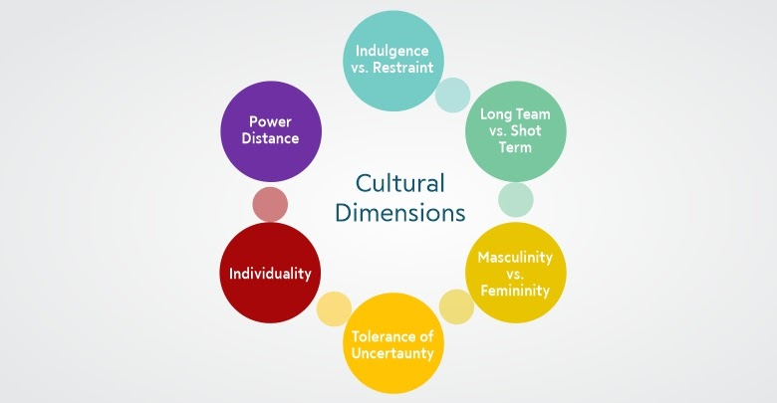
Figure 1: Hofstede's 6 cultural dimensions. Source: (Bruin, 2017)
The model helps in understanding a country’s people’s perspective, expectations, behaviour, etc. from 6 different cultural dimensions. For example, the people of Saudi Arabia hold a high score on power distance which means people in Saudi Arabia try to avoid uncertainty. So, establishing an employee-friendly workplace in IHG’s operation in Saudi should give employees the certainty of jobs (Dev et al., 2019).

Recent change activities and their impacts
An unexpected and undesirable change can come at any time. The occurrence of any incident in a micro or macro-environment keeps the high potentiality of affecting the normal flow of business operation (Will and Muller, 2020). The most recent event, the Covid-19 pandemic has induced businesses to rethink their business model sustainability. The incident required firms to redesign their organisational structure, culture, to give a better workplace for the employees and improve the customer journey. The UK’s exit from European Union has become a concern for many businesses. Companies in the hospitality industry were concerned about having qualified employees as their mostly hired talented are European migrants (Farazad, 2020). Moreover, they were concerned about the rising cost of employment. The then CEO Patrick Whyte, confirmed that the company was not bothered about the Brexit because the company holds a small market share in the UK (Cranny and Gamal El-Din, 2018).
UK’s and the world’s hospitality were in a boom before the pandemic. The pandemic occurrence required people to avoid physical contact to be saved from the virus infection. Over 50% of Intercontinental staff were on furlough. Engaging them in the workplace was a big challenge for Intercontinental. It has taken steps to give employees job security and salary and health benefits, for increasing the employee workplace motivation and engagement. The change in the workplace of Intercontinental hotel, are analysed by using the following change management aspects.
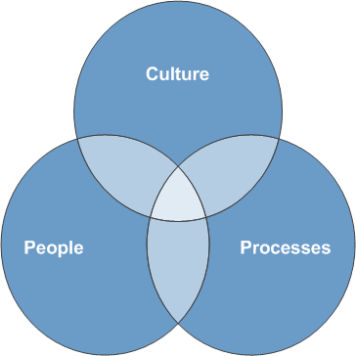
Figure 2: Aspects of Change. Source: (Santos and Quilliam, 2015)
Bringing a change and making the change permanent in an organisation is challenging because people are as usual resistant to change. The pandemic raised the issue of health safety of employees and guests in the hospitality industry. Reopening the operation after relaxing the Covid-19 restrictions in different countries, the Intercontinental hotel has taken steps to safety of employees and customers (Mehta and Panse, 2022). It brought training and other programs to ensure the cleanliness of the operation. In every service area, to ensure contactless services the company uses digital technologies. IHG has a global Cleanliness Board which partners with Cleveland Clinic, Ecolab and Diversey for ensuring training and equipment to improve the stay experience. IHG increased communication with the guests to assure the measurements were taken for the safety the guests. Details about cleanliness are provided on the company’s website, mobile app, and hotel notice boards (IHG PLC, 2020). In reception, guest rooms, meetings and events, and public places in the hotels, and every area, Intercontinental worked on ensuring contactless services. Handling these biggest changes in customer service, they work collaboratively with their employees. There involves a group of people are the employees and customers who are directly related to these service delivery changes in Intercontinental. The process of implementing the changes in Intercontinental was accompanied by using advanced technologies. Culture is an important part of a person’s life. People are much more resistant to any changes. They love to follow tradition and their habits. In implementing the new hotel service, it was a challenge for Intercontinental to alter the habits of guests. Managing these changes with industry expert Cleveland Clinic made it easier to implement. After implementing a change, ensuring the change is a permanent one is not much easy. The company need to be supportive in helping its people to adapt to the change gradually.

Strategic direction and business performance
Intercontinental aims to ensure true hospitality for the customers. Strategic direction refers to the guidelines used to achieve a company’s vision and goals. Proper strategic direction can help a business organisation to enjoy a competitive advantage over its competitors. The vision of Intercontinental is to be one of the great companies across the world.
With the operation in more than 100 countries, Intercontinental hotel is recognised as one of the largest hotel chains in the world. It’s one of the biggest earning sources from the franchise. It operates through the franchise, owned, or management. The company in the 90s focused on providing luxury hotel services. To strengthen its perception, the company recently rebranded with the name IHG Hotels and Resorts. The brand wants to get more relevance to the customers and attract the customers. The company focus on expanding by providing more luxury and lifestyle services. The rebranding of the brand name is made to reinforce the IHG Luxury and Lifestyle collection. It is expanding across the world through its luxurious footprint.
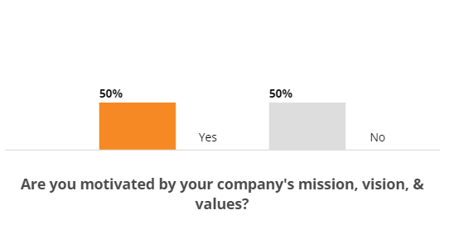
Figure 3: Employee motivation by mission statement in Intercontinental. Source:
A study by Comparably, (2010) where the response from 461 hotel staff of Intercontinental participated demonstrates that the company’s mission statement motivates 50% of the workers in the workplace. A planned and motivating mission statement can motivate employees and increase employee engagement in the workplace. Intercontinental’s mission statement motivates employees in the workplace. Through the mission statement, Intercontinental entails that it would love to create a difference for the guests, employees, colleagues, etc. For many years, the company is giving importance to culture to make a different experience for the guests. The presence in the diverse market has created a competitive advantage for Intercontinental. To enjoy the traditions and culture of different countries, one may now consider taking hotel service from Intercontinental.
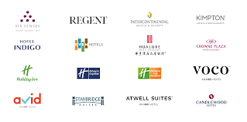
Figure 4: Hotel brands of IHG. Source: (IHG PLC, 2020a)
Intercontinental increasing its presence worldwide by increasing its number of hotel operations. It has a history of 200 years in the hospitality industry where it serves with passion. It tries to luxury seeker guests to give unforgettable hotel experiences. All of the brands of IHG are internationally recognised brands with a high brand image. These brands are established as elegant and luxury hotels. With this strong brand image, IHG can go a long way in the future in the competitive hospitality industry. The customer brand perception of IHG is luxury hotel service where the company is meeting the demand of the customers. During the pandemic time, Intercontinental reported low profits in the years 2020 and 2021 in its US market (Statista, 2022).
The profit analysis and comparison say that IHG definitely facing a tough time due to this pandemic mismatch. The company is recovering from the loss as the scenario of the Covid-19 pandemic is improving. Its revenue in the US market has been improved compared with the previous year 2020.
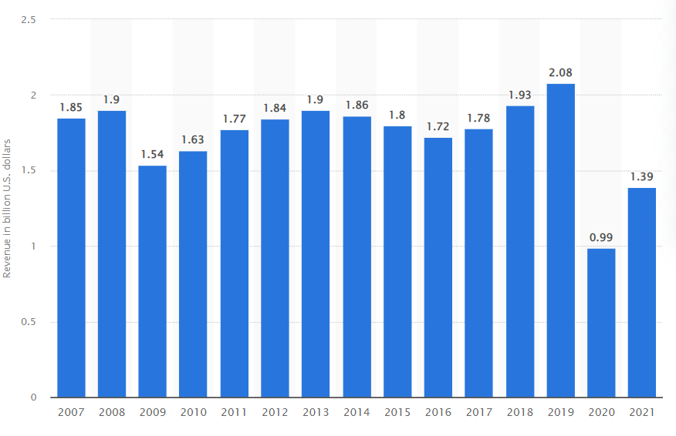
Figure 5: Intercontinental's revenue in the US market. Source: (Statista, 2022).

Conclusions
By following complex organisational structure, where the area and functional both organisational structures are implemented together. To handle the different functions in a business efficiently required an organised way of doing the task. By dividing different functions and giving responsibility to the person, IHG is handling its global operation (Vasić and Čerović, 2018). In the management of global operation, it a great team of diverse people. A flexible work environment is its core where it takes feedback from its employees. It fosters the culture through the statement “you said it, we did it”. Giving value to employee opinions, the company has become an attractive workplace for many talents. The biggest workplace changes and customer service changes happened in IHG during this pandemic time. It partnered with the industry expert to ensure cleanliness in the hotels. The positive response from customers and employees helped the company in implementing contactless services where it ensured the tough of advanced technologies. With a luxury brand image, the company is expanding its operation worldwide (Quek, 2012).

Recommendations
IHG has scope for further expanding its operation. It can leverage the Asian market. Intercontinental is a luxury brand. IHG should bring more service innovations for the customers to be sustainable in this competitive market. Now consumers are demanding more sustainable products and services. So, IHG should use sustainable operation where it needs to take steps. The steps can be taken such as using renewable energies, recycling its products, reducing plastic use, etc. for becoming a sustainable company and getting good attention from the customers, governments, and society as a whole.

References
Bruin, L. de (2017). Hofstede’s Cultural Dimensions EXPLAINED with EXAMPLES | B2U. [online] B2U - Business-to-you.com. Available at: https://www.business-to-you.com/hofstedes-cultural-dimensions/.
Comparably (2010). Overall Culture. [online] Comparably. Available at: https://www.comparably.com/companies/342644/mission.
Cranny, M. and Gamal El-Din, Y. (2018). InterContinental Hotels CEO Isn’t Worried About Brexit. [online] Skift. Available at: https://skift.com/2018/04/19/intercontinental-hotels-ceo-isnt-worried-about-brexit/.
Dev, J., Das, S., Rashidi, Y. and Camp, L.J. (2019). Personalized WhatsApp Privacy: Demographic and Cultural Influences on Indian and Saudi Users. SSRN Electronic Journal. doi:10.2139/ssrn.3391021.
Farazad, K. (2020). The Impact of Brexit on Hotel Industry and 2020 Outlook | By Korosh Farazad. [online] Hospitality Net. Available at: https://www.hospitalitynet.org/opinion/4096893.html.
Hofstede, G., Hofstede, G.J. and Minkov, M. (2010). Cultures and Organizations : Software of the Mind : Intercultural Cooperation and Its Importance for Survival. 3rd ed. Maidenhead: Mcgraw-Hill.
Holyoak, L. (2019). Organisational Culture: Organisational Change? Leadership & Organization Development Journal, 23(6), pp.354–355. doi:10.1108/lodj.2002.23.6.354.4.
IHG (2019). Our History. [online] InterContinental Hotels Group PLC. Available at: https://www.ihgplc.com/en/about-us/our-history.
IHG (2021). Executive Committee. [online] InterContinental Hotels Group PLC. Available at: https://www.ihgplc.com/en/about-us/our-leadership/executive-committee [Accessed 3 Feb. 2021].
IHG PLC (2020a). Introducing IHG. [online] InterContinental Hotels Group PLC. Available at: https://www.ihgplc.com/en/investors/introducing-ihg.
IHG PLC (2020b). Our response to Covid-19. [online] InterContinental Hotels Group PLC. Available at: https://www.ihgplc.com/en/about-us/our-response-to-covid-19.
Mehta, K. and Panse, C. (2022). Effect of Covid-19 pandemic: tourism and hospitality industry. CARDIOMETRY, (22), pp.406–414. doi:10.18137/cardiometry.2022.22.406414.
Moerdyk, A.P., Dodd, N., Donald, F., Kiley, J., Van, G. and Van, E. (2015). Organisational behaviour. Cape Town, South Africa: Oxford University Press Southern Africa.
Quek, M. (2012). Globalising the hotel industry 1946–68: A multinational case study of the Intercontinental Hotel Corporation. Business History, 54(2), pp.201–226. doi:10.1080/00076791.2011.631116.
Santos, N. “Amy” and Quilliam, W. (2015). An Overview of the Change Management Process and Examples of Software to Help Organizations Effectively Manage Change. GSTF Journal on Business Review (GBR), 4(1). doi:10.7603/s40706-015-0001-x.
Statista (2022). IHG: net income 2019. [online] Statista. Available at: https://www.statista.com/statistics/223408/net-income-of-the-intercontinental-hotels-group/.
The Economic Times (2018). IHG: Why employees are proud to be associated with a brand like IHG. The Economic Times. [online] Available at: https://economictimes.indiatimes.com/jobs/why-employees-are-proud-to-be-associated-with-a-brand-like-ihg/articleshow/64825635.cms.
Turi, J.A. and Sorooshian, S. (2019). The impact of organisational structure on organisational learning. Middle East J. of Management, 6(2), p.204. doi:10.1504/mejm.2019.097817.
Vasić, Ž. and Čerović, S. (2018). Financial function transformation in the information era case study Intercontinental Hotels Group. Turisticko poslovanje, (22), pp.51–59. doi:10.5937/turpos1822051v.
Will, M.G. and Muller, J. (2020). Towards a Micro-Foundation of Organizational Change: Conceptual Requirements for a Micro-Macro Framework of Change. International Journal of Learning and Change, 12(2), p.1. doi:10.1504/ijlc.2020.10027814.
Wong, K. (2020). Organizational Culture: Definition, Importance, and Development. [online] Achievers. Available at: https://www.achievers.com/blog/organizational-culture-definition/.

