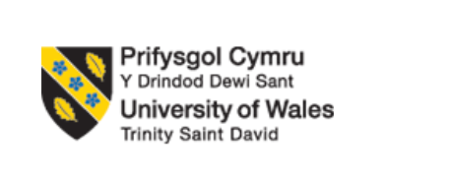
Program: Master of Business Administration
Module: International Business Concepts
Module code: LCMB7034
Name: Amaan Allauddin Sayyed
Student ID: 2437446

Table of Contents
Section 1: International Business Report 2
1. Introduction to the Report 2
2. Industry and Country Overview 2
Industry Introduction 2
South Korea Overview 3
Market Positioning of Apple in South Korea. 3
Competitive Analysis (Porters 5 Forces) 4
3. Adopt Diamond Model of National Advantage by Michael Porter 5
4. Evaluation of Apple’s Operations in South Korea 6
Choice of Foreign MNC/TNC: Focus on Apple as a Major Multinational Corporation (MNC) 6
Political Environment: Analyzing Political Factors in South Korea 6
Economic Factors: South Korea Economic Landscape. 7
Legal Environment: The Legal Issues in South Korea that impact Apple. 8
Cultural Factors: South Korean Culture and Ways how Apple can fit into it. 9
SWOT Analysis: Strength, weaknesses, opportunities, and threats of Apple in South Korea. 10
5. Conclusion to the Report 11
Section 2: Reflective Account 11
Introduction 11
Description 12
Feelings 12
Evaluation 13
Analysis 13
Conclusion 14
Action Plan 14
References 16

Section 1: International Business Report

1. Introduction to the Report
Apple Inc. is an international company that manufactures consumer electronics to the global market, its innovation and dominance. The combination of hardware and software to create a user experience that is both exceptional is also a feature of its products, including the iPhone, iPad, MacBook and Apple Watch. In this report, the operation of Apple Inc. in South Korea will be analysed, as the market is both a great opportunity and a great challenge to international firms. South Korea is a technologically advanced nation, having some of the best in the electronics market like Samsung and LG and thus a competitive yet a strategic market to Apple. This report will evaluate the industry, Apple market strategies and competitiveness by laying emphasis in its positioning in South Korea, as compared to local and multinational competitors. Michael Porters Diamond Model will be employed in the critical analysis of the competitive advantage that Apple enjoys in South Korea, and in addition, examine the political, economic, legal and cultural environment in which Apple operates.

2. Industry and Country Overview

Industry Introduction
Consumer electronics industry is among the most active industries in the world due to the continuous improvement in technology and demand of the consumers to innovations. The products that are under this industry are highly diverse and they comprise of smartphones, personal computers, televisions, wearables and home appliances. By 2024, the world electronics market has been experiencing a healthy growth with consumer demand on smartphones, tablets, and connected devices being at an all-time high (Fatehi and Choi, 2025). However, the industry is highly competitive with a high level of product innovation and price rivalry.
Apple, having concentrated on high-end products, has been able to establish a good standing in the international market. It is however, highly competitive with both local and international players. It can be mentioned that Samsung Electronics is the biggest tech company in South Korea, and the direct competitor to Apple in the production of several products, including smartphones, tablets, and smartwatches. In South Korea, Apple and Samsung are highly competing with Samsung dominating the technological market. However, Apple has managed to be innovative and differentiate through design, user experience, and integration into ecosystems and this has allowed it to remain relevant in this competitive market (Chen, 2024).

South Korea Overview
The Republic of Korea is a highly developed and economically successful country in the world, officially known as South Korea. South Korea is ranked 10 th in the world in terms of the economy, with technology being one of the largest sources of its GDP (Lu et al., 2023). It also hosts some of the major international technology firms such as Samsung and LG electronics that are taking over consumer electronics market. The technological infrastructure of South Korea, high internet speed, and tech-oriented citizens, make it an ideal place to develop the consumer electronics sector (Hartmann et al., 2022).
South Korea consumer electronics market is highly competitive with a large market share by domestic companies like Samsung and LG. These companies enjoy brand loyalty and patronage by the government and finding foreign companies like Apple to permeate the market is hard. The presence of a high-income economy, the development of digital infrastructure, and the constantly expanding consumer base with an ever-growing propensity to utilize new technologies makes South Korea a promising market to foreign companies despite these challenges (Pereira et al., 2022).
There are threats and opportunities of South Korea to Apple. On the one hand, the country is an attractive market of high-end consumer electronics due to the rising number of middle-class and the rising disposable income. On the other hand, the problem of local competition, sensitivity of consumers in relation to prices, and the locality trend in favor of local brands are something that Apple has to grapple with (Saridakis et al., 2024).

Market Positioning of Apple in South Korea.
Apple competitive advantages in South Korea also encompass its high pricing policy, brand loyalty and focusing on product quality. The premium products of Apple such as the iPhone, MacBook and the Apple Watch appeal to the South Korean consumer who values design, performance, and hardware and software integration. However, the South Korean market is very competitive, particularly to Apple as there is Samsung Electronics, a local company and a major competitor of Apple in the world market. Samsung offers the same products, but at a lower cost, which is attractive to price-sensitive consumers.
To overcome these obstacles, Apple enjoys a good presence in South Korea because of its brand image, innovation and customer loyalty. The emphasis on user experience, especially its integrated ecosystem of devices, services, and software, has enabled Apple to keep a base of loyal customers in a very competitive market. However, the high-end pricing model has made Apple unattainable to a significant market of the South Korean market where Samsung and other local rivals offer similar features as those of Apple at much cheaper prices (Moon, 2022b).

Competitive Analysis (Porters 5 Forces)
The Five Forces Model of Michael Porter can be very useful in analyzing the competition of Apple in South Korea and its strategic positioning in the market.
Competitive Rivalry (High):
South Korea has some powerful technology companies like Samsung, LG and Hyundai. These firms have a strong presence both in the local and international markets and they present a stiff competition to Apple. Samsung is the company that enjoys a high presence both in the smartphone, tablet, and wearables markets. The differentiation of its products by design and ecosystem integration has enabled Apple to preserve a competitive advantage, yet the competition is still high (Buckley et al., 2022).
Threat of substitute products (Low):
The barriers of entry into the South Korean consumer electronics market are relatively low and could be a threat to new entrants due to barriers to market entry like high capital requirements, brand loyalty and the existence of domestic players like Samsung and LG. Moreover, the market can be described as highly competitive, due to which the entrance of new companies is not an easy task (Konina, 2023).
Supplier power (Moderate):
Apple supply chain is diversified as the key suppliers reside in the whole world including South Korea. One of the suppliers of Apple in display technologies and semiconductor chips is Samsung Electronics. Although Apple has large-scale operations, which provide it with a high bargaining power, it still has to rely on suppliers to provide it with essential parts, which give it some degree of leverage (Coche et al., 2024).
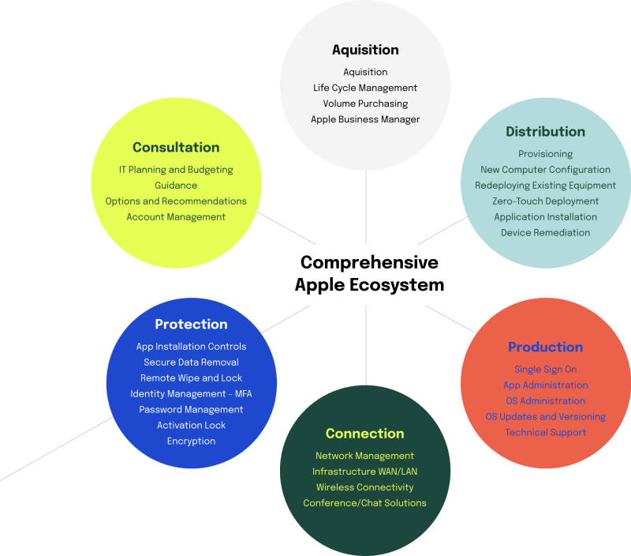
Bargaining Power of Consumers (High):
The South Korean consumers are extremely sophisticated and technologically advanced and this provides them with a high bargaining power. Consumers in South Korea are turning out to be price-sensitive particularly as the local companies like Samsung are offering products with equal competitiveness to Apple expensive-priced products. The threat of substitutes is greater since the substitutes are less expensive and forces Apple to innovate at all times and offer a value to its premium prices (Pereira et al., 2022).
Threat of substitutes (High):
Threat of substitutes in South Korea is high as it has availability of competitive substitute that is offered by the local companies like Samsung, LG which are offering the same products but at a lower price. Moreover, South Korean consumers are very brand-conscious and appreciate technological advancement, implying that they will resort to alternative brands in case they feel that there is a better value (Lu et al., 2023).

3. Adopt Diamond Model of National Advantage by Michael Porter
The model that can be used to explain how nations or regions provide competitive advantages to companies like Apple is the Diamond Model by Michael porter. The model has four factors, namely, factor conditions, demand conditions, related and supporting industries, and firm strategy, structure, and rivalry.
Factor Conditions:
South Korea has an advantage in terms of technology infrastructure including high-speed internet, advanced mobile network and skilled workforce, which puts companies like Apple at an advantage. South Korea has one of the most developed technological ecosystems in the world and the system of suppliers and producers is highly developed. These factor conditions have the benefits of Apple acquiring significant components of their product such as displays and semiconductors among other components that are sourced in South Korea particularly Samsung (Fatehi and Choi, 2025). Furthermore, South Korea has laid emphasis on research and development and innovation that has turned the country into an electronics giant in the world.
Demand Conditions:
The South Koreans have been described as a people with the high demand of high quality technology products. The technologically oriented individuals in the nation are highly inclined towards the utilization of advanced technological equipment with their sophisticated characteristics that qualify to fall within the bracket of the Apple products. The rising affluence of South Korean consumers, as well as their demand to have high-quality electronics, offers great opportunities to Apple. Nonetheless, local companies such as Samsung, which serve a large number of consumers, present competition, and Apple has to be innovative all the time to stay in the market (Chen, 2024).
Related and Supporting Industries:
South Korea has a well-developed electronics supply chain that forms a good backbone to the operations of Apple. Apple enjoys the advantage of having good networks with its local suppliers of key elements such as display technologies and semiconductor chips. Samsung and LG are other key market players, creating a very competitive market environment and, at the same time, offering Apple the opportunity to access the newest technology (Konina, 2023).
Strategies, Structure and Competition of Firm:
Apple is planning to differentiate products in South Korea and they focus on design and innovation. The brand loyalty and high price enabled Apple to create a niche in the competitive South Korean market, although there is strong competition with local giants such as Samsung. The example of the rivalry between Apple and Samsung in South Korea highlights the importance of innovation and brand differentiation as the key components of the competitive strategy (Harvey and Rabetti, 2024).

4. Evaluation of Apple’s Operations in South Korea

Choice of Foreign MNC/TNC: Focus on Apple as a Major Multinational Corporation (MNC)
Apple Inc. is one of the most popular and highly rated multinational companies in the world that is innovative in the field of consumer electronics, and in its ecosystem of products and services, which are interdependent. Apple is based on high pricing, sophisticated technology and brand loyalty as their business model which has made the company achieve remarkable achievements within the foreign markets. Although Apple has its operations in different parts of the world, its operations in South Korea have their own challenges and opportunities, owing to the fact that the country has one of the most competitive technology markets, advanced consumer market and regulatory environment.
Apple operations in South Korea are however threatened by several challenges such as the presence of stiff competition with the local companies, price sensitivity and the regulatory barriers. The key to Apple to succeed in overcoming these difficulties is its continuous innovation and sensitivity to the local consumer preferences. This section will explore how the political, economic, legal and cultural forces of South Korea affect the operations of Apple and then a SWOT will be analyzed.

Political Environment: Analyzing Political Factors in South Korea
In South Korea, the political environment has a great influence on the operations of Apple. South Korea is a mature democracy with good legal system and government departments which support businesses. However, the country is not devoid of political factors that have an impact on Apple business.
Trade Policies and Government Regulations:
South Korea has opportunities and threats to Apple in the regulatory environment. The government has been engaging in the encouragement of innovation in information and communication technologies (ICT) which is advantageous to tech companies such as Apple. Nevertheless, its pricing strategies can be impacted by the trade policy and tariffs on imports. To illustrate, in case the tariffs on foreign-produced electronic products increase, Apple might experience increased costs on the imports which will influence its pricing strategy in South Korea (Harvey & Rabetti, 2024).
Economic Nationalism and Protectionism:
There is a tradition of South Korea shielding its local industries especially in the technological sector where the lead is taken by such companies as Samsung and LG. The South Korean government policies on protectionism, such as favoring local suppliers and companies can be an impediment to the foreign MNCs like Apple. Using the Korean example, the policies might promote the use of domestic material in consumer electronics products over imports, which would be a threat to Apple to source some of its vital components (Lu et al., 2023).
Geopolitical Tensions:
The foreign companies in South Korea are also affected by the geopolitical environment of South Korea. The current tension with North Korea and the diplomatic ties with China may bring about uncertainties. The relations of South Korea with other countries, including the U.S., may also affect Apple because the political forces may cause the fluctuations of trade agreements, tariffs, and free flow of technologies (Coche et al., 2024).
In conclusion, South Korea is a well-established political system, however, Apple will have to face domestic protectionist regulations, trade barriers, and geopolitical tensions. These will influence the pricing, sourcing and long term strategic planning of Apple in the country.

Economic Factors: South Korea Economic Landscape.
South Korea boasts of one of the most competitive economies of the world. By the year 2024, it will be the 10 th largest economy in the world in terms of GDP, consisting of high tech manufacturing and export, and highly skilled work force. South Korea consumer electronics business is a large economy boosting industry, in the local market, as well as export.
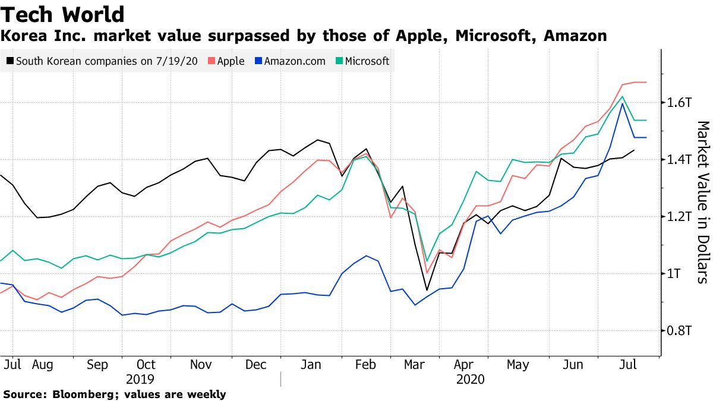
GDP and Disposable Income:
South Korea has a stable growth in the GDP which is backed by high-tech industries and export. The country has also seen an increase in its disposable income by 2024, which is a good indicator of Apple luxury products. Increase in the middle-income and better living conditions is an excellent market of high-quality electronics like iPhone and MacBook produced by Apple but the competition is also stiff (Moon, 2022b).
Tax and Corporate Tax:
Tax regime in South Korea comprises of corporate taxes and consumer taxes that can impact on Apple pricing strategy. The corporate tax rates in South Korea are competitive to those of other other countries in the region and Apple will have to dance around local tax regulations to make the most out of its operations. Additionally, the consumer electronics Value Added Tax (VAT) in South Korea may affect the final cost of Apple products that may be harder to compete with the local companies that offer lower priced products (Lu et al., 2023).
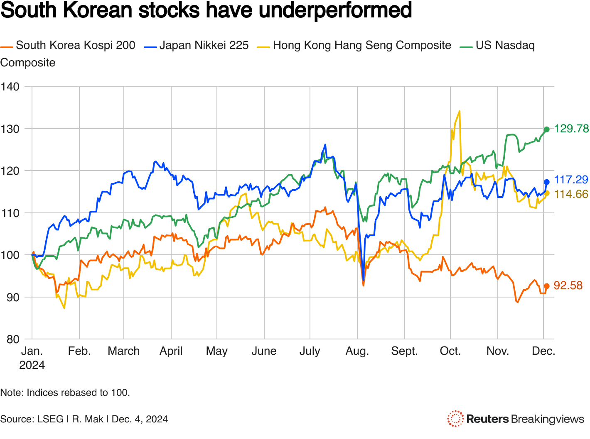
Exchange Rates and Inflation:
Another important economic factor that may affect the operations of Apple is the exchange rate between the South Korean won and the U.S. dollar. Any change in the currency may affect the profitability of Apple, particularly bearing in mind that the company imports its parts in the foreign countries, and sells its products in the U.S. dollars. The inflation rate in South Korea is relatively low, consequently, the stable power of consumers to buy and the threat of the price fluctuations of Apple products are minimized (Pereira et al., 2022).
In conclusion, the fact that South Koreans have a great economy is a massive opportunity to Apple because it has achieved a disposable income, high-technology and well developed market. However, local taxation laws, exchange rates, and competition with local firms will also pose some challenge to Apple.

Legal Environment: The Legal Issues in South Korea that impact Apple.
The legal environment of South Korea is extremely critical in the operations of Apple. South Korea is a highly regulated market, with a strict regulation on the business practices, intellectual property and consumer protection. To improve operations in the country without any legal obstacles, Apple will have to abide by these laws.
Intellectual Property Laws:
South Korea is also endowed with strong intellectual property protection laws and this is an advantage to protect its patents, trademarks and copyrights to Apple. Apple products are creative and are founded on these protection as a means of remaining in the competitive position. Nevertheless, Apple needs to continuously protect its intellectual property against possible counterfeiting and patent violation, particularly, as the market is becoming more competitive with the presence of local competitors, such as Samsung and Huawei (Cotte et al., 2024).
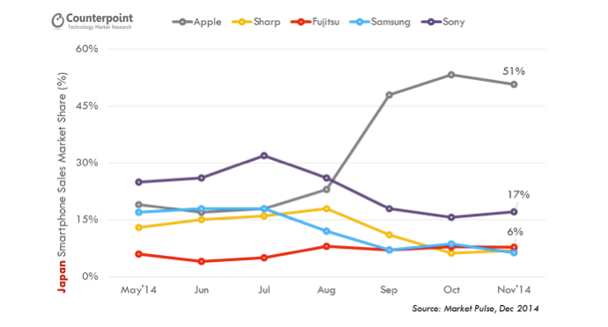
Product Standards and Safety Regulations:
The regulations in South Korea on product safety and quality especially on consumer electronics are strict. Apple has to make sure that its products meet these regulations such as battery safety, environmental regulations and electromagnetic interference regulations. The lack of compliance can result in product recalls, fines, and negative publicity (Fatehi and Choi, 2025).
Consumer Protection Laws:
The South Korean consumer protection laws have been put in place to protect the rights of consumers particularly in the area of warranty of products, refund as well as the safety of products. Apple should not overlook the fact that its policies regarding the returns, warranty and customer care must be aligned according to these policies. Dissatisfaction among consumers or legal issues may damage the brand name of Apple in South Korea, where they are very knowledgeable and conscious of their rights (Harvey and Rabetti, 2024).

Cultural Factors: South Korean Culture and Ways how Apple can fit into it.
The cultural factors play an important role in consumer preference, buying behaviour and marketing strategies. South Koreans have status, brand loyalty and technological affinity among their cultural values that affect the purchasing decisions of consumers.
Brand Loyalty and Status Consciousness:
Brand prestige and status are of much importance to the South Koreans. The high-priced products and innovative design of Apple attract the South Korean inclination towards exclusivity and quality. However, Apple must also grapple with a local pride as well, as South Koreans are more likely to buy local products, which are established and associated with the national identity, like Samsung and LG (Chen, 2024).
Tech-Savvy Consumers:
South Korean consumers are known to be early adopters of a new technology. Apple strategy in South Korea must fit in such a technology-driven market and offer products with the newest technologies, such as 5G technology, artificial intelligence, and camera capabilities among other features. Also, Apple has to make its products localized to the requirements of South Korean users, including integrating them with the local applications and services (Saridakis et al., 2024).
Marketing and Advertising:
Apple marketing strategy in South Korea focuses on promoting its expensive brand through luxurious shopping experience, online advertisements and through the connections with local celebrities. The Apple advertising campaigns tend to emphasize innovation, design, and user experience, which is in line with the South Korean values of the most advanced technology and beauty (Pereira et al., 2022).

SWOT Analysis: Strength, weaknesses, opportunities, and threats of Apple in South Korea.

Strengths:
strong Brand Loyalty: Apple brand is linked to quality, innovativeness and high quality design. This makes it have a competitive edge in South Korea technology market.
Innovation: Apple is an innovative company, particularly in the smartphone and wearable technology, which has made it lead the curve with regard to product offerings.
Ecosystem Integration: Apple has a highly integrated ecosystem, which includes hardware, software and services, and this has enabled it to attain a high customer satisfaction and brand loyalty.
Weaknesses:
Premium Pricing: This premium pricing strategy of Apple makes it less price sensitive to customers and more so in a market where cheaper locally available commodities like Samsung exist.
Dependency on Imports: Apple will face the cost of depending on the exchange rate change and trade policies by depending on imports to supply the components and finished goods.
Low Local Adaptation: Apple can have challenges over adapting its products and services to local tastes and cultural values in South Korea where local brands are so prevalent.
Opportunities:
Increasing Middle Class: The increasing middle class in South Korea is an opportunity that Apple can use to increase its customer base by offering cheaper models and diversification of its products.
Technology Adoption: South Korea being a country with a history of early technology adoption has opportunities that Apple can use to unveil new innovations, which include 5G smartphones, AR devices, and AI-based services.
Environmental and Social Responsibility: Apple can leverage its sustainability and environmental friendliness to appeal to the South Korean customers who would tend to shop at a brand that is environmental friendly.
Threats:
High competition: This is a highly competitive market with Apple competing with local giant companies like Samsung and LG that are similar products at a competitive price.
Regulatory Problems: Apple is likely to have some difficulties with its operations in South Korea because of its strict regulations, in particular, on product safety and data protection.
Economic Slowdown: The economic recessions, alterations in the consumer spending patterns or trade tensions between the countries can also adversely affect Apple sales in South Korea.

5. Conclusion to the Report
In this report, the operations of Apple Inc. in South Korea have been evaluated as well as the political, economic, legal and cultural factors that affect the business strategy of the company. The premium branding, innovation and brand loyalty has helped Apple to establish itself in South Korea. However, the firm faces several problems such as stiff competition against local rivals such as Samsung, regulatory challenges and localism orientations towards local products.
The key competitive advantages that Apple will enjoy in South Korea include its good brand name and technological prowess but to remain competitive it must continue to innovate and match its products with the taste of locals. The company must also take into consideration pricing strategies that are accommodating to the rising middle class and balancing its high-end brand image. Furthermore, it will be crucial to maneuver political and legal policies in South Korea such that Apple emerges a success in the long run.
The strategic recommendations will include, investing more in local partners, expanding the product range of Apple such that it has cheaper brands and enhance their marketing strategies to indicate that it is environmental sustainable. The other area that Apple should focus on to build stronger relations with South Koreans is localization of its services and further enhance its integration of ecosystem. This is through addressing these opportunities and threats that Apple can establish itself in South Korea and can still effectively compete in the world-wide technology market.

Section 2: Reflective Account

Introduction
When writing the report on the operations of Apple Inc. in South Korea, I have taken a systematic approach to research, analysis and synthesis of the business environment using different frameworks and models, including Porters Diamond Model and Porters 5 Forces to analyse the strategic position of the company within the South Korean market. The aim was to gauge the competitiveness of Apple in South Korea whilst considering the political, economic, legal, and cultural environment that affects its operations. This reflective report will critically analyze my process, the challenges encountered, the decisions I made as well as the lesson learned during the report preparation.
I will organize this reflection based on Gibbs Reflective Cycle that includes 6 steps: Description, Feelings, Evaluation, Analysis, Conclusion, and Action Plan. This method will give me a comprehensive review of my research and writing process, and I will be able to see what worked and what did not work and how I may better my future work.

Description
The assignment involved an analysis of the operations of the Apple Inc. in South Korea with a focus on some of the business-related aspects including political, economic, legal, and cultural environment along with a SWOT analysis. Firstly, I chose South Korea as a country of interest because of its well-developed technological base, high-income economy, and the high level of competitors such as Samsung. To gain insight into the regulatory environment, consumer behavior, and the overall competitiveness of the tech sector in South Korea, I did a lot of research.
It was done by collecting data among a variety of reliable academic sources, books, and journal articles that help with my analysis. I also used applicable business models, such as Porters Diamond Model, in assessing the strategic positioning of Apple in the South Korean market. I also examined external issues that influence the operations of Apple, including government policies, competition, and local preferences of consumers.

Feelings
I was excited and challenged when I started the assignment. I was interested to research the forces within a popular multinational company such as Apple within such a competitive market as South Korea. The task however appeared very daunting due to the complexity of assessing a variety of factors including the political landscape of the country, legal environment and cultural factors that directly affect the business strategy of Apple.
As I advanced, I became more confident about the process of research especially after finding and examining credible sources. An important note that caught my attention was the fact that Apple has a serious problem in South Korea as a result of the dominance of domestic firms such as Samsung. I was also shocked to learn that the interrelationship between cultural preferences and consumer behavior is so profound and complex in South Korea. I first failed to realize the aspect of local pride in the determination of consumers especially in terms of brand loyalty and the preference of home-based brands.

Evaluation
The study was a positive experience. I managed to locate numerous academic materials and journals that could offer me pertinent information about the business operations and the business strategy of Apple in South Korea. I especially liked how models, such as the Porters 5 Forces and Porters Diamond Model, allowed me to deconstruct the complicated aspects of the competitive position of Apple in the South Korean market.
The application of various models to examine the strategy of Apple was one of the main strengths of my approach. The use of the Porters models enabled me to evaluate the different forces that exist in the South Korean market in a systematic manner. Indicatively, the application of 5 Forces by Porter revealed the stiff competition that Apple experiences in South Korea and the bargaining power that consumers have in the country. This analysis framework provided structure to my report and enabled me to create actionable information.
There were a few difficulties in the research stage, however. Although I was in a position to obtain enough information on economical and legal factors, I had difficulty in grasping some of the cultural factors of South Korea. Consumer behavior in South Korean market is distinct in that most consumers prefer local brands. I was at first having a hard time judging how Apple branding might be able to cross these cultural barriers and still be successful in such a competitive world.
Also, collecting information about the political climate and trade policies in South Korean was more time consuming than I imagined. To have a clear view on how Apple manages to manoeuvre through trade regulations and government policies in South Korea, I had to weed through a variety of sources. This necessitated a more in-depth appreciation of macroeconomic trends as well as local political aspects.

Analysis
Considering the process, I think that the best lesson which I learned was that it is necessary to understand the local market conditions when studying the activity of a multinational corporation. The technological environment in South Korea is unique, having international technological giants such as Samsung and poses an opportunity as well as a great entry barrier to foreign companies. The success of Apple in South Korea does not only depend on its capability to innovate, but also its capability to accommodate the local cultural peculiarities such as brand loyalty and preferences of consumers.
The most problematic aspects of my analysis were the cultural and legal aspects. Although I knew the general regulatory framework and the economic profile of South Korea, it was the cultural and consumer behavior analysis that demanded more involvement. The success of Apple in South Korea is not merely a case of having the right product, but having a product that appeals to the need of the South Korean consumer to have a high-end and innovative technology. Unlike Samsung that also sells similar products at lower prices, Apple needs to concentrate on developing better brand loyalty and concentrating on high quality.
Additionally, the South Korean political climate, which is typified by trade agreements and protectionist policies, means that Apple has to continuously review its approaches to product sourcing, its tariffs as well as its local policies. The fact that Apple has been able to retain a robust presence in South Korea despite these obstacles is testament to its strategic flexibility and resilience to overcome complicated politics (Coche et al., 2024).

Conclusion
In a retrospective of the research process, I believe that my method of assessing the activities of Apple in South Korea was generally successful but I would have done a better job by including a more detailed examination of certain cultural knowledge and consumer behaviour trends. My frameworks, in particular Porters models, helped me to plan my analysis, however, now I know that a further exploration of the local adaptations strategies used by Apple would have been beneficial to my analysis. I might also have given more attention to the Apple supply chain and collaborations in South Korea which have played one of the main roles in its operation.

Action Plan
In the future, I will work on the following areas in my future reports:
Greater Cultural Insight: I will invest more time in learning about the local culture of the consumer behavior particularly in markets that have good national brands such as South Korea. These will cover researching cultural preferences in advertisement, brand perception, and buying decisions.
Wider Research on Political and Economic Forces: I will make sure that I am more holistic in assessing the political and economic environment such as policies on trade, local regulations and their direct effect on business strategy. This will entail going deeper into the framework to get more insight into how these factors are being applied in practice.
Use of Local Adaptation Strategies: I will be more observant of how multinational firms such as Apple make their products and services to conform to local markets and especially in marketing, technology and integration, and alliances with local suppliers or distributors.
Bettering Data Synthesis: I will practice synthesizing large volumes of data in a more efficient manner, so that each bit of information relates directly to the overall analysis and serves to back my conclusions.

References
Al-Sakaf, H. F. T. A. (2025). International marketing strategy of the enterprise (based on the materials company «Apple Inc.». http://dspace.puet.edu.ua/handle/123456789/15206
Buckley, P. J., Enderwick, P., & Voss, H. (2022). International business. Oxford University Press. https://books.google.com/books?hl=en&lr=&id=KTWAEAAAQBAJ&oi=fnd&pg=PP1&dq=International+Business+Concepts+Apple+inc&ots=8YofM097s7&sig=msxzjReQrwjKVUrwBjnOcko4J2A
Chen, Z. (2024). Business Strategy Analysis: Evidence on Apple Inc. 4th International Conference on Enterprise Management and Economic Development (ICEMED 2024), 104–112. https://books.google.com/books?hl=en&lr=&id=UigeEQAAQBAJ&oi=fnd&pg=PA104&dq=International+Business+Concepts+Apple+inc&ots=TQJIP_F262&sig=uTzMolwgCLYCOosp-TbCfiVIU0k
Coche, E., Kolk, A., & Ocelík, V. (2024). Unravelling cross-country regulatory intricacies of data governance: The relevance of legal insights for digitalization and international business. Journal of International Business Policy, 7(1), 112–127. https://doi.org/10.1057/s42214-023-00172-1
Fatehi, K., & Choi, J. (2025). International Strategic Alliance. In K. Fatehi & J. Choi, International Business Management (pp. 231–254). Springer Nature Switzerland. https://doi.org/10.1007/978-3-031-83295-6_8
Hartmann, S., Lindner, T., Müllner, J., & Puck, J. (2022). Beyond the nation-state: Anchoring supranational institutions in international business research. Journal of International Business Studies, 53(6), 1282.
Harvey, C. R., & Rabetti, D. (2024). International business and decentralized finance. Journal of International Business Studies, 55(7), 840–863. https://doi.org/10.1057/s41267-024-00705-7
Konina, N. (2023). Global Value Chains. In A. Bulatov (Ed.), World Economy and International Business (pp. 611–618). Springer International Publishing. https://doi.org/10.1007/978-3-031-20328-2_30
Lu, J. W., Ma, H., & Xie, X. (2022). Foreignness research in international business: Major streams and future directions. Journal of International Business Studies, 53(3), 449–480. https://doi.org/10.1057/s41267-021-00465-8
Lu, W., Kweh, Q. L., Ting, I. W. K., & Ren, C. (2023). How does stakeholder engagement through environmental, social, and governance affect eco‐efficiency and profitability efficiency? Zooming into Apple Inc.’s counterparts. Business Strategy and the Environment, 32(1), 587–601. https://doi.org/10.1002/bse.3162
Mahadevan, J., & Moore, F. (2023). A framework for a more reflexive engagement with ethnography in International Business Studies. Journal of World Business, 58(4), 101424.
Meyer, K. E., Li, J., & Brouthers, K. D. (2023). International business in the digital age: Global strategies in a world of national institutions. Journal of International Business Studies, 54(4), 577.
Moon, H.-C. (2022b). Global business strategy: Asian perspective. World Scientific. https://books.google.com/books?hl=en&lr=&id=mfBcEAAAQBAJ&oi=fnd&pg=PR5&dq=International+Business+Concepts+Apple+inc&ots=acFmtnEG-P&sig=twC4bsm_R0UbCYj1fRQ8n3q5N7U
Parboteeah, K. P., Cullen, J. B., & Kim, S. (2024b). International Business: Perspectives from developed and emerging markets. Routledge. https://www.taylorfrancis.com/books/mono/10.4324/9781003312932/international-business-john-cullen-praveen-parboteeah-sahrok-kim
Pereira, C. S., Durão, N., Moreira, F., & Veloso, B. (2022). The importance of digital transformation in international business. Sustainability, 14(2), 834.
Pereira, C. S., Veloso, B., Durão, N., & Moreira, F. (2022). The influence of technological innovations on international business strategy before and during COVID-19 pandemic. Procedia Computer Science, 196, 44–51.
Saridakis, G., Khan, Z., Knight, G., Idris, B., Mitra, J., & Khan, H. (2024). A Look into the Future: The Impact of Metaverse on Traditional Theories and Thinking in International Business. Management International Review, 64(4), 597–632. https://doi.org/10.1007/s11575-024-00550-8
Šilenskytė, A., Butkevičienė, J., & Bartminas, A. (2024). Blockchain-based connectivity within digital platforms and ecosystems in international business. Journal of International Management, 30(3), 101109.
Temouri, Y., Budhwar, P., Jones, C., Ylönen, M., Pereira, V., & Cobham, A. (2022). Tax havens and international business: A conceptual framework of accountability‐avoiding foreign direct investment. International Journal of Management Reviews, 24(3), 309–332. https://doi.org/10.1111/ijmr.12279
Theophilus, C. (2022a). Problems and Challenges Encountered in International Marketing (On the basis of “APPLE Inc”) [PhD Thesis]. Private Higher Educational Establishment-Institute “Ukrainian-American ….

