Strategic Travel and Tourism Management
(M6X02119)
Steffan Treharne
1705128
02/12/2019

Content table

Contents
Content table 2
Executive Summary 3
Introduction 4
Main Body 5
Heart of Wales Line and Trail 5
Stakeholders 5
Volunteers 5
Government & Council 6
Tourism 6
Llandrindod Wells – Links 7
Technology 8
Benchmarking 8
Highland railway 9
Devon & Cornwall 9
Recommendations & Conclusion 10
Recommendations 10
Conclusion 12
References 13
Appendices 19
1.1 porters 5 forces 19
1.2 20
Stats in percentage of overnight stays in Wales according to statswales (2017) 20
1.3 stats for Devon & Cornwall line partnership 20
1.4 Llandrindod wells heritage trail. 20
1.5 pest analysis 21
1.6 Swot analysis 21

Executive Summary

The report will try and give recommendations on how the line and trail for the Heart of Wales line for the next stage of growth by end of 2022. It will be looking at possibilities that have not been explored by Transport of wales and Community railway group. Also look at many viable options to progress the rail and trail to make it a more attractive for local communities and tourism by working with local businesses and volunteers.

Introduction

This report will be looking at particular integration of transport modes for The Heart of Wales Line, also making strategic recommendations to politicians and transport planners as to what could be done by key stakeholders to further develop rail-based tourism to take advantage of this increased capacity. It will be looking at pest and swot analysis and will be comparing to Devon & Cornwall rail Partnership and also The West Highland Line, it will be comparing and contrasting with these other destination attractions whilst critically analysing what’s on offer by heart of Wales line and trail.

Main Body

Heart of Wales Line and Trail

The heart of wales line is run by Transport for Wales which is one of many key stakeholders and the line turned 150 years old back in 2018, running from Swansea to Shrewsbury. Alongside the line there is a walking trail that runs from Llanelli to Craven 141 miles according to heart of wales line (2019). The lines aim for the next 3 – 4 years is to expand the capacity of the trains from 64 seats to 120 seats with an extra service taking it from 4 trains each way to 5 each way every day according to heart of Wales (2019). With the heart of Wales line there is a trail which exists because of Prof Les Lumsden according to Community railway group (2019). Being a rambler enthusiast Lumsden was very eager to work with the heart of Wales Line and together created the trail. The trail is run and encouraged by the community railway group who are one of many stakeholders with the line.

Stakeholders

Volunteers

There are many stakeholders in the project of the Line and Trail, these include volunteers who run and maintain the train stations. According to G. Kuhn. Et al (2002) explain one of many reasons people volunteer is because of interest, feel valued and enjoy interpersonal relationships. You can see this when visiting Llandovery train station which is run by volunteers who value the line and its importance to the community and have a sense of value that link them to the line and the relationships they gain by giving their time to volunteer, in theory they are the heart of the line that keeps it going. They also give a voice for the local communities that surround the line and trail without them it cannot simply survive.

Government & Council

Another key stakeholder is government and council which is also one of the key suppliers in Porters five Forces which is in the appendices 1.1 and pest analysis in 1.5, one of many reasons are because of the funding and accreditation the government give to the line and trail which according to transport for wales (2019) which says that the line has seen community railway partnership gain accreditation from both government and transport for Wales, which in turn will see more funding from ACORP and will have a louder voice for possible investment. With government they can help the line with marketing the rail and line by using visit Wales which in turn will have a positive benefit for adding numbers to the future plans of transport for wales trains with doubling seating in 2022. This also relates back to the five forces in appendices 1.1 where government is assisting instead of providing to competitors.

Tourism
Linking government with the line and trail, visit Wales who is owned by the government this will provide more tourists to the line and trail. The best market to target would be Adventure tourism, scenic explorers and cultural explorers. Also, there is a market in Europe with Germany and Netherlands as they are very active type of tourist according to owner of the caravan site in Llandovery (2019). When you look at Wales tourism strategy 2013- 2020, according to gov. Wales (2013) it promotes:
- Develop tourism activity and specialist markets.
- Work to extend the tourism season and associated benefits.
- Identify funding opportunities to improve the visitor infrastructure and product in Wales.

All of the points made above from 2013 until 2020 show that the possible chance of making this a viable option for the tourism niche market that the line and trial are trying to attract. Looking at statswales (2017) in appendices 1.2 it shows that percentages of tourists that stay for one night or more. With help from this the line and trail could easily be full and fill the seats needed to make it a success. figures could rise, such as the figures for the Devon & Cornwall rail partnership since figures came out in 2001. When looking at the figures from 2001 which is in the appendices 1.3 even with the lowest figure of 49% according to dcrp.org.uk (2019) that is still an impressive growth for a train line. There are no figures provided by the heart of wales line to compare. When looking at five forces appendices 1.1 under suppliers it shows product differences and brand identification issues according to F.M. Morhart. Et al (2009) “brand identification can generate resistance to change”. One of the main issues with the line is whilst being 150 years old, it should be defined as a heritage line. links between Llandrindod wells and the line defined by heritage. Most stops on the line are based on culture and heritage, this is one of the niche markets it should be targeting. Heritage and culture, it is defined by sense of place and belonging which links to the word Topophilia which according to Collins English Dictionary (2014) “the love of or emotional connections with place or physical environment”. This links to the passion and emotional connection that the volunteers have for both line and trail, but its due to the tangible and intangible of the environment they live in, in turn brings in a representation associated to the village or town.

Llandrindod Wells – Links

Looking at Llandrindod wells that has an abundance of hotels and a central location in Wales which makes the town an ideal tourist destination for mid Wales and surrounding area according to travelaboutbritain (2019). By looking at five forces appendices 1.1 this is could be considered as threat of new entrance. on the other hand, it’s an opportunity to develop and establish the trail and line as its targeting a richer clientele. By looking at appendices 1.4 heritage walk map of Llandrindod it takes tourists around of many important and heritage sites there are in town, which can be linked up with the trail which can become more enticing to the current visitors to both parties. With the line and trail they can create a downloadable app for a brochure and an audio guide that links to different destinations on the line such as llandrindod. According to museumsandheritage (2018) audio guides are one of the most powerful ways of getting visitors attention and engaging them in to the experience. This Links to technology which is also one of the key five forces on appendices 1.1 which is going to spoke about next.

Technology
Technology is part of a pest analysis in appendices 1.5 and five forces in 1.1, would attract tourists in ways of planning an itinerary by an app. It would search their location and bring suggestions on what is available in the surroundings, such as heritage trail and the line trail being compatible. Looking at a case in Italy where a group of engineers in 2012 according to S. BARILE. (2017), designed an app called Explorer, and that “Tourist tours” describes a tourist route in the city, organized according to the time/weather of the day. This would be a benefit for tourists and can plan new and better designed routes for the line and where people can visit as such places as Llandovery castle, llandrindod wells and Shrewsbury.

Benchmarking

Benchmarking according to Julien, F. W. (1993) “is the continuous process of comparing and measuring an organization's business processes against those of business leaders anywhere in the world. The objective is to identify and understand best practices”. Realistically the line and trail should be looking benchmarking, their benchmark is the highland train line and the Devon & Cornwall railway partnership.

Highland railway

By looking at the highland railway they engage more with the communities such as local businesses and volunteers, one issue that the heart of wales had was engaging with local businesses by creating food hampers which you can eat whilst looking at the scenery and is filled with local produce that surrounds the line according to Scotrail (2019). The rail also has finding like the heart of wales but is still benefiting according to highlandmainlinecrp (2019) “The Government provided financial support to the Association of Community Rail Partnership (ACoRP) to progress the pilot scheme. This shows that the government are still satisfied abut the work being done to keep the project alive and how its effecting communities.

Devon & Cornwall

Devon and & Cornwall success follows up with opening the line up to more rural but also holiday destinations which makes it more viable for the locals and its communities. They work with restaurants, shops, accommodation and other local businesses that benefit the line but also the community according to dcrp.org.uk (2019). They also work with students to give back to the community through projects like the time travelling train project according to dcrp.org.uk (2019). They also have a project called Friends of the Station groups where they support volunteer groups to transform local train stations According to dcrp.org.uk (2019).

Recommendations & Conclusion

Recommendations

There are several recommendations that can help the heart of Wales line such as creating an app that can help them plan day visits or over night stays and plan an itinerary which is in the technology section.
Also they need to engage with the community more, comparing it with the two benchmarked companies it also needs with local education such as schools or universities such as Llandovery college, Gov.uk (2019) explains “that successful colleges respond to the needs of their local economies, rather than targets set by central authorities”, this shows that education is important and vital not only for college but the economic impact it has on the local area as working together with a company such as the heart of wales brings in more skills.

Another recommendation would be Expanding the line looking at appendices 1.3 it shows the length of line and the figures on how its grown since 2001 according to dcrp (2019). Growth is important to any company, according to nibusinessinfo.co.uk (2019) explains why growth is important:

- take advantage of new opportunities
- expand your products or services
- attract more customers
- increase sales
- employ more staff

it’s important for the growth of the line where it could expand to Carmarthen for example, there is a line already links to Llanelli and can open a wider audience for more people on seats while also keeping the line as a heart of wales line Carmarthen is a hot spot destination and has many linkages to other destinations in wales.

This links with Heritage and Culture to Expand products and services as it will give more meaning to the line as Heritage and culture is one of the biggest markets in tourism. Some examples of statistics:

- oxfordeconomics.com (2019), “tourists made 192 million trips to visit the UK’s cultural, historic and natural heritage assets”.
- heritagefund.org.uk (2019), “Heritage-based tourism is worth £20.2billion to the UK economy”.
- britishdestination.com (2013), “The heritage GDP is £5.1 billion excluding natural heritage”.

These points show how important heritage is to tourism and should be seen as an opportunity for the line to work on and also create a trail of heritage like Llandrindod.

Conclusion

To conclude if the trail and rail look at the recommendations it can fill seats on trains that are expected to rise by 2022. Take advantages of making it a heritage themed attraction in itself, also expanding to Carmarthen to open up new opportunities to wider the consumer geological destination to create more consumers for seats available. while using the app would create a more interactive and easier way to create an itinerary which links to local businesses with options of attractions and places to eat. which keeps money within the local economy. Also working with colleges and schools will encourage the youth of today to maybe looking at a career on the line at the same time the knowledge of the line will expand with the minds of todays for the future.

References

1.BARILE, S., CIASULLO, M.V., TROISI, O. and SARNO, D., 2017. The role of technology and institutions in tourism service ecosystems: Findings from a case study. TQM Journal, 29(6), pp. 811-833.
2.britishdestination.com (2013), Direct Impact of Heritage Tourism, https://britishdestinations.files.wordpress.com/2013/10/economic-impact-heritagetourism-2013.pdf
3.Collins English Dictionary (2014) Collins English Dictionary – Complete and Unabridged, 12th Edition 2014 © HarperCollins Publishers 1991, 1994, 1998, 2000, 2003, 2006, 2007, 2009, 2011, 2014. https://www.thefreedictionary.com/topophilia
4.Community railway group (2019) presentation of the trail on Llandovery trip 18/11/2019
5.dcrp (2019) Growth since 2001, www.dcrp.org.uk
6.dcrp.org.uk (2019) Engaging the community, https://dcrp.org.uk/our-work/engaging-the-community/
7.dcrp.org.uk (2019) friends of the station groups, https://dcrp.org.uk/our-work/engaging-the-community/
8.dcrp.org.uk (2019), universities, https://dcrp.org.uk/our-work/engaging-the-community/
9.F.M. Morhart, W. Herzog, T. Tomczak (2009) Brand-specific leadership: Turning employees into brand champions, Journal of Marketing, 73 (2009), pp. 122-142
10.G.Kuhn. et al (2002). The volunteer satisfaction index. Journal of Social Service Research, 28(1), 45–68
11.Gov.uk (2019) Employer and college engagement, https://assets.publishing.service.gov.uk/government/uploads/system/uploads/attachment_data/file/306968/A_New_Conversation.pdf
12.gov.wales (2013), A Tourism Strategy for Wales, https://gov.wales/sites/default/files/publications/2019-04/partnership-for-growth-strategy-for-tourism-2013-2020.pdf
13.Heart of wales line (2019) future improvements, https://www.heart-of-wales.co.uk/FEES
14.Heart of wales line (2019) The Heart of Wales Line Trail, https://www.heart-of-wales.co.uk/experiences
15.heritagefund.org.uk (2019) Economic impact of UK heritage tourism economy, https:/www.heritagefund.org.uk/publications/economic-impact-uk-heritage-tourism-economy
16.highlandmainlinecrp (2019), (ACoRP) to progress the pilot scheme https://www.highlandmainlinecrp.co.uk
17.Julien, F. W. (1993) ‘The power of benchmarking. (cover story)’, Internal Auditor, 50(4), p. 22. Available at: https://search-ebscohost-com.ezproxy.uwtsd.ac.uk/login.aspx?direct=true&db=bth&AN=9402220633&site=ehost-live (Accessed: 2 December 2019).
18.museumsandheritage (2018) Tonwelt: Audio guides – an essential part of the visitor experience, https://advisor.museumsandheritage.com/features/tonwelt-audio-guides-essential-part-visitor-experience/
19.nibusinessinfo.co.uk (2019) Why is growth in business important? https://www.nibusinessinfo.co.uk/content/importance-business-growth
20.Owner of Llandovery caravan site (2019) Llandovery trip and talk
21.oxfordeconomics.com (2019), The impact of heritage tourism for the UK economy, https://www.oxfordeconomics.com/recent-releases/the-impact-of-heritage-tourism-for-the-uk-economy
22.Scotrail (2019) scenic journeys, https://www.scotrail.co.uk/scotland-by-rail/great-scenic-rail-journeys/west-highland-line-glasgow-oban-and-fort-williammallaig
23.statswales (2017) overnight stays in wales, https://statswales.gov.wales/Catalogue/Tourism/wales-tourism-accommodation-occupancy-survey/tourismaccommodationoccupancyrolling12monthaverage
24.Transport for wales (2019) The Heart of Wales: A Credit to Community Rail, https://news.tfwrail.wales/news/the-heart-of-wales-a-credit-to-community-rail
25.travelaboutbritain (2019) Llandrinod wells, https://www.travelaboutbritain.com/walesmid/llandrindod_wells.php

Bibliography

1.Albalate, Daniel, 2017. Tourism and high-speed rail in Spain: Does the AVE increase local visitors? Annals of Tourism Research, 65, pp.71–83.
2.Allen, Justine B., 2014. Sport event volunteers' engagement: management matters. Managing Leisure, 19(1), pp.36–51.
3.Anon, 2010. NR spends on Heart of Wales line. Rail Business Intelligence, (377), p.2.
4.Anon, 2013. Welsh tourism wants more spas to boost number. Leisure Management, 33(3), p.16.
5.BARILE, S., CIASULLO, M.V., TROISI, O. and SARNO, D., 2017. The role of technology and institutions in tourism service ecosystems: Findings from a case study. TQM Journal, 29(6), pp. 811-833.
6.britishdestination.com (2013), Direct Impact of Heritage Tourism, https://britishdestinations.files.wordpress.com/2013/10/economic-impact-heritagetourism-2013.pdf
7.Collins English Dictionary (2014) Collins English Dictionary – Complete and Unabridged, 12th Edition 2014 © HarperCollins Publishers 1991, 1994, 1998, 2000, 2003, 2006, 2007, 2009, 2011, 2014. https://www.thefreedictionary.com/topophilia
8.Community railway group (2019) presentation of the trail on Llandovery trip 18/11/2019
9.Connors, T.D., 2012. The volunteer management handbook leadership strategies for success 2nd ed., Hoboken, NJ: Wiley.
10.Coupland, Bethan, 2014. The authenticating discourses of mining heritage tourism in Cornwall and Wales. Journal of Sociolinguistics, 18(4), pp.495–518.
11.dcrp (2019) Growth since 2001, www.dcrp.org.uk
12.dcrp.org.uk (2019) Engaging the community, https://dcrp.org.uk/our-work/engaging-the-community/
13.dcrp.org.uk (2019) friends of the station groups, https://dcrp.org.uk/our-work/engaging-the-community/
14.dcrp.org.uk (2019), universities, https://dcrp.org.uk/our-work/engaging-the-community/
15.F.M. Morhart, W. Herzog, T. Tomczak (2009) Brand-specific leadership: Turning employees into brand champions, Journal of Marketing, 73 (2009), pp. 122-142
16.G.Kuhn. et al (2002). The volunteer satisfaction index. Journal of Social Service Research, 28(1), 45–68
17.Gov.uk (2019) Employer and college engagement, https://assets.publishing.service.gov.uk/government/uploads/system/uploads/attachment_data/file/306968/A_New_Conversation.pdf
18.gov.wales (2013), A Tourism Strategy for Wales, https://gov.wales/sites/default/files/publications/2019-04/partnership-for-growth-strategy-for-tourism-2013-2020.pdf
19.Gupta, Himani, 2004. How Do Welsh Tourism-SME Websites Approach Customer Relationship Management? Information & Communication Technologies in Tourism 2004: Proceedings of the International Conference in Cairo, Egypt, 2004, pp.525–537.
20.Harris, John, 2018. A Welsh European: Golf, tourism and the remaking of national imaging. International Journal of Cultural Studies, 21(4), pp.405–420.
21.Heart of wales line (2019) future improvements, https://www.heart-of-wales.co.uk/FEES
22.Heart of wales line (2019) The Heart of Wales Line Trail, https://www.heart-of-wales.co.uk/experiences
23.Henderson, Jane, 2019. Setting our direction: working together to develop a national approach to conservation of cultural heritage in Wales. Archives & Records, 40(2), pp.179–198.
24.heritagefund.org.uk (2019) Economic impact of UK heritage tourism economy, https://www.heritagefund.org.uk/publications/economic-impact-uk-heritage-tourism-economy
25.highlandmainlinecrp (2019), (ACoRP) to progress the pilot scheme https://www.highlandmainlinecrp.co.uk
26.Jingjing Lin, 2018. Decision, Implementation, and Confirmation: Experiences of Instructors behind Tourism and Hospitality MOOCs. International Review of Research in Open & Distance Learning, 19(1), pp.1–5.
27.Julien, F. W. (1993) ‘The power of benchmarking. (cover story)’, Internal Auditor, 50(4), p. 22. Available at: https://search-ebscohost-com.ezproxy.uwtsd.ac.uk/login.aspx?direct=true&db=bth&AN=9402220633&site=ehost-live (Accessed: 2 December 2019).
28.Kang, Minjeong, 2016. Moderating effects of identification on volunteer engagement. Journal of Communication Management, 20(2), pp.102–118.
29.Kou, Xiaonan, 2019. The relationship among different types of arts engagement, empathy, and prosocial behavior. Psychology of Aesthetics, Creativity, and the Arts, pp.Psychology of Aesthetics, Creativity, and the Arts, 2019.
30.Larson, Donald W., 2001. Issues of Microenterprise and Agricultural Growth: Do Opportunities Exist Through Forward and Backward Linkages? Journal of Developmental Entrepreneurship, 6(3), pp.203–221.
31.Lumsdon, Les, 2019. The Heart of Wales Line Trail. A to B, (124), pp.49–51.
32.Muriel-Ramirez, Manuel J., 2017. Institutional Foundations of Heritage Railways: The High Cost of Low Trust in the Preservation of Merit Goods. Journal of Economic Issues (Taylor & Francis Ltd), 51(3), pp.663–688.
33.museumsandheritage (2018) Tonwelt: Audio guides – an essential part of the visitor experience, https://advisor.museumsandheritage.com/features/tonwelt-audio-guides-essential-part-visitor-experience/
34.nibusinessinfo.co.uk (2019) Why is growth in business important? https://www.nibusinessinfo.co.uk/content/importance-business-growth
35.Owner of Llandovery caravan site (2019) Llandovery trip and talk
36.oxfordeconomics.com (2019), The impact of heritage tourism for the UK economy, https://www.oxfordeconomics.com/recent-releases/the-impact-of-heritage-tourism-for-the-uk-economy
37.Scotrail (2019) scenic journeys, https://www.scotrail.co.uk/scotland-by-rail/great-scenic-rail-journeys/west-highland-line-glasgow-oban-and-fort-williammallaig
38.statswales (2017) overnight stays in wales, https://statswales.gov.wales/Catalogue/Tourism/wales-tourism-accommodation-occupancy-survey/tourismaccommodationoccupancyrolling12monthaverage
39.Transport for wales (2019) The Heart of Wales: A Credit to Community Rail, https://news.tfwrail.wales/news/the-heart-of-wales-a-credit-to-community-rail
40. travelaboutbritain (2019) Llandrinod wells, https://www.travelaboutbritain.com/walesmid/llandrindod_wells.php Appendices

Appendices

1.1 porters 5 forces

1.2

Stats in percentage of overnight stays in Wales according to statswales (2017)
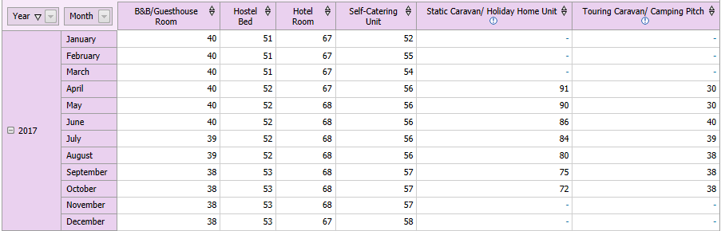

1.3 stats for Devon & Cornwall line partnership
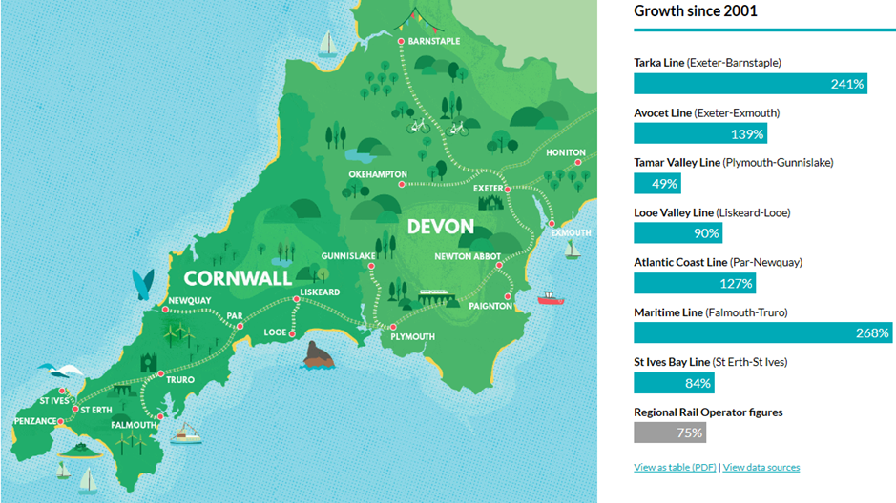

1.4 Llandrindod wells heritage trail.
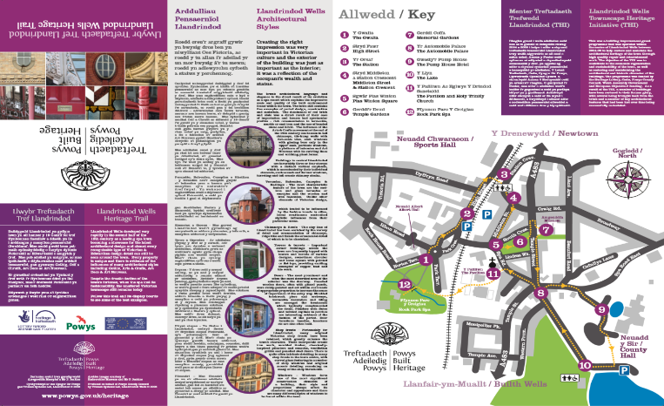

1.5 pest analysis

1.6 Swot analysis

