Student name: Mahagoub Abdelbanat
Module: Project Management
Module code: LCLM5003

Table of Contents
Introduction 4
Main body 4
1. Executive Summary 4
2. Project Background and Context 5
3. Project Objectives and Scope 5
4. Project Organisation and Governance 6
5. Project Methodology 7
6. Risk Management 8
7. Stakeholder Management and Communication 8
8. Project Schedule and Phasing 9
9. Cost and Resource Management 9
10. Quality Management 9
11. Performance Monitoring and Reporting 10
12. Sustainability and Environmental Considerations 10
4. Work Breakdown Structure (WBS) 11
5. Quad Chart 11
6. Gantt Chart (Simplified) 12
7. Stakeholders’ Involvement 12
8. Allocation of Resources 12
• 9. Risk Analysis 13
Conclusion 14
References 15

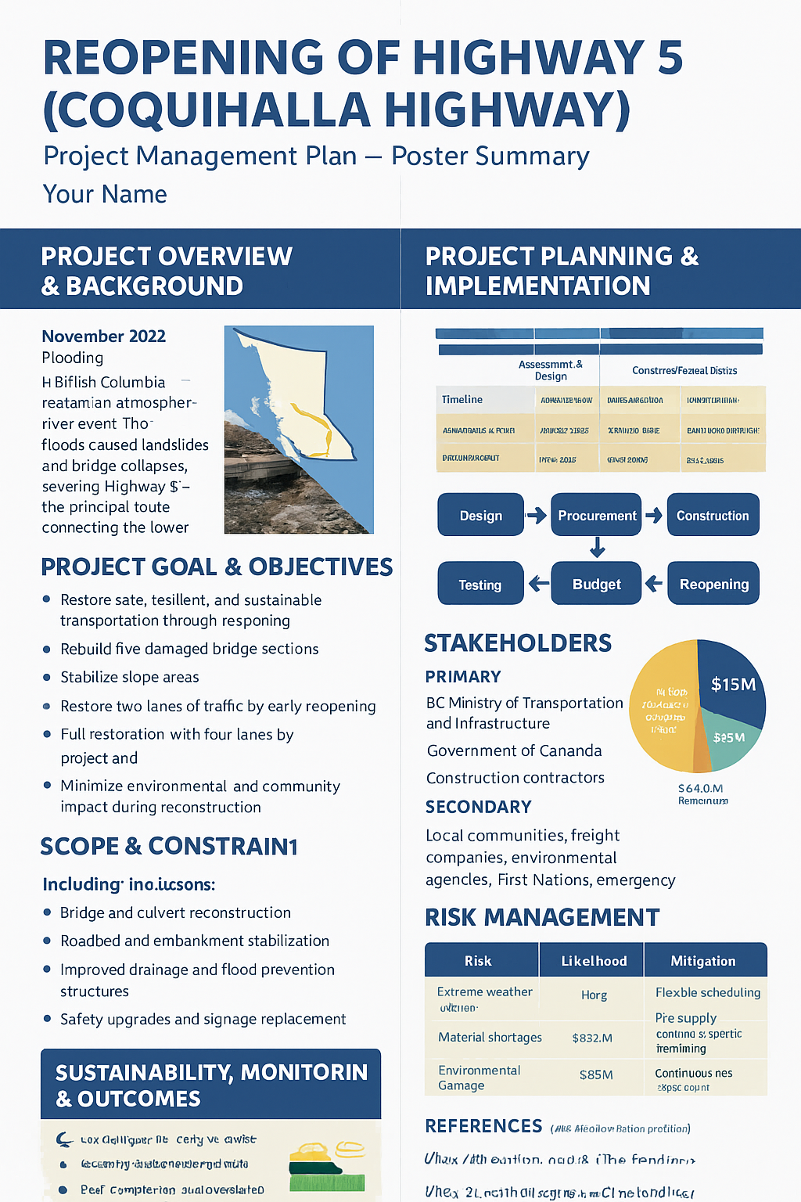

Project Management Plan: Rebuilding the Principal Transportation Corridor

Introduction
Flooding has caused extensive damage to transportation infrastructure along the principal corridor, disrupting the movement of goods and people. The corridor serves as a critical link for regional trade and community access, and its inoperability has significant socio-economic impacts. The purpose of this project is to restore the corridor to full operational capacity, ensuring resilience against future floods and enhancing transportation safety and efficiency

Main body

1. Executive Summary
The principal transportation corridor is a key infrastructure route connecting urban, suburban, and industrial regions. Over time, deterioration has led to congestion, safety risks, and inefficiencies that impact economic activity and commuter mobility. This Project Management Plan (PMP) outlines a comprehensive strategy to rebuild the corridor using internationally recognized project management methodologies, ensuring delivery within budget, schedule, and quality expectations.
The project aims to improve traffic flow, enhance safety, integrate multi-modal transport options, and ensure long-term sustainability. Key project features include phased construction to minimize disruption, a robust risk management framework, quality assurance protocols, and detailed stakeholder engagement.
A hybrid methodology combining PRINCE2 governance principles and PMBOK process groups guides all project phases from initiation to closure. Performance monitoring using Key Performance Indicators (KPIs) ensures accountability and continuous improvement. Environmental sustainability, social acceptance, and community involvement are integrated throughout planning and execution. This PMP serves as a roadmap to ensure that the corridor reconstruction delivers economic, safety, and operational benefits effectively and efficiently.

2. Project Background and Context
The principal transportation corridor serves as a major artery for urban and regional transport, facilitating freight movement, commuter traffic, and access to public services. Current infrastructure exhibits structural wear, limited capacity, and safety deficiencies, resulting in frequent congestion and increased accident rates (Lee, 2018).
Previous maintenance interventions were reactive and fragmented, failing to address long-term infrastructure resilience. The reconstruction project aims to provide a sustainable solution that meets current and future demand while enhancing safety and operational efficiency.
The corridor reconstruction aligns with national infrastructure priorities and international best practices in project management, emphasizing structured governance, risk mitigation, and stakeholder engagement (Verweij, 2015). Key contextual factors influencing the project include urban population growth, multimodal transport integration, environmental protection, and socio-economic considerations. Incorporating intelligent transport systems (ITS), modern construction techniques, and environmental safeguards ensures minimal disruption during construction and long-term operational efficiency.
This project represents a strategic investment to modernize the transportation corridor, enhance regional connectivity, and support economic development. By implementing a structured PMP, the project team can coordinate resources, manage risks, and deliver the corridor reconstruction to meet technical, social, and environmental objectives.

3. Project Objectives and Scope
Objectives:
- Rebuild the corridor to meet national and safety standards.
- Improve traffic flow and reduce congestion through ITS and lane optimization.
- Support multimodal transport, including pedestrian paths, cycling lanes, and public transit integration.
- Ensure minimal environmental and social impact during construction.
- Deliver the project within approved budget, schedule, and quality parameters.

Scope:
- Inclusions: Pavement reconstruction, bridge upgrades, drainage system improvement, ITS deployment, landscaping, traffic management planning, environmental compliance, and stakeholder engagement.
Exclusions: Routine maintenance post-project, unrelated road extensions, and non-infrastructure commercial developments.
Deliverables:
- Upgraded roadway sections and bridges.
- ITS infrastructure, traffic management plans, and signage.
- Environmental compliance reports and audit documentation.
- Stakeholder engagement reports and communications records.
Milestones:
- Project initiation and feasibility study completion.
- Design finalization.
- Procurement and contractor engagement.
- Phased construction start.
- Mid-project review.
- Commissioning, testing, and handover.
- Post-construction evaluation and lessons learned.

4. Project Organisation and Governance
The project will be governed through a structured project organization with clear roles and responsibilities:
Project Board: Comprising government officials, regional planners, and financial sponsors. Responsibilities include strategic oversight, budget approval, scope changes, and milestone authorization.
Project Manager: Responsible for day-to-day management, coordinating contractors, monitoring project performance, and reporting to the board.
Project Team: Includes engineers, planners, environmental specialists, traffic analysts, and community liaison officers, responsible for design, construction supervision, quality control, and stakeholder engagement.
Committees:
- Risk and Safety Committee: Monitors hazards and ensures mitigation strategies are implemented.
- Quality Assurance Committee: Ensures compliance with technical and regulatory standards.
- Stakeholder Engagement Committee: Manages public consultation, feedback integration, and conflict resolution.

Reporting Protocols:
- Weekly progress reports to the Project Manager.
- Monthly performance summaries to the Project Board.
- Quarterly updates to stakeholders.
Escalation Procedures: Urgent issues are escalated to the Project Board. Change requests undergo formal review and approval to maintain governance integrity.
This structure ensures accountability, clear communication, and effective decision-making throughout the project lifecycle (Kerzner, 2017).

5. Project Methodology
A hybrid methodology integrating PRINCE2 governance principles with PMBOK process groups (initiation, planning, execution, monitoring & controlling, closure) will guide the project.
Initiation: Project charter development, feasibility studies, preliminary environmental assessment, and initial risk identification.
Planning: Comprehensive planning includes:
- Detailed design and engineering specifications.
- Work breakdown structure (WBS) and schedule development using Gantt charts and critical path analysis (CPA).
- Cost estimates and resource allocation plans.
- Risk management plan and mitigation strategies.
- Stakeholder engagement plan and communication strategy.
Execution: Phased construction to maintain operational traffic flow. Contractor coordination, HSE compliance, and quality inspections are integral.
Monitoring & Controlling: Schedule, budget, and quality tracking; risk register updates; change control processes; and KPI monitoring to ensure project objectives are met (PMI, 2021).
Closure: Final inspections, handover to authorities, post-construction evaluation, lessons learned, and project documentation archive.
This methodology ensures structured project governance, transparency, and accountability, while accommodating operational flexibility to address unforeseen challenges.

6. Risk Management
Key Risks:
- Traffic disruption and public dissatisfaction.
- Cost overruns due to material price volatility.
- Schedule delays from adverse weather or unforeseen site conditions.
- Environmental impact and regulatory non-compliance.
- Contractor performance and labour shortages.
Assessment: Risks are evaluated using probability, impact, and detection metrics. A risk register will track all identified risks.
Mitigation Measures:
- Phased detours and temporary traffic management to reduce congestion.
- Contingency budgets and alternative suppliers to manage cost risks.
- Schedule buffers for critical path tasks.
- Environmental safeguards and audits to ensure compliance.
- Contractor prequalification, performance monitoring, and clear contractual terms.
Monitoring: Risks reviewed monthly with corrective actions implemented proactively (Kerzner, 2017).

7. Stakeholder Management and Communication
Stakeholders: Government agencies, local communities, commuters, businesses, environmental groups.
Engagement Strategy: Stakeholders are prioritized using a power-interest grid. High-priority stakeholders receive regular updates and opportunities for consultation.
Communication Channels:
- Weekly project team meetings.
- Monthly reports to Project Board.
- Quarterly public briefings and newsletters.
- Social media and website updates.
Feedback Integration: Stakeholder concerns are logged, evaluated, and addressed through corrective actions and communication updates (Bourne, 2015).

8. Project Schedule and Phasing
The project is divided into four phases:
- Phase 1: Design, feasibility studies, approvals, and preliminary works (Months 1–6).
- Phase 2: Structural works including road reconstruction and bridge upgrades (Months 7–18).
- Phase 3: ITS deployment, landscaping, and finishing works (Months 19–24).
- Phase 4: Testing, commissioning, handover, and post-construction evaluation (Months 25–30).
Critical Path Analysis identifies dependencies and ensures timely completion. Phased construction minimizes disruption and allows continuous traffic flow. Contingency periods account for unforeseen delays, weather conditions, and procurement challenges.

9. Cost and Resource Management
Budget: Estimated at $350 million, including construction, labour, procurement, contingency, and project management costs.
Resource Allocation: Human resources, construction machinery, materials, IT systems, and environmental monitoring equipment are aligned with project phases.
Procurement Strategy: Competitive tendering, framework agreements, and prequalification ensure cost efficiency and quality compliance.
Cost Control: Monthly budget reviews, variance analysis, and audits maintain financial discipline. Contingency funds are allocated for unexpected expenditures (Turner, 2016).

10. Quality Management
Quality assurance is ensured through:
- Compliance with national and international construction standards.
- Material testing and inspection protocols.
- Contractor audits and independent quality reviews.
- Continuous improvement through lessons learned and corrective actions (Lock, 2020).

11. Performance Monitoring and Reporting
KPIs:
- Schedule adherence.
- Budget variance.
- Safety incidents.
- Stakeholder satisfaction.
- Quality compliance rates.
Real-time dashboards, weekly team reports, and monthly board reports facilitate proactive monitoring. Performance reviews allow timely corrective measures and continuous improvement.

12. Sustainability and Environmental Considerations
Environmental sustainability measures include:
- Minimizing emissions, noise, and traffic disruptions.
- Stormwater management and landscaping.
- Preservation of green spaces and tree planting.
- Promotion of public transport, pedestrian, and cycling infrastructure.
- Environmental audits to ensure compliance with regulations.

4. Work Breakdown Structure (WBS)
Level 1 | Level 2 | Level 3 | Responsibility
1.0 Corridor Reconstruction | 1.1 Assessment & Survey | 1.1.1 Damage Assessment | Project Engineer
 |  | 1.1.2 Environmental Impact Study | Environmental Specialist
 | 1.2 Planning & Design | 1.2.1 Road Design | Civil Engineer
 |  | 1.2.2 Bridge & Drainage Design | Structural Engineer
 | 1.3 Procurement | 1.3.1 Material Sourcing | Procurement Manager
 |  | 1.3.2 Contractor Selection | Project Manager
 | 1.4 Construction | 1.4.1 Road Reconstruction | Construction Team
 |  | 1.4.2 Bridge & Culvert Repair | Construction Team
 |  | 1.4.3 Drainage System Installation | Construction Team
 | 1.5 Testing & Commissioning | 1.5.1 Safety & Quality Inspection | QA/QC Officer
 |  | 1.5.2 Corridor Reopening | Project Manager

5. Quad Chart
Category | Details
Project Name | Principal Corridor Reconstruction
Purpose / Objectives | Restore transportation, ensure resilience, improve safety
Key Stakeholders | Government agencies, contractors, local communities, suppliers
Budget | $15 million
Schedule | 12 months
Risks | Flood recurrence, material delays, labour shortages
Mitigation | Risk register, contingency funds, alternative suppliers

6. Gantt Chart (Simplified)
Task | Month 1 | Month 2-3 | Month 4-5 | Month 6-9 | Month 10-12
Damage Assessment | ███
Design & Planning |  | ████
Procurement |  |  | ███
Construction |  |  |  | ████████
Testing & Commissioning |  |  |  |  | ████
(Detailed Gantt chart can be created in Microsoft Project or Excel.)

7. Stakeholders’ Involvement
Stakeholder | Role | Engagement Strategy
Government Agencies | Approvals, funding, policy oversight | Monthly reports, formal presentations
Contractors | Road and bridge reconstruction | Weekly meetings, on-site supervision
Local Communities | Feedback, disruption mitigation | Community forums, newsletters
Suppliers | Materials and equipment | Regular procurement meetings
Communication Plan: Weekly progress reports, monthly stakeholder updates, and emergency alerts as needed.

8. Allocation of Resources
Human Resources:
- Project Manager, Civil Engineers, Structural Engineers, Environmental Specialists, QA/QC Officers, Construction Crew
Materials & Equipment:
- Asphalt, concrete, steel, drainage pipes, heavy machinery (excavators, cranes, rollers)
Budget Allocation:
- 50% Construction & Materials
- 20% Labor & Human Resources
- 15% Planning & Design
- 10% Contingency Fund
- 5% Risk Management & Monitoring
- 9. Risk Analysis
Risk | Probability | Impact | Mitigation
Flood recurrence | Medium | High | Temporary barriers, adjust schedule
Material shortage | High | Medium | Multiple suppliers, early procurement
Labor strikes | Low | Medium | Labor contracts, backup workforce
Environmental non-compliance | Low | High | Regular inspections, adherence to regulations
Safety incidents | Medium | High | Safety training, PPE, QA/QC monitoring

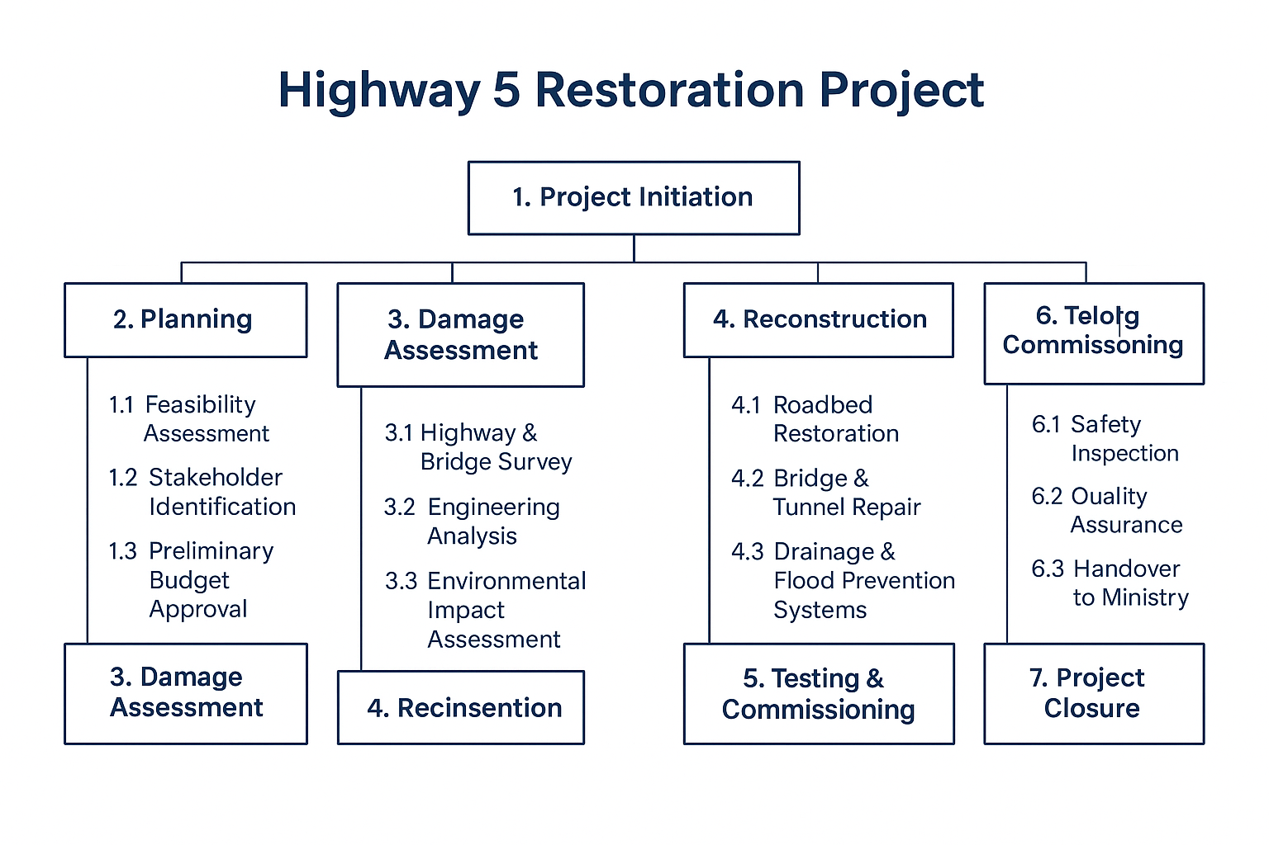

Project Management in a Global Context

Project management in a global context extends beyond traditional and strategic approaches, encompassing cultural, ethical, and adaptive dimensions essential for success in a complex international environment. Traditional project management primarily focuses on the management of scope, time, cost, and quality within localised settings (PMI, 2021). However, global projects require managers to navigate challenges such as distributed virtual teams, cross-cultural communication, and varying legal and regulatory frameworks (Kerzner, 2022). Strategic project management, which aligns projects with organisational goals, must also integrate geopolitical awareness, sustainability considerations, and stakeholder diversity to remain effective in a global context (Turner, 2014). Moreover, project managers must demonstrate cultural intelligence (CQ) and flexibility in leadership styles to accommodate different cultural expectations and work practices (Livermore, 2015). Effective global project management, therefore, demands an expanded mindset that combines technical expertise, strategic alignment, and intercultural competence to achieve sustainable success in an interconnected world (Binder, 2016).

Discussion
Traditional project management has historically focused on achieving project objectives through the effective control of scope, time, cost, and quality (PMI, 2021). While these elements remain fundamental, global projects introduce additional layers of complexity due to geographical dispersion, virtual collaboration, and differing regulatory frameworks (Kerzner, 2022).
Strategic project management aims to align project outcomes with broader organisational goals, ensuring that resources and efforts contribute to long-term success (Turner, 2014). In a global context, however, strategic alignment must consider external influences such as geopolitical risks, international supply chains, and sustainability imperatives. As such, the project manager’s role expands from operational execution to strategic and ethical leadership.
Furthermore, effective project management across borders requires a high degree of cultural intelligence (CQ) — the ability to understand, respect, and adapt to diverse cultural norms and communication styles (Livermore, 2015). Cultural sensitivity enhances collaboration among distributed teams and mitigates conflicts that may arise from differing expectations or behaviours. Binder (2016) emphasises that global project success depends on balancing technical expertise with intercultural competence and adaptability.
Consequently, project managers must utilise digital technologies, foster trust in virtual environments, and apply flexible management methods that respond to rapid global change. The modern project manager, therefore, acts not only as a planner and strategist but also as a cross-cultural leader capable of managing complexity and ambiguity on a global scale.
In summary
Global Project Management = Traditional + Strategic + Cultural + Adaptive + Ethical Dimensions.

Conclusion

This Project Management Plan provides a structured roadmap for reconstructing the principal transportation corridor. By integrating best practices in project management, risk mitigation, stakeholder engagement, quality assurance, and sustainability, the plan ensures effective delivery of economic, operational, and social benefits. Performance monitoring, structured governance, and clear communication support accountability and timely completion. Implementation of this PMP positions the corridor reconstruction project for successful delivery, enhancing mobility, safety, and regional development while minimizing environmental and social impact.

  - References:

Bourne, L., 2015. Stakeholder Relationship Management: A Maturity Model for Organisational Implementation. 2nd ed. Routledge.
Girma, M. (2025). Evaluating corridor development initiatives and their effects on transport and accessibility. Journal of Transport & Infrastructure, (forthcoming) tandfonline.com
Kerzner, H., 2017. Project Management: A Systems Approach to Planning, Scheduling, and Controlling. 12th ed. Hoboken: Wiley.
Lee, C.K., 2018. ‘Urban Transport Infrastructure: Best Practices in Corridor Planning and Reconstruction’, International Journal of Project Management, 36(3), pp. 453–466.
Lock, D., 2020. Project Management. 11th ed. Routledge.
PMI, 2021. A Guide to the Project Management Body of Knowledge (PMBOK® Guide). 7th ed. Project Management Institute.
Sadeghi, S. (2024). Enhancing Project Performance Forecasting using Machine Learning Techniques.
Transportation Corridor Planning: A Model and Case Studies” (≈2004). University of Minnesota/Humphrey Institute.
Turner, R., 2016. Gower Handbook of Project Management. 5th ed. Routledge.
Verweij, S., 2015. Transport Infrastructure and Project Management. London: Routledge.
Yang, W., et al. (2023). Impact of corridor highway system on communities-built environment, sustainable mode choices. Transportation Research Part D.
Binder, J. (2016) Global Project Management: Communication, Collaboration and Management Across Borders. 2nd edn. Farnham: Gower Publishing.
Kerzner, H. (2022) Project Management: A Systems Approach to Planning, Scheduling, and Controlling. 13th edn. Hoboken, NJ: Wiley.
Livermore, D. (2015) Leading with Cultural Intelligence: The Real Secret to Success. 2nd edn. New York: AMACOM.
PMI (Project Management Institute) (2021) A Guide to the Project Management Body of Knowledge (PMBOK® Guide). 7th edn. Newtown Square, PA: Project Management Institute.

