19th of May 2025

University of Wales
Trinity Saint David
root cause analysis and improvement of optical module failures
Ben Rowland-Jones (2213554)
BEng Manufacturing Systems Engineering

Declaration of Authenticity
This thesis is the result of the author’s original research. It has been composed by the author and has not been previously submitted for examination which has led to the award of a degree.

Signed: Ben Rowland-Jones Date: 19/05/2025

Acknowledgements
Firstly, I would like to thank my supervisor Andrew Thorn for the time he has spent guiding me through the last twelve months of this project. His insights and advice helped me through the entire report.
Thank you to the University, for all of its teaching and training I have received that has all lead to this point. All of its staff and facilities has been extremely helpful and needed throughout this course.
I would like to thank my employer, Renishaw for allowing me the time and resources to not only carry out this project, but to allow me time to attend University lectures and tutorials.
Lastly I would like to thank my Wife, without her help and support this project or any of my degree would not have been possible.

Contents
Declaration of Authenticity 1
Acknowledgements 2
Abstract 7
1.0 Introduction 8
2.0 Literature Review 11
2.1 Introduction 11
2.2 Additive Manufacturing Technologies, by Ian Gibson 11
2.3 Optics, by Eugene Hecht 13
2.4 Six Sigma & Quality Management, by Paulo Pereira 13
3.0 Define 16
3.1 Project Charter 16
3.1.1 Project Scope 16
3.1.2 Problem Statement 17
3.2 Project Aims & Objectives 18
3.3 SIPOC & Critical to Quality 19
4.0 Measure 21
4.1 Quad Cell Data 21
4.1.1 Type of Data 21
4.1.2 Data Collection Plan 22
4.1.4 Process Map 23
4.1.5 Sources of Variation 24
5.0 Analyse 25
5.1 Focus Failures 25
5.2 Max Drift Failures 30
5.4 Galvo Positions 34
5.5 Optical Contamination 37
6.0 Improve Phase 40
6.1 BDO Alignment Bench 40
6.2 Galvo Alignment Bench 44
6.3 Optical Contamination Improvements 47
7.0 Control Phase 50
7.1 BDO Alignment Control Charts 50
7.2 Galvo Alignment Control Charts 51
7.3 Quad Module Cleanliness 52
8.0 Conclusion 54
9.0 Appendices 56
9.1 Gannt Chart 56
9.2 Quad Cell PFMEA 57
10.0 Bibliography 62

Table of Figures
Figure 1, RenAM500Q Machine 7
Figure 2, RenAM500 Quad Module/Laser Placement 8
Figure 3, Powder Bed Fusion Graphic 11
Figure 4, DMAIC Roadmap 13
Figure 5, Pareto of Failures in the Quad Fusion Cell from the past Six Months 15
Figure 6, SIPOC of Quad Fusion Cell 18
Figure 7, Example of PICA Entry 20
Figure 8, Data Collection Plan 22
Figure 9, Quad Cell Process Flow 22
Figure 10, Focus Failure PICA 24
Figure 11, Drift Rig Test Log from 5EL032 25
Figure 12, Repeatability Testing Raw Data 26
Figure 13, Repeatability Testing Graphs 26
Figure 14, Excerpt from Quad Cell PFMEA 27
Figure 15, Ishikawa Diagram for Focus Failures 28
Figure 16, Drift Test Screen 30
Figure 17, Ishikawa Diagram for Max Drift Failures 31
Figure 18, Galvo Shift GUI 32
Figure 19, Galvo Motor Cotton Contamination 33
Figure 20, Galvo Alignment Trolley and Target Plate 34
Figure 21, Scatter Plot of Galvo Positions in the X Axis 35
Figure 22, Ishikawa Diagram of Galvo Positions 35
Figure 23, Window Inspection Bench 36
Figure 24, Swarf Contaminant under Microscope 37
Figure 25, 5 Whys Analysis of Why the Problem Occurred 38
Figure 26, 5 Why's Analysis of Why the Problem Was Not Detected 38
Figure 27, Payoff Matrix 40
Figure 28, BDO Alignment Camera 41
Figure 29, BDO Alignment Camera Adjustment Direction 41
Figure 30, 5EL032 Focus Pass Results 42
Figure 31, 5EL032 Focus Results Over Time 42
Figure 32, Improved PFMEA 43
Figure 33, Galvo Alignment Bench Electronics Enclosure 44
Figure 34,Screenshot of Hydra Software 44
Figure 35, Galvo Alignment Golden Unit 46
Figure 36, Galvo Block Cleaning Orientations 47
Figure 37, Scratch/Dig Gauge for Optics Inspection 48
Figure 38, BDO Golden Unit Control Charts 49
Figure 39, GalvoX Position Scatter Plot 50
Figure 40, Module Window Removal 52
Figure 41, Table of Aims & Objectives 54

Abstract
The purpose of this report is to conduct root cause analysis on the top four failure modes in the quad fusion cell and implement process improvements to reduce the number of failures in the area. The quad fusion module is a sub-system within the RenAM500 additive manufacturing machine that controls the focus and direction of the lasers during powder bed fusion; which is achieved using a complex laser beam path that consists of twenty five different optics.
Using the DMAIC method, a thorough investigation was carried out on the top four top failures in the quad cell. The four top failure modes were defined using the last six months worth of data; the failure modes were:
- Galvo positions
- Max drift failures
- Focus failures
- Optical contamination
Each failure mode was split and put through well known analysis techniques such as Ishikawa diagrams and 5whys. The following table shows the root causes of the failure modes and their fixes:
Failure Mode | Root Cause | Fix
Galvo Positions | Target plate adjustment micrometre detached from alignment trolley | Reattached micrometre and used a known good unit to readjust target plate
Max Drift | Contamination found within galvo motors | Sent motors back to supplier for investigation
Focus Failures | BDO alignment camera not in nominal position | Adjusted BDO alignment camera to nominal position
Optical Contamination | Dirty incoming parts and using shared equipment | Sent dirty parts back to machine shop and introduced a daily check

The engineering team then introduced golden units for the galvo and BDO alignment benches, in order to conduct MSA studies and establish control charts in the area. There are also planned future projects to further improve the galvo alignment bench by adding cameras to the alignment trolley, so the production staff would not have to rely on the experience of the operator.

1.0 Introduction
Renishaw plc is a precision engineering company that was founded by Sir David McMurtry and John Deer in 1973 where they developed the first ever touch trigger probe to try and overcome a measurement issue on a Rolls-Royce engine (Renishaw, 2024). Renishaw manufactures multiple products across a number of sectors. These sectors include, the absolute scale and read heads products in the metrology sector, the brain implants in the neurological sector and the RenAM500 machine line in the additive manufacturing sector.
The RenAM500 product line consists of the RenAM500Q, RenAM500S, RenAM500Q Flex, RenAM500S Flex, RenAM500Q Ultra and RenAM500S Ultra. These are all variants of the same metal powder sintering additive manufacturing machines capable of 3D printing complex geometries that are not possible to replicate using subtractive manufacturing methods (Renishaw, 2023). Below in figure 1 is an example of the RenAM500Q machine variant:
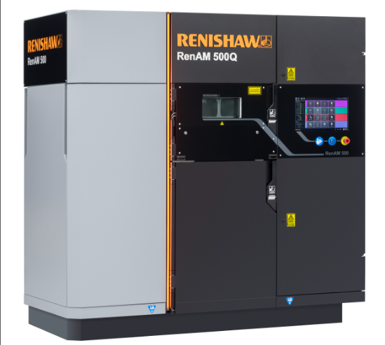

Figure 1, RenAM500Q Machine
The assembly process that will be the focus of this dissertation is the AM quad fusion module assembly. The quad module is the sub-assembly responsible for setting the correct laser beam characteristics and positions from within the RenAM500 additive manufacturing machine.

The quad fusion module is situated at the top of the AM machine with the four lasers connected to the four quadrants of the module which then loop down to the right-hand side of the machine (figure 2):
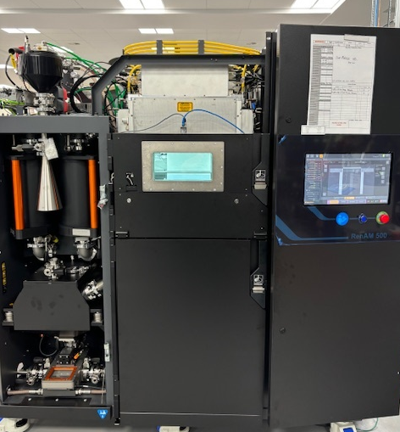
Figure 2, RenAM500 Quad Module/Laser Placement
This report will go through the process of root cause analysis and implementing improvements for the most frequent failure modes that occur within the quad module. The most frequent failure modes within the quad module are:
- Max drift
- Focus offset
- Galvo positioning
- Optical contamination
Max drift, focus offset and galvo positioning failures are all found on the end of line drift test rig where the results of each test generate comma separated values (.csv) files which are used to interrogate the data.
Optical contamination is picked up primarily during the numerous inspection operations that take place throughout the area. In order for the root cause analysis and controlled improvements to be captured under one unifying method, the DMAIC method will be used which stands for:
- Define; defines the problem and everything associated with it
- Measure; data collection of faults or errors
- Analyse; analyses the data from the measure phase to create next steps
- Improve; fixes or negates the defined issues
- Control; process improvement that keeps the issues resolved

2.0 Literature Review

2.1 Introduction
The purpose of this literature review is to provide an overview into some of the existing literature and theories that pertain to this particular report. This review will help to highlight essential work that will be used as a framework for the root cause analysis and optical engineering theory that is at the forefront of this project.
The literature that has been reviewed is a mixture of Six Sigma quality management, optical engineering and additive manufacturing technologies. These areas will give an understanding into the key components of this report i.e. optical modules, the AM machines technology and the root cause analysis and improvements in the quad cell. The books that have been reviewed are:
- Additive Manufacturing Technologies by Ian Gibson
- Optics by Eugene Hecht
- Six Sigma and Quality Management by Paulo Pereira

2.2 Additive Manufacturing Technologies, by Ian Gibson
For the purpose of this report, the review will specifically be on the powder bed fusion (PBF) texts as this is the technology that is incorporated in the RenAM500 series. PBF was one of the first additive manufacturing processes and was first developed in the University of Texas, with the process using the selective laser sintering (SLS) fusion process.
PBF is used in a variety of different materials such as metals, polymers and ceramics, but the basic make up of machinery is the same. There is a heat source used for powder sintering usually in the form of lasers, a mechanism used to sinter powder in specific areas and a device to add and uniformly distribute powder across the bed. Figure 3 below shows a typical example of a powder bed fusion set up:

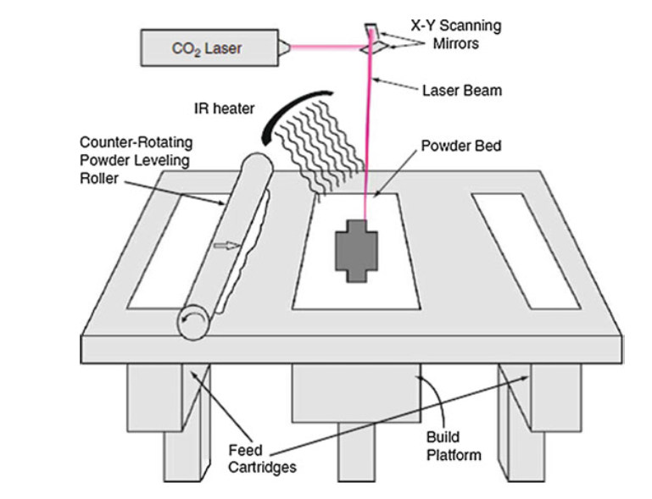
Figure 3, Powder Bed Fusion Graphic
This process takes place in a sealed chamber filled with noble gases, typically nitrogen or argon, to make the conditions more stable, prevent oxidisation and to generally make the machine safer. The RenAM500 series uses argon gas to flood the chamber and remove the oxygen so that there is less than one hundred parts per million of oxygen left.
The lasers that are used on the RenAM500 series are class four fibre optic lasers capable of outputting 500W of power. This is to reach the correct melting point of the metal powder that is used in the machine; using Titanium as an example, the melting point of this powder is 1668⁰C.
Gibson then goes on to talk about solid-state sintering, which is one of the four main types of melting and sintering. Solid-state sintering is the process of fusing metal particles together without fully melting it, i.e. in their solid state. This typically occurs when the particles are heated between one half of the absolute melting temperature and the actual melting temperature. The benefit of reviewing this literature is to give a background of additive manufacturing machines and how they work, to better understand how the technology, and the way it is assembled, can be improved.

2.3 Optics, by Eugene Hecht
As the quad fusion modules primary purpose is redirecting and setting the focus of laser beams using a complex array of optics, reviewing literature on optics is key to understanding why the testing that has been implemented to the quad fusion area need to take place and how they could potentially be improved or refined.
Hecht first gives a brief history of optics dates back to ancient Greece, which shows how much theories of vision and optics have changed through history. From the discovery of the law of refraction in the year 984 by Abu Sad Al Alla Ibn Sahl, through to Isaac Newtons laws of optics that explained that white light is made up of all colours and all colours can be recombined to make white light.
Newton also invented the first reflective telescope, which overcame the aberration issues of the earlier refractive telescopes. Aberration is a potential issue in the quad fusion module; if aberration occurs during any of the drift rig testing then it will result in a genuine failure and the module would have to be reworked.
Section three of Optics covers optical sources, with one of the sources mentioned being lasers. Laser light has a long coherence time and a large coherence area, relative to conventional light. This means that when the laser is fired, the spread of the spot size changes minimally so the light has a smaller divergence (or limited diffraction).
These characteristics ensure that laser beams can have smaller spot sizes at great lengths without losing any irradiance, which is a key property in the RenAM500 optical system as the spot size that the machine aims for is around eighty microns at the powder bed. This knowledge confirms that when focus or thermal drift errors occur, it must be caused by one of the optics in the beam path because laser light will not change unless an outside source (i.e. faulty lenses or mirrors) have a direct impact upon it.

2.4 Six Sigma & Quality Management, by Paulo Pereira
The last and perhaps the most important literature reviewed in this project is a book that covers Six Sigma and it’s methods and quality management. This book is the most relevant due to the fact that the report structure uses a Six Sigma tool, DMAIC. So any research into this topic is beneficial to the project.

Pereira gives an introduction to Lean manufacturing and Six Sigma, first talking about its adoption by automotive giants Ford and Toyota. This then cascaded into global organisations like Motorola and General Electric in the 1980’s to reduce errors and minimise points of variance.
In the healthcare industry, Six Sigma has not been fully integrated, but there are more positive case studies being done. For example, the Indian healthcare industry implemented Six Sigma tools that improved the patient registration cycle time which ultimately lead to a reduction in waiting times, queues and improved staff utilisation.
Pereira then talks about the main perspective, which is based around the Accelerated Change for the Good (ACG) program which is derived from the Japanese term Kaizen or small changes, often. The ACG program uses the Six Sigma tool DMAIC (define, measure, analyse, improve and control) to solve real world problems and drive continuous improvement. Figure 4 below shows the DMAIC roadmap that is used in the case study:
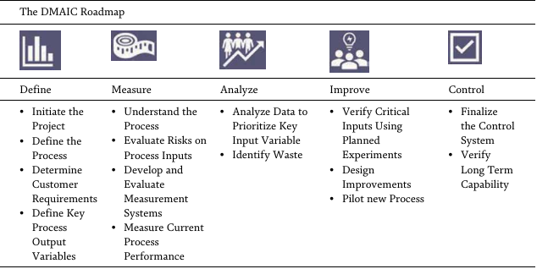
Figure 4, DMAIC Roadmap
The roadmap in figure 4 shows the five main areas along with a bullet point list of what should be included in each of them. The chapter then goes onto various theories and tools used when implementing ACG, such as 5S and a focus on maximising employee involvement and empowerment in continuous improvement with a strong weighting on value adding activities.
The roadmap above can be compared to a case study by Smetkowska (2018) where the DMAIC method was implemented into a printing organisation. The define phase was used to define resources and responsibilities, whilst also considering the elements of the project overall and setting a project end date to aim for.
The case study explains how to properly define the problem in the organisation, referring to a Pareto chart to aid definition. A particular machine, the Kolbus BF 511 was identified as a potential bottleneck.
Then, during the measure phase the persons carrying out the study collected the historical data from that machine and collated it, to be used in the control phase of the case study. Smetkowska explains that the measure phase aims to identify valid and reputable data, inspect current documentation and perform comparative tests on different machines within the organisation.
The next phase that is discussed is the analyse phase, where Smetkowska talks about identifying the key issues pertaining to the machine in question. There is also considerations of resources required to get performance back on track and identification of any potential blockers. The brainstorming session that took place identified four key areas; organisation, machine, method and man which uses some of the key areas in an Ishikawa diagram so this investigation could have been improved by carrying out cause and effect activities.
In the improve phase, Smetkowska talks about developing and testing possible solutions and designing a robust implementation plan to bring about real changes to the organisation. The study then explains the introduction of “one-touch” fasteners and improving the processes work instruction documentation so that it is clearer for employees to follow.
Lastly in the control phase, the study outlines standardising all improvements and monitoring the results to feed into continuous improvement. This phase will also transfer the ownership of the improved process back to the relevant teams.
This case study, along with the Six Sigma book will be used as a template to follow for the root cause analysis and improvement of the quad fusion modules within Renishaw. The DMAIC structure will be used to structure the written report and be used as a guideline throughout the project.

3.0 Define

3.1 Project Charter

3.1.1 Project Scope
As mentioned in the introduction, the quad fusion module is the main component in moving the lasers across the powder bed. As such, any variation or error in the unit will cause irrevocable build deformations and ultimately, customer dissatisfaction. There is currently a high demand for Renishaw’s additive manufacturing machines, so ensuring there is a stock of finished machines to cope with customer demand is imperative to retaining customer contracts and high-volume purchases. The customer demand is threatened when a quad module fails on the drift rig as 95% of the errors have a large rework time of at least two hours.
As this is such a complex assembly, there have been multiple different failure modes when these modules are put through the final test rig, which is called the Drift Rig. In order to determine which of these faults to target with the DMAIC approach, a Pareto chart was made using the data collected from the drift rig. Alkiayat (2014) and Wilkinson (2012) both state that a Pareto chart is ubiquitous in modern quality control settings and is one of the seven quality tools used for process improvement. Below in figure 5 is the Pareto chart on the most common failures in the quad fusion cell in the last six months:
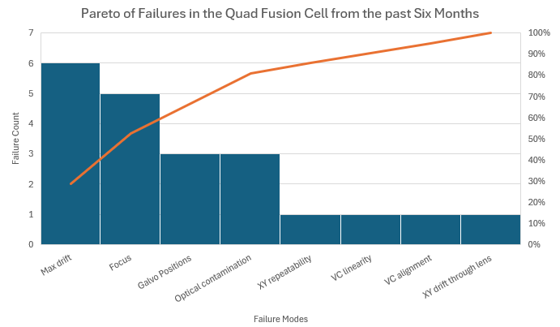
Figure 5, Pareto of Failures in the Quad Fusion Cell from the past Six Months
The Pareto chart in figure 5 confirms the four failure modes that will be at the forefront of this investigation report; the failure modes are:
- Max Drift
- Focus
- Galvo Positioning
- Optical Contamination
The goal of this project is to conduct root cause analysis on the top faults shown in the Pareto chart, using the DMAIC approach, with the aim to reduce the failure count by at least 75% for each failure. This will ensure that the quad module assembly process is more robust and the threat of AM machines going into arrears because of the quad fusion module is reduced. Another metric that will be used to measure success is the time it takes to rework the failures if they occur again in the future, with the aim of a 50% reduction in time spent reworking the modules.
One of the risks that can occur whilst conducting this analysis would be damaging good parts within the assembly trying to perform root cause analysis. The quad module has a variety of lenses, mirrors and filters and complicated circuit boards which are easily damaged beyond repair.
Due to the length of time these failures have occurred, there is always a risk of the root cause never being found, perhaps due to a fundamental design flaw, which would result in a waste of engineering and production time. That risk also ties in with a potential obstacle, production time spent on reworking the modules rather than building new ones. This could potentially effect planning and future stock for the AM machines.

3.1.2 Problem Statement

“There are currently £1 million worth of machines awaiting quad modules, which is worth £2.6 million on the order book (Old, 2024). This is being caused by multiple failure modes in the quad fusion cell, 95% of which can be narrowed down to four main failures.”

In order to capture the multiple failure modes that occur in the quad module, the problem statement will cover the entire module. When these problems are present in the module, a red beacon lights up on the drift rig in the failing quadrant and a pop-up window appears on the PC that displays a FAIL message along with the failure mode. This then prompts the operator to end the script and inform a member of the engineering team who will review the test data and assess next steps in terms of root cause analysis, whether that is further reviewing the test data or stripping the module down.
All of the failure modes above appear when the modules are being tested on the drift rig; except for the optical contamination which could be found at any stage in the process as different optics are fitted to the module throughout the assembly. Although the failure modes appear on the drift rig, this does not necessarily mean that the drift rig is the root cause.
The persons involved when considering the quad fusion modules can be categorised into three sub-teams; from production there are operators, technicians and management. The engineering team consists of a process technician and engineer and the design team consists of a design technician and engineer.

3.2 Project Aims & Objectives
The main aim of this project is to conduct root cause analysis (RCA) on the top failure modes in the quad cell and improving production efficiency hence, enable the AM build line to come off stop.
The objectives of this project aim to reduce the cost of poor quality (CoPQ) in the cell using the data and findings of the RCA whilst also having less of an impact on customer orders by supplying quad modules on time and to a stricter schedule.
Lastly, the aim is to reduce the amount of modules that are returned to the quad cell from the AM build line and commissioning area by attempting to conform to the No Faults Forward logic. No Fault Forward refers to the capturing of faults or errors where they happen, not further along down the production line (Nausley, 2025).

3.3 SIPOC & Critical to Quality
In order to ensure that this project meets customer demands and no work in carried out unnecessarily, a process flow was created and used in a SIPOC model to better determine actual customer needs. SIPOCs are a common Six Sigma tool and are used to monitor products and services to better achieve customer satisfaction (Yeung, 2009); and the abbreviation stands for:
- Suppliers
- Inputs
- Process
- Outputs
- Customers
Figure 6 below shows the process of flow of the quad fusion cell along with the different sub-processes within the area:
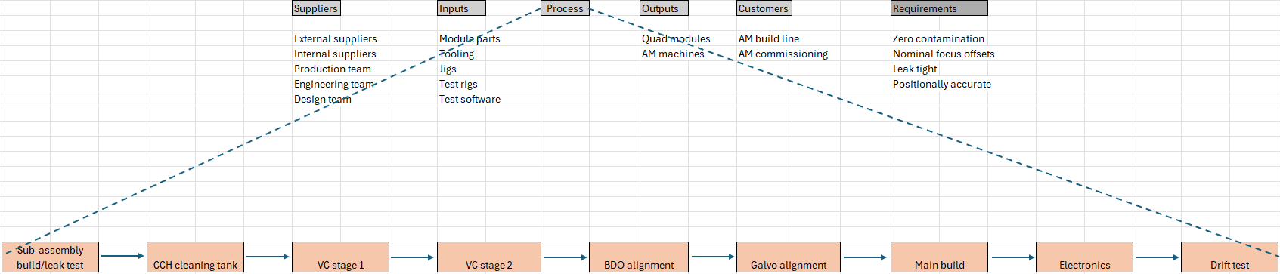
Figure 6, SIPOC of Quad Fusion Cell
As shown, the suppliers of the process are made up of internal and external suppliers, the production team, engineering team and the design team. Inputs are piece parts, tooling, jigs, test rigs and test software. As we do not sell brand new production modules from the production facility, the customers are the AM build line and AM commissioning. From this information, the critical-to-quality (CTQ) requirements are determined. The CTQ is driven by the customer, which in this case is call 6 and commissioning, these teams must have the following in order to carry out their assembly process:

- Zero contamination
  - There must be no contamination on any optics, electronics or internal structure of the quad module
- Nominal focus offsets
  - The focus offsets must be within +/- 7000 microns else the module will fail the focus test in optical commissioning
- Leak tight
  - Each module needs to be free of leaks in the cooling system and air flow system
- Positional accuracy
  - Each module must be capable of achieving an accuracy of less than twenty microns of radial error

4.0 Measure

4.1 Quad Cell Data

4.1.1 Type of Data
There are two sources of data that are used in this project, the source of the optical window contamination comes from the PICA/quarantine system which is a Syteline function. The production operator raises a PICA (process improvement through cause analysis) and put the suspect window in quarantine, if the window is then rejected by engineering, the cost of the window gets added to the AM cost of poor quality (CoPQ). The CoPQ data is the source that is used in this project and is viewed as attribute data, because the windows can either pass or fail the inspection operation. An example of a PICA entry can be found in figure 7 below:
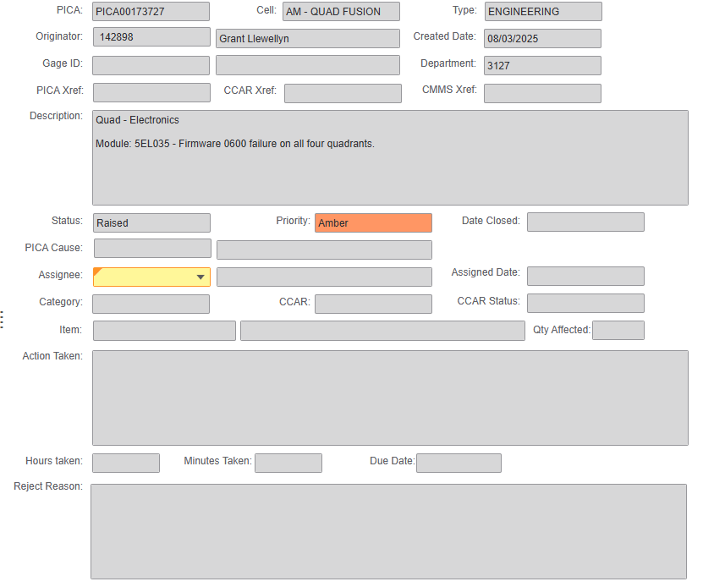
Figure 7, Example of PICA Entry

The second source of data, which is the origin of the other three failure modes covered in this project, comes from the drift rig. The test data collected from the rig comes in the form of .csv files that are automatically generated after every test, whether that test has passed or failed. The .csv files have the results of the each of the six tests that take place during an end of line test, these tests are:
- X/Y offsets (galvo positioning)
- BDPD
- Focus
- Linearity
- X/Y drift through lens
- Thermal drift
Even though the .csv files have got test figures and results in them, this data is still classified as attribute data because the modules can only pass or fail on the drift rig. This pass or fail criteria best describes attribute data as it means that a given process or product is either meeting the design standard or not (Frady, 2023).

4.1.2 Data Collection Plan
Spending the time on an efficient and credible data collection plan will create the benefit of having accurate samples for a given project and will ultimately lead to better results (Kabir, 2016). However, a good sample of data does not automatically mean the project will be an overall success (Olsen, 2012).
The data that has been collected comes from the drift rig and PICA system because this data is the most efficient and accurate way of trying to find the root cause of the four failure modes this project aims to find. The process improvement technician in the quad cell was the person that collected the data, using Renishaw’s shared network transfer folder for the .csv files from the drift rig.
The PICA data was exported from Syteline, which is an enterprise resource planning (ERP) software package that is used throughout Renishaw. The data was exported to a Microsoft Excel document where the irrelevant PICA data was filtered out by part number. Care was taken here as spurious data could have presented itself which may have adverse effects on that section of the project. The data collection plan above has been condensed into the table in figure 8 below:

Question | Answer
Who? | Process Improvement Technician
Where? | Drift Rig/Syteline
What? | Downloading .csv files/PICA data
When? | Previous six months worth of data
What for? | RCA and process improvement
Figure 8, Data Collection Plan

4.1.4 Process Map
In order to fully define and discuss issues in the quad cell and identify sources of variation, a more in-depth process map was created showing the various sub-assembly and testing operations throughout the area. Process mapping is a engineer’s tool that displays the most up to date process that can be used to identify bottle necks and problem areas (Sanders, 1999). The process map for the quad cell can be found in figure 9 below:
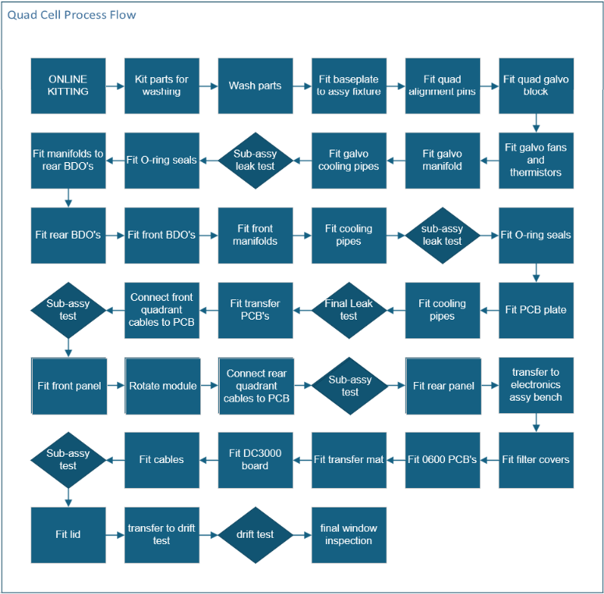
Figure 9, Quad Cell Process Flow

4.1.5 Sources of Variation
The main goal of RCA is to discover the hidden causes of variation in a process or product; only by reducing or eliminating these sources of variation can true process improvement take place (Carlson, 2003). With this statement in mind, it is prudent to note the different sources of variation in the quad cell, these include:
- Fitment of beam delivery optics (BDO) to module
- Fitment of module to drift rig
- Alignment of voice coil to BDO block
- Focus position within BDO assembly
- Alignment of BDO assembly to galvo block
- Different operators/technicians
- Ambient conditions
- Mechanical tolerances e.g. BDO block tolerance
- Optical tolerances e.g. voice coil lens convex tolerance

5.0 Analyse

5.1 Focus Failures
A recent influx of failures during the nominal focus test on the drift rig is the reason why this failure mode appeared in the top four failure modes in the Pareto chart in the define phase. This issue was first picked up by the production operator, who in turn raised a PICA to notify the engineering team; the PICA can be found in figure 10 below:
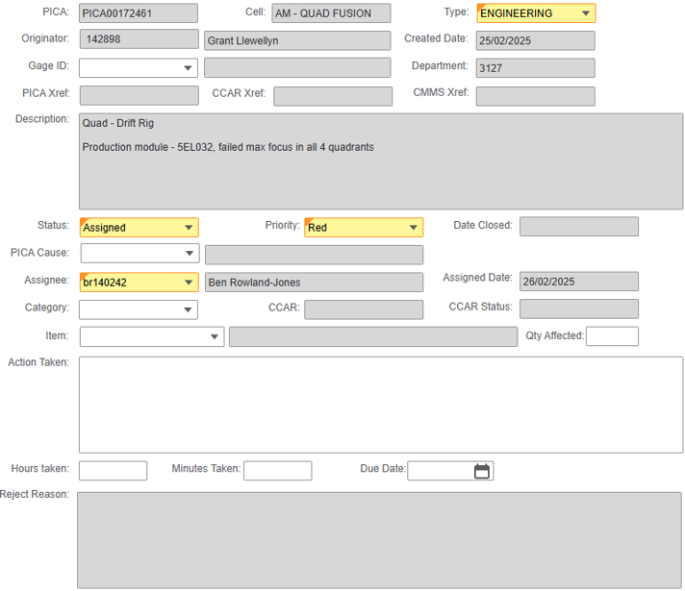
Figure 10, Focus Failure PICA

This shows that quad module 5EL032 has failed for max focus offset during the nominal focus test on the drift rig. The nominal focus test fires the lasers at the four cameras in the drift rig at three different powers: 75W, 250W and 500W. At each power, the cameras start out of focus, come into focus, then go out of focus. This movement is undertaken to be able to measure the focus offset taken from the zero or “in focus” position.
The measurements are then used to calculate a minimum and maximum focus offset, a focus range and an average focus offset. The focus range takes the minimum offset away from the maximum and is measured against a limit of 5000 microns. As you can see below in figure 11, module 5EL032 has failed focus offset at all three powers showing a value of 13115.23 microns which is nearly double the 7000 micron limit.
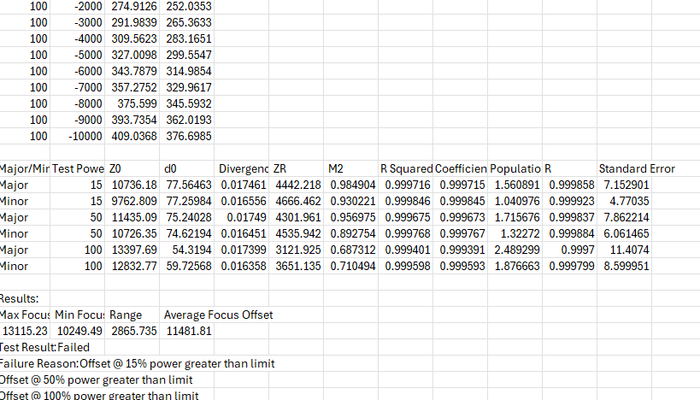
Figure 11, Drift Rig Test Log from 5EL032

To rule out the drift rig as the source of variation, repeatability testing was undertaken. This initial testing gave the engineering team confidence in the test equipment used and enabled next steps to be planned. Repeatability testing is generally associated with the precision of measurements generated on the same material using the same testing method given the same environment (Lau, 2009).
The first part of repeatability testing that took place came in the form of testing module 5EL032 three times back-to-back. The next test was removing the module from the rig, then refitting it and testing it again; then repeating this another two times. Finally, the module window was rotated 180⁰ and then the module was tested a further three times.
The module window was rotated to rule out any fitment or coating errors; because the module window is the only optic that all four lasers pass through in the module. The data is displayed in a chart in figure 12, and again graphically in figure 13 below:
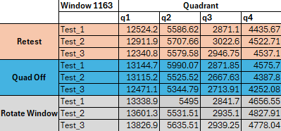
Figure 12, Repeatability Testing Raw Data

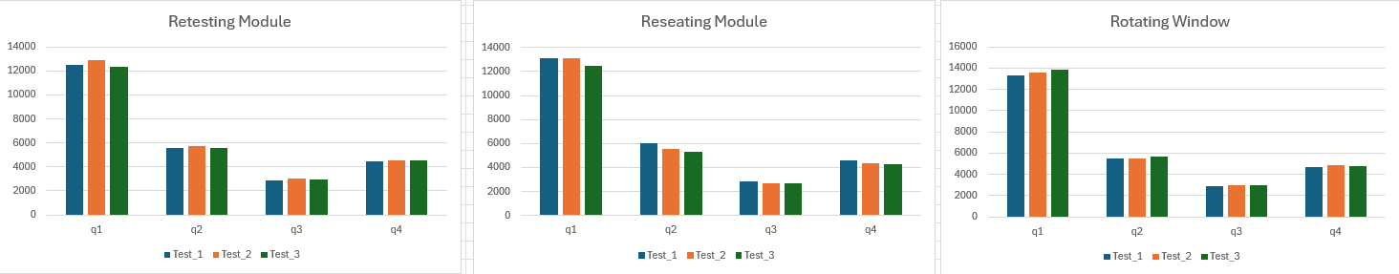
Figure 13, Repeatability Testing Graphs

As shown in figure 13, there is very little variation between testing the module, the fitment of the module or the fitment and function of the module window. This led to the informed decision that the fault was within the module and not in the test equipment.
The purpose of an FMEA (failure modes, effects analysis) is to ensure that a particular process or design does not fall outside of a set of predetermined limits or conditions (Sharma, 2018). This is achieved by a team of people carefully considering any potential failure modes, effects of failures and potential root causes and assigning them a severity, occurrence and detection number.
From these three values, a risk priority number (RPN) is determined which sets the priority list in which the team need to work through. For the quad cell, a process FMEA (PFMEA) was carried out with the intention of achieving what PFMEAs were designed to achieve, identification and prevention of errors in a production process (Banduka, 2016). Shown below in figure 14, is an excerpt from the quad cell PFMEA that pertains to the focus failure mode:
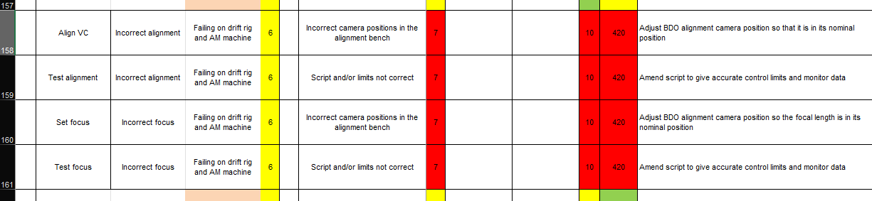
Figure 14, Excerpt from Quad Cell PFMEA

Figure 14 above shows four actions of setting the focus and alignment of the voice coils and then testing them in the finished BDO assembly. A severity number of six has been applied to the four actions which equates to large functionality issues that lead to customer dissatisfaction, according to the Renishaw FMEA template (Hill, 2015). The full PFMEA can be found in Appendix two.
The failure modes have been assigned an occurrence number of seven which equates to seven failures per ten machines. Finally, the failure modes have been given a detection value of ten as the BDO alignment process is not capable of picking up any issues with the camera positions, scripts or process limits. The RPN of these failure modes came in at four hundred and twenty, which sits in the top three largest RPN values in the PFMEA.
The next step in analysing this failure mode was filling out a cause and effect or Ishikawa diagram, to provide a structured and systematic approach to identifying potential root causes for a given problem (Wong, 2016). The cause and effect diagram explains first what the effect is, which is max focus offset failures, then lists potential causes. The diagram can be seen in figure 15 below:
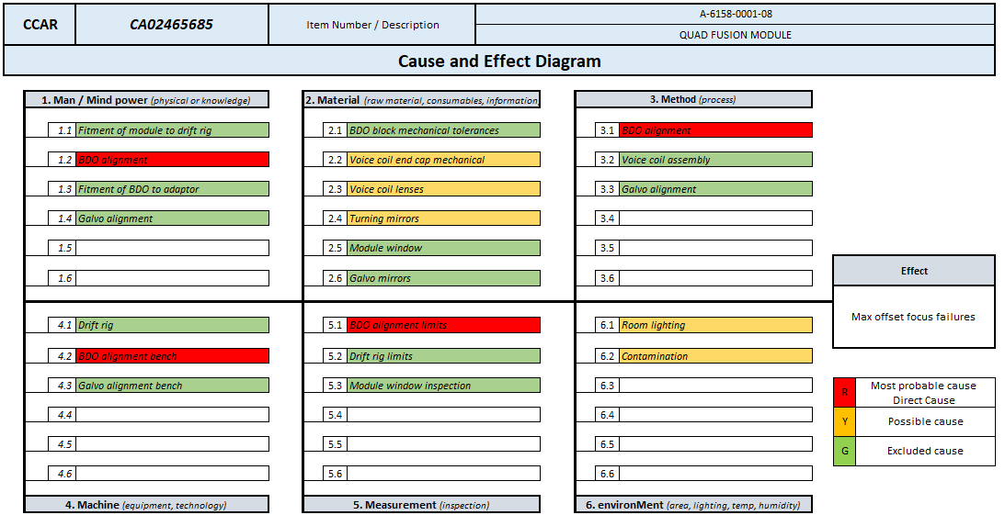
Figure 15, Ishikawa Diagram for Focus Failures

The list of potential causes are listed in the six different categories which are usually used when constructing a cause and effect diagram. Figure 15 shows a list of those categories and the potential effects associated with them.
There are many potential root causes for this specific failure mode, but one stands out from the rest in terms of likely causes and appears in more than one category above; that is the BDO alignment process. It appears in the Man category because the alignment of the voice coil in the BDO assembly is manual and open to interpretation, which is also the reason why it is in the Method category.
The BDO alignment process also appears in Machine and Measurement because the bench is subject to wear and tear of the alignment pins and the upper and lower limits of the test script are not watertight. The upper limit is too wide and needs to be brought down from 16.5 to 7.0 to accurately set the focus and there is no current lower limit, this is a danger as the spot can be too small when setting the focus and disappear from the camera completely.
Actions from the cause and effect diagram were to strip down the failing BDO assemblies and put them back through the BDO alignment bench and assess the results. From this action, the team learned that the suspect BDO assemblies all passed the BDO alignment test; meaning it was not known if the drift rig or the BDO alignment bench was giving false readings.

To verify which piece of equipment was at fault, the modules were completely rebuilt and fitted to the doner AM machine that is used to validate quad modules from the quad cell. The logic being that if the module failed the AM optical commissioning focus test, then the BDO alignment bench was giving false readings. Likewise, if the module passed on the doner machine then the drift rig was showing a false failure.
The modules that were fitted to the doner machine all failed the focus test, with global focus offset (GFO) values ranging between -5 to -9mm (GFO limit is +/- 3mm). This proves that the data the drift rig is outputting is correct and the BDO alignment bench was giving false passes, ergo the root cause of the focus failures of the last six months was the BDO alignment process.

5.2 Max Drift Failures
Max drift failures have been a constant issue within the quad fusion production cell for several years and the root cause has always been an unknown. This failure mode occurs because of a thermal drift test failure. The thermal drift test is the last test that is performed on the drift rig and is where all four lasers are fired in the same position at full 500W power for ninety minutes.
The test measures the beams positional movement due to thermal expansion and/or lensing, meaning there is an impurity present in the anti-reflective coating that affects the beams characteristic when the optic heats up.
The test also measures the spot size minor/major against limits of 110 microns for each test. Meaning the beams are allowed to move no more than 110 microns and the difference between the spots minor and major can be no more than 110 microns. A screenshot taken from a live thermal drift test is displayed in figure 16 below, which shows the four laser spots on screen:
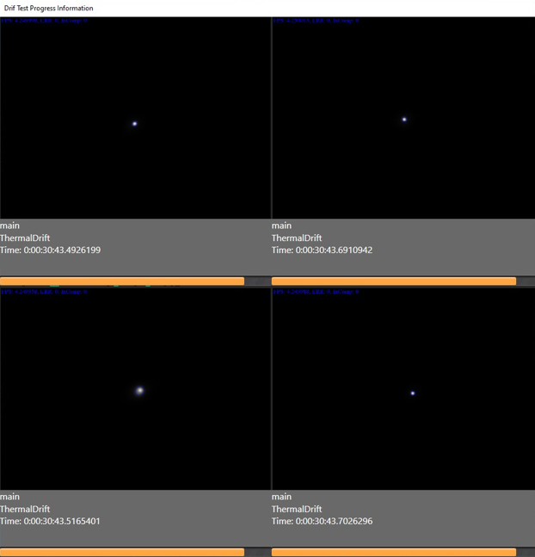
Figure 16, Drift Test Screen

Figure 16 shows the test screen displaying the four laser beams getting picked up by the rigs cameras and shows how far through the test they are. Again, in order to categorise potential root causes, a cause and effect diagram was constructed which can be found in figure 17 below:

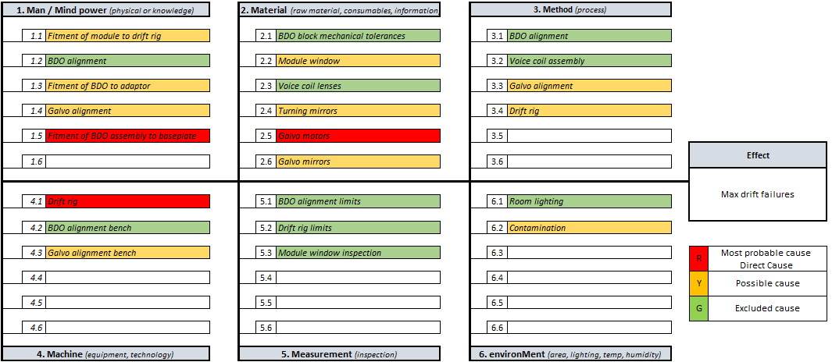
Figure 17, Ishikawa Diagram for Max Drift Failures

Actions from this cause and effect diagram in figure 17 were to use one of the failing modules as a doner module, seeing as each module only has one failing quadrant each. Three modules each had their failing BDO assembly removed and replaced with the three passing BDO assemblies from the doner module.
This allowed three modules to pass and progress onto AM machines whilst the suspect BDO assemblies are all in one module. This allowed production to continue and only having the need to strip down and rework one module until root cause is found.
Using a MATLAB GUI to interrogate the drift rig data, the quadrants that are failing for max drift can be displayed graphically. An example of this is shown below in figure 18, where three of the four quadrants remain inside the limit of 110 microns and the last quadrant goes outside that limit:
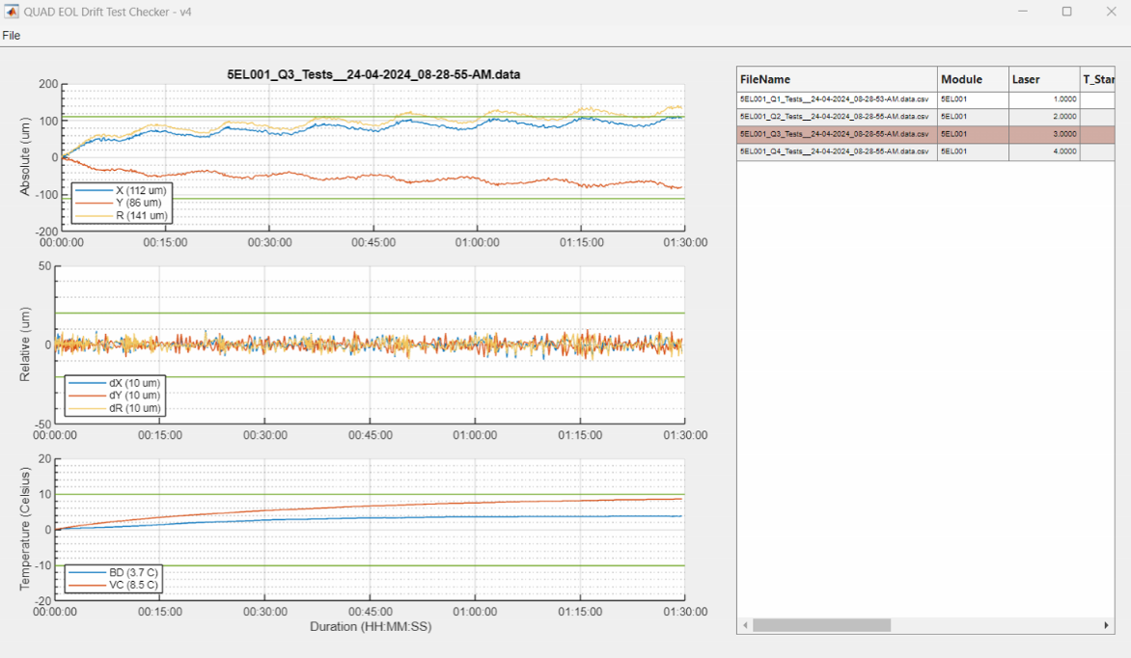
Figure 18, Galvo Shift GUI

From the GUI in figure 18, it shows the absolute error (top graph) in quadrant three goes outside of the upper limit. This data was used to determine that the root cause must be the galvo motors. The drift rig was ruled out as a potential root cause as the other three modules that were failing for max drift before the BDO swap passed the second time around. The galvo motors were thought to be the root cause because that is the only component in the quad module that would cause the beams to drift aside from the electronics.
The electronics were proven to be functioning correctly because in the doner module, three of the four quadrants initially passed with the original BDO assemblies installed and remained in the doner module when the BDO assemblies were replaced. In order to prove the galvo motors were the issue, two were removed from the module and sent back to the supplier for interrogation.
The supplier took the galvo motors apart and found strands of cotton on the internal encoder that allows the galvo motor to rotate and therefore redirect the laser beams in the quad module. These cotton strands were interrupting the encoder positioning technology and causing the motor to rotate when the module when the module did not demand rotation, thus causing the module to have excessive max drift values. Figure 19 below shows the photo of the cotton strand received from the supplier:
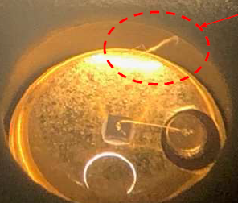
Figure 19, Galvo Motor Cotton Contamination

5.4 Galvo Positions
Once the BDO assemblies are fully built and tested, they are then moved to the galvo alignment bench where they are aligned to that specific modules galvo block. These assemblies then stay aligned to their galvo block for the duration of their time in service. If the galvo positions fall outside of the limits set by the design team, it will have adverse effects when it comes to the x/y offset and scanfield tests during the AM machines optical commissioning procedure.
The way that the alignment is set is very manual and relies on operator knowledge and experience, not just a well worded work instruction. The eight galvo motors are inserted into the four quadrants on the galvo block, then that galvo block assembly along with the four BDO assemblies are fitted to the galvo alignment trolley.
One by one, the alignment laser is fitted to each BDO assembly and the class one alignment laser is fired through the optical path and onto the galvo alignment target plate. The target plate is set by the engineering team and is adjusted using the two micrometres shown below, which adjusts the position of the plate linearly in the x and y direction.
The galvos are then manually rotated in the block which moves the alignment laser onto the corresponding quadrant point. Figure 20 below shows the galvo alignment trolley and a zoomed in image of the alignment plate:
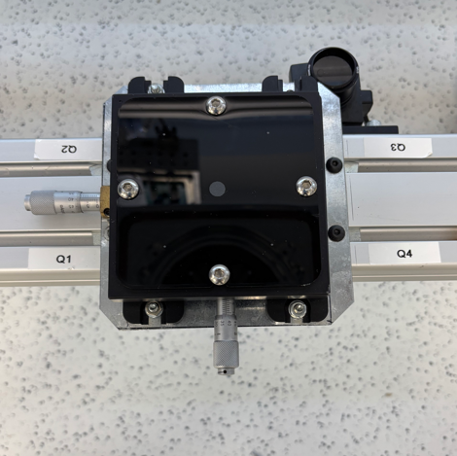
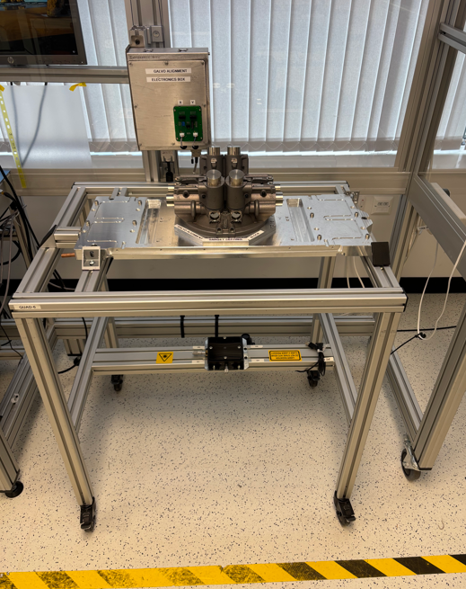
Figure 20, Galvo Alignment Trolley and Target Plate

The issue with this failure mode, along with the focus offset and max drift, is that it does not actually fail any test until it gets onto the drift rig and at that point the module is fully built. This means that to resolve the issue, the module has to be stripped down to sub-assembly level which takes three to four hours before even starting the fault finding process.
Using the data from Renishaw’s generic test rig (GTR) software (Evans, 2024), scatter plots of the x/y offsets of each quadrant were plotted dating back to 2021. This data driven evidence corroborates with the pareto chart in the define phase and shows the last three modules have very different values compared to the normal data spread. The scatter plot is shown in figure 21 below (failing modules in red circle), along with the cause and effect diagram for this failure mode in figure 22:
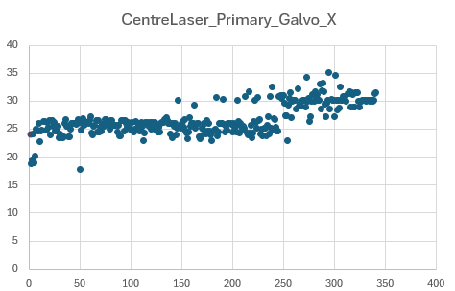
Figure 21, Scatter Plot of Galvo Positions in the X Axis

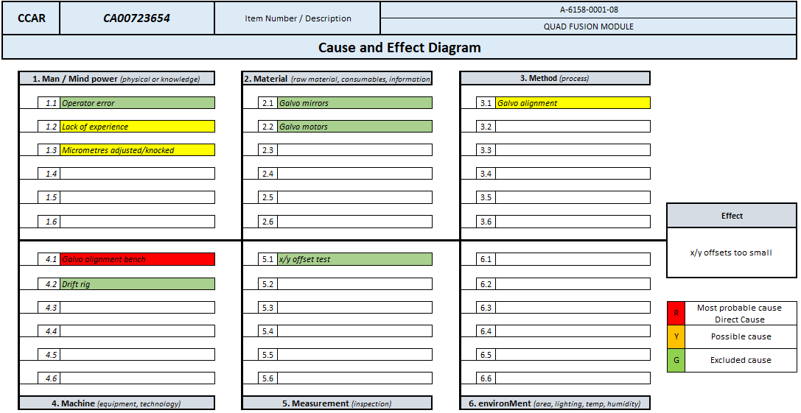
Figure 22, Ishikawa Diagram of Galvo Positions

Actions from figure 22 were to strip the galvo block out of the failing modules and put them back through the galvo alignment bench to see if any of the galvos have become misaligned since the original alignment procedure took place. When the above action took place, it was discovered that one of the micrometres used to adjust the target plate had detached from it’s housing, causing the plate to be at the x extremity limit. This is clearly the root cause of the x/y galvo position failures as the galvos were set to a target plate that was not in its nominal position.

5.5 Optical Contamination
The final failure mode that this report will analyse is optical contamination, more specifically contamination in the form of particles that have been found on the quad modules optical window. There have been three reported cases of contamination being found on the module windows during AM optical commissioning, meaning this failure was not picked up in the quad cell and the suspect modules have been fitted to machines.
A key point to note is that there is a final window inspection operation in the quad cell that is carried out by the production staff. After being removed from the drift rig, the module is fitted to a window inspection rig where the module window is removed and inspected one final time before being moved to the AM build line to be fitted to a machine. The three modules that have been affected by this failure mode all went through the final inspection procedure and were deemed as good parts. Figure 23 below shows the window inspection bench:
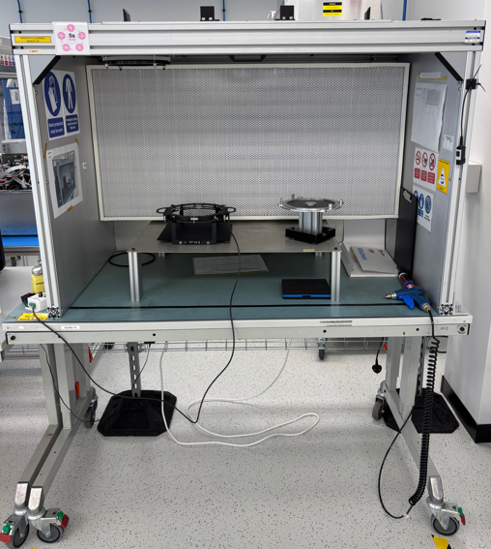
Figure 23, Window Inspection Bench

The module windows have an anti-reflection (AR) coating on them to help filter the laser beams and remains the only optic in the beams path that all four beams interface through in the machine. Initially, the technician who was working on the machine shone a torch on the window and noticed the particle was reflecting light, insinuating that they were metal particles. Upon removal of the windows, the particles were put under a microscope and were found to be metallic, see figure 24 below:

Figure 24, Swarf Contaminant under Microscope

The fact that the particles are metal is an issue, as if the laser had fired onto the metal particle it would have destroyed the coating in that area and caused significant build errors at the customer site. These windows have a value of £2400 each, so finding the source of contamination before the modules get fitted to a machine is paramount (Bennett, 1994), (Nausley, 2025).
The 5 Why’s tool was used to provoke critical thinking and to be able to easily display why a certain problem has occurred. This tool provides a fact-based and structured method of not only identifying any problem, but sets the groundwork for correcting them (Murugaiah, 2010).
Card (2016) argues that 5 Why’s can quite easily have a narrow minded view of what the root cause of an issue is and could potentially omit other root causes. To overcome this potential oversight, multiple instances of the 5 whys tool were written out and can be found in figure 25 below. Underneath in figure 26 are the 5 whys analysis on why the failure wasn’t detected in the quad cell:
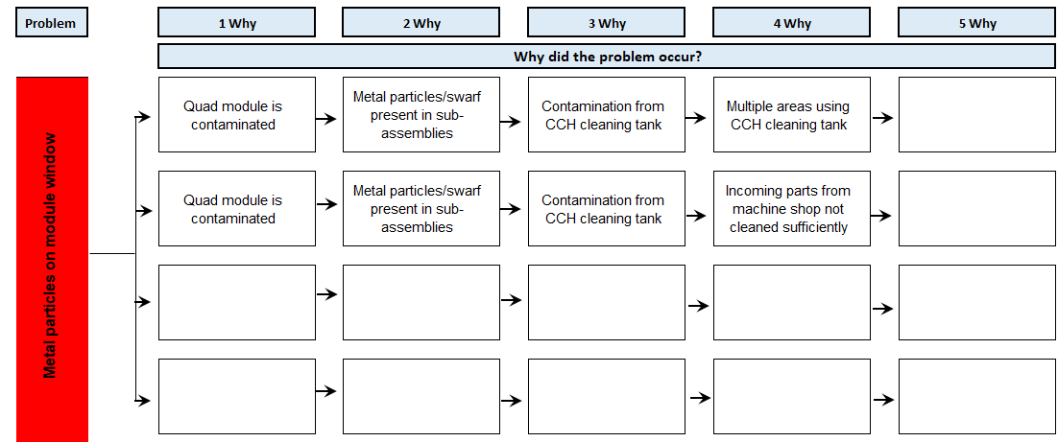
Figure 25, 5 Whys Analysis of Why the Problem Occurred

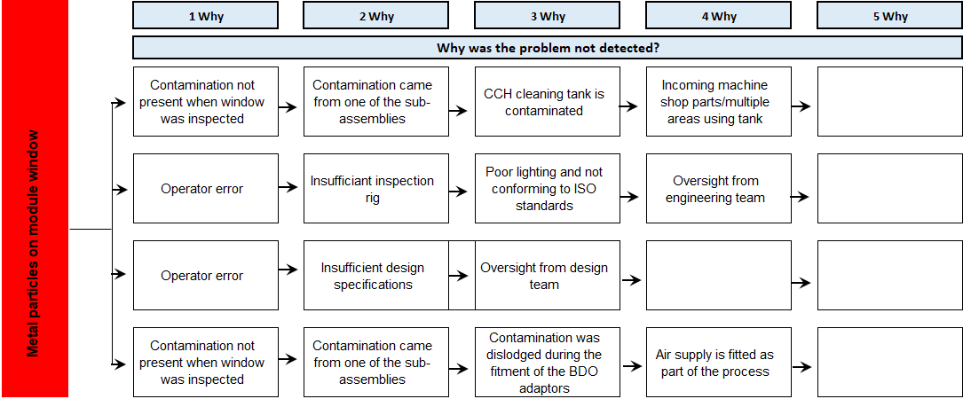
Figure 26, 5 Why's Analysis of Why the Problem Was Not Detected

Next steps for this particular failure mode were to trace back to the origin of the contamination by checking all parts in stock that come from the machine shop for any swarf or contamination. The CCH cleaning tank filters were also checked to see if swarf was present or if the filtration system is working correctly.
Upon inspection it was found that the CCH tank did have metal particles in it’s rinse tank, most likely from the parts supplied by low volume machine shop parts. These particles were sinking to the bottom of the tank and were becoming agitated by the tank when it was running a cleaning cycle. These particles then attached to the parts that are cleaned in the CCH tank and are built into the module when assembled by the production staff.

6.0 Improve Phase

6.1 BDO Alignment Bench
Now that the root cause of the focus failures has been identified as coming from the BDO alignment bench, the engineering and design team needed to develop a solution. This was achieved by brainstorming potential solutions and plugging them into a payoff matrix. Brainstorming is particularly useful as it breeds creativity between a group of people trying to achieve the same goal of problem solving (Al-Samarraie, 2018).
A brainstorming meeting was held between the production, engineering and design teams to attempt to develop a fix for the focus issue. It was important to maintain a focus on quality, time and cost (QTC) when brainstorming ideas, as these are known as a triple constraint in project management. Considering QTCs ensures that whatever the idea or project is being worked on will be delivered on time, in budget and functioning correctly (Bell, 2025).
The brainstorming meeting was structured, meaning each person submitted an idea towards fixing the issue. This was done over Microsoft Teams for the benefit of easing potential social anxieties and giving a digital record of all ideas submitted (Landis, 2008). The list below is an exhaustive list of the ideas that were put forward by the brainstorming team:
- Introduce a fixed voice coil design
  - This would remove some ambiguity in the method of setting the correct focus value by making the voice coil fixed within the BDO assembly
  - It would not account for any errors in the alignment bench
- Adjust the camera position on the bench
  - After adjusting the camera and aligning a set of BDO assemblies, build the module up to the drift rig and assess the results
  - The drift rig test is robust enough to catch any genuine failures and help the engineering team to further fine tune the BDO alignment camera position
- Add an autoexposure setting to the camera configuration file
  - This would rule out any chance of picking up spurious light or secondary spots being picked up by the camera
  - It would also make the process of alignment easier as it would automatically focus on the laser beam

- Improve the preventative maintenance schedule to check camera positions and introduce a golden BDO assembly
  - The golden unit data would be used in control charts to monitor the process and to be used for predictive maintenance (Durocher, 2004)
  - Checking the camera positions will ensure that the rig consistently has the correct setup to allow for the correct alignment of the voice coils

The team decided that more than one of these ideas could be implemented to improve the output from the BDO alignment bench, therefore the ideas above were added to a payoff matrix. The matrix was used to help visualise and analyse the ideas to determine whether or not they are viable in terms of costing and how beneficial they would be (SSDSI, 2025).
The four ideas were added to the matrix based off how much effort and cost each activity would consume and how beneficial the task was perceived to be by the engineering team. The ideas were labelled from one through to four on the matrix, which can be seen below in figure 27 (Thorn, 2024):
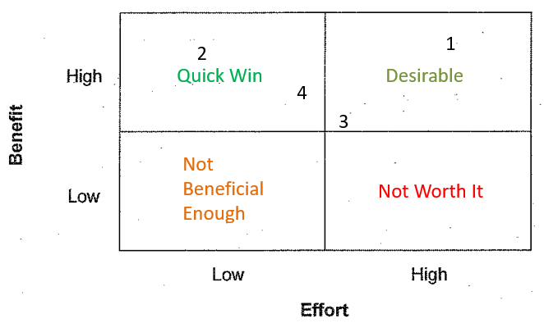
Figure 27, Payoff Matrix

The payoff matrix shows that the four ideas put forward are all highly beneficial so they will all be implemented into the process. The fixed voice coil idea (number one) will take the most effort and costing and will be worked on by the design team at a later date. The same can be said about the auto-exposure setting idea (number three), which will be carried out by a member of the software team.
Changing the camera settings was the most beneficial idea that requires the least amount of effort and money, and was seen as a “quick win” by the engineering team. This was immediately carried out, by adjusting the micrometres on the BDO alignment camera and lens as depicted in red boxes in figure 28 below:
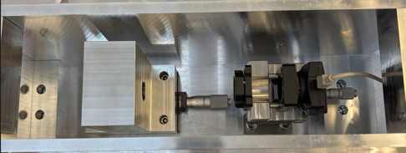
Incoming Laser
Figure 28, BDO Alignment Camera

The engineering team knew from the results of the drift rig that the focus position is between three and four millimetres away from the maximum focus offset limit. So the engineer moved the camera position by four millimetres in the direction denoted by the red arrow in figure 29 below:
Incoming Laser
Figure 29, BDO Alignment Camera Adjustment Direction
The BDO assemblies from 5EL032 (one of the failing modules) was then re-focussed using the new camera position and used as a pilot test to ensure the new camera position was set correctly or if it needed further adjustment (Teijlingen, 2002). The module was then rebuilt and put back through the drift rig, which yielded a pass result in all four quadrants (see figure 30):
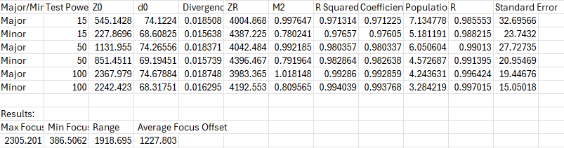
Figure 30, 5EL032 Focus Pass Results

From the results above in figure 30, the engineering team concluded that the current camera settings were satisfactory and the production modules that were failing focus on the drift rig needed to be stripped down and have the BDO assemblies re-focussed with the newly positioned camera. The graphic below (figure 31) shows the difference in focus results for the failing modules before and after the BDO assemblies were focussed using the updated camera position (green points denote results after camera changes):
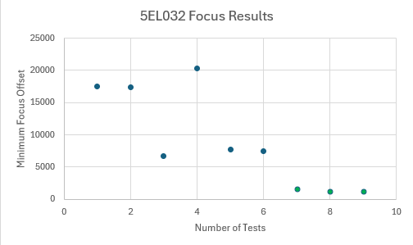
Figure 31, 5EL032 Focus Results Over Time
The above actions have changed the occurrence values in the PFMEA, with the value dropping from seven to two. This resulted in the RPN dropping from 420 down to 120 as shown in figure 32 below:
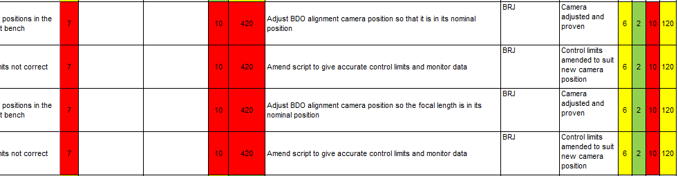
Figure 32, Improved PFMEA

6.2 Galvo Alignment Bench
The engineering team had a brainstorming meeting to go over what changes could be made to the galvo alignment bench to overcome the galvo alignment failures and the max drift failures. The root cause of the galvo alignment failures were due to the adjustment micrometre detaching from the bench, this was immediately reinstalled and set to the nominal settings that were recorded in the past.
Once the micrometres were reset, the failing modules were realigned to the correct positions and retested on the drift rig, yielding galvo positions that were within the nominal data spread. The improvements to this bench for galvo alignment failures are to prevent the above from happening again and to ensure that if it does reoccur, it is easier to rectify.
The logic behind implementing changes to the galvo alignment bench for the max drift failures comes from the knowledge that the root cause of this issue is supplier related. This means the only way to improve the quad cell is to detect any faulty galvo motors before the module is fully built and on the drift rig, ensuring that any failures are captured at source and no faults are progressed forward (Nausley, 2018).
After the brainstorming meeting, it was determined that adding a check for the galvo motors before they are installed in the galvo block was the most sensible option for detecting the max drift failures. This check was introduced using an enclosure that housed all of the relevant electronics needed to power and control a galvo motor, which was then wired into the galvo alignment bench as per figure 33 below:
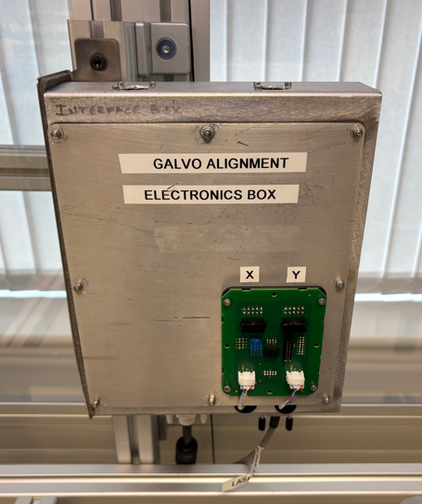
Figure 33, Galvo Alignment Bench Electronics Enclosure

The motors are then jogged (position demand) using Renishaw’s bespoke optical software, Hydra (Hamilton-Shaw, 2025) through its full range of +/-100mm (200mm). Whilst jogging the motors, the production staff monitor the z demand feedback and voice coil current values, ensuring that the feedback error is less than 2mm and the voice coil current values do not exceed 5mA; figure 34 below is a screenshot of the Hydra software and the values discussed above:
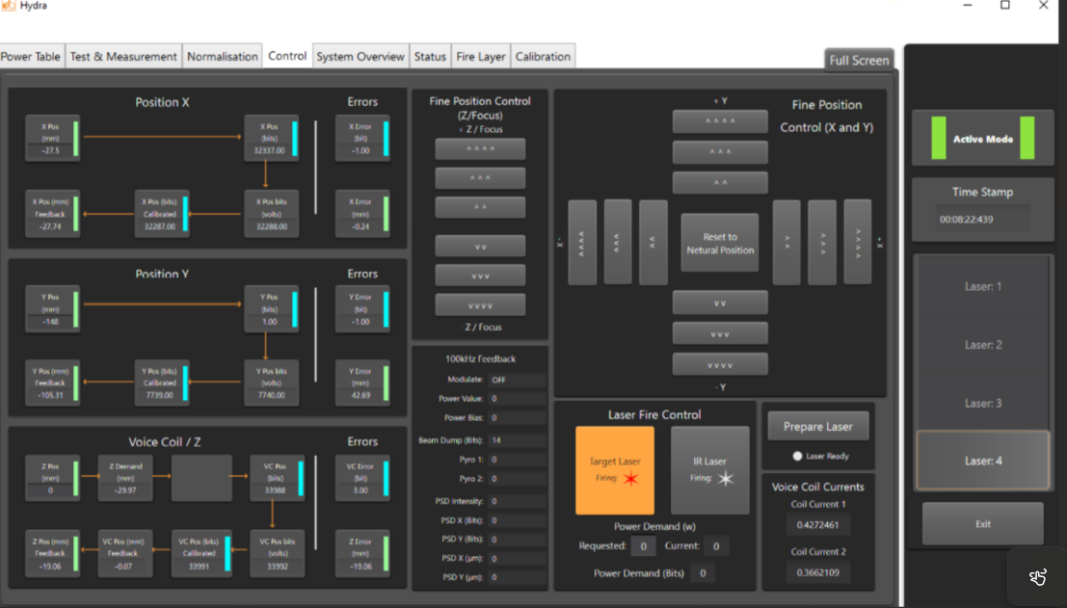
Figure 34,Screenshot of Hydra Software
For the galvo alignment issues, there was a lot more scope for change as the original fault was with Renishaw equipment. There were multiple ideas put forward, which were ranked from most beneficial to least beneficial as there have been studies that have suggested that ranking ideas in a brainstorming activity is easier than simply coming up with the best option (Putman, 2009). The ideas can be found below:
- Install cameras on the target plate
  - This will make the alignment more accurate by giving a positional value
  - This would also allow the alignment laser to be viewed on screen making the alignment process easier (Mesko, 2013)
- Introduce golden unit
- Data from golden unit will be used for predictive maintenance (Zonta, 2020)
- Will aid any fault diagnosis by proving out the alignment bench (Viveros, 2013)
- Enclose the target plate
  - This will ensure that the target plate is not susceptible to outside interference
  - Will make the area cleaner and free of dust
- Mount alignment target plate on a bench
  - More stable platform than the current trolley
  - Less prone to fasteners coming loose overtime as the bench will not move

The introduction of the golden unit is was the only idea mentioned that has been implemented so far, with the other activities added to Renishaw’s activity management system (Lloyd, 2025). The golden unit was implemented using bespoke galvo motors, which were set to the current target plate position.
The unit was verified twenty four hours later when it was placed back on the alignment bench and checked again to see if the positions had moved for any reason i.e. fastener relaxation (Abid, 2015). Because of this, if the target plate was to take a knock or if one of the micrometres were to detach again, one would simply have to align the target plate to the golden unit. A photograph of the galvo alignment golden unit can be found below in figure 35:
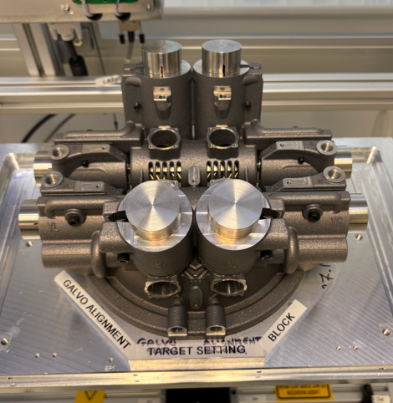
Figure 35, Galvo Alignment Golden Unit

6.3 Optical Contamination Improvements
This failure mode had the most opportunities for improvement as there are many ways in which to reduce the amount of optical contamination (Bennett, 1994). This issue required the input of the production staff, engineering team and design team so the three groups of employees gathered for a structured brainstorming meeting. Multiple ideas were put forward by each person and the top five ideas, ranked by the three teams based on how beneficial they were perceived to be, were:
- Improving the cleaning operations in the machine shop
  - Ensuring that no swarf is present when leaving the machine shop
  - Stopping the contamination at the source is a more viable option that managing the contamination afterwards (Elleuch, 2018)
- Cleaning the galvo blocks in different orientations through the CCH tank
  - This would ensure that all swarf present in the threads will be removed
- Add a daily check for the production staff
  - Put a sacrificial part through the CCH tank and check for swarf
  - Do this before putting production parts through the tank
- Improve window inspection bench in the quad cell
  - Current bench is poorly lit, and using a torch does not conform to ISO 10110-07 standard of optical inspection (ISO, 2017)
- Add a scratch/dig gauge to the inspection bench
  - This would aid production staff with inspecting optics before using them
  - Further conforms to ISO 10110-07 (ISO, 2017)

Stopping the contamination at source as stated in idea number one is a task that needs to be completed by the machine shop, who have their own engineering and design team. This is an ongoing action that will be completed by the machine shop that will affect not just the AM department but Renishaw as a whole.
The engineering team have raised a process change authorisation (PCA) to instruct the production staff to clean the galvo blocks through the CCH tank in three different orientations to ensure all threaded holes are clear of swarf, as per idea number two. Below in figure 36 depicts the galvo block and the three orientations it is now cleaned at:
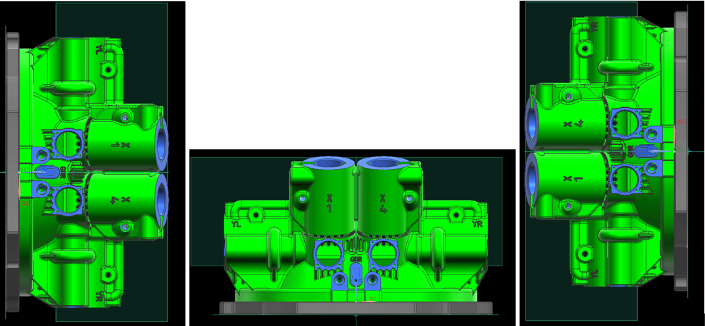
Figure 36, Galvo Block Cleaning Orientations

The third point, adding a check to the CCH tank before cleaning production parts was also implemented by the engineering team to be carried out by production staff. It asks the production staff to clean a BDO pivot and inspect it afterwards for evidence of swarf. This part was chosen as it is black in colour which is a beneficial for inspection due to it’s contrast with the swarf particles (Relle, 2017).
The production staff inspect the part for swarf or debris; if there is none present then they sign the check sheet with their name and date. If there is swarf present, then they should raise a PICA and contact the engineering team who will assess next steps.
Ideas four and five were implemented at the same time, with the addition of strip lights that were rated to 15W as per ISO 10110-7. This action now gives a standard light specification for the production staff to use when inspecting optics before being fitted to the quad modules.
The scratch/dig gauge was purchased from Edmund Optics and is now used to categorise and scratches and digs under ambient light (Edmund Optics, 2025), figure 37 below shows the gauge. Together with the addition of the strip lights formed a marked improvement to the production staff’s ability to inspect optics and, as a result, these changes were cut into the process via PCA.
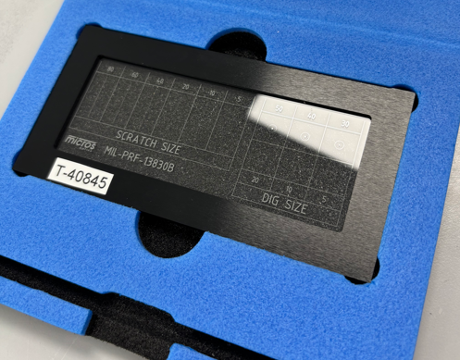
Figure 37, Scratch/Dig Gauge for Optics Inspection

7.0 Control Phase

7.1 BDO Alignment Control Charts
The purpose of a control chart is to easily display the performance of plant equipment or technologies for the purpose of process improvement and quality control (Benneyan, 1998). Due to the introduction of the BDO alignment golden unit, control charts could now be created to monitor its performance.
The control charts were created on Minitab, which is a statistical analysis software used globally (Minitab, 2025). The data that is outputted from the alignment bench to the GTR database is now used in the control charts by filtering the golden units serial number, so the same unit data is being interpreted. Figure 38 below shows a screenshot of the control charts in Minitab:
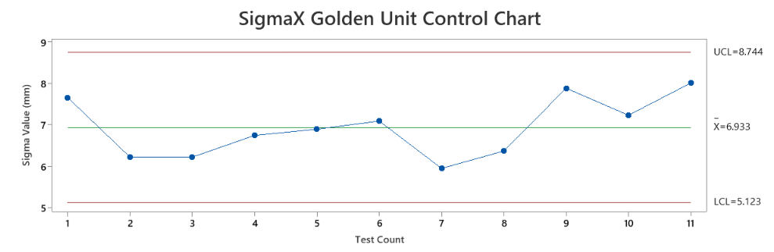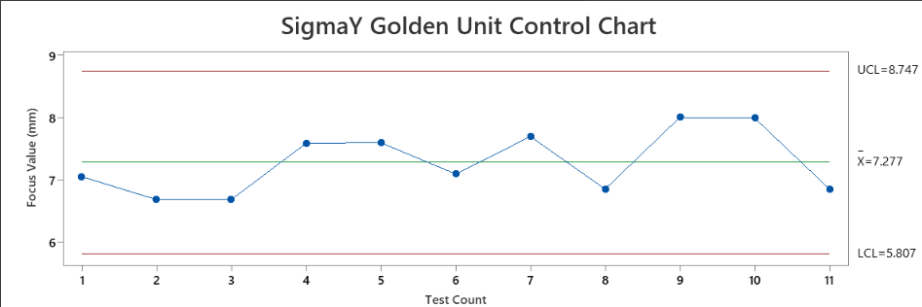
Figure 38, BDO Golden Unit Control Charts

As the golden unit is a relatively new piece of equipment, there is a small amount of data available to observe, but certainly enough to be able to monitor it’s performance. From this limited data it was determined that a reaction plan should be created in order better diagnose and fix any potential issues that arise.
As the engineering team now has a fixed golden unit with known good values, it can be used to alter the BDO alignment cameras positions if they were to drift away from the nominal results. The engineering team are confident that the camera is the only hardware on the bench that could cause the golden unit results to drift, as every other piece of hardware is static and cannot move.

7.2 Galvo Alignment Control Charts
Using Microsoft Excel and the test data from the drift rig, the engineering team overlayed the four quadrants’ galvo positions into one graph (figure 39) to give a graphical representation of where the data spreads. By doing this, the engineering team could determine whether the galvo alignment target plate was in the correct position or if it could be further refined to give better results on the drift rig.
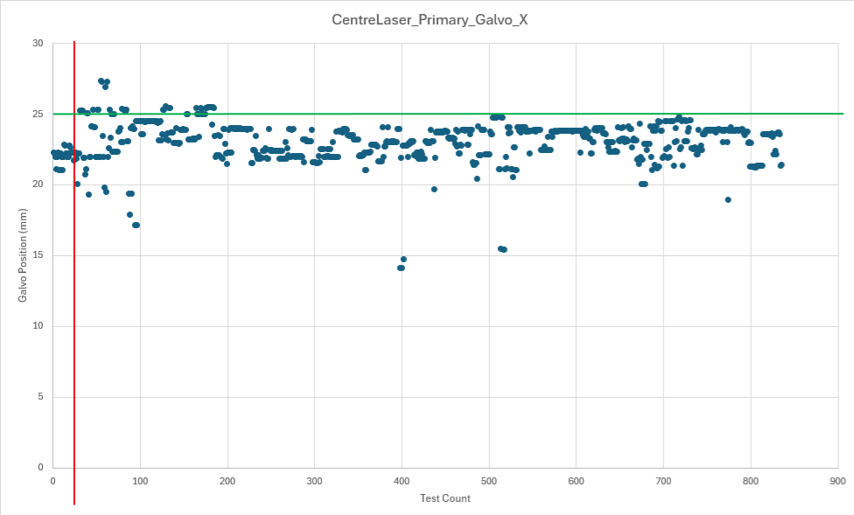
Figure 39, GalvoX Position Scatter Plot

Figure 39 shows the failing modules in the red circle, the red line indicates when the micrometre was refitted to the trolley and the green line is the nominal results. Using the data to the left of the red line it is clear that some more refinement is needed to achieve the perfect galvo alignment positions.
This will be achieved by firstly conducting a gauge R&R study, which will be used to determine whether any variance is introduced by either the product or the measurement system (Soares, 2022). After the variance is determined, control charts will be created using the golden unit data and Minitab software to establish data driven limits.
Again, introducing a golden unit now allows the engineering team to quickly diagnose whether there is an issue with the alignment bench or the quad modules. The golden unit can also be used as a reference part should the micrometre again become detached from its housing.
When the cameras are added to the bench as part of the ongoing improvement, that will allow the engineering team to gather metrics from the galvo alignment bench to monitor the process. This will then allow for any issues to be caught at sub-assembly level, rather than incurring a cost of roughly £1140 (£114 hourly labour rate) of rework and losing a full days production time.

7.3 Quad Module Cleanliness
In order to control the cleanliness of the quad modules going forward, one must look to incoming parts, specifically the parts that are supplied by the machine shop. After the root cause of the swarf was found to be with machine shop parts, the galvo blocks and BDO blocks are now routed through an incoming inspection operation by the quality assurance (QA) team (Vardeman, 1986).
Those metrics are controlled by the machine shop and the QA team, as it is not the responsibility of the AM department to rework the parts that come from the machine shop. As such, any and all defects are immediately returned to the machine shop to be scrapped off or reworked.
As mentioned in the improve phase, a check sheet was created to ensure there is no debris or contamination in the CCH cleaning tank. This check sheet will be used to monitor the amount of times the production staff have found any contamination with the view of either requesting the works engineering team to take the cleaning tank offline and attempt to diagnose the issue or potentially source an improved version of the tank.
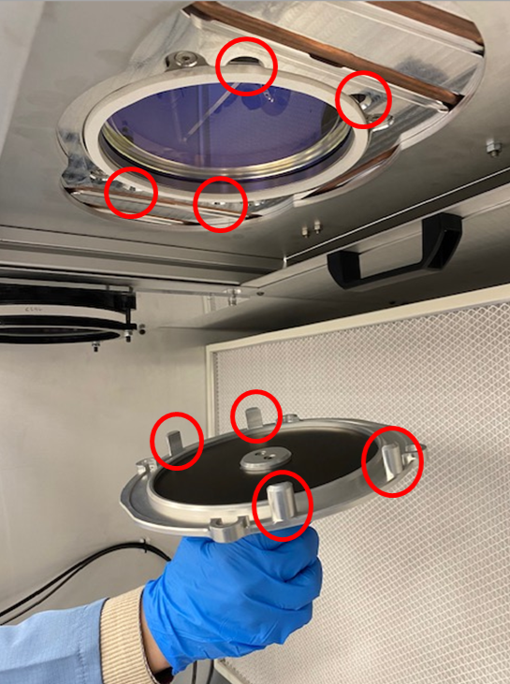
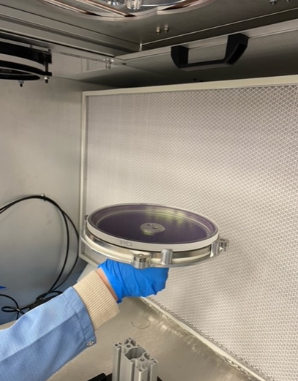
If the worst case scenario occurred and swarf was found inside a quad module that has been fitted to a machine, that module would be removed from the machine and sent back to the quad cell for review. Every module in WIP (work in progress) would be subjected to a full inspection which would involve the removal of each optical window (figure 40) and all four side panels to fully check each optic for contamination.

Figure 40, Module Window Removal

8.0 Conclusion
The purpose of this project was to find the root cause of the top failures in the last six months in the quad cell and implement fixes and improvements with the future in mind. The findings in this report indicate that root causes have been found for all four failure modes, with the fixes already in place. The root causes for the four failure modes covered in this report are:
- Galvo positions: target plate micrometre detached from alignment trolley
- Max drift: contamination found within galvo motors
- Focus failures: BDO alignment camera not in nominal position
- Optical contamination: dirty incoming parts and using shared equipment
Since introducing the reactive fixes to each subject area, the count of failures has decreased significantly and these faults are no longer holding up the production of AM machines. More specifically, the £2.6 million order book was met without missing any shipments, which took a great deal of effort from both the production and engineering teams.
There is also a combination of completed and planned process improvement activities in the quad cell. Short term improvements come in the form of introducing golden units for the BDO and galvo alignment benches to be used in a measurement system analysis and control charts. There was also the introduction of a sacrificial part check in the CCH cleaning tank to stop production from putting new parts into a dirty tank.
Recommendations for future work which will improve the process further include the addition of cameras to the galvo alignment bench. This will allow the production staff to aim for a specific nominal position through the Hydra software, rather than the current process which is to align the galvos by eye. This will also allow the engineering team to derive metrics and to be able to catch any future failures at a sub-assembly level.
The best metric to use to gauge how successful this project has been would be to review the aims and objectives (Donato, 2024). After review, it is clear that they have all been met; to show this, below is a table of aims and objectives along with the current status of each (figure 41):

Aims & Objectives | Outcome
RCA on top four issues in quad cell | All four failure modes went through root cause analysis and each cause was discovered and rectified
Reduce CoPQ in the area | By implementing countermeasures to the failure modes, less parts have been scrapped, less rework has been carried out and CoPQ in the area has reduced by 78%
Less impact on customer orders | There have been no missed shipments or machines on stop since implementing the fixes
Reduce returned modules from commissioning | Only one module has been returned from commissioning since this project began, but for an unrelated failure mode (centroid drift)
Figure 41, Table of Aims & Objectives

The table above shows a successful root cause analysis and implementation of fixes to four real-world failure modes in a complex assembly. This work was undertaken over the course of eight months and spread across three teams of people, the production staff, design team and most of all the engineering team. Not only have the resolutions to the failures helped the production staff meet demanding deadlines, but the ongoing process improvements by the engineering team have laid the roots for a more robust and stable assembly process for the years to come.

9.0 Appendices

9.1 Gannt Chart
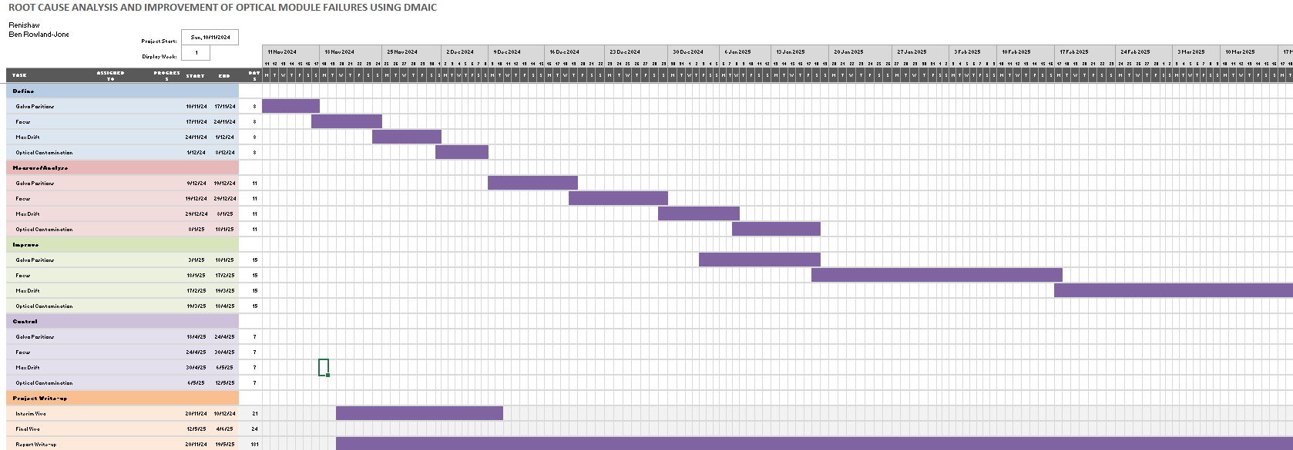

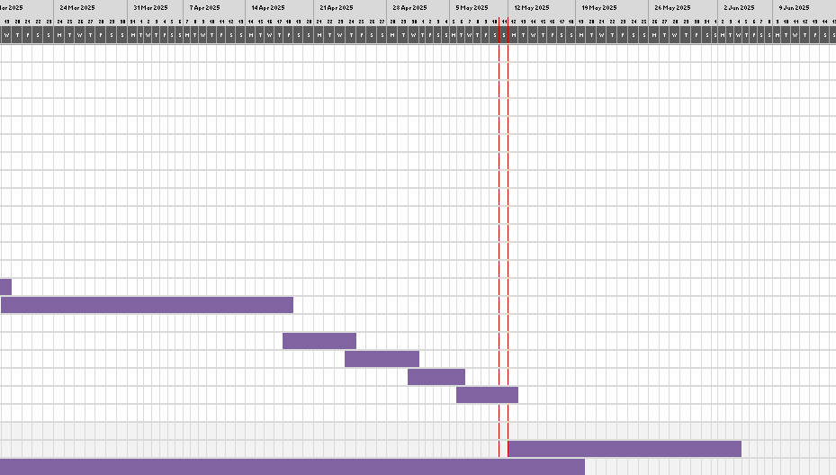

9.2 Quad Cell PFMEA
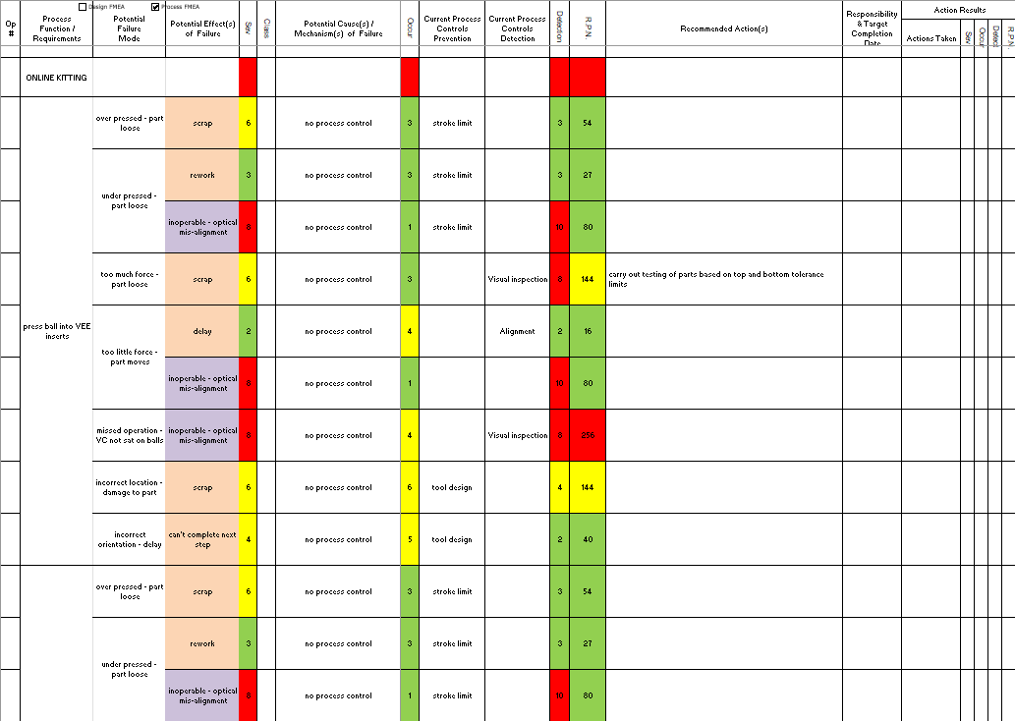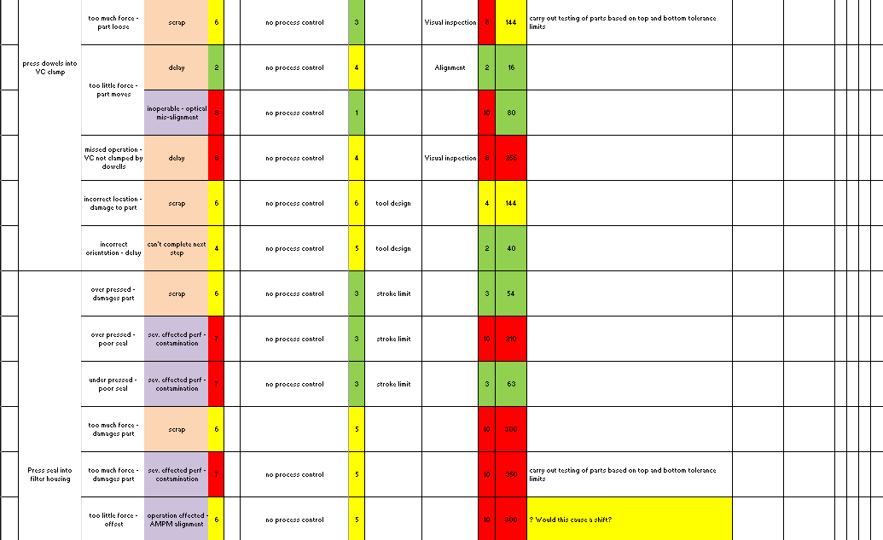
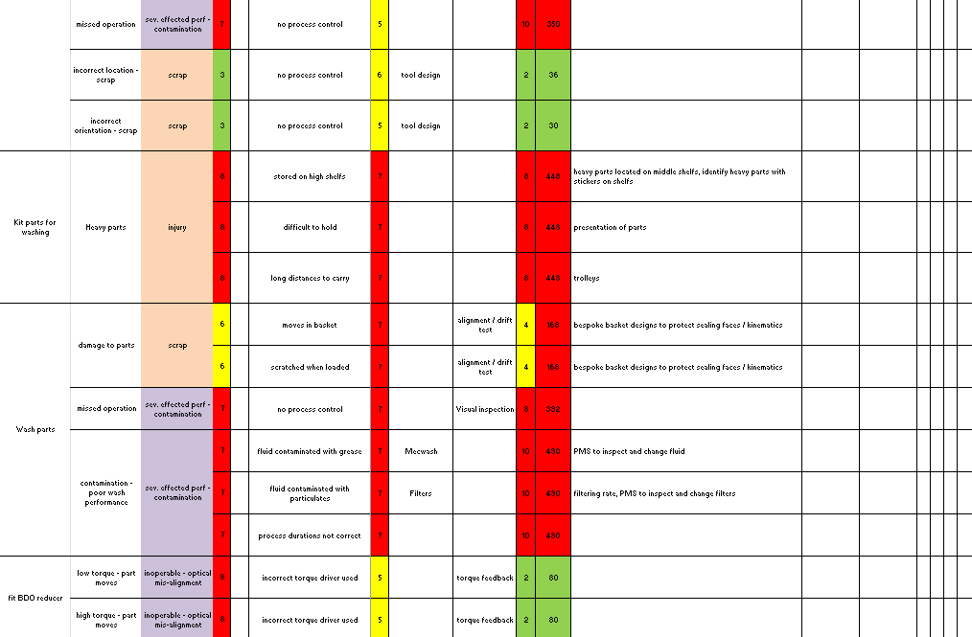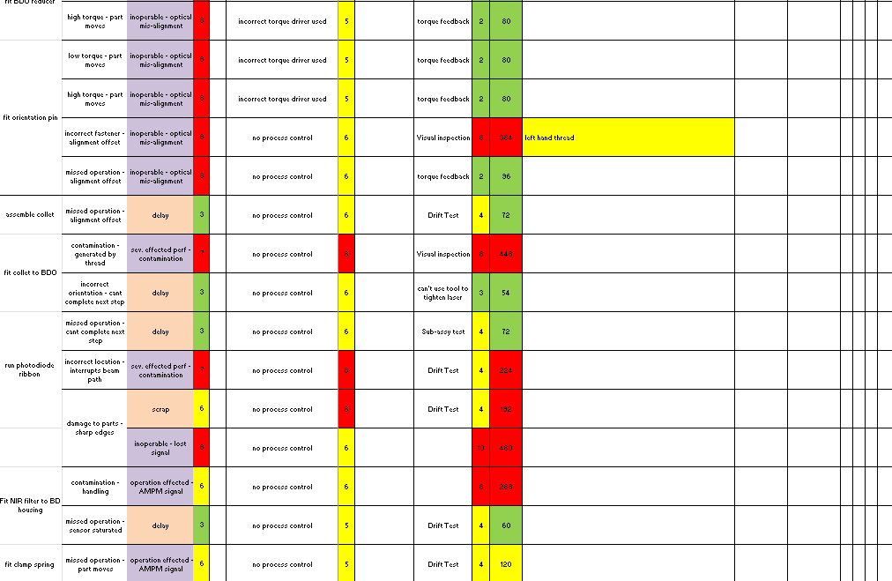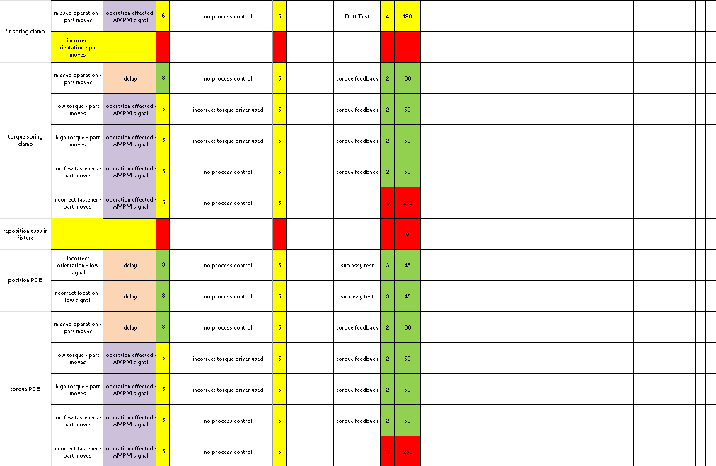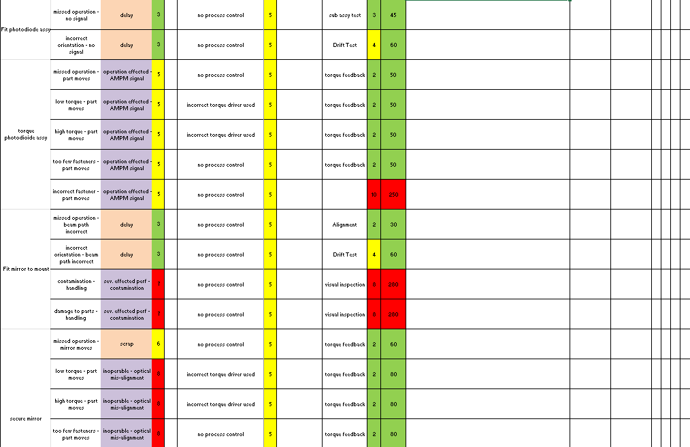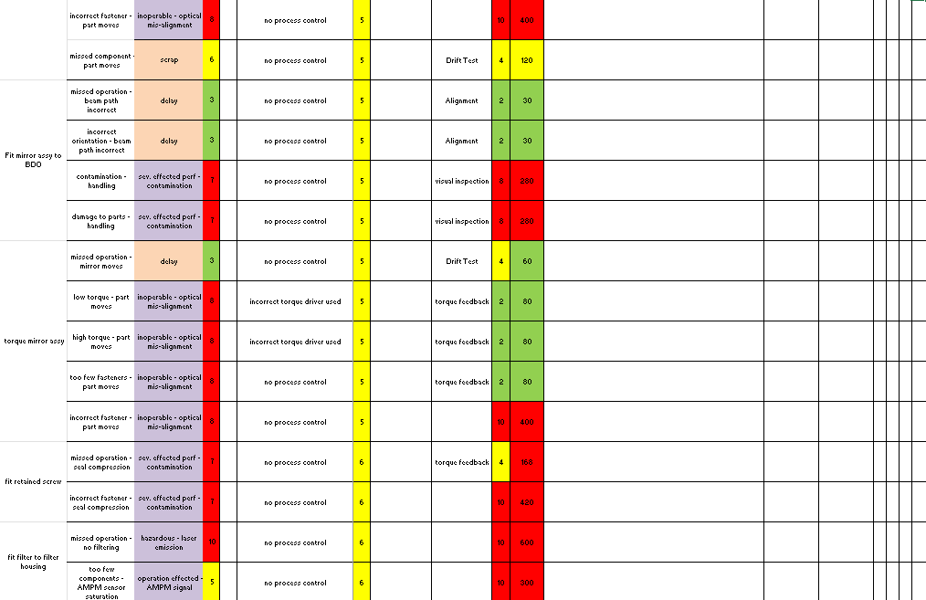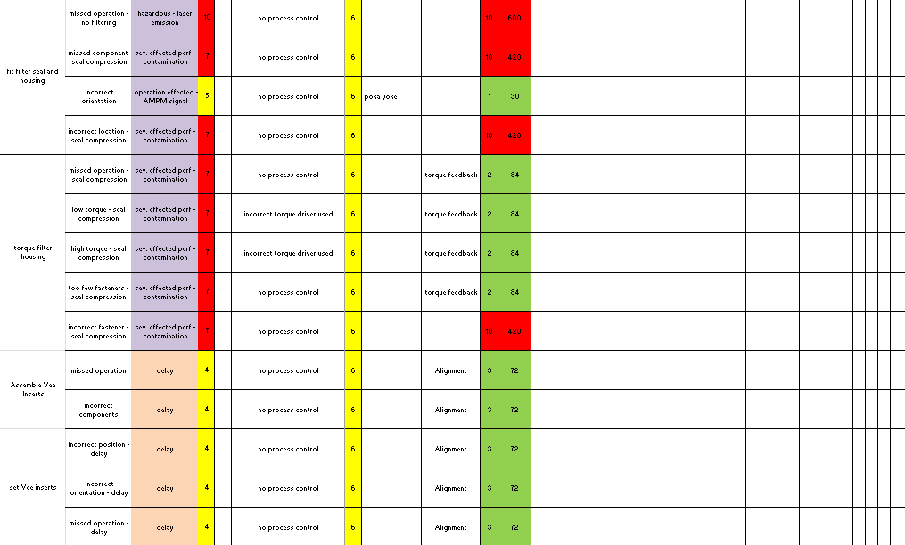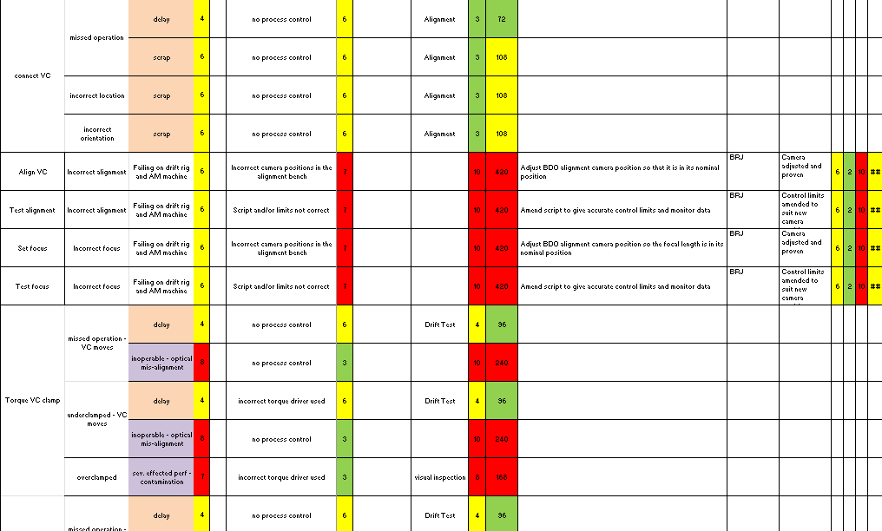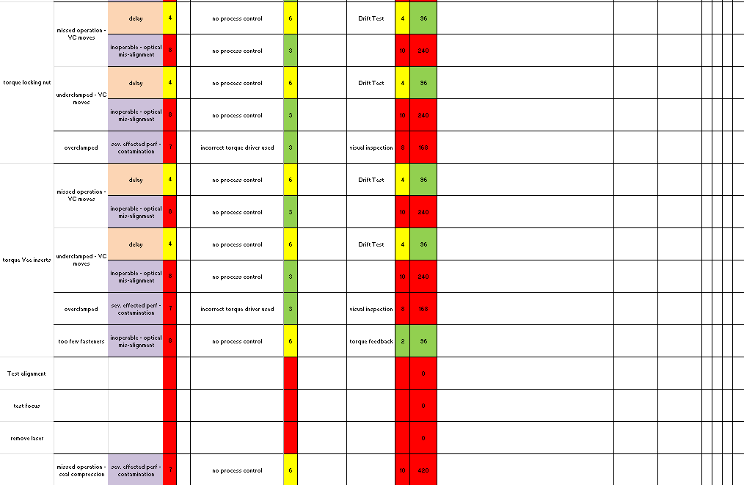

10.0 Bibliography
Abid, M. (2015). AN EXPERIMENTAL STUDY ON THE RELAXATION OF BOLTS. IIUM Engineering Journal.
Alkiayat, M. (2014). A Practical Guide to Creating a Pareto Chart as a Quality Improvement Tool. Global Journal on Quality and Safety in Healthcare.
Al-Samarraie, H. (2018). A review of brainstorming techniques in higher education. Thinking Skills and Creativity.
Banduka, N. (2016). An integrated lean approach to Process Failure Mode and Effect Analysis (PFMEA): A case study from the automotive industry. Advances in Production Engineering & Management .
Bell, A. (2025). Time Cost Quality. Retrieved from AbleSim: https://ablesim.com/time-cost-quality/
Bennett, J. M. (1994). Particles on Surfaces. Boca Raton: CRC Press.
Benneyan, J. C. (1998). Use and interpretation of statistical quality control charts. International Journal for Quality in Health Care.
Card, A. J. (2016). The problem with ‘5 whys’. BMJ Quality & Safety.
Carlson, J. S. (2003). Assembly Root Cause Analysis: A Way to Reduce Dimensional Variation in Assembled Products. International Journal of Flexible Manufacturing Systems.
Donato, H. (2024). How to Measure the Success of a Project: 5 Steps (+ Examples). Project Management.
Durocher, D. B. (2004). Predictive vs. Preventative Maintenance. IEEE.
Edmund Optics. (2025). NIST Traceable Scratch Dig Standards. Retrieved from Edmund Optics: https://www.edmundoptics.com/f/nist-traceable-scratch-dig-standards/13279/
Elleuch, B. (2018). Environmental sustainability and pollution prevention. Environmental Science & Pollution Research.
Evans, N. (2024). GTR Software. (B. Rowland-Jones, Interviewer)
Frady, L. (2023). Variable vs. Attribute Data: What’s the Difference? Retrieved from ISIXSIGMA: https://www.isixsigma.com/control-charts/variable-vs-attribute-data-whats-the-difference/
Hamilton-Shaw, N. (2025). Hydra Software. (B. Rowland-Jones, Interviewer)
Hill, T. (2015). FMEA Structure. Pontyclun: Renishaw.
ISO. (2017). ISO 10110-7:2017. Retrieved from ISO: https://www.iso.org/standard/65444.html
Kabir, S. M. (2016). Methods of Data Collection.
Landis, M. (2008). Better Brainstorming. Journal of Accountancy.
Lau, A. (2009). What Are Repeatability and Reproducibility? Petroleum Products and Lubricants.
Lloyd, A. (2025). Activities Management System. (B. Rowland-Jones, Interviewer)
Mesko, M. (2013). Laser Spot Detection. Journal of Information, Control and Management Systems.
Minitab. (2025). About Us. Retrieved from Minitab: https://www.minitab.com/en-us/company/
Murugaiah, U. (2010). Scrap loss reduction using the 5‐whys analysis. International Journal of Quality & Reliability Management.
Nausley, G. (2018). A Rose by Any Other Name…. Retrieved from SME: https://www.sme.org/technologies/articles/2018/june/a-rose-by-any-other-name/
Nausley, G. (2025). “No Fault Forward” is the New Buzzword in the Assembly Industry. Industry 4.0, Application, Quality Control.
Noor, S. (2022). Simple Random Sampling. International Journal of Education & Language Studies.
Olsen, W. (2012). Data Collection: Key debates and methods in social research. Sage.
Putman, V. L. (2009). Brainstorming, Brainstorming Rules and Decision Making. The Journal of Creative Behavior Volume.
Relle, L. (2017). Good Background Colors for Readers: A Study of People with and without Dyslexia. Pittsburgh: Carnegie Mellon University.
Renishaw. (2023). About Renishaw. Retrieved from www.renishaw.com: https://www.renishaw.com/en/about-renishaw--6432
Renishaw. (2024). Our History. Retrieved from Renishaw: https://www.renishaw.com/en/our-history--32458
Sanders, D. (1999). The Process Map. Quality Engineering.
Sharma, K. D. (2018). Failure Mode and Effect Analysis (FMEA) Implementation: A Literature Review. Journal of Advance Research in Aeronautics and Space Science.
Smętkowska, M. (2018). Using Six Sigma DMAIC to improve the quality of the production process: a case study. Procedia; Social and Behavioural Sceinces.
Soares, W. d. (2022). Gage R&R studies in measurement system analysis: A systematic literature review. Quality Engineering.
SSDSI. (2025). How to Use a Payoff Matrix to Prioritize Solutions. Retrieved from Six Sigma DSI: https://sixsigmadsi.com/payoff-matrix/
Teijlingen, E. v. (2002). The Importance of Pilot Studies. Nursing Standard.
Thorn, A. (2024). Payoff Matrix. Swansea, Swansea, Wales.
Vardeman, S. B. (1986). The Legitimate Role of Inspection in Modern SQC. The American Statistician.
Viveros, P. (2013). Resolving equipment failure causes by root cause analysis and theory of inventive problem solving. Proceedings of the Institution of Mechanical Engineers. Santa Maria: Federico Santa María Technical University.
Wilkinson, L. (2012). Revising the Pareto Chart. The American Statistician.
Wong, K. (2016). Quality Improvement in Behavioral Health. Reno: Springer.
Yeung, S. M.-C. (2009). Using Six Sigma – SIPOC for customer satisfaction. International Journal of Six Sigma and Competitive Advantage.
Zonta, T. (2020). Predictive maintenance in the Industry 4.0: A systematic literature review. Computers & Industrial Engineering.

