Name: Mihaela Breazu

Student ID: 2027946

Module Number: BMSK4003

Module title: Digital Skills and Research Methods

Lecturer name: Koushik Modak

University Name: UWTSD

Digital Skills and Research Methods

Assessment 2

Impact of Virtual Learning Environment (VLE) on learning experience of students at the University of Wales Trinity Saint David London Campus (UWTSD)

Abstract
The virtual learning environment used in the educational organisation brings benefits for the students and teachers. This research study has aimed at investigating the impacts of benefits of VLE on the learning experiences of the students at UWTSD. Under mixed research design and mixed data collection methods, online survey strategy and desk research strategy have been selected. Both quantitative and qualitative data collection methods have concluded that the students have been able to develop their learning progress and experiences with the help of VLE.

Table of Contents
Abstract ii
Introduction 1
Rationale of Research 1
Research Aim and Objectives 1
Literature review 3
Research Methodology 4
Primary data analysis 5
Secondary data analysis 12
Conclusion and Recommendation 13
Reference 14
Appendix 15
Google Survey Form 15
Questionnaire 15

Introduction
Online learning has been embraced since the pandemic hit the world. Before the pandemic, online learning was rising with the help of advanced technologies and the internet (Rokibul Kabir, 2020). A virtual learning environment represents the online platform used for educational purposes which combines the activities of managing courses, resources, and informational sites for the students. Online learning within a virtual learning environment has been developed as it brings lots of benefits for the students and teachers (Hayati and Hashemy, 2013). University of Wales Trinity Saint David has been using Moodle for managing the virtual learning environment to educate the students and to manage lesson planning. The students have different opinions and feedback regarding the virtual learning environment and its impacts on their learning progress. This is the main concerned of this investigation under the mixed method.

Rationale of Research
Every type of industry is changing with technologies, the internet, and different approaches to developing success and results (Risquez and McAvinia, 2018). The educational organisations are working for new approaches and techniques which can develop the education system and can enhance student’s learning experiences and skills. Studies showed that the student’s learning experiences are related to the contribution from the educational sector and the environment. The virtual learning environment has helped the organisation to plan for the digital lesson planning and activities for the students (Barnes and Jenkins, 2014). The benefits of a virtual learning environment have enhanced the options for the students to develop their learning, skills, and career. However, in some cases, a virtual learning environment can create negative consequences on the learning experiences of the students if they are not managed properly (Tran and Meacheam, 2020). The students of UWTSD have experienced VLE and it has impacts on student’s learning experiences and skills development. The research study has chosen to discuss and analyse the impacts of the benefits of Virtual Learning Environment (VLE) on the learning experiences of the students at (UWTSD) London Campus.

Research Aim and Objectives
This research paper has aimed at investigating the impact of the Virtual Learning Environment (VLE) on developing the learning experience of the students at (UWTSD).
The research objectives of the paper are:
- To assess the benefits of Virtual Learning Environment for the students at (UWTSD).
- To investigate the factors supporting and affecting students’ learning experience in (UWTSD).
- To analyse the impacts of benefits and usages of Virtual Learning Environment (VLE) on developing the learning experience of the students at (UWTSD).
- To recommend sustainable strategies for using the benefits of VLE to develop students’ learning experience at (UWTSD).

Literature review
The usages of a virtual learning environment have impacts on the students and teachers. However, there are certain discussions and arguments related to the benefits of a virtual learning environment for the education system. According to Crane et al (2012), virtual classroom learning represents the inclusivity and engagement of the students. Also, the virtual learning environment develops the accessibility to the materials and skills development opportunities. On the other hand, Hu and Tian (2012) argued that a virtual learning environment comes up with benefits related to community and relationship building. However, Hayati and Hashemy (2013) responded that a virtual learning environment reduces the costs of travel and education for the students. Barnes and Jenkins (2014) also stated that a virtual learning environment can help the students to get expanded world view and career options. But, Raftery and Risquez (2018) mentioned that a virtual learning environment improves the technical skills of the students with more scopes for the learning. Risquez and McAvinia (2018) stated that within the virtual learning environment, immediate feedback on learning can be managed. This also represents the flexibility and comfort in learning and lesson planning.
Hu and Tian (2012) stated that supports and resource planning for the students contribute to the development of student’s learning experiences. Also, a positive environment in the educational organisation can help the students to develop their learning. On the other hand, Barnes and Jenkins (2014) argued that the students can perform better if their learning preferences and styles match with the lesson planning. In this situation, supports are necessary for the students. However, Tran and Meacheam, (2020) mentioned that the engagement of the students contributes to their understanding and student’s learning experiences in the organisation.
According to Crane et al (2012), students can develop their learning and experiences within virtual learning environments if they get proper information, supports, and resources for the education. On the other hand, Raftery and Risquez (2018) argued that the application of a virtual learning environment helps the students to get options for career development and skills development. These develop the learning experiences of the students. But, Rokibul Kabir (2020) mentioned that educational organisations are supposed to develop proper virtual learning environments for enhancing student’s learning experience. The engagement of the students within virtual learning environments can improve their thinking, learning, and skills development as well.

Research Methodology
This research paper has chosen both numerical data and detailed data to accomplish the aim of the paper. Under primary and secondary research, qualitative and quantitative data have been chosen to fulfil the purpose. Positivism research philosophy has been accepted to value the data collection with less judgement and biasness of the researcher. With the help of positivism research philosophy, social data collection is possible and the respondents can be involved (Thelwall and Mas-Bleda, 2020). Under positivism research philosophy, the research study has chosen a deductive research approach. The application of the deductive research approach considers the analysis and test of the assumption and objectives.
Data Collection and Sampling Method
A mixed research design has been followed for primary and secondary data collection tools. An online survey research strategy has been chosen for the primary data collection method. The respondents have been selected under the sampling method and have been communicated for their consent. The application of the purposive sampling method has been decided. The purposive sampling method helps the researcher to choose easier respondents for the collection of data in a flexible way (Aleixandre and Cerezo, 2019). This sampling method has been effective for this research study due to its convenience for data collection under different circumstances. 20 students of the London branch of (UWTSD) have been communicated for the online survey. To collect secondary and detailed data under the desk research strategy, updated case studies, journals, reports, and articles have been identified and selected.

Primary data analysis
For the analysis and evaluation of data collected from respondents, MS Excel has been selected. To evaluate detailed data and information from the sources, a qualitative data analysis tool has been selected. The evaluated data is as follows:
- Do you think that online learning is more effective than face to face?
A-No
B-Yes
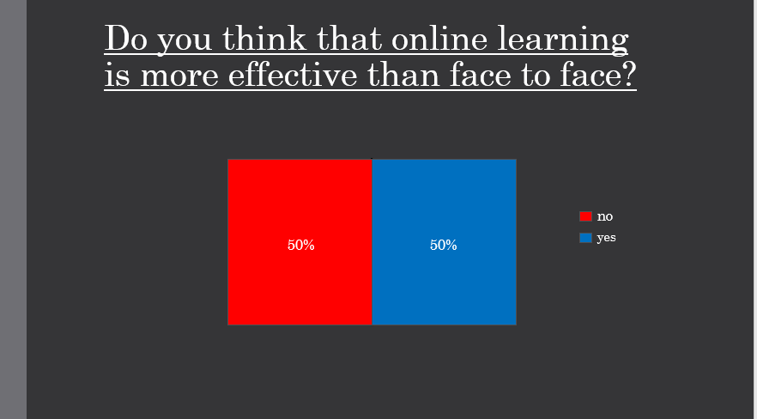
The figure represented that around 50% of the respondents in the survey have agreed that online learning is more effective than face to face. On the other hand, 50% of them agreeing that face to face is better than online.

2.Which is your age group?
A:18-30
B:30-35
C:35+
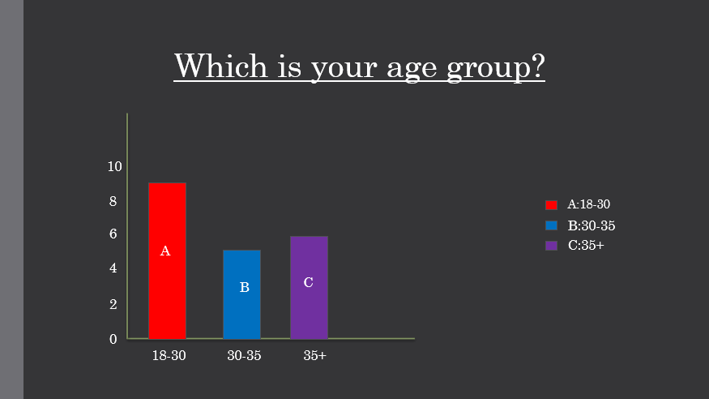
The figure represented that 9 students in the survey are aged between 18-30, 5 of the students between 30-35 and the other 6 are 35+.

3.How effective online learning is?
A: 1-5
B: 5-10

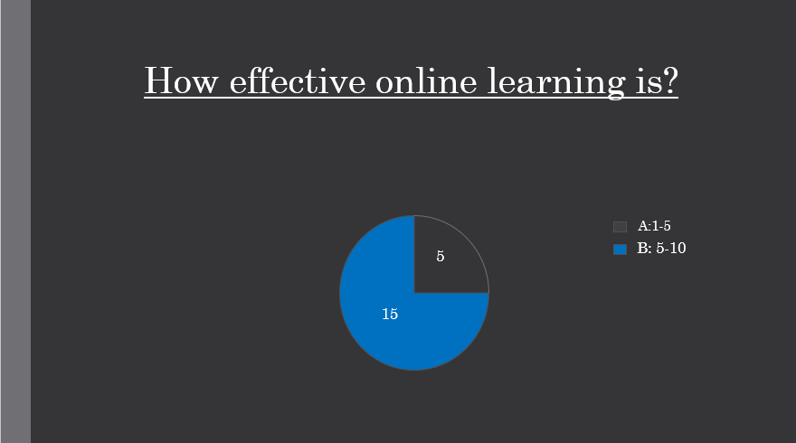
The figure represents that 15 of the students agrees with B:5-10 and the others 5 with A:1-5.

4.Do you think it’s easier for you learning online or face to face?
50% of the students are considering that it is better to learn online and the other 50% are considering otherwise.

5.You think this moodle will bring us benefit? 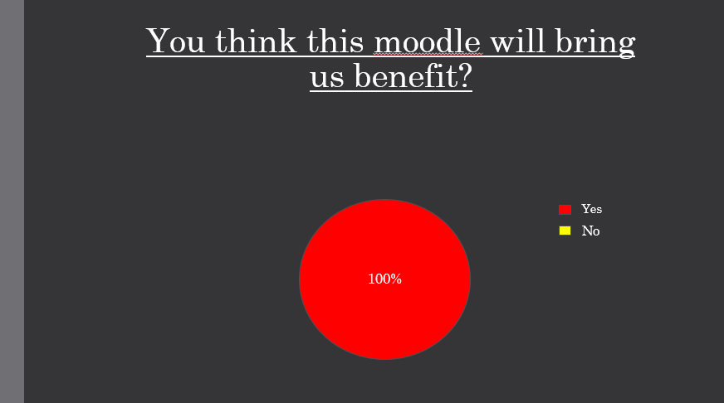

The figure represented that 100% of the students agrees that moodle will bring benefits.

Secondary data analysis
Students of the developed countries are relying on technologies and the internet to enhance their study and learning. The educational organisations have been relying on a virtual learning environment which happens to be effective even in this pandemic (Rokibul Kabir, 2020). The application of a virtual learning environment has developed the options for the learning, skills development, engagement, and career development of the students. And these factors are highly related to the student’s learning progress and experiences as well.
Over the period, the technologies have helped the students to develop more learning from various approaches and sources (Risquez and McAvinia, 2018). The educational organisations in the UK are using a virtual learning environment and technology-based learning to improve the learning of the students. Also, this has developed student’s experience within engagement and flexibility in the online classroom.

Conclusion and Recommendation
The benefits of a virtual learning environment have helped the educational organisation to think of the student’s education, learning progress, and experiences. Also, the educational organisation has been able to contribute to student’s satisfaction, skills development, and learning experience. However, UWTSD is supposed to work on their lesson planning and application of virtual learning environment to develop student’s learning experiences and satisfaction. Also, the application of a virtual learning environment is supposed to be inclusive for managing student engagement and learning progress.

Reference
Aleixandre Agulló, J. and Cerezo Herrero, E., 2019. Bilingual education research: a bibliometric study. Elia, (19), pp.235-370.
Barnes, D. and Jenkins, D., 2014. Student Satisfaction Negates Pedagogic Rights, Theirs and Ours!.Student Engagement and Experience Journal, 3(2).
Crane, L., Benachour, P. and Coulton, P., 2012. Student Experiences with Mobile Electronic Updates from a Virtual Learning Environment. International Journal of Mobile and Blended Learning, 4(3), pp.16-33.
Hayati, D. and Hashemy, S., 2013. Communication Technologies and Virtual Learning Environment (VLE) in Teaching Literature. International Journal of Innovation, Management and Technology,.
Hu, B. and Tian, L., 2012. Do teachers and students share similar beliefs about teaching and learning strategies?. System, 40(2), pp.237-254.
Raftery, D. and Risquez, A., 2018. Engaging students through the VLE: comparing like with like using the #VLEIreland student survey. Irish Journal of Technology Enhanced Learning, 3(2), p.24.
Risquez, A. and McAvinia, C., 2018. The VLE versus Open Education. Irish Journal of Technology Enhanced Learning, 3(2), p.86.
Rokibul Kabir, M., 2020. Impact of Faculty and Student Readiness on Virtual Learning Adoption amid Covid-19. Revista Internacional de Educación para la Justicia Social, 9(3), pp.387-414.
Thelwall, M. and Mas-Bleda, A., 2020. How common are explicit research questions in journal articles?. Quantitative Science Studies, pp.1-19.
Tran, T. and Meacheam, D., 2020. Enhancing Learners' Experience through Extending Learning Systems. IEEE Transactions on Learning Technologies, pp.1-1.

Appendix
In-Class exercise: Questionnaire Design
Student Name Mihaela Breazu Student ID:2027946
Module Name: Digital Skills and Research Methods (SFTW) Group: 1

Aim: This exercise is aimed to help you in your questionnaire design. Please note, you need to use this questionnaire to conduct a survey which is also one of the important parts of your research report. You will also need to attach this questionnaire to your final report.

For any further questions, please list them below.
Question 1:Do you think that online learning is more effective than face to face? A no
B Yes

Question 2:Which is your age group?
A 18-30
B 30-35
C 35+

Question 3:How effective online learning is ?
A 1-5
B 5-10

Question 4: Do you think it's easier for you online to learning or face to face?
A no
B Yes

Question 5: You think this moodle will bring us benefit?
A Yes
B no

